Tracy Lee, Chief Deputy Secretary
Tim Gasperson, Director of Operations
Brian Gates, Director of Programs
Theresa Starling, Director of Administration

N. C. DEPARTMENT OF ADULT CORRECTION
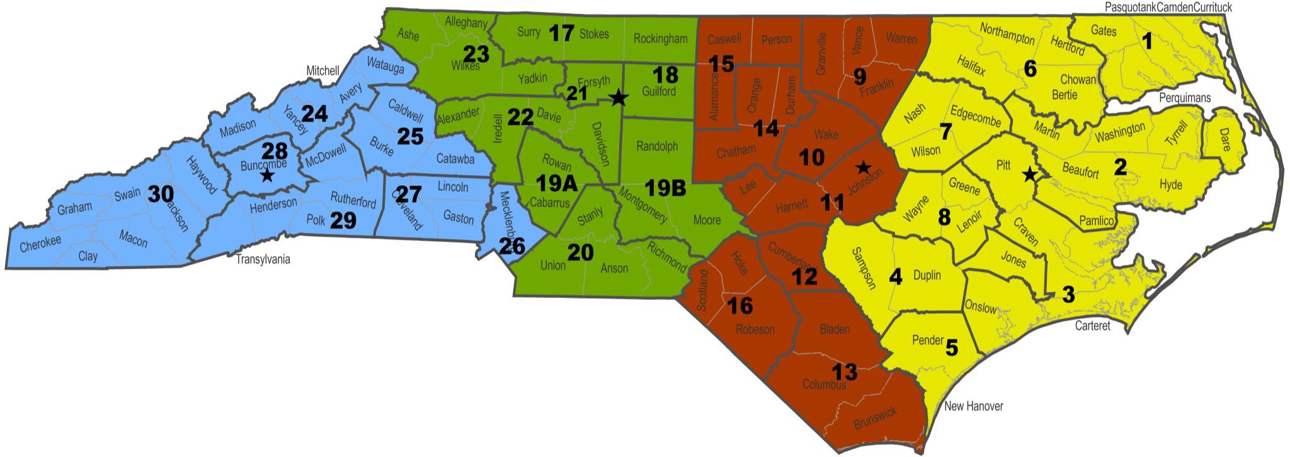
DIVISION OF COMMUNITY SUPERVISION

Fourth Judicial Division

Third Judicial Division
Second Judicial Division

First Judicial Division

Fourth Judicial Division
Third Judicial Division
Second Judicial Division
First Judicial Division

JD Dir.  Asst JD Dir. JDM Dist 24 | (Vacant)  Latasha White  Michael Lawing | JD Dir.  Asst JD Dir. JDM Dist 17 | (Vacant)  Shawn Owens Daniel Attaway | JD Dir.  Asst JD Dir. JDM Dist 9 | Sheila Moore  Moses Barrow  Kimberly Wright | JD Dir.  Asst JD Dir. JDM Dist 1 | William Woolard Heather Bevell Jennifer Gallop
JDM Dist 25 | Edward Hummel | JDM Dist 18 | Darryl Wilson | JDM Dist 10 | Alan Pitstick | JDM Dist 2 | David McCarthy
JDM Dist 26 | Matt Hardin | JDM Dist 19A | Valerie Washington | JDM Dist 11 | Nicole Patterson | JDM Dist 3 | Charles Raiford
JDM Dist 27 | Kim Gettys | JDM Dist 19B | Heather Marsh | JDM Dist 12 | Leslie Henley | JDM Dist 4 | Ashley Dail
JDM Dist 28 | Michael Gier | JDM Dist 20 | Shakitha Johnson | JDM Dist 13 | Jamie Williamson | JDM Dist 5 | John Corwin
JDM Dist 29 | Kathryn Rhodes | JDM Dist 21 | Stephen Warden | JDM Dist 14 | Angela Winchester | JDM Dist 6 | Alton Brown
JDM Dist 30 | Todd Sellers | JDM Dist 22 | Robin Griffin | JDM Dist 15 | Aries Cox | JDM Dist 7 | Tyler Ellis
 |  | JDM Dist 23 | Lorie Goins | JDM Dist 16 | James Harding | JDM Dist 8 | (Vacant)

