COVID-19 Updates ~ Consolidated Federal Programs

The purpose of this listserv is to provide updated information to answer questions being posed in response to the National and State of Emergencies in the US & NC due to the COVID-19 outbreak for at least the next two-weeks.

Consolidated and MEP Monitoring Events:
All Cross-Program Consolidated Monitoring Reviews and Migrant Education Program (MEP) Program Quality Reviews (PQRs) scheduled from March 16, 2020 through May 31, 2020 have been postponed and will be rescheduled during September 2020. See attached.

Parent and Family Engagement:
There have been some questions regarding if there would be any repercussions if Parent and Family Engagement (PFE) activities are cancelled for the remainder of the year. Given the current situation and the fact that ESSA does not mandate a specific number of PFE activities per year, there would not be any repercussions for not holding additional PFE activities. Also, the COVID-19 outbreak is already providing the necessity for increased parent and family communication. If you have already prepared PFE resources (materials to make games, cards books, etc.), we encourage you to utilize and distribute these resources to parents.

If you have any questions or need additional guidance, feel free to contact Dr. Melissa Nixon (melissa.nixon@dpi.nc.gov).

MEP Updates:
We realize that MEP Recruiters have a unique job that requires frequent home and labor camp visits. However, MEP Recruiters should practice social distancing as much as possible. Do not conduct active recruitment in labor camps since camps typically contain more than the maximum recommended group size. Practice frequent handwashing and carry hand sanitizer if you are required to travel.

As a reminder PRC 051 funds can be used to provide food and other basic necessities for migrant families who may be out of work or struggling to feed their children during this time. Funds may also be used to provide for mobile hotspots or devices to assists students in completing online learning.

Please ensure that you are providing information to your families about any nutrition assistance or other assistance that your districts are offering in a language that is understandable to those families who may not speak English.

The Virtual Regional MEP Meetings that are scheduled for Wednesday, March 18th and Thursday, March 19th have been postponed. You will receive an update with more information about rescheduling these meetings when it becomes available. The MEP Summit scheduled for April 30th and the Statewide PAC Meetings for April 6-9 are cancelled for this year. Any outstanding Program Quality Reviews (PQRs) will be rescheduled for next school year.

If you have any questions, please contact your respective MEP administrator – Rachel Wright-Junio (Rachel.wrightjunio@dpi.nc.gov) or Heriberto Corral (Heriberto.corral@dpi.nc.gov).
IPG Updates:
Due to NC school’s closing for two weeks and the focus needing to be on ensuring that student learning continues, the application deadline for IPG Cohort I-B has been extended until 5:00 p.m. Eastern Standard Time on April 24, 2020. If you have any questions or concerns, feel free to contact Susan Brigman (susan.brigman@dpi.nc.gov).

TSI Fund Updates:
As a reminder, TSI funds are set to expire on September 30, 2020. There will not be any extensions granted for these funds. If funds are not spent or encumbered by September 30, 2020, and liquidated by December 31, 2020, then the remaining funds will be reverted.

CSI Fund Updates:
CSI visits scheduled for April and May will be postponed.

Thank you for all that you are doing for the students and families across our state during these times, and please be safe in your efforts for the health of all involved.

Consolidated Federal Programs DPI Staff
Tricia, Susan and Alex

Dr. LaTricia Townsend
Director
Federal Program Monitoring and Support Division

Susan Brigman
Interim Assistant Director
Federal Program Monitoring & Support Division
Alex Charles
Section Chief
Federal Program Monitoring & Support Division

- COVID-19 Monitoring Postponement Memo March 16 2020.pdf
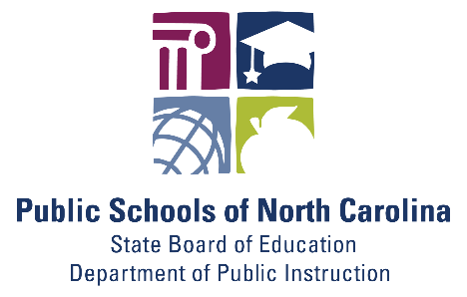
Stay Connected with North Carolina Public Schools:
SUBSCRIBER SERVICES:
Manage Subscriptions | Unsubscribe from All Topics | Help

