FOR IMMEDIATE RELEASE

March 14, 2020

CONTACTS:
Eric C. Davis
Chair, Member At-Large
North Carolina State Board of Education
eric.davis@dpi.nc.gov

Dr. Deanna Townsend-Smith
Director of Board Operations and Policy
North Carolina State Board of Education
deanna.townsend-smith@dpi.nc.gov
919-807-3608

North Carolina State Board of Education Approves
“Resolution in Support of School Closures and Emergency Actions
to Prepare and Respond to the Novel Coronavirus (COVID-19)”

RALEIGH, NC – On March 14, 2020, Governor Roy Cooper Issued Executive Order No. 117 Prohibiting Mass Gatherings and Directing the Statewide Closure of K-12 Public Schools to Limit the Spread of COVID-19.

In a special meeting this evening the North Carolina State Board of Education unanimously adopted a resolution to support the implementation of school closures for students enacted in the Executive Order No. 117. Consistent with Governor Cooper’s Executive Order, the State Board and the Department of Public of Instruction will continue their ongoing, collaborative efforts with the North Carolina Department of Health and Human Services to help mitigate impacts of school closures.

In coordination with the Governor’s Office and the General Assembly, a joint education and public health working group will implement measures to provide for the health, nutrition, safety, educational needs and well-being of children during the school closure period. The working group will also utilize and seek flexibilities in federal and state laws in order to assist with these important efforts.

Eric Davis, the Chair of the North Carolina State Board of Education, said about the State Board’s Resolution and the rapidly-evolving COVID-19:

We are facing challenging times in our State that affect all of our citizens, including our children. The State Board of Education, our State Superintendent, and the Department of Public Instruction are committed to supporting our educators and students using all possible means during this emerging public health situation. These are extraordinary times that must be met with extraordinary measures.

We will seek to support our public schools across the state. Work is already underway to help feed children who are out of school. To serve students we will seek to leverage our existing digital capabilities and we will work with educators to find new ways to deliver instruction. In collaboration with local health professionals, education leaders, and our partners from all sectors we will work to address the many issues our communities are facing because of COVID-19. Importantly, throughout this situation we will continue to partner with local superintendents and school leaders to coordinate responses and to identify and implement local solutions.

To be sure, we have significant challenges before us as a State, but we believe in the resolve of all North Carolinians to support children, regardless of the circumstances.

About the North Carolina State Board of Education

Article IX of the North Carolina Constitution empowers and directs the State Board of Education to “supervise and administer the free public school system and the educational funds provided for its support” and to “make all needed rules and regulations in relation thereto, subject to laws enacted by the General Assembly.” State Board members include the Lieutenant Governor, the State Treasurer, and 11 other members appointed by the Governor and confirmed by the Legislature in joint session. Eight of the eleven Board members appointed by the Governor represent each of the state's eight education regions, and three are at-large appointees. The eleven gubernatorial appointees serve eight-year terms; the two ex-officio members' terms coincide with the term of their respective offices. Rules and policies that the Board of Education develops set the direction for the Department of Public Instruction and local public school organization and operations.

The State Board’s recently-adopted Strategic Plans sets forth North Carolina’s goals to ensure that every public school student will be empowered to accept academic challenges, prepared to pursue their chosen path after graduating high school, and encouraged to become lifelong learners with the capacity to engage in a globally-collaborative society:

- Goal 1: Eliminate opportunity gaps by 2025
- Goal 2: Improve school and district performance by 2025
- Goal 3: Increase educator preparedness to meet the needs of every student by 2025

For More Information about the State Board of Education:
https://stateboard.ncpublicschools.gov/

For More Information about the State Board’s of Education’s Strategic Plan:
https://simbli.eboardsolutions.com/StrategicPlan/PlanDetail.aspx?S=10399&PID=487%20

Attachments: Resolution & Governor Executive Order
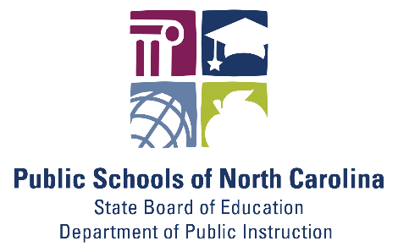
Stay Connected with North Carolina Public Schools:
SUBSCRIBER SERVICES:
Manage Subscriptions | Unsubscribe from All Topics | Help

