North Carolina
Analysis of Impediments to Fair Housing Choice
2021-2025

Draft for Public Comment 3.29.2021

March 2021

Please email all public comments to Valerie,Moore@nccommerce.com by 11:59 pm on April 29, 2021.
Contents
Introduction & Executive Summary of the Analysis 4
Why the AI was Developed 4
Who Conducted the AI 4
Participants 5
Methodology Used 5
How AI was Funded 6
Conclusions 6
Jurisdictional Background Data 10
Historical Residential Settlement Patterns 10
Demographic, Income and Employment Data 10
Key Findings 10
Race and Ethnicity 11
Dissimilarity Index 14
Ancestry and National Origin 16
Limited English Proficiency 18
Disability 19
Household Type 22
Income, Unemployment and Poverty 23
Racially / Ethnically Concentrated Areas of Poverty 27
Housing Profile 30
Age of Housing Stock 30
Vacancy Rates 30
Housing Tenure 32
Housing Affordability 34
Cost Burden 35
Other Relevant Data 37
Communities of Opportunity 37
Location of Assisted Inventory in Opportunity Areas 42
Evaluation of State’s Current Fair Housing Legal Status 48
Fair Housing Statutes 48
Federal Statutes 48
State Statute 48
Municipal Statutes 48
Fair Housing Entities 49
U.S. Department of Housing & Urban Development 49
North Carolina Human Relations Commission 49
The Fair Housing Project of Legal Aid of North Carolina 49
Existence of Housing Discrimination Complaints 49
Patterns and Trends in Housing Discrimination 51
Assessment of Current Fair Housing Programs & Activities 54
Progress Achieved since Previous AI 56
Public Sector Policy Review 61
State Building, Occupancy, Health and Safety Codes 61
State Policies on Community Development and Housing Activities 63
Community Development Block Grant Program 64
Community Development Block Grant – Disaster Recovery Program 67
HOME Investment Partnerships Program 67
Emergency Solutions Grant Program 68
Housing Opportunities for Persons With AIDS 69
Low Income Housing Tax Credit Program and the Qualified Allocation Plan 70
Olmstead Settlement Initiative 78
Language Access Plans 78
North Carolina Department of Commerce (DOC) 79
North Carolina Housing Finance Agency (NCHFA) 79
North Carolina Department of Health and Human Services (NCDHHS) 79
North Carolina Department of Environmental Quality (DEQ) 80
North Carolina Office of Recovery and Resiliency (NCORR) 81
Private Sector Policy Review 82
Home Mortgage Lending 82
High-Cost Lending Practices 84
Fair Housing Action Plan 85
Signature Page 88
Appendix A: Public Engagement Plan 89
Appendix B: NCHRC Fair Housing Activities 90

Introduction & Executive Summary of the Analysis

Why the AI was Developed
On September 8, 2020, a Final Rule published by the U.S. Department of Housing & Urban Development (HUD) titled Preserving Community and Neighborhood Choice became effective. This rule revised the definition of “fair housing” to include “housing that, among other attributes, is affordable, safe, decent, free of unlawful discrimination, and accessible as require under civil rights laws.” The rule also substantially broadened the definition of “affirmatively furthering fair housing” to mean “any action rationally related to promoting any attribute or attributes of fair housing”. Notably, the rule also eliminated the previously long-standing requirement that states and other HUD grantees prepare an Analysis of Impediments to Fair Housing Choice (an AI) as the means for evaluating the degree to which private and public sector policies, practices, statutes and programs expand or restrict housing choice for members of the protected classes.

Although the Final Rule eliminated the requirement to prepare an AI, it retained the following requirement: Nothing in this paragraph relieves jurisdictions of their obligations under civil rights and fair housing statutes and regulations. In other words, states and other HUD grantees still are required to ensure that they are not contributing to patterns of discrimination within their jurisdictions. For this reason, the North Carolina Department of Commerce (DOC), the agency charged with the administration and management of the state’s Community Development Block Grant (CDBG) funding, chose to move forward with developing the AI. The AI remains a valuable tool to:
- Evaluate residential segregation patterns
- Evaluate how private and public sector policies, practices, statutes and programs expand or restrict housing choice for members of the protected classes
- Identify impediments, or barriers, to fair housing choice
- Implement a Fair Housing Action Plan to lessen or eliminate housing discrimination, and
- Document its efforts at expanding housing choice for members of the protected classes

Who Conducted the AI
DOC was the lead entity in preparing the AI. As the recipient state agency of CDBG funding, DOC collaborated with other state entities that also receive funding from the U.S. Department of Housing & Urban Development (HUD), or are subrecipients of HUD funding through DOC, to prepare the AI. These included the following:
- North Carolina Housing Finance Agency – a recipient of the state’s federal Housing Trust Fund (HTF) allocation from HUD and the state’s Low-Income Housing Tax Credit (LIHTC) allocation from the Internal Revenue Service
- North Carolina Department of Environmental Quality – a subrecipient to DOC for CDBG funds invested in infrastructure projects
- North Carolina Department of Health and Human Services – a recipient of Emergency Solutions Grant (ESG) funds and Housing Opportunities for People with AIDS (HOPWA) funding from HUD
- North Carolina Human Relations Commission – a designated HUD Fair Housing Assistance Program (FHAP) entity that receives HUD funding to investigate housing discrimination complaints in North Carolina.

Participants
DOC committed to an extensive outreach process to solicit input from residents and stakeholders across the state. Outreach initiatives included remote public meetings and stakeholder meetings, a project website and an online survey.
DOC hosted three public meetings to identify fair housing issues and learn how North Carolina residents are discriminated against when searching for housing. In response to COVID-19, the meetings were hosted virtually on Zoom and were free and open to all members of the public. The schedule included:
- Tuesday, September 29, 2020 from noon – 1:30 pm
- Thursday, October 1, 2020 from 6:00 – 7:30 pm
- Saturday, October 3, 2020 from 11:00 am – 12:30 pm
DOC also conducted three stakeholder meetings to provide an extended working session to coordinate with a diverse group of stakeholders on solutions and related implementation strategies. In response to COVID-19, these meetings also were hosted virtually on Zoom. Each stakeholder meeting focused on a specific topic.
- Fair Housing Organizations and Advocacy Groups on Tuesday, September 29, 2020 at 3:00 pm
- Municipal Agencies and Regional Planners on Wednesday, September 30, 2020 at 1:00 pm
- Continuum of Care Organizations on Thursday, October 1, 2020 at 10 am
Appendix A includes the complete Public Engagement Plan, which describes all outreach activities, provides lists of all attendees and complete summaries of all meetings held in conjunction with the AI.
PLACEHOLDER: add info on public meetings outreach when completed

Methodology Used
A comprehensive approach was used to complete the AI. The following sources were utilized:
- Most recently available demographic data regarding population, household, housing, income, and employment at the census tract and municipal level
- A variety of online databases providing indicators that reflect local issues and based on research that validates the connections between the indicators and increased opportunity across the state for North Carolinians
- Public policies, codes and statutes affecting the siting and development of housing
- Administrative policies concerning fair housing, affordable housing and community development
- Financial lending institution data from the Home Mortgage Disclosure Act (HMDA) database
- Agencies that provide housing and housing related services to members of the protected classes
- Fair housing complaints filed with HUD and the North Carolina Human Relations Commission, and
- Interviews and stakeholder meetings conducted with state agencies and non-governmental organizations that provide housing and housing related services to members of the protected classes.

How AI was Funded
The AI was funded with CDBG funds from DOC.

Conclusions
The Fair Housing Action Plan includes a list of impediments to fair housing choice identified through the AI process. This section of the AI lists each impediment and discusses briefly why it is a barrier to fair housing. Actions are recommended for each impediment along with measurable objectives to mark progress achieved. Most of the impediments listed below have been carried over from the 2015 AI as they remain relevant today. This is logical given that the trends and conditions underlying the impediments occurred over decades and cannot be resolved fully within five years.

Goal A: Expand fair housing awareness and compliance to preserve and expand housing choice for members of the protected classes.
Impediment A.1: Discrimination in the rental housing market persists with disability and race as the two most often cited alleged bases of discrimination. Between 2015-2019, 55.4% of all cases alleged discrimination based on disability and 32.2% based on race. In addition, according to the NCHRC, recent trends in discrimination against persons with disabilities involve discriminatory behavior against persons with emotional support animals (ESAs). Resistance from rental housing providers in the form of “no pet” policies, requiring pet deposits and establishing animal breed, size and weight policies (even though ESAs are not considered pets under fair housing laws) are reflected in many of the inquiries and complaints filed with the Commission. Fair housing education and enforcement are the best tools to change this behavior.
Action: The Department of Commerce will collaborate with its AI partner agencies to expand fair housing education and enforcement under the guidance of the North Carolina Human Relations Commission with emphasis on the rental market.
Measurable Objectives: Number of trainings annually, county locations, number of participants, topics covered, number of cases filed (an increase can indicate a more informed citizenry).
Impediment A.2: A lack of awareness and knowledge of fair housing laws in rural areas among both consumers and providers restricts housing choice where enforcement resources are the most limited but where housing is more affordable. The NCHRC has identified increasing cases filed from residents in Wake, Buncombe, New Hanover, Pitt and Cumberland counties—all higher growth counties where significant residential development has occurred in rural areas. It is in these previously rural areas where landlords, primarily, may feel they can continue discriminatory practices that were more commonly accepted before and went unchecked. As a result, HUD issued a directive to the NCHRC to target rural areas with more fair housing education and outreach, partnering with local human relations commissions to achieve this objective.
Action: The DOC in collaboration with its AI partner agencies will target fair housing resources to rural areas on the fringes of growing communities.
Measurable Objectives: Number of trainings annually, county locations, number of participants, topics covered, number of cases filed (an increase can indicate a more informed citizenry).

Goal B: Expand inventory of affordable housing for members of the protected classes.
Impediment B.1: An inadequate supply of rental housing that is affordable, as well as accessible to persons with disabilities, severely limits housing choice. Large families and single female-headed households with children have disproportionately higher rates of poverty and are more often renters. The state is behind in fulfilling its obligations under Olmstead to increase community integration for persons with disabilities.
Action: NCHFA will continue expanding new rental housing production through the LIHTC and HTF programs and state programs.
Measurable Objective: Number of new affordable rental units constructed, number of existing rental units rehabiltated.
Action: NCHFA will continue to prioritize the preservation of rental housing with expiring subsidies over the next five years.
Measurable Objective: No loss of subsidized rental units from the state’s assisted inventory over the next five years.
Action: NCHFA and NCDHHS will continue its planning initiative to meet the state’s obligation under Olmstead to provide appropriate housing for persons with disabilities.
Measurable Objective: Completion and approval of a Strategic Housing Plan under Olmstead by March 2022.
Measurable Objective: Provision of community-based services and supportive housing for persons with disabilities in accordance with the Olmstead Strategic Housing Plan and schedule.

Goal C: Increase homeownership among Black and Hispanic households.
Impediment C.1: Homeownership among Black and Hispanic households is less than 50%, respectively. Several factors impact these trends including higher unemployment, higher poverty, lower and stagnating household incomes, and higher mortgage denial rates.
Action: DOC and its AI partner agencies will provide funding for homeownership counseling and economic development initiatives aimed at improving the financial stability of households and communities.
Measurable Objective: Number of homebuyers assisted, number of jobs created, number of small businesses created/retained/expanded

Goal D: Increase knowledge and implementation of obligation to affirmatively further fair housing among HUD program small town subrecipients.
Impediment D.1: Turnover among public officials in subrecipient small towns makes it imperative to maintain the education efforts regarding affirmatively furthering fair housing. DEQ’s Division of Water Infrastructure Affirmatively Furthering Fair Housing Plan required of CDBG applicants is an excellent tool to achieve this.
Action: DEQ’s Division of Water Infrastructure will continue to ensure compliance with the Plan through its small town subrecipients.
Measurable Objective: Number of new applicants adopting the Plan, number of non-compliant applicants
Action: DOC and its AI partner agencies will duplicate the AFFH Plan, where appropriate, among their programs.
Measurable Objective: Number of new applicants adopting the Plan, number of non-compliant applicants

Goal E: Ensure access to housing and other services to persons with limited English proficiency.
Impediment E.1: There are over 30 language groups in the state that meet the safe harbor threshold for translation of vital documents as required by Title VI of the Civil Rights Act of 1964. As a recipient of federal funding, the state is required to ensure that persons with LEP who are otherwise eligible have access to its programs.
Action: DOC and its AI partner agencies will each maintain complete Language Access Plans and review them annually to identify changes in population trends, which might require updating the Plans.
Measurable Objectives: Verification of annual review of each agency’s LAP, revised LAPs upon release of new Census data, number of persons with LEP served by each agency or program, number of complaints filed under the LAPs, number of LAP trainings provided to agency staff.

Jurisdictional Background Data
The scope of the AI encompasses the State of North Carolina as a whole. Data analysis is primarily conducted at the county- and regional-level. As a result, this AI will provide a broad-level findings, solutions, and implementation processes.
Map 1 County Map of North Carolina
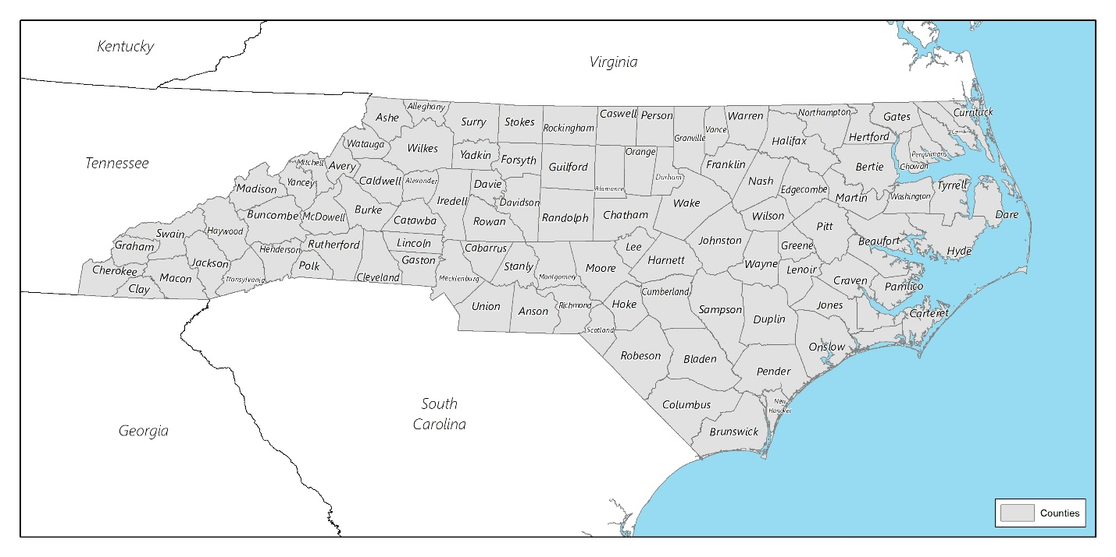
Source: U.S. Census Bureau

Historical Residential Settlement Patterns
The first North Carolina settlements by the Spanish and English were primarily located along the Albemarle Sound in the northeast. Settlement advanced slowly south along the coast and rivers and eventually westward into the Piedmont. Some early settlers brough indentured servants and African laborers with them. As the tobacco industry developed, early growth and prosperity of the State became dependent on slave labor. These plantations were primarily located in the Eastern Tidewater and the upland areas of Piedmont. Today, these areas continue to have a large African American population. Other minority groups, such as Hispanic and Asian populations, have seen recent and rapid growth in urban areas, such as Charlotte and Raleigh, due to economic opportunities. These same economic opportunities have led to a general population boom in North Carolina’s cities.

Demographic, Income and Employment Data
This section will describe demographic characteristics that affect housing choice among North Carolina residents. It will provide context to existing conditions and pinpoint issues to inform strategies for broadening the availability of housing opportunities among residents.

Key Findings
- North Carolina is continuing to see population growth, albeit slower than it has been historically.
- North Carolina’s urban areas and rural counties in the Inner Coastal Plains region tend to have the highest concentration of minorities. Montgomery, Lee, Sampson, and Duplin Counties are notable for having especially high Hispanic populations.
- Segregation across the state is decreasing overall, with only three counties showing indicators of high levels of segregation.
- Foreign-born residents, many of whom may require language assistance, are concentrated in and around the Charlotte and Raleigh-Durham-Cary metropolitan areas.
- The largest group of Limited English Proficiency households are Spanish speakers, distantly followed by Chinese, Vietnamese, and Arabic.
- Most North Carolina households are family households consisting of married couples.
- Large families and single female-headed households with children have disproportionately higher rates of poverty.
- Median household income, after adjusting for inflation, has largely remained stagnant.
- North Carolina has 67 racially and ethnically concentrated areas of poverty, primarily located in urban metropolitan areas.
- North Carolina’s housing stock is relatively new compared to the nation with few counties having homes constructed before 1978.
- Most North Carolina residents are homeowners, but Black and Hispanic households showed lower homeownership rates than renter rates.
- Home values have decreased in the past ten years while gross rent has increased.
- Renters are significantly more cost-burdened than homeowners. However, rates of cost-burden have decreased over the past ten years.

Race and Ethnicity
Between 1970 and 2018, North Carolina has consistently seen growth each decade, having almost doubled its population during this time. While this overall growth continues, growth appears to be slowing across all populations with the slowest rates expected in the approaching decade. This stagnation follows national historic trends of lower rates of natural growth (births/deaths) and immigration. Groups with the highest rates, both historically and recently, are Asians (35.6% between 2010 and 2018) and Hispanics (17.0%). Areas with the largest population expansions are concentrated in and around the more densely populated cities in the Piedmont and Costal Plans regions. This includes the Research Triangle, Charlotte, and the coastal counties in the southernmost portion of the State. Population-declining areas are generally rural and distant from major towns and cities.
Areas with the largest concentration of minorities are in the Inner Coastal Plains region of North Carolina, especially along the I-95 corridor. Anson County and Charlotte are also notable areas for having a high concentration of minorities. Montgomery, Lee, Sampson, and Duplin Counties are notable for having especially high Hispanic populations.
Figure 1 Population Trends by Race/Ethnicity in North Carolina, 1970-2018
Source: U.S. Census Bureau 1970-2010; 2014-2018 American Community Survey B03002

Table 1 Population by Race/Ethnicity in North Carolina, 1970-2018
Year | Statewide | White | Black | Asian | *Hispanic
1970 | 5,082,059 | 3,901,767 | 1,180,292 | 4,264 | -
1980 | 5,881,766 | 4,457,507 | 1,318,857 | 19,596 | 56,667
1990 | 6,628,637 | 5,008,491 | 1,456,323 | 52,166 | 76,726
2000 | 8,049,313 | 5,804,656 | 1,737,545 | 113,689 | 378,963
2010 | 9,535,483 | 6,223,995 | 2,019,854 | 206,579 | 800,120
2018 | 10,155,624 | 6,433,039 | 2,146,254 | 280,059 | 935,950
Source: U.S. Census Bureau 1970-2010; 2014-2018 American Community Survey: B03002
* Note that it was not until the 1980 census that all Americans were asked if they were of “Spanish/Hispanic Origin.”

Table 2 Population Growth by Race/Ethnicity in North Carolina, 1970-2018
Year | Statewide | White | Black | Asian | Hispanic
1970 | - | - | - | - | -
1980 | +15.7% | +14.2% | +11.7% | +359.6% | -
1990 | +12.7% | +12.4% | +10.4% | +166.2% | +35.4%
2000 | +21.4% | +15.9% | +19.3% | +117.9% | +393.9%
2010 | +18.5% | +7.2% | +16.2% | +81.7% | +111.1%
2018 | +6.5% | +3.4% | +6.3% | +35.6% | +17.0%
Source: U.S. Census Bureau 1970-2010; 2014-2018 American Community Survey: B03002

Map 2 Population Change, 2010-2018
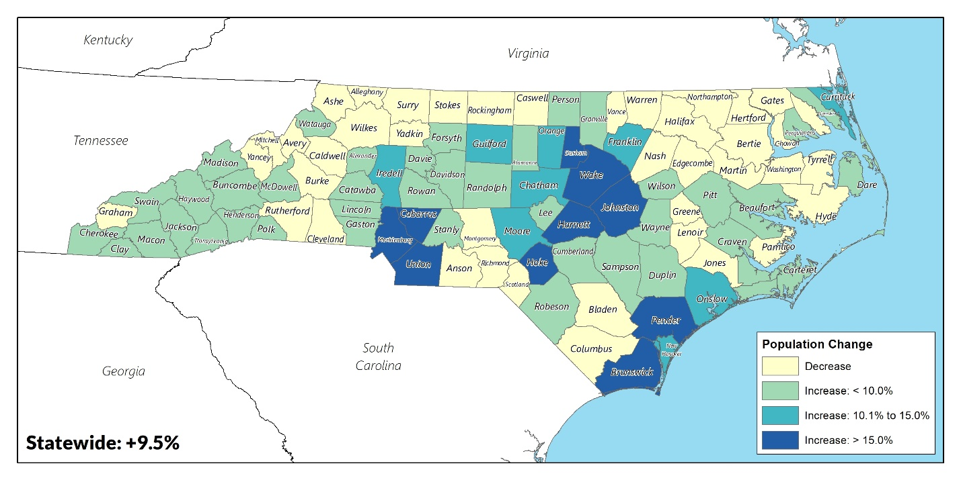
Source: 2006-2010 & 2014-2018 American Community Survey: B030032

Map 3 Minority Population, 2018
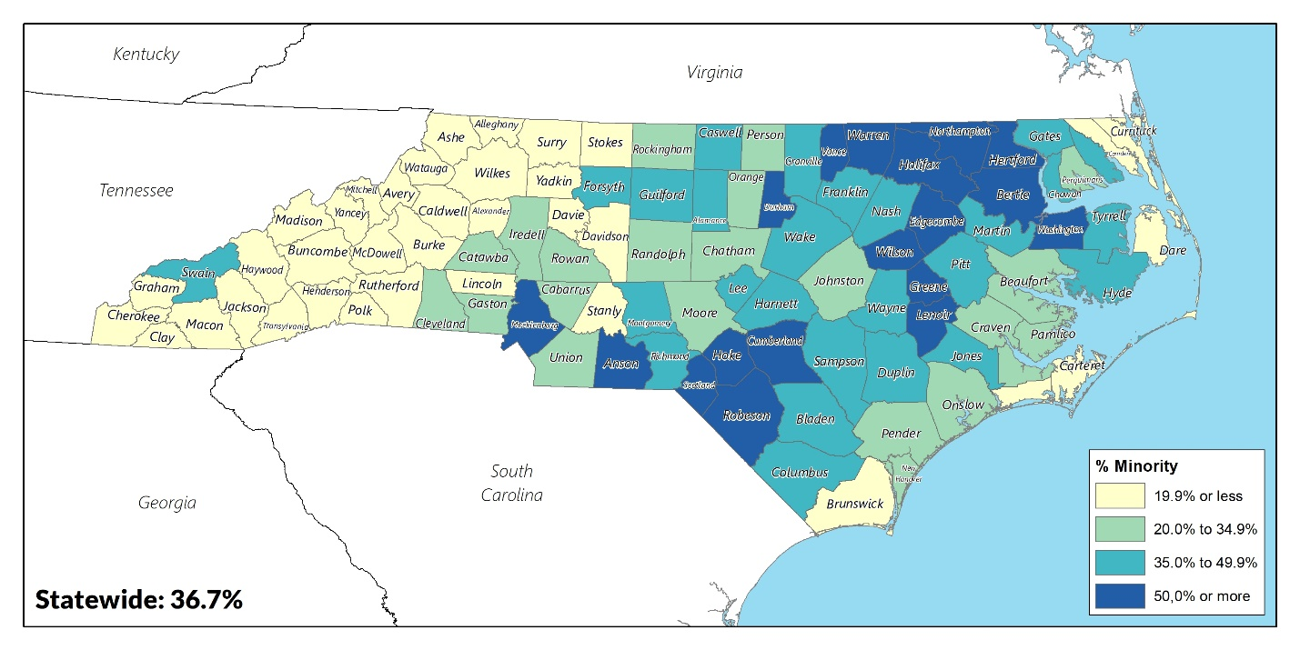
Source: 2006-2010 & 2014-2018 American Community Survey: B030032

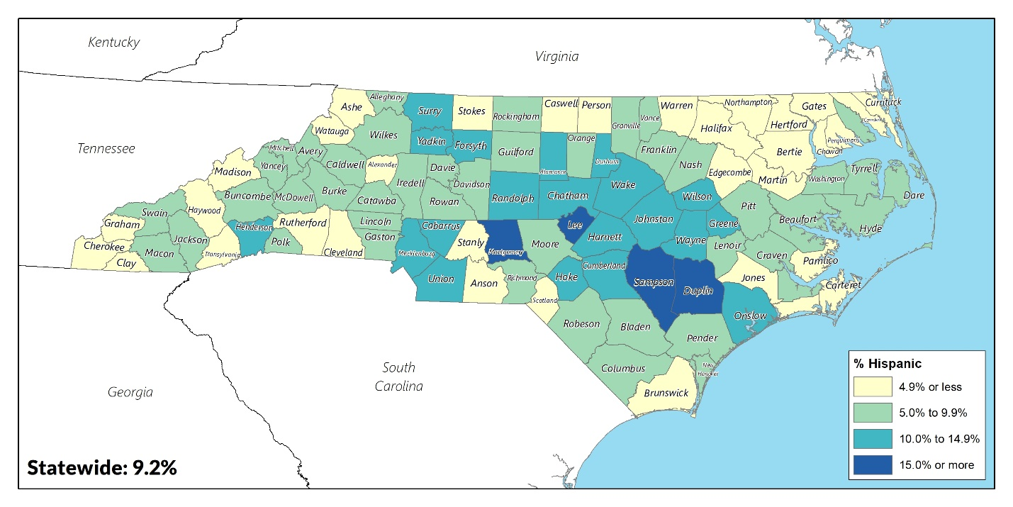
Map 4 Hispanic Population, 2018
Source: 2006-2010 & 2014-2018 American Community Survey: B030032

Dissimilarity Index
Residential segregation is a measure of the degree of separation of racial or ethnic groups living in a neighborhood or community. Latent factors, such as attitudes, or overt factors, such as real estate practices, can limit the range of housing opportunities for minorities. A lack of racial or ethnic integration in a community may create other problems, such as reinforcing prejudicial attitudes and behaviors, narrowing opportunities for interaction, and reducing the degree to which community life is considered harmonious. Areas of extreme minority isolation often experience poverty and social problems at rates that are disproportionately high. Racial segregation has been linked to diminished employment prospects, poor educational attainment, increased infant and adult mortality rates and increased homicide rates.
Segregation can be measured using a statistical tool called the dissimilarity index. This index measures the degree of separation between racial or ethnic groups living in a community. Since White residents are the majority in North Carolina, all other racial and ethnic groups were compared to the White population as a baseline. Dissimilarly index scores were determined for each county for Black, Asian and Hispanic populations as well as an aggregated index comparing the non-White population with the White population.
The index of dissimilarity allows for comparisons between subpopulations (i.e. different races/ethnicities), indicating how much one group is spatially separated from another within a community. In other words, it measures the evenness with which two groups are distributed across the neighborhoods that make up a community. The index of dissimilarity is rated on a scale from 0 to 100, in which a score of 0 corresponds to perfect integration and a score of 100 represents total segregation. According to HUD, a score under 40 is considered low, between 40 and 54 is moderate, and above 60 is high segregation.
Table 3 Dissimilarity Index, 2010-2018
 | 2010 DI with White Population | 2010 Population | 2010 % of Total Population | 2018 DI with White Population | 2018 Population | 2018% of Total Population
White | - | 6,223,995 | 65.3% | - | 6,433,039 | 63.3%
Black | 52.2 | 2,019,854 | 21.2% | 51.3 | 2,146,254 | 21.1%
Asian | 56.7 | 206,579 | 2.2% | 56.0 | 280,059 | 2.8%
Hispanic | 46.0 | 800,120 | 8.4% | 42.8 | 935,950 | 9.2%
Source: 2006-2010 & 2014-2018 American Community Survey: B030032

In 2018, North Carolina saw moderate levels of segregation in the Black, Asian, and Hispanic populations. With North Carolina becoming increasingly diverse, it is notable that the state overall is becoming increasingly more integrated. The dissimilarity index was also conducted at the county level. However, counties with a minority group population below 1,000 require caution when interpreting their dissimilarity index. As a result, the dissimilarity index for North Carolina counties’ Asian populations is not included. Only three counties showed high levels of segregation for particular minority groups: Swain, Graham, and Gates County.

Table 4 Counties with High Levels of Segregation, 2018
County | 2018 DI
Black
Swain County | 82.2
Graham County | 63.0
Hispanic
Gates County | 65.9
Source: 2014-2018 American Community Survey: B030032

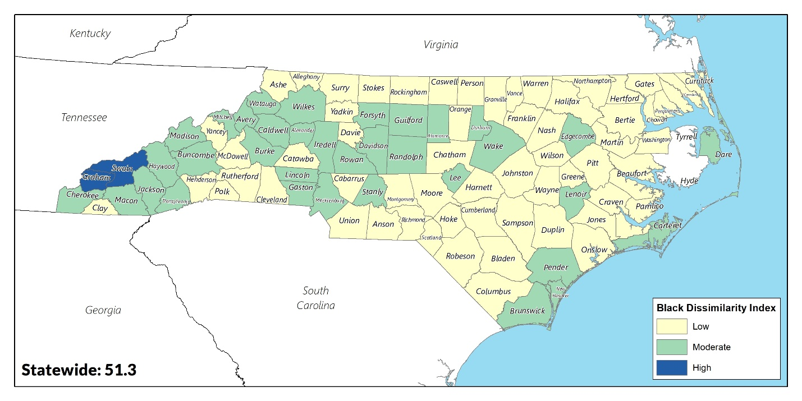
Map 5 Black Dissimilarity Index by County, 2018
Source: 2014-2018 American Community Survey: B030032

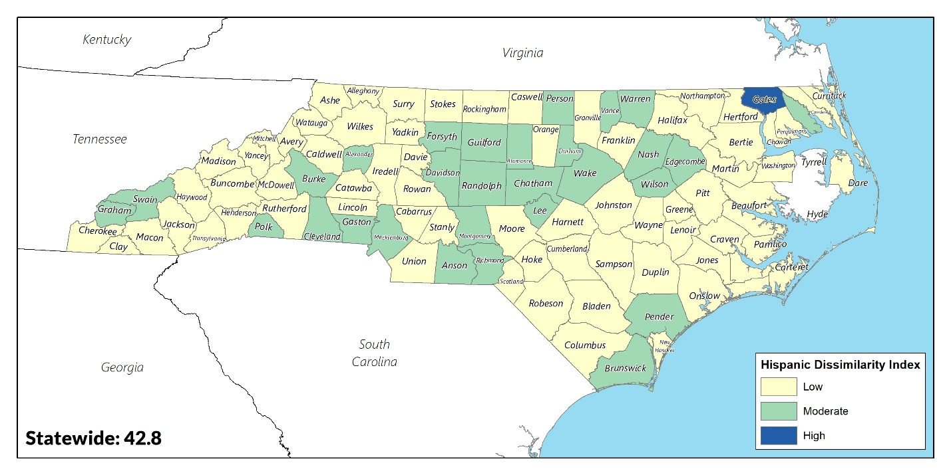
Map 6 Hispanic Dissimilarity Index, 2018
Source: 2014-2018 American Community Survey: B030032

Ancestry and National Origin
It is illegal to refuse the right to housing based on place of birth or ancestry. Census data on native and foreign-born populations revealed that 7.9% of North Carolina residents were foreign-born or born outside of the U.S. in Puerto Rico or on U.S. island areas as of 2018. Areas with a high concentration of foreign-born residents tend to be counties with large municipalities and include Charlotte in Mecklenburg County, Chapel Hill in Orange County, and Wake and Durham Counties. The largest foreign-born population in North Carolina, by a large margin, comes from Mexico, accounting for 29.5% of all foreign-born residents. The next largest group comes from India, consisting of 8.3% of all foreign-born residents.

Table 5 Top 10 Countries of Origin for Foreign-born Residents
Rank | Country of Origin | Population
1 | Mexico | 235,756
2 | India | 66,430
3 | Honduras | 32,547
4 | China | 32,035
5 | El Salvador | 30,618
6 | Vietnam | 23,814
7 | Canada | 18,952
8 | Guatemala | 18,946
9 | Philippines | 17,509
10 | Germany | 16,100
Source: 2014-2018 American Community Survey: B05006

Map 7 Foreign-born Population, 2018
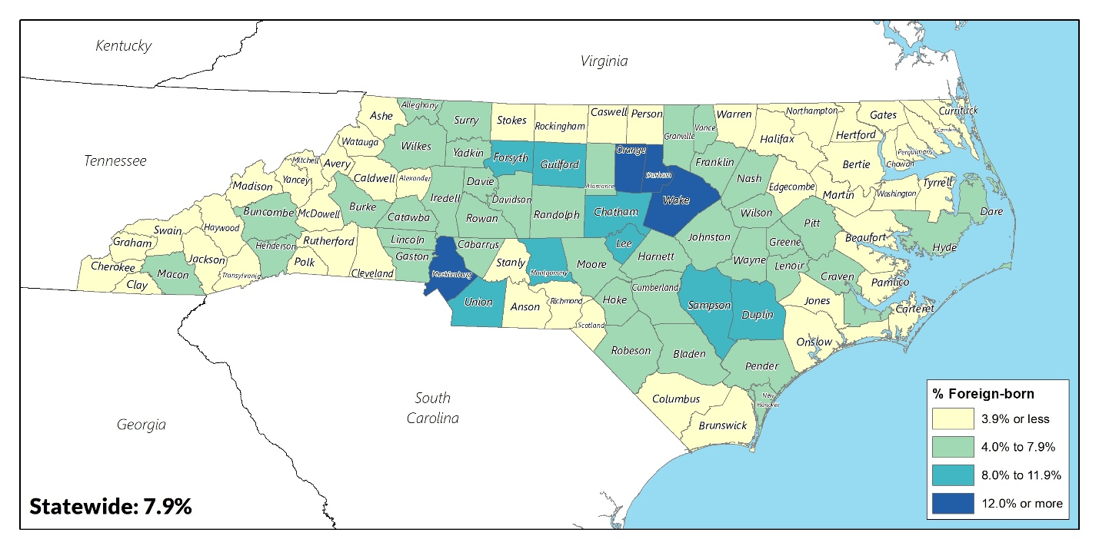
Source: 2014-2018 American Community Survey: B05006

Limited English Proficiency
Persons with limited English proficiency (LEP) are defined as persons who have a limited ability to read, write, speak or understand English. HUD uses the prevalence of persons with LEP to identify the potential for impediments to fair housing choice due to their inability to comprehend English. Persons with LEP may encounter obstacles to fair housing by virtue of language and cultural barriers within their new environment. To assist these individuals, it is important that a community recognizes their presence and the potential for discrimination, whether intentional or inadvertent, and establishes policies to eliminate barriers. It is also incumbent upon HUD entitlement communities to determine the need for language assistance and comply with Title VI of the Civil Rights Act of 1964.
Local jurisdictions are advised to conduct a four-factor analysis to ensure meaningful access to services for LEP persons. The four factors include:
- The number or proportion of LEP persons served or encountered in the eligible service population
- The frequency with which LEP persons come into contact with the program
- The nature and importance of the program, activity, or service provided
- The resources available and costs to the service provider
Translation of vital documents would be required for any language groups that reaches the LEP threshold of 5%, and at least partially, into any languages that reach the safe harbor threshold of 1,000 persons. The ten largest LEP populations are listed in the following table.
Table 6 Limited English Proficient Persons by Language in North Carolina, 2018
Rank | Language | Total Speakers | # LEP | % LEP
#1 LEP Language | Spanish | 761,108 | 309,235 | 40.6%
#2 LEP Language | Chinese (incl. Mandarin, Cantonese) | 43,423 | 16,323 | 37.6%
#3 LEP Language | Vietnamese | 21,024 | 13,641 | 64.9%
#4 LEP Language | Arabic | 21,972 | 8,571 | 39.0%
#5 LEP Language | Korean | 17,466 | 7,295 | 41.8%
#6 LEP Language | French (incl. Cajun) | 27,652 | 6,989 | 25.3%
#7 LEP Language | Nepali, Marathi, or other Indic languages | 15,266 | 6,005 | 39.3%
#8 LEP Language | Gujarati | 9,528 | 4,890 | 51.3%
#9 LEP Language | Russian | 12,582 | 4,045 | 32.1%
#10 LEP Language | Thai, Lao, or other Tai-Kadai languages | 7,626 | 3,883 | 50.9%
Source: 2014-2018 American Community Survey: S16001

There are over 30 language groups in North Carolina that meet the safe harbor threshold. The significance of this trend lies in the requirement for the state to provide meaningful access to its programs and services to persons with LEP. The state can target its language assistance services to those counties where the LEP populations meet the safe harbor thresholds at the county level. The following chart provides county-level LEP population data for those counties where it is made available by the Census. (Note: this data was only available for households, not persons, and may undervalue the number of LEP persons in each county where data was available.)
Table 7 Limited English Proficient Households by Language in North Carolina by County
 | County
Languages meeting LEP threshold | Mecklenburg | Guilford | Wake | Cumberland | Durham | Forsyth
Spanish | 13,103 | 1,913 | 5,289 | 2,172 | 3,926 | 3,301
French, Haitian or Cajun | 680 | 118 | 144 | 187 | 0 | 35
German or other West Germanic languages | 0 | 0 | 0 | 110 | 236 | 0
Russian, Polish, or other Slavic languages | 667 | 144 | 275 | 0 | 71 | 139
Other Indo-European languages | 1292 | 907 | 464 | 184 | 211 | 576
Korean | 333 | 158 | 443 | 385 | 131 | 110
Chinese (incl. Mandarin, Cantonese) | 691 | 522 | 766 | 16 | 124 | 124
Vietnamese | 733 | 164 | 241 | 74 | 229 | 87
Tagalog (incl. Filipino) | 78 | 57 | 77 | 124 | 0 | 0
Arabic | 517 | 277 | 237 | 111 | 60 | 0
Other Asian and Pacific Island languages | 2,066 | 522 | 667 | 169 | 225 | 170
Source: 2014-2018 American Community Survey: S16002

Disability
As defined by the Census Bureau, a disability is a long-lasting physical, mental, or emotional condition that can make it difficult for a person to engage in activities such as walking, climbing stairs, dressing, bathing, learning or remembering. This condition can also impede a person from being able to go outside the home alone or to work at a job or business.
The Fair Housing Act prohibits discrimination based on physical, mental, or emotional disability, provided “reasonable accommodation” can be made. This may include changes to address the needs of persons with disabilities, such as adaptive structural changes (e.g., constructing an entrance ramp) or administrative changes (e.g., permitting the use of a service animal). In North Carolina, 13.3% of the population is estimated to have at least one disability in 2018, with the elderly more likely to have a disability than any other age group. Additionally, the counties with large towns and cities had lower rates of persons with disabilities compared to the rest of the State.

Table 8 Disability Type by Age in North Carolina, 2018
 | Children (under 18 years) |  | Population 18 to 64 years |  | Elderly (65 years and over)
Population Type | Total | Percent | Total | Percent | Total | Percent
Total Civilian Population | 2,293,730 | 22.5% | 6,240,946 | 61.3% | 1,649,045 | 16.2%
With a Disability | 104,014 | 4.5% | 680,863 | 10.9% | 566,292 | 34.3%
Hearing Difficulty | 15,066 | 0.7% | 134,780 | 2.2% | 238,724 | 14.5%
Vision Difficulty | 17,605 | 0.8% | 139,131 | 2.2% | 102609 | 6.2%
Cognitive Difficulty | 76,363 | 3.3% | 280,543 | 4.5% | 142846 | 8.7%
Ambulatory Difficulty | 9,571 | 0.4% | 340,363 | 5.5% | 349,193 | 21.2%
Self-Care Difficulty | 15,272 | 0.7% | 124,291 | 2.0% | 117,240 | 7.1%
Independent Living Difficulty | - | - | 244,352 | 3.9% | 223,786 | 13.6%
Source: 2014-2018 American Community Survey: S1810
Among the civilian noninstitutionalized population between the ages of 18 to 64, there are significant differences in labor force participation rates among those with and without a disability. In 2018, 39.0% of persons with a disability participate in the labor force compared to 80.6% of persons without a disability. Among those participating in the labor force, 13.6% of persons with disabilities are unemployed compared to 5.7% of persons without a disability.
Table 9 Employment Status for Individuals by Disability Status in North Carolina, 2018
Employment Status | With a disability |  | Without a disability
 | Subtotal | Percent | Subtotal | Percent
Not in Labor Force | 429,011 | 61.0% | 1,051,036 | 19.4%
In Labor Force | 273,823 | 39.0% | 4,378,772 | 80.6%
Employed | 236,597 | 86.4% | 4,129,880 | 94.3%
Unemployed | 37,226 | 13.6% | 248,892 | 5.7%
Source: 2014-2018 American Community Survey: C18120

According to the National Organization on Disabilities, a significant income gap exists for people with disabilities given their lower rate of employment. Among persons in the labor force with one or more disabilities, 20.6% of persons are living in poverty compared to 13.1% of persons without a disability. The median income for the disabled population was equivalent to only 69% of the median income of $31,672 for the non-disabled population. Even in the absence of discrimination, people with disabilities often experience greater obstacles in securing affordable housing that is accessible due to the higher potential for lower wages and rates of employment.

Table 10 Median Income and Poverty Rates by Disability Status in North Carolina, 2018
Population | Median Annual Income | Poverty Rate
Total Population | $31,206 | 14.0%
with a disability | $21,811 | 20.6%
without a disability | $31,672 | 13.1%
Source: 2014-2018 American Community Survey: C18130

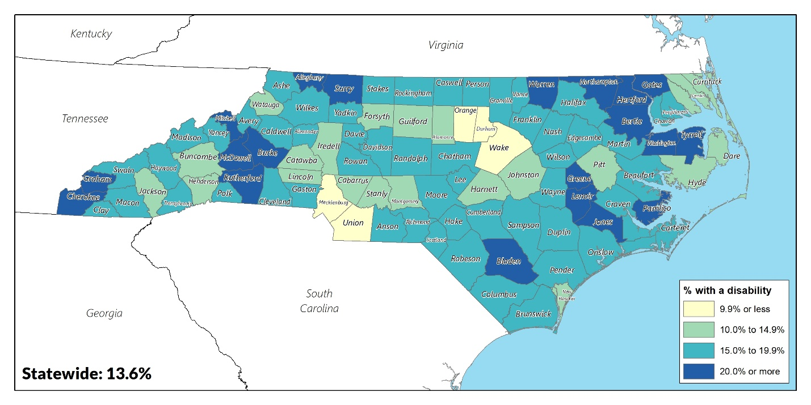
Map 8 Population with a Disability, 2018
Source: 2014-2018 American Community Survey: S1810

Map 9 Unemployment Rate of Persons with at Least One Disability, 2018
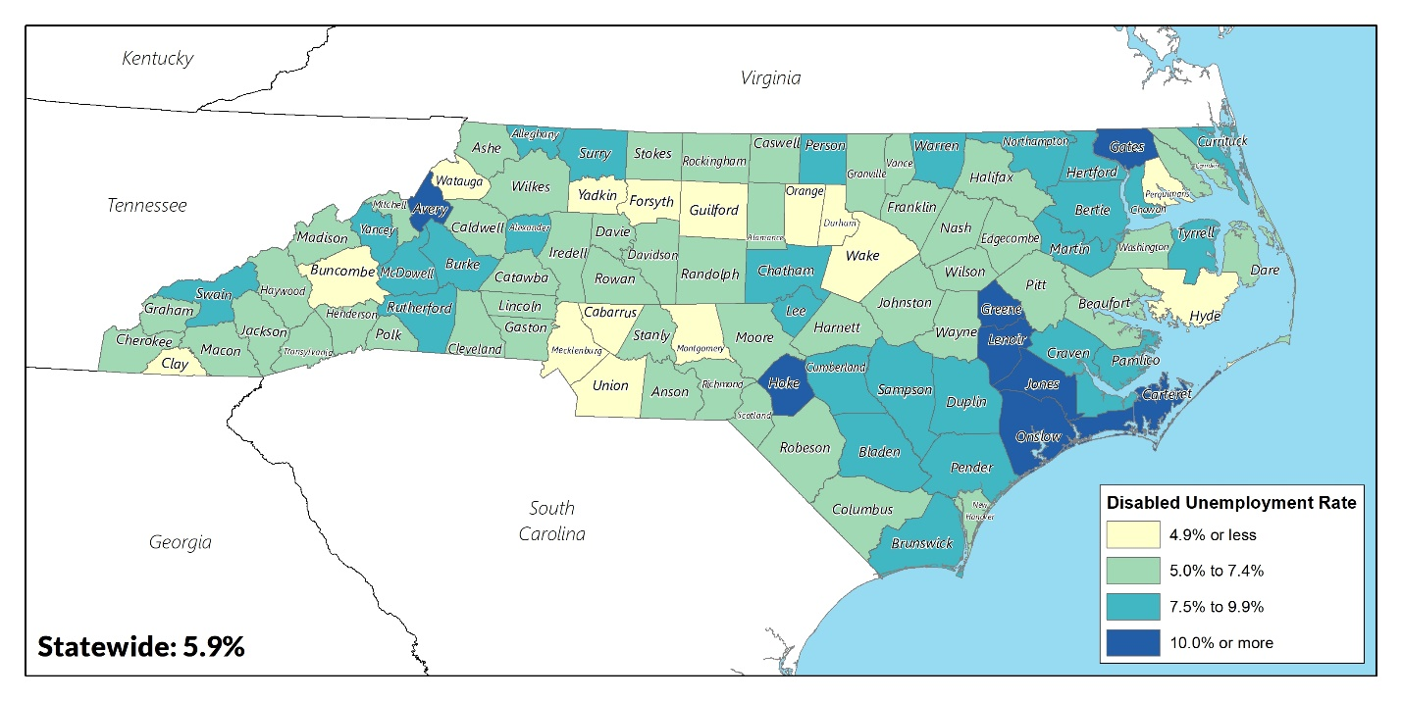
Source: 2014-2018 American Community Survey: C18120

Household Type
The Census Bureau defines households as either family or non-family. Family households are married couples with or without children, single parents with children, and other families comprised of related persons. Non-family households are either single persons living alone or two or more non-related persons living together.
Title VIII of the Civil Rights Act of 1968 protects against gender discrimination in housing. Protection for families with children was added in the 1988 amendments to Title VIII. Except in limited circumstances involving elderly housing and owner-occupied buildings of one to four units, it is unlawful to refuse to rent or sell to families with children.
Family households comprised the majority of North Carolina households at 65.7% in 2018. This is a slight decrease from 2010 when it was 66.8%. Household compositions have remained mostly consistent between 2010 and 2018, with the most notable difference being a 5.8- percentage point decrease in female-headed households with children.
Table 11 Household Type and Presence of Children in North Carolina, 2010-2018
Household Type | 2010 |  | 2018
 | Total | Percent | Total | Percent
Family Households | 2,422,692 | 66.8% | 2,573,526 | 65.7%
Married Couples | 1,795,126 | 74.1% | 1,886,087 | 73.3%
with children | 729,708 | 40.6% | 717,865 | 38.1%
without children | 1,065,418 | 59.4% | 1,168,222 | 61.9%
Female-headed Household | 473,166 | 19.5% | 513,968 | 20.0%
with children | 282,131 | 59.6% | 276,724 | 53.8%
without children | 191,035 | 40.4% | 237,244 | 46.2%
Male-headed Households | 154,400 | 6.4% | 173,471 | 6.7%
with children | 78,051 | 50.6% | 85,921 | 49.5%
without children | 76,249 | 49.4% | 87,550 | 50.5%
Nonfamily Households | 1,203,487 | 33.2% | 1,345,071 | 34.3%
Total Households | 3,626,179 | - | 3,918,597 | -
Source: 2014-2018 American Community Survey: B11001, K201101

Female-headed households with children often experience difficulty in obtaining housing as a result of lower incomes and higher expenses such as childcare. In 2018, 42.1% of female-headed households with children were living in poverty compared to 23.8% of male-headed households with children and 7.4% of married-couple households with children.

Table 12 Poverty Status by Family Household Type and Number of Children
Household Type | Poverty Rate
Family Households | 10.2%
without children | 5.0%
with children | 16.4%
1 or 2 children | 13.6%
3 or 4 children | 27.3%
5 or more children | 41.5%
Married-couple family with children | 7.4%
Male householder, no wife present, with children | 23.8%
Female householder, no husband present, with children | 42.1%
Source: 2014-2018 American Community Survey: B17006, B17023

Income, Unemployment and Poverty
Household income is strongly related to housing choice, as household income is one of several factors used to determine eligibility for a home mortgage loan or rental lease. Employment greatly influences an individual’s poverty status and housing choice. Lower earnings due to unemployment and income disparities limit a household’s ability to afford housing
The 2018 North Carolina median household income was $52,413, slightly lower than the national average of $53,855. When adjusted for inflation, household income has remained almost stagnant between 2010 and 2018. Apart from Asian households - whose incomes increased by 16.8% - wages have remained relatively stagnant. White households had a slight 1.1% decrease between 2010 and 2018 while slight increases were seen among Black households (1.2%) and Hispanic households (0.6%). Counties with above average household incomes were clustered in more urban areas and along the coast.
Figure 2 Statewide Median Household Income, 2000-2018 (adjusted to 2018 dollars)
Source: 2014-2018 American Community Survey: S1903

Table 13 Statewide Median Household Income by Race/Ethnicity, 2010-2018 (adjusted to 2018 dollars)
 | 2010 | 2018 | % Change
Statewide | $ 52,465 | $ 52,413 | -0.1%
White | $ 58,844 | $ 58,171 | -1.1%
Black | $ 36,815 | $ 37,242 | 1.2%
Asian | $ 68,898 | $ 80,500 | 16.8%
Hispanic | $ 39,747 | $ 40,001 | 0.6%
Source: 2014-2018 American Community Survey: S1903

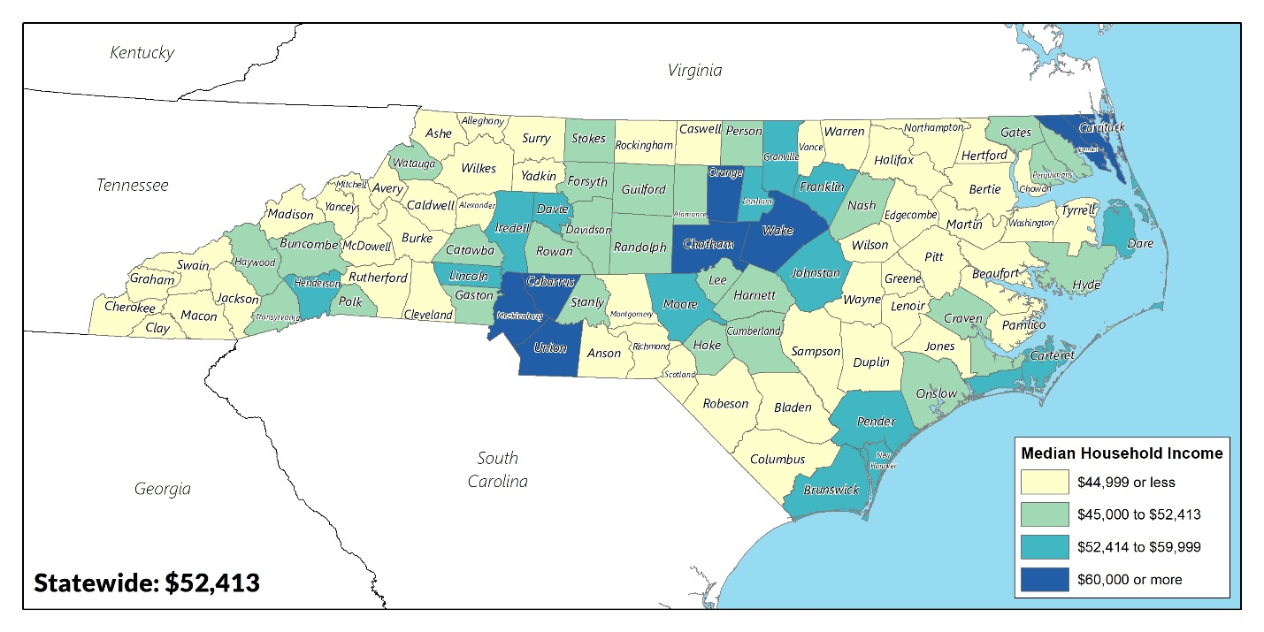
Map 10 Median Household Income, 2018
Source: 2014-2018 American Community Survey: S1903

The 2018 Statewide unemployment rate was 6.3%. With an unemployment rate of 5.5%, males were slightly less likely than females (5.9%) to be unemployed. In terms of race and ethnicity, Black civilians had the highest rates of unemployment (10.3%) compared to other groups. Areas with the highest rates of unemployment tend to be located in the Coastal Plains region with especially high rates in areas around the Chowan River, Lenoir County, and Scotland County.
Table 14 Civilian Labor Force by Sex & Race/Ethnicity in North Carolina, 2018
 | Total | %
Total CLF | 5,069,937
Employed | 4,750,531 | 93.7%
Unemployed | 319,406 | 6.3%
Male CLF | 2,400,331
Employed | 2,268,312 | 94.5%
Unemployed | 132,018 | 5.5%
Female CLF | 2,204,386
Employed | 2,074,327 | 94.1%
Unemployed | 130,059 | 5.9%
White CLF | 3,547,225
Employed | 3,369,864 | 95.0%
Unemployed | 177,361 | 5.0%
Black CLF | 1,076,649
Employed | 965,754 | 89.7%
Unemployed | 110,895 | 10.3%
Asian CLF | 149,171
Employed | 142,011 | 95.2%
Unemployed | 7,160 | 4.8%
Hispanic CLF | 435,762
Employed | 414,410 | 95.1%
Unemployed | 21,352 | 4.9%
Source: 2014-2018 American Community Survey: S2301

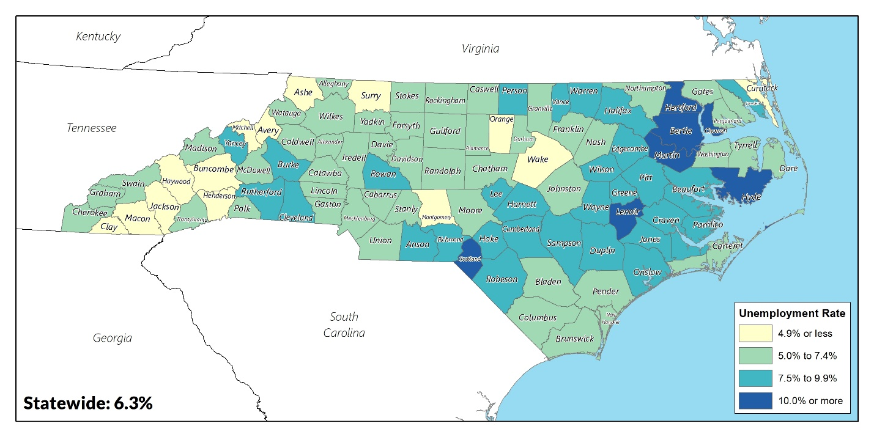
Map 11 Unemployment Rate, 2018
Source: 2014-2018 American Community Survey: S2301

The poverty rate in North Carolina was 15.4% in 2018 - down from 17.5% in 2010 and slightly above the national rate of 14.1%. The only racial groups with below average poverty rates are Whites and Asians. In 2018, the poverty rates among Black and Hispanic persons were 23.5% and 28.5%, respectively. Members of the protected classes are disproportionately affected by this issue, as they are far more likely to have lower incomes or live in poverty. The rural portions of the Coastal Plains region see the highest rates of poverty.
Table 15 Poverty Status by Race/Ethnicity, 2018
 | Poverty Rate
Population | 2010 | 2018
Statewide | 17.5% | 15.4%
White | 13.2% | 12.1%
Black | 27.7% | 23.5%
Asian | 14.1% | 11.9%
Hispanic | 33.9% | 28.5%
Source: 2006-2010 & 2014-2018 American Community Survey: S1701

Map 12 Poverty Rate, 2018
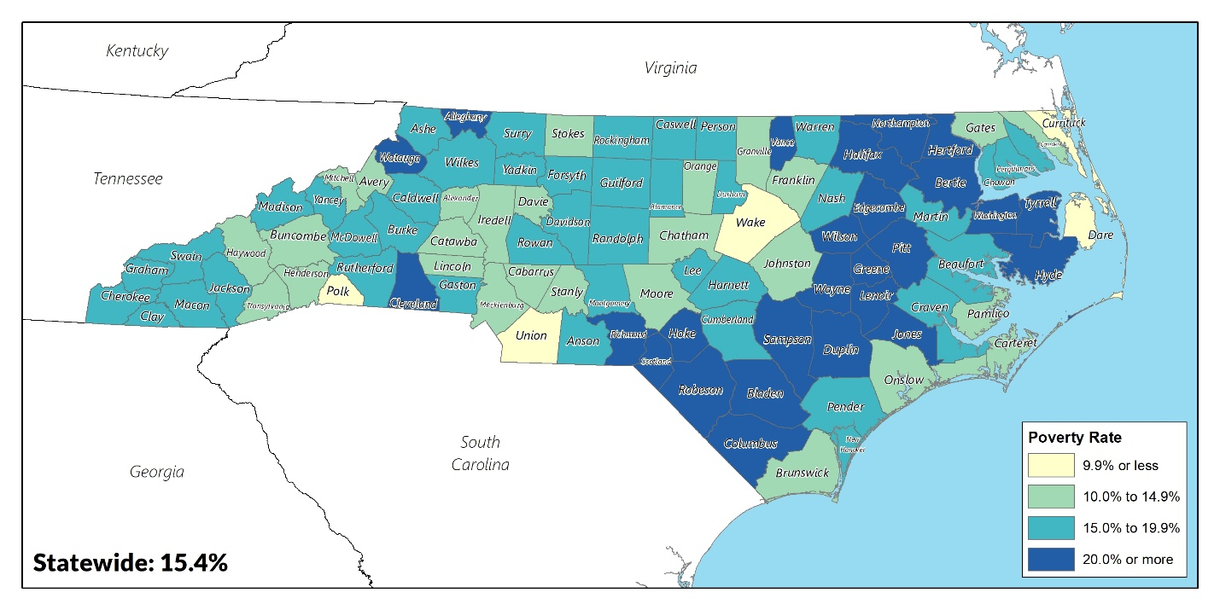
Source: 2018 American Community Survey: S1701

Racially / Ethnically Concentrated Areas of Poverty
HUD defines R/ECAPs as census tracts with a non-White population of at least 50% (and 20% outside of metropolitan/micropolitan areas) and a poverty rate that either exceeds 40% or is three times the average tract poverty rate for the metropolitan/micropolitan area, whichever is lower. By combining these data, it is possible to determine geographic patterns where there are concentrated areas of poverty among racial/ethnic minorities. Although ethnicity and race as defined by the US Census Bureau are not the same, this study uses rates of both non-White and Hispanic populations to map a single combined group of racial and ethnic concentrations, henceforth referred to collectively as "racially concentrated areas of poverty,” or RCAPs.
Table 16 R/ECAPs in North Carolina, 2018
Census Tract | County | Population | % Minority | % Poverty
Census Tract 210 | Alamance County | 3,749 | 64.1% | 40.5%
Census Tract 9 | Buncombe County | 3,049 | 52.6% | 40.8%
Census Tract 9608 | Craven County | 2,397 | 76.2% | 43.8%
Census Tract 2 | Cumberland County | 2,286 | 90.6% | 56.4%
Census Tract 38 | Cumberland County | 2,925 | 88.0% | 40.7%
Census Tract 24.01 | Cumberland County | 1,542 | 87.2% | 43.9%
Census Tract 5 | Cumberland County | 2,293 | 66.6% | 47.4%
Census Tract 614 | Davidson County | 3,183 | 68.0% | 44.8%
Census Tract 901 | Duplin County | 9,818 | 53.7% | 40.1%
Census Tract 14 | Durham County | 2,505 | 98.9% | 60.0%
Census Tract 10.02 | Durham County | 5,779 | 92.2% | 42.6%
Census Tract 11 | Durham County | 3,173 | 85.3% | 44.1%
Census Tract 15.02 | Durham County | 6,177 | 77.3% | 40.6%
Census Tract 15.01 | Durham County | 3,162 | 54.7% | 83.7%
Census Tract 6 | Forsyth County | 2,234 | 98.8% | 48.0%
Census Tract 5 | Forsyth County | 2,287 | 97.8% | 41.7%
Census Tract 16.02 | Forsyth County | 3,359 | 94.3% | 45.1%
Census Tract 3.01 | Forsyth County | 1,860 | 92.8% | 53.8%
Census Tract 8.01 | Forsyth County | 3,468 | 87.2% | 80.5%
Census Tract 7 | Forsyth County | 1,972 | 85.1% | 46.1%
Census Tract 34.04 | Forsyth County | 4,124 | 85.1% | 51.2%
Census Tract 19.01 | Forsyth County | 1,606 | 79.5% | 52.0%
Census Tract 8.02 | Forsyth County | 2,383 | 79.1% | 58.2%
Census Tract 20.01 | Forsyth County | 2,909 | 74.6% | 42.2%
Census Tract 2 | Forsyth County | 1,157 | 60.6% | 57.5%
Census Tract 319 | Gaston County | 2,471 | 77.2% | 44.5%
Census Tract 114 | Guilford County | 5,462 | 96.9% | 60.3%
Census Tract 127.06 | Guilford County | 3,429 | 94.4% | 42.0%
Census Tract 139 | Guilford County | 4,402 | 93.3% | 51.0%
Census Tract 112 | Guilford County | 5,997 | 90.7% | 50.0%
Census Tract 110 | Guilford County | 5,173 | 89.1% | 52.6%
Census Tract 140 | Guilford County | 3,287 | 61.6% | 42.9%
Census Tract 145.01 | Guilford County | 1,291 | 61.2% | 43.2%
Census Tract 403.01 | Johnston County | 4,635 | 63.1% | 42.9%
Census Tract 302 | Lee County | 3,621 | 77.2% | 45.1%
Census Tract 103 | Lenoir County | 1,504 | 99.5% | 61.3%
Census Tract 105 | Lenoir County | 3,554 | 94.9% | 43.0%
Census Tract 107 | Lenoir County | 2,115 | 74.2% | 41.2%
Census Tract 39.03 | Mecklenburg County | 2,023 | 95.8% | 58.8%
Census Tract 23 | Mecklenburg County | 3,271 | 94.3% | 56.6%
Census Tract 51 | Mecklenburg County | 2,309 | 94.1% | 43.3%
Census Tract 47 | Mecklenburg County | 1,725 | 76.3% | 45.3%
Census Tract 56.09 | Mecklenburg County | 3,462 | 70.7% | 63.1%
Census Tract 37 | Mecklenburg County | 3,735 | 65.5% | 40.4%
Census Tract 111 | New Hanover County | 2,724 | 88.3% | 50.8%
Census Tract 108 | New Hanover County | 2,907 | 60.0% | 40.5%
Census Tract 9603 | Pasquotank County | 2,680 | 86.2% | 49.2%
Census Tract 7.02 | Pitt County | 3,016 | 91.3% | 56.2%
Census Tract 7.01 | Pitt County | 3,720 | 82.4% | 52.3%
Census Tract 9608.01 | Robeson County | 3,579 | 85.2% | 53.5%
Census Tract 9605.02 | Robeson County | 4,898 | 80.6% | 45.7%
Census Tract 9611 | Robeson County | 2,093 | 69.5% | 46.6%
Census Tract 102 | Scotland County | 4,154 | 81.0% | 43.1%
Census Tract 103 | Scotland County | 4,494 | 69.0% | 43.0%
Census Tract 9607 | Vance County | 3,893 | 92.8% | 45.1%
Census Tract 509 | Wake County | 3,200 | 79.5% | 42.7%
Census Tract 508 | Wake County | 4,066 | 78.4% | 40.4%
Census Tract 506 | Wake County | 3,609 | 65.7% | 43.4%
Census Tract 524.08 | Wake County | 3,485 | 59.7% | 47.3%
Census Tract 524.09 | Wake County | 4,068 | 51.9% | 47.7%
Census Tract 18 | Wayne County | 2,220 | 77.6% | 45.9%
Census Tract 19 | Wayne County | 4,609 | 73.8% | 46.3%
Census Tract 8.01 | Wilson County | 1,484 | 97.9% | 63.2%
Census Tract 7 | Wilson County | 4,747 | 93.3% | 42.1%
Census Tract 2 | Wilson County | 1,245 | 91.8% | 63.0%
Census Tract 3 | Wilson County | 2,266 | 88.7% | 41.6%
Census Tract 8.02 | Wilson County | 3,996 | 82.9% | 42.1%
Source: 2014-2018 American Community Survey: B03002, S1701
Statewide, there are 67 RCAPs, accounting for 3.1% of North Carolina’s 2,195 census tracts. They are home to 220,016 residents or 2.1% of North Carolina’s population. However, they account for 5.8% of all Black residents and 3.5% of all Hispanic residents across the state.
Most of the R/ECAPs are in relatively densely populated areas. Forsyth County, home to Winston-Salem, has the highest number of RCAPs (11), followed by Guilford County (7 in Greensboro), and Mecklenburg County (6 in Charlotte). Only one RCAP was located outside of a metropolitan/micropolitan area in Duplin County but still met the 50% minority threshold.
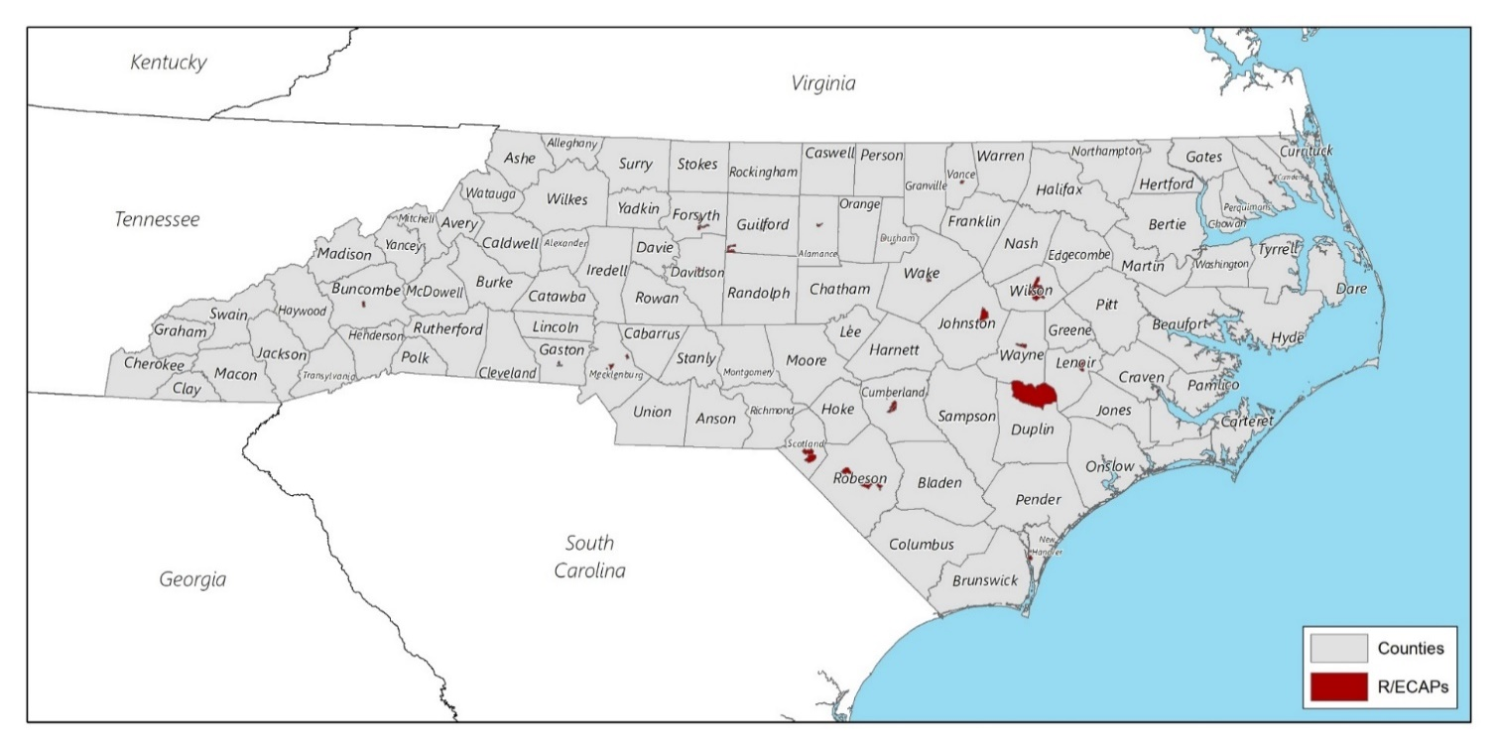
Map 13 Racially and Ethnically Concentrated Areas of Poverty in North Carolina, 2018
Source: 2014-2018 American Community Survey: B03002, S1701

Housing Profile

Age of Housing Stock
North Carolina’s housing stock is relatively modern with the median year of homes built of 1988. Older homes typically need mechanical system and energy efficiency upgrades, which may not be financially feasible, particularly among low- and moderate-income households. High energy costs can contribute to cost burden. For persons with health conditions such as asthma, features such as excessive moisture and dampness, inadequate or poorly maintained heating and ventilation systems and structural defects are associated with exposure to indoor asthma triggers.
Another significant concern is the presence of lead-based paint. In 1978, the federal government banned the use of lead-based paint in homes after studies showed that lead caused severe health problems, particularly among children under the age of six. The nervous systems of children could even be damaged before birth. Although lead-based paint is no longer on the market, many older homes still have lead-based paint on the walls and trim. Scraping paint and sanding old paint can release dust containing lead that, when inhaled, can be harmful. There are ten counties in North Carolina with a median year of structures built before 1978: Caldwell, Edgecombe, Halifax, Lenoir, Martin, Mitchell, Rockingham, Stanly, Tyrell, and Washington Counties.
Map 14 Median Year Structure Built, 2018
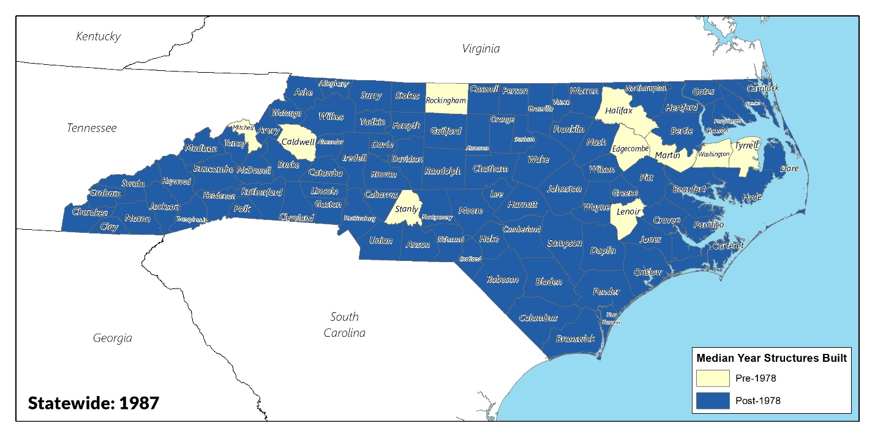
Source: 2014-2018 American Community Survey: B25035

Vacancy Rates
Vacancy rate data come from the American Community Survey, which defines vacancy rate as the ratio of vacant available units to total units.
Homeowner vacancy rates in North Carolina sit near the national average at 1.9%, indicative of a tight sales market. Homeowner vacancy is the ratio of vacant available for-sale and sold housing units to the total number of vacant and owner-occupied housing units.
Like homeowner vacancies, rental vacancies are the ratio of vacant available for-rent and rented unoccupied units to the total number of vacant available and rental-occupied housing units. Rental vacancy rates are higher than homeowner vacancy rates at 7.0%. The highest vacancy rates are found along the coast, westernmost counties in the Mountain region, and the counties around Fayetteville.
Table 17 Statewide Vacancy Rates by Tenure. 2018
Vacancy Status | # Vacant | % Vacant
Total Vacant Housing Units | 654,469 | 14.3%
Vacant for Rent | 103,950 | 2.3%
Vacant Rented Units | 21,738 | 0.5%
Vacant for Sale | 49,548 | 1.1%
Vacant Sold (not occupied) | 19,826 | 0.4%
Vacant (seasonal, recreational, or occasional use) | 211,487 | 4.6%
Vacant (other) | 246,528 | 5.4%
Total Housing Units | 4,573,066 | -
Source: 2014-2018 American Community Survey: B25004

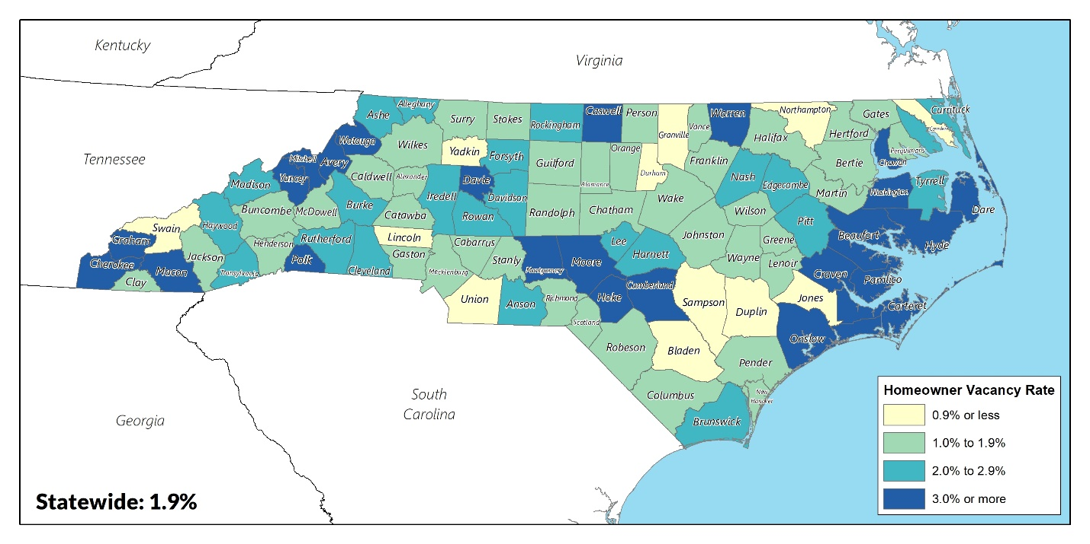
Map 15 Homeowner Vacancy Rates, 2018
Source: 2014-2018 American Community Survey: DP04

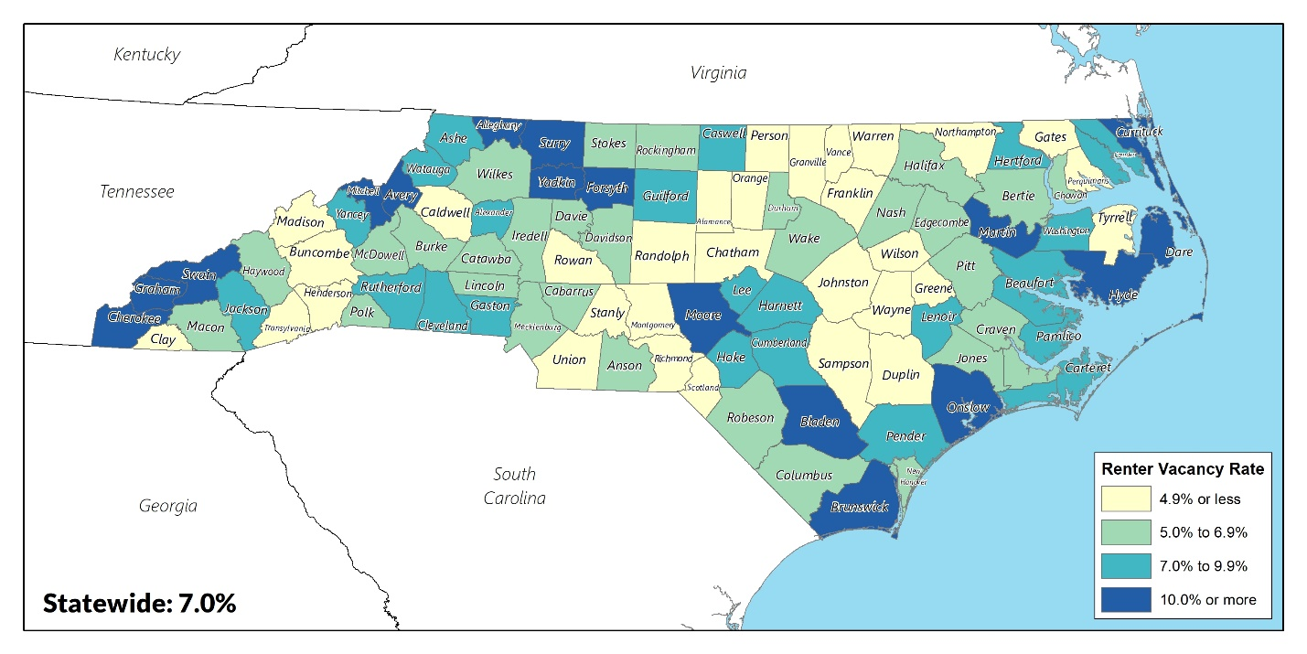
Map 16 Renter Vacancy Rates, 2018
Source: 2014-2018 American Community Survey: DP04

Housing Tenure
The value in home ownership lies in the accumulation of wealth as the owner’s share of equity increases with the property’s value. Paying a monthly mortgage instead of rent is an investment in an asset that is likely to appreciate. According to one study, “a family that puts 5 percent down to buy a house will earn a 100 percent return on the investment every time the house appreciates 5 percent.”
The state’s homeownership rate of 67.2% has remained higher than the renter rate in 2018 with a slight increase of 2.1 percentage points since 2010. There are, however, significant variations by race. Only White households have above-average homeownership rates (73.8% in 2018). While Asian households had below-average homeownership rates (60.1%), they are the only minority group to have more homeowners than renters. Both Black and Hispanic households showed lower homeownership rates than renter rates, at 48.5% and 44.3%, respectively. However, Black households are the only group to see an increase in homeownership between 2010 and 2018, growing by 3.5 percentage points. Geographically, densely populated areas tended to have lower homeownership rates.

Figure 3 Tenure by Race/Ethnicity in North Carolina, 2010-2018

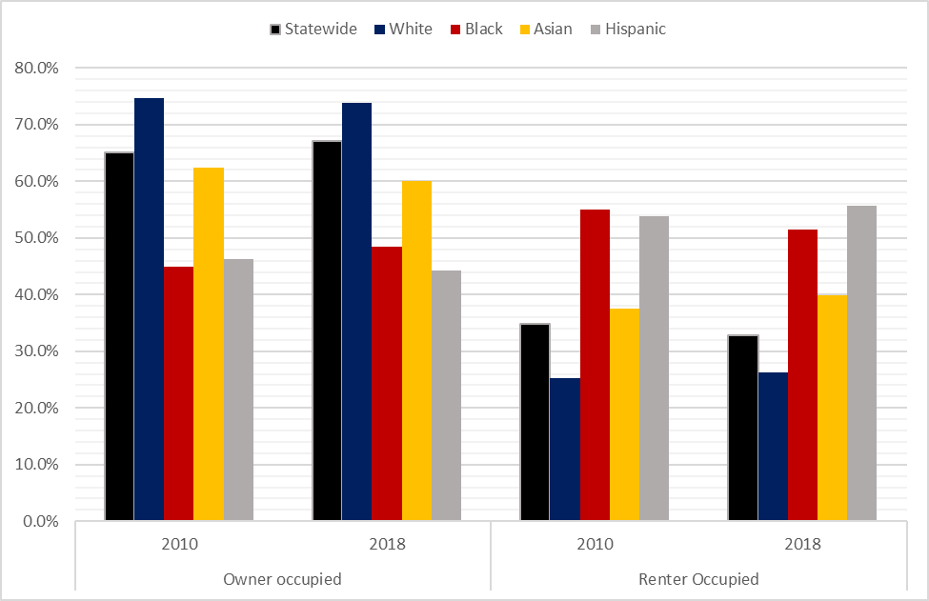
Source: 2006-2010 & 2014-2018 American Community Survey: B25003

Map 17 Homeownership Rates, 2018
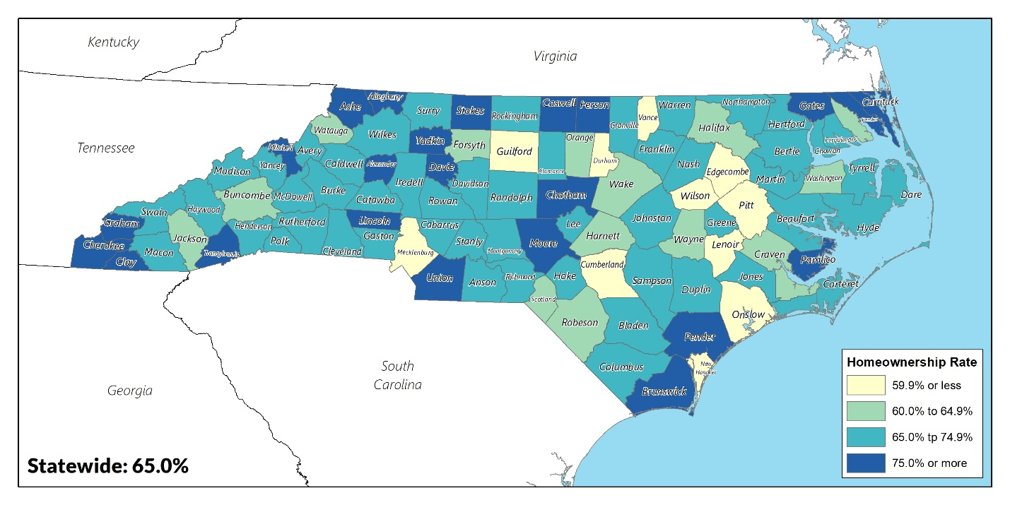
Source: 2014-2018 American Community Survey: B25003

Housing Affordability
Increasing housing costs are not a direct form of housing discrimination. However, a lack of affordable housing does constrain housing choice. Residents may be limited to a smaller selection of neighborhoods or communities because of a lack of affordable housing in other areas.
Home values are often used as a proxy for other non-market goods affecting quality of life, such as accessibility to public transit and green space, growth potential in terms of population and development, quality of schools, and more. The 2018 North Carolina median home value was $165,900, which is 19.0% less than the national home value of $204,900. Additionally, home values declined by 3.4% after adjusting for inflation. While state rent rates were lower than the US rate in 2018, both median gross rent (rent plus utilities) and median contract rent (rent only) increased since 2010. This could be indicative of an increased demand for renter-occupied units compared to owner-occupied units. The largest increases in housing costs for both owner- and renter-occupied units tended to occur in and around major metropolitan areas including Ashville, Charlotte-Concord-Gastonia, Raleigh-Durham-Cary, Wilmington, and Greenville.
Table 18 Housing Values, 2018 (adjusted to 2018 dollars)
 | 2010 | 2018 | % Change
Median Home Value | $ 171,660 | $ 165,900 | -3.4%
Median Gross Rent | $ 827 | $ 877 | 6.1%
Median Contract Rent | $ 641 | $ 687 | 7.1%
Source: 2006-2010 & 2014-2018 American Community Survey: B25058, B25064, B25077

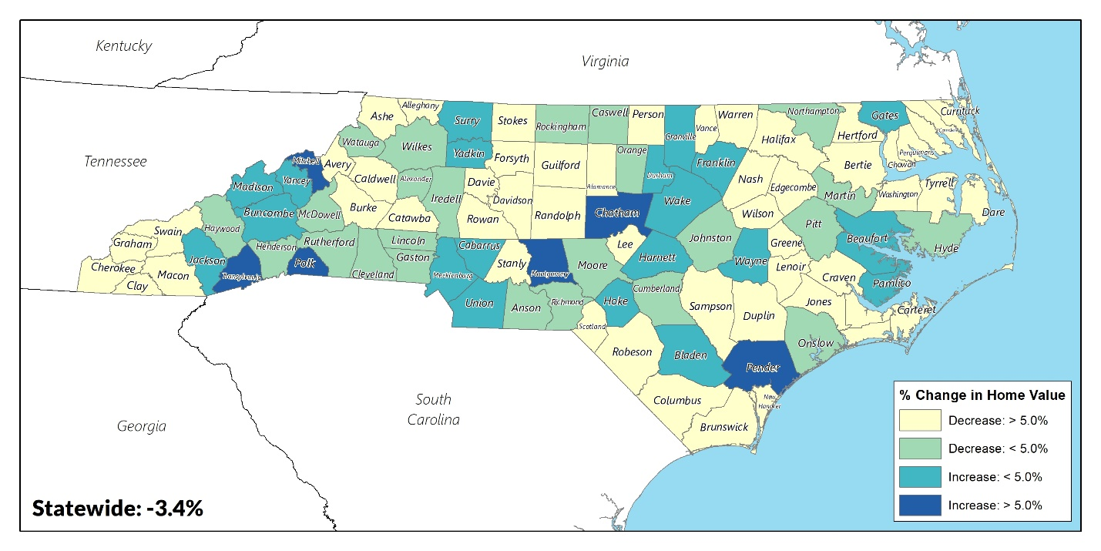
Map 18 Change in Median Housing Value, 2010-2018
Source: 2006-2010 & 2014-2018 American Community Survey: B25077

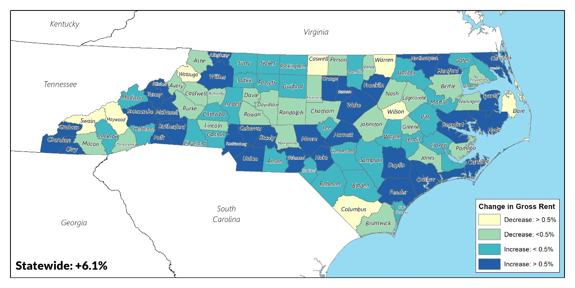
Map 19 Change in Median Gross Rent, 2010-2018
Source: 2006-2010 & 2014-2018 American Community Survey: B25064

Cost Burden
Cost burdened households are defined by HUD as households spending more than 30% of their annual income on housing costs. Severely cost burdened households spend more than 50% of their income. Independent from median income, cost burden serves as an indicator of a homeowner’s ability to afford property maintenance and improvements.
Overall, rates of cost-burden are decreasing in North Carolina, indicating a more affordable housing market for the state overall. In 2018, 28.9% of all households were cost burdened, a 3.0% decrease since 2010. Homeowners tended to be less cost-burdened than renters and saw a 5.4% decrease in overall cost-burden between 2010 and 2018. Renters are virtually unchanged during this same period. Interestingly, rates of severe cost-burden (paying more than 50% of income on housing costs) decreased slightly while cost-burden rates (paying more than 30% of income on housing costs) increased slightly.

Table 19 Cost-burden by Tenure, 2010-2018
 | 2010 |  | 2018
 | # | % | # | %
Total Households | 1,154,697 | 31.8% | 1,131,945 | 28.9%
Cost-burdened (30-50%) | 651,853 | 18.0% | 629,930 | 16.1%
Severely Cost-burdened (>50%) | 502,844 | 13.9% | 502,015 | 12.8%
Owner-occupied Households | 645,006 | 26.1% | 528,055 | 20.7%
Cost-burdened (30-50%) | 401,430 | 16.3% | 318,794 | 12.5%
Severely Cost-burdened (>50%) | 243,576 | 9.9% | 209,261 | 8.2%
Renter-occupied Households | 509,691 | 44.0% | 603,890 | 44.1%
Cost-burdened (30-50%) | 250,423 | 21.6% | 311,136 | 22.7%
Severely Cost-burdened (>50%) | 259,268 | 22.4% | 292,754 | 21.4%
Source: 2006-2010 & 2014-2018 American Community Survey: B25070, B25091

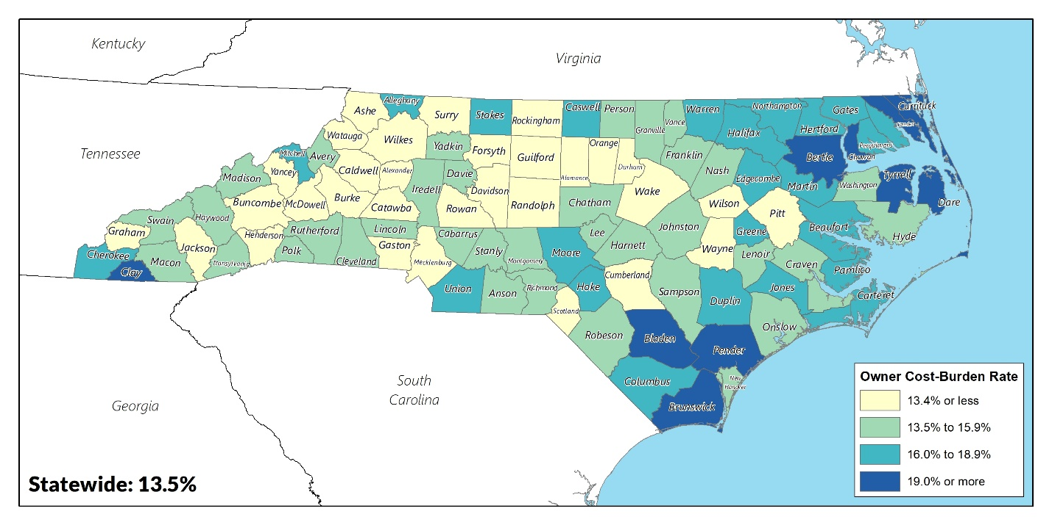
Map 20 Homeowner Cost-burden Rate, 2018
Source: 2014-2018 American Community Survey: B25091

Map 21 Renter Cost-burden Rate, 2018
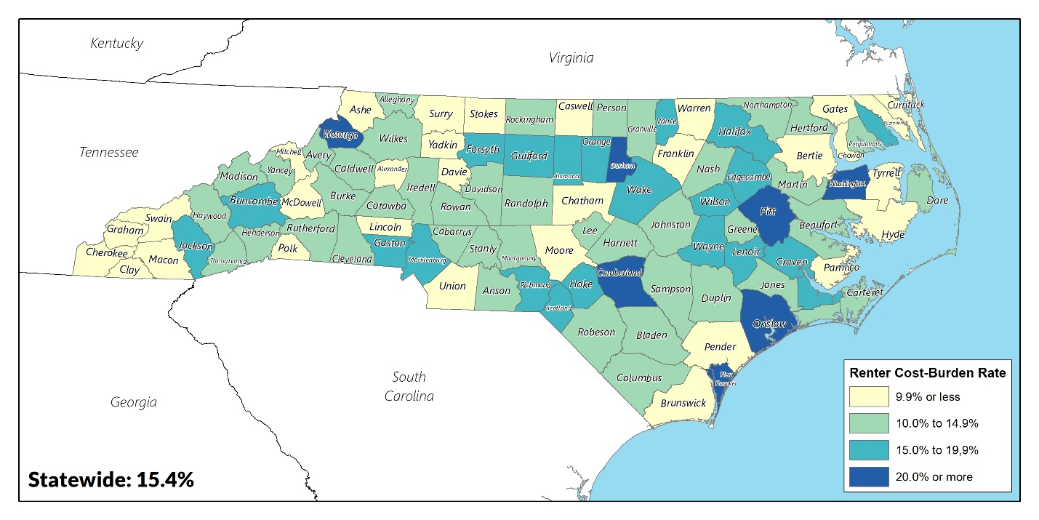
Source: 2018 American Community Survey: B25070

Other Relevant Data

Communities of Opportunity
A large body of social research has demonstrated the powerful negative effects of residential segregation on income and opportunity for minority families, which are commonly concentrated in communities “characterized by older housing stock, slow growth, and low tax bases – the resources that support public services and schools.” Households living in lower-income areas of racial and ethnic concentration have fewer opportunities for education, wealth building, and employment. The rationale for this analysis is to help communities determine where to invest housing resources by pinpointing the areas of greatest existing need. However, current evidence suggests that adding more subsidized housing to places that already have a high concentration of social and economic issues (i.e., R/ECAPs) could be counter-productive and not meet the spirit of the goals of HUD programs. This does not mean, however, that R/ECAPs should be ignored by communities. Residents in R/ECAPs still need services and high-quality places to live and stabilizing and improving conditions in the lowest-income neighborhoods remains a key priority for North Carolina. Rather, investment should be balanced between existing R/ECAPs (improving the quality of life for residents who want to remain in their neighborhoods) and other communities that offer opportunities and advantages for families and individuals.
The Communities of Opportunity model is highly spatial and therefore map-based, generating a geographic footprint of inequality. The process of creating opportunity maps involves building a set of indicators that reflect local issues and are also based on research that validates the connections between the indicators and increased opportunity. The resulting maps allow communities to analyze opportunity, comprehensively and comparatively, to communicate who has access to opportunity-rich areas and who does not, and to understand what needs to be remedied in opportunity-poor communities. The combination of identifying R/ECAPs and Communities of Opportunity creates a holistic approach to community investment.
An Opportunity Index was developed to classify and visualize areas of opportunity for North Carolina residents. The Opportunity Index identifies areas in which new affordable housing developments may be more financially feasible in the long-term due to proximity to factors that allow residents to have successful access to employment, quality education, and a healthy environment. The data is linearly normalized to values between 0 and 1, after which census tracts are classified as having High Opportunity if they have a score above the median and Low Opportunity if they have a score below the median. The variables and weight for each index are summarized in the table below, followed by a more detailed description of each index.

School Proficiency Index
The School Proficiency Index uses public school-level data on the performance students on state exams to describe which neighborhoods have high-performing elementary and secondary schools nearby and which are near lower performing elementary schools. This data is supplied by the US Department of Education through EDFacts for the school year (SY) 2017-18, providing the percentage of students in a school that scored at or above “proficient,” which is defined by the North Carolina Department of Public Instruction (NC DPI) for the State. The index aggregates the percentage of proficient students at the school district level for Reading/Language Arts and Math assessments, normalizes these scores relative to other school districts within North Carolina, and overlaid on North Carolina county boundaries. Some local education agencies have suppressed their data to protect student privacy; as a result, they are not reflected on the map.
Generally, urban metropolitan areas had higher performing schools, including school districts in and around Ashville, Charlotte, Wake County, and Wilmington. The lowest performing school districts are located in the rural Coastal Plains.
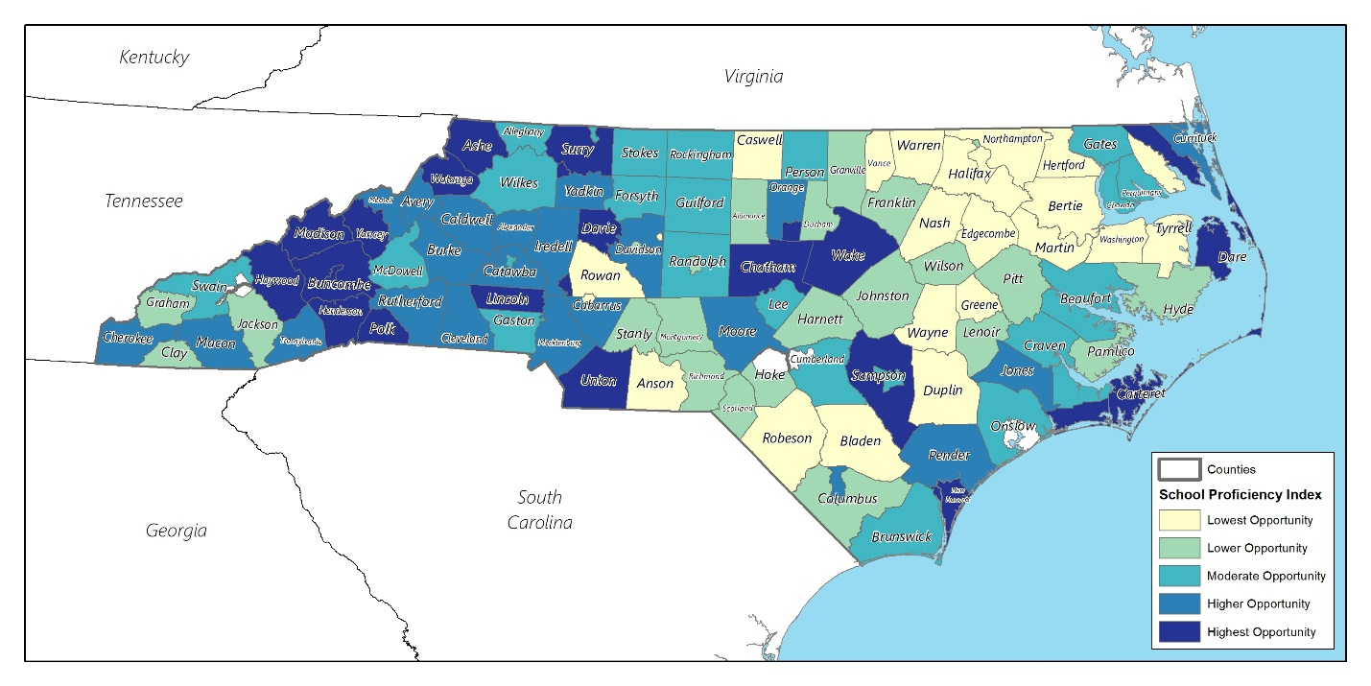
Map 22 School Proficiency Index, 2017-2018
Source: U.S. Department of Education, EDFacts, 2017-2018

Labor Market Engagement Index
The Labor Force Engagement Index is a measure of the relative intensity of labor market engagement and human capital. The index is a combination of unemployment rates, labor force participation rates, mean commuting time, and percent of the population with at least a bachelor’s degree within a census tract. Employment opportunities are necessary for individuals to afford stable housing. Labor force participation represents the amount of labor resources available for the production for goods and services. Mean commuting time indicates ease of access to centers of employment. The percent of the population with at least a bachelor’s degree is used to estimate the availability of skilled labor. The lowest scores are primarily located in the rural Inner Coastal Plains. The highest scores can be found in the larger metropolitan areas and most of the Tidewater region. While Hyde County shows the lowest levels of opportunity in the Tidewater region, this is likely a result of its very low population.
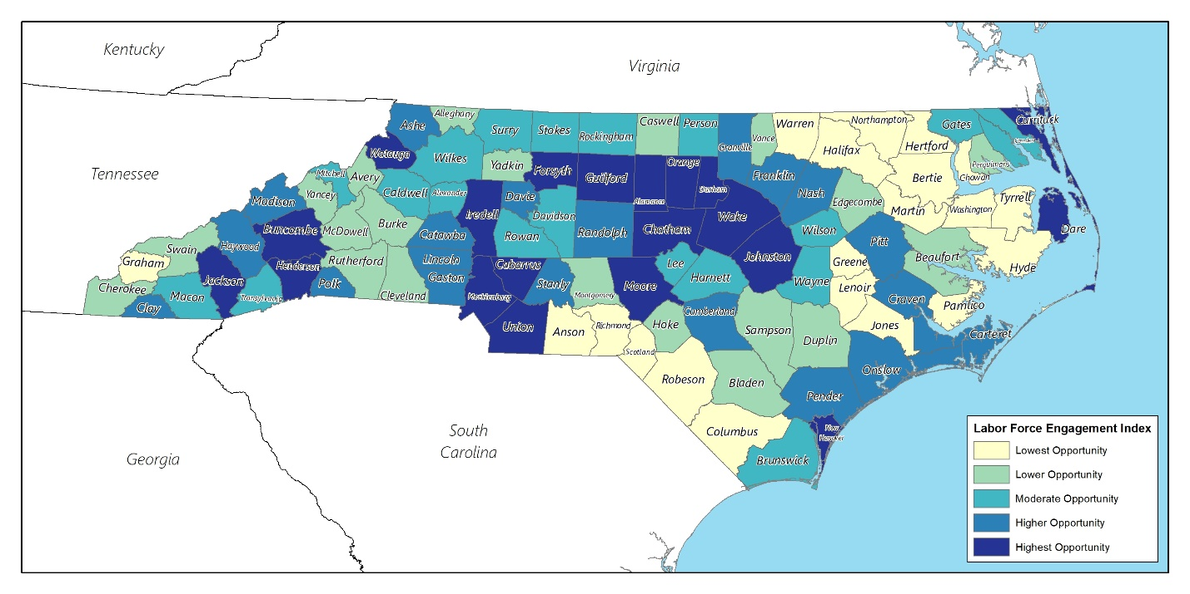
Map 23 Labor Market Engagement Index, 2018 Source: 2018 American Community Survey: DP03, S1501, S2301

Environmental Health Index
The Environmental Health Index summarizes potential exposure to harmful toxins and access to health insurance and food at the census tract level. Toxins include carcinogenic, respiratory, and neurological hazards. Low food access was defined as the percentage of low-income individuals beyond a half-mile from a supermarket. Higher index values indicate less exposure to toxins harmful to human health and better access to food for low-income individuals and health insurance. Environmental hazards have an adverse effect on children’s growth and development and can limit one’s ability to work. Low-income and minority individuals are also found to be disproportionately affected by environmental hazards, perpetuating the lack of opportunity for vulnerable populations. The lowest environmental health scores are concentrated in urban metropolitan areas, likely a result of their location in high traffic areas and having higher rates of poverty. Areas in white had incomplete data in one of the three data sets used.
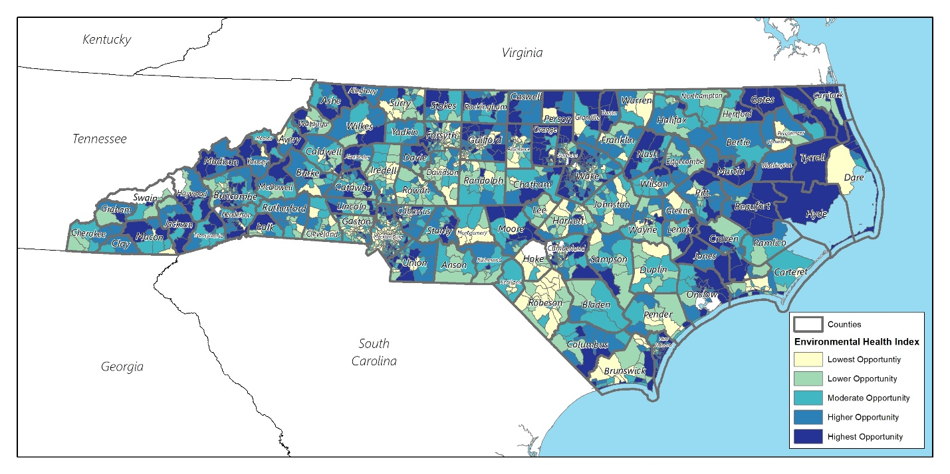
Map 24 Environmental Health Index
Source: 2018 American Community Survey: S2701; HUD Affirmatively Furthering Fair Housing (AFFH), 2015; National Air Toxics Assessment (NATA), 2015; USDA Food Access Research Atlas, 2015

Prosperity Index
This index is a combination of poverty rate and the percentage of households with children receiving public assistance. Public assistance includes Supplemental Security Income (SSI), cash public assistance income, or Food Stamps/SNAP. Poverty has lasting effects that can impact a wide range of factors, including public education primarily funded by the local community, job opportunities, and the ability to afford quality housing. Poverty tended to be most concentrated in the rural Inner Coastal Plains region. Urban areas and the Tidewater region showed the lowest concentrations of poverty and receipt of public assistance.

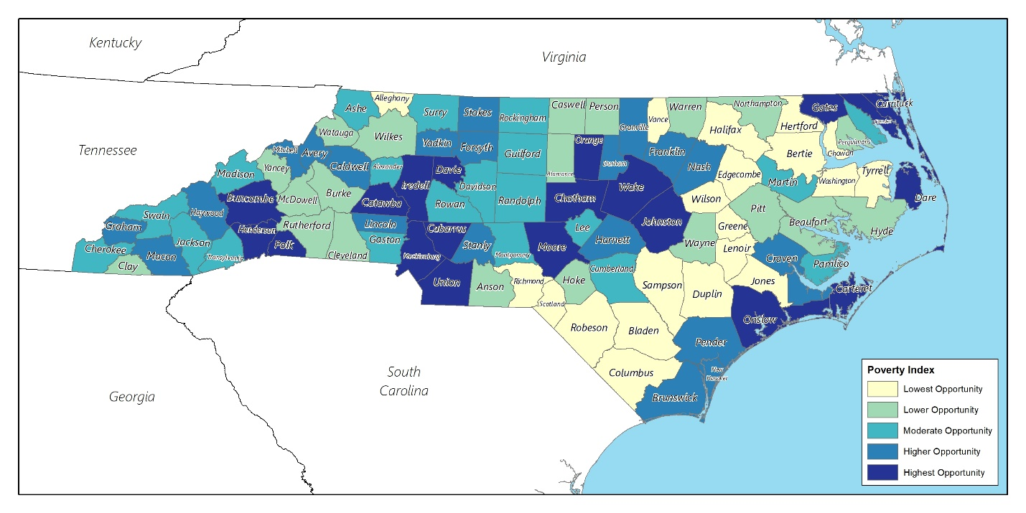
Map 25 Prosperity Index, 2018
Source: 2018 American Community Survey: S1701, B09010

Location of Assisted Inventory in Opportunity Areas
One way to utilize the Communities of Opportunity model is to evaluate the degree to which the State’s assisted housing investment has been made in higher opportunity areas. The assisted inventory includes rental properties funded through federal subsidy programs such as the Low-Income Housing Tax Credit (LIHTC) program, HOME, federal Housing Trust Fund and other federal and State resources.

Assisted housing in North Carolina appeared to be distributed relative to an area’s population size; almost 40% of the entire assisted inventory is in found in the seven largest counties near their urban centers. These areas tend to have better access to opportunities such as employment centers, public transit, and high-performing school districts. Conversely, special attention should be made to assisted housing in low opportunity areas, especially in the Inner Coastal Plains. It is possible that current programs do not give low- and moderate-income households a wider variety of housing options in these areas.

Table 20 Assisted Inventory in North Carolina by County, 2020
Jurisdiction | Assisted Properties | Assisted Units | % Properties | % Units
North Carolina | 3,020 | 146,743 | - | -
Wake County | 340 | 12,742 | 11.26% | 8.68%
Mecklenburg County | 180 | 12,736 | 5.96% | 8.68%
Guilford County | 164 | 9,014 | 5.43% | 6.14%
Durham County | 103 | 6,796 | 3.41% | 4.63%
Forsyth County | 84 | 6,434 | 2.78% | 4.38%
Cumberland County | 88 | 5,364 | 2.91% | 3.66%
Buncombe County | 70 | 4,476 | 2.32% | 3.05%
Robeson County | 60 | 3,441 | 1.99% | 2.34%
Pitt County | 60 | 3,387 | 1.99% | 2.31%
New Hanover County | 52 | 3,336 | 1.72% | 2.27%
Wayne County | 41 | 3,066 | 1.36% | 2.09%
Gaston County | 72 | 3,008 | 2.38% | 2.05%
Alamance County | 50 | 2,693 | 1.66% | 1.84%
Johnston County | 48 | 2,627 | 1.59% | 1.79%
Cabarrus County | 44 | 2,275 | 1.46% | 1.55%
Wilson County | 70 | 2,200 | 2.32% | 1.50%
Iredell County | 43 | 2,191 | 1.42% | 1.49%
Onslow County | 31 | 2,111 | 1.03% | 1.44%
Craven County | 37 | 2,085 | 1.23% | 1.42%
Rockingham County | 46 | 2,002 | 1.52% | 1.36%
Lenoir County | 31 | 1,818 | 1.03% | 1.24%
Catawba County | 31 | 1,766 | 1.03% | 1.20%
Cleveland County | 37 | 1,759 | 1.23% | 1.20%
Rowan County | 33 | 1,709 | 1.09% | 1.16%
Davidson County | 28 | 1,684 | 0.93% | 1.15%
Edgecombe County | 36 | 1,678 | 1.19% | 1.14%
Lee County | 28 | 1,613 | 0.93% | 1.10%
Halifax County | 33 | 1,473 | 1.09% | 1.00%
Surry County | 38 | 1,465 | 1.26% | 1.00%
Nash County | 33 | 1,463 | 1.09% | 1.00%
Orange County | 50 | 1,434 | 1.66% | 0.98%
Columbus County | 36 | 1,406 | 1.19% | 0.96%
Harnett County | 40 | 1,402 | 1.32% | 0.96%
Randolph County | 28 | 1,349 | 0.93% | 0.92%
Richmond County | 26 | 1,329 | 0.86% | 0.91%
Carteret County | 25 | 1,291 | 0.83% | 0.88%
Burke County | 31 | 1,247 | 1.03% | 0.85%
Caldwell County | 25 | 1,247 | 0.83% | 0.85%
Henderson County | 21 | 1,205 | 0.70% | 0.82%
Pasquotank County | 17 | 1,188 | 0.56% | 0.81%
Beaufort County | 30 | 1,185 | 0.99% | 0.81%
Vance County | 42 | 1,092 | 1.39% | 0.74%
Stanly County | 26 | 1,083 | 0.86% | 0.74%
Moore County | 31 | 1,070 | 1.03% | 0.73%
Granville County | 23 | 908 | 0.76% | 0.62%
Wilkes County | 18 | 833 | 0.60% | 0.57%
Bladen County | 22 | 797 | 0.73% | 0.54%
Brunswick County | 16 | 795 | 0.53% | 0.54%
Martin County | 14 | 795 | 0.46% | 0.54%
Scotland County | 19 | 757 | 0.63% | 0.52%
Sampson County | 18 | 730 | 0.60% | 0.50%
Duplin County | 21 | 716 | 0.70% | 0.49%
Person County | 17 | 696 | 0.56% | 0.47%
Rutherford County | 17 | 665 | 0.56% | 0.45%
Lincoln County | 14 | 614 | 0.46% | 0.42%
Chatham County | 17 | 612 | 0.56% | 0.42%
Haywood County | 13 | 571 | 0.43% | 0.39%
Union County | 12 | 566 | 0.40% | 0.39%
Hertford County | 16 | 553 | 0.53% | 0.38%
Stokes County | 18 | 549 | 0.60% | 0.37%
Hoke County | 16 | 520 | 0.53% | 0.35%
Davie County | 14 | 514 | 0.46% | 0.35%
Transylvania County | 10 | 495 | 0.33% | 0.34%
Franklin County | 17 | 466 | 0.56% | 0.32%
Montgomery County | 14 | 464 | 0.46% | 0.32%
Anson County | 10 | 428 | 0.33% | 0.29%
Chowan County | 8 | 393 | 0.26% | 0.27%
Yadkin County | 15 | 392 | 0.50% | 0.27%
Northampton County | 12 | 385 | 0.40% | 0.26%
Washington County | 8 | 371 | 0.26% | 0.25%
McDowell County | 10 | 357 | 0.33% | 0.24%
Madison County | 8 | 339 | 0.26% | 0.23%
Ashe County | 12 | 319 | 0.40% | 0.22%
Macon County | 7 | 293 | 0.23% | 0.20%
Warren County | 15 | 292 | 0.50% | 0.20%
Yancey County | 8 | 292 | 0.26% | 0.20%
Pender County | 7 | 266 | 0.23% | 0.18%
Watauga County | 8 | 260 | 0.26% | 0.18%
Cherokee County | 8 | 256 | 0.26% | 0.17%
Jackson County | 8 | 254 | 0.26% | 0.17%
Mitchell County | 8 | 239 | 0.26% | 0.16%
Caswell County | 6 | 208 | 0.20% | 0.14%
Bertie County | 8 | 182 | 0.26% | 0.12%
Greene County | 6 | 176 | 0.20% | 0.12%
Alexander County | 6 | 174 | 0.20% | 0.12%
Perquimans County | 6 | 174 | 0.20% | 0.12%
Polk County | 7 | 172 | 0.23% | 0.12%
Avery County | 7 | 151 | 0.23% | 0.10%
Alleghany County | 5 | 134 | 0.17% | 0.09%
Dare County | 3 | 97 | 0.10% | 0.07%
Jones County | 5 | 96 | 0.17% | 0.07%
Pamlico County | 5 | 94 | 0.17% | 0.06%
Graham County | 3 | 84 | 0.10% | 0.06%
Swain County | 3 | 84 | 0.10% | 0.06%
Clay County | 4 | 72 | 0.13% | 0.05%
Currituck County | 2 | 51 | 0.07% | 0.03%
Hyde County | 3 | 47 | 0.10% | 0.03%
Tyrrell County | 2 | 41 | 0.07% | 0.03%
Camden County | 1 | 7 | 0.03% | 0.00%
Gates County | 1 | 7 | 0.03% | 0.00%
Source: National Housing Preservation Database (NHPD), October 2020

The following map and table reflect the distribution of assisted units expected to have their period of affordability expire before 2030. The units are subject to income restrictions that keep them affordable for a finite period of time. Preservation of affordable units is more cost effective than the construction of new affordable units, so focusing on the renewal of these affordability restrictions will preserve a significant contribution to the total supply of affordable housing over the next decade. The table also provides the number of expiring units that are owned by for-profit entities because these are most likely at greatest for conversion to market-rate units, particularly in higher opportunity markets. A total of 1,196 assisted properties consisting of 38,482 units are expected to have their periods of affordability expire within ten years. Of these expiring units, 773 units are expected to expire within in five years. Distribution of expiring units is consistent with population size and density with Wake, Mecklenburg and Guildford Counties each having almost 1,000 units expected to expire before 2025.

Table 21 Subsidized Housing Units expected to expire before 2030
 | All Units |  | For Profit Units
County | Units Expiring Before 2025 | Units Expiring Between 2026-2030 | Units Expiring Before 2025 | Units Expiring Between 2026-2030
Alamance | 212 | 494 | 50 | -
Alexander | 14 | 40 | - | -
Alleghany | 36 | 32 | - | -
Anson | 16 | - | - | -
Ashe | 67 | 30 | - | -
Avery | 19 | - | - | -
Beaufort | 170 | 52 | 54 | -
Bertie | 107 | - | 24 | -
Bladen | 192 | 56 | - | -
Brunswick | 31 | 80 | - | -
Buncombe | 860 | 975 | 255 | 499
Burke | 195 | 120 | 38 | 24
Cabarrus | 40 | 620 | - | -
Caldwell | 224 | 162 | 42 | -
Camden | - | 50 | - | -
Carteret | 149 | 162 | 44 | 40
Caswell | 14 | - | - | -
Catawba | 329 | 168 | 48 | 112
Chatham | 49 | 144 | - | 96
Cherokee | - | 24 | - | -
Chowan | 66 | 50 | - | -
Clay | 7 | - | - | -
Cleveland | 185 | - | 76 | -
Columbus | 203 | 68 | - | -
Craven | 135 | 226 | 2 | 34
Cumberland | 900 | 602 | 308 | 256
Currituck | - | 44 | - | -
Dare | - | 44 | - | -
Davidson | 67 | - | 19 | -
Davie | 39 | - | - | -
Duplin | 257 | 86 | - | -
Durham | 1,052 | 1,232 | 238 | 181
Edgecombe | 193 | 149 | 64 | -
Forsyth | 705 | 1,077 | 90 | 837
Franklin | 80 | 3 | 6 | 3
Gaston | 707 | 155 | 132 | 148
Gates | - | - | - | -
Graham | 20 | - | - | -
Granville | 59 | 2 | 12 | 2
Greene | 56 | 48 | 16 | -
Guilford | 983 | 1,515 | 538 | 187
Halifax | 360 | 56 | - | 36
Harnett | 350 | 20 | 2 | -
Haywood | 69 | 134 | - | -
Henderson | 136 | 144 | 64 | -
Hertford | 96 | 24 | - | -
Hoke | 44 | 27 | - | -
Hyde | 31 | 16 | 24 | -
Iredell | 242 | 470 | 79 | 140
Jackson | 34 | 160 | - | -
Johnston | 588 | 12 | - | -
Jones | 32 | - | - | -
Lee | 343 | 131 | 40 | -
Lenoir | 281 | 257 | 24 | 107
Lincoln | 99 | 20 | - | -
Macon | 103 | - | 96 | -
Madison | 7 | - | - | -
Martin | 69 | 24 | - | -
McDowell | 89 | 36 | 44 | -
Mecklenburg | 994 | 2,289 | 207 | 984
Mitchell | 24 | 38 | - | -
Montgomery | 91 | - | - | -
Moore | 139 | 48 | 48 | 16
Nash | 100 | 80 | - | -
New Hanover | 269 | 785 | 103 | 103
Northampton | 63 | 30 | - | 30
Onslow | 172 | 526 | - | -
Orange | 274 | 168 | 91 | 124
Pamlico | 50 | 20 | 24 | -
Pasquotank | 175 | 163 | 19 | -
Pender | 70 | 40 | - | 40
Perquimans | 36 | - | - | -
Person | 69 | 138 | - | -
Pitt | 335 | 383 | 33 | 48
Polk | 14 | - | - | -
Randolph | 182 | 213 | 30 | 123
Richmond | 129 | 82 | 36 | -
Robeson | 475 | 301 | - | 97
Rockingham | 286 | - | 40 | -
Rowan | 126 | 161 | - | -
Rutherford | 103 | 36 | - | -
Sampson | 36 | 21 | - | -
Scotland | 134 | 48 | - | -
Stanly | 20 | 56 | - | -
Stokes | 195 | 48 | 28 | 48
Surry | 218 | 1 | - | -
Swain | - | - | - | -
Transylvania | 73 | 60 | - | 20
Tyrrell | 7 | 34 | - | -
Union | 45 | 72 | - | 32
Vance | 440 | 182 | 106 | -
Wake | 1,503 | 2,839 | 393 | 1,406
Warren | 175 | 16 | 67 | -
Washington | 29 | 16 | - | -
Watauga | 20 | 76 | - | -
Wayne | 263 | 133 | 55 | -
Wilkes | 102 | 41 | - | -
Wilson | 139 | 61 | 76 | 9
Yadkin | 125 | 56 | 24 | -
Yancey | 6 | 50 | - | -

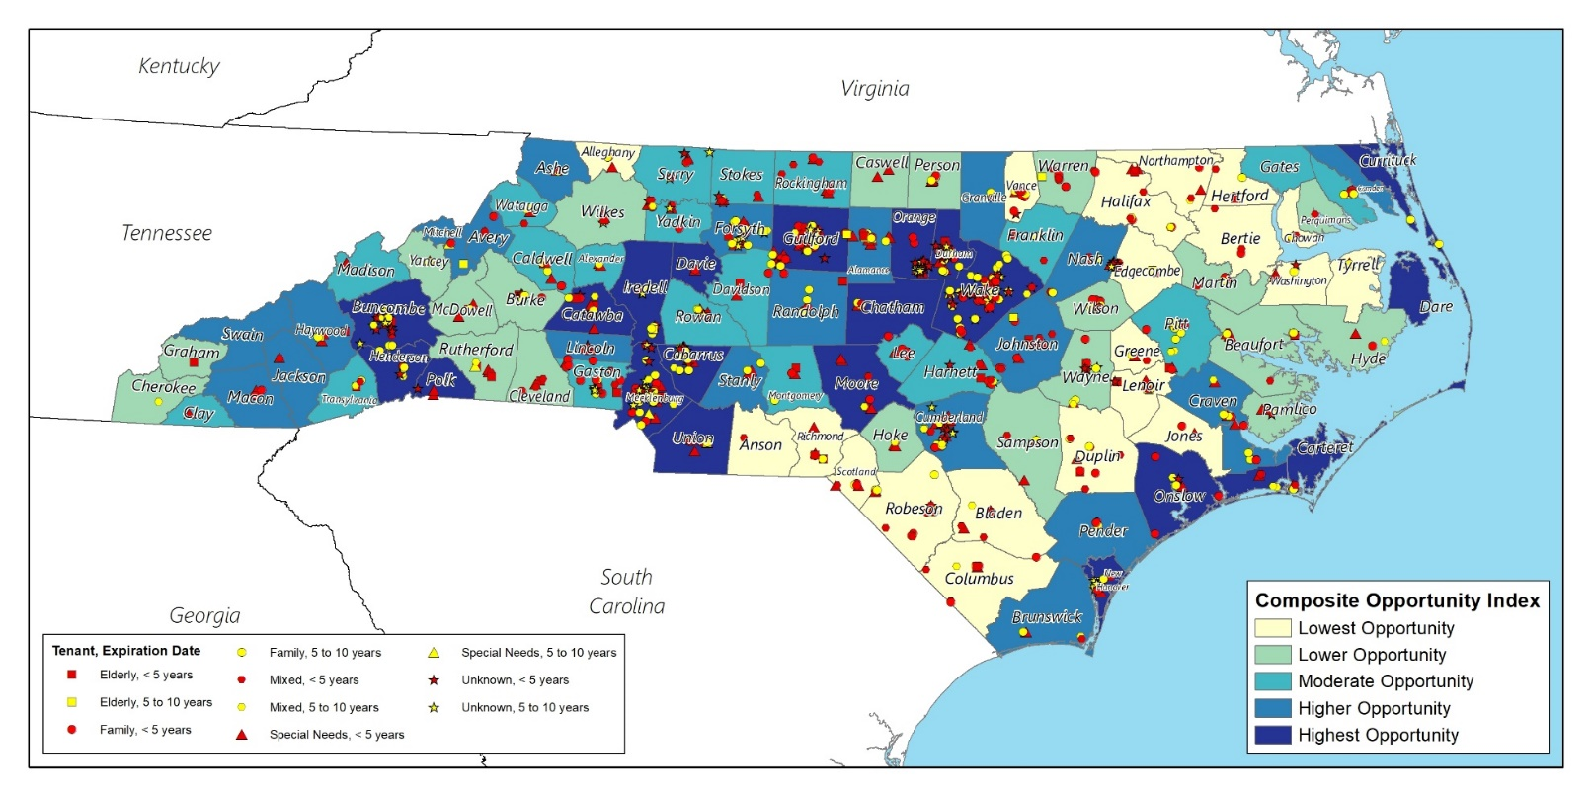
Map 26 Assisted Inventory in North Carolina, 2020
Source: National Housing Preservation Database (NHPD), October 2020

Evaluation of State’s Current Fair Housing Legal Status
North Carolinians can receive fair housing services from HUD, the North Carolina Human Relations Commission, The Fair Housing Project of Legal Aid of North Carolina and several local human relations commissions serving specific jurisdictions. This section summarizes the State-level fair housing organizations and analyzes the existence of fair housing complaints or compliance reviews where a charge of a finding of discrimination has been made.

Fair Housing Statutes

Federal Statutes
Several federal statutes protect people from housing discrimination or from being denied participation in federally funded programs. These include:
- The federal Fair Housing Act protects people from discrimination when they are renting or buying a home, getting a mortgage, seeking housing assistance, or engaging in other housing-related activities.
- Title VI of the Civil Rights Act of 1964 provides that no person in the United States shall, on the ground of race, color, or national origin, be excluded from participation in, be denied the benefits of, or be subjected to discrimination under any program or activity receiving federal financial assistance. Title VI applies to programs or activities receiving federal financial assistance from HUD.
- Section 504 of the Rehabilitation Act of 1973 prohibits discrimination on the basis of disability in any program or activity receiving federal financial assistance. Titles II and III of the Americans with Disabilities Act prohibit discrimination on the basis of disability in all programs, services, and activities of public entities and by private entities that own, operate, or lease places of public accommodation.
- Title I of Section 109 of the Housing and Community Development Act of 1974 prohibits discrimination on the basis of race, color, national origin, disability, age, religion, and sex within Community Development Block Grant (CDBG) programs or activities.

State Statute
The North Carolina State Fair Housing Act (Chapter 41A of the North Carolina General Statutes) makes it unlawful to discriminate against any person in a real estate transaction because of race, color, religion, sex, national origin, handicapping condition, or familial status. The State also prohibits discrimination in the siting of residential development containing affordable housing units.

Municipal Statutes
Five jurisdictions within North Carolina have established local human relations commissions, including Charlotte/Mecklenburg, Durham, Greensboro, Orange County and Winston-Salem. Residents within these jurisdictions have the benefit of filing discrimination complaints with a local entity in addition to filing with the North Carolina Human Relations Commission, the Fair Housing Project of Legal Aid of North Carolina and HUD.

Fair Housing Entities

U.S. Department of Housing & Urban Development
The Office of Fair Housing & Equal Opportunity (FHEO) of HUD administers federal laws and establishes national policies to ensure that all Americans have equal access to the housing of their choice. Housing discrimination complaints filed with HUD may be referred to the North Carolina Human Relations Commission for investigation.

North Carolina Human Relations Commission
The North Carolina Human Relations Commission is a “substantially equivalent agency” under HUD’s Fair Housing Assistance Program (FHAP). This means that NCHRC has been certified as substantially equivalent after HUD determined that the Commission administers a law (i.e., the North Carolina State Fair Housing Act) which provides rights, procedures, remedies and judicial review provisions that are substantially equivalent to the federal Fair Housing Act. As a result, HUD refers complaints of housing discrimination that it receives from North Carolinians to NCHRC for investigation.

As a FHAP agency, the Commission receives grant funding from HUD to assist in the enforcement of the federal Fair Housing Act. The Commission also receives some financial and operational assistance from FHEO to enforce the State Fair Housing Act.

The Fair Housing Project of Legal Aid of North Carolina
The Fair Housing Project is a grantee under HUD’s Fair Housing Initiatives Program (FHIP) and provides the following services across the State:
- Education and outreach on fair housing issues to residents, advocates and service providers
- Legal representation to persons who have been discriminated against
- Conducting research into fair housing and predatory lending, and
- Conducting fair housing testing to determine possible discrimination based on race, disability, familial status, and other grounds.
As a FHIP agency, the Fair Housing Project receives grant funding from HUD to carry out its activities.

Existence of Housing Discrimination Complaints
A lack of filed complaints does not necessarily indicate a lack of housing discrimination. Some persons may not file complaints because they are not aware of how to go about filing a complaint or where to file a complaint. In a tight rental market, tenants may want to avoid confrontations with prospective landlords. Discriminatory practices can be subtle and may not be detected by someone who does not have the benefit of comparing his treatment with that of another home seeker. Other times, persons may be aware that they are being discriminated against, but they may not be aware that the discrimination is against the law and that there are legal remedies to address the discrimination. Finally, households may be more interested in achieving their first priority of finding decent housing and may prefer to avoid going through the process of filing a complaint and following through with it. Therefore, fair housing education and outreach remain critical to inform residents how to identify discrimination and take appropriate actions to fight it.

This section analyzes housing discrimination complaints filed with HUD by North Carolinians between January 2015 and July 2020. Many of the HUD complaints may have been referred to the Human Relations Commission or the Fair Housing Project for investigation and resolution.
Between January 2015 and July 2020, 836 cases in North Carolina were filed with HUD. Of these cases, 463 (55.4%) alleged discrimination based on disability and accounted for more than half of all cases. According to the National Fair Housing Alliance’s 2020 report, Fair Housing in Jeopardy: Trump Administration Undermines Critical Tools for Achieving Racial Equity, complaints by persons with disabilities represented the majority (58.9%) of cases filed nationally in 2019.
From January 1, 2015 to September 30, 2020, the NCHRC investigated and/or is currently investigating a total of 340 fair housing discrimination cases. Most of these (cases received by the NCHRC through July 31, 2020) are included in the total cases received by HUD for the period January 1, 2015 to September 30, 2020.
Table 22 Housing Discrimination Complaints by Basis of Discrimination, January 2015-July 2020
Basis of Discrimination | Cases
 | Number | Percent
Disability | 463 | 55.4%
Race | 269 | 32.2%
Sex | 107 | 12.8%
National Origin | 106 | 12.7%
Familial Status | 104 | 12.4%
Retaliation | 59 | 7.1%
Color | 27 | 3.2%
Religion | 22 | 2.6%
Total exceeds 836 cases and 100% due to some reported complaints included more than one basis of discrimination.
Source: HUD’s Office of Fair Housing and Equal Opportunity

The number of cases filed has fluctuated each year between 2015 and 2020 ranging from 125 cases in 2017 to a high of 166 cases in 2016. The number of cases filed in 2020 only include those filed through the beginning of August. Taking into account the shorter time frame, the number of cases filed for 2020 is expected to remain similar to 2018 and 2019. Areas with the largest number of fair housing cases are primarily located in urban counties, with Durham and Mecklenburg Counties having the most cases by a significant margin. However, the number of cases within these counties fluctuated similarly to the state trend.
Table 23 Top Ten Counties with Highest Number of Housing Discrimination Cases, 2015-2020
County | Cases
 | Number | Percent
Durham | 146 | 17.5%
Mecklenburg | 144 | 17.2%
Guilford | 91 | 10.9%
Wake | 67 | 8.0%
Forsyth | 66 | 7.9%
Orange | 40 | 4.3%
Buncombe | 24 | 2.9%
New Hanover | 18 | 2.1%
Cumberland | 13 | 1.6%
Pitt | 13 | 1.6%
Source: HUD Office of Fair Housing and Equal Opportunity
Since 2015, 705 out of the 836 fair housing cases have been closed; of the 131 open cases, 66 or 50.3% were filed in 2020. No cause determination was the most common case disposition, accounting for the outcome of 425 or 60.3% of closed cases. Cases where conciliation or a settlement was successful accounted for 199 or 28.2% of closed cases. In line with the recorded bases of discrimination, most settled cases (117) were related to discrimination against persons with disabilities.

Patterns and Trends in Housing Discrimination
National statistics from HUD indicate that race, color and national origin discrimination dealing with coercion, intimidation, threats and interference in fair housing are on the rise since 2018. The NCHRC has noticed a comparable increase in these types of cases during the same period.
According to the NCHRC, recent trends in discrimination against persons with disabilities involves discriminatory behavior against persons with emotional support animals (ESAs). Resistance from housing providers in the form of “no pet” policies, requiring pet deposits and establishing animal breed, size and weight policies (even though ESAs are not considered pets under fair housing laws) are reflected in many of the inquiries and complaints filed with the Commission. Other commonly reported bases of alleged discrimination included race (269 or 32.2% of cases), sex (107 or 12.8%), national origin (106 or 12.7%) and familial status (104 or 12.4%). Among the 836 total cases, 598 alleged discrimination on multiple bases.

The NCHRC provided the following additional information related to its cases. The fair housing discrimination trends and the most common bases alleging fair housing discrimination that the NCHRC sees throughout North Carolina are:
- Sex Discrimination: This type of discrimination pertains to gender, gender identity, sexual harassment complaints and some domestic violence issues.
- Handicap (Disability) Discrimination: This type of discrimination pertains to physical and/or mental disabilities involving either service/emotional support animal complaints and/or fair housing design and construction complaints.
- Race/Color/National Origin Discrimination: This type of discrimination pertains to coercion, harassment, threats, intimidation, and retaliation complaints based on the person’s race/color/national origin.
- Race/National Origin Discrimination: This type of discrimination pertains to complaints that deal with blanket ban policies affecting ex-offenders because of their race/national origin and who are trying to obtain housing, primarily in the Housing Choice Voucher program administered by public housing authorities.
Regarding discrimination affecting ex-offenders because of their race/national origin and who are trying to obtain housing, individuals with a criminal record are not a protected class under the Fair Housing Act. However, the Act does prohibit landlords from using criminal records as a pretext for intentional discrimination or in a manner that causes an unjustified discriminatory effect on a protected class. The two exemptions to the policy include sexual offenders and illegal drug abuse offenses.
Among the 1,877 issues cited in cases during the period studied, the majority involved discriminatory terms, conditions and privileges; failure to make reasonable accommodation; discrimination in the terms, conditions and privileges related to renting; denying or making housing unavailable; refusing to rent; coercive acts; and discriminatory advertising.
Table 24 Housing Discrimination Complaints by Issue, 2015-2020
Issue | 2015 | 2016 | 2017 | 2018 | 2019 | 2020 | Total
Discriminatory terms, conditions, privileges, or services and facilities | 69 | 81 | 69 | 82 | 74 | 57 | 432
Failure to make reasonable accommodation | 56 | 59 | 45 | 68 | 68 | 47 | 343
Discrimination in terms/conditions/privileges relating to rental | 53 | 60 | 39 | 43 | 60 | 26 | 281
Otherwise deny or make housing unavailable | 58 | 44 | 20 | 35 | 29 | 6 | 192
Discriminatory refusal to rent | 27 | 36 | 21 | 25 | 25 | 18 | 152
Discriminatory acts under Section 818 (coercion, etc.) | 24 | 28 | 25 | 26 | 20 | 7 | 130
Discriminatory advertisement | 22 | 24 | 24 | 12 | 16 | 3 | 101
Discrimination in services and facilities relating to rental | 4 | 12 | 13 | 11 | 8 | 6 | 54
Other discriminatory acts | 3 | 9 | 13 | 8 | 4 | 1 | 38
Failure to permit reasonable modification | 5 | 4 | 4 | 9 | 7 | 1 | 30
Discriminatory refusal to negotiate for rental | 7 | 6 | 6 | 5 | 5 | - | 29
False denial or representation of availability - rental | 6 | 4 | - | 3 | 1 | 1 | 15
Discriminatory financing (includes real estate transactions) | 1 | 5 | 1 | 2 | 3 | 2 | 14
Discriminatory refusal to sell | 4 | 4 | 2 | 3 | 1 | - | 14
Discrimination in terms/ conditions/privileges relating to sale | 2 | 4 | 1 | 2 | 2 | 2 | 13
Non-compliance with design and construction requirements (handicap) | - | 5 | 8 | - | - | - | 13
Use of discriminatory indicators | - | - | 8 | 1 | - | - | 9
Using ordinances to discriminate in zoning and land use | 1 | 3 | - | 3 | - | 1 | 8
Discrimination in terms and conditions of membership | - | 1 | 1 | 2 | 1 | - | 5
Steering | - | 1 | 1 | 1 | - | 1 | 4
Total Issues | 342 | 390 | 301 | 341 | 324 | 179 | 1,877
Total Complaints | 144 | 166 | 125 | 154 | 160 | 87 | 836

An analysis by transaction type revealed that over 82% of all housing discrimination complaints occurred in the rental market. This is comparable to the national rate of 83.75% reported in the 2020 NFHA report.

Table 25 Housing Discrimination Complaint Data by Transaction Type, 2015-2020
Type | Number | Percent
Rental | 1,541 | 82.1%
Harassment | 130 | 6.9%
Advertising | 101 | 5.4%
Other | 52 | 2.8%
Sales | 45 | 2.4%
Zoning/Land Use | 8 | 0.4%
Total | 1,877 | 100.0%

Other recent trends noted by the NCHRC included the following:
- The number of people displaced, evicted and/or becoming homeless is increasing due to Covid-19, and they are remaining unhoused for longer periods of time
- Eviction mediations are increasing, particularly in Winston-Salem and Greensboro
- There is not a comprehensive approach or program in place to address the impact of Covid-19 on housing

Geographically, the NCHRC has identified increasing cases filed from residents in Wake, Buncombe, New Hanover, Pitt and Cumberland counties. These five counties are higher growth counties in North Carolina where significant residential development has occurred in rural areas. It is in these previously rural areas where landlords, primarily, may feel they can continue discriminatory practices that were more commonly accepted before and went unchecked. As a result, HUD issued a directive to the NCHRC to target rural areas with more fair housing education and outreach, partnering with local human relations commissions to achieve this objective.

There are only five local human relations commissions across the state, all in eastern North Carolina: Orange County, Greensboro, Winston/Salem, Charlotte/Mecklenburg County and Durham. The City of Fayetteville and surrounding Cumberland County has submitted a request for approval of a human relations commission to the State General Assembly, a required and difficult step in the process. Typically, strong local support is needed to secure General Assembly approval in this matter.

Assessment of Current Fair Housing Programs & Activities

North Carolina Human Relations Commission
The NCHRC receive requests from housing providers, city and county Community Development Block Grant (CDGB) departments, local human relations commission, city/county/regional Realtors associations, etc. to conduct fair housing trainings for local landlords/property manager/property owners who rent their properties.

The NCHRC distributes a substantial variety of fair housing educational literature to the public, including the following:
- The North Carolina Fair Housing Act booklet (in English and in Spanish)
- Fair Housing is the Law brochure (in English and in Spanish)
- Fair Housing is For Everyone (in English and in Spanish)
- Fair Housing is the Law poster (in English and in Spanish)

The NCHRC distributes their fair housing literature through:
- Attendance at community events, workshops and seminars
- Conducting fair housing trainings to landlords, property managers, etc.
- Responding to requests via email or telephone from landlords, property managers, property owners renting their own properties, local human relations commissions, fair housing community organizations, etc.
- Conducting compliance fair housing trainings to respondents named in fair housing complaints filed with the NCHRC, which is responsible for conciliation between complainants and the respondents
- Conducting other NCHRC trainings (i.e., cultural diversity training, local human relations commission orientation training, hate crimes/bias training, etc.)

Appendix A includes summary charts of events where the NCHRC distributed over 11,800 pieces of educational materials to 3,710 persons during fiscal years 2018 to 2020.

The NCHRC conciliates complaints between complainants and respondents, one of the requirements included in conciliation agreements is that the respondent receive compliance fair housing training from the NCHRC and/or a HUD approved fair housing organization. When the NCHRC conducts the compliance fair housing training, the fair housing brochures, booklets and/or posters are provided to the respondents.

The NCHRC provided related information from July 1, 2019 to June 30, 2020 to the following 26 local governments in the preparation of their respective Analyses of Impediments to Fair Housing Choice:
- Lee County
- City of Jacksonville and Onslow County
- City of Raleigh and Wake County
- City of Hickory
- Buncombe County
- Henderson County
- Madison County
- Transylvania County
- City of Plymouth (Washington County)
- City of Jonesville (Yadkin County)
- Person County
- City of Aulander (Bertie County)
- City of Lumberton (Robeson County)
- City of Robbins (Moore County)
- City of Sanford (Lee County)
- City of Concord (Cabarrus County)
- Cabarrus County
- City of Statesville (Iredell County)
- Iredell County
- City of Mooresville (Rowan County)
- City of Kannapolis (Rowan County)
- City of Fayetteville (Cumberland County)
- Cumberland County
- City of High Point (Guilford County)
- Guilford County
- City of Burlington (Alamance County)

Progress Achieved since Previous AI
The information provided below is taken from the Consolidated Annual Performance & Evaluation Reports (CAPERs) submitted to HUD by DOC annually. Information provided in each CAPER is from the Con Plan partners, which consists of the state agencies responsible for the administration and management of HUD funding in North Carolina.

Private Sector Impediments, Suggested Actions and Measurable Objectives
Impediment 1: | Discrimination in the rental housing market on the basis of race and disability.
Action 1.1: | In partnership with the Housing Finance Agency (HFA), enhance education and outreach efforts targeting consumers and providers of housing in the state’s non-entitlement areas.
Measurable Objective 1.1: | The number of outreach and education sessions offered and the number of participants.
Impediment 2: | Lack of reasonable accommodation and modification.
Action 2.1: | In partnership with the HFA, enhance targeted outreach and education efforts for housing providers, highlighting legal rights and obligations relating to reasonable accommodation and modification.
Measurable Objective 2.1: | The number of outreach and education and action sessions offered and the number of participants.
Impediment 3: | Lack of understanding of fair housing law in rural areas of the state, both among housing consumers and housing providers.
Action 3.1: | In partnership with the HFA, enhance outreach and education efforts targeting consumers and providers of housing in rural areas of the state, focusing on rights and obligations under the Federal Fair Housing Act and the North Carolina Fair Housing Act.
Measurable Objective 3.1: | The number of outreach and education and action sessions offered and the number of participants.
Progress Achieved on Impediments 1-3:
2016
NCHFA sponsored 14 fair housing trainings in partnership with the NC Fair Housing Project. The half-day trainings were offered to service providers and property owners and/or managers. Each day included a session tailored for service providers in the morning and a session tailored for property owners and/or managers in the afternoon. Fair housing trainings were offered in Wilmington, Greensboro, Goldsboro, Statesville, Charlotte, Raleigh, and Asheville. Over 250 service providers and property owners and/or managers attended these trainings. In addition to these publicly offered fair housing training sessions, HOME-funded partners for the SFR program were required to attend a fair housing and LEP training in the summer.

2017
NCHFA sponsored 28 fair housing trainings in partnership with the NC Fair Housing Project. The half-day trainings were offered to service providers and property owners and/or managers. Each day included a session tailored for service providers in the morning and a session tailored for property owners and/or managers in the afternoon. NCHFA also provides fair housing information to property owners and/or managers through resources posted on NCHFA’s website and circulated to NCHFA partners across the state, such as the “Reasonable Accommodation Quick Guide for Property Owners and Managers” and the “Fair Housing and Tenant Selection” memo from June 2016. HOME-funded partners who assist homeowners and homebuyers must create and implement a Marketing / Outreach Plan. The HOPWA program provided one Fair Housing raining to Ryan White Part B and HOPWA monitoring staff and one Fair Housing training to the 10 HOPWA sub-recipients that did not attend the NCHFA sponsored Fair Housing training.

2018
NCHFA sponsored a number of fair housing trainings across the state in partnership with the NC Fair Housing Project. The half-day trainings were offered to service providers and property owners and/or managers. Each day included a session tailored for service providers in the morning and a session tailored for property owners and/or managers in the afternoon. In addition to these publicly offered fair housing training sessions, HOME-funded partners for the SFRLP, CPLP, and SHLP programs (single-family rehab and home buyer assistance programs) were required to attend fair housing and LEP trainings in the spring/summer of 2018.NCHFA also provides fair housing information to property owners and/or managers through resources posted on NCHFA’s website and circulated to NCHFA partners across the state, such as the “Reasonable Accommodation Quick Guide for Property Owners and Managers” and the “Fair Housing and Tenant Selection” memo from June 2016. NCHFA reviews properties’ tenant selection plans to ensure conformity to the memo and fair housing laws and regulations. HOME-funded partners who assist homeowners and homebuyers must create and implement a Marketing/Outreach Plan. The Marketing/Outreach Plan helps the partners effectively market the availability of housing opportunities to individuals of both minority and non-minority groups that are least likely to apply for assistance. The Marketing/Outreach Plan includes strategies designed to attract homeowners and homebuyers regardless of race, color, religion, sex, familial status, or disability, and describes initial advertising, outreach, and other marketing activities to inform potential homeowners and homebuyers of available assistance. HOME-funded rental developments must create and implement an AFHMP. The AFHMP helps owners/agents effectively market the availability of housing opportunities to individuals of both minority and non-minority groups that are least likely to apply for occupancy. The AFHMP assists marketing strategies designed to attract renters regardless of race, color, religion, sex, familial status, or disability, and describes initial advertising, outreach (community contacts) and other marketing activities which inform potential renters of the existence of units. CDBG continues to ensure the provision of services to underserved households by providing economic opportunity through job creation and the installation of systems that provide clean water and environmentally sound sewer systems. HOPWA continues to serve underserved households by providing permanent housing options, supportive services and leveraging with Ryan White Part B for HIV care and support and CDC HIV/STD Prevention funded services.

2019
NCHFA sponsored a number of fair housing trainings across the state in partnership with the NC Fair Housing Project. The half-day trainings were offered to service providers and property owners and/or managers. Each day included a session tailored for service providers in the morning and a session tailored for property owners and/or managers in the afternoon. NCHFA is continuing to partner with the NC Fair Housing Project in 2020. In addition to these publicly offered fair housing training sessions, HOME-funded partners for the SFRLP, CPLP, and SHLP programs (single-family rehab and home buyer assistance programs) were required to attend fair housing and LEP trainings in the spring/summer of 2019. NCHFA also provides fair housing information to property owners and/or managers through resources posted on NCHFA’s website and circulated to NCHFA partners across the state, such as the “Reasonable Accommodation Quick Guide for Property Owners and Managers” and the “Fair Housing and Tenant Selection” policy (both updated in 2018). NCHFA reviews properties’ tenant selection plans to ensure conformity to the memo and fair housing laws and regulations. HOME-funded partners who assist homeowners and homebuyers must create and implement a Marketing/Outreach Plan. The Marketing/Outreach Plan helps the partners effectively market the availability of housing opportunities to individuals of both minority and non-minority groups that are least likely to apply for assistance. The Marketing/Outreach Plan includes strategies designed to attract homeowners and homebuyers regardless of race, color, religion, sex, familial status, or disability, and describes initial advertising, outreach, and other marketing activities to inform potential homeowners and homebuyers of available assistance. HOME-funded rental developments must create and implement an Affirmative Fair Housing Marketing Plan (AFHMP). The AFHMP helps owners/agents effectively market the availability of housing opportunities to individuals of both minority and non-minority groups that are least likely to apply for occupancy. The AFHMP assists marketing strategies designed to attract renters regardless of race, color, religion, sex, familial status, or disability, and describes initial advertising, outreach (community contacts) and other marketing activities which inform potential renters of the existence of units.

Impediment 4: | Black and Hispanic residents experience higher rates of home purchase loan denials than white and non-Hispanic residents, leading to lower rates of homeownership.
Action 4.1: | In partnership with the HFA, and with the participation of the Department of Commerce, convene a homeownership workgroup to identify ways to overcome disproportionately low homeownership rates among black and Hispanic residents. Task the workgroup with the identification of potential avenues to improve financial literacy, address lack of understanding of credit, loans, and lending, and any other challenges the workgroup may uncover.
Measurable Objective 4.1: | The establishment of the homeownership workgroup, the identification of challenges to homeownership, and suggestions of ways to improve homeownership rates among black and Hispanic residents.
Progress Achieved on Impediment 4:
No progress was made.

Public Sector Impediments, Suggested Actions and Measurable Objectives
Impediment 1: | Limited fair housing infrastructure serving rural state residents.
Action 1.1: | In partnership with the HFA and Department of Commerce, contract with state and local Fair Housing Initiative Program (FHIP) participants to conduct outreach and education activities in rural areas of the state.
Measurable Objective 1.1: | The hiring of FHIP organizations and the number of outreach and education sessions that they conduct.
Progress Achieved on Impediment 5.1:
No progress made.

Impediment 2: | Limited understanding of duty to affirmatively further fair housing.
Action 2.1: | Require prospective sub-grantees of Community Development Block Grant (CDBG) funding to complete fair housing training. As funding applications from local jurisdictions are considered and scored, award additional points to those whose officials have completed fair housing training.
Measurable Objective 2.1: | The establishment of a fair housing training requirement for local CDBG sub-grantees and the development of additional scoring criteria for local jurisdictions whose officials complete fair housing training.
Progress Achieved on Impediment 2.1:
No progress was made.

Action 2.2: | Require a letter from sub-grantees certifying that they will administer CDBG funding in a manner consistent with the findings and objectives of the state AI.
Measurable Objective 2.2: | The number of letters received from CDBG sub-grantees.
Progress Achieved on Impediment 2.2:
No progress was made.

Action 2.3: | In lieu of requiring local jurisdictions to complete an AI, employ resources to conduct fair housing activities, including outreach, education, and training.
Measurable Objective 2.3: | The amount of money and other resources dedicated to providing fair housing outreach, education, and training.
Progress Achieved on Impediment 2.3:
Partial progress was made. The Department of Environmental Quality, Division of Water Infrastructure, instituted in 2020 a requirement that its CDBG subrecipients complete an Affirmatively Furthering Fair Housing Plan as part of their contractual agreements.

Action 2.4: | The DOC will continue to monitor fair housing activities for grantees.
Measurable Objective 2.4: | Records of fair housing activities conducted by local jurisdictions.
Progress Achieved on Impediment 2.4:
No progress was made.

Impediment 3: | Lack of understanding of fair housing law by units of local government in non-entitlement areas.
Action 3.1: | The Department of Commerce will contract with state and local FHIP organizations to provide fair housing outreach, education, and training to local government officials.
Measurable Objective 3.1: | The number of FHIP organizations hired, the number of fair housing outreach, education, and training sessions conducted, and the number of units of local government whose officials participate in those sessions.
Progress Achieved on Impediment 3.1:
No progress was made.

As part of completing future CAPERs, NCDOC and its partner agencies will include this same list of impediments identified in the AI and provide updates on their collective progress annually.

Public Sector Policy Review
The AI is a review of impediments to fair housing choice in the public and private sector. Impediments to fair housing choice are any actions, omissions, or decisions taken because of race, color, religion, sex, disability, familial status or national origin that restrict housing choices or the availability of housing choices, or any actions, omissions or decisions that have the effect of restricting housing choices or the availability of housing choices on the basis of race, color, religion, sex, disability, familial status or national origin. Policies, practices or procedures that appear neutral on their face but which operate to deny or adversely affect the provision of housing to persons of a particular race, color, religion, sex, disability, familial status or national origin may constitute such impediments.
An important element of the AI includes an examination of public policy in terms of its impact on housing choice. This section evaluates the public policies in North Carolina to determine opportunities for furthering the expansion of fair housing choice.

State Building, Occupancy, Health and Safety Codes
Accessible design and construction requirements are necessary to make public and common use spaces and facilities accessible and safe to everyone. This gives people with disabilities greater freedom of choice to choose where they live. The Fair Housing Act requires all “covered multifamily dwellings” to be accessible to and usable by people with disabilities. Here, covered multifamily dwellings are defined as buildings containing four or more units, either with all ground floor units or at least one elevator. The following seven accessibility standards are required by the Fair Housing Act for these dwelling units:

- An accessible building entrance on an accessible route.
- Accessible common and public use areas
- Usable doors (usable by a person in a wheelchair)
- Accessible route into and through the dwelling unit
- Light switches, electrical outlets, thermostats, and other environmental controls in accessible locations
- Reinforced walls in bathrooms for later installation of grab bars
- Usable kitchens and bathrooms

Additionally, it is unlawful to refuse to make reasonable accommodations that allow for a person with a disability equal opportunity to use and enjoy their home.

Building design and construction standards in North Carolina more than adequately implements accessible measures for people with disabilities by utilizing the North Carolina Building Code, which also incorporates International Building Code 2015, for their construction, rehabilitation, and maintenance regulations. State building regulations were last updated in 2018. Chapter 11 determines the design and construction of facilities for accessibility for individuals with disabilities. These standards almost meet all the accessibility requirements outlined by the Fair Housing Act. While all toilet and bathing facilities are required to be accessible, there is not a clear provision for requiring reinforced walls in bathrooms for later installation of grab bars.
Section 1104 and 1105 details requirements for accessible routes entrances, including access to common and public use areas. At least one accessible route within the site shall be provided from public transportation stops, accessible parking, accessible passenger loading zones, and public streets or sidewalks to the accessible building entrance served. The minimum width of the accessible path must be 48 inches minimum. Accessible routes are required with in and between almost all sites, including commercial buildings with five or more tenants, healthcare providers, transportation facilities, airports, and any government building. Exceptions to providing accessible routes are provided if the site does not provide any pedestrian access or if the area of a floor or mezzanine is below 3,000 square feet. Recreational facilities must also provide accessible features to all spaces except for swimming pools.

Section 1107 describes accessibility requirements for dwelling units and sleeping units. All public spaces serving dwelling units shall be accessible, including bathrooms, kitchens, living and dining areas, and any connected exterior spaces. The following table describes the minimum required number of accessible units and features required based on the number of dwelling units a building provides:

Table 26 Accessible Dwelling Unit and Sleeping Unit Requirements in North Carolina
Total number of units provided | Minimum required number of accessible units without roll-in showers | Minimum number of accessible units with roll-in showers | Total number of required accessible units
1 to 25 | 1 | 0 | 1
26 to 50 | 2 | 0 | 2
51 to 75 | 3 | 1 | 4
76 to 100 | 4 | 1 | 5
101 to 150 | 5 | 2 | 7
151 to 200 | 6 | 2 | 8
201 to 300 | 7 | 3 | 10
301 to 400 | 8 | 4 | 12
401 to 500 | 9 | 4 | 13
501 to 1,000 | 2% of total | 1% of total | 3% of total
Over 1,000 | 20, plus 1 for each 100, or fraction thereof, over 1,000 | 10, plus 1 for each 100, or fraction thereof, over 1,000 | 300, plus 2 for each 100, or fraction thereof, over 1,000
Source: 2018 North Carolina Building Code
General exceptions to providing accessible units include structures without elevator services for units on upper floors, site impracticality (e.g. high grade slopes), or structures where the lowest floor of a building without elevator service are at or above design flood elevation.
Section 1109.13 describes controls, operating mechanisms, and hardware such as switches that control lighting and ventilation and electrical convenience outlets. These features are required to be accessible with some exception:

- If the operable parts are intended for use only by service or maintenance personnel
- Receptacles serving a dedicated use Where two or more outlets are provided in a kitchen above a length of countertop that is uninterrupted by a sink or appliance, one outlet shall not be required to be accessible.
- Floor electrical receptables
- HVAC diffusers
- For redundant light switches, one control is not required to be accessible
- Access doors or gates in barrier walls and fences protecting pools, spas and hot tubs
- Section 1109.2 requires toilet room and bathing rooms to be accessible. Exceptions to providing accessible bathrooms include:
- Toilet rooms or bathing rooms accessed only through a private office, not for common or public use and intended for use by a single occupant
- Where multiple single-user toilet rooms or bathing rooms are clustered at a single location, at least 50 percent must be accessible
- Where no more than one urinal is provided in a toilet room or bathing room, the urinal is not required to be accessible.
- Toilet rooms or bathing rooms that are part of critical care or intensive care patient sleeping rooms serving accessible units are not required to be accessible.

While it may be implied, there is not a clear requirement for providing reinforced walls for reasonable accommodation installations. Clarity on reasonable accommodation requirements may provide greater housing opportunities for persons with disabilities.

State Policies on Community Development and Housing Activities
Collectively, the Community Development Block Grant (CDBG), HOME Investment Partnerships, Emergency Solutions Grant (ESG) and Housing Opportunities for Persons With AIDS (HOPWA) programs are under the authority of the Community Planning and Development (CPD) division of the U.S. Department of Housing & Urban Development (HUD). In addition, since 2016, North Carolina has received an annual allocation from the Housing Trust Fund (HTF), also under the authority of HUD. In 2020, the state received $7.2 million in HTF funding. The state also receives approximately $29 million annually in tax credits provided through the federal Low-Income Housing Tax Credit (LIHTC) program administered by the Internal Revenue Service.

Annually, the state is required to engage the public and stakeholders in the development of its Annual Action Plan to identify the eligible activities it will fund and implement with CDBG, HOME, ESG, HOPWA and HTF funds. In addition, the state prepares a Consolidated Plan every five years to set priorities and goals for upcoming Annual Action Plans.

This section analyzes the state-level policies in place that guide how North Carolina affirmatively furthers fair housing as part of its planning process and in the implementation of its federal funding programs.

Community Development Block Grant Program
The North Carolina Division of Water Infrastructure, a division within the Department of Environmental Quality (DEQ), administers CDBG funds for projects that improve water quality, including treatment plants, sewer and water line extensions, and line replacements and rehabilitation. While funding has fluctuated between program years, the DEQ received $28,014,788 in 2019, the highest amount received within the past seven years.
Figure 4 CDBG Water Infrastructure Investment in North Carolina by Year, 2013-2019
Source: North Carolina Division of Water

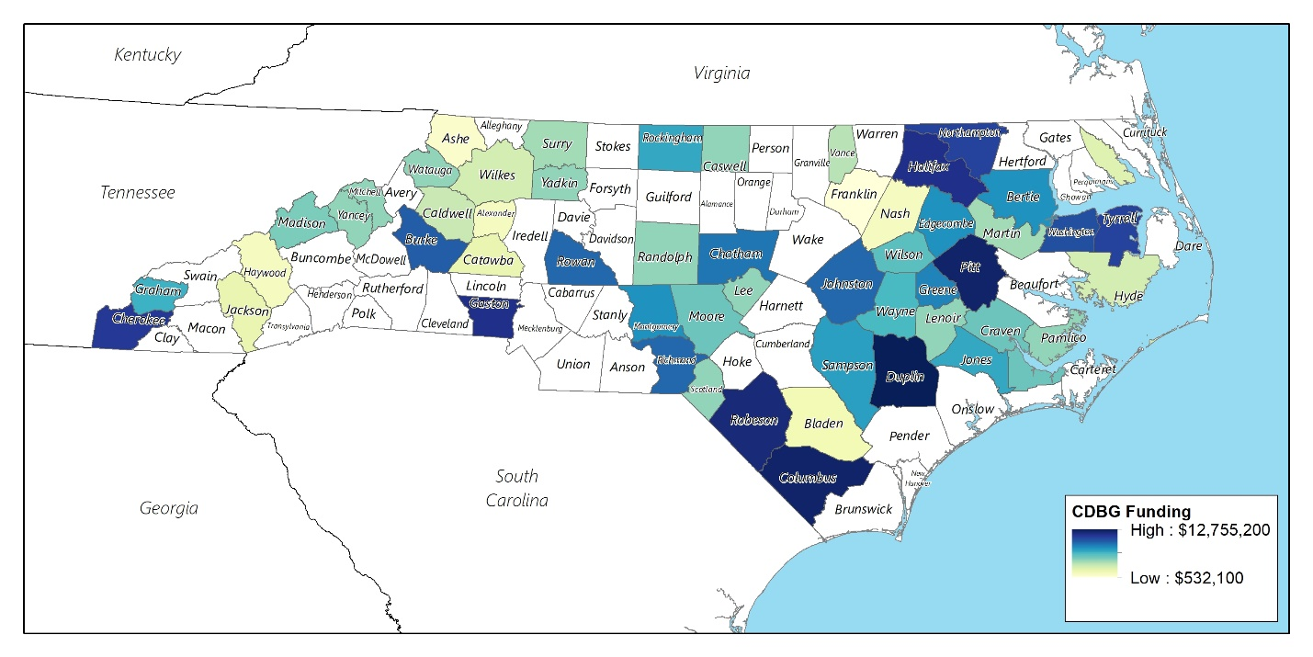
Map 27 CDBG Water Infrastructure Investment, 2013-2019
Source: North Carolina Division of Water
Table 27 CDBG Water Infrastructure Investment by County, 2013-2019
County | Funding | MHI | Poverty Rate
TOTAL | $ 182,101,458 | $ 32,656 | 30.4%
Duplin | $ 12,755,200 | $ 34,475 | 27.6%
Pitt | $ 11,966,325 | $ 36,396 | 26.4%
Columbus | $ 11,376,000 | $ 26,217 | 31.5%
Robeson | $ 10,376,241 | $ 26,301 | 40.1%
Halifax | $ 8,199,622 | $ 26,382 | 33.4%
Gaston | $ 7,572,682 | $ 53,146 | 21.1%
Cherokee | $ 5,816,925 | $ 25,352 | 36.2%
Northampton | $ 4,983,500 | $ 33,611 | 27.2%
Tyrrell | $ 4,962,000 | $ 28,752 | 33.1%
Washington | $ 4,588,947 | $ 16,020 | 50.6%
Rowan | $ 4,402,649 | $ 33,010 | 31.2%
Richmond | $ 4,350,000 | $ 29,643 | 29.3%
Johnston | $ 4,348,572 | $ 36,494 | 30.4%
Chatham | $ 3,999,550 | $ 50,651 | 22.9%
Greene | $ 3,999,466 | $ 35,638 | 24.7%
Montgomery | $ 3,865,000 | $ 30,195 | 35.0%
Bertie | $ 3,741,549 | $ 27,188 | 34.7%
Sampson | $ 3,563,000 | $ 25,250 | 53.6%
Rockingham | $ 3,299,298 | $ 35,926 | 20.5%
Jones | $ 3,209,131 | $ 17,813 | 60.2%
Caldwell/Burke | $ 3,000,000 | $ 37,283 | 21.6%
Graham | $ 3,000,000 | $ 14,067 | 47.7%
Edgecombe | $ 2,981,569 | $ 35,516 | 23.6%
Wayne | $ 2,781,618 | $ 29,512 | 36.3%
Wilson | $ 2,664,062 | $ 36,949 | 23.5%
Craven | $ 2,584,331 | $ 38,021 | 25.8%
Moore | $ 2,550,000 | $ 32,332 | 24.2%
Madison | $ 2,045,050 | $ 38,864 | 7.4%
Burke | $ 2,000,000 | $ 42,516 | 18.1%
Caswell | $ 2,000,000 | $ 18,649 | 47.9%
Lee | $ 2,000,000 | $ 46,067 | 18.5%
Lenoir | $ 2,000,000 | $ 31,981 | 29.4%
Pamlico | $ 2,000,000 | $ 44,524 | 14.5%
Randolph | $ 2,000,000 | $ 39,665 | 27.8%
Scotland | $ 2,000,000 | $ 29,388 | 34.0%
Watauga | $ 2,000,000 | $ 19,574 | 56.1%
Yadkin | $ 2,000,000 | $ 28,456 | 31.6%
Yancey | $ 2,000,000 | $ 36,310 | 25.7%
Mitchell | $ 1,999,500 | $ 30,000 | 37.2%
Catawba/Burke | $ 1,965,700 | $ 35,987 | 19.6%
Nash/Edgecombe | $ 1,789,530 | $ 32,361 | 30.1%
Surry | $ 1,731,600 | $ 33,988 | 25.8%
Martin | $ 1,698,000 | $ 32,396 | 11.6%
Vance | $ 1,532,400 | $ 30,145 | 30.1%
Hyde | $ 1,200,000 | $ 45,466 | 22.3%
Wilkes | $ 1,193,114 | $ 40,829 | 19.9%
Pasquotank | $ 1,070,447 | $ 36,681 | 24.6%
Jackson | $ 1,000,000 | $ 44,028 | 19.4%
Bladen | $ 940,500 | $ 33,958 | 24.9%
Haywood | $ 910,050 | $ 58,553 | 7.9%
Alexander | $ 894,750 | $ 44,961 | 14.9%
Ashe | $ 661,480 | $ 25,446 | 23.2%
Franklin | $ 532,100 | $ 29,941 | 24.2%
Source: North Carolina Division of Water
DEQ manages a statewide competitive process among the 400 small town potential applicants. Grant-funded projects include primarily the rehabilitation of extension lines for failing wells and septic systems in very low- and moderate-income areas where water/sewer service rates exceed the state’s average rates. Over the past six years, DEQ has financed 720 housing unit connections for upgraded service.
These funds are primarily invested in rural areas of North Carolina, especially in the Inner Coastal Plains. Four counties in this region have received over $10 million in CDBG funds for water and sewage infrastructure: Duplin, Pitt, Columbus and Robeson. These counties show significantly higher poverty rates and lower median household incomes compared to the statewide benchmarks of 14% poverty and a $52,413 median household income.
All CDBG grantees are required to undergo fair housing training, which is mandatory for elected officials, a community’s Section 3 representative and the local grant administrator. DEQ provides the in-person training, which has changed to virtual training since Covid-19. Notably, DEQ has created an Affirmatively Furthering Fair Housing Plan template for all CDBG subgrantees. An educational tool itself, the plan template includes a clear policy statement with an overview of applicable state and federal laws including the recent Preserving Community and Neighborhood Choice final rule. The plan requires each subrecipient community to designate a fair housing officer and explains its role and responsibilities. The housing complaint process provides links to online resources for filing a discrimination complaint with HUD, the North Carolina Office of Administrative Hearings and the U.S. Department of Justice.
Each plan is guided by the unique local needs and interests identified by a community. The proposed activities must be implemented on a quarterly basis and tracked for compliance. In addition, DEQ requires three activities such as publication of fair housing complaint procedures and the contact information for the fair housing officer, inclusion of the Equal Housing Opportunity logo or phrase on all CDBG documents made publicly available and displaying of fair housing and Equal Housing Opportunity posters in prominent locations. The elected body of the community is required to adopt the completed plan, the Equal Housing Opportunity Resolution and the Fair Housing Complaint Procedure to remain in compliance with its CDBG grant agreement. It was recommended that DEQ note that the document is available in Spanish beneath the title of the plan on the first page along with contact information for obtaining the Spanish version. In terms of language assistance, DEQ places this responsibility on the subrecipient, which may include seeking language services from their county or a nearby town.
Instances of non-compliance with fair housing requirements are strongly enforced during the post-award training. DEQ staff work closely with subrecipients when corrective action is required. A subrecipient community’s fair housing plan is required to be submitted each February and grant funds can be frozen for non-submittals. DEQ reported no instances of non-compliance related to fair housing.
DEQ strongly encourages its own staff to attend the same fair housing training as its CDBG subrecipients although it is not required.

Community Development Block Grant – Disaster Recovery Program
[We were unable to make contact with Laura Hogshead.]

HOME Investment Partnerships Program
The North Carolina Housing Finance Agency (NCHFA) administers the state’s HOME funds as one of several resources for its numerous housing programs. In 2020 the state was allocated just under $18.2 million in HOME funds. The Agency uses HOME funds to finance single-family rehabilitation and rental production activities as well as its community partners loan pool and self-help loan pool programs. The two loan pools provide downpayment assistance and homeowner counseling for homebuyers and gap financing for Habitat for Humanity chapters in new single-family unit production.
The following map illustrates active HOME-financed housing activities as of November 2020. Of the 15,464 dwelling units represented on the map, 773 units (5.0%) are located in R/ECAPs. Additionally, 12,494 units (80.7%) are located in central urban counties. As defined by the United States Office of Management and Budget, central urban counties contain at least 50% of the county’s population within urban areas of 10,000 or more people or contain at least 5,000 people residing within a single urban area.

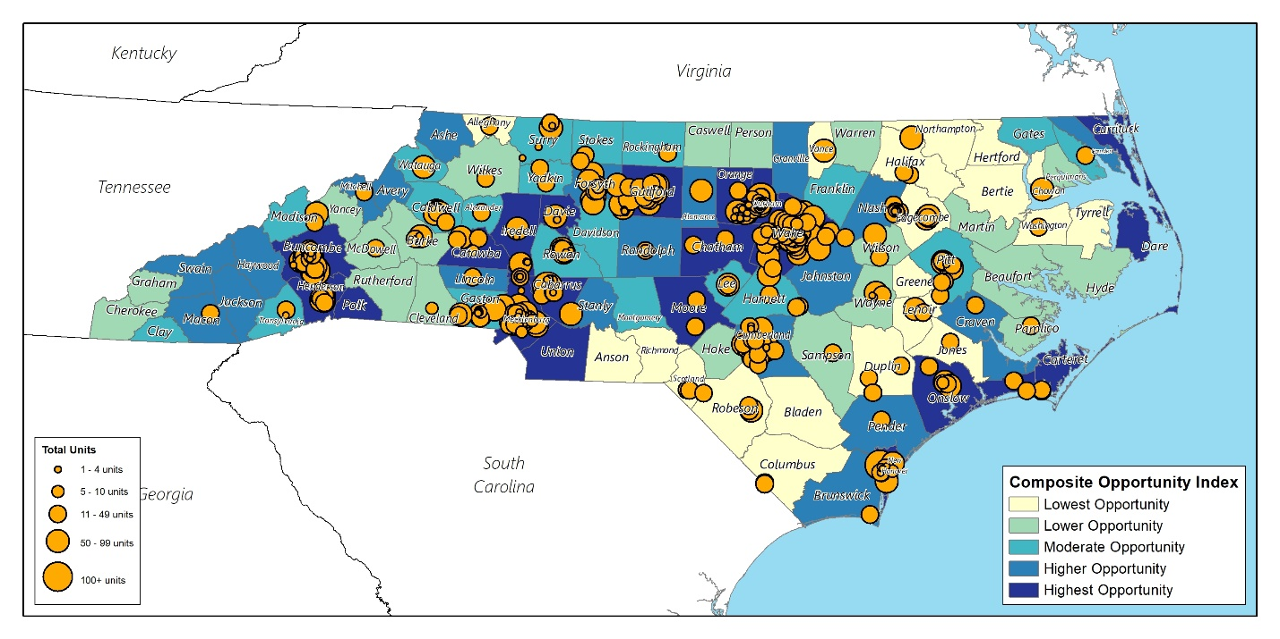
Map 28 HOME Program Investments in North Carolina, 2020
Source: NCHFA

Emergency Solutions Grant Program
The North Carolina Department of Health and Human Services, Division of Aging and Adult Services, administers the state’s allocation of Emergency Solutions Grant (ESG) funding provided by HUD. Eligible activities include street outreach, emergency shelter, homelessness prevention, rapid re-housing assistance, administration of the Homeless Management Information System (HMIS), as well as administrative activities to oversee the implementation of the grant. Since 2015, the state’s ESG allocation dropped 1.7% in 2016 from $5,033,564 to $4,946,338 before gradually increasing to $5,342,722 in 2020.
Recipients of state ESG funding awards are provided with copies of the NC ESG Monitoring Guide and the NC ESG Desk Guide 2020. Section 16 of the Desk Guide includes the non-discriminatory, equal opportunity and affirmatively furthering fair housing requirements required of all subrecipients. These include the following:
- Subrecipients must make known that NC ESG rental assistance and services are available to all on a nondiscriminatory basis and ensure that all citizens have equal access to information about NC ESG and equal access to the financial assistance and services provided under this program.
- Persons with limited English proficient persons may be entitled to language assistance under Title VI in order to receive a particular service, benefit, or encounter. As a condition of receiving ESG funds, the subrecipient agrees to take reasonable steps to ensure meaningful access to activities for LEP persons, such as acquiring translators to translate vital documents, advertisements, or notices, acquiring interpreters for face to face interviews with LEP persons, placing advertisements and notices in newspapers that serve LEP persons, partnering with other organizations that serve LEP populations to provide interpretation, translation, or dissemination of information regarding the project, hiring bilingual employees or volunteers for outreach and intake activities, contracting with a telephone line interpreter service, etc.
- All notices and communications must be provided in a manner that is effective for persons with hearing, visual, and other communication related disabilities consistent with section 504 of the Rehabilitation Act of 1973 and implementing regulations at 24 CFR 8.6. If the procedures that the subrecipient intends to use to make known the availability of the rental assistance and services are unlikely to reach persons of any race, color, religion, sex, age, national origin, familial status, or disability who may qualify for such rental assistance and services, then the subrecipient must establish additional procedures that will ensure that such persons are made aware of the rental assistance and services.
- Subrecipients have a duty to affirmatively further fair housing opportunities for protected classes include race, color, national origin, religion, sex, disability, and familial status. Examples of affirmatively furthering fair housing include: (1) marketing the program to all eligible persons, including persons with disabilities and persons with limited English proficiency; (2) making buildings and communications that facilitate applications and service delivery accessible to persons with disabilities; providing fair housing counseling services or referrals to fair housing agencies; (4) informing participants of how to file a housing discrimination complaint, including providing the toll-free number for the Housing Discrimination Hotline; and (5) recruiting landlords and service providers in areas that expand housing choice to program participants.
Should non-compliance with these requirements be identified, then DHHS will notify the subrecipient and provide technical assistance to correct the shortcomings. In severe cases of non-compliance, DHHS can recapture ESG funds. In its attempt to prevent discriminatory behavior from occurring among some subrecipients, DHHS works to ensure that emergency shelters have low-barrier policies, which refers to shelters that do not require prerequisites to gain admittance such as sobriety or mental health treatment. DHHS has denied funding to shelters that do not have a low-barrier policy.
DHHS staff are required to comply with all applicable statutes and regulations for the ESG program but no formal staff training is required.

Housing Opportunities for Persons With AIDS
The North Carolina Department of Health and Human Services, Division of Public Health, Communicable Disease Branch, administers the state’s annual allocation of Housing Opportunities for Persons with AIDS (HOPWA) funding, in collaboration with its Ryan White funding. Eligible activities include acquisition, rehabilitation, or new construction of housing units; costs for facility operations; rental assistance; and short-term payments to prevent homelessness. Since 2015, the state’s annual grant amount has increased 68% from $2,143,296 to $3,610,021 in 2020. Eighty of the state’s 100 counties are eligible to receive funds; the remaining 10 counties receive their allocations directly from HUD.
For the HOPWA program, the state is divided into 10 regions with service provider agencies located within each region collaborating to form networks for the purpose of devising locally driven planning and program implementation to identify needs and suitable solutions for addressing their needs. Towards this end, the 2021 Request for Funding Availability (RFA) will be expanded to include three new eligible activities: hotel/motel accommodations as a temporary housing option for people with HIV/AIDS who may be in health-compromising or uninhabitable living situations; facility repair funding to preserve existing rental and owner-occupied units; and removal of barriers and caps on funding and allowing local subrecipients to decide how best to allocate spending among tenant-based rental assistance, permanent housing placement, and mortgage or rent and utilities.
DHHS has worked with the regional networks to enhance marketing to unserved populations. The networks are encouraged to seek more clients and examine how to address their needs with the proposed new activities. In 2020, DHHS awarded high performing subrecipients with additional funding. It is anticipated that the new activities proposed for 2021 will facilitate a more open application process.
The state’s HOPWA Policies and Procedures Manual clearly lists the applicable federal statutes that apply to subrecipients’ obligations to comply with fair housing laws and non-discriminatory requirements. Subrecipients are monitored twice annually with non-compliance potentially impacting future funding approval.
DHHS HOPWA staff and network providers receive fair housing training from DOC.

Low Income Housing Tax Credit Program and the Qualified Allocation Plan
The Qualified Allocation Plan (QAP) is a public policy based on guidelines established by Section 42 of the Internal Revenue Code, which establishes the NCHFA’s priorities for rental housing initiatives financed with Low Income Housing Tax Credits (LIHTC). The following series of maps illustrate the types and locations of investments made with LIHTC funding and tax-exempt bond financing in 2020.
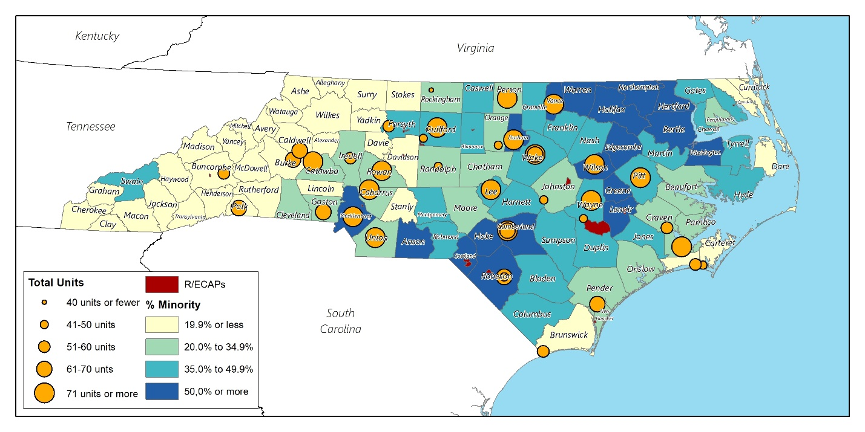
Map 29 Low Income Housing Tax Credit Investments in North Carolina, 2020
Source: North Carolina Housing Finance Agency

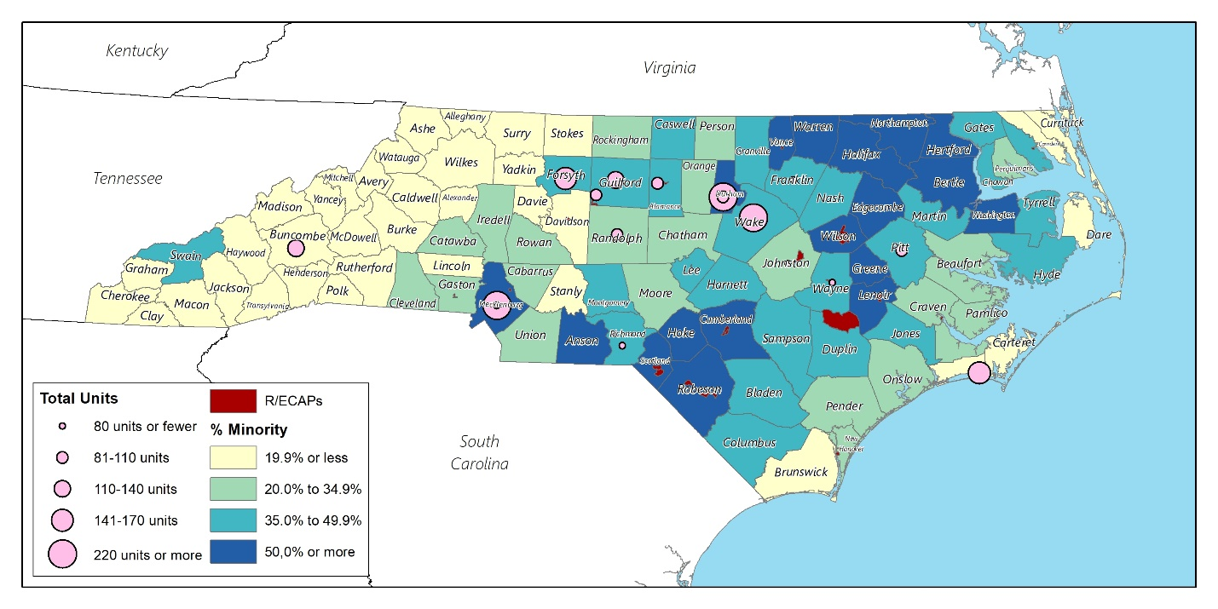
Map 30 Tax-Exempt Bond Financing Properties in North Carolina, 2020
Source: North Carolina Housing Finance Agency

Unlike federal programs that provide grants or loans for housing development, the LIHTC program generates private equity from the sale of tax credits to assist with the hard and soft development costs of rental units. Generally, for-profit corporations such as banks purchase the credits based on current demand for them. In return, corporations receive an annual dollar-for-dollar reduction of federal taxes each year for the first fifteen years that units are in operation. Each year, the QAP must be approved by the Governor before the tax credits can be awarded by NCHFA to developers. Because the competition for tax credits is robust, tax credit developers design their rental housing projects to achieve maximum scoring under NCHFA’s QAP priority scoring categories. The QAP has a major impact on what populations are served, the types of projects that will be undertaken and, indirectly, where rental housing is built or rehabilitated.
QAP policies across the country have changed in recent years to address issues central to a recent federal fair housing case, The Inclusive Communities Project, Inc. v. Texas Department of Housing and Community Affairs (N.D. Tex. 2010), in which a local affordable housing advocate challenged the Texas QAP. The Department of Housing and Community Affairs (TDHCA) is the housing finance agency for the State of Texas. The lawsuit alleged that TDHCA disproportionately approved tax credits for low- income housing in minority neighborhoods and denied applications for family tax credit housing in predominantly White neighborhoods. The plaintiff alleged that TDHCA’s policy in awarding credits perpetuated racial segregation in violation of the Fair Housing Act. TDHCA argued that it prioritized tax credit applications for projects located in qualified census tracts (QCTs) in accordance with Section 42 of the Internal Revenue Code and that, as such, it was unavoidable that tax credit projects would be located in concentrated minority neighborhoods rather than predominantly White neighborhoods.
TDHCA’s motion for summary judgment (i.e. dismissal of the case) was denied in 2010. Following a trial, the court found in March 2012 that actions taken by TDHCA in allocating tax credits had a disparate impact under the Fair Housing Act.
This finding was followed by an opinion issued by the Fifth Circuit Court of Appeals in March 2014, which determined that the correct legal standard to apply in disparate impact claims under the Fair Housing Act is the standard adopted in HUD regulations regarding burdens of proof (24 CFR 100.500). These rules establish liability for practices with discriminatory effects, whether or not those practices are intentionally discriminatory. A practice has a discriminatory effect where it actually or predictably results in a disparate impact on a group of persons or creates, increases, reinforces, or perpetuates segregated housing patterns. In 2015, the United States Supreme Court held that “disparate-impact claims are cognizable under the Fair Housing Act.”
The results of this legal precedent perfectly summarize the challenge of affirmatively furthering housing in cities, counties and states across the U.S.: balancing the creation of affordable housing in lower poverty and predominantly non-minority areas (i.e., higher opportunity areas) with the need to preserve affordable housing and improve the quality of life for residents in higher poverty and predominantly minority areas (i.e., lower opportunity areas). This is the context within which North Carolina’s 2021 QAP (Draft 2) was evaluated for purposes of the AI.
The QAP was reviewed to determine the presence of five tax credit allocation priorities meant to incentivize developers to create LIHTC developments in locations with lower poverty rates and higher opportunity. The five allocation priorities included:
- High-opportunity neighborhoods
- Access to amenities
- Approval by the community
- Furthering investment in blighted neighborhoods
- Avoiding concentrations of affordable housing
The total annual tax credit authority for North Carolina in 2020 was just over $29 million. The set-asides established in the QAP reflect distinctions in specific needs and county market conditions as determined by NCHFA. The QAP includes two primary set-asides for how the 9% tax credits will be allocated based on availability of credits after (1) forward commitments are satisfied and (2) a set-aside for Disaster Recovery in the East region is satisfied for new construction: 10% for housing rehabilitation and the remainder for new construction. Within the new construction set-aside, the state is divided into four regions, each with a specified set-aside: West 16%, Central 23%, Metro 38% and East 23%.
High-opportunity neighborhoods refer to areas that are typically suitable for long-term growth with existing or planned infrastructure in the vicinity of quality schools and employment opportunities, among other things. The significance of locating LIHTC developments in high-opportunity areas is that these are also areas with lower poverty rates. Exercising fair housing choice means having the opportunity to move to another neighborhood that offers economic opportunity, proximity to the workplace, better schools, and a safer and more secure environment should a lower income household choose to move. Affirmative moves from R/ECAP areas to lower poverty areas of opportunity help to break down patterns of segregation. NCHFA fosters this goal by awarding for three specific criteria.
First, proposed developments cannot be located in areas of minority and low-income concentration; however, NCHFA may make an exception for projects in economically distressed areas with community revitalization plans with public funds committed to support the revitalization effort. Second, a proposed development can receive up to 38 points for a location in close proximity to community amenities (see following paragraph). Third, up to two points are awarded for projects located in High Income Counties if at least 25% of the qualified low-income units are made affordable to and occupied by households with incomes at or below 30% of area median income.
Access to amenities such as health care services, grocery stores, pharmacies and other community uses that contribute to the quality of life can be awarded a maximum of 38 points in the LIHTC application scoring process. Specified amenities include grocery stores, other shopping, pharmacies, services, healthcare, public facilities, public schools near family developments, senior centers near senior developments, and retail. Higher points are awarded for amenities located closer to the proposed development.
With regard to local community approval and the potential for public opposition, the fair housing rule of thumb is that a housing project financed with public funding sources should not be subjected to a higher standard of public notification and/or approval process than privately financed housing. Different treatment on this basis is discriminatory if the tenants of a proposed development will be members of the protected classes (families with children, persons with disabilities, minorities, etc.). A community’s land use regulations should be the sole determining factor in deciding whether a public meeting is required. If an apartment building is permitted by right in a certain location, a public hearing is typically not required. The method of financing (i.e., conventional market-rate financing versus tax credit equity or other public subsidies) should not be a factor for consideration when deciding whether a public meeting is required. NCHFA’s QAP does not require a letter of local support for its LIHTC applications.
In some cases, careful and coordinated planning involving revitalization of deteriorated structures and conditions in some areas can spur new investment in blighted neighborhoods and enhance living conditions for residents. New LIHTC projects are frequently part of the equation for this type of initiative, providing new quality and affordable housing for longtime residents. The QAP can be a useful and valuable tool in guiding LIHTC investment, particularly when it is part of a broader comprehensive community plan. HUD’s Choice Neighborhood Initiative is one example of how this can be achieved. The QAP allows NCHFA to fund one new construction project with Choice Neighborhood Initiative Implementation funds with up to $1 million in tax credits. This provision is effective on an annual basis through 2025.
In addition to the Choice Neighborhood Initiative set-aside, the QAP awards a maximum of 10 points for neighborhood characteristics. The full 10 points will be awarded if structures within one-half mile of the proposed development are well-maintained or the project site qualifies as a Redevelopment Project. Five points are awarded if structures within one-half mile are not well-maintained and there are visible signs of deterioration. No points are awarded if structures within one-half mile are blighted or have physical security modifications (e.g., barbed wire fencing or bars on windows). (Blighted is defined as a structure that is abandoned, deteriorated substantially beyond normal wear and tear, a public nuisance or appears to violate minimum health and safety standards.)
One of the desired outcomes of the lawsuit filed by The Inclusive Communities Project against the Texas Department of Housing and Community Affairs was to avoid concentrations of affordable housing created through the LIHTC program in predominantly minority areas with high poverty. The QAP includes as one of its general requirements that proposed developments cannot be located in areas of minority and low-income concentration; however, NCHFA may make an exception for projects in economically distressed areas with community revitalization plans with public funds committed to support the revitalization effort.
The QAP includes several additional provisions that work toward preventing discrimination and/or expanding fair housing choice. These include:
- Prohibiting projects from giving preferences to potential tenants based on whether or not they (1) reside in the jurisdiction of the project, (2) have a particular disability or (3) are part of a specific occupational group (e.g., artists).
- Requiring that 5% of all units in a new construction development meet specified accessibility standards in addition to the mobility impaired units required by state and federal laws and building codes.
- Requiring that 10% of the total units target persons with disabilities and persons who are homeless
- Providing points for higher percentages of 1-bedroom units and projects proposed in the DHHS priority counties to meet the state’s Olmstead Settlement Initiative requirements.
Overall, the NCHFA QAP includes provisions for developer incentives to expand housing choice in higher opportunity areas. In a large rural state like North Carolina, however, the need for creating new, decent and safe affordable housing in rural areas is also great. NCHFA seems to strike a balance between the two.
NCHFA also offers community programs to help local governments and nonprofit organizations finance new housing and rehabilitate existing housing for low- to moderate-income households through North Carolina. The following maps illustrate the location of investments made through three of NCHFA’s community programs: the Community Partners Loan Pool (CPLP), the Essential Single-Family Rehabilitation Loan Pool (SFRLP), and the Self-Help Loan Pool.
The CPLP provides qualified home buyers with down payment assistance up to 20% of the sales price, not to exceed $30,000 or up to 10% of the purchase price when combined with a USDA Section 502 loan. To be eligible to participate in the program, the borrower must have a household income not exceeding 80% AMI for the county in which they intend to purchase a home and complete an approved homebuyer education course with two hours of housing counselor, among other requirements.
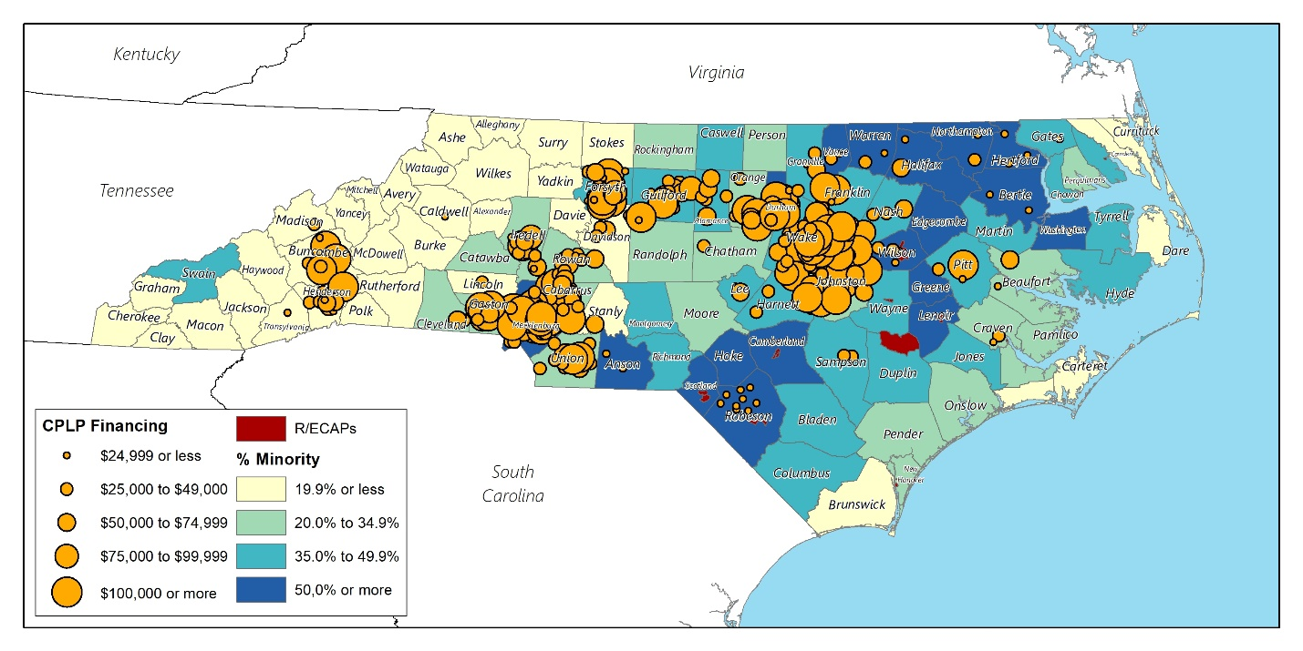
Map 31 NCHFA Community Partners Loan Pool (CPLP) Financing
Source: North Carolina Housing Finance Agency
SFRLP funds are available to eligible organizations for the rehabilitation of owner-occupied homes in 33-34 selected counties based on a three-year rotating basis. Households residing in CDBG Entitlement cities are not eligible for the program. Only one applicant per county will received funding. Projects eligible to receive SFRLP funds must abide by the following criteria:
- Units must be owner-occupied.
- Units must be occupied by elderly, disabled and/or veteran household members, or must have lead hazards and be occupied by a child 6 years of age or younger.
- Household income must be below 80% of the area median income.
- The organization must have the technical capacity to manage residential construction projects.

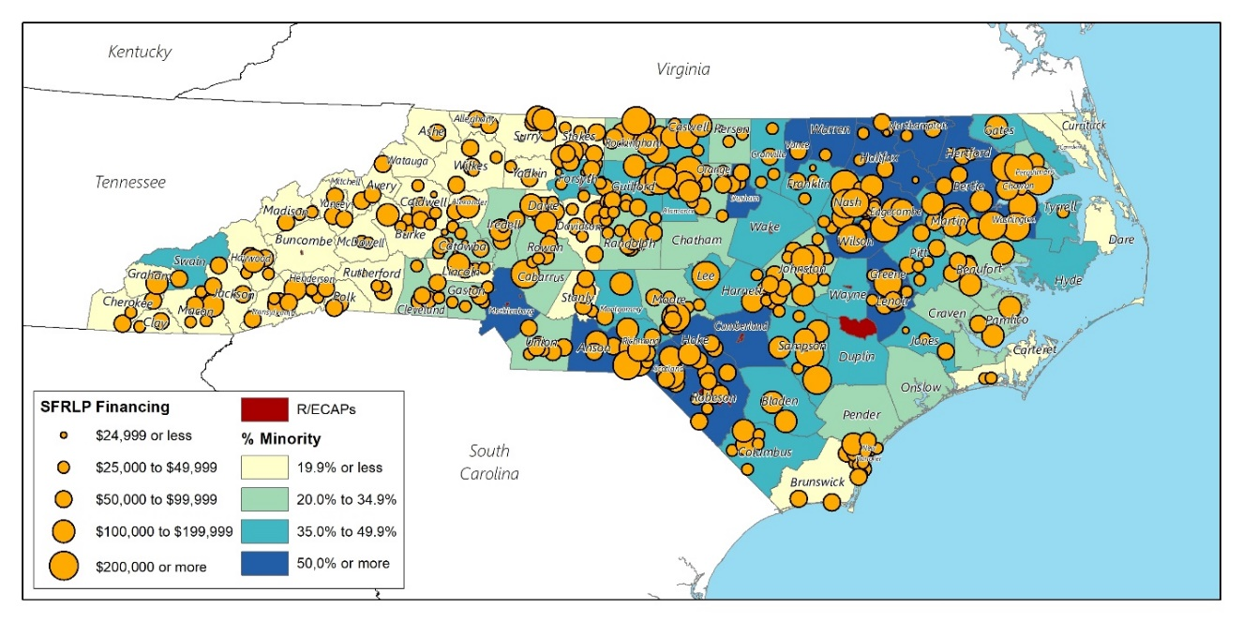
Map 32 NCHFA Essential Single-Family Rehabilitation Loan Pool (SFRLP) Financing
Source: North Carolina Housing Finance Agency
The SHLP program offers up to $35,000 in mortgage financing to assist eligible buyers purchase homes built or rehabilitated by SHLP Member organizations, typically a local NC Habitat for Humanity affiliate. To be eligible for SHLP funding, a homebuyer must already be a participant in a self-help housing program (i.e., helping with the construction or rehab of the house they are buying) as well as meet SHLP program guidelines, which include:
- Household income at or below 80% of the AMI.
- Completed an approved home buyer education course and at least two hours of one-on-one pre-purchase counseling.
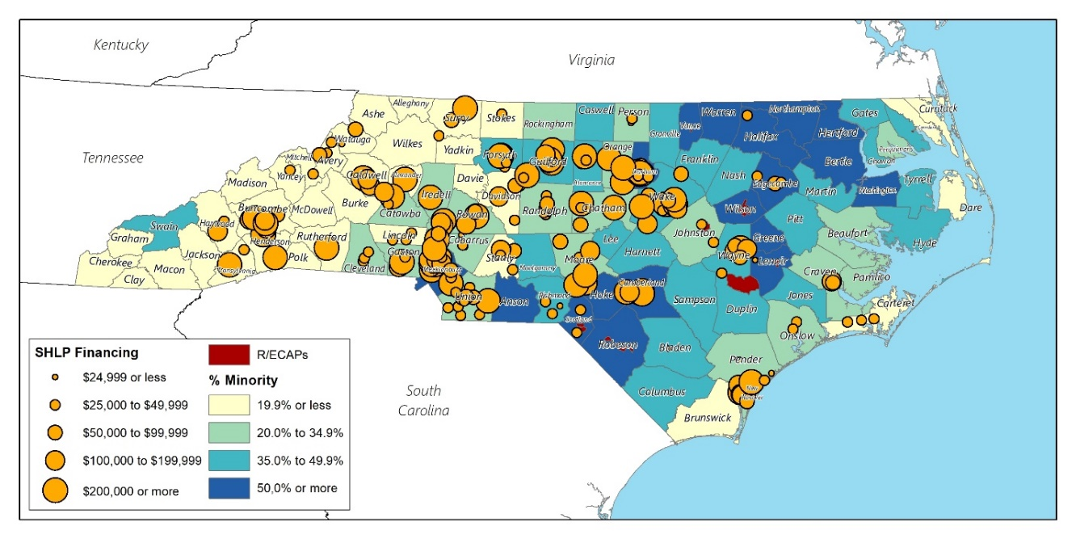
Map 33 NCHFA Self-Help Loan Pool (SHLP) Financing
Source: North Carolina Housing Finance Agency

Olmstead Settlement Initiative
The U.S. Supreme Court’s 1999 landmark decision in Olmstead v. L.C. found the unjustified segregation of people with disabilities to be a form of unlawful discrimination under the Americans with Disabilities Act (ADA). The Olmstead decision envisioned that states would provide appropriate long-term services and supports to individuals with disabilities through home and community-based services and end forced segregation in institutions.
The Department of Justice began investigating North Carolina’s compliance in 2010, specifically focused on mental health services. An August 2012 settlement was issued in which North Carolina agreed to expand community-based services and supportive housing over the next eight years, to establish a pre-admission screening process to prevent people from unnecessarily entering institutions and to create an institutional discharge planning process to ease transitions into community-based settings.
NCDHHS and NCHFA are working to achieve affordable housing and appropriate services for eligible North Carolinians. The State developed a 2017 Permanent Supportive Housing Plan to both increase the pipeline of eligible units and maximize access to opportunities. The State will initiate the development of a Strategic Housing Plan in March 2021 with release anticipated for March 2022. Challenges in developing the plan include, among others, a lack of adequate inventory of affordable housing throughout North Carolina’s counties and resources that vary greatly across target populations.
Currently, the State is preparing an Environmental Scan to identify resources and inventory as the basis for meeting its Olmstead Settlement targets. Listening sessions are planned for stakeholders, service providers, families and advocates across disability populations and throughout the State. Analysis of federal and State programs and resources will be included in the scan, the goal of which is to quantify the availability of appropriate housing need and resources for target populations. In the meantime, North Carolina has been pursuing additional financial resources to fund its Olmstead plan, such as Mainstream Vouchers and Section 811 funding.

Language Access Plans
To improve public safety, health, convenience, comfort, and general welfare of all residents, a language access plan is necessary for individuals who are non-English speaking or have limited English proficiency (LEP) to access available services. Procedures for providing language assistance to LEP residents were analyzed for five state agencies: North Carolina Department of Commerce (DOC), North Carolina Housing Finance Agency (NCHFA), North Carolina Department of Health and Human Services (DHHS), North Carolina Department of Environmental Quality (DEQ), and North Carolina Office of Recovery and Resiliency (ORR).
While translation and interpretation services are consistent across all agencies, the details of the agencies’ respective LAPs varied. Three of the agencies (NCHFA, DEQ, and ORR) provided the results of their four-factor analysis. Two agencies (DOC and NCHFA) identified direct points of contact for questions and complaints related to language assistance services or the LAP. Two agencies detailed procedures for training employees on providing language assistance services. Incorporating these policies and procedures in all LAPs would provide clear guidelines to ensure LEP individuals will be given consistent service and facilitate internal staff training.

North Carolina Department of Commerce (DOC)
DOC’s website has a Language Services page translated into ten languages. Interpretation and translation serves are managed by a dedicated Language Access Coordinator who oversees the agency’s Language Access Plan and serves as a direct point of contact for language assistance services. DOC provides service users an interpreter at no cost to the client. Posters in the office are displayed that will allow for clients to point to the phrase “You have the right to an interpreter at no cost to you. Please point to your language. An interpreter will be called. Please wait,” in one of thirty languages to select the appropriate interpreter.
Translated vital documents are offered in the four most common non-English languages spoken in North Carolina according to US Census data: Spanish, Traditional Chinese, Vietnamese and French. Additional translations may be offered based on changes in data, experience, and other federal requirements. The contact form on the webpage, which is also capable of being translated, allows for clients to ask questions, request assistance, or make complaints

North Carolina Housing Finance Agency (NCHFA)
NCHFA is “is a self-supporting public agency that finances affordable housing opportunities for North Carolinians whose needs are not met by the market.” NCHFA updated its LAP in September 2019, detailing each aspect of the four-factor analysis they conducted. The analysis determined that based on ACS data and program usage, that Spanish-speakers are the main LEP population using NCHFA programs. Since NCHFA does not directly provide services with individual households, instead providing funding to other organizations, NCHFA does not frequently interact with LEP persons. Additionally, any delay in access to NCHFA programs would primarily affect partner organizations rather than individual households. As a result, NCHFA requires all partner organizations to comply with Title VI regulations and conduct their own four-factor analysis to be provided to NCHFA. Current resources available to Spanish-speaking households in North Carolina include translations for their website, vital documents, program brochures, and other materials. Translations in other languages can also be provided upon request.
Two points of contact are provided for public comments related to the LAP and will be responded to within 15 business days. The LAP is expected to be re-examined once new Census data is released and revised as necessary.

North Carolina Department of Health and Human Services (NCDHHS)
While DHHS does not appear to have a publicly available LAP, it provides a number of resources for LEP persons on the agency’s website. In particular, DHHS strongly emphasizes awareness of LEP rights and looking for signs of discrimination. “Know Your Right” brochures, providing examples of national origin discrimination, are available in ten different languages: Arabic, Cambodian, Chinese, Creole, English, Hmong, Korean, Russian, Spanish, and Vietnamese. These languages have the largest number of LEP persons in North Carolina as well, indicating an awareness of the needs for the state’s LEP population.
DHSS also provides the procedures for filing a Title VI complaint for customers or clients participating in programs or activities provided by the U.S. Department of Health and Human Services and the U.S. Department of Agriculture. These forms are available in English and Spanish. Internal tools, such as “I Speak” flashcards to identify the language of an LEP person and oral interpretation services displayed at county offices are also publicly available.

North Carolina Department of Environmental Quality (DEQ)
DEQ updated their LAP in February 2020. The plan follows a two-step framework from EPA Guidance: the Program Assessment and the LEP Plan. The program assessment includes the four-factor analysis. The analysis determines that there is reason to expect that LEP persons will be using DEQ programs based on the state’s LEP population and identifies the largest LEP populations in North Carolina: Spanish, Chinese, Vietnamese and other Asian languages. The nature and importance of DEQ programs vary in in terms of urgency and scale; communicating information regarding water source contamination compared to recycling programs will vastly differ. DEQ will conduct ongoing evaluation for LEP services provided for their programs as the plan is implemented. In terms of resources, DEQ has already leveraged funding toward translation of their website and vital documents, a phone line to access bilingual staff, and community outreach.
To implement the LEP Plan, DEQ separates the plan into five cyclical steps:
- Identifying LEP individuals who need language assistance – DEQ will coordinate with program staff, the DEQ Office of Public Affairs, and the DEQ Environmental Justice Program to identify communities in need of language assistance through ACS data, community outreach, and environmental justice reports.
- Language Assistance Measures – DEQ identifies two principal methods of serving LEP individuals: oral services and written language services. Written Spanish translation or interpretation services from DEQ bilingual staff are available to DEQ programs. DEQ also uses third-party translation and interpretation services when appropriate. DEQ intends to provide its offices and vehicles with a supply of language assistance flashcards and materials translated into the languages of the five most commonly needed languages. When approached by an LEP person, DEQ staff can present the individual with a flashcard to facilitate the choice of the appropriate language. Once the language is identified, DEQ will attempt to provide appropriate language assistance onsite or collect contact information to seek appropriate support offsite.
- Training of DEQ staff will focus on employees most likely to directly encounter LEP individuals and will include information on the LEP plan and related resources, policies, and procedures. Refresher training and the opportunity to provide feedback on the LEP plan will be conducted routinely.
- Providing notice to LEP persons – DEQ looks to inform LEP persons of language services through public announcements, media releases, and communicating with community groups. A centralized contact system, utilizing a dropdown list for the preferred language, is also being considered. This will allow for LEP persons to directly contact NCDEQ, facilitating faster responses from DEQ itself. DEQ currently has a Spanish webpage that will continue to be expanded and improved.
- Monitoring and updating the LEP plan – DEQ commits to reviewing the plan every two years in terms of effectiveness for language assistance measures and staff training. Feedback from agency staff and the public will be taken into consideration along with evaluating other resources that could be used for language assistance services.
Overall, the DEQ LAP provides a complete framework, including policy directives, planning, and procedures, including areas to consider for re-evaluation in the future.

North Carolina Office of Recovery and Resiliency (NCORR)
ORR is committed to “the resiliency of rebuilding efforts, planning, and exploring opportunities for mitigation against future natural disasters with an emphasis on improving conditions for low- and moderate-income beneficiaries.” The LAP for ORR was last updated in December 2019. While the plan states the four-factor analysis was conducted, only the number of LEP persons served or encountered and the resources available to ORR are made clear. ORR determined that North Carolina has a substantial LEP population, especially in Spanish-speakers, and is expected to grow in the future based on ACS data. As an organization, ORR is willing to provide oral language assistance, written translation services, staff training related to LEP policies and procedures, and notice of free language services. Guidelines for each of these resources are detailed in the plan. Finally, ORR intends to monitor and update the LAP on an ongoing basis when new demographic data is released by the federal or state government. Of note, ORR mentioned incorporating the LAP into ORRs’ Assessment of Fair Housing.
The frequency in which LEP persons come into contact with ORR programs and the nature and importance of the program are not explicit in the plan. However, the pressing and often unpredictable nature of disaster preparedness, response, recovery, and resiliency would imply the importance of communicating ORR programs to LEP populations.

Private Sector Policy Review
In addition to the public sector policies that influence fair housing choice, there are private sector policies that can influence the development, financing and advertising of real estate. In this section of the AI, mortgage lending practices, high-cost lending and real estate advertising are analyzed.

Home Mortgage Lending
Under the terms of the Financial Institutions Reform, Recovery, and Enforcement Act of 1989 (F.I.R.R.E.A.), any commercial lending institution that makes five or more home mortgage loans must report all residential loan activity to the Federal Reserve Bank under the terms of the Home Mortgage Disclosure Act (HMDA). The HMDA regulations require most institutions involved in lending to comply and report information on loans denied, withdrawn, or incomplete by race, sex, and income of the applicant. The information from the HMDA statements assists in determining whether financial institutions are serving the housing needs of their communities. The data also helps to identify possible discriminatory lending practices and patterns.

The most recent HMDA data available for North Carolina is from 2017 to 2019. Reviewing this data helps to determine the need to encourage area lenders, other business lenders, and the community at large to actively promote existing programs and develop new programs to assist residents in securing home mortgage loans for home purchases. The data focuses on the number of homeowner mortgage applications received by lenders for home purchase of one- to four-family dwellings and manufactured housing units. The information provided is for the primary applicant only. Co-applicants were not included in the analysis. In addition, where no information is provided or categorized as not applicable, no analysis has been conducted due to lack of information. The data indicates that Black applicants faced higher denial rates and lower origination rates (approvals) than White applicants; denial rates for Blacks and Whites were 35.0% and 18.4%, respectively. Hispanic applicants also showed above average loan denial rates (21.6%)

Table 28 Mortgage application outcomes by race/ethnicity in North Carolina, 2017-2019
 | White |  | Black |  | Asian |  | Other |  | Hispanic |  | Total
 | # | % | # | % | # | % | # | % | # | % | # | %
Approved | 622,247 | 81.57% | 90,811 | 65.00% | 29,558 | 81.99% | 125,597 | 74.6% | 37,680 | 73.28% | 868,213 | 78.43%
Denied | 140,556 | 18.43% | 48,888 | 35.00% | 6,493 | 18.01% | 42,797 | 25.4% | 13,740 | 26.72% | 238,734 | 21.57%
Total | 762,803 | - | 139,699 | - | 36,051 | - | 168,394 | - | 51,420 | - | 1,106,947 | -
Source: FFIEC HMDA

Table 29 Rate of high cost loan originations by race/ethnicity, 2017-2019
 | White |  | Black |  | Asian |  | Other |  | Hispanic |  | Total
 | # | % | # | % | # | % | # | % | # | % | # | %
Not high cost | 762,649 | 99.98% | 139,671 | 99.98% | 36,047 | 99.99% | 168,349 | 99.97% | 51,406 | 99.97% | 1,106,716 | 99.98%
High cost | 154 | 0.02% | 28 | 0.02% | 4 | 0.01% | 45 | 0.03% | 15 | 0.03% | 231 | 0.02%
Total | 762,803 | - | 139,699 | - | 36,051 | - | 168,394 | - | 51,421 | - | 1,106,947 | -
Source: FFIEC HMDA

Table 30 High cost loan originations by income level by race, 2017-2019
 | White |  | Black |  | Asian |  | Other |  | Hispanic |  | Total
 | # | % | # | % | # | % | # | % | # | % | # | %
High Cost Loans Originated | 154 | 66.67% | 28 | 12.12% | 4 | 1.73% | 45 | 19.48% | 15 | 6.49% | 231 | 100.00%
Applicant Income Above AMI | 73 | 47.40% | 13 | 46.43% | 3 | 75.00% | 29 | 64.44% | 5 | 33.33% | 118 | 51.08%
Applicant Income Below AMI | 81 | 52.60% | 15 | 53.57% | 1 | 25.00% | 16 | 35.56% | 10 | 66.67% | 113 | 48.92%
Source: FFIEC HMDA

High-Cost Lending Practices
The widespread housing finance market crisis of 2007-2009 brought a new level of public attention to lending practices that victimize vulnerable populations. Subprime lending, designed for borrowers who are considered a credit risk, increased the availability of credit to low-income persons. At the same time, subprime lending often exploited borrowers, piling on excessive fees, penalties and interest rates that make financial stability difficult to achieve. Higher monthly mortgage payments make housing less affordable, increasing the risk of mortgage delinquency and foreclosure and the likelihood that properties will fall into disrepair.

Some subprime borrowers have credit scores, income levels and down payments high enough to qualify for conventional, prime loans, but are nonetheless steered toward more expensive subprime mortgages. This is especially true of minority groups, which tend to fall disproportionately into the category of subprime borrowers. The practice of targeting minorities for subprime lending qualifies as mortgage discrimination.

Since 2005, Housing Mortgage Disclosure Act data has included price information for loans priced above reporting thresholds set by the Federal Reserve Board. This data is provided by lenders via Loan Application Registers and can be aggregated to complete an analysis of loans by lender or for a specified geographic area. HMDA does not require lenders to report credit scores for applicants, so the data does not indicate which loans are subprime. It does, however, provide price information for loans considered “high-cost.”

A loan is considered high cost if it meets one of the following criteria:
- A first-lien loan with an interest rate at least three percentage points higher than the prevailing U.S. Treasury standard at the time the loan application was filed. The standard is equal to the current price of comparable-maturity Treasury securities.
- A second-lien loan with an interest rate at least five percentage points higher than the standard.

Not all loans carrying high APRs are subprime, and not all subprime loans carry high APRs. However, high-cost lending is a strong predictor of subprime lending, and it can also indicate a loan that applies a heavy cost burden on the borrower, increasing the risk of mortgage delinquency.
Originations of high-cost loans show differences by race and ethnicity. However, the small sample size makes it difficult to infer if these groups are disproportionately impacted by high-cost loans. The overall rate of high-cost loan originations between 2017 and 2019 was low in North Carolina; only 0.02% of originated loans were high-cost loans. Rates of high-cost loans were also low across race and ethnicity. When considering income, there appears to similar rates of high-cost loans for recipients above and below area median income across the state. However, when broken down by race and ethnicity, Hispanic applicants with incomes below AMI and Asian applicants with incomes above AMI Asian had much higher rates of high-cost loans.

Fair Housing Action Plan
The Fair Housing Action Plan includes a list of impediments to fair housing choice identified through the AI process. This section of the AI lists each impediment and discusses briefly why it is a barrier to fair housing. Actions are recommended for each impediment along with measurable objectives to mark progress achieved. Most of the impediments listed below have been carried over from the 2015 AI as they remain relevant today. This is logical given that the trends and conditions underlying the impediments occurred over decades and cannot be resolved fully within five years.

Goal A: Expand fair housing awareness and compliance to preserve and expand housing choice for members of the protected classes.
Impediment A.1: Discrimination in the rental housing market persists with disability and race as the two most often cited alleged bases of discrimination. Between 2015-2019, 55.4% of all cases alleged discrimination based on disability and 32.2% based on race. In addition, according to the NCHRC, recent trends in discrimination against persons with disabilities involve discriminatory behavior against persons with emotional support animals (ESAs). Resistance from rental housing providers in the form of “no pet” policies, requiring pet deposits and establishing animal breed, size and weight policies (even though ESAs are not considered pets under fair housing laws) are reflected in many of the inquiries and complaints filed with the Commission. Fair housing education and enforcement are the best tools to change this behavior.
Action: The Department of Commerce will collaborate with its AI partner agencies to expand fair housing education and enforcement under the guidance of the North Carolina Human Relations Commission with emphasis on the rental market.
Measurable Objectives: Number of trainings annually, county locations, number of participants, topics covered, number of cases filed (an increase can indicate a more informed citizenry).
Impediment A.2: A lack of awareness and knowledge of fair housing laws in rural areas among both consumers and providers restricts housing choice where enforcement resources are the most limited but where housing is more affordable. The NCHRC has identified increasing cases filed from residents in Wake, Buncombe, New Hanover, Pitt and Cumberland counties—all higher growth counties where significant residential development has occurred in rural areas. It is in these previously rural areas where landlords, primarily, may feel they can continue discriminatory practices that were more commonly accepted before and went unchecked. As a result, HUD issued a directive to the NCHRC to target rural areas with more fair housing education and outreach, partnering with local human relations commissions to achieve this objective.
Action: The DOC in collaboration with its AI partner agencies will target fair housing resources to rural areas on the fringes of growing communities.
Measurable Objectives: Number of trainings annually, county locations, number of participants, topics covered, number of cases filed (an increase can indicate a more informed citizenry).

Goal B: Expand inventory of affordable housing for members of the protected classes.
Impediment B.1: An inadequate supply of rental housing that is affordable, as well as accessible to persons with disabilities, severely limits housing choice. Large families and single female-headed households with children have disproportionately higher rates of poverty and are more often renters. The state is behind in fulfilling its obligations under Olmstead to increase community integration for persons with disabilities.
Action: NCHFA will continue expanding new rental housing production through the LIHTC and HTF programs and state programs.
Measurable Objective: Number of new affordable rental units constructed, number of existing rental units rehabiltated.
Action: NCHFA will continue to prioritize the preservation of rental housing with expiring subsidies over the next five years.
Measurable Objective: No loss of subsidized rental units from the state’s assisted inventory over the next five years.
Action: NCHFA and NCDHHS will continue its planning initiative to meet the state’s obligation under Olmstead to provide appropriate housing for persons with disabilities.
Measurable Objective: Completion and approval of a Strategic Housing Plan under Olmstead by March 2022.
Measurable Objective: Provision of community-based services and supportive housing for persons with disabilities in accordance with the Olmstead Strategic Housing Plan and schedule.

Goal C: Increase homeownership among Black and Hispanic households.
Impediment C.1: Homeownership among Black and Hispanic households is less than 50%, respectively. Several factors impact these trends including higher unemployment, higher poverty, lower and stagnating household incomes, and higher mortgage denial rates.
Action: DOC and its AI partner agencies will provide funding for homeownership counseling and economic development initiatives aimed at improving the financial stability of households and communities.
Measurable Objective: Number of homebuyers assisted, number of jobs created, number of small businesses created/retained/expanded

Goal D: Increase knowledge and implementation of obligation to affirmatively further fair housing among HUD program small town subrecipients.
Impediment D.1: Turnover among public officials in subrecipient small towns makes it imperative to maintain the education efforts regarding affirmatively furthering fair housing. DEQ’s Division of Water Infrastructure Affirmatively Furthering Fair Housing Plan required of CDBG applicants is an excellent tool to achieve this.
Action: DEQ’s Division of Water Infrastructure will continue to ensure compliance with the Plan through its small town subrecipients.
Measurable Objective: Number of new applicants adopting the Plan, number of non-compliant applicants
Action: DOC and its AI partner agencies will duplicate the AFFH Plan, where appropriate, among their programs.
Measurable Objective: Number of new applicants adopting the Plan, number of non-compliant applicants

Goal E: Ensure access to housing and other services to persons with limited English proficiency.
Impediment E.1: There are over 30 language groups in the state that meet the safe harbor threshold for translation of vital documents as required by Title VI of the Civil Rights Act of 1964. As a recipient of federal funding, the state is required to ensure that persons with LEP who are otherwise eligible have access to its programs.
Action: DOC and its AI partner agencies will each maintain complete Language Access Plans and review them annually to identify changes in population trends, which might require updating the Plans.
Measurable Objectives: Verification of annual review of each agency’s LAP, revised LAPs upon release of new Census data, number of persons with LEP served by each agency or program, number of complaints filed under the LAPs, number of LAP trainings provided to agency staff.

Signature Page
By my signature I certify that the Analysis of Impediments to Fair Housing Choice for the State of North Carolina is in compliance with the intent and directives of the regulations of the Community Development Block Grant Program.

__________________________________________________________
(name, title)
___________________________
Date

Appendix A: Public Engagement Plan

Appendix B: NCHRC Fair Housing Activities

Under the federal Fair Housing Act, it is illegal to discriminate against someone in housing based on their race, color, religion, sex, disability, familial status or national origin. These are collectively referred to as “members of protected classes” because these personal characteristics are protected by law. The North Carolina Fair Housing Act includes these same seven protected classes; it also includes a prohibition against discrimination in the siting of affordable housing.
Preserving Community and Neighborhood Choice Final Rule, 24 C.F.R. § 5, 91, 92, 570, 574, 576, 903 (2020).
For a given geographic area, the index is equal to [(a/A) * (a/t)], where “a” is the group population of a sub-region, “t” is the population of all groups in the sub-region, and “A” is the total group population in the larger region.
Kathleen C. Engel and Patricia A. McCoy, “From Credit Denial to Predatory Lending: The Challenge of Sustaining Minority Homeownership,” in Segregation: The Rising Costs for America, edited by James H. Carr and Nandinee K. Kutty (New York: Routledge 2008) p. 82.
On September 4, 2020, HUD issued its Final Rule on disparate impact, a legal principle that protects minorities from adverse policies and practices even if discrimination is not implicit. On October 28, 2020, the U.S. District Court for the District of Massachusetts issued a stay and preliminary injunction to prevent HUD from implementing this new rule, which would make it harder to bring discrimination claims under the Fair Housing Act.
The five allocation priorities are found in “Effect of QAP Incentives on the Location of LIHTC Properties” published by the U.S. Department of Housing & Urban Development, Office of Policy Development & Research (April 2015).

