PAT MCCRORY
Governor

DONALD R. VAN DER VAART
Secretary

SHEILA C. HOLMAN
Director
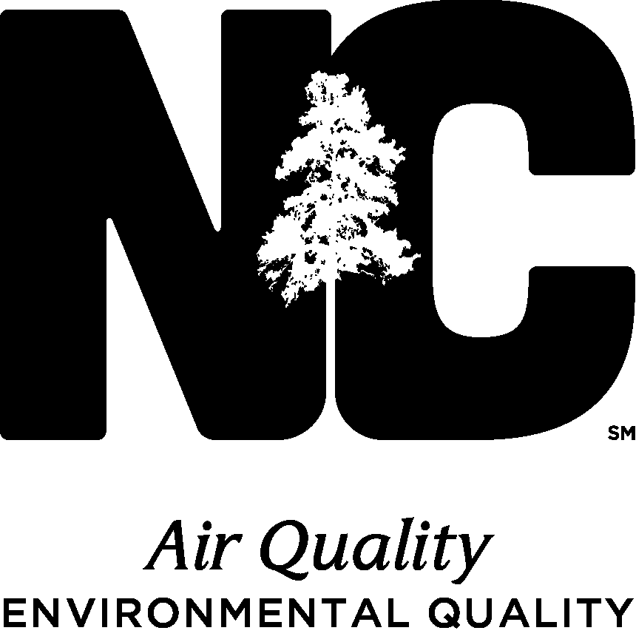
June 17, 2016

Dear Air Quality Permit Holder,

This letter has been sent to make you aware that the Department of Environmental Quality – Division of Air Quality (DAQ) has developed a new registration program and revised the exemption process for facilities with low actual emissions.

- Eligibility requirements for Permit Exemption:
- Actual emissions from the previous year(s) (and future projected actual) of particulate matter (PM₁₀), sulfur dioxide, nitrogen oxides, volatile organic compounds, carbon monoxide, hazardous air pollutants, and toxic air pollutants are each less than five (5) tons per year and whose actual total aggregate of these emissions are less than 10 tons per year (NCAC 2Q .0102(d)), OR
- The only sources that would require a permit at the facility are stationary reciprocating internal combustion engines, used for emergency and/or non-emergency purposes (NCAC 2Q .0903).
- Can be subject to 40 CFR Part 63 (MACT or GACT) and 40 CFR Part 60 (NSPS).
- Cannot be subject to Rule 2Q .0315 (Synthetic Minor Facilities) or 2Q .0500 (Title V Procedures).

- Eligibility requirements for Registration - For facilities that do not qualify for permit exemption, the Division has developed a new registration program that is intended to simplify the regulatory requirements and allow the eligible facility to register rather than acquiring and maintaining an air permit.

Benefits of Registration:
- Simple application process
- No expiration date
- No air emissions inventory requirement
- No fees (application or annual)
- Allows the facility to make minor modifications if the changes allow the facility to remain within the eligibility requirements

Eligibility requirements for Registration:
- Actual aggregate emissions are greater than or equal to 5 tons and less than 25 tons per year of these pollutants: particulate matter (PM₁₀), carbon monoxide, nitrogen oxides, sulfur dioxide, volatile organic compounds, hazardous air pollutants, and toxic air pollutants.
- Cannot be subject to Rule 2Q .0315 (Synthetic Minor Facilities) or 2Q .0500 (Title V Procedures)
- Cannot be subject to 40 CFR Part 63 (MACT) {Note: Can be subject to 40 CFR Part 63 (GACT)}
- Cannot emit volatile organic compounds or nitrogen oxides if the facility is located in a nonattainment area
- Cannot be subject to 40 CFR Part 60 (NSPS) except for sources which are exempt under 2Q .0102 (g) or (h)

If you are a currently permitted facility, then you have one of three options available:

- You may elect to keep your current air permit.
- No action necessary.

- Apply for permit exemption.
- Submit a letter (sample letter is attached) signed by the authorized official requesting rescission of your air permit and provide supporting documentation showing the facility has met and is expected to continue to meet the eligibility requirements.

- Apply to be a registered facility.
  - Submit the registration application (attached) signed by the authorized official to the Regional Office and include supporting documentation to validate that your facility meets the required eligibility requirements. If possible, provide up to 5 years’ worth of data to substantiate this claim or, at a minimum, provide supporting information showing the facility meets the criteria.

Be aware that even though your facility may no longer be subject to air permitting requirements, the operations must still comply with all air quality regulations and other applicable state, federal and local laws and regulations. Furthermore, it is DAQ’s intent to periodically conduct compliance assurance visits at both registered and exempt facilities. The choice to pursue exemption, registration, or to retain your current air permit should be evaluated in accordance with the specific needs of your facility. Some facilities may find that there are benefits for retaining their air quality permit.

If you need assistance or have questions concerning this new program, please contact the Permitting Coordinator, [Name] Regional Office at [RO Phone].

Sincerely,
[Name], Regional Supervisor
Division of Air Quality, NC DEQ

c: [Name] Regional Office

