Hatteras Village

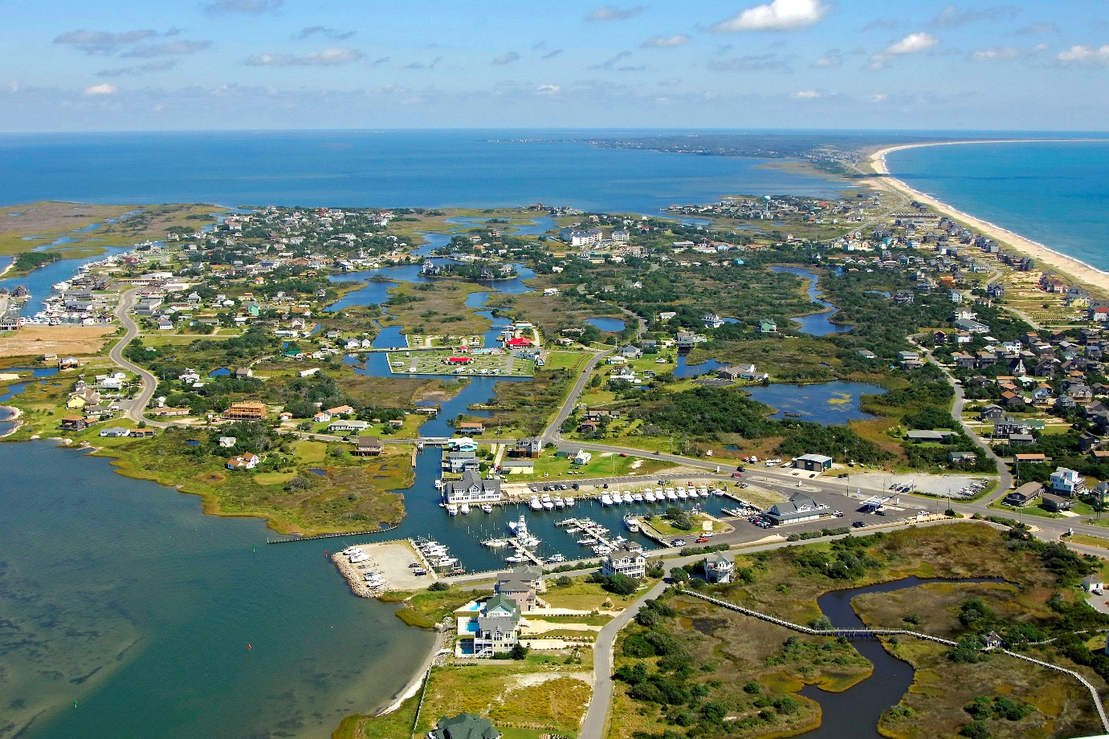
Photo: Marinas.com

Resilience Evaluation and Needs Assessment
Final Report
April 2018

Table of Contents
Project Overview..……………………………………………………………………………………………………….....2
Purpose and Scope………………………………………………………………………………………………………....3
Section 1: Introduction…………………………………………………………………………………………………….4
Section 2: RENA Framework in Practice……………………………………………………………………………5
Resilience evaluation
2.1.RE: Map town assets………………………………………………………………………………………5
2.2.RE: Identify current issues………………………………………………………………………………6
2.3.RE: Conduct public input meetings…………………………………………………………………7
2.4.RE: Overlay current and future models…………………………………………………………..7
Needs Assessment
2.5.NA: Identify hotspots…………………………………………………………………………………….8
2.6.NA: Prioritize assets………………………………………………………………………………………8
2.7.NA: Document existing projects…………………………………………………………………….9
2.8.NA: Explore future projects……………………………………………………………………………9
Data Resources……………………………………………………………………………………………………………….10
Funding Resources………………………………………………………………………………………………………….12
Appendix…………………………………………………………………………………………………………………………16
Project Overview
In 2016, The Division of Coastal Management (DCM) commenced a five-year project to create a resilience framework guide for coastal communities in North Carolina. DCM hired a two-year Fellow, Monica Gregory, as part of the Coastal Management Fellowship (CMF) through the National Oceanic and Atmospheric Administration (NOAA). The Fellow was hired to lay the groundwork for the guide by working with five communities to implement a vulnerability assessment and a needs assessment within their towns. The five communities will serve as case studies in the guide to illustrate the planning process, highlight best practices, and discuss resilience projects identified through the vulnerability assessment. Edenton, Pine Knoll Shores, Oriental, Duck, and Hatteras Village participated in the project. The outcome of the five-year project will be a comprehensive guide to resilience-building in coastal communities in North Carolina.
The final guide aims to serve local governments by:
1) illustrating a successful planning framework they can use to engage their communities in resilience and adaptation projects;
2) identifying common needs from local governments and compiling state and federal resources that can address those needs;
3) providing case studies across the North Carolina coast that can help guide other local governments in resilience planning;
and
4) discussing adaptation and mitigation strategies that can be applied in a variety of situations experienced by coastal communities in our state.

Purpose and Scope for Hatteras Village
The purpose of this two-year project is to identify and map social and physical assets important to the community, better understand vulnerabilities in Hatteras Village, and identify hotspots where the village can prioritize resilience-building projects. Through the process, participants could identify local government and community-specific needs in building resilience if they participated in a survey or workshop process.
The final map and accompanying guide for Hatteras Village can be used for resilience planning purposes as well as for future grant applications related to resilience-building to highlight identified areas in need of adaptation and mitigation projects. DCM strongly recommends that Hatteras Village holds a public workshop or input session to allow residents to voice their concerns, priorities, and needs.

Section 1: Introduction
Regional survey
In February 2017, DCM released a survey to local-level staff and elected officials in coastal towns and counties to better understand their experiences with hazards and their needs for addressing them. DCM had an 11% response rate, which is about average for an online survey. Through questions about impacts from coastal hazards and existing planning efforts, DCM identified a critical need for a formal resilience planning framework to be used by regional, county, and town staff in adapting to and mitigating impacts from major and minor storms, sea level rise, hurricanes, and Nor’easters, among other hazards.
DCM staff formed an advisory committee to guide the research and selection process. Advisors included staff from The Nature Conservancy, North Carolina Sea Grant, the Coastal Federation, and DCM planners and field staff. DCM conducted a review of published resilience guides and community resilience planning methodologies.
DCM drew from various resources to create the methodology used in pilot communities. The Community Resilience Building guide, the U.S. Climate Resilience Toolkit, the California Adaptation Planning Guide, and the Community Based Vulnerability Assessment Guide from MDC, Inc. and UNC Chapel Hill heavily influenced this project.

Selection process
To select pilot communities for case studies, DCM staff consulted state planners, state field staff, and nonprofit organizations for recommendations on towns with staff capacity and community buy-in to work this process from beginning to end. After receiving recommendations from Dare County officials reach out to Hatteras Village, DCM staff held an initial scoping meeting with two Outer Banks residents in July 2017. After discussing their history with coastal hazards, staff capacity, and community dynamics, the residents in Hatteras Village accepted our invitation to participate in the pilot program as one of five case study communities in the DCM resilience framework guide.

Section 2: RENA Framework in Practice
DCM used the following eight-step process in each pilot community, divided into the resilience evaluation phase and the needs assessment phase:
Resilience evaluation (RE):
- Map assets
- Identify current issues
- Conduct public input meetings
- Overlay current and future models
Needs assessment (NA):
- Identify hotspots
- Prioritize assets
- Document existing projects
- Explore future projects

Resilience Evaluation (RE)
2.1.RE. Map assets
In July 2017, DCM staff met with two residents familiar with Hatteras Village to map important community assets and discuss potential physical and social vulnerabilities. DCM downloaded a base map of the village from ArcGIS and printed the map at a large enough scale to identify roads and specific parcels. DCM brought the map to the meeting.
At the mapping meeting, the residents worked with DCM to physically color in parcels that are considered important assets to Hatteras Village. DCM staff provided sharpies, highlighters, post-it notes, and colored tabs at the meeting. For each asset category, one color was used. For example, critical facilities like medical facilities and emergency helicopter landings were identified then colored with red sharpie. DCM staff recorded their color and location to later create a GIS attribute table and a key for the map.
Under the GIS polygon layer, town leaders identified cemeteries, churches, commercial areas, critical facilities, historic structures, marinas, museums, recreation areas, and utilities as assets that may be physically vulnerable to flooding and other coastal hazards. In addition, DCM and town leaders mapped high ground areas, areas that flood repetitively due to winds or precipitation, emergency ferry entrances, helicopter pads, and stormwater system data from a recent feasibility study.
Though not included in the map for Hatteras Village, social vulnerability indicators exist. Data such as census information on reported income and information on property tax value could be used to map socially vulnerable areas. Such indicators can be used to identify areas where financial resources for recovery post-disaster may be limited. Social vulnerability indicators that may be used in other communities – such as concentrated areas of 65+ residents, concentrated areas of non-English speakers, and concentrated areas where people have low trust in government – were not identified in Hatteras Village.
After working with village residents, DCM staff returned to their home office and used the physical map to create a digital map in ArcGIS. DCM created a narrative explaining the map as well as a key to use with the map. DCM sent questions, the draft map, and the draft narrative to town leaders for comments and additions.
2.2.RE. Identify current issues
In Fall 2017, DCM collected the experiences and viewpoints of staff and elected officials in four of five case study communities across North Carolina. The survey focused on staff knowledge and experience with coastal hazards and their impacts in the community.
Hatteras Village did not complete a survey. DCM recommends contacts who worked on this project in Hatteras Village or Dare County officials lead a survey to collect community-specific information to better assess local knowledge and needs in relation to coastal hazards and their impacts.

2.3.RE. Conduct public input meetings
In Spring 2018, DCM conducted public input sessions in three of five case study communities across North Carolina. The public input sessions served to groundtruth asset maps and invite residents to make additions highlighting their knowledge and concerns in their communities.
Hatteras Village did not complete a public input session. DCM recommends contacts who worked on this project in Hatteras Village or Dare County officials lead a public input session or workshop to engage as many residents as possible in the Village, allow residents to prioritize impacts they are experiencing, and create a comprehensive, inclusive asset map that can be used for future sea level rise and hazards planning.
To replicate the RENA workshop process, Hatteras Village or Dare County officials can refer to the final project guide located on DCM’s website.
2.4.RE. Overlay current and future models
In 2018, the CMF reached out to The Nature Conservancy (TNC) to request a collaboration between DCM’s asset mapping and TNC’s coastal resilience mapping tool. TNC agreed to host town asset maps so local government staff could easily apply sea level rise and coastal flooding models to their maps. TNC uses NOAA data for a variety of future scenarios; all data are readily available for download through the NOAA Digital Coast’s Coastal Flood Mapper. Potential datasets include:
- Shallow Coastal Flooding - Areas subject to shallow coastal flooding.
- FEMA Flood Zones - Areas at risk from flooding.
- Storm Surge - Areas at risk from storm surge.
- Sea Level Rise - Areas likely to be inundated by sea level rise.
All datasets are available for Dare County, including Hatteras Village. Future scenarios through TNC’s coastal resilience mapper include risk in three separate years: 2045, 2060, and 2100. Town staff and leaders can choose to plan for low, medium, or high risk in any given year to see which assets will be most at risk from one or a combination of hazardous events.

Needs Assessment (NA) Process

2.5.NA. Hotspot identification
Through TNC’s mapping portal, Dare County staff and Hatteras Village residents can view their asset maps and overlay sea level rise scenarios, storm surge scenarios, and coastal flooding data. Staff or residents can pinpoint areas to focus resilience-building efforts that are consistent with their ongoing resilience work or with their current town vision. County staff or village residents can decide what planning scenario they wish to use: for example, the county or village can use the medium sea level rise scenario for the year 2045 to identify assets and areas they wish to adapt or mitigate from increased flooding.
In the future, staff or residents can hold additional workshops or community meetings to comprehensively outline their priorities in the face of sea level rise, increased frequency and severity of storm surge, and increased flooding.
2.6.NA. Prioritize assets
Hatteras Village and Dare County can prioritize assets and areas of vulnerability to focus their resilience-building efforts. Assets could be prioritized be residents in the community; by cost-benefit or return-on-investment analyses; or by other means selected by the village or county. County staff or residents could hold additional workshops to receive input from the community regarding asset prioritization.
2.7.NA. Document existing projects
Hatteras Village is an historic village on the Outer Banks of North Carolina. For hundreds of years, people have adapted to changing conditions inherent in living on a barrier island. Over the years, town leaders have worked with county government staff and nonprofit organizations to increase their resilience to sea level rise and storm surge. Recent efforts include:
1. The NC-12 Feasibility Study for Hatteras Village – This 2016 feasibility study is a preliminary step to the National Environmental Policy Act (NEPA) process to identify potential project scope, a range of estimated costs of completion, and project-specific concerns related to preserving the North Carolina (NC) 12 corridor between Hatteras Village and the unincorporated limits of Frisco, North Carolina (the project). This feasibility study provides information on various possible options to improve the stability of the NC 12 corridor over both a short-term (5-year) and long-term (50-year) timeframe. The short-term solutions will provide the North Carolina Department of Transportation (NCDOT) with potential options for maintaining or restoring the integrity of NC 12 with minimal interruption of traffic should a storm event or coastal processes compromise roadway access. The analysis of long-term solutions considers the costs of different alternatives so that the project can potentially be added to a list of funded projects within NCDOT’s State Transportation Improvement Program (STIP).
2.8.NA. Explore future projects
If Hatteras Village conducts surveys or resident workshops, recommendations from locals will emerge. Suggestions from DCM staff include:
- Adopt the final asset map (after resident input) into land-use planning decisions to decrease unsustainable development in areas vulnerable to sea level rise or flooding.
- Align community plans through the lens of resilience, including economic plans, housing plans, and natural resource management plans.
- Continue working with the Community Rating System to increase the Village’s rating and reduce the cost of flood insurance. Work with The Nature Conservancy and other entities like the Coastal Federation to achieve a higher score.
- Increase freeboard requirements within the village boundaries.
- Prepare for future impacts by using long-term planning scenarios such as “medium” or “high” scenarios in year 2100.
- Work to plan collaboratively for climate impacts at the watershed level. Bringing entities such as town officials, county officials, and neighboring town staff and officials will be critical. The Albemarle Pamlico National Estuary Partnership (APNEP) can help facilitate meetings or workshops related to climate planning.
Data Resources
The following resources tools and useful guides to plan for resilience. Researchers, planners, and town managers may find them useful in the context of hazard mitigation, resilience-building, and community engagement.
- Coastal Inundation Toolkit (NOAA Digital Coast):
A toolkit that communities can use to understand coastal inundation and to identify their risks and vulnerabilities. Users can visualize information to better explain risk concepts: https://coast.noaa.gov/digitalcoast/training/coastal-inundation-toolkit.html
- Coastal Resilience Index (Mississippi-Alabama Sea Grant Consortium):
A guide that can communities can use to examine different elements to increase their resilience: http://masgc.org/news/article/assessing-resilience-cri
- Community Based Vulnerability Assessment, 2009 (University of North Carolina and MDC, Inc):
A guidebook for communities to walk through the process of assessing their physical and social vulnerabilities, with an emphasis on social justice and inclusion:
http://www.mdcinc.org/sites/default/files/resources/Community%20Based%20Vulnerability%20Assessment.pdf
- Community Toolbox (University of Kansas):
A toolbox with extensive resources to better understand and engage with community members. The toolbox includes resources for developing assessment plans, understanding and describing communities, and conducting focus groups, among others: http://ctb.ku.edu/en/table-of-contents
- Naturally Resilient Communities, 2017 (APA, TNC, ASCE, and partners):
An online tool that helps decision-makers explore solutions to natural hazards based on the type of hazard, the type of community, the project scale, and the project cost. Additionally, the tool provides case studies from several regions in the U.S.:
http://nrcsolutions.org/strategies/?fwp_hazards=coastal
- The U.S. Climate Resilience Toolkit, 2016 (NOAA):
The Toolkit is designed to help people find and use tools, information, and subject matter expertise to build climate resilience. The Toolkit offers information from across the U.S. federal government in one easy-to-use location. https://toolkit.climate.gov/
- Vulnerability, Consequences, and Adaptation Planning Scenarios (VCAPS) tutorial, 2013 (University of South Carolina, South Carolina Sea Grant Consortium, Carolinas Integrated Sciences and Assessments, and Social and Environmental Research Institute): A tutorial that walks through the process of using VCAPS, a tool for community decision-makers to better understand the challenges their communities face under climate change stressors: http://www.vcapsforplanning.org/docs/VCAPS%20UserGuide%2025March13.pdf
- Rising to the Challenge, Together, 2017 (The Kresge Foundation): An overview of the climate adaptation field with guidance on how to move forward cohesively: https://kresge.org/content/rising-challenge-together?utm_source=ASAP&utm_campaign=5851507e8a-EMAIL_CAMPAIGN_2017_12_29&utm_medium=email&utm_term=0_390b9a48ee-5851507e8a-420011193&mc_cid=5851507e8a&mc_eid=0e67b19bed
- ClimateAssessment.org, 2018 (National collaboration): ClimateAssessment.org facilitates rigorous and transparent evaluation of climate science and climate adaptation/mitigation practice, and aims to further develop and support a network of scientists and practitioners in producing, managing, and using credible and relevant climate-related information: https://www.climateassessment.org/
- Coastal Resilience, 2017 (The Nature Conservancy): A portal by The Nature Conservancy focused on case studies, mapping tools, and resources for communities to build their resilience to coastal hazards and their impacts: http://coastalresilience.org/

Funding Resources
The following short-list compiles information on local and national grant programs, information on nonprofits and agencies focused on funding resiliency-related projects, and existing lists of funding sources from other organizations. This list is not comprehensive.
Grants
- State Grant Program - North Carolina’s Department of Environmental Quality, Division of Coastal Management (DEQ-DCM) Planning and Management Grants
  - Funding frequency: Periodic; As funding allows
  - Description: DEQ-DCM’s Planning and Management grants help local governments in the 20 coastal counties fund local planning and management projects. Funding is prioritized by issue. During the 2017-2018 cycle, Natural Hazards and Storm Recovery projects were encouraged.
  - For more information: https://deq.nc.gov/about/divisions/coastal-management/coastal-management-land-use-planning/grants
- State Grant Program: Clean Water Management Trust Fund (CWMTF)
  - Funding frequency: Annually
  - Description: The CWMTF grants are available to non-profit and governmental organizations to protect land for natural, historical and cultural benefit, limit encroachment on military installations, restore degraded streams, and develop and improve stormwater treatment technology.
  - For more information: https://cwmtf.nc.gov/

- State Grant Program: Water Resources Development Grant Program
  - Funding frequency: Bi-annually
  - Description: The purpose of this program is to provide cost-share grants and technical assistance to local governments throughout the state. Applications for grants are accepted for seven purposes: General Navigation, Recreational Navigation, Water Management, Stream Restoration, Land Acquisition and Facility Development for Water-Based Recreation, NRCS Environmental Quality Incentives Program (EQIP) stream restoration projects and Feasibility/Engineering Studies.
  - For more information: http://deq.nc.gov/about/divisions/water-resources/water-resources-grants/financial-assistance
- Federal Grants: U.S. Climate Resilience Toolkit List
  - Funding frequency: Dependent on grant
  - Description: The U.S. Climate Resilience Toolkit is a website designed to help people find and use tools, information, and subject matter expertise to build climate resilience. The Toolkit offers information from all across the U.S. federal government in one easy-to-use location. In the United States, a range of government entities and private foundations offer financial and technical resources to advance local adaptation and mitigation efforts. For convenience, the Toolkit has compiled a list of some of those funding resources.
  - For more information: https://toolkit.climate.gov/content/funding-opportunities
- Federal Grants: Resilience AmeriCorps VISTAs Funding List
  - Funding frequency: Dependent on grant
  - Description: Resilience AmeriCorps VISTA builds capacity in vulnerable, low-income communities to develop plans and implement projects that increase the community’s resilience to shocks and stressors. The document was created for Resilience AmeriCorps VISTA members and lists a variety of grants for resilience-building.
  - For more information: http://www.regions.noaa.gov/secar/wp-content/uploads/2013/06/Federal-Funding-for-Resilience-Projects.pdf [PDF Download]
- Federal Grants: National Oceanic and Atmospheric Administration (NOAA), Office of Coastal Management (OCM)
  - Funding frequency: Dependent on grant
  - Description: NOAA is an agency that enriches life through science. Our reach goes from the surface of the sun to the depths of the ocean floor as we work to keep citizens informed of the changing environment around them. NOAA’s OCM manages a competitive grant program that funds projects that are helping coastal communities and ecosystems prepare for and recover from extreme weather events, climate hazards, and changing ocean conditions. All project proposals undergo a rigorous merit review and selection process by a panel of subject matter experts from across the United States that include representatives of government, academia, and private industry.
  - For more Information: https://coast.noaa.gov/resilience-grant/
- National Non-Profit Grants: The Kresge Foundation
  - Funding frequency: Dependent on grant
  - Description: The Kresge Foundation is a $3.6 billion private, national foundation that works to expand opportunities in America’s cities through grant-making and social investing in arts and culture, education, environment, health, human services and community development.
  - For more information: https://kresge.org/opportunities
- National Non-Profit Grants: Model Forest Policy Program (MFPP)
  - Funding frequency: Dependent on grant
  - Description: The Model Forest Policy Program is a national nonprofit that builds the capacity of communities to be climate resilient by sustaining water resources, productive forests, citizens’ wellbeing, and thriving economies. Our team compiled a Climate Resilience Funding Guide to help communities identify financial support for climate adaptation projects. MFPP’s will help communities learn about established funding programs that have evolved to provide funding for climate adaptation activities, and to match those funding sources with local adaptation goals.
  - For more information: http://www.mfpp.org/climate-resilience-funding-guide/ [Guide available to download for free]
Organizations
- Local Non-Profit Organization: Coastal Federation
  - Description: The North Carolina Coastal Federation is a member-supported 501(c)3 that focuses on protecting and restoring the North Carolina coast. Since 1982, the federation has been in the field restoring miles of coastline; training and educating students, adults and communities to take actions that result in cleaner coastal waters and advocating for an accessible, healthy, productive coast. The Coastal Federation has worked in communities across North Carolina to assist with grant-writing and to implement on-the-ground projects.
  - For more information: https://www.nccoast.org/about-us/
- Local Non-Profit Organization: North Carolina Land of Water (NC LOW)
  - Description: NC LOW is a 501(c)3 non-profit formed around 2016 that may be able to assist with identifying funding sources for local projects in North Carolina. CAMA counties covered in NC LOW’s region include: Bertie, Beaufort, Camden, Carteret, Chowan, Craven, Currituck, Dare, Gates, Hertford, Hyde, Pamlico, Pasquotank, Perquimans, Tyrrell, and Washington.
  - For more information: http://www.nclandofwater.org/
- National Non-Profit Organization (local chapter): The Nature Conservancy, North Carolina
  - Description: The mission of The Nature Conservancy is to conserve the lands and waters on which all life depends. For 41 years, TNC has been working in North Carolina. Staff in Kill Devil Hills, North Carolina, worked extensively with the CMF to host asset maps created by DCM and local governments. TNC has tools, resources, and staff expertise to assist communities to build resilience.
  - For more information: https://www.nature.org/ourinitiatives/regions/northamerica/unitedstates/northcarolina/index.htm

Appendix
Appendix 1: Asset Maps
-1A. Asset Map without feasibility study………………………………………………………………………17
-1B. Asset Map with feasibility study……………………………………………………………………………18
-1C. Asset Map Narrative……………………………………………………………………………………………..19
-1D. GIS Data Sources…………………………………………………………………………………………………..24
Appendix 2: Survey Example for Future Use
-2A. Survey Example…………………………………………………………………………………………………….25
-2B. Survey Report Example…………………………………………………………………………………………35
Appendix 4: Modeling Examples………………………………………………………………………………………………57
Appendix 5: TNC Mapping Portal – Workflow Example……………………………………………………………59
Appendix 5: Timeline & Schedule of Activities………………………………………………………………………….61

APPENDIX 1
1A. Asset Map without feasability study

1B. Asset Map with feasibility study

1C. Asset Map Narrative

Introduction and Purpose
The Division of Coastal Management (DCM) and Hatteras Village are working to create a map of the community’s physical and social vulnerabilities to coastal hazards. Creating the vulnerability map is a multi-step process that aims to understand a community’s hazards and capabilities, as well as to prioritize assets to include on the map. After the village leaders work with DCM to create initial maps, residents will have an opportunity to add their knowledge to the maps through public meetings, follow-up interviews, and community surveys.
The mapping project is a three-part process: village leader and DCM asset mapping, public input, and analysis. After the asset map is completed and reviewed by the village leaders, DCM and leaders will conduct public meetings and surveys to add residents’ experiences with coastal hazards. DCM will combine knowledge from leaders and residents into one map, add additional layers from coastal hazard models, and pinpoint ‘hotspots’ where towns can focus project-planning efforts and funding to increase their resilience.
DCM is undertaking this process as a pilot program to better understand community experiences with hazards and to identify areas where town staff can focus resources to mitigate future hazard-related damages. At the end of the project period, DCM intends to create a step-by-step framework guide for other coastal communities to repeat this process. Hatteras Village will be one of five case studies in that guide. The Towns of Edenton, Oriental, Pine Knoll Shores, and Duck are also case studies in this project.
Mapping Hatteras Village: Introduction
Under the GIS polygon layer, village leaders identified cemeteries, churches, commercial areas, critical facilities, high ground points, historic structures on the national registry, marinas, museums, recreational areas, repetitively flooded areas, and utilities as physical assets. Staff wanted emphasis on several assets which are denoted under the GIS point layer by points or special icons on the map. Those assets are the emergency entrance where ferries and other vessels can access the village as well as helicopter pads by the ferry landing and the medical complex (see Appendix 1A). Stormwater system data from a recent feasibility study was added to a second map (see Appendix 1B).
Hatteras Village did not identify social vulnerability components to include on the map.
Physical Assets

Village leaders identified cemeteries, churches, commercial areas, critical facilities, high ground areas, registered historic structures, marinas, the museum, recreation areas, utilities, the emergency entrance to the Village, and the helicopter pads as important assets. In addition, a layer is included that shows a feasibility study of improvements to the Village’s stormwater system (see Appendix II). The overlay shows approximate locations of pipes and ditches but may not be accurate: it should be used as a guiding tool only.

Identified assets are important to protect for their economic, cultural, or natural significance: mitigation or adaptation projects should be considered for those assets that are projected to be most affected by increased sea level rise, heavy precipitation and stormwater flooding, and storm surge. Repetitively flooded areas were also identified from local input to better understand which assets are currently most affected by flooding.

Cemetery | Church | Commerce | Critical Facilities | High Ground | Historic Structures: registered | Marina | Museum | Recreation | Repetitive Flooding | Utilities | Emergency Entrance | Helicopter Pad
 |  | Jeffrey’s Seafood Packing House | Village Complex: Fire station, post office, community meeting center, library, civic center, church | Graveyard of the Atlantic Museum | Hatteras Weather Bureau Station | Hatteras Landing Marina | Graveyard of the Atlantic Museum | Cape Hatteras National Seashore |  | Electric - for Ocracoke & Hatteras
 |  |  | Medical Facility | Natural Ridge | Ellsworth and Lovie Ballance House | Hatteras Harbor Marina |  | Hatteras Island Ocean Center |  | Water Tower
 |  |  | Ferry terminal |  |  | Village Marina |  | Park |  | Solar Panels
 |  |  | US Coast Guard |  |  | Hatteras Marlin Club |  | Parking
 |  |  | Hatteras Village Civic Center |  |  | Fosters Quay
 |  |  |  |  |  | Teach's Lair Marine
 |  |  |  |  |  | Oden's Dock
See below for a table listing the physical assets with additional identifying information.

Cemeteries
In Hatteras Village, there are an abundance of small family cemeteries scattered across the landscape. The cemeteries represent hundreds of years of history, and many of the same families still live in Hatteras Village or along the Outer Banks. In addition, cemeteries are an important resource that draws in visitors interested in the history and culture of the region. Sea level rise will impact cemeteries, especially those in low-lying areas.

Churches
The churches in Hatteras Village serve as important meeting points for residents. In addition, they can house first responders after a disaster and assist in rebuilding efforts by serving as supply pantries.

Commerce
Jeffrey’s Seafood Packing Houses were identified as a critical asset for economic resilience in the Village. After major storm events followed by extreme flooding, the packing houses are some of the first businesses to re-open and to bring back workers and residents.
Critical Facilities
Critical facilities are buildings that are important in the aftermath of a disaster, whether because they provide public assistance (such as police stations or fire stations) or because the populations residing within the facility may need immediate assistance post-disaster (such as nursing homes or hospitals). In Hatteras Village, the complex that houses the fire station, post office, community meeting center, library, civic center, and a church is highly critical and should be targeted for mitigation efforts. The ferry terminal, US Coast Guard station, and the civic center also serve as essential points in Hatteras post-disaster.

High Ground
Several high ground areas were identified as places that could be targeted for demonstration projects, new construction, or local parking when low-lying areas are flooded.

Repetitive Flooding
Most areas in Hatteras Village experience flooding from storm surge, heavy precipitation, wind-driven events, or a combination of weather impacts. However, certain areas hold water for longer than others, making roads impassable or causing repetitive damage to assets. Areas that experience repetitive flooding can be targeted for resilience projects including but not limited to green infrastructure projects, pumping stations, or drainage infrastructure upgrades.
Historic Structures (Registered)
There are two registered historic structures in Hatteras Village: The Hatteras Weather Bureau station, which currently serves as a visitor center, and the Ellsworth and Lovie Balance House, one of many historic homes in the area. Registered historic structures may be eligible for additional federal funding to protect them from the impacts from climate change.

Marinas
Hatteras Village hosts seven marinas located along Pamlico Sound: Hatteras Landing, Teach’s Lair, Hatteras Harbor, Village Marina, Foster’s Quay, Oden’s Dock, and Hatteras Marlin Club. Marinas are essential for the Village’s economic success both in terms of daily use and tourism. Protecting marinas may be a priority for town leaders if they are at-risk to impacts from climate change.

Museum
The Graveyard of the Atlantic Museum houses historic treasures from Outer Banks’ history and brings in thousands of visitors per year. The museum is located on high ground and may serve as an ideal location for natural infrastructure demonstration projects.
Recreation
Recreation areas are critical for tourism in Hatteras Village: thousands of people visit Cape Hatteras National Seashore per year, particularly during the summer months. In addition to Cape Hatteras National Seashore, Hatteras Village has the Hatteras Island Ocean Center, a public park, and a public parking area. Recreation areas are economically important, and some can serve as natural buffers from weather events and flooding.
Repetitive Flooding
Areas marked as repetitive flooding were pinpointed because water ponds for long periods of time on those streets and intersections. At times, areas are impassable for days because waters do not recede. These areas should be targeted for mitigation projects to help decrease standing water time and make streets passable for daily use.
Utilities
Utilities are important infrastructure that should be identified pre- and post-disaster to keep a community safe and healthy. In Hatteras Village, the electric station that feeds Hatteras and Ocracoke, the solar panels, and the water tower were identified as critical utilities. By mapping utilities, town leaders can quickly locate areas to repair or to focus mitigation planning efforts, particularly if they are in low-lying or at-risk areas.

Emergency Entrance
There is a boat and ferry entrance to the northwest along Pamlico Sound. This entrance is used post-disaster: it has been critical for supply delivery and to ferry students to and from school when NC-12 is impassable. The emergency entrance must be protected for its value as a critical facility post-disaster.

Helicopter Pad
There are two helicopter pads in Hatteras Village: one is located by the critical facilities in the center of the Village, close to the medical center. The second is located by the Ocracoke Island Ferry Landing at the U.S. Coast Guard Station. These helicopter pads should be protected for their medical, rescue, and post-disaster value.

Geography
DCM staff included waterbodies on the map to better visualize locations prone to flooding based on natural geography, as well as to identify areas with the potential to mitigate flooding, such as wetlands that could be expanded for their ecosystem benefits and for their function as natural buffers.

Social Vulnerabilities
Hatteras Village did not identify social vulnerability components to include on the map. However, it is worth noting that the median age of residents in Hatteras Village is around 60. An older average age may increase the need for resources to immediately assist residents after a disaster and to help rebuild when needed. In addition, Pine Knoll Shores experiences an increase in their tourist population during hurricane season. Resources and communications to the tourist population are essential to prepare people for impacts from extreme weather.
Additional social vulnerability indicators that could be used in other communities – such as concentrated areas of 65+ residents or concentrated areas of non-English speakers – were not identified in Hatteras Village.

1C. GIS Data Sources
The following table lists data sources used to compile asset maps in Hatteras Village and other communities.
Layer Type | Source | Website
Building Footprint  Schools  Flood Hazard Areas  City Limits | NC Flood Mapping Program | https://sdd.nc.gov/sdd/DataDownload.aspx
Roads, Bridges, Rail | NC DOT | https://connect.ncdot.gov/resources/gis/pages/gis-data-layers.aspx
Waterbodies | USGS – National Hydrological Dataset | https://viewer.nationalmap.gov/basic/
Critical Infrastructure (Police, Fire…) | USGS – National Structures Dataset | https://viewer.nationalmap.gov/basic/
Historic Districts/Buildings | NC Historic Preservation Office | http://gis.ncdcr.gov/hpoweb/default.htm?config=AdvancedUser.xml
Duck & Hatteras Parcels | NC OneMap | http://data.nconemap.gov/geoportal/catalog/main/home.page
Edenton Parcels | Chowan County | http://maps.agdmaps.com/nc/chowan/
Pine Knoll Shores Parcels | Carteret County | http://gisdata-cc-gis.opendata.arcgis.com/
Oriental Parcels | Pamlico County | http://maps.agdmaps.com/nc/pamlico/

2A. Town Staff Survey – Example from Pine Knoll Shores
Hatteras Village did not conduct a survey for local leaders or residents in the village. To collect localized knowledge and specific information in relation to coastal hazard perceptions and needs to address them, DCM recommends Hatteras Village leaders create a survey and disseminate it to local business leaders, governing boards in the village, and relevant entities.
This survey was created using Qualtrics survey engine. It can be replicated for free if less than 60 responses are collected.
Town of Pine Knoll Shores: Coastal Hazards Survey

Thank you for taking the time to complete this survey. Your input is very important to us! We are working with partners from the National Oceanic and Atmospheric Administration and the N.C. Division of Coastal Management to assess our vulnerabilities to coastal hazards such as storms and flooding and how we can become a more resilient community. We would like to hear from you about the most common and pressing hazards and environmental issues you experience in Pine Knoll Shores, along with your needs for addressing them.
This survey contains three sections and should take less than 15 minutes to complete:
1. General Information
2. Environmental Issues in Our Community
3. Local Government Needs
All responses will remain confidential; no individual respondent will be identified in the survey report. If you would like to participate, please complete this survey by 5 p.m. on October 27, 2017. If you have questions or need assistance with the survey, please contact Monica Gregory at monica.gregory@ncdenr.gov or (252) 808-2808, ext. 230.
*Please note: this survey is intended for local government officials and staff only. Separate methods will be used to gather information from residents.
Thank you for taking the time to complete our survey!

1. Do you currently work for the Town of Pine Knoll Shores or serve as commissioner or board member for the town?
- Yes (1)
- No (2)
Condition: No Is Selected. Skip To: End of Survey. Condition: Yes Is Selected. Skip To: Which position from the following list....

2. Which position from the following list most closely matches your own?
- Accounting or Finance Officer (1)
- Administrative Assistant (2)
- Code Enforcement Officer (12)
- Elected Official (4)
- GIS Analyst (5)
- Human Resources Officer (6)
- Intern (7)
- Planner (8)
- Permitting Agent/Inspector (9)
- Policy Analyst (3)
- Public Works Official
- Town/County Manager or Town/County Manager Assistant (10)
- Other: (11) ____________________

3. Approximately how long have you worked for the Town of Pine Knoll Shores?
- Less than 1 year (1)
- 1-5 years (2)
- 6-10 years (3)
- Over 10 years (4)

4. Please check all the issues you are aware that Pine Knoll Shores has faced in the last 10 years:
- Algal blooms (1)
- Beach erosion/estuarine shoreline erosion (2)
- Damaging winds (3)
- Drainage issues (16)
- Drought (4)
- Dune instability (5)
- Infrastructure failure/damage (6)
- Extreme temperatures (7)
- Flooding due to heavy precipitation/stormwater management issues (8)
- Hurricane (9)
- Nor'easter (10)
- Riverine flooding (11)
- Saltwater intrusion (12)
- Storm surge (13)
- Tidal flooding (14)
- Other (please list): (15) ____________________

5. In your experience, what are the three most pressing environmental issues facing Pine Knoll Shores at this time?

6. In what ways do those three environmental issues affect our community (e.g., damage to human health, damage to local economy, displacement of citizens, etc.)?

7. On a scale of what 1 to 10, where 1 is "completely unable" and 10 is "fully able," how would you rate Pine Knoll Shores’ ability to withstand and recover from a minor storm with limited flooding?
- 1 (1)
- 2 (2)
- 3 (3)
- 4 (4)
- 5 (5)
- 6 (6)
- 7 (7)
- 8 (8)
- 9 (9)
- 10 (10)

8. Why did you select this rating?

9. On a scale of what 1 to 10, where 1 is "completely unable" and 10 is "fully able," how would you rate Pine Knoll Shores’ ability to withstand and recover from a major storm with extensive flooding?
- 1 (1)
- 2 (2)
- 3 (3)
- 4 (4)
- 5 (5)
- 6 (6)
- 7 (7)
- 8 (8)
- 9 (9)
- 10 (10)

10. Why did you select this rating?

11. In your experience, do environmental issues disproportionately affect different sectors of our community (e.g., the elderly, the disabled, low-income, etc.)?
- Yes (1)
- No (2)
Condition: No Is Selected. Skip To: Click to write the question text.

11a. Which groups in Pine Knoll Shores are disproportionately affected? Please be as specific as possible.

12. In your experience, do environmental issues affect specific areas in Pine Knoll Shores more than others (certain streets, neighborhoods, buildings, etc.)?
- Yes (1)
- No (2)
Condition: No Is Selected. Skip To: End of Block.

12a. Which areas are more affected by environmental issues? Please be as specific as possible, including street names, neighborhood names, or building names, if you know them.

13. In your opinion, what is the most difficult part of dealing with environmental issues in Pine Knoll Shores (e.g., community buy-in, lack of financial resources, size of staff, etc.)?

14. In your experience, what does the Town need in terms of tools and resources to better address our environmental issues?
- Additional staff (1)
- Assistance with finding relevant funding (2)
- Assistance with grant writing (3)
- Digital resources from state or federal entities, such as visualization tools or case studies on similar issues your community faces (4)
- Resources to increase community buy-in (5)
- Training (7)
- Outreach materials (8)
- Other (please list): (6) ____________________

15. Do you have additional comments pertaining to your experiences with environmental issues in Pine Knoll Shores?

16. If you have anything else that you would like to share with us, please let us know!

- Thank you again for sharing your experiences and needs with us. If you have any questions or concerns, please contact Monica Gregory at monica.gregory@ncdenr.gov.Have a good day!

2B. Full Survey Report – Example from Pine Knoll Shores
Default Report
Town of Pine Knoll Shores: Coastal Hazards Survey
November 2nd 2017, 9:00 am MDT
1. - Do you currently work for the Town of Pine Knoll Shores or serve as commissioner or board member for the town?
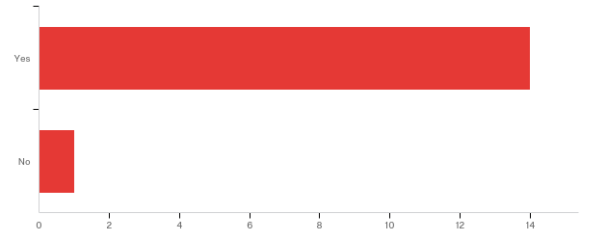

# | Answer | % | Count
1 | Yes | 93.33% | 14
2 | No | 6.67% | 1
 | Total | 100% | 15

2. - Which position from the following list most closely matches your own?

Position | Number | Percentage
Planning Board Member | 5 | 38.46%
Elected Official | 2 | 15.38%
Public Safety Official | 2 | 15.38%
Administrative Assistant | 1 | 7.69%
Planner | 1 | 7.69%
Strategic Planning Committee | 1 | 7.69%
Public Services Administrator | 1 | 7.69%
 | 13 | 100.00%

3. - Approximately how long have you worked with the Town of Pine Knoll Shores?
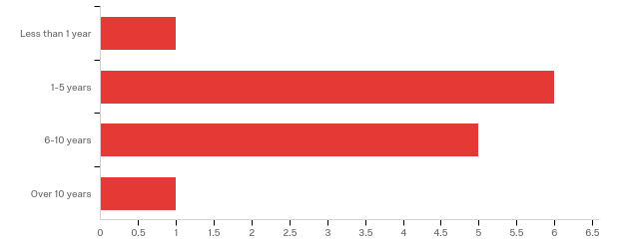

# | Answer | % | Count
1 | Less than 1 year | 7.69% | 1
2 | 1-5 years | 46.15% | 6
3 | 6-10 years | 38.46% | 5
4 | Over 10 years | 7.69% | 1
 | Total | 100% | 13

4. - Please check all the issues you are aware Pine Knoll Shores has faced in the last 10 years:
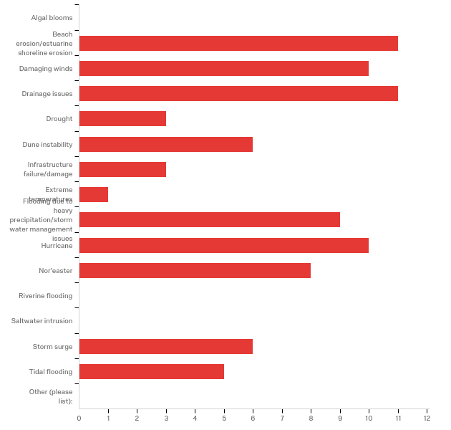

# | Answer | % | Count
1 | Algal blooms | 0.00% | 0
2 | Beach erosion/estuarine shoreline erosion | 13.25% | 11
3 | Damaging winds | 12.05% | 10
16 | Drainage issues | 13.25% | 11
4 | Drought | 3.61% | 3
5 | Dune instability | 7.23% | 6
6 | Infrastructure failure/damage | 3.61% | 3
7 | Extreme temperatures | 1.20% | 1
8 | Flooding due to heavy precipitation/stormwater management issues | 10.84% | 9
9 | Hurricane | 12.05% | 10
10 | Nor'easter | 9.64% | 8
11 | Riverine flooding | 0.00% | 0
12 | Saltwater intrusion | 0.00% | 0
13 | Storm surge | 7.23% | 6
14 | Tidal flooding | 6.02% | 5
15 | Other (please list): | 0.00% | 0
 | Total | 100% | 83

Other (please list):
Other (please list): - Text

5. - In your experience, what are the three most pressing environmental issues facing Pine Knoll Shores at this time?

In your experience, what are the three most pressing environmental issues facing Pine Knoll Shores at this time?
Salt water intrusion. Storm surge sound side from hurricane.
Shoreline stabilization, water quality, stormwater
beach erosion, loss of recreational beach, storm water runoff,
Infrastructure failure, Beach erosion, local flooding areas
beach erosion,
storm water flooding; beach erosion, canal pollution
Beach erosion, storm surge, and damaging winds.
shoreline erosion, storm water flooding, loss of protective vegetation
Hurricanes, wind events, drainage
Storm water management, Beach erosion, Hurricanes
stormwater flooding, beach erosion, water quality preservation

6. - In what ways do those three environmental issues affect our community (e.g.: damage to human health, damage to local economy, displacement of citizens, etc.)?

In what ways do those three environmental issues affect our community (e.g.: damage to human health, damage to local economy, displacement of citizens, etc.)?
House value, repair costs. possible bodily harm.
Potential impact to human health and well being
damage to local economy, water quality, land use projections
Possible home/ property damage, infrastructure replacement costs
damage to local economy,
you just named them
All the above
increased weather threats to infrastructure, reduced property values
Structural damage. Nothing major
Local economy, Human health, Property damage
damage to property, displaced residents

7. - On a scale of what 1 to 10, where 1 is "completely unable" and 10 is "fully able," how would you rate Pine Knoll Shores' ability to withstand and recover from a minor storm with limited flooding?
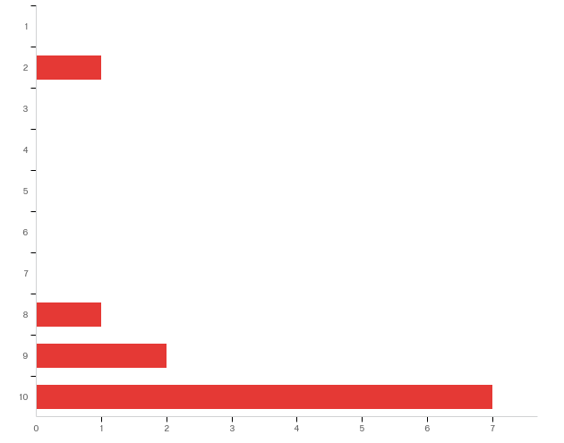

# | Answer | % | Count
1 | 1 | 0.00% | 0
2 | 2 | 9.09% | 1
3 | 3 | 0.00% | 0
4 | 4 | 0.00% | 0
5 | 5 | 0.00% | 0
6 | 6 | 0.00% | 0
7 | 7 | 0.00% | 0
8 | 8 | 9.09% | 1
9 | 9 | 18.18% | 2
10 | 10 | 63.64% | 7
 | Total | 100% | 11

8. - Why did you select this rating?

Why did you select this rating?
PKS is a StormReady city.
Town capable of fully completing this task
Town has made every effort to retain dense maritime vegetation which protects structures from wind. Also public safety has been proactive in putting in systems to deal with flooding in low areas. New construction requires capture of 2" of rainfall and engineered stormwater systems.
Town is well abreast of problems, needs to maintain adequate services
the key is minor - we have with stood a great deal in the past 20 years.
30 plus years living in PKS firsthand knowledge
We have proficient staff in public works, police, fire, town management, and community partnerships.
proper planning and equipment, knowledgeable and enthusiastic staff
Experience with storms.
Town's efforts to control stormwater.
History of Town being able to respond and recover

9. - On a scale of what 1 to 10, where 1 is "completely unable" and 10 is "fully able," how would you rate Pine Knoll Shores' ability to withstand and recover from a major storm with extensive flooding?
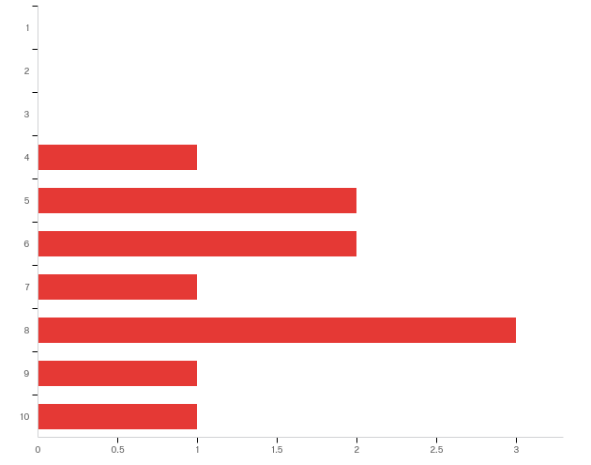

# | Answer | % | Count
1 | 1 | 0.00% | 0
2 | 2 | 0.00% | 0
3 | 3 | 0.00% | 0
4 | 4 | 9.09% | 1
5 | 5 | 18.18% | 2
6 | 6 | 18.18% | 2
7 | 7 | 9.09% | 1
8 | 8 | 27.27% | 3
9 | 9 | 9.09% | 1
10 | 10 | 9.09% | 1
 | Total | 100% | 11

10. - Why did you select this rating?

Why did you select this rating?
Need resources or rented equipment to clean up and repair infrastructure.
Not sure of the Town's full capacity in this situation
Only a guess since we haven't had a major storm since I've lived here (2002). Some parts of town would do better than others. Sound side homes would be flooded, a storm surge would wipe out dune structure which protects beach front properties. But Town management is highly qualified and proactive in bringing together resources to deal with all issues.
Capable staff and adequate cash to address problems
PKS being on an island is exposed to significant storm flooding and erosion which could, if major, eliminate a major portion of the town.
it’s just a guess. in 30 years i’ve never experienced “major flooding”
Depending on the storm size, intensity, and damage; we would be able to recover; however, it will press our resources.
same as the previous answer, however longer recovery period due to staff and equipment limitations and need for outside support (restoring of utilities, debris clearance and removal, and competition with other communities for resources)
Minor flooding
The Town is a storm ready community because of its planning.
Ability in the past to respond/recover

11. - In your experience, do environmental issues disproportionately affect different sectors of our community (e.g.: the elderly, the disabled, low-income, etc.)?
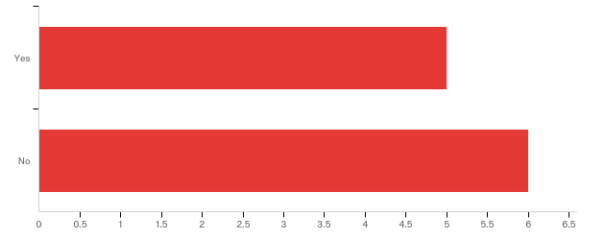

# | Answer | % | Count
1 | Yes | 45.45% | 5
2 | No | 54.55% | 6
 | Total | 100% | 11

11a. - Which groups in Pine Knoll Shores are disproportionately affected? Please be as specific as possible.

Which groups in Pine Knoll Shores are disproportionately affected? Please be as specific as possible.
Depends on locale of property.
The elderly, especially those with health issues, are not as capable of dealing with change. They don't have the technology to stay informed, not as easily evacuated or relocated when conditions require it.
elderly and low income who cannot respond quickly
we are a town with many elderly people. many widows, some widowers
primarily the elderly which are the majority of full time residents, second home owners which will not have ready access to survey and effect repairs

12. - In your experience, do environmental issues affect specific areas in Pine Knoll Shores more than others (certain streets, neighborhoods, buildings, etc.)?
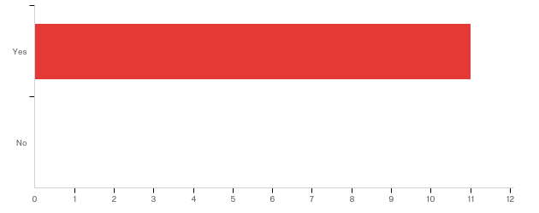

# | Answer | % | Count
1 | Yes | 100.00% | 11
2 | No | 0.00% | 0
 | Total | 100% | 11

12a. - Which areas are more affected by environmental issues? Please be as specific as possible, including street names, neighborhood names, or building names, if you know them.

Which areas are more affected by environmental issues? Please be as specific as possible, including street names, neighborhood names, or building names, if you know them.
East side and older homes. Some wooden ocean side condo's.
Flooding issues mostly in eastern part of Town
East end of town, sound side properties and beachfront. Live Oak floods during normal rainfall, as do a few neighborhoods around the golf course especially the cul-de-sacs.
Low lying streets- Yaupon, Juniper areas
those close to the sound and those with little dune protection on the ocean side.
the east end of town.. juniper, willow, cedar etc.
Cedar Rd, Holly Rd, Juniper Rd ; Flooding
areas subject to regular flooding (Yaupon, Juniper, Myrtle Ct, ocean and sound front structures
Flooding in eastern part of town and some cul-de-sacs.
Mimosa Blvd., Willow Rd.
Eastern portion of town experiences stormwater flooding and oceanfront is susceptible to beach erosion

13. - In your opinion, what is the most difficult part of dealing with environmental issues in Pine Knoll Shores (e.g. community buy-in, lack of financial resources, size of staff, etc.)?

In your opinion, what is the most difficult part of dealing with environmental issues in Pine Knoll Shores (e.g. community buy-in, lack of financial resources, size of staff, etc.)?
staff size and rainy day fund needs more reserves.
Community buy-in and understanding of the issue
Community buy-in, often costs money to do the right thing. And there are those who deny we have any environmental issues. Unfortunately, it tends to get political.
Funding
major catastrophic issues will overwhelm the town staff.
community buy in is a problem. The attitude is why should the majority of the town fix the cheap lots since people knew the flooding problems when they bought their house or lot
Significant recourses would be size of staff. Police and Fire Departments across the board need 2-3 more full-time personnel.
having or getting on site equipment and operators necessary to clear streets and restore utilities
Impatience of some citizens.
Community buy-in.
Size of staff

14. - In your experience, what does the Town of Pine Knoll Shores need in terms of tools and resources to better address our environmental issues?
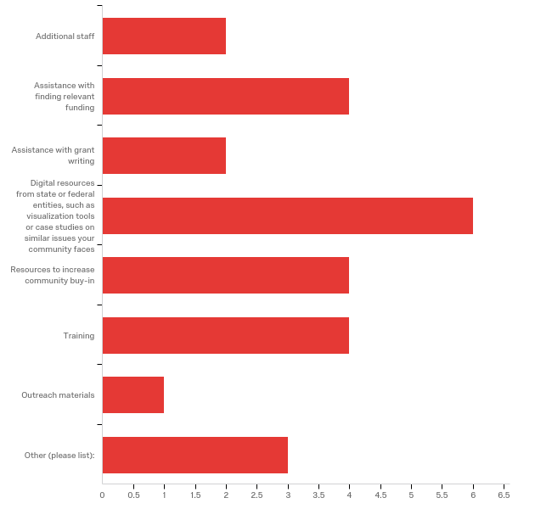

# | Answer | % | Count
1 | Additional staff | 7.69% | 2
2 | Assistance with finding relevant funding | 15.38% | 4
3 | Assistance with grant writing | 7.69% | 2
4 | Digital resources from state or federal entities, such as visualization tools or case studies on similar issues your community faces | 23.08% | 6
5 | Resources to increase community buy-in | 15.38% | 4
7 | Training | 15.38% | 4
8 | Outreach materials | 3.85% | 1
6 | Other (please list): | 11.54% | 3
 | Total | 100% | 26

Other (please list):
Other (please list): - Text
Nothing really. Others don’t need to pay for town problems via Grants, rtc
the staff of PKS is doing an excellent job on environmental issues. Just keep doing.
Additional fire and police personnel in a full-time capacity.

15. - Do you have additional comments pertaining to your experiences with environmental issues in Pine Knoll Shores?

Do you have additional comments pertaining to your experiences with environmental issues in Pine Knoll Shores?
No.
The Town appears to be very pro-active
not at this time
This survey is geared to start new programs labeled “. Environmental” for the sake of expediency which is not needed.
No
the town staff is very proactive in anticipating and planning for environmental issues and in keeping the town citizens and the second home owners informed throughout occasions of potential and actual emergencies. Both staff and HOAs are good at keeping lines of communication open
Pine Knoll Shores is working very diligently to prevent as much as possible environmental issues.
Not at this time

16. - If you have anything else that you would like to share with us, please let us know!

If you have anything else that you would like to share with us, please let us know!
None.
No
Thanks, will do. It's an amazing place to live and we want to keep it that way.
PKS is an excellent place to live and we enjoy it as is. Increased services means increased taxes which we do not need.
We love our police and fire department. They need additional full-time personnel.
nothing at this time
N/A

Appendix 4: Modeling Examples
The Nature Conservancy (TNC) hosted our asset maps on their coastal resilience mapping tool starting in 2018. The tool allows town staff, planners, and the public to see which assets will be affected under a variety of conditions in current and future scenarios. Below are some samples of models that can be overlaid onto Hatteras Village’s asset map through the tool.
You can view the asset maps on TNC’s tool here.

Sea level rise at the medium scenario, year 2060 – Wetland areas are partially inundated and marinas, recreation areas, and critical facilities are impacted:

Category 3 Hurricane Storm Surge in current year – Nearly all mapped assets on both the oceanside and soundside are impacted to varying degrees, with most of the island affected by 3 to 6 feet of water. If combined with sea level rise models, some assets could be severely impacted in year 2060.

Closer view with low opacity of assets in Hatteras Village under a category 3 hurricane storm surge:
Appendix 5: TNC Mapping Portal – Workflow Example
The following workflow was created by Lora Eddy from The Nature Conservancy to assist communities in visualizing risk. In Section II. Adding Community Specific Information to Your Map, towns can find a version of their asset map to help visualize their vulnerabilities to coastal hazards like flooding and sea level rise.

Flood and Sea Level Rise app - Example Workflow
Dare County
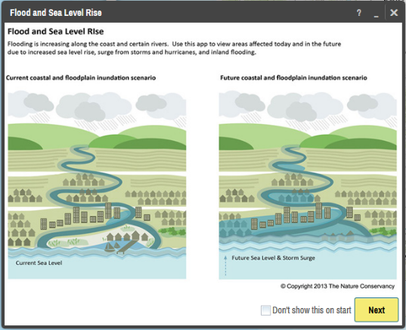
I. Visualizing Risk

- In your internet browser enter: maps.coastalresilience.org/northcarolina/
- Activate the Flood app by clicking on the icon on the left.

- Choose a Region
- Click on “Select a Region” box and select Dare County from the drop-down menu.
- The map zooms to Dare

- Zoom into Manteo
- Zoom by using the center scroll of your mouse or double-clicking over the area OR

- In the top right corner of the map in the search bar, type in Manteo, NC
- As you type in the search box the drop-down list will auto-populate
- Select the address and the map will zoom to the address

- Choose a Hazard
- Click the “Select a Hazard” box and select Coastal Flooding (NC Emergency Mgmt)
- Slide the “Sea Level Rise” slider to 40 cm to see flooding impacts due to sea level rise alone
- Slide the “Flood Extent” slider to 100-yr to see areas in the future at risk to coastal flooding with sea level rise.
- Click on the icon next to “Flood Extent” for more information about the data you have selected

- Click on Opacity
- Click on the slider to adjust the opacity of the storm surge

- Minimize the Flood app window and leave the map on your zoomed in location.

II. Adding Community Specific Information to your Map
- Activate the Community Planning app by clicking on icon on the left.

- Select Dare County>Flood Map>Effective DFIRM and turn on this data layer by clicking on the button next to Effective DFIRM
- Notice the change on the map and legend
- Minimize the legend
- Click on the icon for more information about the data layer you have selected
- Click the … to expand a pop-up menu that allows you to adjust the data layer’s transparency, adjust the transparency to half

- Select Dare County>Infrastructure>Building Footprints and turn on this data layer by clicking on the button next to Building Footprints

- Move around the map dragging and dropping to view roads, buildings and land that are at a higher risk to flooding.

- To view Parcel boundaries Select Dare County>Land Use>Parcels

**Coastal Resilience Map Hints & Tips:
- Click on Tour for a brief introduction to the mapping site or visit coastalresilience.org/tools/training/ for an online Try Me Tutorials.
- This web-based tool can be used in most Internet browsers, including Chrome, Firefox, and Safari. NOT Internet Explorer.
- Refresh your browser window (push the F5 key) if the tool seems laggy (e.g. layers are stuck).
- Also try using a browser window which does not retain cookies or other browsing data. For example:
  - Chrome: incognito window
Firefox and Safari: private browsing window
Appendix 6: Timeline and Schedule of Activities
Below is the approximate timeline from the initial meeting with Hatteras Village residents to the completion of the project. Hatteras Village did not move forward with a survey of village leaders or with a public input workshop.
Month/Year | Purpose | Activities
July 2017 | Scoping meeting with Hatteras Village residents | - Discuss project and time commitment  - Identify potential stakeholders to include  - Establish initial timeline
July 2017 | Map vulnerabilities with two resident-experts | - Identify community assets and potential physical and social vulnerabilities
August 2017 – December 2017 | Revise asset map, write narrative to justify included assets, and begin final report for Hatteras Village | - Update asset map according to resident-expert comments and suggested revisions  - Write a narrative to complement the map so both the experts and the public can easily understand what assets were included and why (see Appendix 1C)  - Begin final town report with information from background research, meetings with village, and other relevant information
January 2018 – May 2018 | Update asset maps and upload them to the coastal resilience mapping tool to pinpoint hotspots and prioritize projects. | - Added resident input to asset maps if applicable  - Worked with TNC to upload asset maps to the coastal resilience mapping tool  - Complete final report for the town

“‘Resilience’ means the ability to anticipate, prepare for, and adapt to changing conditions and withstand, respond to, and recover rapidly from disruptions.” (Former President Barack Obama, Executive Order 13653)
According to FEMA, “assets are defined broadly to include anything that is important to the character and function of a community and can be described very generally in the following four categories: People, Economy, Built environment, Natural environment.”
In the context of this project, a physical vulnerability is indicated by a geographic area exposed to a hazard, such as waterfront properties repeatedly flooded after hurricanes. A social vulnerability is indicated by a population that is exposed to a hazard, such as residents in a neighborhood in a low-lying area that repeatedly floods. Both physical and social vulnerabilities can be low or high risk, depending on their level of exposure, preparedness, and ability to recover after a disaster, among other indicators.
See Appendix 1B.
In the context of this project, a physical vulnerability is indicated by a geographic area exposed to a hazard, such as waterfront properties repeatedly flooded after hurricanes. A social vulnerability is indicated by a population that is exposed to a hazard, such as residents in a neighborhood in a low-lying area that repeatedly floods. Both physical and social vulnerabilities can be low or high risk, depending on their level of exposure, preparedness, and ability to recover after a disaster, among other indicators.

