

Where is All of Our Soil Going?

**A Supplement for the**

**Middle School Curriculum**

Created by: Caroline C. Medlin,

Updated by: Rebecca C. Coppa NCDEQ - Land Quality Section



**Student Packet Contents**

**Introduction**

**Activity**

* + **Part #1 The Narrative**
  + **Part #2 Construction Schedule**
  + **Part #3 Maintenance Plan**
  + **Part #4 Vicinity Map**
  + **Part #5 Site Topo Map & Development Plan**
  + **Part #6 The Erosion and Sediment Control Plan**

**Erosion & Sediment Word Match Activity**

**Where is All of Our Soil Going?**

**Introduction**

A Supplement for the Middle School Curriculum

Created by: Caroline C. Medlin, NCDEQ - Land Quality  
Updated by: Rebecca C. Coppa, NCDEQ Sedimentation and Education Engineer

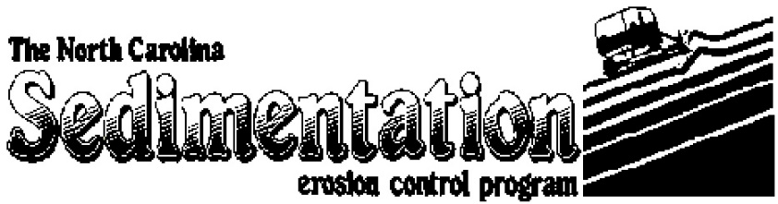

Why is the loss of soil so important? Soil is more than just DIRT; soil provides the nutrients required to grow the food we eat as well as the necessary nutrients for the trees and flowers we enjoy. IT TAKES 500 YEARS TO MAKE ONE INCH OF TOPSOIL!!! Be part of the solution—help prevent soil erosion!

PREPARATION FOR ACTIVITY: When a person, usually someone called a contractor or developer, decides to build a new building, there is a lot of paperwork he or she must do before any actual construction can begin. One thing that state and local governments require is an *Erosion and Sedimentation Control Plan*, or *ESCP*. This plan makes sure that the contractor has considered how to prevent erosion before, during, and after construction. In this activity, your team will be a developer that wants to build a McDonalds in Greensboro, NC. The company that finishes their ESCP first and correctly will be awarded the job of constructing the new McDonalds!

|  |
| --- |
| statesealFor Additional Information on Erosion and Sedimentation Control,  Visit NC Department of Environmental Quality Website: <https://deq.nc.gov/E&SC>  Or contact the current Sediment Education Engineer/Specialist:  Sediment Education Engineer/Specialist Land Quality Section 1612 Mail Service Center Raleigh, NC 27699-1612 |

**Part # 1 The Narrative**

The first part of this plan is the narrative. The narrative provides a written description of the project, site, adjacent property, soils and planned erosion and sedimentation control practices. Carefully read the narrative below. In the blanks provided select the best word to complete the paragraph. Each word will be used only once.

bottom   
eroded   
flooding   
sediment   
fence   
Guilford   
pond   
pine   
sloping   
control   
acre

**Project Description**

The purpose of the project is to construct a McDonalds fast-food restaurant with associated paved roads and parking lots. Approximately one _______ will be disturbed during this construction period. The site is located within the city limits of Greensboro in ____________ County.

**Site Description**

The site has gently __________ topography. The site is now covered with grasses and the surrounding area is covered by a stand of mixed hardwood and _________ trees 25 to 80 feet tall.

**Soils**

The soil in the construction zone is clay with some sandy loam mixed in. This soil type is fairly easily _________, especially with the steep slopes involved with this project. Steps will be taken to ensure that erosion ____________ measures will be effectively installed and that a groundcover is established as soon as possible.

**Planned Erosion and**

**Sedimentation Control Practices**

l. *Grass-lined Channel* - This channel is lined by vegetation and is designed to convey runoff water

without damaging the area, __________ or depositing sediment in inappropriate areas. This practice is used along roadsides, property boundaries and for drainage in low-lying areas.   
2. *Sediment Basin* -   
A basin or __________ that is strategically located to catch water runoff and is used to prevent sedimentation in off-site streams, lakes and drainage ways. The pond will collect water that contains a high concentration of ___________ and will store the water until the sediment is able to drop out and concentrate in one area versus contaminating other waterways.   
3. *Sediment Fence* -   
This is a fence composed of a filter fabric that is buried at the _________ in the soil and then stretched and supported by posts. It is used to retain sediment from small disturbed areas by reducing the velocity of sheet erosion. This allows the sediment to build up behind the __________. When necessary, the sediment is disposed of properly by distributing the soil over a land area.

**Part # 2 Construction Schedule**

|  |  |  |
| --- | --- | --- |
| The construction schedule establishes a plan for the sequence of events to take place during a construction phase of the project. Below are five steps of a construction schedule. Read each step carefully, determine the proper series of events and label them accordingly, the first step being #1 and the last #5. | ________ Remove temporary erosion control measures. |  |
| ________ Create and submit ESCP to obtain plan approval and other applicable permits. |  |
| ________ Clear vegetation to begin construction. |  |
| ________ Pave roads and parking lots after construction of building is complete. |  |
| ________ Install sediment basin as first construction activity. |  |

**Part # 3 Maintenance Plan**

The maintenance plan explains how the erosion and sediment control measures are going to be checked and fixed if they are not working properly. If a sediment basin fills up with sediment, then they must be cleaned out to work properly.

The following is an example of a maintenance plan. Read it carefully and then answer the questions.

1. All erosion and sedimentation control measures must be checked after every rainfall that is heavy enough to produce runoff. Even if there is no heavy rainfall, the structures must be checked at least once a week. Any repairs that are needed must be done immediately to maintain erosion control.

2. The sediment basin will be cleaned out when the level of sediment reaches 2 feet below the top of the riser. If the sediment basin does not drain properly, then the gravel will be cleaned or replaced.

3. Sediment will be removed from the sediment trap and inlet protection device when the storage capacity is half filled.

4. Sediment will be removed from behind the sediment fence when it becomes about 0.5 feet deep at the fence. The sediment fence will be repaired as necessary.

5. All seeded areas will be fertilized, reseeded as necessary, and mulched to maintain a vegetative cover.

It is scheduled that each Monday morning the control structures are checked to make sure they are working properly.

On Wednesday there is a two-hour downpour that produces some runoff.

On Friday there is a light sprinkling of rain that lasts 15 minutes.

1. During this week, how many times do you need to check your control structures? Why?

____________________________________________________________________________

1. What must be done if the sediment basin stops draining properly?

________________________________________________________________________

1. You must remove the sediment behind the sediment fence when it is _____ feet deep.

**Part # 4 Vicinity Map**

|  |  |
| --- | --- |
| The vicinity map shows what lies in the area of the proposed construction project. Study the map and then answer the questions below.  What is the closest road intersection to the construction site?  ____________________  What water source is most likely to be impacted by the new construction?  ____________________  ____________________  What is the closest city to the construction site?  ____________________ |  |

**Part # 5 Site Topo Map & Development Plan**

There are many different types of maps. Maps are used to depict an area through symbols and lines and words. A street map is familiar to most people and the type of map used most often to navigate through city However, a street map would be of no use in an area with no roads or towns. A **topography** (topo) **map** uses the shape of the land and the natural contours of slopes and valleys to depict an area. Look at the enclosed map. The topo map has features similar to a street map, such as a legend which tells the meaning of the symbols used in the map, a scale and a north arrow. Instead of streets, a topo map uses contour lines to define the lay of the land. Contour lines tell how many feet above sea level a point is. Each contour line represents a set amount of feet. On the map provided each line represents two feet.

Therefore, there is a two-foot difference, higher or lower, between each set of lines.

1. Locate the highest point on the map. Place a dot on your map to show this point.

2. Locate the lowest point and mark it with a "*" on your map.

The **Site Development Plan** utilizes a topo map to show how a building or parking lot will fit with the landscape. The map enclosed is a plan of a McDonalds restaurant which could be built on the land represented by the topo map. The plan helps the contractor see how much land will be disturbed by the building, if the building will fit on the property, and how the building and parking lots will lie in reference to the shape of the land.

1. Given the property boundaries and the tree line, with a colored pen mark the limits of disturbance or construction limits. This barrier will become the area within which the soil will be disturbed and where control measures will need to be constructed.

2. Each time something is added to the map the legend should be updated with the correct symbol and label.

**Part # 6 The Erosion and Sedimentation Control Plan**

|  |  |
| --- | --- |
| The Sediment and Erosion Plan once again builds upon the topo map and the Site Development Plan to define the sediment and erosion control structures necessary to stabilize the soil. Using the control measures shown below, place a symbol in the box on the map where the measure should be located. Work with your team to place the control measures in the best location to control erosion and sedimentation!  Silt Fence  Sediment Basin  Bonus:  Rock (Riprap) |  |

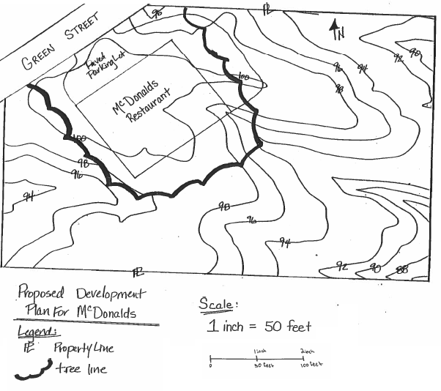

**Words Definitions**

Water Body a. water cannot infiltrate into the soil

Contour b. when soil stays suspended in the water, making it “muddy”

Sediment c. soil that reaches waterways or other property by erosion

Runoff d. Sediment in our rivers and streams is water __________

Sand e. Applied after an area has been seeded

Climate f. The most natural and best erosion control practice

Sediment Basin g. The movement of soil by wind, water, or gravity

Impervious h. Water from storms that flows across the land surface

Turbidity i. Used to keep sediment from leaving a construction site

Pollution j. An Erosion & Sediment Control plan is required when one or more

acres are __________

Mulch k. Determines the amount of rainfall an area will get, and how warm

an area will be

Erosion l. Type of small, fine soil particles

Grass m. Stream, creek, river, pond, or lake

Disturbed n. Topographic maps show _________ lines to represent elevations.

Clay o. Type of large, granular particles

**Erosion & Sedimentation Word Match**

**Directions:** Write the letter of the word’s definition next to

the word



* This activity with answer key can be requested from the Land Quality Sections’ Education Program

