BENCHMARK EXCEEDANCE or TIER 2 DISCHARGE MONITORING REPORT (DMR) – STORMWATER
SUBMIT TO REGIONAL OFFICE*

General Permit No. NCG240000

*Use this form if any stormwater samples have EXCEEDED A BENCHMARK or if the facility is in TIER 2 MONITORING for any parameter.
Send sample results to the DEMLR Regional Office within 30 days of receipt from the laboratory.

Certificate of Coverage No. NCG24

Facility Name: __________________________________ Sample Collection Period: 1 2 3 4 Calendar Year ______________
County: _______________________________ For Monthly Monitoring: Month_______________
Phone No.: (_____)_________________ Person Collecting Samples: _________________________________
Certified Laboratory: __________________________ Lab # _______ __________________________ Lab # _______

Has this facility had 4 or more benchmark exceedances for any single parameter, at any one SW discharge outfall (SDO)? Yes No
Have you contacted the Regional Office? Yes No Whom at the Region did you speak with? ___________________________________

CERTIFICATION
"I certify, under penalty of law, that this document and all attachments were prepared under my direction or supervision in accordance with a system designed to assure that qualified personnel properly gather and evaluate the information submitted. Based on my inquiry of the person or persons who manage the system, or those persons directly responsible for gathering the information, the information submitted is, to the best of my knowledge and belief, true, accurate, and complete. I am aware that there are significant penalties for submitting false information, including the possibility of fines and imprisonment for knowing violations." [Required by 40 CFR §122.22]

Signature __________________________________________________ Date _______________

Mail Benchmark Exceedance/Tier 2 DMR to Your DEMLR Regional Office Land Quality Section:

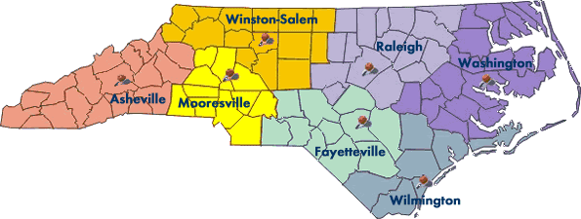
ASHEVILLE REGIONAL OFFICE  2090 US Highway 70  Swannanoa, NC 28778  (828) 296-4500 | FAYETTEVILLE REGIONAL OFFICE  225 Green Street  Systel Building Suite 714  Fayetteville, NC 28301-5043  (910) 433-3300 | MOORESVILLE REGIONAL OFFICE  610 East Center Avenue/Suite 301  Mooresville, NC 28115  (704) 663-1699
RALEIGH REGIONAL OFFICE  3800 Barrett Drive  Raleigh, NC 27609  (919) 791-4200 | WASHINGTON REGIONAL OFFICE  943 Washington Square Mall  Washington, NC 27889  (252) 946-6481 | WILMINGTON REGIONAL OFFICE  127 Cardinal Drive Extension  Wilmington, NC 28405-2845  (910) 796-7215
WINSTON-SALEM REGIONAL OFFICE  450 Hanes Mill Road, Suite 300  Winston-Salem, NC 27103  (336) 776-9800 | CENTRAL OFFICE  Questions for The Central Office Stormwater Permitting Program?  (919) 707-9220

Certificate of Coverage No. NCG24
Stormwater Monitoring Requirements
Outfall  No. | Date Sample Collected | Total Rain-fall | Is this SDO in Tier 2? | Does this SDO include Vehicle Maint. Activities (VMA)? | TSS,  mg/l | COD,  mg/l | Fecal Coliform,  Col/100mL | TN,  mg/l | TP,  mg/l | Cu, mg/l | Pb, mg/l | Zn, mg/l | pH,  SU | Non-polar O&G, mg/l (VMA)  If applicable | New Motor Oil Usage (gal/mo.)  If applicable
- | mm/dd/yy  or “NO FLOW” | in | Y/N | Y/N | 100 | 120 | 1000 | 30 | 2 | 0.010 | 0.075 | 0.126 | 6.0-9.0 | 15 | >55 gal/mo. average requires TSS and Non-polar O&G monitoring

