Laserfiche: WebLink
Underground Storage Tank Section

Purpose and General Information
This document provides some basic instructions in carrying out the common searches in the Laserfiche Document Management System.
Documents stored in the Laserfiche Document Management System are viewable through the public webpage. This is web-based software, so an internet connection is necessary.
WebLink URL: http://edocs.deq.nc.gov/WasteManagement/Search.aspx

On the left near the top, you will see three tabs: “Home”, “Browse”, and “Search”. Each allow different views and methods for searching files. Across the top center of the page, there is also a general search box. Again, just a different way for searching files.

General Search Box
You can type any term you want in this box and it will conduct a search across all fields (indices) and programs. If you need to search for multiple terms you can use asterisks (*) on each side of your search terms to provide more precise searches.
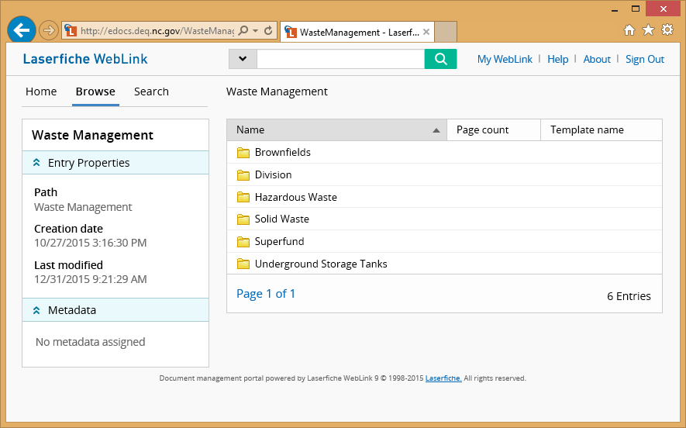

Example: *WA-*LSA* will return entries in the Washington Regional Office with LSA in the record. Be aware if the LSA appears in any part of the record it will be included in this search.

Search Tab
You can select the “Search” tab on the left. It will then give you choices for searching the files. The search most familiar to previous users is “Template”. This will show all the fields associated with our template, “WM”. After you make your choices and entries in the Template (see descriptions and examples below), click the search box on the bottom of the template to launch this search.
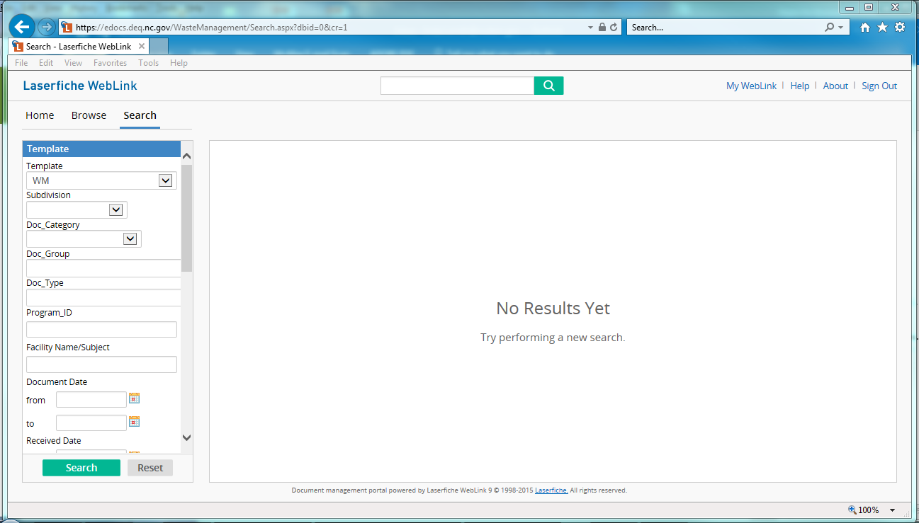

You can also use the drop-downs and text boxes to conduct searches. Choices in the drop-down fields will limit your search. You cannot type in the drop-down fields.

Example, if you choose the Subdivision drop-down UST, you will be limited to searching only the UST programs. Then if you choose the Doc_Type of NFA (NFA), your search will return all No Further Action documents. Not all drop-downs need to be chosen.

Things to remember, the search box at the top of the page conducts a “fuzzy” search. A fuzzy search will return all entries that contain the search term. The search fields on the left don’t use fuzzy searches, but you can use asterisks (*) on each side of your search term to act as a fuzzy search (the asterisk is called a wildcard).

Example, if you choose the Subdivision drop-down UST to limit your search to the UST program and then enter *WS-71* in the Program ID text box it will return all Winston-Salem regional office UST Numbers that begin with 71.

Program ID for the UST Subdivision contains the UST Number, available from the UST incident management databases. (Incident Management Database for Regional Underground Storage Tanks, Aboveground Incident Management Database for Regional Aboveground Storage Tanks)
Facility Name/Subject contains the name of the facility as entered in the UST incident management databases
Facility/Site Address, City, State, Zipcode are also imported from the databases
Template entries for UST past the Facility/Site County are either not used or for internal data entry tracking
Name is not a searchable field in the Template, but it can be searched in the top search box with a fuzzy search.

Browse Tab
The “Browse” tab allows a folder view, where users can click on the folders to open them.
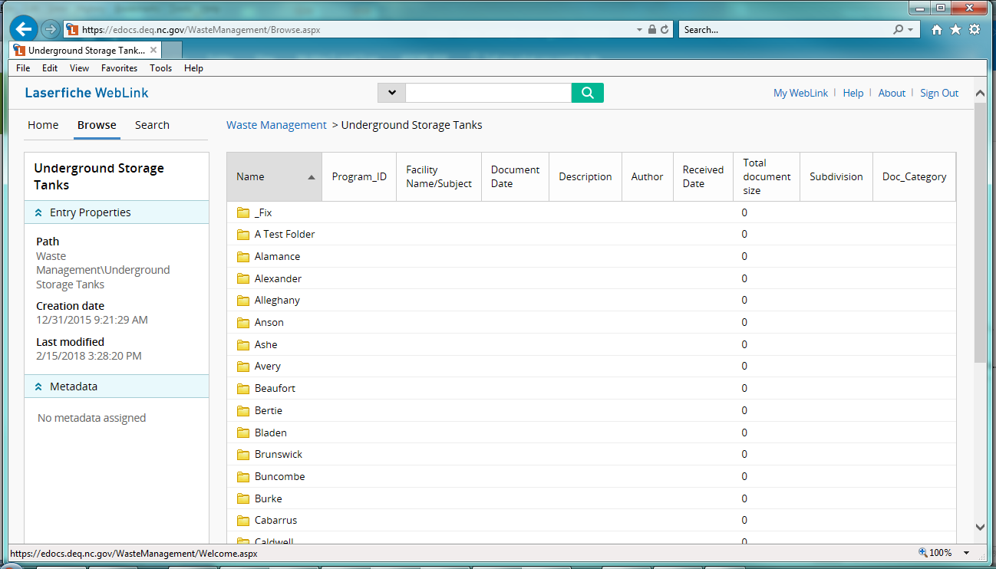
You will notice there are breadcrumbs (Waste Management > Underground Storage Tanks) across the top that allow you to go back or up a level. Breadcrumbs provide links to previous pages.

Links

Laserfiche User Guide online
https://www.laserfiche.com/support/webhelp/laserfiche/9.2/en-us/userguide/laserfiche_client.htm

IMPORTANT NOTE:

Many but not all historical facility files, have been added to this electronic file system. The document Groups may include but are not limited to: General, Corrective Action, Groundwater, Enforcement, etc. Document Types and other file name examples are included in the following pages and table. In addition, the user should be aware, if searching by a date range, that some of the documents that were imported have incorrect dates. You may not get the full set of documents anticipated if you do not account for this. The oldest date for Underground Storage Tank data is an incorrect entry of 5/12/1950.

Underground Storage Tank Laserfiche File Naming Convention

UST Number_Incident Number_Document Group_Document Type_Date_text.file type
UST Number is a unique number that begins with a two-letter code (indicating a UST Regional Office) followed by a hyphen (Example: WS-1111):
AS – Asheville Regional Office
FA – Fayetteville Regional Office
MO – Mooresville Regional Office
RA – Raleigh Regional Office
WA – Washington Regional Office
WI – Wilmington Regional Office
WS – Winston-Salem Regional Office
Incident Number is unique to the individual Regional Office and may be unique in the state. It is always a set of numbers. A site with an Incident Number is a site that has had a contamination event occur. Sites that enter our system due to complaints or other situations where contamination did not occur will only have a UST Number.
Both UST Number and Incident Number can be obtained from the UST databases on our website.
DocGroup and DocType provide limits to what kind of document the file contains. This information is presented in the following table, see last column for examples.
YYYYMMDD is the date of the document in the format of YearMonthDay, with no separations.
text is an optional identifier, using abbreviations found in the DocType column in the table and/or short descriptions.
Examples: WA-1778_20448_M_DENR_20000309_00001.PDF
FA-3630_29601_M_DENR_20171031_NRP Approval & Cover Letter.pdf
FA-88453_90253_CA_UST-62_20170925_w supporting documents.pdf
FA-92460_90236_G_NORR_20170501_NORR for Initial Assessment.pdf
FA-3532_29552_CA_RPTS_20170510_Letter Report.doc

UST DocGroup and DocTypes (If changes occur an updated table will be posted on our website)

Group | Group | Type | Type | Entry Format
Closure (C) | C | Closure Information (CI) | CI | C_CI
Closure (C) | C | Miscellaneous Closure Documentation (MISCCLO) | MISCCLO | C_MISCCLO
Closure (C) | C | NFA (NFA) | NFA | C_NFA
Closure (C) | C | Notice of Residual Petroleum (NRP) | NRP | C_NRP
Closure (C) | C | Other (O) | O | C_O
Closure (C) | C | Public Notices (PUBNOT) | PUBNOT | C_PUBNOT
Closure (C) | C | Site Investigation for Permanent Closure-Change in Service (UST-2) | UST-2 | C_UST-2
Closure (C) | C | UST Closure Report - Clean Closure (UST-12) | UST-12 | C_UST-12
Closure (C) | C | UST Closure Report - PIB (UST12PIB) | UST12PIB | C_UST12PIB
Corrective Action (CA) | CA | 20 Day Report (20-DAY) | 20-DAY | CA_20-DAY
Corrective Action (CA) | CA | 24-Hr Notification of Discharge Form (UST-62) | UST-62 | CA_UST-62
Corrective Action (CA) | CA | 24-Hr Release and UST Leak Reporting (UST-61) | UST-61 | CA_UST-61
Corrective Action (CA) | CA | 45 Day Report (45-DAY) | 45-DAY | CA_45-DAY
Corrective Action (CA) | CA | Aggressive Fluid Vapor Recovery (AFVR) | AFVR | CA_AFVR
Corrective Action (CA) | CA | Alternate Water (ALTWTR) | ALTWTR | CA_ALTWTR
Corrective Action (CA) | CA | Bottled Water (BTLWTR) | BTLWTR | CA_BTLWTR
Corrective Action (CA) | CA | Bulk Water (BWTR) | BWTR | CA_BWTR
Corrective Action (CA) | CA | Closure Report (CLO) | CLO | CA_CLO
Corrective Action (CA) | CA | Comprehensive Site Assessment (CSA) | CSA | CA_CSA
Corrective Action (CA) | CA | Contractor Information (CNTINF) | CNTINF | CA_CNTINF
Corrective Action (CA) | CA | Corrective Action Information (CAI) | CAI | CA_CAI
Corrective Action (CA) | CA | Corrective Action Plan (CAP) | CAP | CA_CAP
Corrective Action (CA) | CA | Deed Recordation (DR) | DR | CA_DR
Corrective Action (CA) | CA | Field Notes & Test Results (FNTR) | FNTR | CA_FNTR
Corrective Action (CA) | CA | Free Product Recovery Report (FPR) | FPR | CA_FPR
Corrective Action (CA) | CA | Free Product Recovery System Specification Report (FPRSS) | FPRSS | CA_FPRSS
Corrective Action (CA) | CA | General Technical Data (TECHDA) | TECHDA | CA_TECHDA
Corrective Action (CA) | CA | Health Risk Evaluation (HRE) | HRE | CA_HRE
Corrective Action (CA) | CA | Initial Abatement Action Report (IAR) | IAR | CA_IAR
Corrective Action (CA) | CA | Lab Data (LAB) | LAB | CA_LAB
Corrective Action (CA) | CA | Limited Site Assessment (1 or 2) (LSA) | LSA | CA_LSA
Corrective Action (CA) | CA | Letter Report (LTRRPT) | LTRRPT | CA_LTRRPT
Corrective Action (CA) | CA | Mobile Multi Phase Extraction (MMPE) | MMPE | CA_MMPE
Corrective Action (CA) | CA | Monitoring Report (MRP) | MRP | CA_MRP
Corrective Action (CA) | CA | NC Licensed Surveyor (NCPS) | NCPS | CA_NCPS
Corrective Action (CA) | CA | New Technology Cleanup Report (NTCP) | NTCP | CA_NTCP
Corrective Action (CA) | CA | Notice of Intent UST Permanent Closure-Change in Service (UST-3) | UST-3 | CA_UST-3
Corrective Action (CA) | CA | Other (O) | O | CA_O
Corrective Action (CA) | CA | Other Reports (RPTS) | RPTS | CA_RPTS
Corrective Action (CA) | CA | POE (POE) | POE | CA_POE
Corrective Action (CA) | CA | Public Water Supply (PWS) | PWS | CA_PWS
Corrective Action (CA) | CA | Receptor Survey (RS) | RS | CA_RS
Corrective Action (CA) | CA | Remediation Monitoring Report (RMR) | RMR | CA_RMR
Corrective Action (CA) | CA | Site Check Report (SCH) | SCH | CA_SCH
Corrective Action (CA) | CA | Site Cleanup and Site Closure Report (SCSC) | SCSC | CA_SCSC
Corrective Action (CA) | CA | Site Closure Report (SCR) | SCR | CA_SCR
Corrective Action (CA) | CA | Soil Assessment Report (SAR) | SAR | CA_SAR
Corrective Action (CA) | CA | Soil Cleanup Plan (SCP) | SCP | CA_SCP
Corrective Action (CA) | CA | Soil Excavation Report (SE) | SE | CA_SE
Corrective Action (CA) | CA | System Enhancement Recommendations (SER) | SER | CA_SER
Corrective Action (CA) | CA | Tank Closure Report (TCR) | TCR | CA_TCR
Corrective Action (CA) | CA | UST Suspected Release Notification (24-Hour) (UST-17A) | UST-17A | CA_UST-17A
Corrective Action (CA) | CA | UST Suspected Release Notification (7-Day) (UST-17B) | UST-17B | CA_UST-17B
Corrective Action (CA) | CA | Variance Report (VR) | VR | CA_VR
Corrective Action (CA) | CA | Water Supply Well (WSW) | WSW | CA_WSW
Corrective Action (CA) | CA | Waterline (WL) | WL | CA_WL
Corrective Action (CA) | CA | Well Records (WR) | WR | CA_WR
Enforcement (E) | E | 10-Day Letter (10-DAY) | 10-DAY | E_10-DAY
Enforcement (E) | E | Administrative Order on Consent (AOC) | AOC | E_AOC
Enforcement (E) | E | Civil Penalty Assessment (CPA) | CPA | E_CPA
Enforcement (E) | E | Compliance Order (CO) | CO | E_CO
Enforcement (E) | E | Immediate Action Notice of Violation (IANOV) | IANOV | E_IANOV
Enforcement (E) | E | Notice of Violation (NOV) | NOV | E_NOV
Enforcement (E) | E | Other (O) | O | E_O
Enforcement (E) | E | Owner-Operator Responses to NOV (OORESP) | OORESP | E_OORESP
Enforcement (E) | E | Settlement Agreement (SA) | SA | E_SA
Financial (F) | F | Certificate of Insurance (CERTINS) | CERTINS | F_CERTINS
Financial (F) | F | Correspondence (C) | C | F_C
Financial (F) | F | Fee Adjustment Documentation (FEEAD) | FEEAD | F_FEEAD
Financial (F) | F | Invoice-Fee Payment Information (PMTINFO) | PMTINFO | F_PMTINFO
Financial (F) | F | NC Certification Form (NCCERT) | NCCERT | F_NCCERT
Financial (F) | F | Pre-approval Task Authorization (PATA) | PATA | F_PATA
Financial (F) | F | Refund Documentation (REFDOC) | REFDOC | F_REFDOC
Financial (F) | F | Settlement Agreements-Third Party Claims (SA) | SA | F_SA
Financial (F) | F | State Lead Task Authorization (SLTA) | SLTA | F_SLTA
General (G) | G | Acceptance Letter (ACCLTR) | ACCLTR | G_ACCLTR
General (G) | G | Access Agreement (ACCAGMT) | ACCAGMT | G_ACCAGMT
General (G) | G | Alternate Fuels Compatibility Checklist (UST-20) | UST-20 | G_UST-20
General (G) | G | Annual Containment Sump Visual Inspections (UST-22C) | UST-22C | G_UST-22C
General (G) | G | Annual Interstitial Sensor Operability Check (UST-22B) | UST-22B | G_UST-22B
General (G) | G | Annual Overfill Prevention Operability Check (UST-22A) | UST-22A | G_UST-22A
General (G) | G | Annual UST Equipment Operability (UST-22) | UST-22 | G_UST-22
General (G) | G | Application to Install or Replace UST (Post) (UST-6B) | UST-6B | G_UST-6B
General (G) | G | Application to Install or Replace UST (Pre) (UST-6A) | UST-6A | G_UST-6A
General (G) | G | Attorney Correspondence (ATNYCOR) | ATNYCOR | G_ATNYCOR
General (G) | G | Cert - No Visible Corrosion on Metal Piping Components (UST-24) | UST-24 | G_UST-24
General (G) | G | Certification of LD Exemption for Piping (UST-19) | UST-19 | G_UST-19
General (G) | G | Change of Ownership Notification (UST-15) | UST-15 | G_UST-15
General (G) | G | Compartmented Tank Notification (UST-13) | UST-13 | G_UST-13
General (G) | G | Compliance Assistance Visit (CAV) | CAV | G_CAV
General (G) | G | Correspondence (C) | C | G_C
General (G) | G | CP System Evaluation, Impressed Current (UST-7B) | UST-7B | G_UST-7B
General (G) | G | CP System Evaluation, Sacrificial Anode (UST-7A) | UST-7A | G_UST-7A
General (G) | G | IC CP Sys 60-Day Record of Rectifier Op (UST-21) | UST-21 | G_UST-21
General (G) | G | Notice of Intent to Install - Old Form (UST-6) | UST-6 | G_UST-6
General (G) | G | Notice of Intent to Install Vapor or GW Monitoring System (UST-4) | UST-4 | G_UST-4
General (G) | G | Notice of Regulatory Requirement (NORR) | NORR | G_NORR
General (G) | G | Notification of Activities Involving USTs (EPA7530-1) | EPA7530-1 | G_EPA7530-1
General (G) | G | Notification of Activities Involving USTs (UST-1) | UST-1 | G_UST-1
General (G) | G | Notification of Activities Involving USTs (UST-8) | UST-8 | G_UST-8
General (G) | G | Oil Terminal Facility Registration (OTF-1) | OTF-1 | G_OTF-1
General (G) | G | Other (O) | O | G_O
General (G) | G | Ownership of USTS (UST-15A) | UST-15A | G_UST-15A
General (G) | G | Pictures and Diagrams (PICDIAG) | PICDIAG | G_PICDIAG
General (G) | G | Risk Ranking Abatement (RRA) | RRA | G_RRA
General (G) | G | Site Investigation Report for Install of Vapor-GWM Sys (UST-5) | UST-5 | G_UST-5
General (G) | G | STF Eligibility Information (ELIG) | ELIG | G_ELIG
General (G) | G | Technical Assistance (TA) | TA | G_TA
General (G) | G | Triennial UST Containment Sump-UDC Integrity Testing (UST-23B) | UST-23B | G_UST-23B
General (G) | G | Triennial UST Interstice Integrity Testing (UST-23D) | UST-23D | G_UST-23D
General (G) | G | Triennial UST Piping Integrity Testing (UST-23C) | UST-23C | G_UST-23C
General (G) | G | Triennial UST Spill Bucket Integrity Testing (UST-23A) | UST-23A | G_UST-23A
General (G) | G | Upgrade Notification for USTs (UPGRADE) | UPGRADE | G_UPGRADE
Groundwater (GW) | GW | Comprehensive Monitoring Event (CME) | CME | GW_CME
Groundwater (GW) | GW | Correspondence (C) | C | GW_C
Groundwater (GW) | GW | Other (O) | O | GW_O
Inspection/Investigation (I) | I | Complaint Investigation (CMP) | CMP | I_CMP
Inspection/Investigation (I) | I | General Inspection Checklist (UST-10B) | UST-10B | I_UST-10B
Inspection/Investigation (I) | I | Installation Inspection Checklist (UST-10A) | UST-10A | I_UST-10A
Inspection/Investigation (I) | I | Miscellaneous Inspection/Investigation Letters (MISINSP) | MISINSP | I_MISINSP
Inspection/Investigation (I) | I | Other (O) | O | I_O
Inspection/Investigation (I) | I | Pictures and Diagrams (PICDIAG) | PICDIAG | I_PICDIAG
Inspection/Investigation (I) | I | Primary Operator Certificate (POCERT) | POCERT | I_POCERT
Miscellaneous (M) | M | Correspondence (C) | C | M_C
Miscellaneous (M) | M | DENR (DENR) | DENR | M_DENR
Miscellaneous (M) | M | Environmental Site Assessment (1 or 2) (ESA) | ESA | M_ESA
Miscellaneous (M) | M | MISC (MISC) | MISC | M_MISC
Miscellaneous (M) | M | NFA (NFA) | NFA | M_NFA
Miscellaneous (M) | M | Reports (RPTS) | RPTS | M_RPTS
Miscellaneous (M) | M | RP (RP) | RP | M_RP
Permit (P) | P | Certificate of Approval for Storage/Treatment of Soil (SR-71) | SR-71 | P_SR-71
Permit (P) | P | Correspondence (C) | C | P_C
Permit (P) | P | Denial of Permit Letter (PERMDEN) | PERMDEN | P_PERMDEN
Permit (P) | P | Documentation Received for Release of Permit (DOCREL) | DOCREL | P_DOCREL
Permit (P) | P | Invoice and Compliance Questionnaire (INVCQ) | INVCQ | P_INVCQ
Permit (P) | P | Land App Agreement Contain/Treat Soils on Private Lands (SR-72) | SR-72 | P_SR-72
Permit (P) | P | Leak Detection Records (LDREC) | LDREC | P_LDREC
Permit (P) | P | Manual Tank Gauging Records (UST-16) | UST-16 | P_UST-16
Permit (P) | P | Monitoring Well Permit (MW) | MW | P_MW
Permit (P) | P | Non-Discharge Permit Application for Soil Remediation (SR-70) | SR-70 | P_SR-70
Permit (P) | P | Non-Discharge Permit Report (NDP) | NDP | P_NDP
Permit (P) | P | NPDES Permits (NPDES) | NPDES | P_NPDES
Permit (P) | P | Oil Terminal Certificate (OILTERM) | OILTERM | P_OILTERM
Permit (P) | P | Other (O) | O | P_O
Permit (P) | P | Permit Rejection Letter (PERMREJ) | PERMREJ | P_PERMREJ
Permit (P) | P | Permitting Information (PI) | PI | P_PI
Permit (P) | P | POTW Monitoring Report (POTW) | POTW | P_POTW
Permit (P) | P | UIC/Injection Permit (UIC) | UIC | P_UIC
Permit (P) | P | UST Permit-Certificate (USTPERM) | USTPERM | P_USTPERM
Permit (P) | P | UST Section Groundwater Quality Monitoring (UST-59) | UST-59 | P_UST-59

