9-Element Watershed Restoration Plan for Greenfield Lake,
Wilmington, North Carolina

Greenfield Lake (Fig. 1) is an 100 acre (40.5 hectare) urban lake with a 3.9 mi² (2,465 acres = 998 ha) watershed entirely within the city limits of Wilmington, North Carolina. The watershed has 37.0% impervious surface coverage and contains approximately 10,627 people (Fig. 2). This popular recreational impoundment has experienced noxious phytoplankton and macrophyte blooms, anoxia and hypoxia, and fish kills for many years.

Chlorophyll a and BOD are strongly correlated within the lake, indicating that decaying algal blooms are an important source of oxygen demand resulting in low dissolved oxygen. Nutrient addition bioassays demonstrated that the phytoplankton strongly responded to nitrogen (N) inputs, indicating that N is a key nutrient that requires control. Spatially, ammonium, nitrate, and N/P ratios were higher in the upper lake compared with the lower lake, indicating tributary input of inorganic N, whereas phosphorus (P) was highest in the lower lake. A year-long survey indicated that waterfowl, especially cormorants, contributed somewhat to the lake's total N load but a considerable amount of phosphorus (P), particularly in winter. The lake sediments apparently function as P reservoirs, supplying P to the water column during summer, setting the stage for runoff-induced nitrate pulses and subsequent algal blooms. Lake restoration measures initiated in 2005 included installation of solar-powered circulators, introduction of grass carp, and herbicide treatments. These measures resulted in loss of surface macrophyte and algal mats, and reduced DO violations, but led to a significant (p = 0.0001) increase in phytoplankton chlorophyll a and a tripling of chlorophyll a standard violations in comparison with pre-restoration years (Mallin et al. 2016). During the period March 2005 – December 2013 chlorophyll a within the lake exceeded the state standard of 40 µg/L 31% of the time sampled (52/168 measurements, state-certified laboratory data). Visible cyanobacterial (i.e. blue-green algal) blooms continue to appear in the lake (Vander Borgh 2014). The lake was placed on the North Carolina 303(d) list in February 2014 for excessive chlorophyll a violations.

While the lake has not been assessed for fecal coliform water contact violations following state protocols, we do note it contains excessive fecal bacterial counts. Based on monthly to bimonthly state-certified laboratory data, from March 2005 – December 2013 fecal coliform bacterial counts exceeded 200 CFU/100 mL on 59/168 occasions, or 35% of samples. Thus, Greenfield Lake requires restoration measures that primarily are aimed at reduction of N and P loading, and secondarily to reduce fecal bacterial loading. What follows is a 9-element plan that we propose to accomplish these goals.

EPA’S 9 ELEMENTS FOR WATERSHED PLANS

1. An identification of the causes and sources or groups of sources that will need to be controlled to achieve pollutant load reductions estimated in the watershed

As part of the EPA Phase II requirements, the City of Wilmington (COW) has funded researchers from the University of North Carolina Wilmington (UNCW) to collect and analyze chemical, biological and physical data from Greenfield Lake (state certified data). An analysis of these data from 2000-2013, as well as additional nutrient limitation experiments and an additional waterfowl use survey has resulted in a peer-reviewed paper that will be forthcoming in the journal Lake and Reservoir Management (Mallin et al. 2016). The results indicated that the lake is currently phosphorus (P) replete, with waterfowl defecation being a significant cause of the P lake load. However, N loading appears to be largely as result of stormwater runoff that enters the lake from five major tributary streams (see Fig. 1). Thus, focusing efforts on incoming streams will likely yield the best results in reducing incoming N. The primary task is to determine which streams carry the greatest nutrient load (i.e., where to focus efforts and limited resources), and which BMPs will be most effective in nutrient reductions.

Source: high watershed impervious surface, golf course runoff, home, garden and ornamental fertilization, pet and urban wildlife manure deposition.

Stressor: N and P loading to the lake

Indicator: Excessive chlorophyll a concentrations, periodic low dissolved oxygen, presence of aquatic weeds and visible blue-green algal blooms.

We note that stormwater runoff also brings excessive fecal bacterial loading to this urban lake.

2. A description of the NPS management measures that will need to be implemented to achieve load reductions as well as to achieve other watershed goals identified in the watershed management plan (protection measures, future impacts in the watershed)

Buffers – streamside buffers can be effective in nutrient removal if sufficiently wide; however, in this urban environment there is likely too little available streamside space for their effective use.

Constructed wetlands can be a highly effective method of nutrient reduction, as has been seen in a large constructed wetland (JEL Wade Park and Wetland) in Wilmington in upper Hewletts Creek (Mallin et al. 2012). However, to be effective the wetland must be large enough to treat the expected load from the upstream area or efficacy will be reduced. Depending upon the findings from the tributary studies in year 1, there may be a place for constructed wetlands in one or more locations.

Floating macrophyte islands may be a candidate to install in selected tributaries where space is limiting for wetland construction. These floating islands enhance nutrient removal by vegetation uptake, repackaging, and especially denitrification (Borne et al. 2013).

3. An estimate of pollutant load reductions expected for the management measures

Floating macrophyte islands are a relatively new technology with few literature assessments. Mean nitrogen concentrations reductions in a recent study (Borne et al. 2013) were 32% for organic N and 42% for dissolved inorganic N (nitrate + ammonium).

Created wetlands are seeing growing popularity in the field of stream and lake restoration. Nutrient load reductions vary widely, depending upon the situation. Total N load reduction from the JEL Wade wetland on the south branch of Hewletts Creek in Wilmington was very high at 86%, as was total P reduction at 89% (Mallin et al. 2012). However, a small wetland at the headwaters of Burnt Mill Creek in Wilmington did not reduce nutrient loads significantly. A review paper placed average nitrate removal in general for constructed wetlands at 67% and average TKN removal at 24% (Pennington et al. 2003).

4. An estimate of the amount of technical and financial assistance needed, associated cost or sources, and authorities that will be relied upon to implement the plan

The plan requires coordination between the City of Wilmington, UNC Wilmington, Cape Fear River Watch (CFRW), NCSU, and NCDENR. Key representatives will include Dave Mayes, P.E., City of Wilmington Public Services Director and Derek Pielech, Wilmington Stormwater Services Manager; Dr. Mike Mallin and Dr. Larry Cahoon, University of North Carolina Wilmington; Mr. Frank Yelverton, Cape Fear River Watch Executive Director and Mr. Kemp Burdette, Cape Fear Riverkeeper; Dr. Bill Hunt, North Carolina State University. The total plan will require approximately $300,000 in addition to the efforts that are currently funded and on-going in the lake.

5. An information and education component that will be used to enhance public understanding of the project

Throughout the program results and outcomes of existing and expanded water quality monitoring and rehabilitation efforts will be provided to over 2,000 residents and children through ongoing education workshops held during CFRW’s annual LakeFest and StriperFest, Greenfield Lake education programs Raindrop Journey and Eco Tours conducted by CFRW, and through other daily activities in and around the Greenfield Lake watershed. We note that CFRW already operates the lake’s boat concession and this facility would make an ideal venue for public education and citizen engagement. Water quality and lake rehabilitation results will be published in a report to the City as well as presented at three free seminars.

6. A schedule for implementing the nonpoint source management measures identified in the plan that is reasonably expeditious

Year 1 (short term)
a) Monthly sampling of the five inflowing perennial streams for N and P and fecal coliform bacteria concentrations and loads (UNCW researchers; note that UNCW graduate student Nick Iraola will be performing nutrient inflow-outflow estimates as part of his MS thesis in Marine Sciences).
b) Creation of a set of detailed lake depth measurements with concurrent sediment sampling to assess the locations of excessive P concentrations, as well as N concentrations (UNCW researchers).
c) Concurrent bimonthly in-lake sampling of the water column for nutrients, chlorophyll a, fecal bacteria and physical parameters at three sites (ongoing effort by UNCW funded by City of Wilmington).
d) Concurrent educational efforts by Cape Fear River Watch.
e) Concurrent visual examination of the lake shoreline for excessive weed and algae growth (ongoing at present by Cape Fear River Watch).

Year 2 (Medium term)
a) Decision on type and location of BMPs based on year 1 nutrient load data (with NCSU).
b) Installation of BMPs in selected locations (with NCSU)
c) Assessment of potential of sediment dredging in selected areas to reduce in-lake P sources (UNCW and COW) and subsequent targeted dredging if feasible.
d) Concurrent educational efforts by Cape Fear River Watch.
e) Concurrent visual examination of the lake shoreline for excessive weed and algae growth (ongoing at present by Cape Fear River Watch).

Year 3 (Medium and long term)
a) Assessment of the efficacy of the individual BMPs in removal of nutrients and fecal bacteria; i.e. upstream vs downstream monthly monitoring (UNCW researchers).
b) Concurrent bimonthly in-lake sampling of the water column for nutrients, chlorophyll a, fecal bacteria and physical parameters at three sites (ongoing effort by UNCW funded by City of Wilmington).
c) Concurrent educational efforts by Cape Fear River Watch, including their ongoing First Saturday Seminar program..
d) Concurrent visual examination of the lake shoreline for excessive weed and algae growth (ongoing at present by Cape Fear River Watch and COW).

7. A description or interim, measurable milestones for determining whether nonpoint source management measures or other management control actions are being implemented

a) Completion of incoming stream nutrient loads assessment Short term
b) Completion of lake depth and lake sediment nutrient burdens Short term
c) Installation of stream BMPs Medium term
d) Testing of BMP efficacy Medium term
e) Education and outreach efforts Medium term
d) Lake and stream monitoring (ongoing) Long term
e) Shoreline surveys (ongoing) Long term

8. A set of criteria that can be used to determine whether pollutant load reductions are being achieved over time and substantial progress is being made towards attaining water quality standards

Several measureable criteria are being proposed:
a) Reduction of chlorophyll a violations within the lake.
b) Reduction of N and P concentrations within the lake.
c) Reduction of fecal coliform counts within the lake.
d) Reduction of N and P concentrations/loads in the tributaries upstream and downstream of the installed BMPs.
e) Number of citizens who have benefited from the CFRW educational/outreach efforts.
f) Presence of fish kills within the lake.
g) Presence of visible algae blooms within the lake.
______________________________________________________________________

Pollutant issue Target criteria/indicators
______________________________________________________________________

Algae Nitrogen load
Eutrophication Phosphorus load
Chlorophyll a
Incidence of visible algal blooms
Fish kills
BMPs installed

Fecal bacteria Fecal coliform counts
______________________________________________________________________

9. A monitoring component to evaluate the effectiveness of the implementation efforts over time measured against the criteria established to measure achieved pollutant load reductions

There is a strong monitoring component already existing within the lake, around the lake, and on selected tributaries, and monitoring built into the proposed effort.
a) Assessment of the efficacy of the individual BMPs in removal of nutrients and fecal bacteria; i.e. upstream vs downstream (UNCW researchers in Year 3 of the proposed program).
b) Concurrent bimonthly in-lake sampling of the water column for nutrients, chlorophyll a, fecal bacteria and physical parameters at three sites (ongoing effort by UNCW funded by City of Wilmington and expected to continue as part of the city’s Phase Ii non-point source control program).
c) Concurrent bimonthly sampling of four tributary stations for nutrients, chlorophyll a, fecal bacteria and physical parameters at three sites (ongoing effort by UNCW funded by City of Wilmington and expected to continue as part of the city’s Phase II non-point source control program).
d) Cape Fear River Watch performs regular inspections around the perimeter of the lake to look for nuisance growths of algae or aquatic macrophytes and fish kills.

References

Borne K.E., C.C. Tanner and E.A. Fassman-Beck. 2013. Stormwater nitrogen removal performance of a floating treatment wetland. Water Science and Technology 68:1657-1664.

Mallin, M.A., J. McAuliffe, M.R. McIver, D. Mayes and M.R. Hanson. 2012. High pollutant removal efficacy of a large constructed wetland leads to receiving stream improvements. Journal of Environmental Quality 41:2046-2055.

Mallin, M.A., M.R. McIver, E.J. Wambach and A.R. Robuck. 2016. Algal blooms, circulators, waterfowl and eutrophic Greenfield Lake, N.C. Lake and Reservoir Management. 32:168-181.

Pennington, S.R., M.D. Kaplowitz and S.G. Witter. 2003. Reexamining best management practices for improving water quality in urban watersheds. Journal of the American Water Resources Association, 39:1027-1041.

Vander Borgh, M. 2014. Division of Water Resources Algal Bloom Report on Greenfield Lake. Department of Environment and Natural Resources, Division of Water Resources

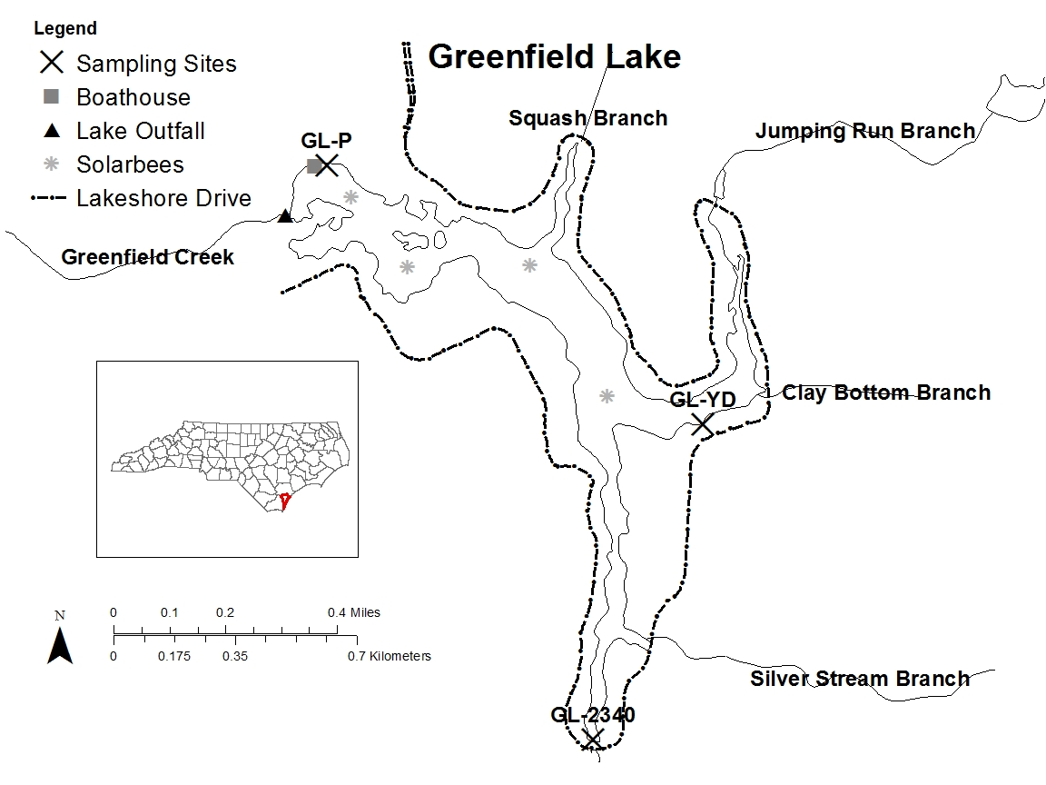

Figure 1. Map of Greenfield Lake, Wilmington, North Carolina, showing at least five principal tributaries and locations of UNCW in-lake long-term monitoring stations.

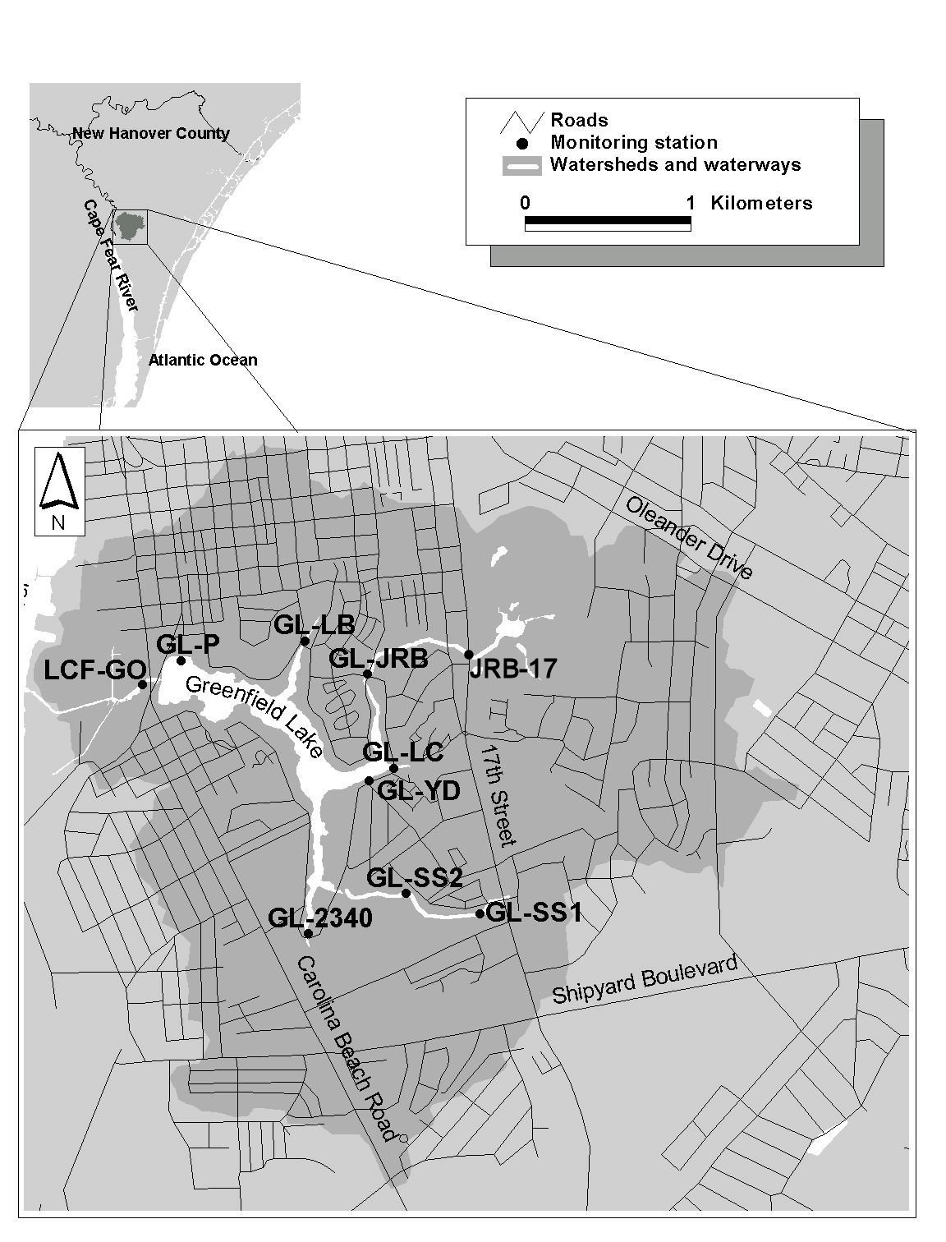
Figure 2. Greenfield lake watershed showing UNCW monitoring stations and the extensive urbanization impacting the tributaries and lake.

