Shoreline Stabilization Application Form

Three copies of the application (including attachments) and the application fee should be sent to:
If sending via US Postal Service | If sending via delivery service (UPS, FedEx, etc.)
Karen Higgins  DWR – 401 & Buffer Permitting Branch  1617 Mail Service Center  Raleigh, NC 27699-1617 | Karen Higgins  DWR – 401 & Buffer Permitting Branch  512 N. Salisbury Street  Raleigh, NC 27604

- Applicant Information [15A NCAC 02H .0502(a)]
1. Owner Information
Name:
Mailing Address:

Telephone Number: Fax Number:
E-mail Address:
2. Agent/ Contact Person Information
A signed and dated copy of the Agent Authorization letter must be attached if the Agent has signed this application form. (A form can be downloaded here: http://www.saw.usace.army.mil/Portals/59/docs/regulatory/regdocs/Permits/SAMPLE_AGENT_AUTHORIZATION_FORM.pdf)
Name:
Company Affiliation:
Mailing Address:

Telephone Number: Fax Number:
E-mail Address:

- Project Information [15A NCAC 02H .0502(a) & (b)]
- Attach a vicinity map (i.e. street map) clearly showing the location of the property with respect to local landmarks such as towns, rivers, and roads.
- Provide a detailed site plan showing property boundaries and proposed locations of vegetation clearing, buildings, retaining walls, docks, impervious surfaces, rip rap, excavation or dredging below Full Pond/ Normal Water Level elevations, and construction access corridors. You may use the diagram provided at the end of this application form.
- Attach a photograph of the shoreline/ buffer proposed to be stabilized. (Include a scale of some sort- a yard stick, shovel handle, etc.)
- Location of the property (where work is to be conducted)
County: Nearest Town:
Lake/ river/ ocean adjacent to property:
Property size (acres):
Subdivision name or site address (include phase/lot number):
Directions to site - please include road names and numbers, landmarks, etc.:
Latitude (in decimal degrees) Longitude (decimal degrees)
- Describe the existing land use or condition of the site at the time of this application (residential, undeveloped, etc.):
- Describe proposed work (include discussion as to how hardening of shoreline has been avoided, or why it is necessary):
- Will work be conducted from land? From water?
- Total amount of impacts below the normal pool lake level / Normal Water Level
Permanent impacts (including all excavation, backfill, rip rap, retaining walls, etc.) in square feet: _____
Temporary impacts in square feet:
_____

- Total amount of impacts above the normal pool lake level / Normal Water Level and 50 feet land-ward
Permanent impacts (including back fill, excavation, rip rap, retaining walls, etc.) in square feet: _____
Temporary impacts (temporary clearing, construction corridor) in square feet:
_____

- Please describe the vegetation above the normal pool lake level/ Normal Water Level and 50 feet landward to be impacted (number of trees, for instance):
- Signature

Owner/Agent's Signature* [15A NCAC 02H .0502(f)] Date
*Agent's signature is valid only if an authorization letter from the owner is provided.
- Please approximately sketch the following information on this plan and provide dimensions for each item:
  - All proposed vegetation clearing
  - Location of rip rap or fill to be placed above the Full Pond/ Normal Water Level elevation
  - Location of rip rap or fill to be placed below the Full Pond/ Normal Water Level elevation
  - Location of any proposed structures such as buildings, retaining walls, docks, etc.
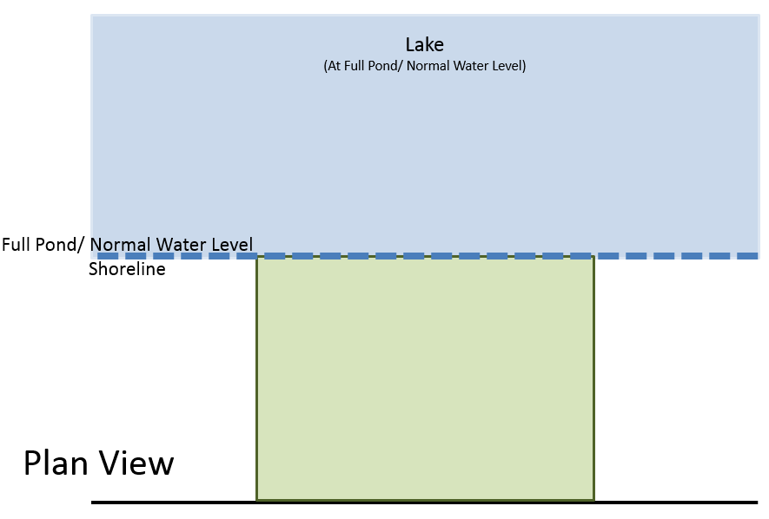
  - Location of any excavation or dredging below the Full Pond/ Normal Water Level elevation
