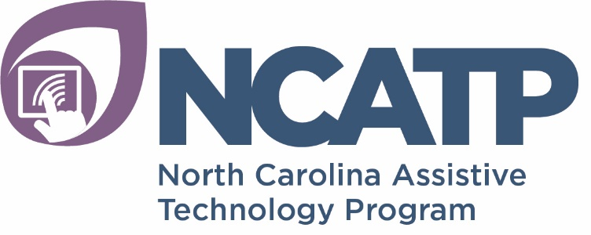

Payment for Services Agreement

TO: NC ASSISTIVE TECHNOLOGY PROGRAM

Thank you for choosing NCATP to provide your Augmentative Communication/Assistive Technology (AT) services. We are committed to providing the best services possible. Please review this entire policy before signing. If you have ANY questions, please contact the NCATP Intake Coordinator at 919-855-3613 and we would be happy to speak with you.

By signing this financial policy, you understand that as the patient or legal guardian, you are ultimately responsible for payment of all services rendered. Charges are based on established rates and a quote can be supplied if needed. By signing this financial policy, you understand and agree to any charges for assessment and training related to this service. You certify that the information you have provided for the purpose of payment is, to the best of your knowledge, complete and accurate. It is your responsibility to notify NCATP if billing or insurance information changes during the course of service.

Important Notes about Medicaid
As of January 1, 2020, NCATP is no longer an NC Medicaid provider.

My funding options have been explained to me and I am choosing to pay for the services I am requesting from NCATP. In consideration of the services to be rendered, I am the authorized representative and agree to pay NCATP for all services supplied to ________________________, including travel.

I understand that I am ultimately responsible for payment of services and that I will be invoiced for services received.

________________________________________ ____________________
Signature of Patient or Authorized Representative Date

__________________________________________ _____________________
Name of Patient & Authorized Representative (print) Date

April 2011
Rev.8/8/17-tdk
Rev.2/19/2020

