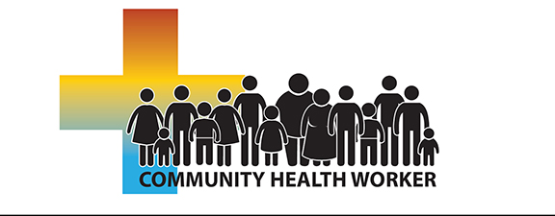
Presents
North Carolina
Community Health Worker Online
May 17, 2021 – August 30, 2021
This course is designed to provide individuals with the required knowledge, tools, and resources to become recognized as a certified Community Health Worker (CHW) in North Carolina, working in a variety of healthcare and community settings. (Health Departments, Hospitals, Federally Qualified Health Centers, Clinics, Faith-based Organizations, etc.) Upon successful completion of this class, student will be eligible for listing as a NC Certified Community Health Worker.
LOCATION: Online, Blackboard, LMS
REGISTRATION: www.robeson.edu/healtho/ Then press “Click to Register”
CONTACT: Christy Locklear @ 910-272-3609 chlocklear@robeson.edu
Required Course Material: Foundations for Community Health Workers: ISBN 978-1-119-0681-9
PRE-REQUISITES: High School Diploma or GED
Cost: $182 Registration Fee (That does not include cost of textbook)

