TEXT to 9-1-1
NOW AVAILABLE
In Rutherford County

CALL IF YOU CAN,
ONLY
TEXT WHEN YOU CAN’T
ALWAYS GIVE YOUR
LOCATION!

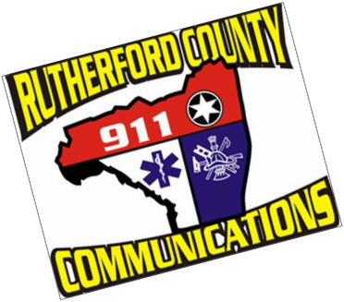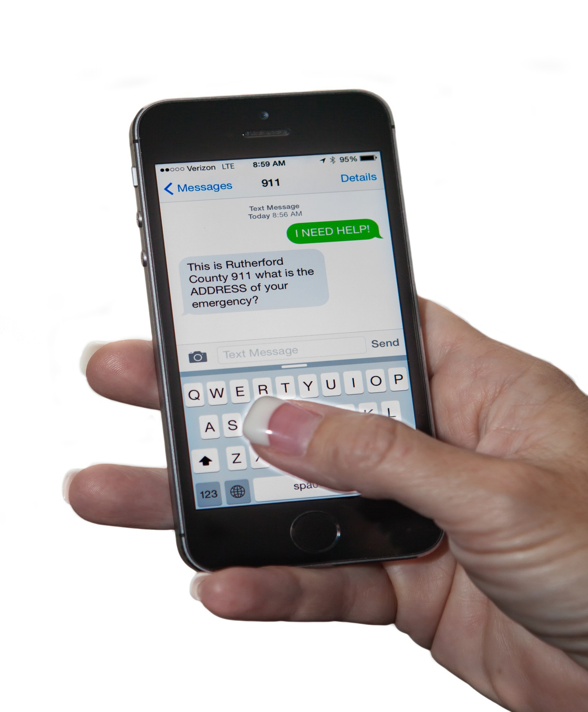

Available
from the following wireless carriers…

AT&T Sprint
T-Mobile
Verizon

Rutherford County Sheriff’s Office - Sheriff Chris Francis

For more information please visit www.rutherfordcountync.gov/….

