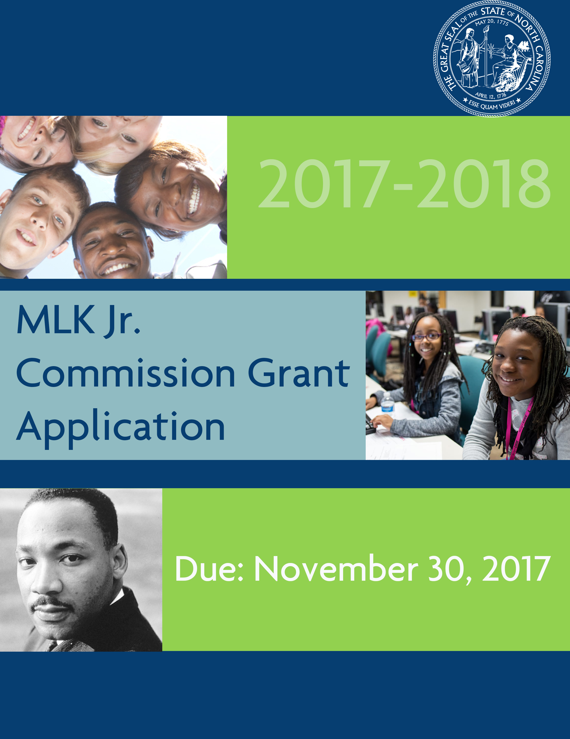

FY2017 Martin Luther King Jr. Commission Grant Request for Proposal

The North Carolina Martin Luther King, Jr. Commission is seeking applications for its FY 2017-18 grant program. The Commission has been authorized by the North Carolina General Assembly to award grants that promote an awareness and appreciation of the life and philosophy of Dr. Martin Luther King, Jr. The theme of the FY 2017 Martin Luther King, Jr. Grant Program is “Nonviolence in our Communities,” as described in a quote from Dr. King:

“Nonviolence is a powerful and just weapon, which cuts without wounding and ennobles the man who wields it.

It is a sword that heals.” – MLK Jr.

Purpose of the Martin Luther King, Jr. Grant Program
The overall goals of the program are to engage children in peer-to-peer educational activities that disseminate information about the life and philosophy of Dr. Martin Luther King, Jr. and to capture the outcomes of such activities. The program anticipates that, through these activities, young children will understand the life and teachings of Dr. King.

This year the Commission is requesting that eligible applicants submit a proposal that will focus on awareness and educational activities that lift Dr. King’s philosophy of nonviolence toward ourselves, others and the world. Activities should focus on reaching children under 14 and provided detailed narratives about activities relevant to their target area and target population. Applicants may also benefit from documenting how these activities may be replicated to serve as a model for other target areas across the state and country. The North Carolina Martin Luther King, Jr. Commission is interested in engaging local faith, community and other partners that are actively working to promote nonviolence and to think creatively about activities that will disseminate information about Dr. King’s philosophy.
Eligible activities could include, but are not limited to:
- developing and delivering replicable school performances about the positive aspects of non-violence behavior
- utilizing performances or other media to present the peer-to-peer counseling that is effective in reducing the long-range emotional and physical impacts of bullying; recommending guidance for handling situations where bullying exists
- creating mentoring and / or tutorial programs to enhance learning for special needs children
- offering local/regional oratorical competitions for middle-school children and providing awards for the winners
- launching an educational School Bowl that includes questions and answers about Dr. King’s life, his speeches, his philosophy and the applications of his philosophy to everyday life and providing awards for winners;
- delivering a competitive poster competition; and coordinating with local/regional art events to offer visibility for winners of the competition;
- offering presentations to exemplify the advantages of living and working in a culturally diverse environment;
- developing and implementing projects to reach Limited English Proficiency (LEP) populations;
- conducting research and developing a paper about the relationship between Dr. King’s philosophy and its impact on the increasing cultural diversity North Carolina will be experiencing in the next decades; delivering a presentation on this topic;

Department of Administration
MLK Jr. Commission
Mini-Grant Application FY 2017-2018
Eligibility Requirements
To qualify for a grant, applicant organizations should:

- Be a local government agency, or 501(c)(3) non-profit organization registered with the North Carolina Secretary of State.
- The Commission desires to reach geographically diverse groups and applicants are encouraged to partner with other organizations within a region such as a local Youth Council, Human Relations Commission, Urban League, or community college to design and implement programs to maximize the number of children and families reached in their region.
- Include proposal specifics that illustrate how the program will impact 50 or more youth. Programs intended to develop Internet based tools should articulate the potential number of youth likely to engage in the technology.
- Involve youth in project development, implementation, evaluation and writing of grant proposals.
- Present a corporate seal if your organization is incorporated. The corporate seal will be required on the contract if application is approved for funding.
Application Requirements
The application is fill-in. Complete the application, print, and sign.

- All funding requests should not be less than $200.00 and not more than $1000.00.
- Grant applications (three (3) stapled copies) must be received in the Department of Administration Office by 5:00pm on November 30, 2017.
- Non-profit organizations must submit a letter of reference with the application. This letter may come from a local government official or the sponsoring agency director and must be signed by that person. Applications without reference letters will be eligible for consideration.
- Funds must be used to directly fund the project and cannot be used for expenses such as clothing, salaries, entertainment, gifts, or food.
- In partnership with the State Youth program FY 17-18 issue priorities, programs targeting non-violence, peer pressure, bullying, character development impacting youth will receive additional consideration.

Applications will be reviewed, rated and recommended by a Subcommittee of the North Carolina Martin Luther King Jr. Commission. Rating criteria will include:
  - Purpose / Objective: Project Overview, need of target area and estimated number of the target population
  - Work Plan: Project specifics such as delivery method, location of proposed activities and any information of planned partner collaboration and project support from multicultural organizations.
  - Leveraged Resources: Summary of resources leveraged to supplement the grant funding. Ex monetary or in-kind contributions, donated venue space, technical expertise. The applicant is encouraged to submit a letter of commitment from each organization providing in-kind resources, detailing the desired commitment. Ability to secure leveraged resources is not a requirement for rating of the application but it is preferred.
  - Outcomes: Project Specifics on proposed benefit to community that details number of children reached, involvement of culturally diverse children and methods used to track and document desired outcomes.

a. Progress & Annual reports must be submitted to the NC Department of Administration, per the NC Executive Budget Act requirements for the use of state funds. Those reports will include name of organization, address, scope of work, outcome of the project and total expenditures. Portions of these reports will appear in the State’s uniform grants reporting tool, NC Grants. Instructions and Technical support will be provided to Grant awardees to assist with this requirement
Grant Requirements
- Project must be completed within 120 days of designated completion date as documented in the Program Description.
- Source of project funds (North Carolina Martin Luther King Jr. Commission) must be stated in all documents, publications, media, and oral or visual presentations related to the project.
Disbursement of Grant Funds
- Funds can be dispersed within 30 days after the approval of the contract.
- Consider when requesting a grant that you will receive your funds in early 2018.

Return Completed Application Packet to one of the addresses below:

You may mail your application by US Postal Service to:
The NC Martin Luther King, Jr. Commission,
Department of Administration
1301 Mail Service Center,
Raleigh, NC 27699-1301

You may send your application by overnight delivery to:
The NC Martin Luther King, Jr. Commission
Department of Administration
116 West Jones Street
Raleigh, NC 27603

Statutory Charge for the NC Martin Luther King, Jr. Commission
General Statutes 143B-426.34A. Martin Luther King, Jr. Commission – creation; powers and duties.
There is hereby created the Martin Luther King, Jr. Commission of the Department of Administration. The Martin Luther King, Jr. Commission shall have the following functions and duties:
(1) To encourage appropriate ceremonies and activities throughout the State relating to the observance of the legal holiday honoring Martin Luther King, Jr.'s birthday;
(2) To provide advice and assistance to local governments and private organizations across the State with respect to the observance of such holiday; and
(3) To promote among the people of North Carolina an awareness and appreciation of the life and work of Martin Luther King, Jr. (1993, c. 502.)

Name of Organization: Click or tap here to enter text.
FOR OFFICE USE ONLY
Date Received: _________________
No.: _________________
General Information

Federal Tax ID Number (TIN): Click or tap here to enter text.

Physical Address of Organization (Do not use P.O. Box): Click or tap here to enter text.

County: Click or tap here to enter text.

Web Address: Click or tap here to enter text.

Contact Person for Organization: Click or tap here to enter text.

Telephone Number of Contact Person: Click or tap here to enter text.

Email Address of Contact Person: Click or tap here to enter text.
The Organization
Are you a local government agency, or 501(c)(3)? Click or tap here to enter text.
If yes, please provide organizational name Click or tap here to enter text.

Age of Organization: Click or tap here to enter text.

Number of Youth Members: Click or tap here to enter text.

Ending date of organization’s fiscal year: Click or tap here to enter text.

Is the organization funded? ☐ Yes ☐ No
(If yes, give a brief statement of amount and purpose of funding)
Click or tap here to enter text.

Give a brief history of the organization. Click or tap here to enter text.

Have you previously received a Grant from the NC Department of Administration? ☐ Yes ☐ No
(If yes, when, and for what project? In 2-3 sentences, please describe the results of the project.)
Click or tap here to enter text.

Is your organization seeking funds from other sources? ☐ Yes ☐ No
If yes, list sources and amounts and 2-3 sentences.
Click or tap here to enter text.

Grant Amount Requested: Click or tap here to enter text.
The Project

Number of youth under 14 the project will serve: Click or tap here to enter text.

Age range of all youth to be served: Click or tap here to enter text.

Will project continue after all grant funds are exhausted? ☐ Yes ☐ No
(If yes, explain in 2-3 sentences how it will continue)
Click or tap here to enter text.

- Complete the itemized budget sheet included in this application. [see worksheet to follow]
- Complete the project description sheet included in this application. [see worksheet to follow]
Signatures and Verification of Review of Grant Application

By placing our signatures below, we hereby certify and confirm that this application provides accurate and true statement regarding the purpose and obligations of our agency. We further certify and confirm that we have read, reviewed, and understand all materials.

________________________________________________
Organization Chairperson Printed Name

_______________________________________________ __________________________________
Organization Chairperson Signature Date

If needed,

________________________________________________
Additional Organization Chairperson Printed Name

_______________________________________________ __________________________________
Additional Organization Chairperson Signature Date

Itemized Project Budget

Budget Items Cost
1 | Click or tap here to enter text.
2 | Click or tap here to enter text.
3 | Click or tap here to enter text.
4 | Click or tap here to enter text.
5 | Click or tap here to enter text.
6 | Click or tap here to enter text.
7 | Click or tap here to enter text.
8 | Click or tap here to enter text.
9 | Click or tap here to enter text.
10 | Click or tap here to enter text.
11 | Click or tap here to enter text.
12 | Click or tap here to enter text.
13 | Click or tap here to enter text.
14 | Click or tap here to enter text.
15 | Click or tap here to enter text.
 | Total | 0.00

Project Description

Give a detailed description of the project, stating purpose and goals. Also, give a project timetable, including specific dates.

Click or tap here to enter text.

