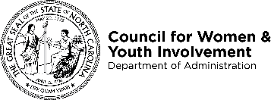
Domestic Violence Intervention Programs
Guidelines for Approved Programs Applying to Expand Their Service Area

Agencies that have been approved to provide Domestic Violence Intervention Program (DVIP) Services by the NC Council for Women and Youth Involvement may apply to expand their service area to new counties at any point during the year. The following guide will walk you through the expansion process for each date.
- If you are planning to expand your service area into a county that already has an approved Domestic Violence Intervention Program:
  - Speak with the DVIP Program Director (Lori Gerber, MS) at NC CFW & YI about the current number of program participants in that county and whether an additional program is needed.
  - Consider expanding into a county that does not currently have an approved DVIP, a list of approved DVIPs is available on our website.
In order to be approved for expansion, agencies are required to submit the following materials for each individual county included in the proposed expansion.
- Three (3) Letters of Support from agencies within the proposed county.
- A current (within 60 days of expansion application) memorandum of understanding (MOU) with the Victim Service Provider(s) within the proposed county.
- A completed Renewal Application cover sheet with new counties listed.
All information should be submitted to DVIP@doa.nc.gov.

