How To Search For a Surplus Transfer
AssetWorks

How to Search for a Surplus Transfer

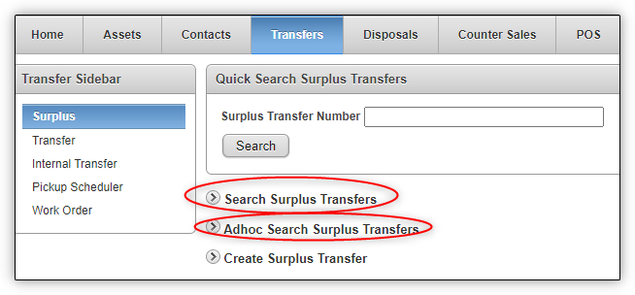

Searching for a Surplus Transfer
There are three ways to search for a surplus transfer from the Transfer>Surplus menu: Quick Search Surplus Transfers, Search Surplus Transfers, and Adhoc Search Surplus Transfers. We’ll discuss each of them below.

Quick Search Surplus Transfers
In order to quickly search for an existing surplus transfer by its Surplus Transfer Number, enter that number into the Quick Search Surplus Transfers box and press the Enter key or click the Search button.
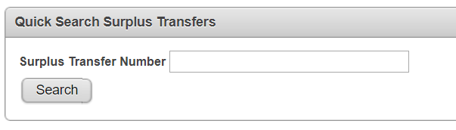

Search Surplus Transfers
To perform a more advanced search of existing surplus transfers, click the arrow to expand the Search Surplus Transfers region. This will open up the functionality and allow you to specify a wide variety of additional search criteria. Once you have chosen your search criteria, click the Search button.

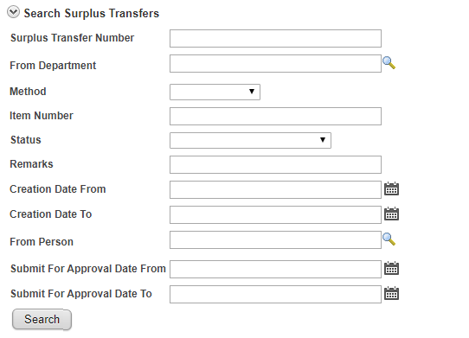

Adhoc Search Surplus Transfers
The Adhoc Search Surplus Transfer region personalizes your search, by allowing you to select which fields will be displayed. Click the arrow next to this option on the Transfer>Surplus page to reveal this functionality. The search defaults to a Primary Report option, which displays all open surplus transactions to a maximum of one year.
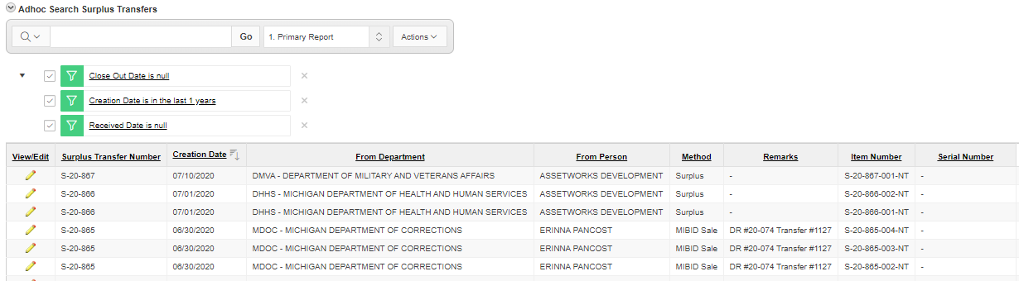

There are also six standard reports you can choose from, including Closed, No Assets Assigned, Rejected Assets, Waiting For Approval and Waiting For Receipt reports.
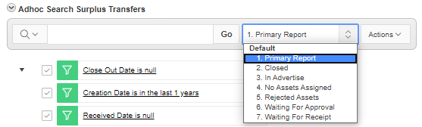

If you wish to localize your search, the system offers several filtering options. For example, all display columns are filterable and even more filtering options are available under the Actions menu.
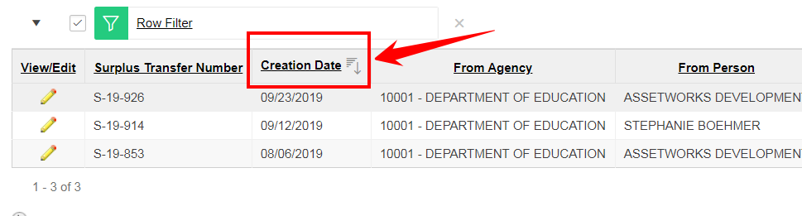

Related Content
- Only assets that are on a Surplus Transfer will show up in the Search results.
- You will only see assets within your approved Agency and Division.

