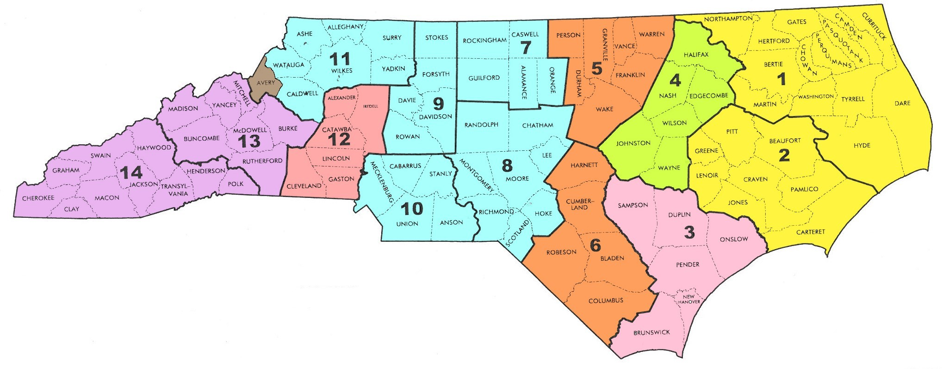
STATE OF NORTH CAROLINA
RECYCLING VENDORS BY REGION AS OF
July 01, 2019

REGIONS 1, 2: No Contracted Vendor
REGION 3: Encore Recycling, 910-590-5163
REGIONS 4: Wall Recycling, 919-828-5426
REGIONS 5, 6: DH Griffin Recycling, 336-855-7030
REGIONS 7, 8, 9, 10, 11: Holmes Iron and Metal, 704-633-6119
AVERY COUNTY: My County Metals, 828-765-5265
REGION 12: Morris Scrap Metal Co., 704-739-3869
REGIONS 13, 14: Biltmore Iron and Metal, 828-253-9317

Each Region has a single vendor to handle all of you scrap metal needs. This is a Mandatory Contract, for State Agencies, and a Convenience Contract for Non-State Agencies and LEA’s. You cannot use any vendor other than the contracted vendor. If you require a container at your facility, please contact the vendor. Containers are provided at no charge if your facility generates enough scrap to warrant a container. The container size should be something that you and the contractor agree on.

Questions may be directed to Stan Black @ State Surplus (919) 814-5612, stanley.black@doa.nc.gov
Region 8:
D H Griffin Recycling, Container Pick-up, 336-389-5413

Region 9:
Holmes Iron and Metal, Container Pick-up, 704-633-6119

Region 10:
Holmes Iron and Metal, Container Pick-up, 704-633-6119

Region 11:
Holmes Iron and Metal, Container Pick-up, 704-633-6119
**Avery County: My County Metals, 828-765-5265***
Region 12:
Morris Scrap Metal Co., Container Pick-up, 704-739-3869

Region 13:
Biltmore Iron and Metal, Container Pick-up, 800-253-9317

Region 14:
Biltmore Iron and Metal, Container Pick-up, 800-253-9317

Region 1:
No Contracted Vendor, Call Stan Black, 919-814-5612

Region 2:
No Contracted Vendor, Call Stan Black, 919-814-5612

Region 3:
Encore Recycling, Container Pick-up, 910-590-5163

Region 4:
Wall Recycling, Container Pick-up, 919-828-5426

Region 5:
D H Griffin Recycling, Container Pick-up, 336-855-7030

Region 6:
D H Griffin Recycling, Container Pick-up, 336-855-7030

Region 7:
Holmes Iron and Metal, Container Pick-up, 704-633-6119

