FEMA Region IV Office
Atlanta, Georgia
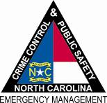

North Carolina Department of
Crime Control & Public Safety

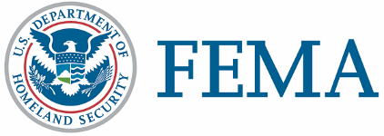

April 22, 2011
NC-1969 - NR-004
FEMA Media Contact: 770-220-5226
State Media Contact: 919-715-3747

News Release
DISASTER WORKERS KNOCKING ON DOORS IN SEVERAL COUNTIES
RALEIGH, N.C. – Community relations teams from the state of North Carolina and the Federal Emergency Management Agency (FEMA) are on foot in many storm-damaged counties, delivering recovery information to area residents who had losses from recent storms, tornadoes and flooding. They help storm survivors register for federal disaster assistance. FEMA team members wear FEMA shirts and photo IDs.
Assistance from FEMA could include:
  - Temporary housing - money to rent a different place to live.
  - Repairs - grants to repair some of the damage from the disaster that is not covered by insurance.
  - Other needs assistance - grants for necessary and serious needs caused by the disaster. This includes medical, dental, funeral, personal property, transportation, vehicle repair or replacement, moving and storage and other expenses that FEMA approves.
Those with losses in the following counties may register with FEMA: Bertie, Bladen, Craven, Cumberland, Currituck, Greene, Halifax, Harnett, Hertford, Hoke, Johnston, Lee, Onslow, Pitt, Robeson, Sampson, Wake and Wilson.
Team members also meet with community-based organizations, community leaders and public officials. When community relations workers learn about unmet needs, they pass the information to the state or federal staff best able to respond.
Affected residents and business owners in the designated counties may apply for assistance by calling FEMA's toll-free registration number, 800-621-FEMA (3362) or TTY 800-462-7585 for those with speech and hearing disabilities. Multilingual operators are available to assist with the application process. Registration lines are available from 7 a.m. to 10 p.m. An application may also be completed online by going to www.DisasterAssistance.gov.
Survivors can also apply for federal assistance directly through a web enabled mobile device or smartphone. Visit m.fema.gov and follow the link to “apply online for federal assistance.”
The U.S. Small Business Administration is offering low-interest disaster loans to homeowners and renters as well as business owners. Learn more at 800-659-2955.
(MORE)

DISASTER WORKERS KNOCKING ON DOORS IN SEVERAL COUNTIES – Page 2

FEMA’s mission is to support our citizens and first responders to ensure that as a nation we work together to build, sustain, and improve our capability to prepare for, protect against, respond to, recover from, and mitigate all hazards.

Disaster recovery assistance is available without regard to race, color, religion, nationality, sex, age, disability, English proficiency or economic status. If you or someone you know has been discriminated against, call FEMA toll-free at 800-621-FEMA (3362). For TTY call 800-462-7585.

FEMA’s temporary housing assistance and grants for public transportation expenses, medical and dental expenses, and funeral and burial expenses do not require individuals to apply for an SBA loan. However, applicants who receive SBA loan applications must submit them to SBA loan officers to be eligible for assistance that covers personal property, vehicle repair or replacement, and moving and storage expenses.

###

