FEMA Region IV Office
Atlanta, Georgia
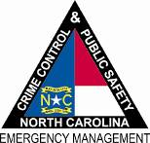

North Carolina Department of
Crime Control & Public Safety

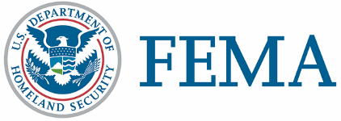

April 21, 2011
NC-1969 - NR - 002
FEMA Media Contact: 770-220-5226
State Media Contact: 919-715-3747

News Release

DISASTER RECOVERY CENTERS OPEN IN BERTIE AND CUMBERLAND COUNTIES
RALEIGH, N.C. – Disaster recovery centers opened Thursday in Bertie and Cumberland counties to help those whose homes or businesses were affected by recent storms and tornadoes. Centers will be open from 8 a.m. to 7 p.m. seven days a week at the following addresses:
Bertie County  Colerain Community Building  106 W. Academy St.  Colerain, NC 27924 | Cumberland County  Department of Social Services  1ST floor conference room  1225 Ramsey St.  Fayetteville, NC 28301
More centers will open soon in other counties designated for assistance.
Representatives from the Federal Emergency Management Agency, North Carolina Division of Emergency Management and other agencies are available to explain assistance programs and help survivors apply for disaster aid. Recovery specialists also help disaster survivors get in touch with other programs that may be able to help.
Before going to a center, people with storm losses should register with FEMA online at www.DisasterAssistance.gov or by calling 800-621-FEMA (3362). Those with speech or hearing impairment may call (TTY) 800-462-7585. Help is available in all languages.
Persons affected by the storms can also apply for federal assistance directly through a web enabled mobile device or smartphone. Visit m.fema.gov and follow the link to “apply online for federal assistance.”
Federal Disaster Assistance can include grants for rental assistance and home repairs, low-cost loans from the Small Business Administration to cover uninsured property losses and other programs to help recover from the effects of the disaster.
FEMA’s mission is to support our citizens and first responders to ensure that as a nation we work together to build, sustain, and improve our capability to prepare for, protect against, respond to, recover from, and mitigate all hazards.

(MORE)
DISASTER RECOVERY CENTERS OPEN – Page 2

Disaster recovery assistance is available without regard to race, color, religion, nationality, sex, age, disability, English proficiency or economic status. If you or someone you know has been discriminated against, call FEMA toll-free at 800-621-FEMA (3362). For TTY call 800-462-7585.

FEMA’s temporary housing assistance and grants for public transportation expenses, medical and dental expenses, and funeral and burial expenses do not require individuals to apply for an SBA loan. However, applicants who receive SBA loan applications must submit them to SBA loan officers to be eligible for assistance that covers personal property, vehicle repair or replacement, and moving and storage expenses.

###

