Joint Field Office
Raleigh, NC
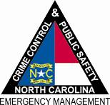

North Carolina Department of
Crime Control & Public Safety

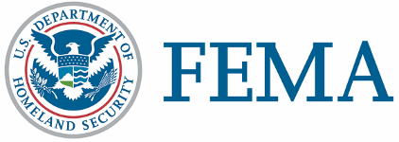

May 19, 2011
NC-1969 - NR- 048
FEMA Media Contact: 919-779-8371
State Media Contact: 919-715-3747

News Release

REGISTERING WITH VOLUNTEER AGENCIES NOT THE SAME AS FEMA

RALEIGH, N.C. – Have you called FEMA?

The Federal Emergency Management Agency, North Carolina Emergency Management and many other agencies and volunteer organizations are actively working to help survivors recover from the April 16 severe storms and tornadoes.

Since the disaster, more than 8,000 people have registered with FEMA for assistance, but many others have not signed in yet.

If you only called your county emergency manager or the Red Cross or some other voluntary agency, then you haven’t registered for federal disaster assistance.

The deadline to register is June 20.

Registering takes about 20 minutes either by phone, on the internet or with mobile devices.
Phone registration can be done between 7 a.m. and 10 p.m. daily. Call toll-free 800-621-FEMA (3362) or TTY 800-462-7585.

Applicants can also register online at www.DisasterAssistance.gov or with a web-enabled mobile device or smartphone. Visit m.fema.gov and follow the link to “apply online for federal assistance.”

Federal and state disaster assistance can include grants for rental assistance and home repairs, low-interest loans from the Small Business Administration to cover uninsured property losses, and other programs to help recover from the effects of the disaster.

For more information about this disaster, go to www.nccrimecontrol.org and click on the red “April Tornadoes” tab. More information is also available at www.fema.gov.

FEMA’s mission is to support our citizens and first responders to ensure that as a nation we work together to build, sustain, and improve our capability to prepare for, protect against, respond to, recover from, and mitigate all hazards.

FEMA’s temporary housing assistance and grants for medical and dental expenses, and funeral and burial expenses do not require individuals to apply for an SBA loan. However, applicants who receive SBA loan applications must submit them to SBA loan officers to be eligible for assistance that covers personal property, vehicle repair or replacement, and moving and storage expenses.
###

