NORTH CAROLINA

REGISTER

VOLUME 35 ● ISSUE 07 ● Pages 702 – 821

October 1, 2020

I. EXECUTIVE ORDERS

Executive Order No. 160-163 702 – 734

II. IN ADDITION

Health and Human Services, Department of – Notice of Application 735

III. PROPOSED RULES

Agriculture and Consumer Services, Department of

Plant Conservation Board 736 – 754

Public Safety, Department of

Alcoholic Beverage Control Commission 754 – 755

Environmental Quality, Department of

Environmental Management Commission 755 – 758

Marine Fisheries Commission 758 – 779

Wildlife Resources Commission 779 – 782

Public Instruction, Department of

Education, State Board of 782 – 783

Secretary of State, Department of

Department 783 – 784

Occupational Licensing Boards and Commissions

Landscape Contractors' Licensing Board 784 – 785

IV. APPROVED RULES 786 – 813

Agriculture and Consumer Services, Department of

Pesticide Board

Natural and Cultural Resources, Department of

Department

Public Safety, Department of

Crime Victims Compensation Commission

Environmental Quality, Department of

Environmental Management Commission

State Board of Education

Education, State Board of

Occupational Licensing Boards and Commissions

General Contractors, Licensing Board for

Cosmetic Art Examiners, Board of

Dental Examiners, Board of

Medical Board

State Human Resources Commission

State Human Resources Commission

V. RULES REVIEW COMMISSION 814 – 818

VI. CONTESTED CASE DECISIONS

Index to ALJ Decisions 819– 821

Contact List for Rulemaking Questions or Concerns

For questions or concerns regarding the Administrative Procedure Act or any of its components, consult with the agencies below. The bolded headings are typical issues which the given agency can address but are not inclusive.

Rule Notices, Filings, Register, Deadlines, Copies of Proposed Rules, etc.

Office of Administrative Hearings

Rules Division
1711 New Hope Church Road 984-236-1850
Raleigh, North Carolina 27609 984-236-1947 FAX

contact: Molly Masich, Codifier of Rules molly.masich@oah.nc.gov 984-236-1934
Dana McGhee, Publications Coordinator dana.mcghee@oah.nc.gov 984-236-1937
Lindsay Silvester, Editorial Assistant lindsay.silvester@oah.nc.gov 984-236-1938
Cathy Matthews-Thayer, Editorial Assistant cathy.thayer@oah.nc.gov 984-236-1901

Rule Review and Legal Issues

Rules Review Commission
1711 New Hope Church Road 984-236-1850
Raleigh, North Carolina 27609 984-236-1947 FAX

contact: Amber Cronk May, Commission Counsel amber.may@oah.nc.gov 984-236-1936
Amanda Reeder, Commission Counsel amanda.reeder@oah.nc.gov 984-236-1939
Ashley Snyder, Commission Counsel ashley.snyder@oah.nc.gov 984-236-1941
Karlene Turrentine, Commission Counsel karlene.turrentine@oah.nc.gov 984-236-1948
Alexander Burgos, Paralegal alexander.burgos@oah.nc.gov 984-236-1940
Julie Brincefield, Administrative Assistant julie.brincefield@oah.nc.gov 984-236-1935

Fiscal Notes & Economic Analysis

Office of State Budget and Management
116 West Jones Street
Raleigh, North Carolina 27603-8005
Contact: Carrie Hollis, Economic Analyst osbmruleanalysis@osbm.nc.gov 984-236-0689

NC Association of County Commissioners
215 North Dawson Street 919-715-2893
Raleigh, North Carolina 27603
contact: Amy Bason amy.bason@ncacc.org

NC League of Municipalities 919-715-4000
150 Fayetteville Street, Suite 300
Raleigh, North Carolina 27601
contact: Sarah Collins scollins@nclm.org

Legislative Process Concerning Rulemaking
545 Legislative Office Building
300 North Salisbury Street 919-733-2578
Raleigh, North Carolina 27611 919-715-5460 FAX

Jason Moran-Bates, Staff Attorney
Jeremy Ray, Staff Attorney

NORTH CAROLINA REGISTER
Publication Schedule for January 2020 – December 2020

FILING DEADLINES |  |  | NOTICE OF TEXT |  | PERMANENT RULE |  |  | TEMPORARY RULES
Volume & issue number | Issue date | Last day for filing | Earliest date for public hearing | End of required comment  Period | Deadline to submit to RRC  for review at  next meeting | RRC Meeting Date | Earliest Eff.  Date of  Permanent Rule | 270th day from publication in the Register
34:13 | 01/02/20 | 12/06/19 | 01/17/20 | 03/02/20 | 03/20/20 | 04/16/20 | 05/01/20 | 09/28/20
34:14 | 01/15/20 | 12/19/19 | 01/30/20 | 03/16/20 | 03/20/20 | 04/16/20 | 05/01/20 | 10/11/20
34:15 | 02/03/20 | 01/10/20 | 02/18/20 | 04/03/20 | 04/20/20 | 05/21/20 | 06/01/20 | 10/30/20
34:16 | 02/17/20 | 01/27/20 | 03/03/20 | 04/17/20 | 04/20/20 | 05/21/20 | 06/01/20 | 11/13/20
34:17 | 03/02/20 | 02/10/20 | 03/17/20 | 05/01/20 | 05/20/20 | 06/18/20 | 07/01/20 | 11/27/20
34:18 | 03/16/20 | 02/24/20 | 03/31/20 | 05/15/20 | 05/20/20 | 06/18/20 | 07/01/20 | 12/11/20
34:19 | 04/01/20 | 03/11/20 | 04/16/20 | 06/01/20 | 06/22/20 | 07/16/20 | 08/01/20 | 12/27/20
34:20 | 04/15/20 | 03/24/20 | 04/30/20 | 06/15/20 | 06/22/20 | 07/16/20 | 08/01/20 | 01/10/21
34:21 | 05/01/20 | 04/09/20 | 05/16/20 | 06/30/20 | 07/20/20 | 08/20/20 | 09/01/20 | 01/26/21
34:22 | 05/15/20 | 04/24/20 | 05/30/20 | 07/14/20 | 07/20/20 | 08/20/20 | 09/01/20 | 02/09/21
34:23 | 06/01/20 | 05/08/20 | 06/16/20 | 07/31/20 | 08/20/20 | 09/17/20 | 10/01/20 | 02/26/21
34:24 | 06/15/20 | 05/22/20 | 06/30/20 | 08/14/20 | 08/20/20 | 09/17/20 | 10/01/20 | 03/12/21
35:01 | 07/01/20 | 06/10/20 | 07/16/20 | 08/31/20 | 09/21/20 | 10/15/20 | 11/01/20 | 03/28/21
35:02 | 07/15/20 | 06/23/20 | 07/30/20 | 09/14/20 | 09/21/20 | 10/15/20 | 11/01/20 | 04/11/21
35:03 | 08/03/20 | 07/13/20 | 08/18/20 | 10/02/20 | 10/20/20 | 11/19/20 | 12/01/20 | 04/30/21
35:04 | 08/17/20 | 07/27/20 | 09/01/20 | 10/16/20 | 10/20/20 | 11/19/20 | 12/01/20 | 05/14/21
35:05 | 09/01/20 | 08/11/20 | 09/16/20 | 11/02/20 | 11/20/20 | 12/17/20 | 01/01/21 | 05/29/21
35:06 | 09/15/20 | 08/24/20 | 09/30/20 | 11/16/20 | 11/20/20 | 12/17/20 | 01/01/21 | 06/12/21
35:07 | 10/01/20 | 09/10/20 | 10/16/20 | 11/30/20 | 12/21/20 | 01/21/21 | 02/01/21 | 06/28/21
35:08 | 10/15/20 | 09/24/20 | 10/30/20 | 12/14/20 | 12/21/20 | 01/21/21 | 02/01/21 | 07/12/21
35:09 | 11/02/20 | 10/12/20 | 11/17/20 | 01/04/21 | 01/20/21 | 02/18/21 | 03/01/21 | 07/30/21
35:10 | 11/16/20 | 10/23/20 | 12/01/20 | 01/15/21 | 01/20/21 | 02/18/21 | 03/01/21 | 08/13/21
35:11 | 12/01/20 | 11/05/20 | 12/16/20 | 02/01/21 | 02/22/21 | 03/18/21 | 04/01/21 | 08/28/21
35:12 | 12/15/20 | 11/20/20 | 12/30/20 | 02/15/21 | 02/22/21 | 03/18/21 | 04/01/21 | 09/11/21

This document is prepared by the Office of Administrative Hearings as a public service and is not to be deemed binding or controlling.

EXPLANATION OF THE PUBLICATION SCHEDULE

This Publication Schedule is prepared by the Office of Administrative Hearings as a public service and the computation of time periods are not to be deemed binding or controlling. Time is computed according to 26 NCAC 2C .0302 and the Rules of Civil Procedure, Rule 6.

GENERAL

The North Carolina Register shall be published twice a month and contains the following information submitted for publication by a state agency:
(1) temporary rules;
(2) text of proposed rules;
(3) text of permanent rules approved by the Rules Review Commission;
(4) emergency rules
(5) Executive Orders of the Governor;
(6) final decision letters from the U.S. Attorney General concerning changes in laws affecting voting in a jurisdiction subject of Section 5 of the Voting Rights Act of 1965, as required by G.S. 120-30.9H; and
(7) other information the Codifier of Rules determines to be helpful to the public.

COMPUTING TIME: In computing time in the schedule, the day of publication of the North Carolina Register is not included. The last day of the period so computed is included, unless it is a Saturday, Sunday, or State holiday, in which event the period runs until the preceding day which is not a Saturday, Sunday, or State holiday.

FILING DEADLINES

ISSUE DATE: The Register is published on the first and fifteen of each month if the first or fifteenth of the month is not a Saturday, Sunday, or State holiday for employees mandated by the State Personnel Commission. If the first or fifteenth of any month is a Saturday, Sunday, or a holiday for State employees, the North Carolina Register issue for that day will be published on the day of that month after the first or fifteenth that is not a Saturday, Sunday, or holiday for State employees.

LAST DAY FOR FILING: The last day for filing for any issue is 15 days before the issue date excluding Saturdays, Sundays, and holidays for State employees.

NOTICE OF TEXT

EARLIEST DATE FOR PUBLIC HEARING: The hearing date shall be at least 15 days after the date a notice of the hearing is published.

END OF REQUIRED COMMENT PERIOD
An agency shall accept comments on the text of a proposed rule for at least 60 days after the text is published or until the date of any public hearings held on the proposed rule, whichever is longer.

DEADLINE TO SUBMIT TO THE RULES REVIEW COMMISSION: The Commission shall review a rule submitted to it on or before the twentieth of a month by the last day of the next month.

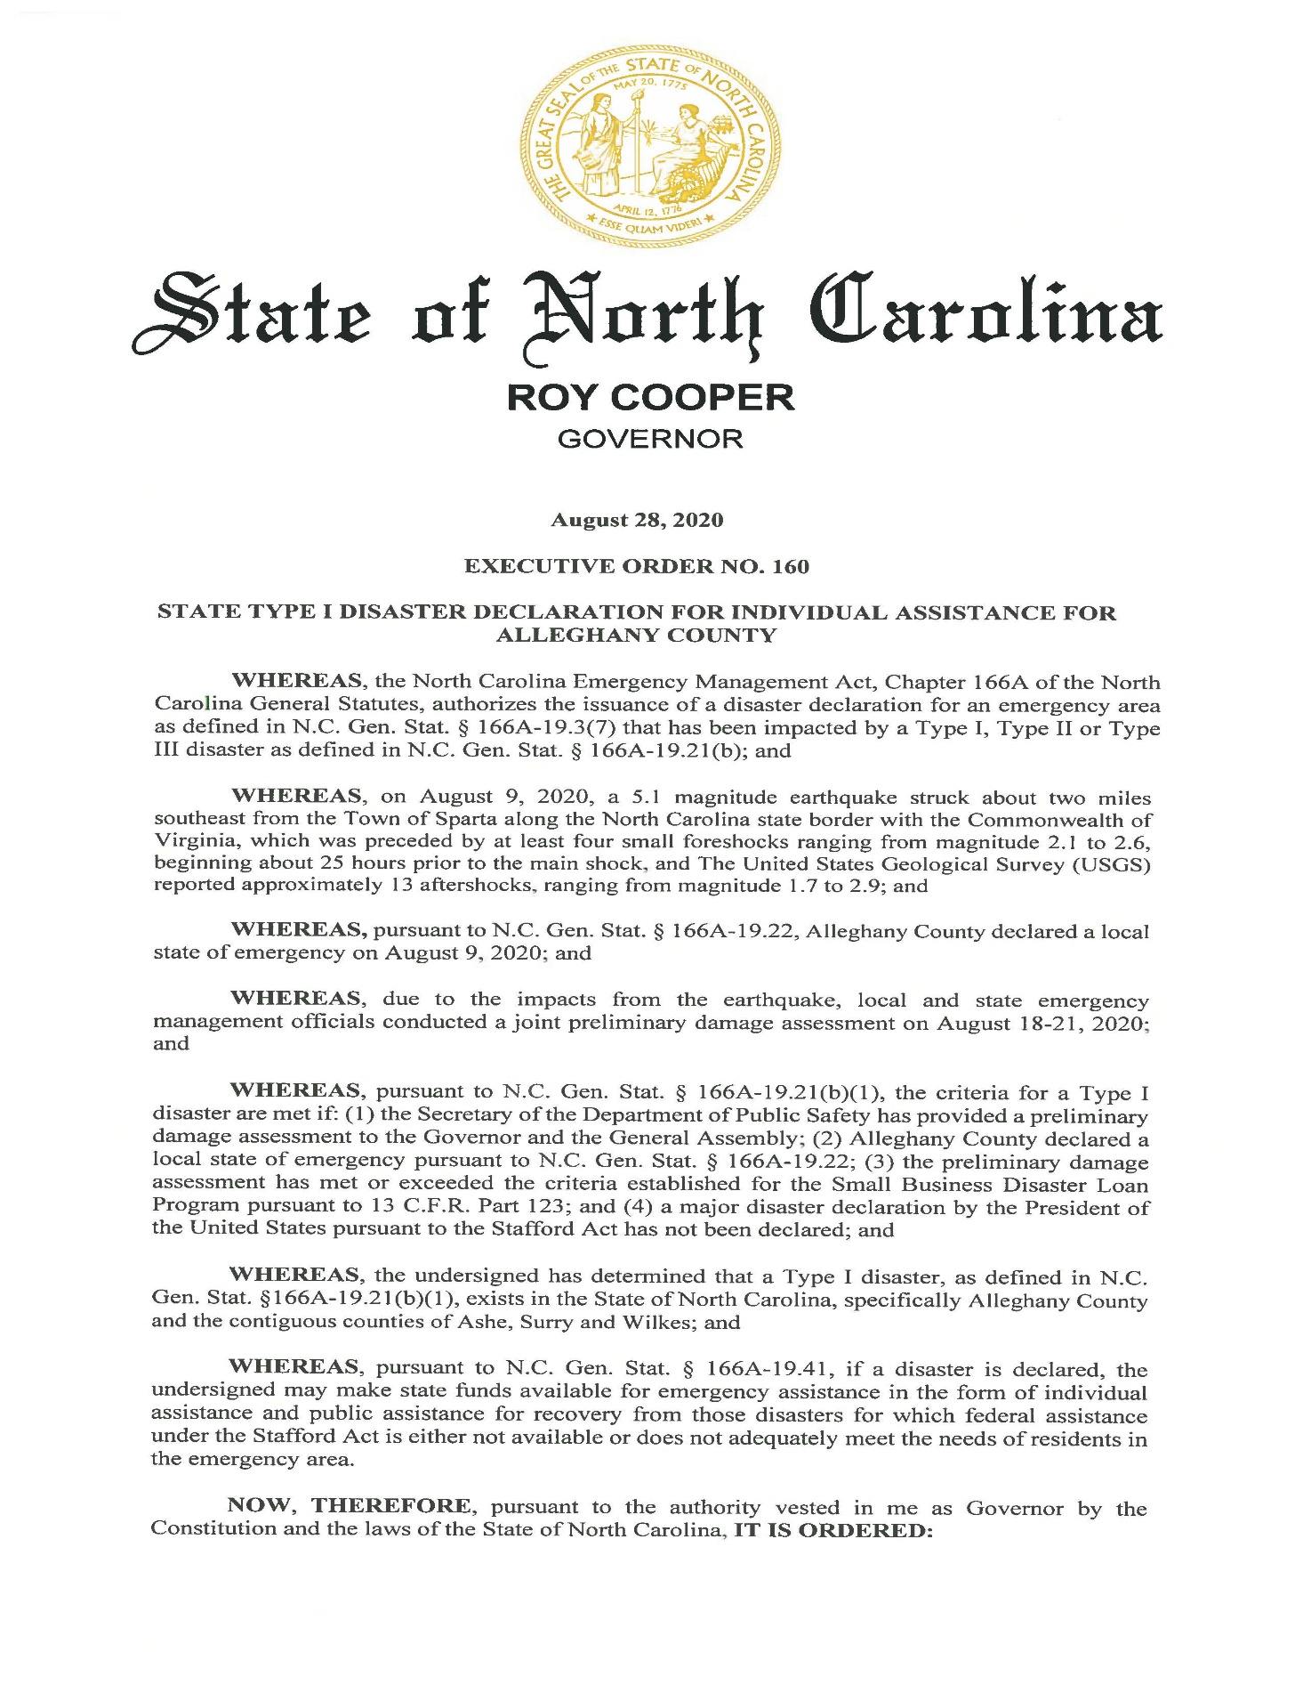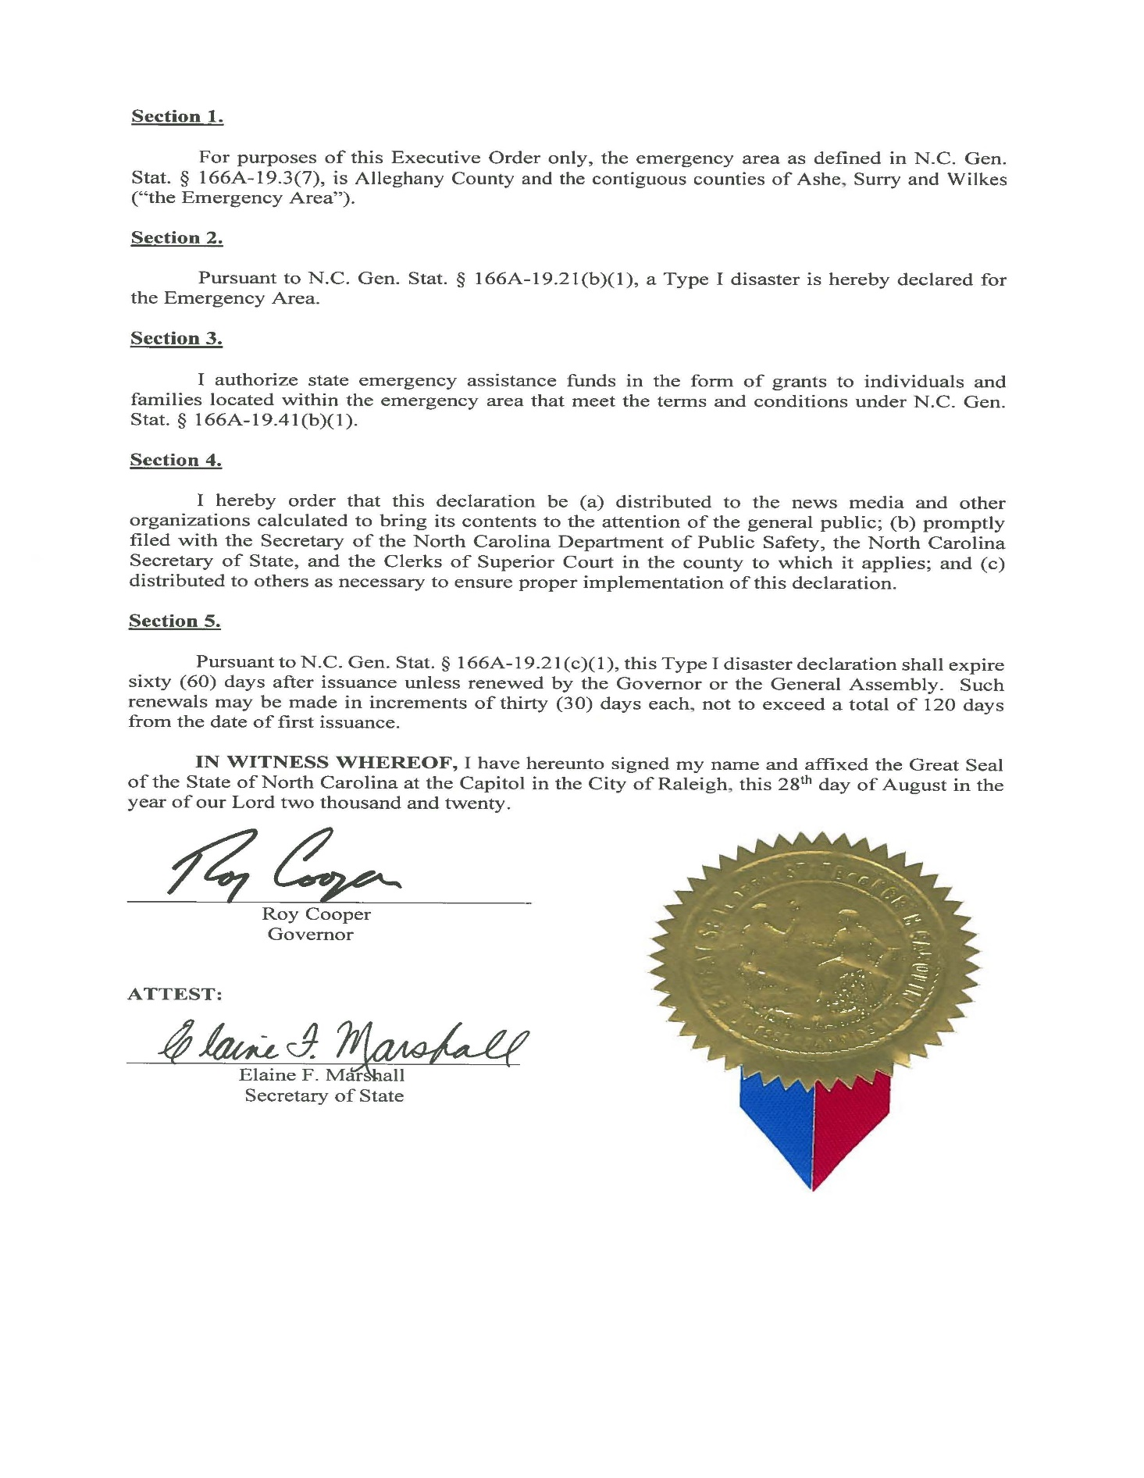
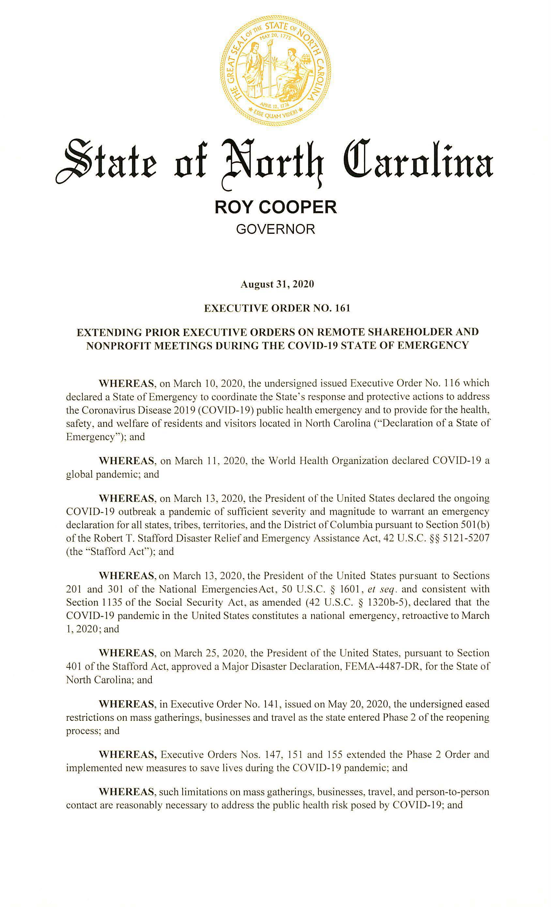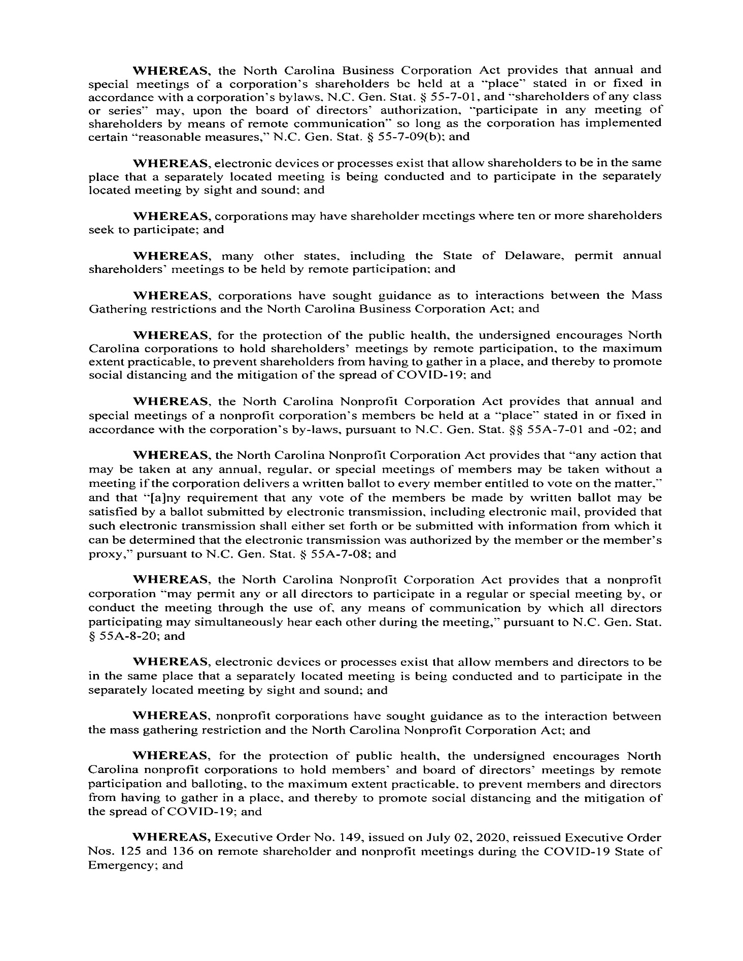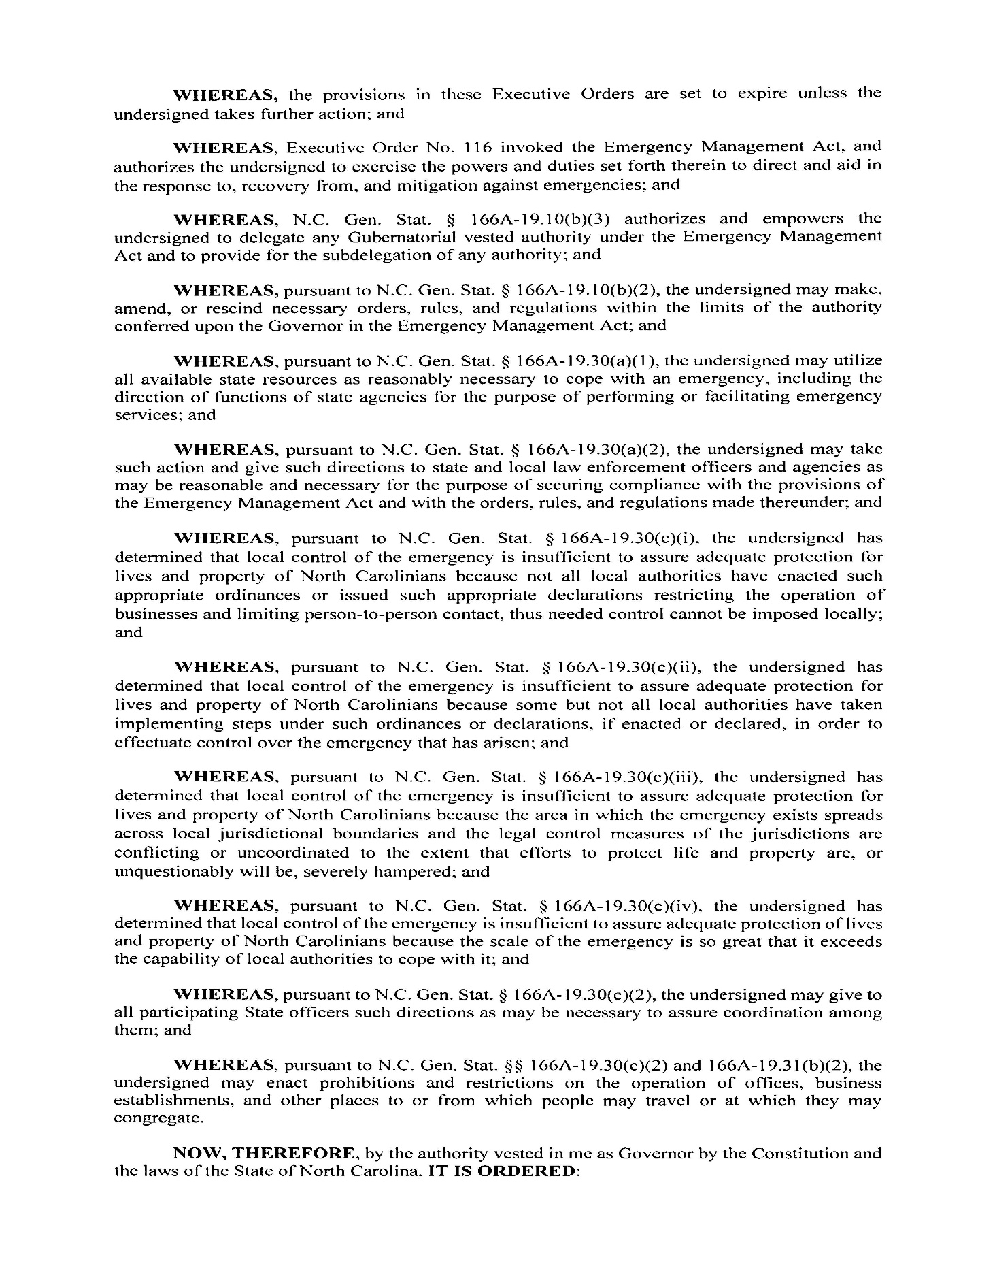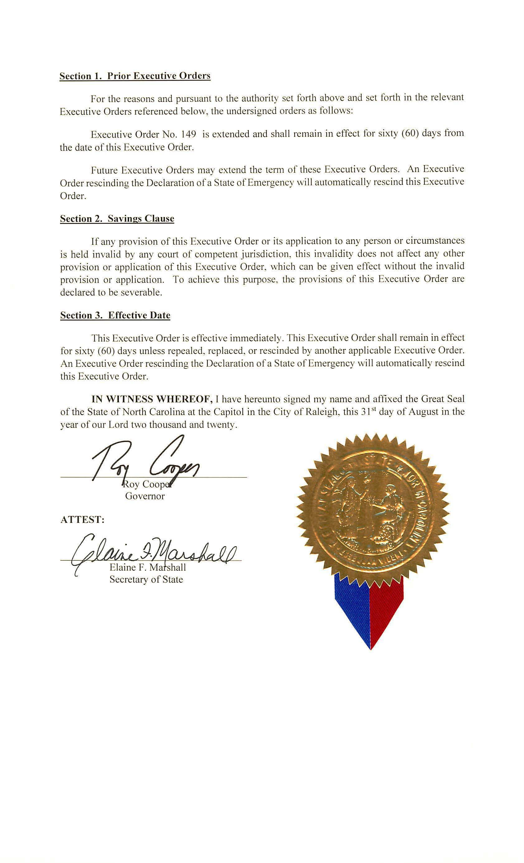
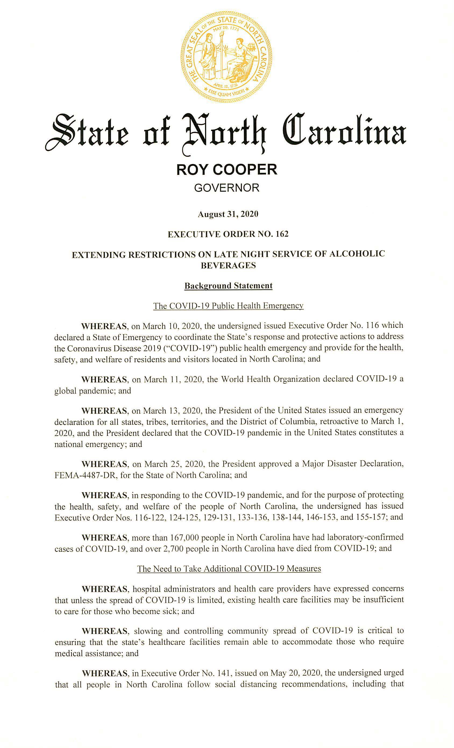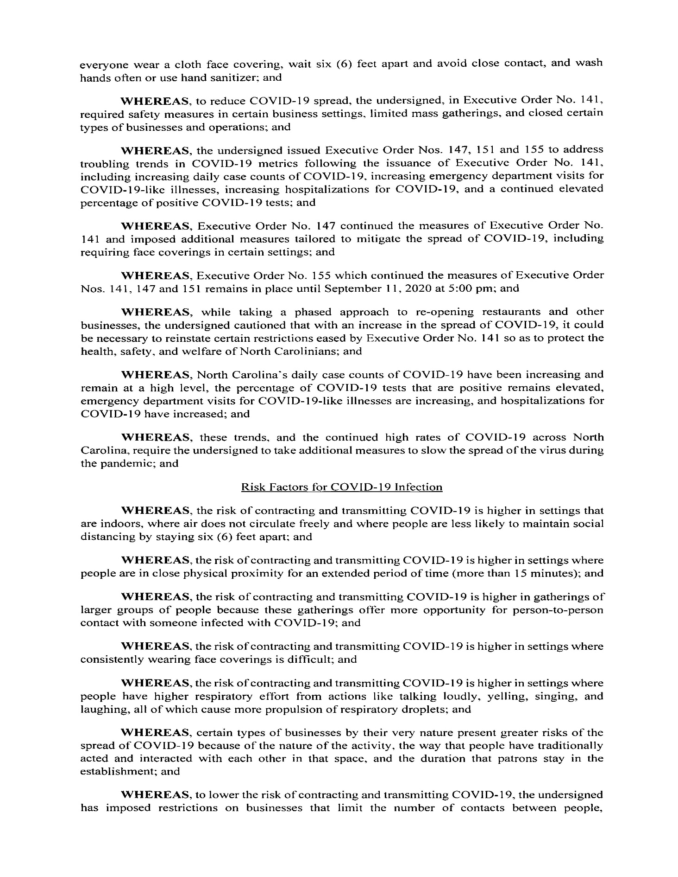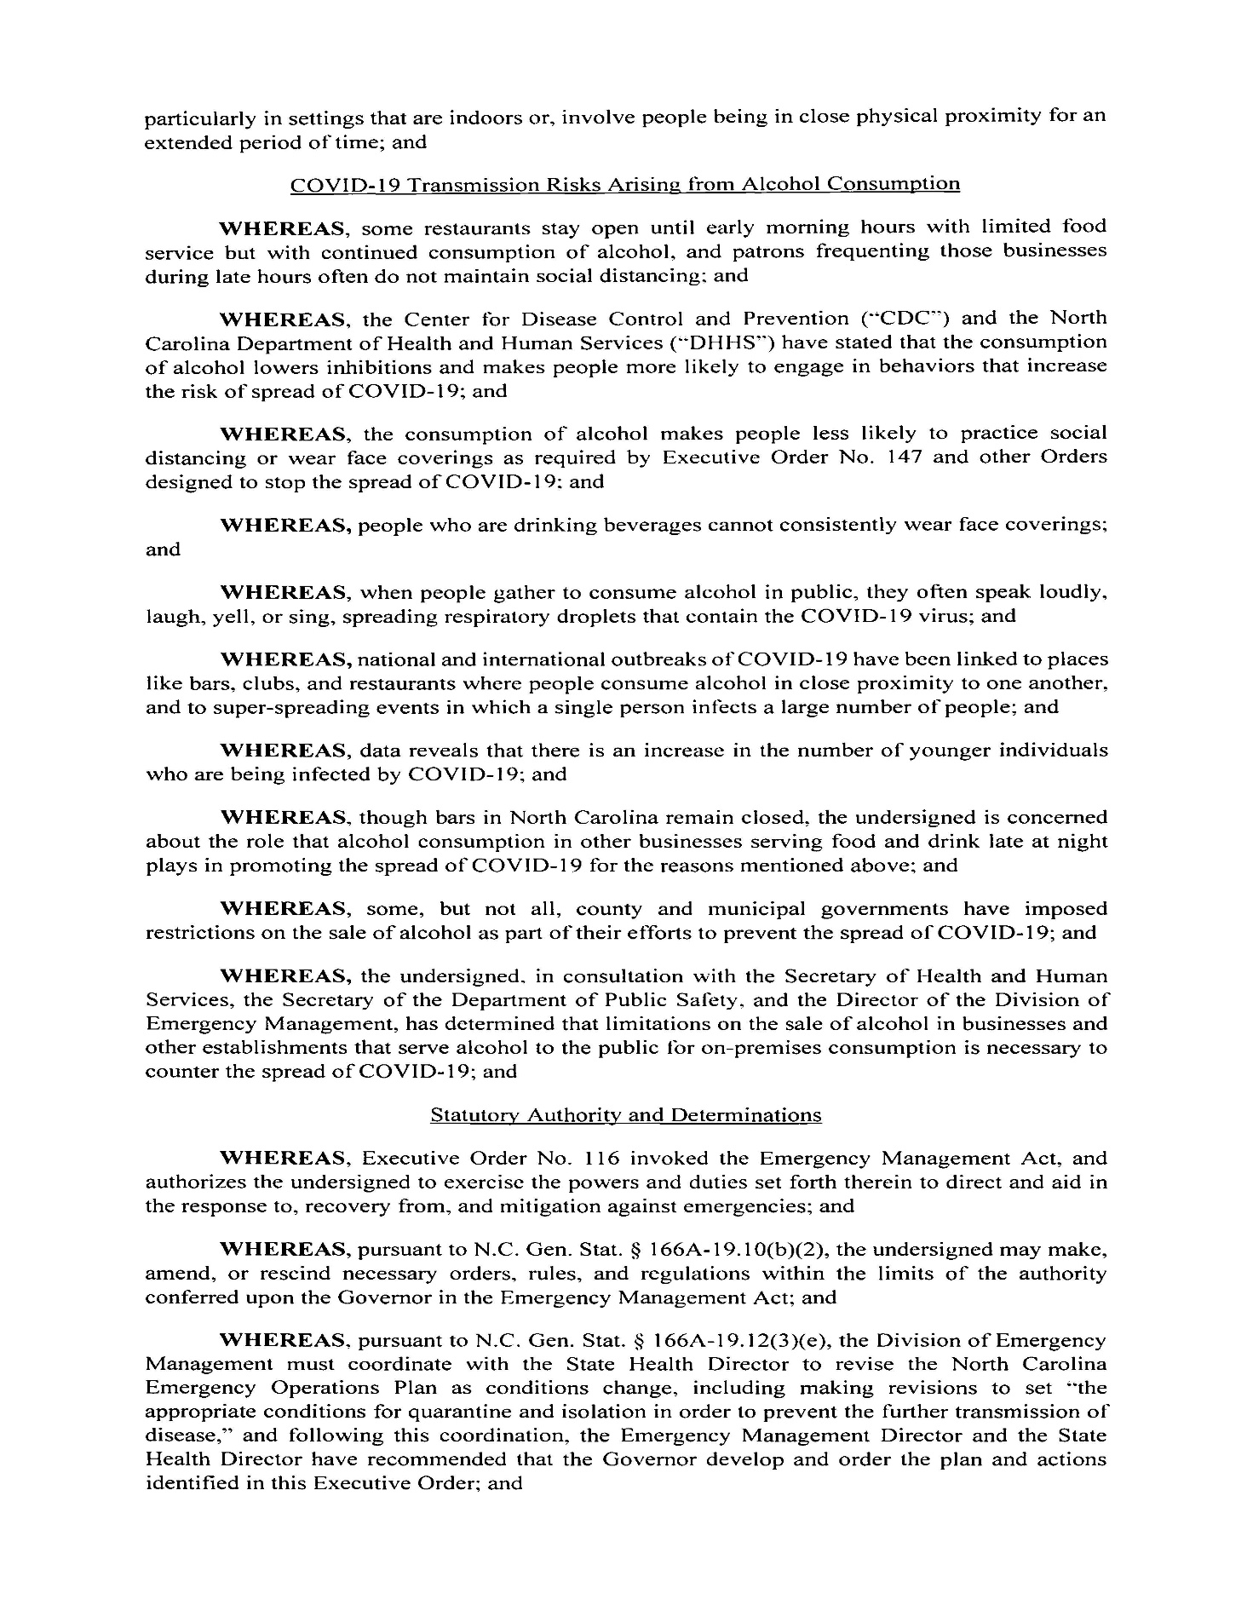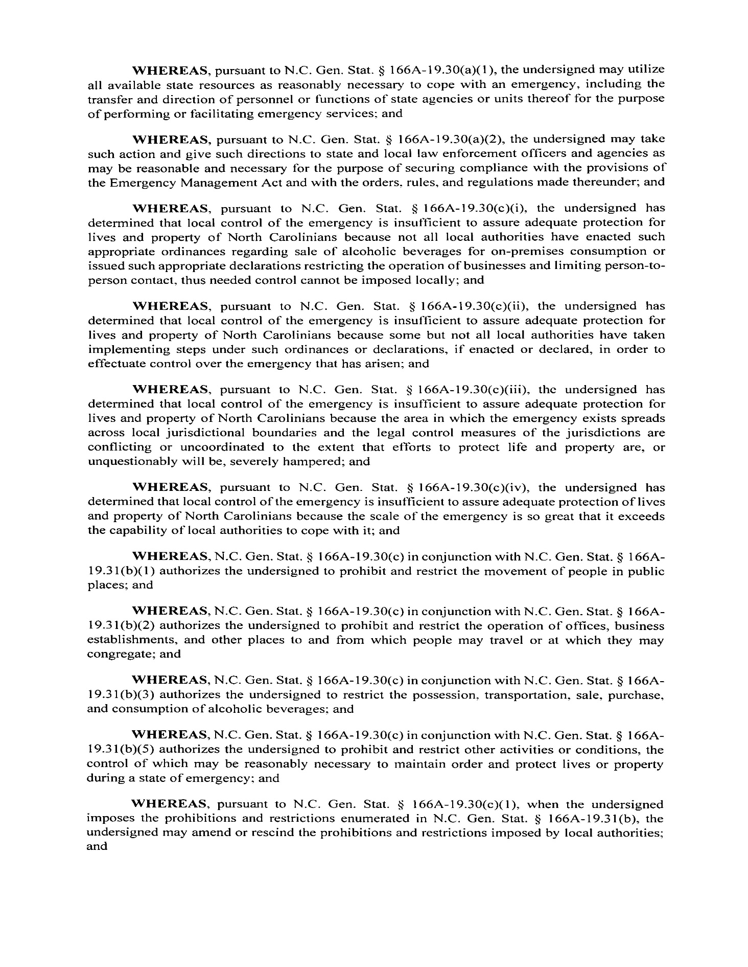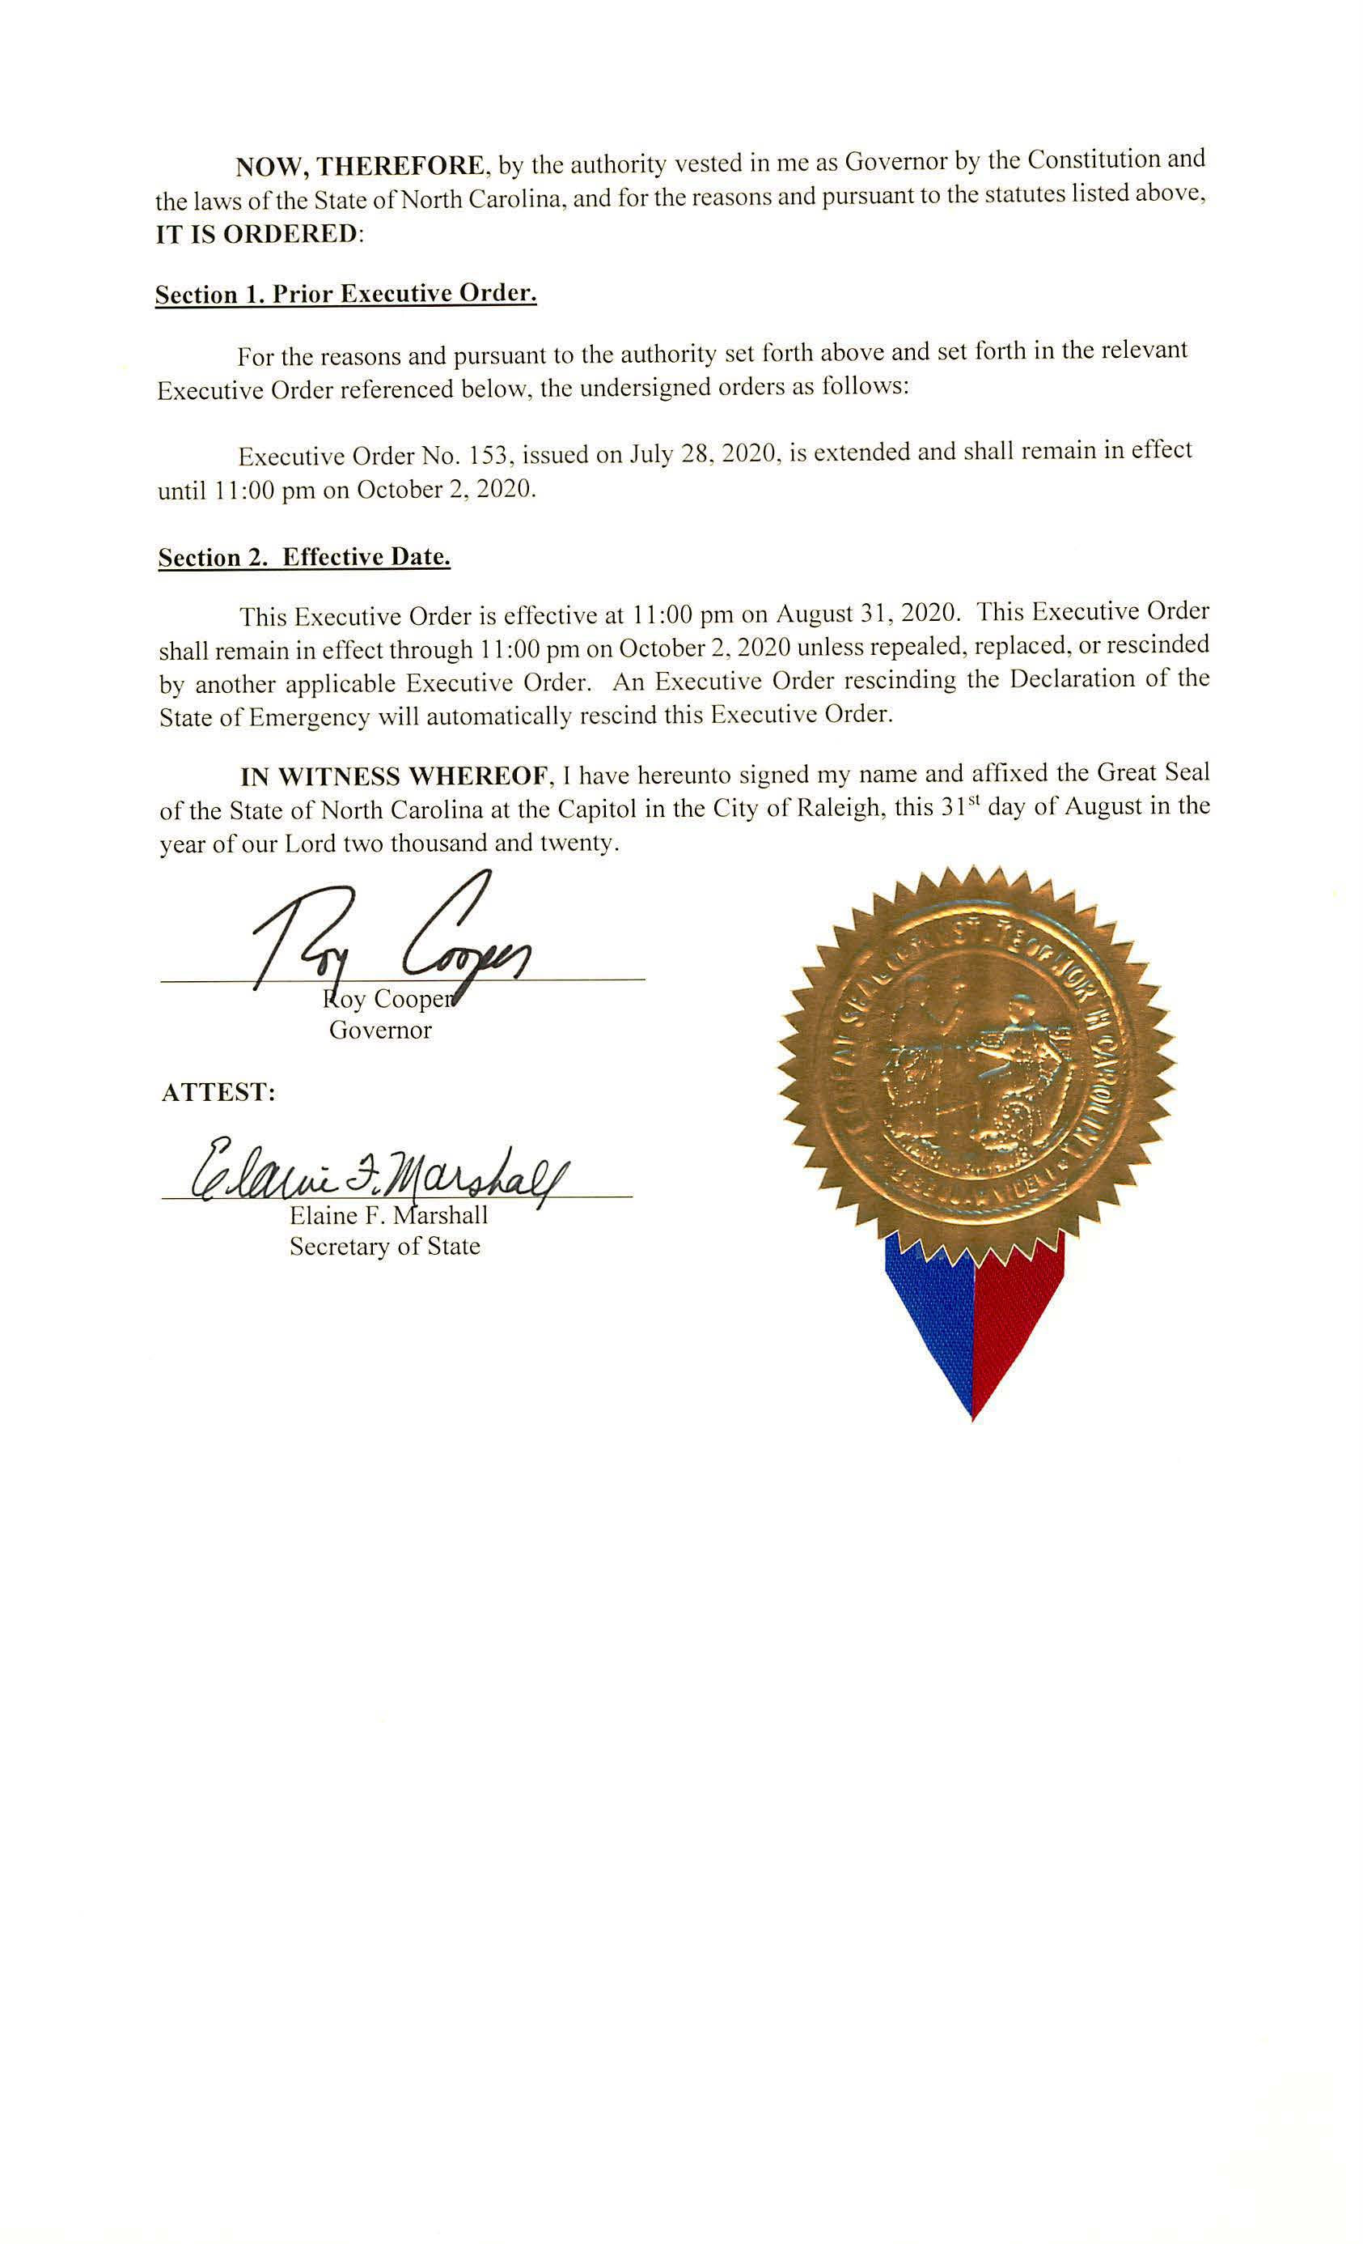
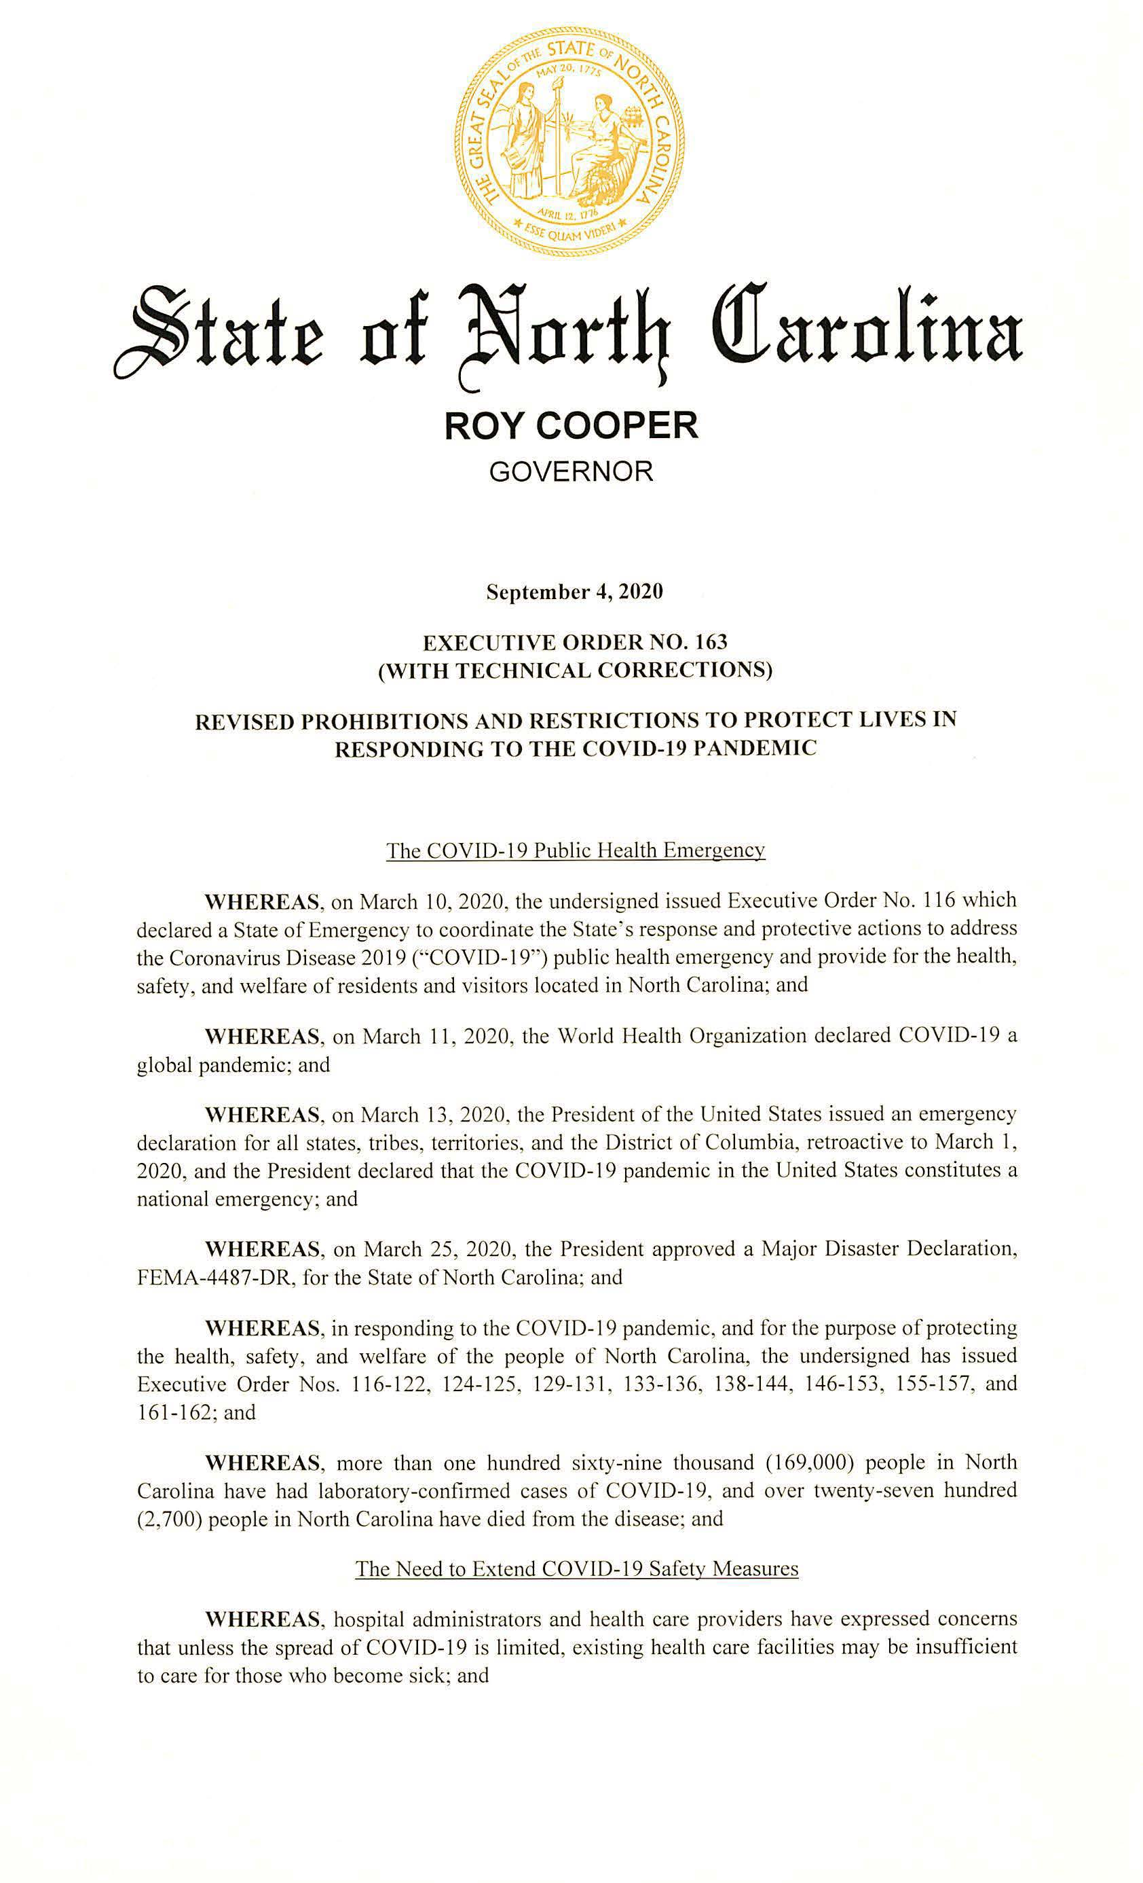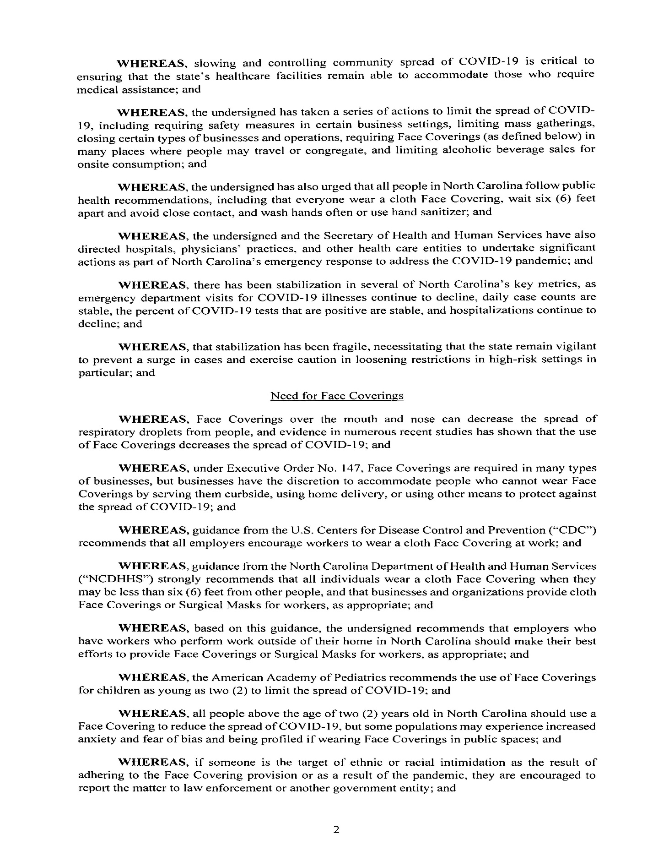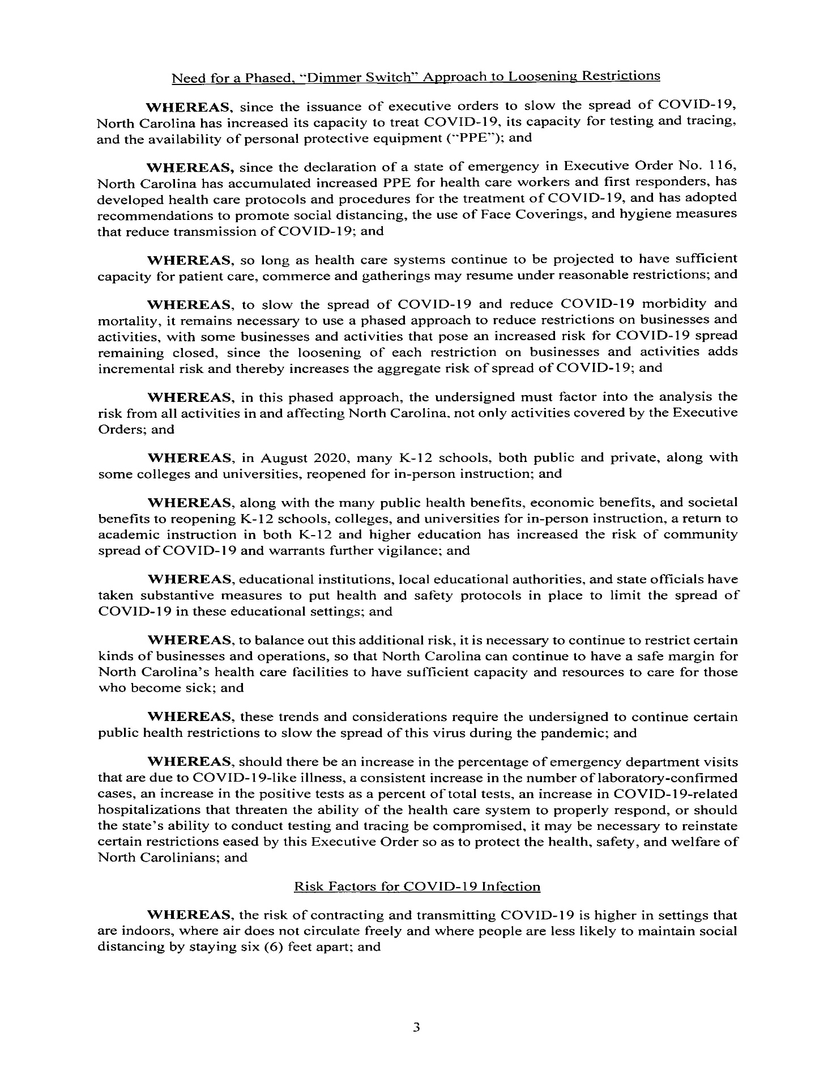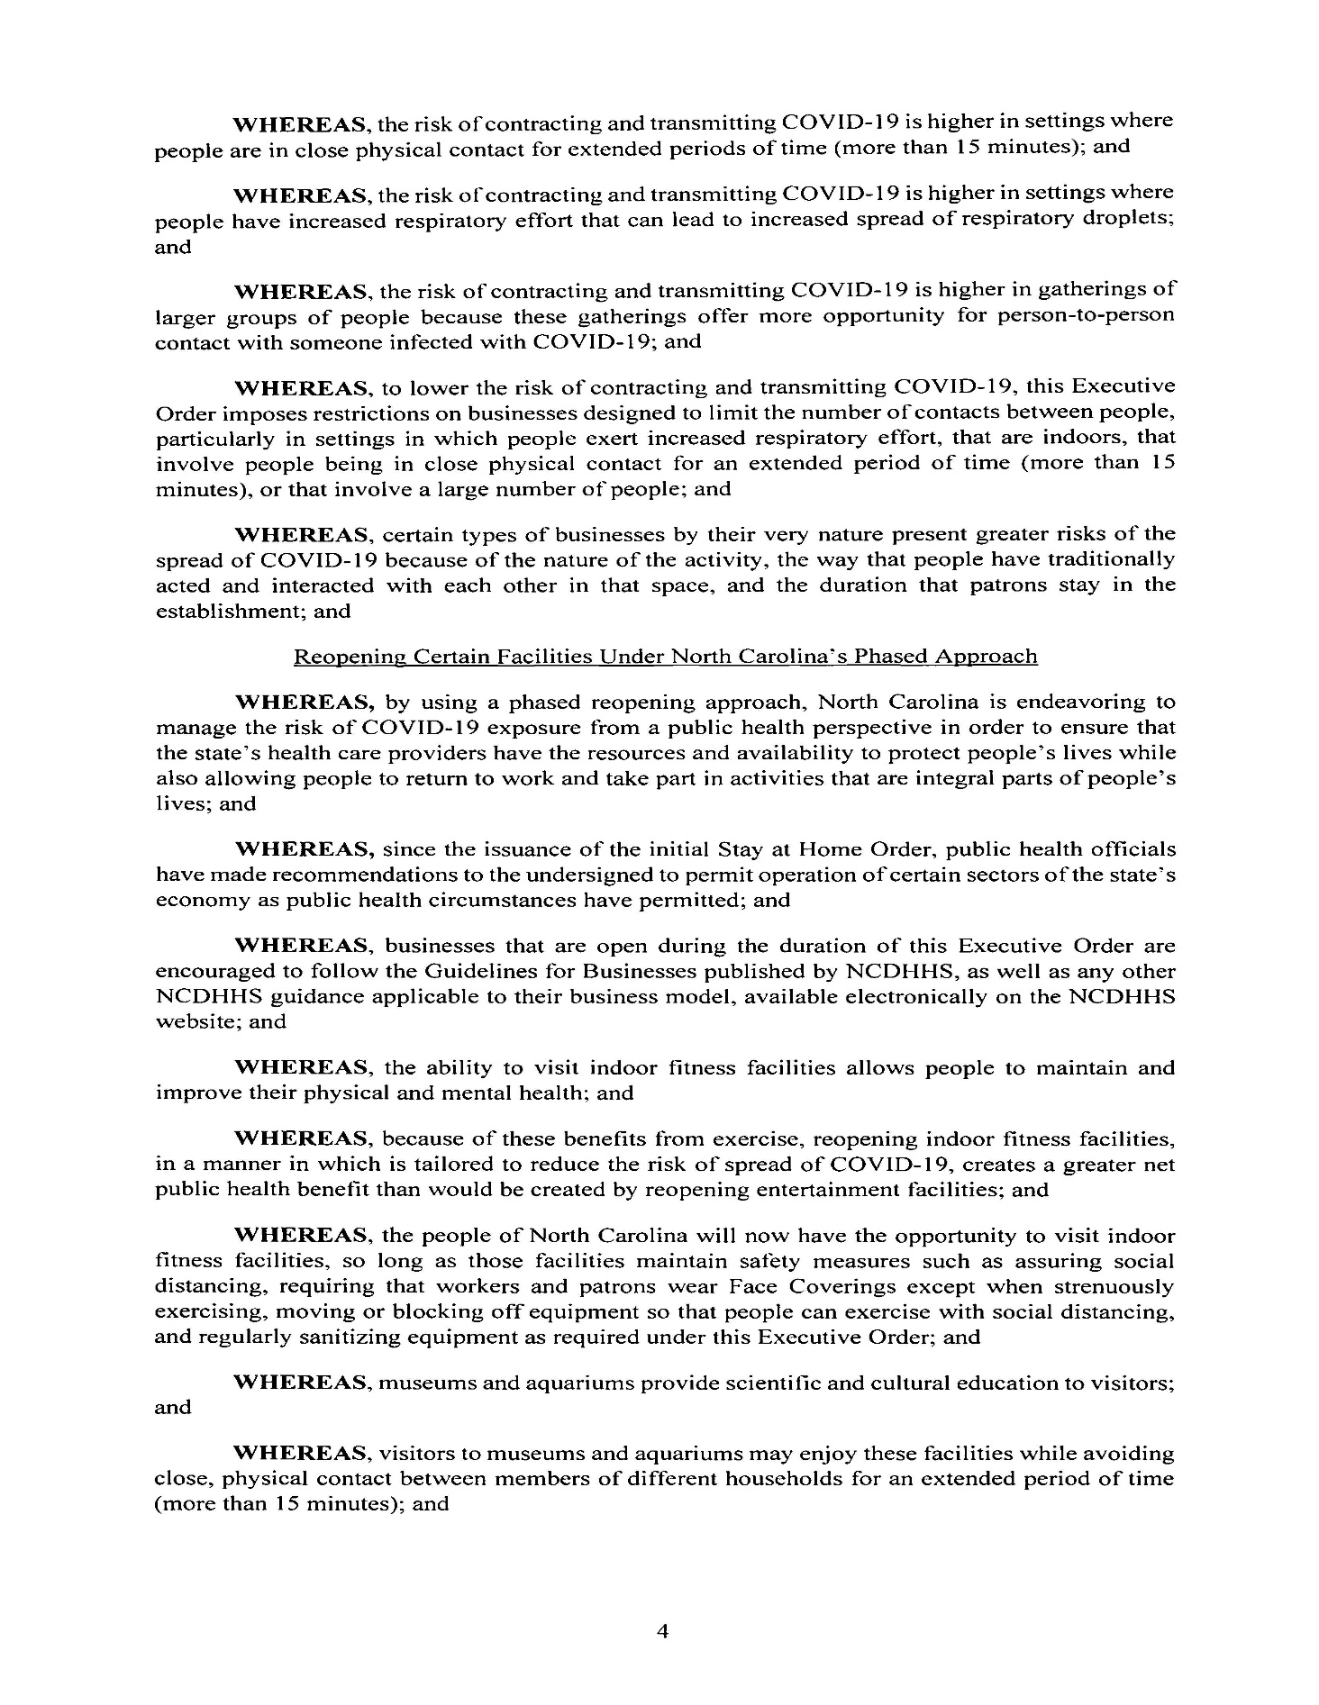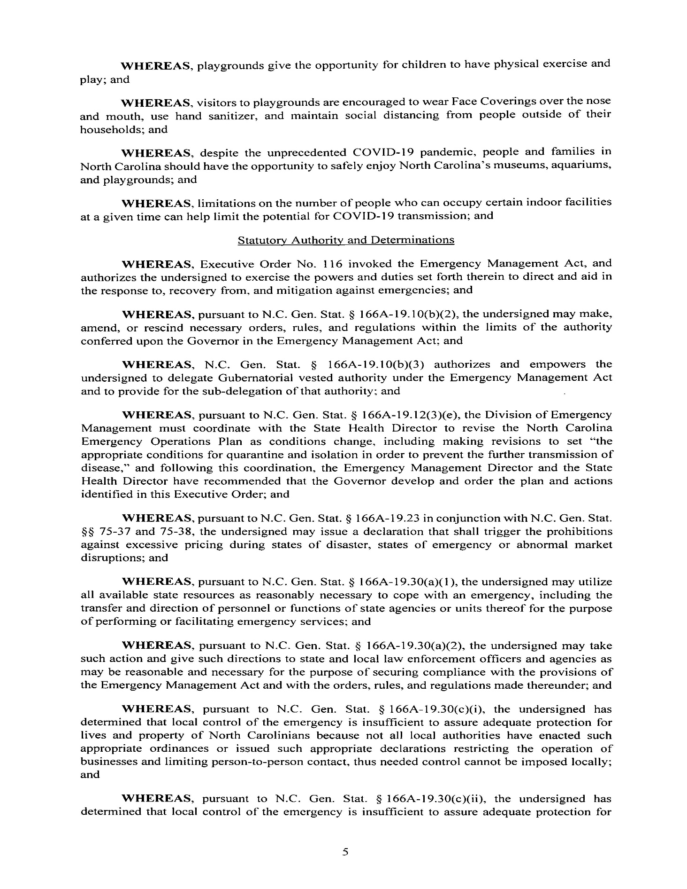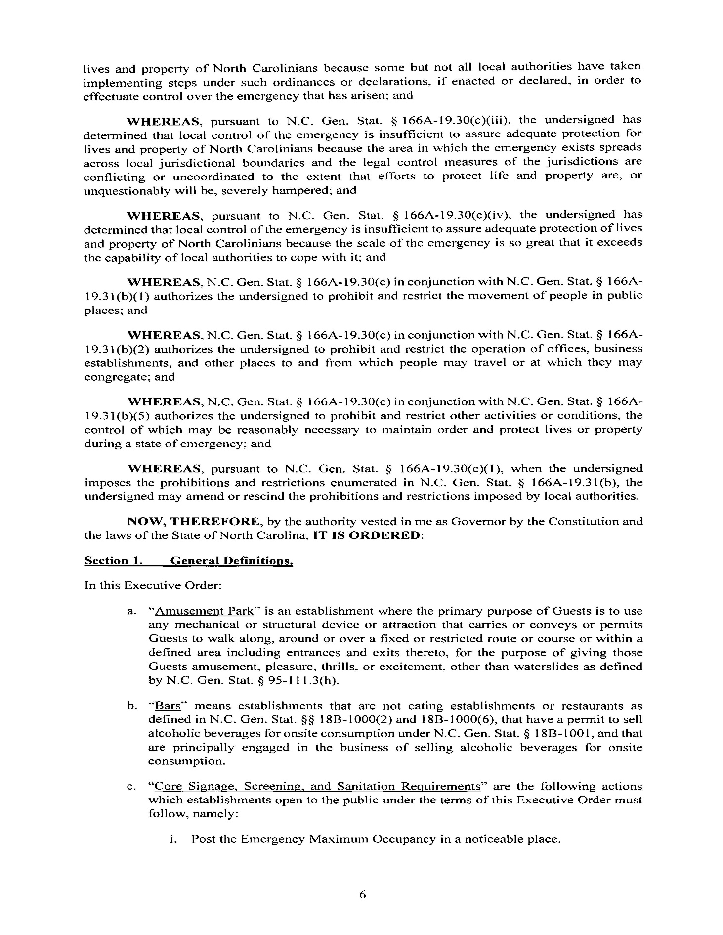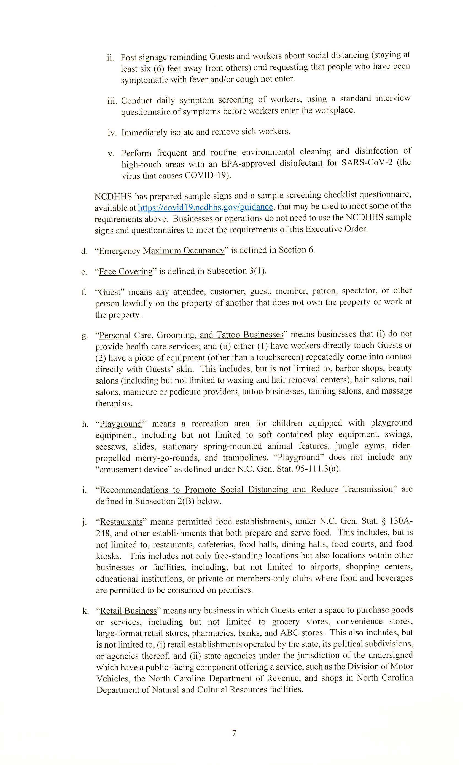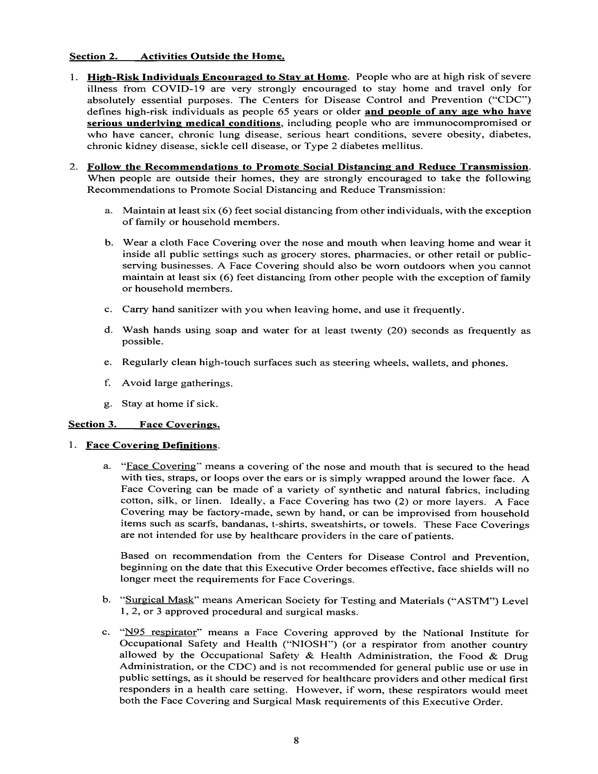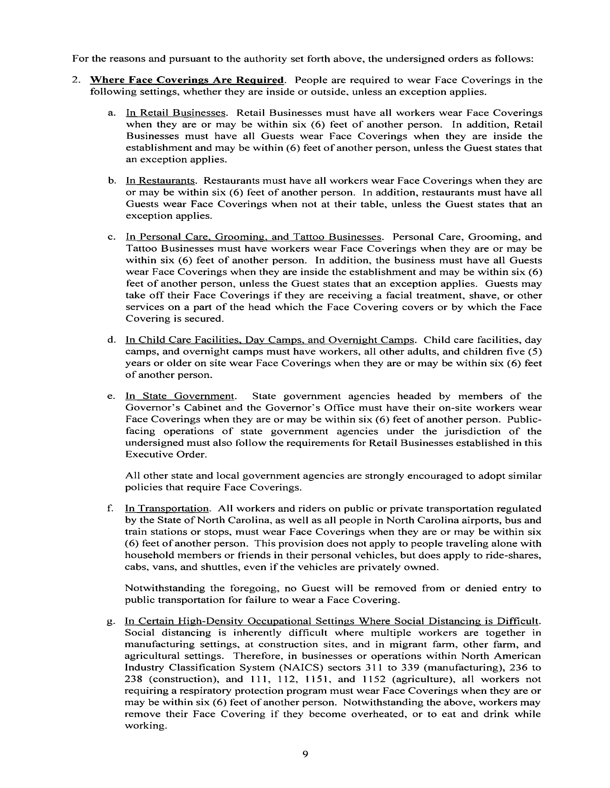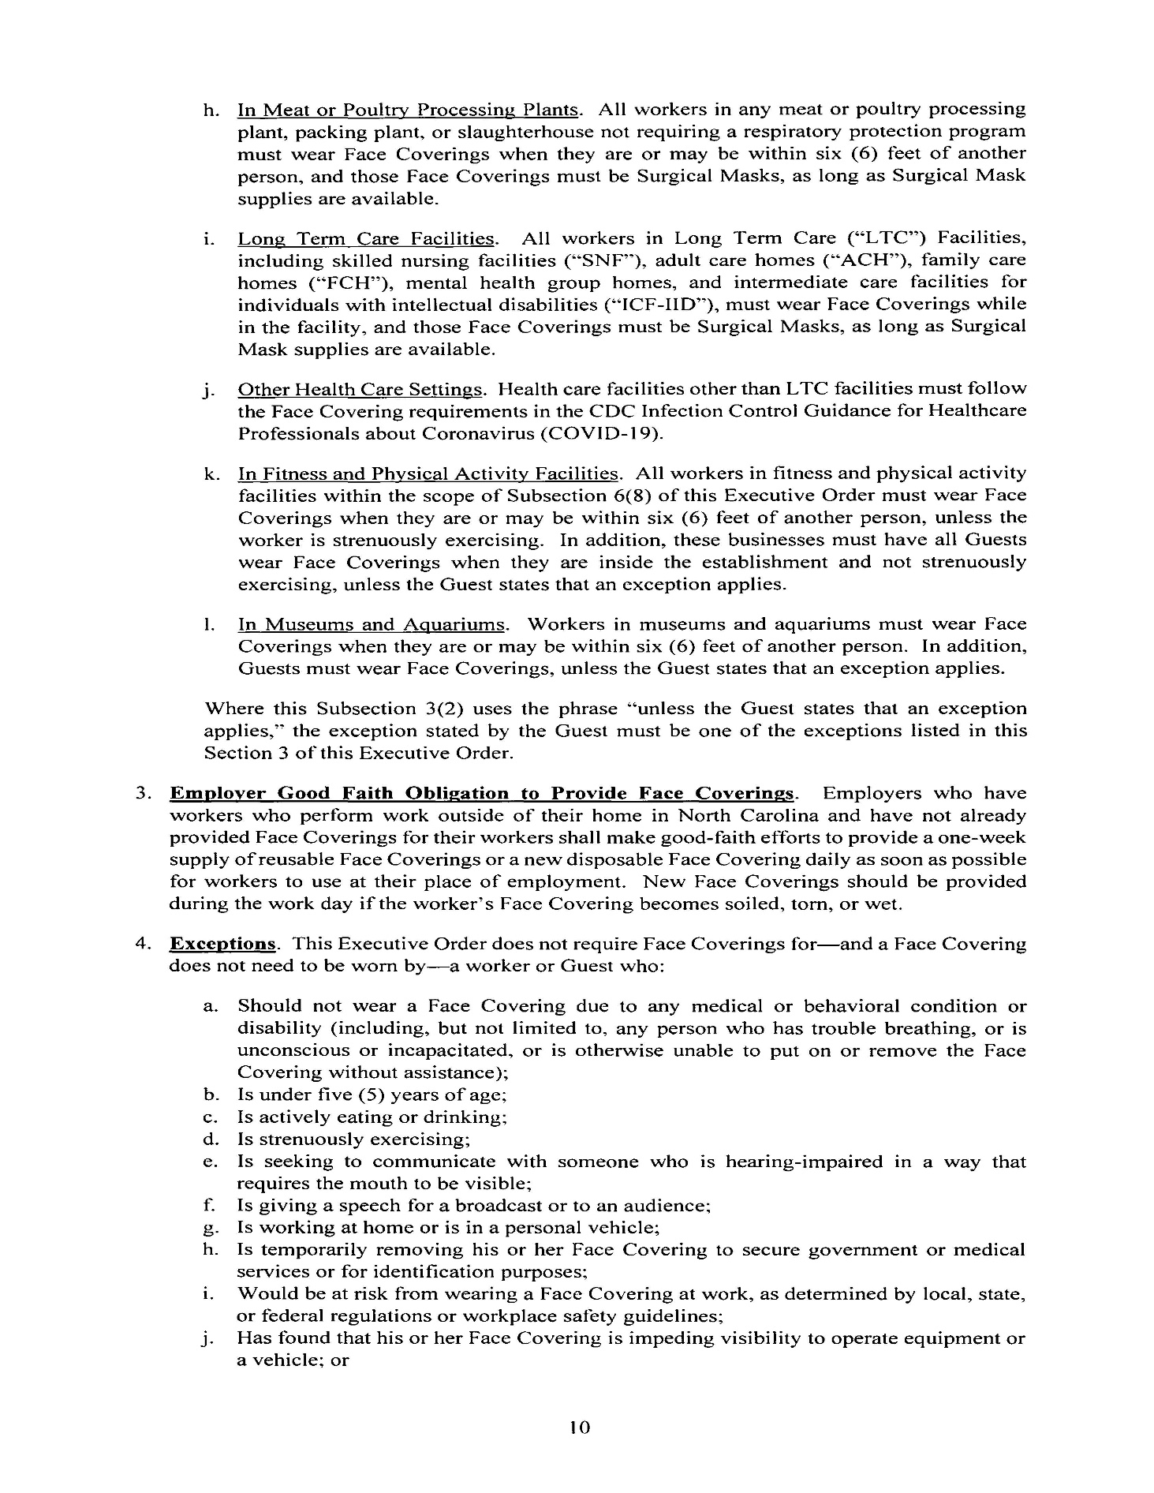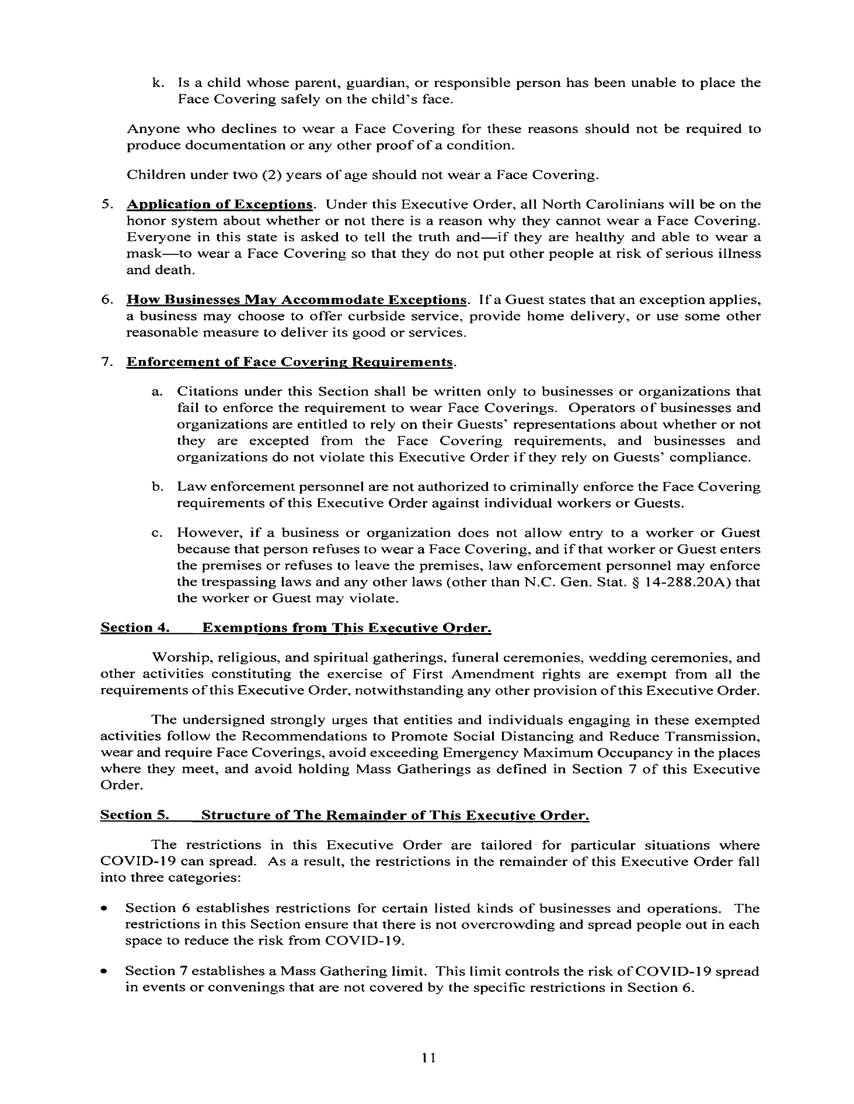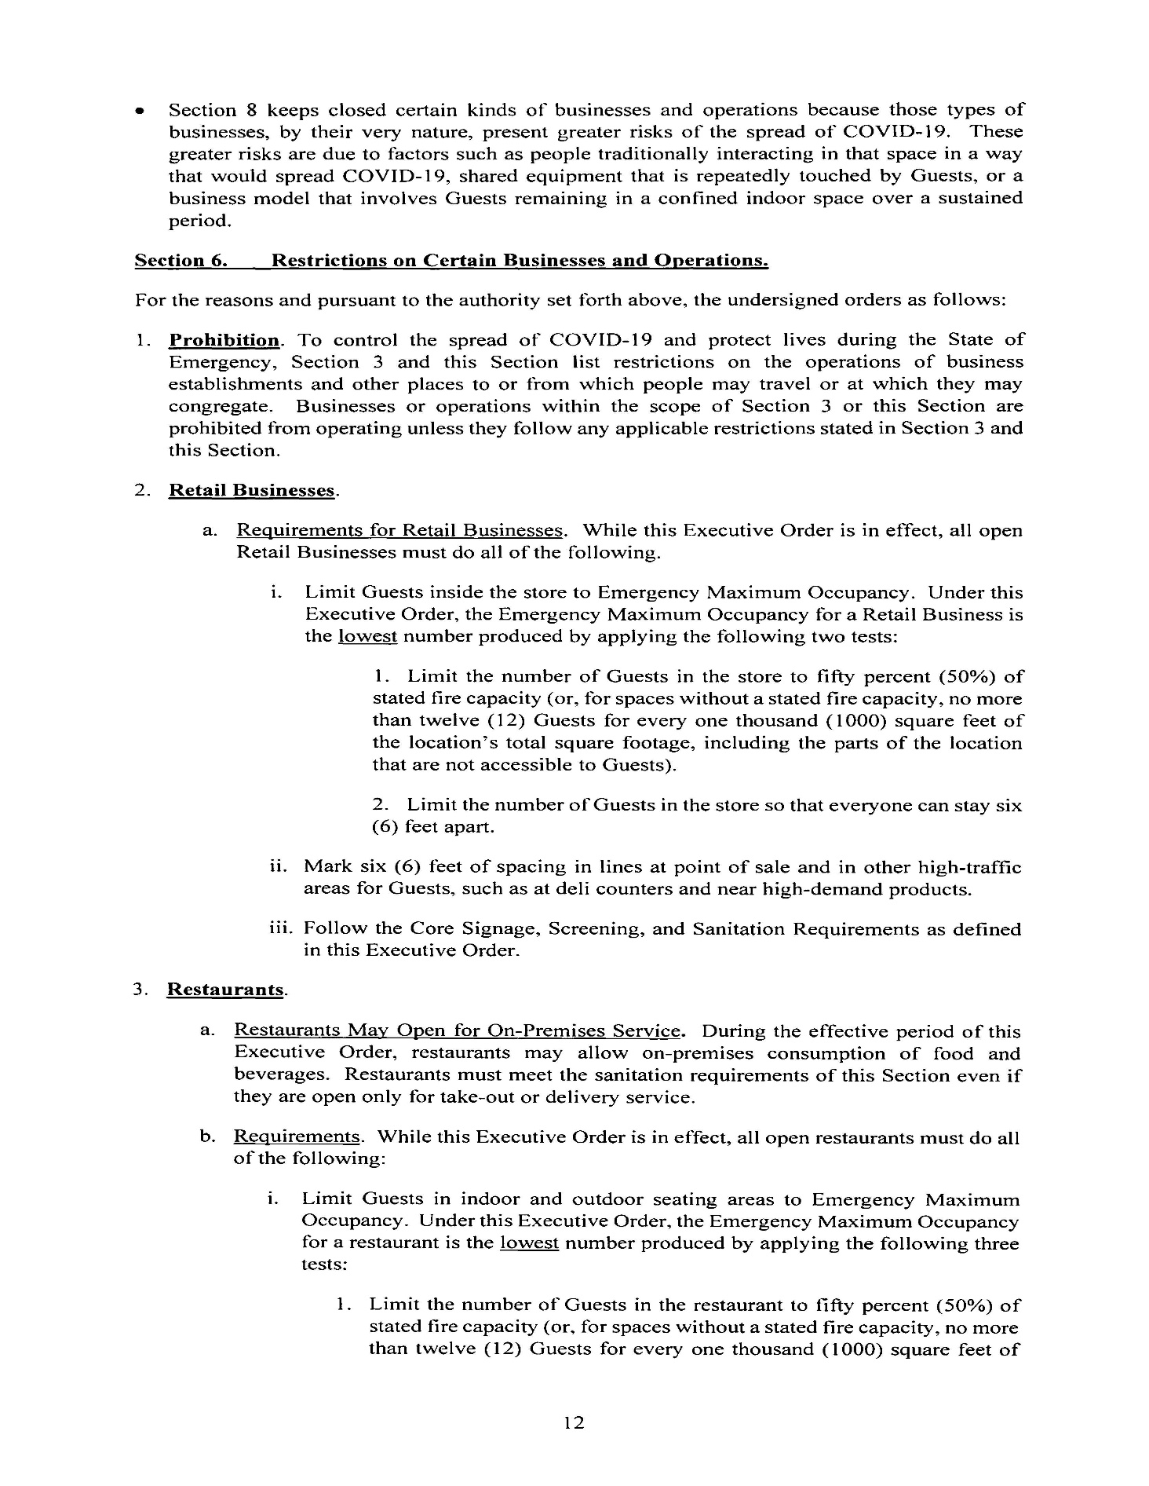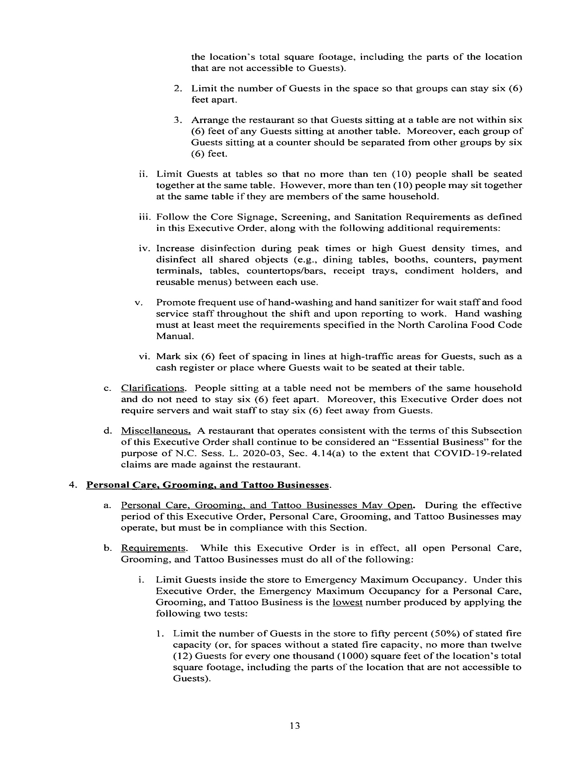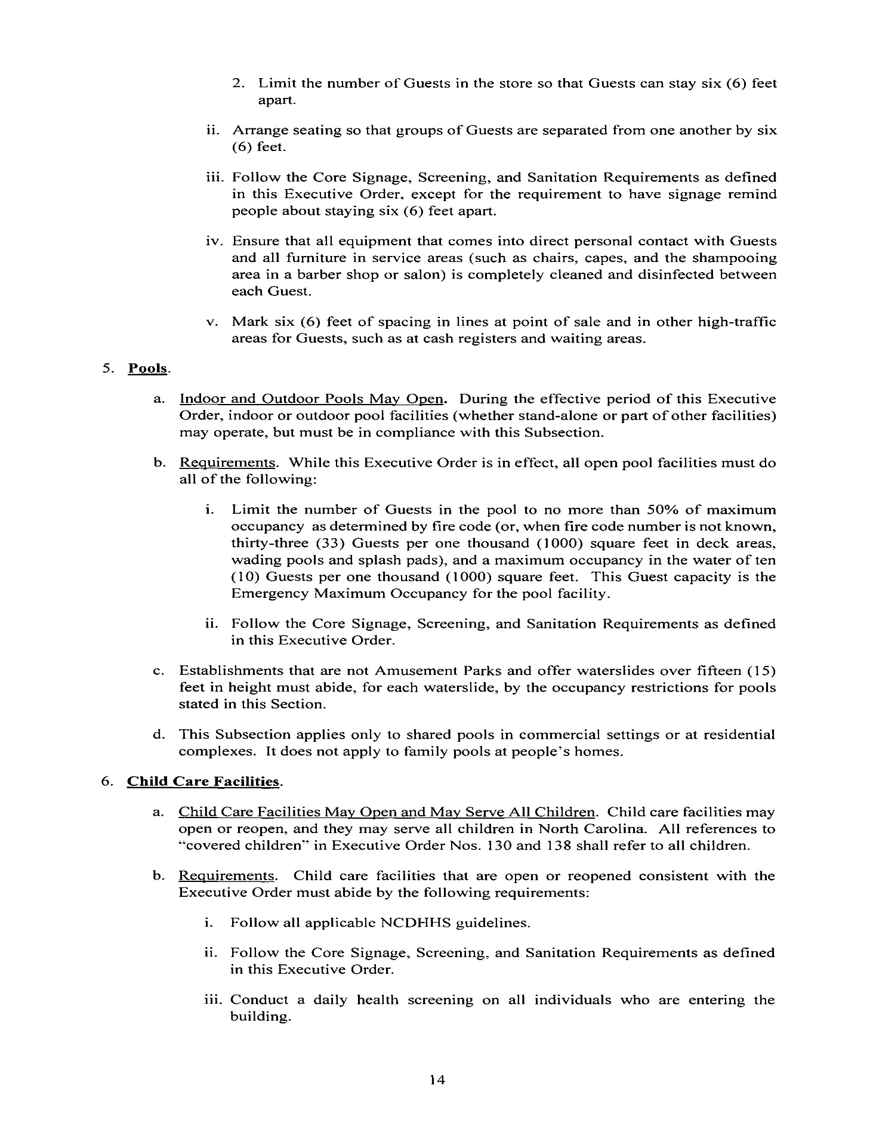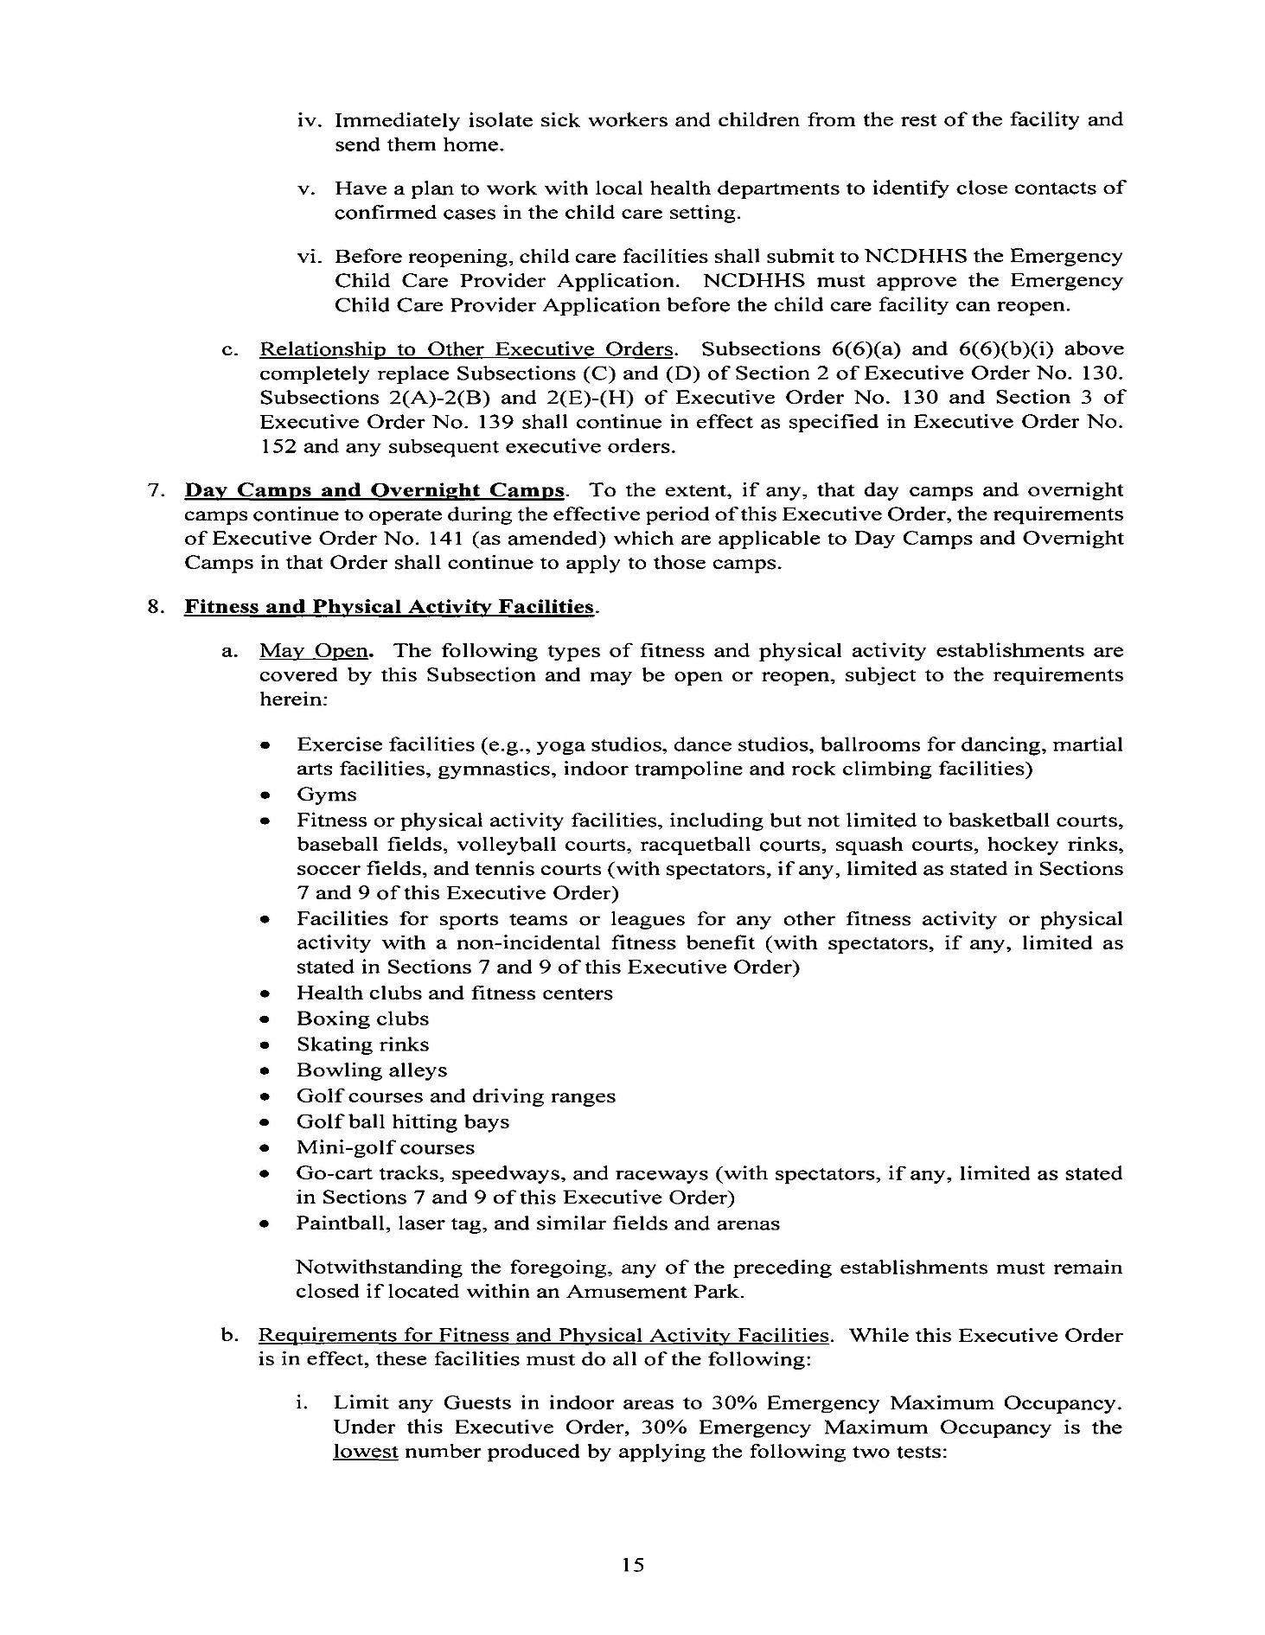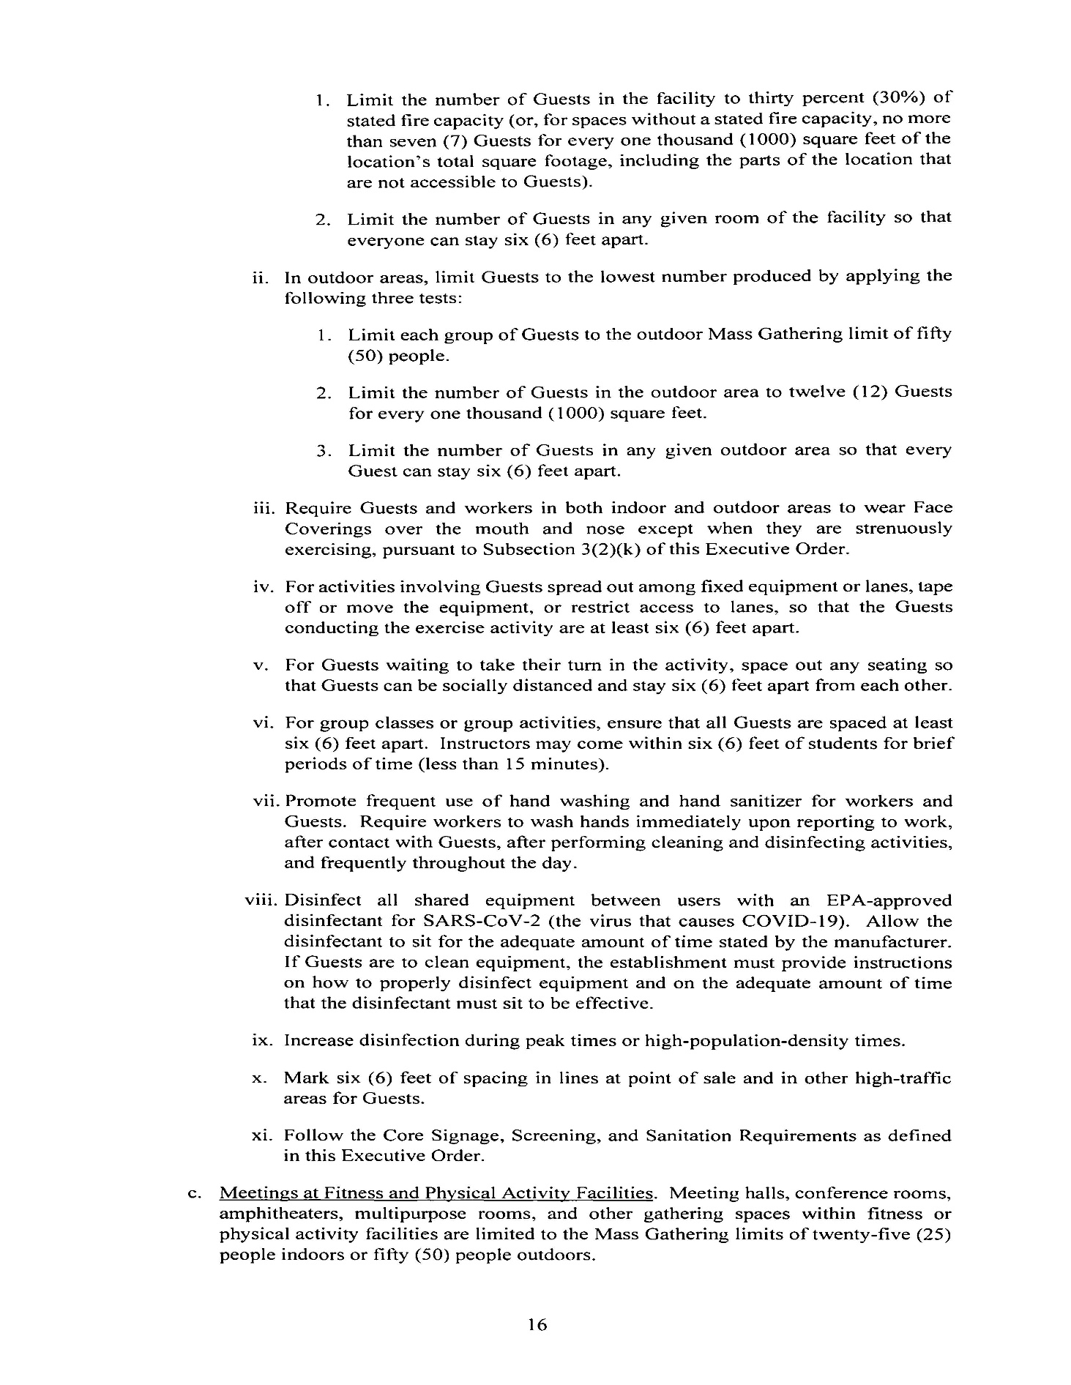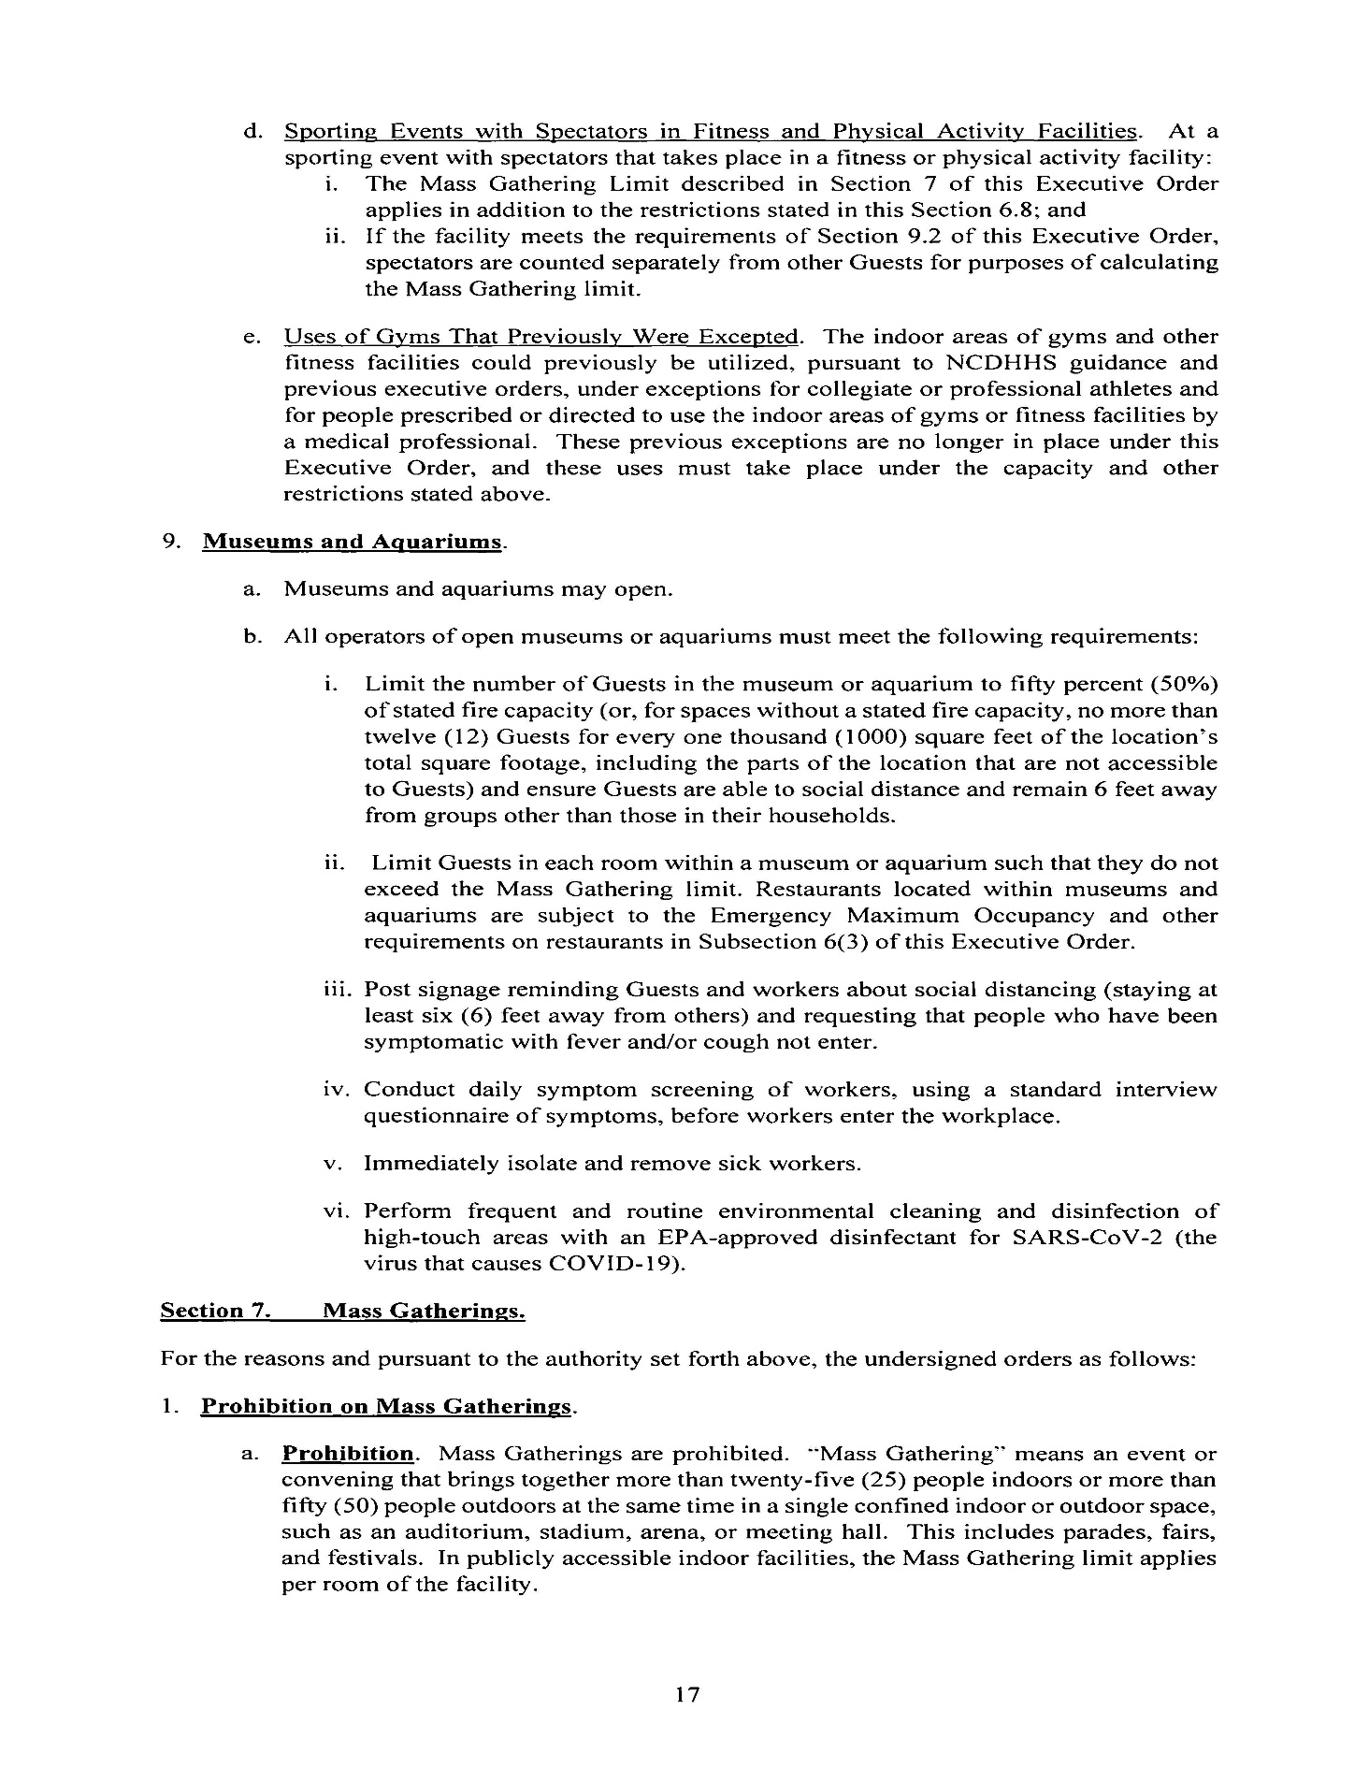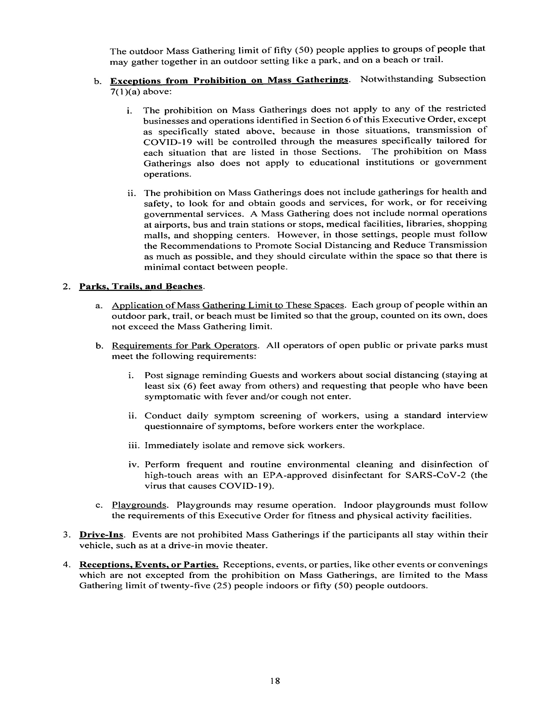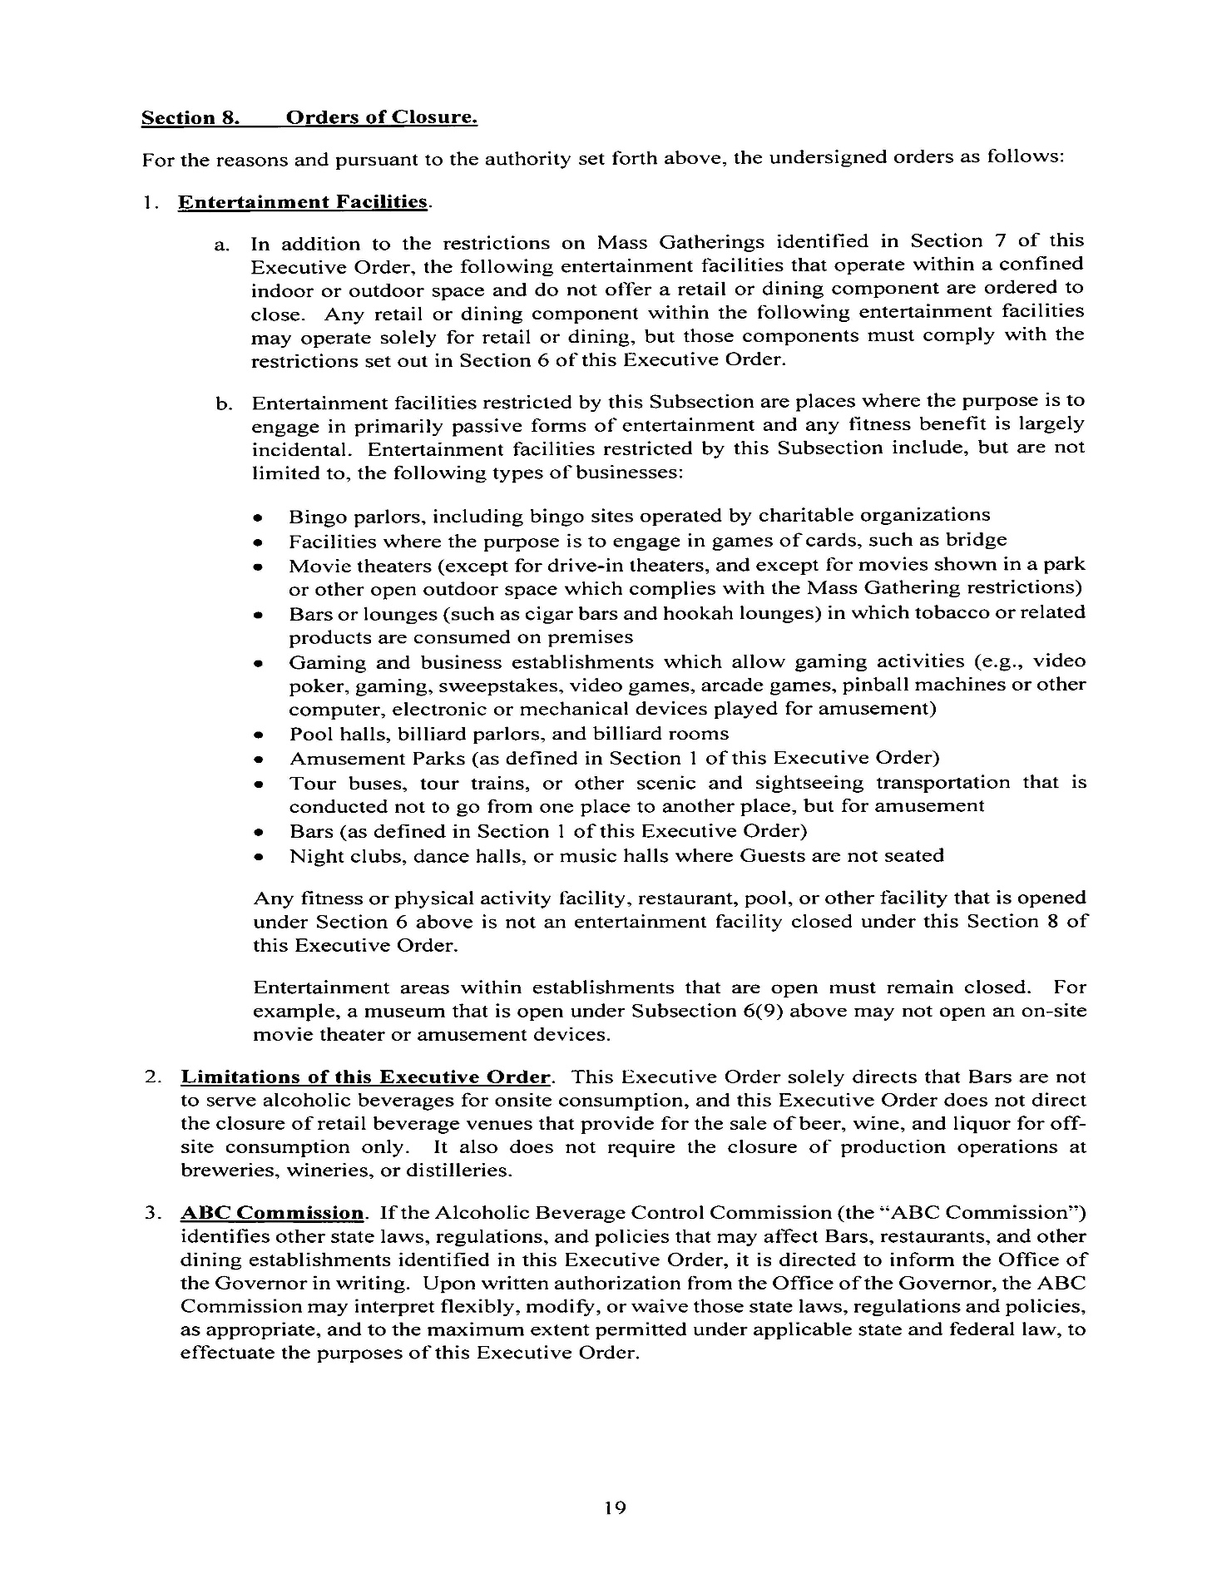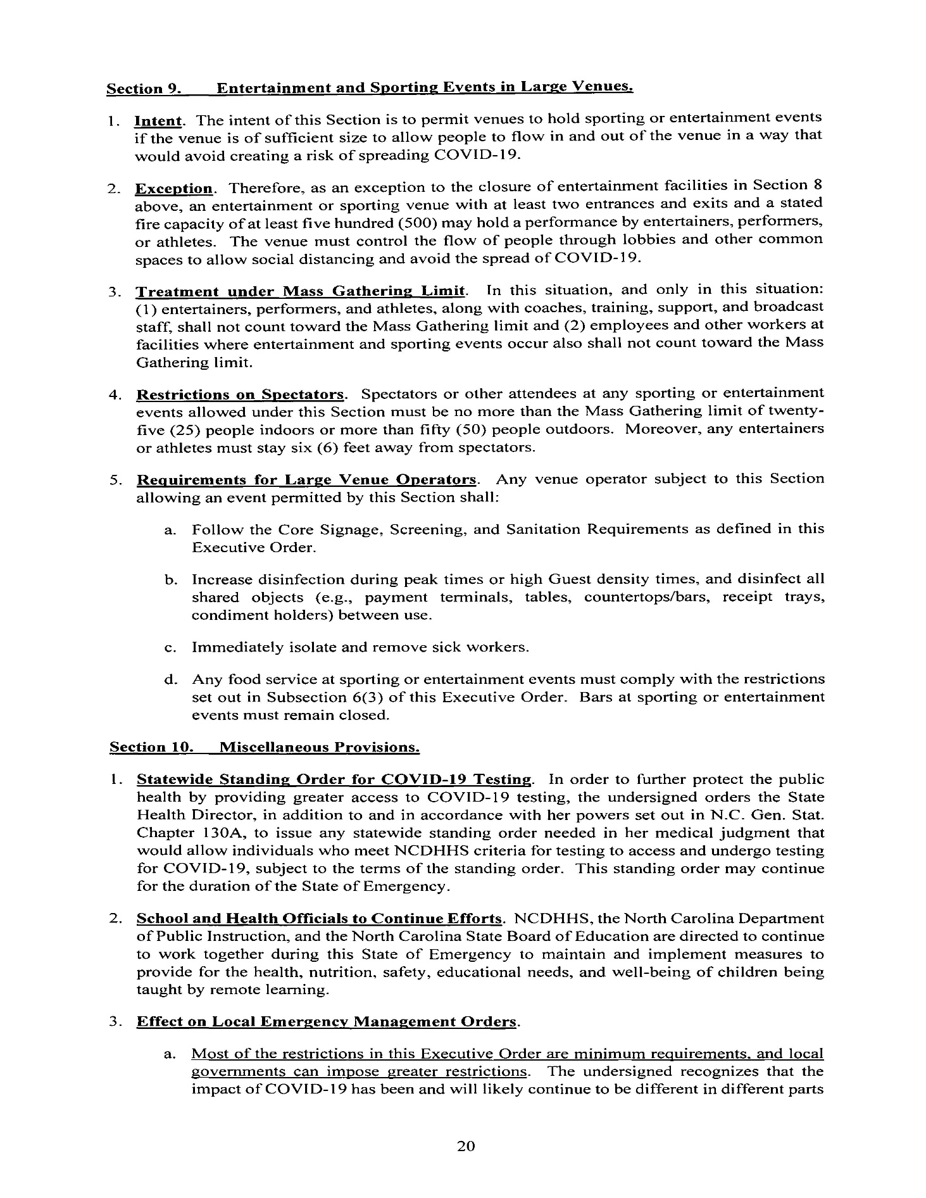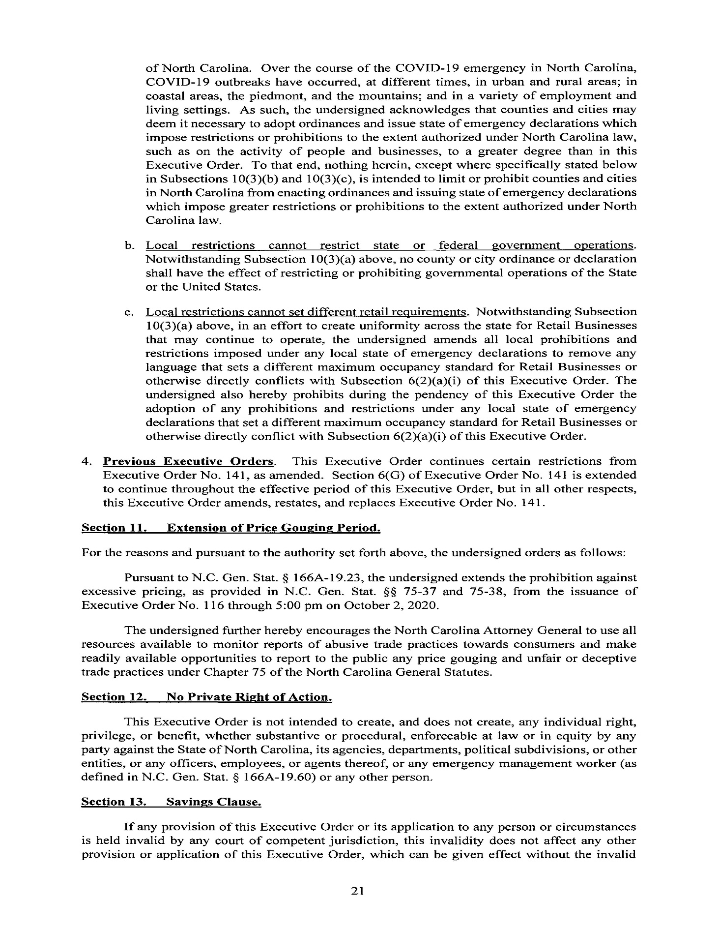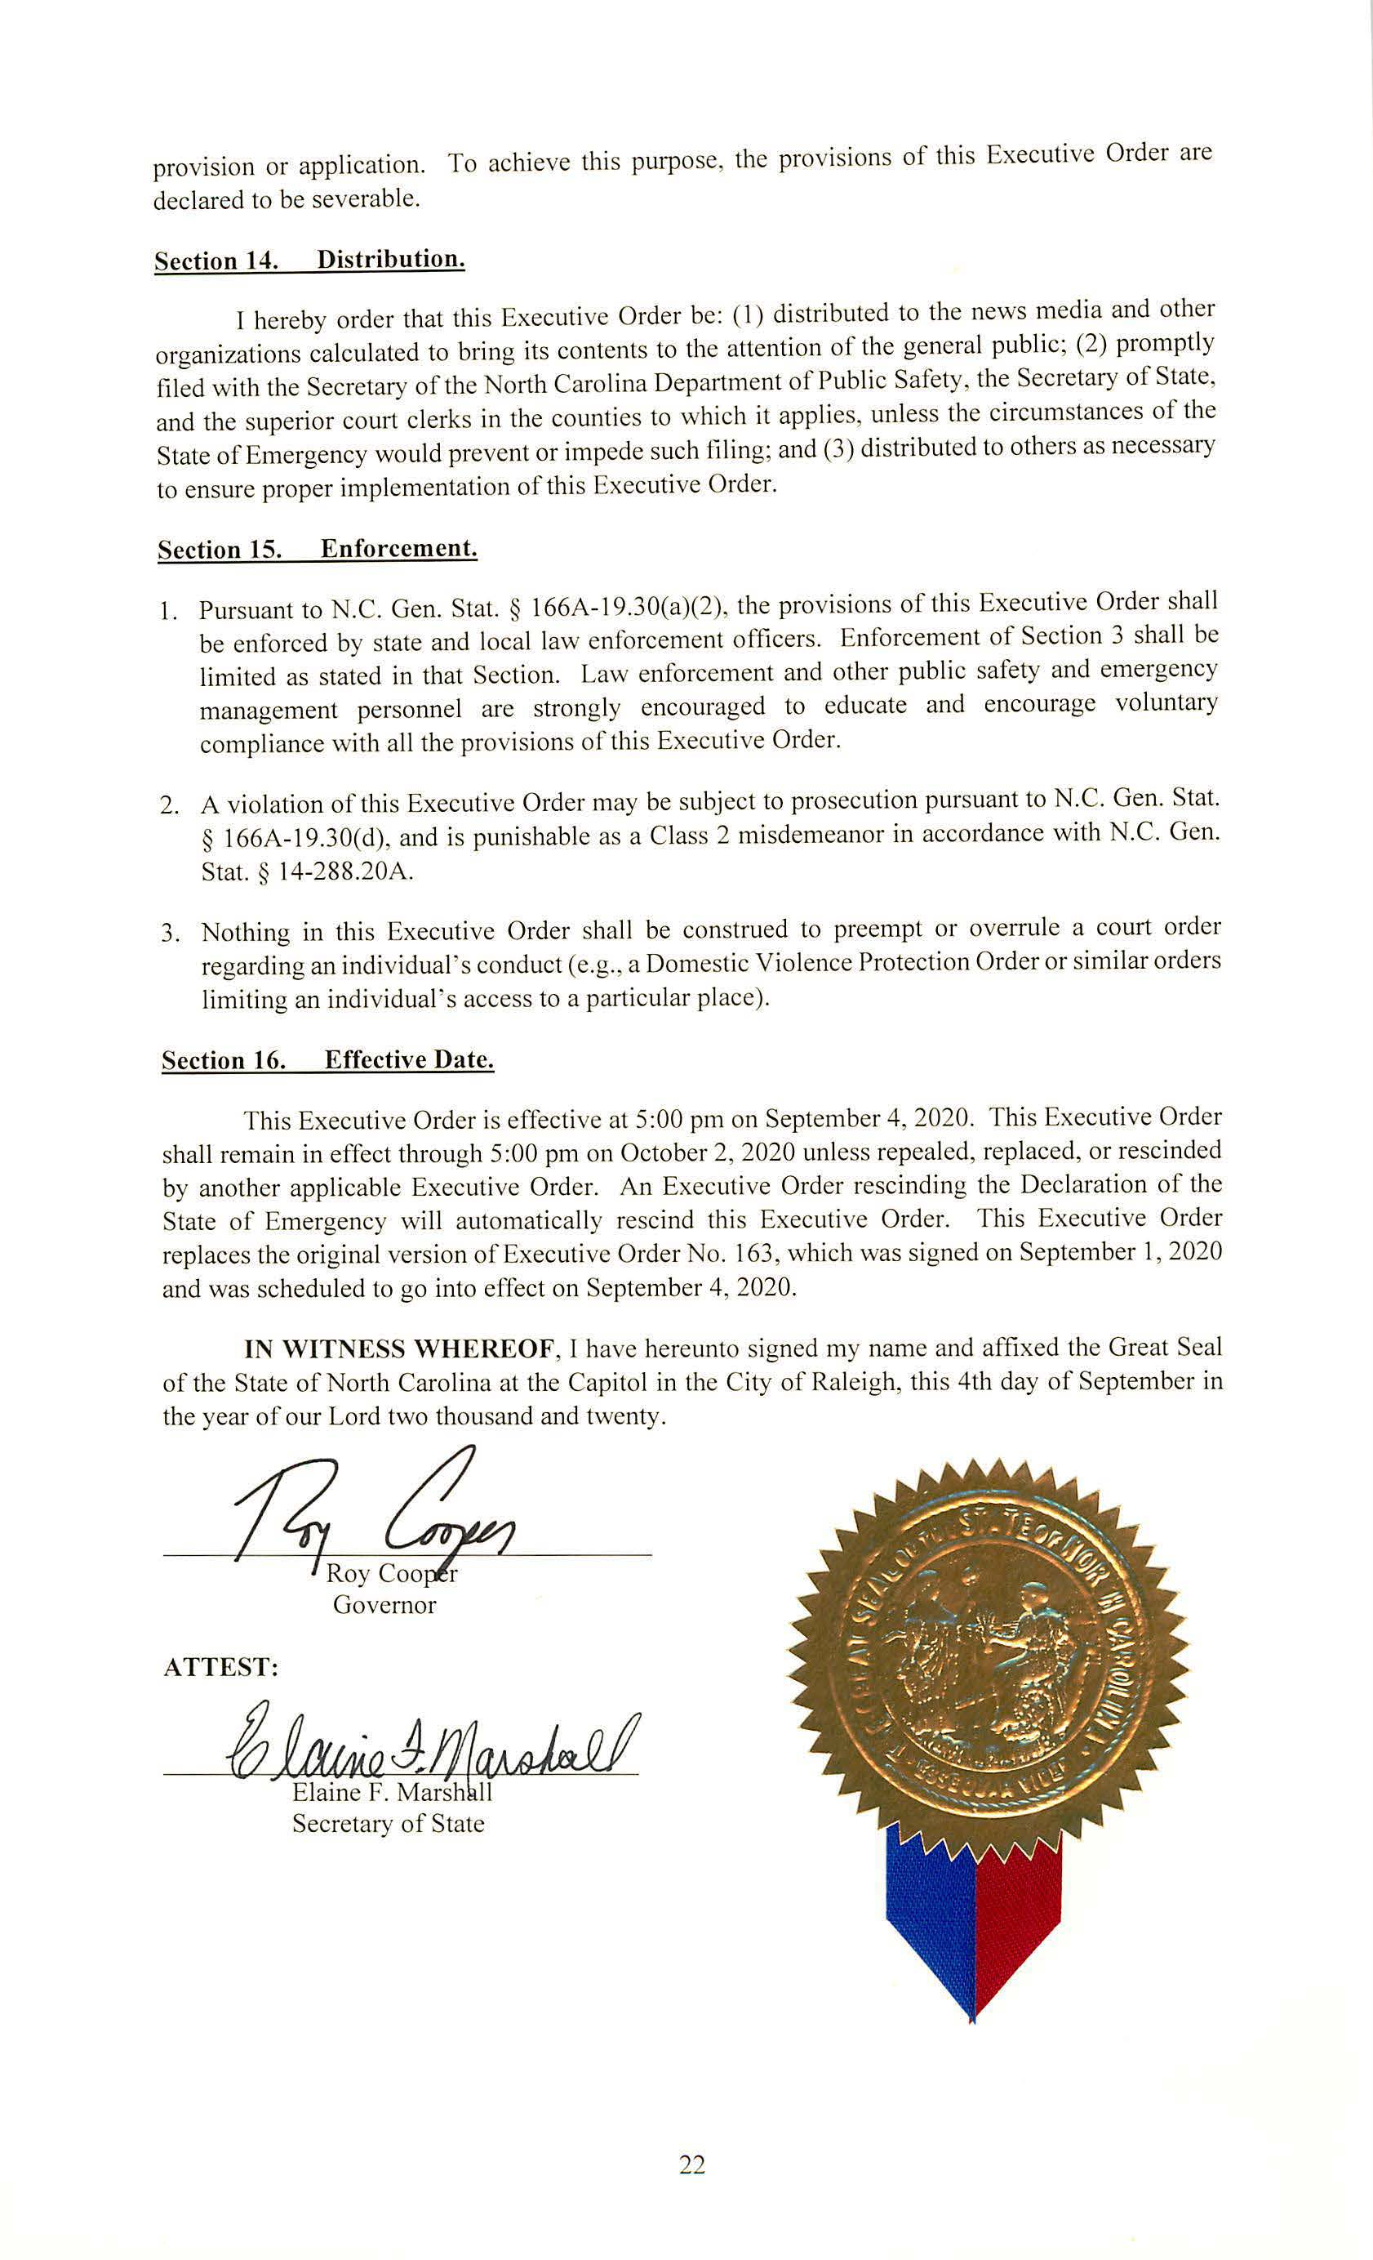

Notice of Application to modify existing Innovative Approval of a Wastewater System for On-site Subsurface Use

Pursuant to G.S. 130A-343(g), the North Carolina Department of Health and Human Services (DHHS) shall publish a Notice in the NC Register that a manufacturer has submitted a request for approval of a wastewater system, component, or device for on-site subsurface use. The following applications have been submitted to DHHS:

Application by: Jim Bell, PE
Bio-Microbics, Inc
8450 Cole Parkway
Shawnee, KS 66227

For: New Innovative Approval for FAST Wastewater Treatment Systems

Application by: David Lentz, PE
Infiltrator Water Technologies, LLC
PO Box 768
Old Saybrook, CT 06475

For: Modifications to an Innovative Approval for Chamber Trench Systems

Application by: David Lentz, PE
Infiltrator Water Technologies, LLC
PO Box 768
Old Saybrook, CT 06475

For: Modifications to the Innovative Approval for Expanded Polystyrene Aggregate Trench Systems

DHHS Contact: Jon Fowlkes

1-919-707-5875

Fax: 919-845-3972

jon.fowlkes@dhhs.nc.gov

These applications may be reviewed by contacting the applicant or Jon Fowlkes, Branch Head, at 5605 Six Forks Rd, Raleigh, NC, On-Site Water Protection Branch, Environmental Health Section, Division of Public Health. Draft proposed innovative approvals and proposed final action on the application by DHHS can be viewed on the On-Site Water Protection Branch web site: http://ehs.ncpublichealth.com/oswp/.

Written public comments may be submitted to DHHS within 30 days of the date of the Notice publication in the North Carolina Register. All written comments should be submitted to Jon Fowlkes, Branch Head, On-site Water Protection Branch, 1642 Mail Service Center, Raleigh, NC 27699-1642, jon.fowlkes@dhhs.nc.gov, or fax 919-845-3972. Written comments received by DHHS in accordance with this Notice will be taken into consideration before a final agency decision is made on the innovative subsurface wastewater system application.

Note from the Codifier: The notices published in this Section of the NC Register include the text of proposed rules. The agency must accept comments on the proposed rule(s) for at least 60 days from the publication date, or until the public hearing, or a later date if specified in the notice by the agency. If the agency adopts a rule that differs substantially from a prior published notice, the agency must publish the text of the proposed different rule and accept comment on the proposed different rule for 60 days.
Statutory reference: G.S. 150B-21.2.

Title 02 – Department of Agriculture and Consumer Services

Notice is hereby given in accordance with G.S. 150B-21.2 that the Plant Conservation Board intends to amend the rule cited as 02 NCAC 48F .0301.

Link to agency website pursuant to G.S. 150B-19.1(c): http://www.ncagr.gov/AdministrativeRules/ProposedRules/index.htm

Proposed Effective Date: February 1, 2021

Instructions on How to Demand a Public Hearing: (must be requested in writing within 15 days of notice): Any person may request a public hearing on the proposed rules by submitting a request in writing no later than October 16, 2020 to Phil Wilson, Director, Plant Industry Division, 1060 Mail Service Center, Raleigh, NC 27699-1060.

Reason for Proposed Action: The proposed amendment updates the Protected Plant Species and corrects the spelling and names of certain plants.

Comments may be submitted to: Phil Wilson, 1060 Mail Service Center, Raleigh, NC 27699-1060; email phil.wilson@ncagr.gov

Comment period ends: November 30, 2020

Procedure for Subjecting a Proposed Rule to Legislative Review: If an objection is not resolved prior to the adoption of the rule, a person may also submit written objections to the Rules Review Commission after the adoption of the Rule. If the Rules Review Commission receives written and signed objections after the adoption of the Rule in accordance with G.S. 150B-21.3(b2) from 10 or more persons clearly requesting review by the legislature and the Rules Review Commission approves the rule, the rule will become effective as provided in G.S. 150B-21.3(b1). The Commission will receive written objections until 5:00 p.m. on the day following the day the Commission approves the rule. The Commission will receive those objections by mail, delivery service, hand delivery, or facsimile transmission. If you have any further questions concerning the submission of objections to the Commission, please call a Commission staff attorney at 919-431-3000.

Fiscal impact. Does any rule or combination of rules in this notice create an economic impact? Check all that apply.

State funds affected

Local funds affected

Substantial economic impact (>= $1,000,000)

Approved by OSBM

No fiscal note required

Chapter 48 - Plant Industry

SUBCHAPTER 48F - PLANT CONSERVATION

SECTION .0300 - ENDANGERED PLANT SPECIES LIST: THREATENED PLANT SPECIES LIST: LIST OF SPECIES OF SPECIAL CONCERN

02 NCAC 48F .0301 Protected PLANT SPECIES LIST

The North Carolina Plant Conservation Board hereby establishes the following list of protected plant species (** indicates federally listed):

Species Status
(1) Acmispon helleri Threatened

Carolina Prairie-trefoil;
(1)(2) Acrobolbus ciliatus Special Concern, Vulnerable

A liverwort;
(2)(3) Adiantum capillus-veneris Threatened

Venus Hair Fern;
(3)(4) Adlumia fungosa Special Concern, Vulnerable

Climbing Fumitory;
(4)(5) Aeschynomene virginica** Threatened

Sensitive Jointvetch;
(5)(6) Agalinis virgata Threatened

Branched Gerardia;
(6)(7) Agrostis mertensii Endangered

Artic Arctic Bentgrass;
(8) Aletris lutea Threatened

Yellow Colic-root;
(9) Allium allegheniense Special Concern, Vulnerable

Allegheny Onion;
(7)(10) Allium cuthbertii keeverae Threatened Special Concern, Vulnerable

Striped Garlic; Keever's Onion;
(8)(11) Alnus viridis ssp. crispa Special Concern, Vulnerable

Green Alder;
(9)(12) Amaranthus pumilus** Threatened

Seabeach Amaranth;
(10)(13) Amorpha confusa Threatened

Savanna Indigo-bush;
(11)(14) Amorpha georgiana Endangered

Georgia Indigo-bush;
(12)(15) Amphicarpum muhlenbergianum Endangered

Florida Goober Grass, Blue Maidencane;
(13) Andropogon mohrii Threatened

Bog Bluestem;
(14)(16) Anemone berlandieri Endangered

Southern Anemone;
(15)(17) Anemone caroliniana Endangered

Prairie Anemone;
(16)(18) Arabis pycnocarpa var. adpressipilis Endangered

Hairy Rockcress;
(17)(19) Arethusa bulbosa Endangered

Bog Rose;
(18)(20) Aristida condensata Threatened

Big Three-awn Grass;
(19)(21) Aristida simpliciflora Endangered

Chapman's Three-awn;
(20)(22) Arnoglossum ovatum var. lanceolatum Endangered

Savanna Indian-plantain;
(23) Asclepias cinerea Special Concern, Historical

Carolina Milkweed;
(21)(24) Asclepias pedicellata Special Concern, Vulnerable

Savanna Milkweed;
(22)(25) Asplenium heteroresiliens Endangered

Carolina Spleenwort;
(23)(26) Asplenium monanthes Endangered

Single-sorus Spleenwort;
(24)(27) Asplenium ruta-muraria var. cryptolepis Special Concern, Vulnerable

American Wall-rue Spleenwort; Wall-rue;
(25)(28) Astragalus michauxii Special Concern, Vulnerable

Sandhills Milkvetch;
(26)(29) Baccharis glomeruliflora Special Concern, Historical Endangered

Silverling;
(27)(30) Bacopa caroliniana Threatened

Blue Water-hyssop;
(28)(31) Bacopa innominata Special Concern, Historical

Tropical Water-hyssop;
(29)(32) Balduina atropurpurea Endangered

Purple-disk Honeycomb-head;
(33) Baptista aberrans Endangered

Eastern Prairie Blue Wild Indigo
(30)(34) Baptisia alba Threatened

Thick-pod White Wild Indigo;
(31)(35) Baptisia bracteata Special Concern, Historical

Creamy Wild Indigo;
(32) Baptisia australis var. aberrans Endangered

Prairie Blue Wild Indigo;
(33)(36) Berberis canadensis Special Concern, Vulnerable

American Barberry;
(34)(37) Betula cordifolia Special Concern, Vulnerable

Mountain Paper Birch;
(35) Boechera missouriensis Special Concern, Vulnerable

Missouri Rockcress;
(38) Bouteloua curtipendula var. curtipendula Threatened

Sideoats Grama;
(39) Bromus ciliatus Special Concern, Vulnerable

Fringed Brome;
(36)(40) Buchnera americana Endangered

American Bluehearts;
(37)(41) Buckleya distichophylla Threatened

Piratebush;
(38)(42) Bulbostylis warei Special Concern, Historical

Ware's Hair Sedge;
(39)(43) Calamagrostis cainii Endangered

Cain's Reed Grass; Reedgrass;
(44) Calamagrostis canadensis var. canadensis Special Concern, Vulnerable

Canada Reedgrass;
(40)(45) Calopogon multiflorus Endangered

Many-flower Many-flowered Grass-pink;
(41)(46) Caltha palustris var. palustris Endangered

Marsh-marigold; Marsh Marigold;
(42)(47) Camassia scilloides Threatened

Wild Hyacinth;
(48) Campanula aparinoides var. aparinoides Threatened

Marsh Bellflower;
(43)(49) Campanula rotundifolia Endangered

Bluebells;
(44)(50) Campylium stellatum Special Concern, Vulnerable

Yellow Starry Fen Moss;
(45) Canoparmelia amabilis Special Concern, Vulnerable

Worthy Shield Lichen;
(46)(51) Cardamine dissecta Special Concern, Vulnerable

Dissected Toothwort;
(47) Cardamine douglassii Threatened

Douglass's Bittercress;
(48)(52) Cardamine longii Special Concern, Vulnerable

Long's Bittercress;
(49)(53) Cardamine micranthera** Endangered

Small-anthered Bittercress;
(50) Cardamine rotundifolia Threatened

Mountain Watercress;
(54) Carex amplisquama Special Concern, Vulnerable

Fort Mountain Sedge;
(55) Carex arctata Special Concern, Vulnerable

Black Sedge;
(51)(56) Carex argyrantha Endangered

Hay Sedge;
(52)(57) Carex barrattii Special Concern, Historical

Barratt's Sedge;
(58) Carex basiantha Endangered

Widow Sedge;
(53)(59) Carex buxbaumii Special Concern, Vulnerable

Brown Bog Sedge;
(60) Carex calcifugens Special Concern, Vulnerable

Calcium-fleeing Sedge;
(54)(61) Carex careyana Threatened

Carey's Sedge;
(55)(62) Carex cherokeensis Endangered Threatened

Cherokee Sedge;
(56)(63) Carex conoidea Special Concern, Vulnerable Threatened

Cone-shaped Sedge: Sedge, Field Sedge;
(57)(64) Carex cristatella Special Concern, Historical Vulnerable

Small-crested Crested Sedge;
(58) Carex decomposita Special Concern, Vulnerable

Cypress Knee Sedge;
(59)(65) Carex eburnea Threatened

Bristle-leaf Sedge;
(60)(66) Carex exilis Endangered

Coastal Sedge;
(61) Carex hitchcockiana Special Concern, Vulnerable

Hitchcock's Sedge;
(62)(67) Carex hormathodes Threatened

A Marsh Straw Sedge;
(68) Carex impressinervia Special Concern, Vulnerable

Ravine Sedge;
(69) Carex jamesii Special Concern, Vulnerable

James's Sedge;
(70) Carex lasiocarpa var. americana Special Concern, Vulnerable

Slender Sedge;
(63)(71) Carex lutea** Endangered

Golden Sedge;
(72) Carex meadii Endangered

Mead's Sedge;
(64)(73) Carex oligocarpa Threatened

Rich-woods Sedge;
(65)(74) Carex oligosperma Endangered

Few-seeded Sedge;
(66)(75) Carex pedunculata var. pedunculata Special Concern, Vulnerable

Longstalk Sedge;
(67) Carex purpurifera Special Concern, Vulnerable

Purple Sedge;
(68)(76) Carex radfordii Threatened

Radford's Sedge;
(69)(77) Carex reniformis Threatened

Kidney Sedge;
(78) Carex superata Threatened

Limestone Forest Sedge;
(70)(79) Carex tenax Endangered

Wire Sedge;
(80) Carex trichocarpa Special Concern, Vulnerable

Hairy-fruited Sedge;
(71)(81) Carex trisperma Endangered

Three-seeded Sedge;
(82) Carex utriculata Endangered

Beaked Sedge;
(83) Carex vesicaria Endangered

Inflated Sedge;
(72)(84) Carex vestita Special Concern, Historical Threatened

Velvet Sedge;
(73)(85) Carya laciniosa Threatened

Big Shellbark Hickory;
(74)(86) Carya myristiciformis Endangered

Nutmeg Hickory;
(87) Caulophyllum giganteum Special Concern, Vulnerable

Northern Blue Cohosh;
(75)(88) Celastrus scandens Endangered

American Bittersweet;
(76)(89) Cetraria arenaria Special Concern, Vulnerable

Sand-loving Iceland Lichen;
(77) Euphorbia cordifolia Threatened

Heartleaf Sandmat;
(78)(90) Chamerion platyphyllum Endangered

Fireweed;
(79)(91) Chasmanthium nitidum Threatened

A Shiny Spanglegrass;
(80)(92) Chelone cuthbertii Special Concern, Vulnerable

Cuthbert's Turtlehead;
(81) Chenopodium simplex Threatened

Giant-seed Goosefoot;
(93) Chenopodiastrum simplex Threatened

Mapleleaf Goosefoot;
(82)(94) Chiloscyphus appalachianus Special Concern, Vulnerable

A Liverwort; liverwort;
(83)(95) Chiloscyphus muricatus Special Concern, Vulnerable

A Liverwort; liverwort;
(84)(96) Chrysoma pauciflosculosa Endangered

Woody Goldenrod;
(85)(97) Cirsium carolinianum Endangered

Carolina Thistle;
(86)(98) Cirsium lecontei Special Concern, Vulnerable

Leconte's LeConte's Thistle;
(87) Cladonia psoromica Threatened

Bluff Mountain Reindeer Lichen;
(88)(99) Clematis occidentalis var. occidentalis Special Concern, Vulnerable

Mountain Clematis;
(89)(100) Clinopodium georgianum Endangered

Georgia Calamint;
(90) Coeloglossum viride var. virescens Endangered

Long-bracted Frog Orchid;
(91) Coelorachis cylindrica Special Concern, Historical

Carolina Jointgrass;
(92) Collinsonia tuberosa Special Concern, Vulnerable

Piedmont Horsebalm;
(93)(101) Collinsonia verticillata Special Concern, Vulnerable Threatened

Whorled Horsebalm;
(94)(102) Conioselinum chinense Threatened

Hemlock-parsley;
(95)(103) Coptis trifolia var. groenlandica Threatened

Goldthread;
(104) Coreopsis aristulata Threatened

Short-awned Coreopsis;
(96)(105) Cornus asperifolia Endangered

Roughleaf Dogwood;
(106) Cornus racemosa Special Concern, Vulnerable

Gray Dogwood;
(97)(107) Corydalis micrantha Threatened

Slender Corydalis;
(108) Coryphopteris simulata Endangered

Bog Fern;
(109) Crataegus pallens Threatened

Pale Hawthorn;
(98)(110) Crinum americanum var. americanum Special Concern, Historical

Swamp-lily;
(99)(111) Crocanthemum bicknellii Special Concern, Vulnerable

Plains Sunrose;
(100)(112) Crocanthemum carolinianum Endangered

Carolina Sunrose;
(101)(113) Crocanthemum corymbosum Threatened

Pinebarren Sunrose;
(102)(114) Crocanthemum georgianum Endangered

Georgia Sunrose;
(103)(115) Crocanthemum nashii Endangered

Florida Scrub Sunrose, Florida Scrub Frostweed;
(104)(116) Crocanthemum propinquum Threatened

Creeping Sunrose;
(105)(117) Crocanthemum rosmarinifolium Threatened

Rosemary Sunrose;
(106)(118) Croton monanthogynus Endangered

Prairie-tea Croton;
(107)(119) Cyperus dentatus Special Concern, Historical

Toothed Flatsedge;
(108)(120) Cyperus granitophilus Threatened

Granite Flatsedge;
(109)(121) Cyperus lecontei Threatened

Leconte's LeConte's Flatsedge;
(122) Cyperus subsquarrosus Special Concern, Historical

Small-flowered Halfchaff;
(110)(123) Cyperus tetragonus Special Concern, Vulnerable

Four-angled Flatsedge;
(124) Cyperus virens Special Concern, Vulnerable

Greens Flatsedge;
(111)(125) Cystopteris tennesseensis Endangered

Tennessee Bladder-fern;
(112) Rubus dalibarda Endangered

Robin Runaway;
(126) Dactylorhiza viridis Threatened

Long-bracted Frog Orchid;
(113)(127) Delphinium exaltatum Endangered Threatened

Tall Larkspur;
(114)(128) Deschampsia cespitosa ssp. glauca Threatened

Tufted Hairgrass;
(115)(129) Desmodium ochroleucum Special Concern, Historical

White Tick-trefoil, Creamy Tick-trefoil;
(116)(130) Desmodium sessilifolium Special Concern, Historical

Sessile Tick-trefoil;
(117)(131) Diarrhena Americana americana Endangered Threatened

Eastern Beakgrass; Beakgrain;
(132) Dichanthelium annulum Endangered

Ringed Witchgrass;
(118) Dichanthelium aciculare ssp. neuranthum Special Concern, Vulnerable

Nerved Witch Grass
(119)(133) Dichanthelium caerulescens Endangered Threatened

Blue Witch Grass; Witchgrass;
(120)(134) Dichanthelium hirstii Endangered

Hirsts' Hirst Brothers' Panic Grass; Witchgrass;
(135) Dichanthelium spretum Endangered

Eaton's Witchgrass;
(136) Dichanthelium strigosum var. glabrescens Threatened

Hairless Witchgrass;
(121)(137) Diervilla rivularis Threatened

Riverbank Bush-honeysuckle;
(122)(138) Dionaea muscipula Special Concern, Vulnerable Threatened

Venus Flytrap;
(123) Primula meadia Threatened

Shooting-star;
(124) Draba ramosissima Special Concern, Vulnerable

Branching Draba;
(125) Drepanolejeunea appalachiana Special Concern, Vulnerable

A Liverwort;
(139) Diplachne maritima Endangered

Salt-meadow Grass;
(126)(140) Drosera filiformis Special Concern, Vulnerable

Threadleaf Sundew;
(127)(141) Echinacea laevigata** Endangered

Smooth Coneflower;
(128) Echinacea purpurea Special Concern, Vulnerable

Purple Coneflower,
(129) Echinodorus tenellus Endangered

Dwarf Burhead;
(130)(142) Eleocharis cellulosa Endangered Threatened

Gulfcoast Spikerush;
(131)(143) Eleocharis elongata Endangered

Florida Spikerush;
(144) Eleocharis parvula Threatened

Dwarf Spikerush;
(132)(145) Eleocharis robbinsii Special Concern, Vulnerable

Robbins' Spikerush;
(133)(146) Eleocharis vivipara Endangered Threatened

Viviparous Spikerush;
(134)(147) Elymus trachycaulus ssp. trachycaulus Threatened

Slender Wheatgrass;
(135) Elymus virgincus var. halophilus Special Concern, Vulnerable

Terrell Grass;
(136)(148) Enemion biternatum Special Concern, Vulnerable

Eastern Isopyrun;
(137) Epidendrum magnoliae Threatened

Green Fly Orchid;
(149) Epidendrum conopseum Threatened

Green-fly Orchid;
(150) Erigenia bulbosa Threatened

Harbinger-of-spring;
(138)(151) Eriocaulon aquaticum Special Concern, Vulnerable

Seven-angled pipewort; Pipewort;
(139)(152) Eriocaulon parkeri Threatened

Estuary Pipewort;
(140)(153) Eriocaulon texense Endangered

Texas Hatpins;
(141)(154) Eriogonum tomentosum Special Concern, Historical

Southern Wild-buckwheat
(142)(155) Erythrina herbacea Endangered

Coralbean;
(143)(156) Eupatorium leptophyllum Endangered

Limesink Dog-fennel;
(144)(157) Eupatorium paludicola Threatened Endangered

Bay Boneset;
(145)(158) Euphorbia commutata Threatened

Cliff Spurge;
(159) Euphorbia cordifolia Threatened

Heartleaf Sandmat;
(146)(160) Euphorbia mercurialina Special Concern, Vulnerable

Cumberland Spurge;
(147)(161) Filipendula rubra Endangered

Queen-of-the-Prairie;
(148)(162) Fimbristylis perpusilla Threatened

Harper's Fimbry;
(149) Fleishmannia incarnata Threatened

Pink Thoroughwort:
(150)(163) Gaillardia aestivalis var. aestivalis Endangered

Sandhills Blanket-flower;
(151)(164) Galactia mollis Threatened

Soft Milk-pea;
(152)(165) Gaylussacia brachycera Endangered

Box Huckleberry;
(153)(166) Gaylussacia nana Endangered

Confederate Huckleberry; Dwarf Dangleberry;
(167) Gaylussacia orocola Endangered

Appalachian Dwarf Huckleberry;
(154)(168) Gelsemium rankinii Special Concern, Vulnerable

Swamp Jessamine;
(155)(169) Gentiana alba Special Concern, Vulnerable Historical

Yellow Pale Gentian;
(170) Gentiana latidens Threatened

Balsalm Mountain Gentian;
(156)(171) Gentianopsis crinita Threatened Endangered

Eastern Fringed Gentian;
(157)(172) Geum aleppicum Endangered

Yellow Avens;
(158)(173) Geum geniculatum Special Concern, Vulnerable

Bent Avens;
(159)(174) Geum laciniatum Endangered

Rough Avens;
(160)(175) Geum lobatum Endangered

Lobed Barren-strawberry;
(161)(176) Geum radiatum** Endangered

Spreading Avens;
(162)(177) Gillenia stipulata Threatened

Indian Physic;
(178) Glyceria laxa Special Concern, Vulnerable

Lax Mannagrass;
(163)(179) Gratiola aurea lutea Special Concern, Vulnerable

Golden Hedge-hyssop;
(164)(180) Gymnocarpium appalachianum Threatened

Appalachian Oak Fern;
(165)(181) Gymnoderma lineare** Endangered

Rock Gnome Lichen;
(166) Senecio suaveolens Special Concern, Historical

Sweet Indian-plantain;
(182) Harperella nodosa [Ptilimnium nodosum]** Endangered

Harperella;
(183) Helanthium tenellum Endangered

Dwarf Burhead;
(167)(184) Helenium brevifolium Endangered

Littleleaf Sneezeweed;
(168)(185) Helenium vernale Endangered

Spring Sneezeweed;
(169)(186) Helianthus floridanus Threatened

Florida Sunflower;
(170)(187) Helianthus laevigatus Special Concern, Vulnerable

Smooth Sunflower;
(171)(188) Helianthus occidenatlis ssp. occidentalis Special Concern, Historical

Naked-stem Sunflower;
(172)(189) Helianthus schweinitzii** Endangered

Schweinitz's Sunflower;
(173)(190) Helonias bullata** Threatened

Swamp Pink;
(174)(191) Hexastylis contracta Endangered

Mountain Heartleaf;
(175)(192) Hexastylis naniflora** Threatened

Dwarf-flowered Heartleaf;
(176)(193) Hibiscus aculeatus Threatened

Comfortroot;
(194) Hottonia inflata Special Concern, Vulnerable

Featherfoil;
(177)(195) Houstonia montana ** Endangered

Roan Mountain Bluet;
(178)(196) Hudsonia montana** Threatened

Mountain Golden-heather;
(179)(197) Hudsonia tomentosa Threatened

Sand Heather;
(198) Hydrastis canadensis Special Concern, Vulnerable

Goldenseal;
(180)(199) Hymenocallis occidentalis var. occidentalis Special Concern, Historical

Hillside Spider-lily;
(181)(200) Hymenocallis pygmaea Threatened Special Concern, Vulnerable

Waccamaw River Spiderlily;
(182)(201) Hypericum adpressum Special Concern, Historical

Bog St. John's-wort;
(183)(202) Hypericum brachyphyllum Special Concern, Vulnerable

Coastal Plain St. John's-wort;
(184)(203) Hypericum fasciculatum Endangered

Peelbark St. John's-wort;
(204) Hypericum radfordiorum Special Concern, Vulnerable

Radford's St. John's-wort;
(185)(205) Hypericum suffruticosum Special Concern, Historical

Pineland St. John's-wort;
(206) Hypotrachyna virginica Special Concern, Vulnerable

Virginia Loop Lichen;
(186)(207) Ilex collina Special Concern, Vulnerable

Long-stalked Holly;
(187)(208) Ipomoea imperati Threatened Special Concern, Vulnerable

Beach Morning-glory;
(209) Ipomoea macrorhiza Special Concern, Historical

Manroot;
(188)(210) Isoetes microvela Threatened

Thin-wall Quillwort;
(189)(211) Isoetes piedmontana Endangered Threatened

Piedmont Quillwort;
(190)(212) Isotria medeoloides** Threatened

Small Whorled Pogonia;
(191)(213) Iva microcephala Threatened

Small-headed Marsh Elder;
(192)(214) Jeffersonia diphylla Threatened

Twinleaf:
(215) Juncus articulatus Special Concern, Historical

Jointleafed Rush;
(193)(216) Juncus caesariensis Endangered

New Jersey Rush;
(194)(217) Juniperus communis var. depressa Special Concern, Vulnerable Threatened

Dwarf Juniper;
(195)(218) Kalmia angustifolia Threatened

Sheep-laurel;
(196)(219) Lachnocaulon minus Threatened

Brown Bogbutton;
(197)(220) Lechea maritima var. virginica Endangered Threatened

Maritime Pinweed;
(198)(221) Lechea torreyi var. congesta Endangered

Torrey's Pinweed;
(199)(222) Lejeunea blomquistii Special Concern, Vulnerable

A Liverwort; liverwort;
(200) Leptochloa fascicularis var. maritima Endangered

Long-awned Spangletop;
(201)(223) Liatris aspera Threatened Special Concern, Vulnerable

Rough Blazing-star;
(202)(224) Liatris helleri** Threatened

Heller's Blazing-star;
(203)(225) Liatris microcephala Special Concern, Vulnerable

Small-head Blazing-star;
(204)(226) Lilium canadense var. canadense Endangered

Yellow Canada Lily;
(205) Lilium canadense ssp. editorum Endangered

Red Canada Lily;
(206)(227) Lilium grayi Threatened

Gray's Lily;
(207)(228) Lilium philadelphicum var. philadelphicum Endangered

Wood Lily;
(208)(229) Lilium pyrophilum Endangered

Sandhills Lily;
(209)(230) Limosella australis Threatened

Awl-leaf Awl-leaf, Mudwort;
(210)(231) Lindera melissifolia** Endangered

Pondberry;
(232) Lindera subcoriacea Special Concern, Vulnerable

Bog Spicebush;
(211)(233) Linum floridanum var. chrysocarpum Threatened

Yellow-fruited Flax;
(212)(234) Linum sulcatum Special Concern, Historical

Glade Flax;
(213)(235) Liparis loeselii Endangered

Fen Orchid;
(214) Lipocarpha micrantha Special Concern, Historical

Small-flowered Hemicarpha;
(215)(236) Lithospermum canescens Threatened

Hoary Puccoon;
(216)(237) Litsea aestivalis Special Concern, Vulnerable

Pondspice;
(217)(238) Lobelia boykinii Endangered

Boykin's Lobelia;
(218)(239) Lophiola aurea Endangered

Golden-crest;
(219) [Lotus] Acmispon helleri Special Concern, Vulnerable

Carolina Birdfoot-trefoil;
(220)(240) Ludwigia lanceolata Endangered

Lanceleaf Seedbox;
(221)(241) Ludwigia linifolia Threatened

Flaxleaf Seedbox;
(222)(242) Ludwigia ravenii Threatened Endangered

Raven's Seedbox;
(223)(243) Ludwigia sphaerocarpa Endangered

Globe-fruit seedbox; Seedbox;
(224)(244) Ludwigia suffruticosa Threatened

Shrubby Seedbox;
(245) Lupinus villosus Endangered

Pink Sandhill Lupine;
(246) Lycopodiella inundata Endangered

Northern Bog Clubmoss;
(225)(247) Lysimachia asperulifolia** Endangered

Rough-leaf Loosestrife;
(248) Lysimachia borealis Threatened

Northern Starflower;
(226)(249) Lysimachia fraseri Endangered

Fraser's Loosestrife;
(227)(250) Macbridea caroliniana Endangered

Carolina Birds-in-a-Nest, Carolina Bogmint;
(228)(251) Magnolia macrophylla Threatened Special Concern, Vulnerable

Bigleaf Magnolia;
(229)(252) Malaxis spicata Special Concern, Vulnerable

Florida Adder's-mouth;
(230)(253) Marshallia grandiflora Special Concern, Historical

Large-flowered Barbara's-buttons;
(254) Marshallia legrandii Endangered

Oak Barrens Barbara's-buttons;
(231)(255) Marshallia trinervia Special Concern, Historical

Broadleaf Barbara's-buttons;
(256) Melanthium woodii Threatened

Ozark Bunchflower;
(232)(257) Melica nitens Endangered

Three-flowered Melic;
(233)(258) Menyanthes trifoliata Threatened

Buckbean;
(234)(259) Micranthes pensylvanica Endangered

Swamp Saxifrage;
(235) Micropolypodium nimbatum Threatened

West Indian Dwarf Polypody;
(236) Minuartia godfreyi Endangered

Godfrey's Sandwort;
(260) Mnesithea cylindrica Special Concern, Historical

Carolina Jointgrass;
(237)(261) Minuartia Mononeuria groenlandica Threatened

Greenland Sandwort;
(262) Mononeuria paludicola Endangered

Godfrey's Sandwort;
(238)(263) Minuartia uniflora Endangered

Single-flowered Sandwort;
(239) Monotropsis odorata Special Concern, Vulnerable

Sweet Pinesap;
(264) Moranopteris nimbata Threatened

West Indian Dwarf Polypody;
(240)(265) Muhlenbergia glomerata Special Concern, Vulnerable

Spiked Muhly;
(241)(266) Muhlenbergia sobolifera Special Concern, Vulnerable Threatened

Rock Muhly;
(242)(267) Muhlenbergia torreyana Special Concern, Vulnerable

Pinebarren Smokegrass;
(243)(268) Myrica gale Endangered

Sweet Gale;
(244)(269) Myriophyllum laxum Endangered

Loose Water-milfoil;
(245)(270) Myriophyllum tenellum Endangered

Leafless Water-milfoil;
(271) Nabalus albus Special Concern, Vulnerable

White Rattlesnakeroot;
(246)(272) Narthecium montanum Special Concern, Historical

Appalachian Yellow Asphodel;
(247)(273) Oenothera perennis Special Concern, Vulnerable

Perennial Sundrops;
(248)(274) Oldenlandia boscii Endangered Threatened

Bosc's Bluet;
(249)(275) Orbexilum macrophyllum Special Concern, Historical

Bigleaf Scurfpea;
(250)(276) Orbexilum onobrychis Special Concern, Historical

Lanceleaf Scurfpea;
(277) Orbexilum pedunculatum Endangered

Western Sampson's Snakeroot;
(278) Oreojuncus trifidus Threatened

Highland Rush;
(279) Orthochilus ecristata Endangered

Spiked Medusa;
(251) Oxypolis canbyi** Endangered

Canby's Dropwort;
(252)(280) Pachysandra procumbens Endangered

Allegheny Spurge;
(281) Packera crawfordii Endangered

Crawford's Ragwort;
(253)(282) Packera millefolium Threatened Special Concern, Vulnerable

Divided-leaf Blue Ridge Ragwort;
(254)(283) Packera paupercula var. appalachiana Threatened

Prairie Appalachian Ragwort;
(284) Packera paupercula var. paupercula Special Concern, Vulnerable

Balsam Ragwort;
(255)(285) Packera schweinitziana Threatened

Schweinitz's New England Ragwort;
(286) Packera serpenticola Threatened

Buck Creek Ragwort;
(256)(287) Panicum flexile Threatened

Wiry Panic Grass;
(257) Parietaria praetermissa Special Concern, Vulnerable

Large-seed Pellitory;
(258)(288) Parnassia caroliniana Threatened

Carolina Grass-of-parnassus;
(259)(289) Parnassia grandifolia Threatened

Large-leaved Bigleaf Grass-of-parnassus;
(260)(290) Paronychia herniarioides Endangered

Michaux's Whitlow-wort;
(261)(291) Paspalum dissectum Endangered

Mudbank Crown Grass;
(262)(292) Pedicularis lanceolata Threatened

Swamp Lousewort;
(263)(293) Pellaea wrightiana Endangered

Wright's Cliff-brake;
(264)(294) Persicaria hirsuta Endangered

Hairy Smartweed;
(265)(295) Phacelia maculata Endangered

Spotted Flatrock Phacelia;
(266)(296) Phegopteris connectilis Endangered

Northern Beech Fern;
(297) Phemeranthus piedmontanus Endangered

Piedmont Rock-pink;
(298) Pinguicula lutea Special Concern, Vulnerable

Yellow Butterwort;
(267)(299) Pinguicula pumila Endangered Threatened

Small Butterwort;
(268)(300) Pityopsis graminifolia var. graminifolia Endangered

A Silkgrass;
(269)(301) Plantago cordata Endangered

Heart-leaf Plantain;
(270)(302) Plantago sparsiflora Threatened

Pineland Plantain;
(303) Platanthera herbiola Special Concern, Vulnerable

Tubercled Rein Orchid;
(271) Platanthera grandiflora Threatened

Large Purple-fringed Orchid;
(272)(304) Platanthera integra Special Concern, Vulnerable Threatened

Yellow Fringeless Orchid;
(273)(305) Plantanthera integrilabia Platanthera integrilabia** Special Concern, Historical Threatened

White Fringeless Orchid;
(274)(306) Platanthera nivea Threatened Endangered

Snowy Orchid;
(275)(307) Platanthera peramoena Threatened

Purple Fringeless Orchid;
(308) Platanthera shriveri Endangered

Shriver's Purple Fringed Orchid;
(276)(309) Poa saltuensis Threatened

A Old-pasture Bluegrass;
(277)(310) Polemonium reptans var. reptans Threatened

Spreading Jacob's Ladder;
(278)(311) Polygala hookeri Special Concern, Vulnerable

Hooker's Milkwort;
(312) Polygala senega Special Concern, Vulnerable

Seneca Snakeroot;
(279)(313) Polygonella articulata Special Concern, Historical

Northern Wireweed, Coast Jointweed;
(280)(314) Polygonum glaucum Endangered

Seabeach Knotweed;
(281)(315) Ponthieva racemosa Threatened

Shadow-witch;
(282)(316) Portulaca smallii Threatened

Small's Portulaca;
(317) Potamogeton illinoensis Endangered

Illinois Pondweed;
(318) Primula meadia Special Concern, Vulnerable

Eastern Shooting-star;
(319) Pseudognaphalium helleri Endangered

Heller's Rabbit-tobacco;
(283) Prenanthes alba Threatened

White Rattlesnakeroot;
(284) Pteroglossaspis ecristata Endangered

Spiked Medusa;
(285)(320) Ptilimnium costatum Threatened

Ribbed Big Bishop-weed;
(286) Ptilimnium nodosum** Endangered

Harperella;
(287)(321) Pyrola elliptica Endangered Threatened

Elliptic Shinleaf;
(322) Pyxidanthera brevifolia Threatened

Sandhills Pyxie-moss;
(323) Quercus elliottii Endangered

Running Oak;
(288)(324) Quercus ilicifolia Endangered

Bear Oak
(325) Quercus minima Endangered

Dwarf Live Oak;
(289)(326) Quercus prinoides Endangered

Dwarf Chinquapin Oak;
(290)(327) Ranunculus ambigens Special Concern, Historical

Water-plantain Spearwort;
(291) Ranunculus flabellaris Special Concern, Historical

Yellow Water-crowfoot;
(292)(328) Ranunculus hederaceus Endangered Threatened

Ivy Buttercup; Ivy-leaved Water Crowfoot;
(293)(329) Rhexia aristosa Special Concern, Vulnerable

Awned Meadow-beauty;
(294)(330) Rhodiola rosea Endangered

Roseroot;
(295)(331) Rhododendron prinophyllum Threatened

Election Pink;
(296)(332) Rhus michauxii** Endangered

Michaux's Sumac;
(297)(333) Rhynchospora crinipes Threatened

Alabama Beaksedge;
(298)(334) Rhynchospora decurrens Threatened

Swamp Forest Beaksedge;
(299)(335) Rhynchospora harperi Special Concern, Vulnerable

Harper's Beaksedge:
(300)(336) Rhynchospora macra Threatened

Southern White Beaksedge;
(337) Rhynchospora microcarpa Threatened

Southern Beaksedge;
(301)(338) Rhynchospora odorata Special Concern, Vulnerable

Fragrant Beaksedge;
(302)(339) Rhynchospora pleiantha Threatened

Coastal Beaksedge;
(303)(340) Rhynchospora thornei Special Concern, Vulnerable

Thorne's Beaksedge;
(304)(341) Rhynchospora tracyi Threatened

Tracy's Beaksedge;
(305)(342) Rubus idaeus ssp. var. strigosus Threatened

American Red Raspberry;
(343) Rubus repens Endangered

Robin Runaway;
(306)(344) Rudbeckia heliopsidis Endangered

Sun-facing Coneflower;
(307)(345) Ruellia ciliosa Threatened

Sandhills Wild-petunia;
(308)(346) Ruellia humilis Endangered Threatened

Low Wild-petunia;
(309)(347) Ruellia purshiana Special Concern, Vulnerable

Pursh's Wild-petunia;
(310)(348) Ruellia strepens Endangered

Limestone Wild-petunia;
(311)(349) Sabal palmetto Threatened

Cabbage Palm; Palmetto;
(312)(350) Sabatia kennedyana Threatened

Plymouth Gentian;
(313)(351) Sageretia minutiflora Threatened

Small-flowered Buckthorn;
(314)(352) Sagittaria chapmanii Endangered Threatened

Chapman's Arrowhead;
(315)(353) Sagittaria fasciculata** Endangered

Bunched Arrowhead;
(316)(354) Sagittaria isoetiformis Threatened

Quillwort Arrowhead;
(317)(355) Sagittaria macrocarpa Threatened

Streamhead Sagittaria; Arrowhead;
(318)(356) Sagittaria weatherbiana Endangered

Grassleaf Weatherby's Arrowhead;
(319)(357) Sarracenia jonesii** Endangered

Mountain Sweet Pitcher Plant;
(320)(358) Sarracenia minor var. minor Endangered

Hooded Pitcher Plant;
(321)(359) Sarracenia oreophila** Endangered

Green Pitcher Plant;
(360) Sarracenia purpurea var. montana Endangered

Southern Appalachian Purple Pitcher Plant;
(322)(361) Sceptridium jenmanii Special Concern, Vulnerable

Alabama Grape-fern;
(323)(362) Schisandra glabra Threatened

Magnolia Vine;
(324)(363) Schwalbea americana** Endangered

Chaffseed;
(325)(364) Scirpus flaccidifolius Endangered

Reclining Bulrush;
(326)(365) Scirpus lineatus Threatened

Drooping Bulrush;
(327)(366) Scleria baldwinii Threatened

Baldwin's Nutrush;
(367) Scleria bellii Endangered

Smooth-seeded Hairy Nutrush;
(328)(368) Scleria reticularis Threatened Special Concern, Vulnerable

Netted Nutrush;
(369) Sclerolepis uniflora Threatened

Sclerolepis;
(329)(370) Scutellaria australis Endangered

Southern Skullcap;
(330)(371) Scutellaria galericulata Special Concern, Historical

Hooded Skullcap;
(331)(372) Scutellaria leonardii Endangered

Shale-barren Skullcap;
(332)(373) Scutellaria nervosa Endangered

Veined Skullcap;
(333) Ditrysinia fruticosa Special Concern, Vulnerable

Sebastian-bush;
(334)(374) Sedum pusillum Endangered

Puck's Orpine;
(375) Senecio suaveolens Endangered

Sweet Indian-plantain;
(376) Sesuvium maritimum Endangered

Slender Sea-purslane;
(377) Sesuvium portulacastrum Endangered

Shoreline Sea-purslane;
(335)(378) Seymeria pectinate pectinata ssp.pectinata Special Concern, Historical

Sticky Afzelia; Comb Seymeria;
(336)(379) Shortia galacifolia var. brevistyla Endangered Threatened

Northern Oconee Bells;
(337)(380) Shortia galacifolia var. galacifolia Special Concern, Vulnerable

Southern Oconee Bells;
(338)(381) Sideroxylon tenax Threatened

Tough Bumelia;
(339)(382) Silene ovata Special Concern, Vulnerable

Mountain Catchfly;
(340)(383) Silphium connatum Special Concern, Vulnerable

Virginia Cup-plant;
(341)(384) Silphium perfoliatum Threatened Special Concern, Vulnerable

Northern Common Cup-plant;
(342)(385) Sisyrinchium dichotomum** Endangered

White Irisette;
(343)(386) Solidago leavenworthii Threatened Endangered

Leavenworth;s Leavenworth's Goldenrod;
(344)(387) Solidago plumosa Threatened

Yadkin River Goldenrod;
(345)(388) Solidago ptarmicoides Endangered

Prairie Goldenrod;
(346)(389) Solidago radula Endangered

Western Rough Goldenrod;
(390) Solidago rigida var. glabrata Special Concern, Vulnerable

Southeastern Bold Goldenrod;
(347)(391) Solidago rigida var. rigida Threatened

Prairie Midwestern Bold Goldenrod;
(348)(392) Solidago spithamaea** Threatened

Blue Ridge Goldenrod;
(349)(393) Solidago tortifolia Endangered

Twisted-leaf Goldenrod; Leafy Pineywoods Godenrod;
(394) Solidago verna Threatened

Spring-flowering Goldenrod;
(350)(395) Solidago villosicarpa Endangered Threatened

Coastal Carolina Maritime Goldenrod:
(351)(396) Sparganium emersum acaule Threatened Endangered

Greenfruit Bur-reed;
(352)(397) Spartina pectinata Special Concern, Vulnerable Threatened

Freshwater Cordgrass;
(353)(398) Sphagnum contortum Threatened

Contorted Peatmoss;
(399) Sphagnum warnstorfii Special Concern, Vulnerable

Fen Peatmoss;
(354)(400) Spigelia marilandica Threatened

Pink-root;
(355)(401) Spiraea corymbosa Endangered

Shinyleaf Meadowsweet; Rock Spiraea;
(356)(402) Spiraea virginiana** Threatened

Virginia Spiraea;
(357) Spiranthes eatonii Endangered

Eaton's Ladies'-tresses;
(358)(403) Spiranthes lacera var. lacera Endangered

Northern Slender Ladies'-tresses;
(359)(404) Spiranthes laciniata Special Concern, Vulnerable

Lace-lip Ladies'-tresses;
(360)(405) Spiranthes longilabris Endangered

Giant Spiral Orchid;
(361)(406) Spiranthes lucida Endangered

Shining Ladies'-tresses;
(362)(407) Spiranthes ochroleuca Threatened

Yellow Nodding Ladies'-tresses;
(363)(408) Sporobolus heterolepis Threatened

Prairie Dropseed;
(364)(409) Sporobolus teretifolius Threatened Endangered

Wireleaf Dropseed;
(365)(410) Sporobolus virginicus Threatened

Saltmarsh Seashore Dropseed;
(411) Stachys appalachiana Endangered

Appalachian Hedge-nettle;
(412) Stachys eplingii Endangered

Epling's Hedge-nettle;
(413) Stachys matthewsii Endangered

Yadkin Hedge-nettle;
(366)(414) Stenanthium gramineum var. robustum Threatened Endangered

Bog Featherbells;
(367)(415) Stenathium Stenanthium leimanthoides Threatened

Pinebarren Pinebarrens Death-camas;
(368) Streptopus amplexifolius Special Concern, Vulnerable

White Mandarin;
(369)(416) Stylisma aquatica Endangered

Water Dawnflower;
(370)(417) Stylisma pickeringii var. pickeringii Special Concern, Vulnerable

Pickering's Dawnflower;
(418) Symphyotrichum concinnum Endangered

Narrow-leaved Smooth Aster;
(371)(419) Symphyotrichum depauperatum Endangered

Serpentine Aster;
(372)(420) Symphyotrichum georgianum Threatened

Georgia Aster;
(373) Symphyotrichum leave var. concinnum Threatened

Narrow-leaf Aster;
(374)(421) Symphyotrichum oblongifolium Threatened

Eastern Aromatic Aster;
(375)(422) Symphyotrichum rhiannon Threatened

Buck Creek Aster;
(376)(423) Synandra hispidula Endangered Threatened

Synandra;
(377)(424) Taxus canadensis Threatened

Canada Yew;
(378)(425) Thalictrum cooleyi** Endangered

Cooley's Meadowrue;
(426) Thalictrum macrostylum Special Concern, Vulnerable

Small-leaved Meadowrue;
(379)(427) Thaspium pinnatifidum Threatened Endangered

Mountain Thaspium;
(380) Thelypteris simulata Endangered

Bog Fern;
(381)(428) Thermopsis fraxinifolia Special Concern, Vulnerable

Ash-leaved Golden-banner;
(382) Thermopsis mollis Special Concern, Vulnerable

Appalachian Golden-banner;
(383) Tradescantia virginiana Threatened

Virginia Spiderwort;
(429) Tiedmannia [Oxypolis] canbyi** Endangered

Canby's Dropwort;
(384)(430)Triantha glutinosa Special Concern, Vulnerable

Sticky Bog Asphodel;
(385) Trichomanes boschianum Endangered

Appalachian Filmy-fern;
(386)(431) Trichostema brachiatum Endangered

Glade Bluecurls;
(432) Trichostema nesophilum Special Concern, Vulnerable

Dune Bluecurls;
(387)(433) Tridens ambiguus Endangered

Pineland Triodia;
(388)(434) Tridens chapmanii Threatened Special Concern, Vulnerable

Chapman's Redtop; Triodia;
(389)(435) Tridens strictus Special Concern, Historical

Spike Triodia;
(390) Trientalis borealis Endangered Threatened

Starflower;
(391)(436) Trifolium carolinianum Special Concern, Historical

Carolina Clover;
(392)(437) Trifolium reflexum Threatened

Buffalo Clover;
(393)(438) Trillium discolor Threatened

Mottled Pale Yellow Trillium;
(394)(439) Trillium flexipes Special Concern, Historical Threatened

Bent White Trillium;
(395)(440) Trillium pusillum var. ozarkanum Endangered

Alabama Least Trillium;
(396)(441) Trillium pusillum var. pusillum Endangered

Carolina Least Trillium;
(397)(442) Trillium pusillum var. virginianum Endangered

Virginia Least Trillium;
(443) Trillium recurvatum Threatened

Prairie Trillium;
(398)(444) Trillium sessile Threatened

Sessile-flowered Trillium;
(399)(445) Trillium simile Threatened Special Concern, Vulnerable

Sweet White Trillium;
(400)(446) Trisetum spicatum Special Concern, Historical

Soft Spike Trisetum;
(401)(447) Turritis glabra Endangered

Tower Mustard;
(402)(448) Urtica chamaedryoides Endangered Threatened

Dwarf Stinging Nettle;
(403)(449) Utricularia cornuta Threatened

Horned Bladderwort;
(404)(450) Utricularia geminiscapa Special Concern, Vulnerable

Two-flowered Bladderwort;
(405)(451) Utricularia minor Special Concern, Historical

Small Bladderwort;
(406)(452) Utricularia olivacea Threatened

Dwarf Bladderwort:
(407)(453) Utricularia resupinata Endangered

Northeastern Bladderwort;
(408)(454) Vaccinium macrocarpon Threatened

Cranberry;
(409) Veratrum woodii Threatened

Ozark Bunchflower;
(455) Vandenboschia boschiana Endangered

Appalachian Filmy-fern;
(410)(456) Veronica americana Threatened

American Speedwell;
(411) Viola walteri var. appalachiensis Special Concern, Vulnerable

Appalachian Voilet;
(412)(457) Warea cuneifolia Endangered

Carolina Pineland-cress;
(413)(458) Woodsia ilvensis Endangered

Rusty Cliff Fern;
(414) Xyris chapmanii Special Concern, Vulnerable

Chapman's Yellow-eyed-grass;
(415)(459) Xyris floridana Threatened Special Concern, Vulnerable

Florida Yellow-eyed-grass;
(416)(460) Xyris scabrifolia Special Concern, Vulnerable

Harper's Roughleaf Yellow-eyed-grass;
(417)(461) Xyris serotina Threatened Special Concern, Historical

Acid-swamp Yellow-eyed-grass;
(418)(462) Xyris stricta Endangered

Pineland Yellow-eyed grass;
(419)(463) Zephyranthes simpsonii Endangered

Rain Lily. Florida Atamasco-lily.

Authority G.S. 106-202.15.

Title 14B – Department of Public Safety

Notice is hereby given in accordance with G.S. 150B-21.2 that the Alcoholic Beverage Control Commission intends to amend the rules cited as 14B NCAC 15C .0602 and .0607.

Link to agency website pursuant to G.S. 150B-19.1(c): https://abc.nc.gov/

Proposed Effective Date: February 1, 2021

Public Hearing:
Date: November 4, 2020
Time: 10:00 a.m.
Location: ABC Commission Hearing Room, 400 East Tryon Road, Raleigh, NC 27610

Reason for Proposed Action: To define what constitutes "come to rest" for purposes of receipt of malt beverages and wine by wholesalers from nonresident malt beverage vendors and nonresident wine vendors prior to the wholesaler delivering these alcoholic beverages to retail permittees. The term "come to rest" is used in G.S. 18B-1113 and 18B-1114, but the term is not otherwise defined. Rule 14B NCAC 15C .0602(f) is also being amended to set out the factors considered by the ABC Commission in approving an application to allow maintenance of malt beverage and wine invoices off the retail premises.

Comments may be submitted to: Walker Reagan, 400 East Tryon Road, Raleigh, NC 27610; phone (919)779-8367; fax (919)661-6765; email walker.reagan@abc.nc.gov

Comment period ends: November 30, 2020

Procedure for Subjecting a Proposed Rule to Legislative Review: If an objection is not resolved prior to the adoption of the rule, a person may also submit written objections to the Rules Review Commission after the adoption of the Rule. If the Rules Review Commission receives written and signed objections after the adoption of the Rule in accordance with G.S. 150B-21.3(b2) from 10 or more persons clearly requesting review by the legislature and the Rules Review Commission approves the rule, the rule will become effective as provided in G.S. 150B-21.3(b1). The Commission will receive written objections until 5:00 p.m. on the day following the day the Commission approves the rule. The Commission will receive those objections by mail, delivery service, hand delivery, or facsimile transmission. If you have any further questions concerning the submission of objections to the Commission, please call a Commission staff attorney at 919-431-3000.

Fiscal impact. Does any rule or combination of rules in this notice create an economic impact? Check all that apply.

State funds affected

Local funds affected

Substantial economic impact (>= $1,000,000)

Approved by OSBM

No fiscal note required

Chapter 15 - Alcoholic Beverage Control Commission

SUBCHAPTER 15C - INDUSTRY MEMBERS: RETAIL/INDUSTRY MEMBER RELATIONSHIPS: SHIP CHANDLERS: AIR CARRIERS: FUEL ALCOHOL

SECTION .0600 - SALES AND DELIVERIES OF MALT BEVERAGES AND WINE

14B NCAC 15C .0602 SALES AND PURCHASE RESTRICTIONS: RECORDS

(a) All malt beverages, unfortified wine, and fortified wine intended for sale, delivery, or shipment to retail permittees in the wholesaler's designated sales territory shall be delivered by the supplier or its designee to the wholesaler. The malt beverages, unfortified wine, and fortified wine delivered to the wholesaler shall be unloaded from the delivery vehicle, placed on the floor of the wholesaler's permitted premises so that its entire weight is supported by the floor, inventoried, inspected, and verified for taxes by the wholesaler. The provisions of this Paragraph do not apply to products sold, delivered, or shipped pursuant to G.S. 18B-1101(7) or G.S. 18B-1104(a)(8).

(a)(b) No wholesaler of malt beverages shall sell malt beverages to any person who does not hold a retail or wholesale Malt Beverage malt beverage permit, and no wholesaler of wine shall sell any fortified wine or unfortified wine to any person who does not hold the appropriate retail or wholesale Fortified or Unfortified Wine Permit; fortified or unfortified wine permit, except, that a wholesaler may furnish or sell wine or malt beverages to his the wholesaler's employees for the sole use of the employees.

(b)(c) No retail malt beverage or wine permittee shall purchase those alcoholic beverages malt beverages or wine from anyone other than a licensed wholesaler.

(c) No malt beverage wholesaler shall sell, ship, or distribute any brand of malt beverages to any retail permittee located outside the territory described in that wholesaler's distribution agreement for the product filed pursuant to G.S. 18B-1303(a).

(d) All persons holding retail Malt Beverage or Wine Permits malt beverage or wine permits shall keep the sales tickets and delivery receipts furnished by the wholesaler, pursuant to Rule .0502 of this Subchapter, as well as and all other records of purchases of malt beverages and wine, filed wine. All receipts and records required to be retained pursuant to this Paragraph shall be kept separate and apart from all other records. Delivery receipts shall set forth terms of sale for each separate transaction between the retailer and the wholesaler and shall include for each separate sale:

(1) the date of sale;

(2) the trade name of the retail establishment;

(3) location; the location of the retail establishment;

(4) the quantity of each brand of alcoholic beverage sold;

(5) the unit price;

(6) the total price;

(7) the amount paid; and

(8) the invoice or receipt number.

(e) The retailer shall retain for inspection copies of all sales tickets and delivery receipts on the premises for three years.

(f) A retail permittee who operates multiple locations may maintain beer malt beverage and wine invoices at one central location other location, other than the licensed premises, upon written application to and approval by the Commission. When considering the application, the Commission shall consider the following:

(1) whether all permits are held by the same applicant;

(2) whether electronic copies of the invoices will be accessible to law enforcement at the retail location; and

(3) whether the permittee agrees to make the original invoices available on the licensed premises to law enforcement within 48 hours of the request by law enforcement.

Authority G.S. 18B-100; 18B-207; 18B-1107; 18B-1109; 18B-1113; 18B-1114. 18B-1303(a).

14B NCAC 15C .0607 MALT BEVERAGE AND WINE SHIPMENTS TO MILITARY BASES

No industry member except a wholesaler shall ship malt beverages or wine directly to a United States military or naval reservation within North Carolina. All malt beverages and wine intended for that purpose shall be shipped to wholesalers and these wholesalers. These beverages shall come to rest upon the warehouse floor of the wholesalers wholesalers, as set forth in 14B NCAC 15C .0602(a), who may then deliver them to United States military or naval reservations within North Carolina.

Authority G.S. 18B-109(b); 18B-100; 18B-207.

Title 15A – Department of Environmental Quality

Notice is hereby given in accordance with G.S. 150B-21.2 that the Environmental Management Commission intends to amend the rule cited as 15A NCAC 02Q .0203.

Link to agency website pursuant to G.S. 150B-19.1(c): http://deq.nc.gov/about/divisions/air-quality/air-quality-rules/rules-hearing-process

Proposed Effective Date: March 1, 2021

Public Hearing:
Date: November 12, 2020
Time: 6:00 p.m.
Location: Cisco Webex, Digital Hearing Link:
https://ncdenrits.webex.com/ncdenrits/onstage/g.php?MTID=e44293934a2a2ce5d36b5e8560565d3b3
Meeting Number (Access Code): 171 927 8952 Meeting Password: NCDAQ

*If you wish to speak at the digital public hearing, you must register, provide the required information, and follow instructions on ways to join the public hearing. Registration must be completed by 4:00 PM on November 12, 2020. To register, please click the following link:
https://forms.office.com/Pages/ResponsePage.aspx?id=3IF2etC5mkSFw-zCbNftGcdRQfzEdNdMhe982T18CERUMjMyUDVFMTdJSDIzMTNMUlhDUkRMMk45VC4u

*For instructions on ways to join the public hearing, please refer to the following link:
https://files.nc.gov/ncdeq/Air%20Quality/rules/hearing/instructions-on-ways-to-join-webex.pdf
https://www.webex.com/test-meeting.html
*If you have technical difficulties, the following automated voicemail has been set up to receive your verbal comments: 919-707-8430

Reason for Proposed Action: To receive comments on the proposed amendment of the Permit and Application Fees rule. Also, to receive comment on the accompanying fiscal note for the proposed amendment.

On August 31, 2001, the North Carolina Division of Air Quality (DAQ) obtained EPA approval of its Title V operating permit program. Under the Clean Air Act (CAA), Section 502(b)(3), the DAQ is required to collect fees “sufficient to cover all reasonable (direct and indirect) costs required to develop and administer” its Title V program. A significant portion of the DAQ’s Title V revenues are received from the annual tonnage, or “per ton” fee, and have declined due to decreasing emissions in recent years. Declining emissions and number of Title V facilities has led to a projected funding shortfall for the DAQ’s EPA-approved Title V operating permit program for Fiscal Year (FY) 2020-2021. Failure to address the projected funding shortfalls could result in the DAQ’s inability to administer certain aspects of the program, and may result in the eventual partial or full withdrawal of EPA approval.

The DAQ also identified additional Title V funds required to implement its salary administration plan. The plan establishes a single, objective, and transparent salary schedule with the goal of reducing current or future inequities in comparable occupational groups.

In order to allow the DAQ to collect revenues sufficient to cover the costs of administering the Title V program and implement the salary administration plan, the Environmental Management Commission (EMC) is proposing to revise the permit and application fees for Title V sources in 15A NCAC 02Q .0203.

On September 10, 2020, the EMC approved proceeding to public comment on the proposed Title V fee revisions.

15A NCAC 02Q .0203 is proposed for amendment to revise the Title V annual and application fees. The annual base and tonnage fees will be increased to $10,000 and $40.00 per ton, respectively. The revised Title V application fees for minor and significant modifications are proposed to be $3,000 and $7,000, respectively. The revisions will also incorporate a new annual added complexity fee of $2,500 for moderately complex facilities and $7,500 for highly complex facilities. The complexity of a facility will be based on the number of applicable federal programs, and complexity fees will be adjusted annually for inflation as currently allowed for Title V annual and application fees. The amended rule will also incorporate the inflation adjustments for all applicable fees to reflect the calendar year 2021 fees.

The Commission is amending 15A NCAC 02Q .0203 to update the fees that are charged pursuant to G.S. 143-215.3(1d). That statute requires the Commission to establish the fees in conformance with the Clean Air Act, specifically USC 7661a, Section 502(b)(3)(B). As set forth in the US Code and Rule 15A NCAC 02Q .0204, those fees are subject to an inflation adjustment every year on January 1. Therefore, the fee amounts published in this Register will be subject to that inflation adjustment. At this time, the Commission does not know the exact amount of that adjustment, but is publishing the Rule with the fees as charged in 2020 to give the regulated public a basis upon which to comment. The Commission acknowledges that the fee will be higher than those published.

Comments may be submitted to: Patrick Knowlson, 217 West Jones St., 1641 Mail Service Center, Raleigh, NC 27699-1641; phone (919) 707-8711; fax (919) 715-0717; email daq.publiccomments@ncdenr.gov (Please type "Title V Fees Hearing" in the subject line) or at the following automated voicemail: (919)-707-8430

Comment period ends: November 30, 2020

Procedure for Subjecting a Proposed Rule to Legislative Review: If an objection is not resolved prior to the adoption of the rule, a person may also submit written objections to the Rules Review Commission after the adoption of the Rule. If the Rules Review Commission receives written and signed objections after the adoption of the Rule in accordance with G.S. 150B-21.3(b2) from 10 or more persons clearly requesting review by the legislature and the Rules Review Commission approves the rule, the rule will become effective as provided in G.S. 150B-21.3(b1). The Commission will receive written objections until 5:00 p.m. on the day following the day the Commission approves the rule. The Commission will receive those objections by mail, delivery service, hand delivery, or facsimile transmission. If you have any further questions concerning the submission of objections to the Commission, please call a Commission staff attorney at 919-431-3000.

Fiscal impact. Does any rule or combination of rules in this notice create an economic impact? Check all that apply.

State funds affected

Local funds affected

Substantial economic impact (>= $1,000,000)

Approved by OSBM

No fiscal note required

Chapter 02 - Environmental Management

SUBCHAPTER 02Q - AIR QUALITY PERMITS PROCEDURES

SECTION .0200 - PERMIT FEES

15A NCAC 02Q .0203 PERMIT AND APPLICATION FEES

(a) The owner or operator of any facility holding a permit shall pay the following annual permit fees:
ANNUAL PERMIT FEES
(FEES FOR CALENDAR YEAR 2011 2021)
Facility Category | Tonnage Factor | Basic Permit Fee | Nonattainment Area Added Fee
Title V | $30.00 $40.00 | $6,500 $10,000 | $3,500 $3998
Synthetic Minor |  | $1,500
Small |  | $250
General  General Title V ACI | 50% of the otherwise applicable fee  10% of the otherwise applicable fee

(Note: fee shaded in gray is fee for calendar year 2020, not adjusted for inflation for 2021)

A facility, other than a Title V facility, that has been in compliance is eligible for a 25 percent discount from the annual permit fees as described in Paragraph (a) of 15A NCAC 02Q .0205(a). Annual permit fees for Title V facilities in this Paragraph shall be adjusted for inflation as described in 15A NCAC 02Q .0204. Annual permit fees for Title V facilities consist of the sum of the applicable fee elements. The current annual permit fees shall be found on the Division's website at https://deq.nc.gov/about/divisions/air-quality/air-quality-permits/modifying-applying-for-air-quality-permit. Annual permit fees for Title V facilities in this Paragraph are equal to the sum of the basic permit fee, tonnage factor fee, and nonattainment area added fee, as applicable.

(b) In addition to the annual permit fees required by Paragraph (a) of this Rule, the owner or operator of a Title V facility shall pay the following annual complexity fee, as applicable:

(1) For facilities subject to at least three and no greater than six of the federal programs identified in Paragraph (c) of this Rule, the added annual complexity fee shall be two thousand five hundred dollars ($2,500); or

(2) For facilities subject to seven or greater of the federal programs identified in Paragraph (c) of this Rule, the added annual complexity fee shall be seven thousand five hundred dollars ($7,500).

Annual complexity fees for Title V facilities shall be adjusted for inflation as described in 15A NCAC 02Q .0204.

(c) Each of the programs and regulations identified in Subparagraphs (1) through (5) of this Paragraph are considered a federal program for the purposes of determining annual complexity fees under Paragraph (b) of this Rule:

(1) The PSD program is considered one federal program for any facility that is subject to 15A NCAC 02D .0530;

(2) The Risk Management Program under Section 112r of the Clean Air Act is considered one federal program for any facility that is subject to 15A NCAC 02D .2100;

(3) Each Subpart under 40 CFR Part 60, New Source Performance Standards (NSPS) is considered one federal program, with the exception of Subparts A, B, Ba, and C;

(4) Each Subpart under 40 CFR Part 61, National Emission Standards for Hazardous Air Pollutants (NESHAP) is considered one federal program, with the exception of Subpart A; and

(5) Each Subpart under 40 CFR Part 63, NESHAP for Source Categories, is considered one federal program, with the exception of Subparts A, B, C, D, and E.

The sum of all applicable federal programs identified in Subparagraphs (1) through (5) of this Paragraph shall be used to determine the annual complexity fee in accordance with Paragraph (b) of this Rule.

(b)(d) In addition to the annual permit fee, fee and annual complexity fee, a permit applicant shall pay a non-refundable permit application fee as follows:

PERMIT APPLICATION FEES
(FEES FOR CALENDAR YEAR 1994 2021)
Facility Category |  | New or Modification | New or Significant Modification | Significant Modification | Minor Modification | Ownership Change
Title V |  |  | $7,200 $10,177 | $7,000 | $700 $3,000 | $50 $60
Title V (PSD or NSR/NAA) |  | $10,900 $15,406 |  |  |  | $50 $60
Title V (PSD and NSR/NAA) |  | 21,200 $29,965 |  |  |  | $50 $60
Synthetic Minor |  | $400 |  |  |  | $50
Small |  | $50 |  |  |  | $50
General |  |  | 50% of the otherwise applicable fee |  |  | $25
General Title V ACI |  |  | 10% of the otherwise applicable fee

(Note: fees shaded in gray are fees for calendar year 2020, not adjusted for inflation for 2021)

Permit application fees for Title V facilities shall be adjusted for inflation as described in 15A NCAC 02Q .0204. The current permit application fees shall be found on the Division's website at https://deq.nc.gov/about/divisions/air-quality/air-quality-permits/modifying-applying-for-air-quality-permit.

(e) The current annual permit fees, annual complexity fees, and permit application fees shall be found on the Division's website at https://deq.nc.gov/about/divisions/air-quality/air-quality-permits/modifying-applying-for-air-quality-permit.

(c)(f) If a facility, other than a general facility, belongs to more than one facility category, the fees shall be those of the applicable category with the highest fees. If a permit application belongs to more than one type of application, the fee shall be that of the applicable permit application type with the highest fee.

(d)(g) The tonnage factor fee shall be applicable only to Title V facilities. It shall be computed by multiplying the tonnage factor indicated in the table in Paragraph (a) of this Rule by the facility's combined total actual emissions of all regulated air pollutants, rounded to the nearest ton, contained in the latest emissions inventory that has been completed by the Division. The calculation shall not include: include the amount of actual emissions of each pollutant that exceeds 4,000 tons per year and the actual emissions of pollutants listed in Subparagraphs (1) through (4) of this Paragraph as follows:

(1) carbon monoxide;

(2) any pollutant that is regulated solely because it is a Class I or II substance listed pursuant to Section 602 of the federal Clean Air Act (ozone depletors);

(3) any pollutant that is regulated solely because it is subject to a regulation or standard pursuant to Section 112(r) of the federal Clean Air Act (accidental releases); and

(4) the amount of actual emissions of each pollutant that exceeds 4,000 tons per year.

(4) greenhouse gases.

Even though a pollutant may be classified in more than one pollutant category, the amount of pollutant emitted shall be counted only once for tonnage factor fee purposes and in a pollutant category chosen by the permittee. If a facility has more than one permit, the tonnage factor fee for the facility's combined total actual emissions as described in this Paragraph shall be paid only on the permit whose anniversary date first occurs on or after July 1.

(e)(h) The nonattainment area added fee shall be applicable only to Title V facilities required to comply with 15A NCAC 02D .0531 (Sources in Nonattainment Areas), 15A NCAC 02D .0900 (Volatile Organic Compounds), or 15A NCAC 02D .1400 (Nitrogen Oxides) and either:

(1) are in an area designated in 40 CFR 81.334 as nonattainment, or

(2) are covered by a nonattainment or maintenance State Implementation Plan submitted for approval or approved as part of 40 CFR Part 52, Subpart II.

(f)(i) The facility category, Title V (PSD or NSR/NAA), in the permit application fees table in Paragraph (b)(d) of this Rule means a facility whose application shall be subject to review pursuant to 15A NCAC 02D .0530 (Prevention of Significant Deterioration) or 15A NCAC 02D .0531.

(g)(j) The facility category, Title V (PSD and NSR/NAA), in the permit application fees table in Paragraph (b)(d) of this Rule means a facility whose application shall be subject to review pursuant to 15A NCAC 02D .0530 and .0531.

(h)(k) Minor modification permit applications that are group processed shall require the payment of only one permit application fee per facility included in the group.

(i)(l) No permit application fee shall be required for renewal of an existing permit, for changes to an unexpired permit when the only reason for the changes is initiated by the Director or the Commission, for a name change with no ownership change, for a change pursuant to 15A NCAC 02Q .0523 (Changes Not Requiring Permit Revisions), or for a construction date change, a test date change, a reporting procedure change, or a similar change.

(j)(m) The permit application fee paid for modifications pursuant to 15A NCAC 02Q .0400, Acid Rain Procedures, shall be the fee for the same modification if it were subject to 15A NCAC 02Q .0500, Title V Procedures.

(k)(n) An applicant who files permit applications pursuant to 15A NCAC 02Q .0504 shall pay an application fee equal to the application fee for the permit required pursuant to 15A NCAC 02Q .0500; this fee shall cover both applications, provided that the second application covers only what is covered under the first application. If permit terms or conditions in an existing or future permit issued pursuant to 15A NCAC 02Q .0500 are established or modified by an application for a modification and if these terms or conditions are enforceable by the Division only, then the applicant shall pay the fee under the column entitled "Minor Modification" in the table in Paragraph (b)(d) of this Rule.

Authority G.S. 143-215.3(a)(1),(1a),(1b),(1d).

* * * * * * * * * * * * * * * * * * * *

Notice is hereby given in accordance with G.S. 150B-21.2 and G.S. 150B-21.3A(c)(2)g. that the Marine Fisheries Commission intends to amend the rules cited as 15A NCAC 03R .0104, .0117, readopt with substantive changes the rules cited as 15A NCAC 03O .0201, .0202, .0204; 03R .0105; 18A .0146, .0150, .0154, .0155, .0159, .0160, .0167, .0171, .0172, .0179, .0180, .0189, .0190, .0704, .0901-.0907, .0909, .0913, .0914, readopt without substantive changes the rules cited as 15A NCAC 03Q .0101-.0109; 18A .0140-.0143, .0163, .0169, .0170, .0188, and repeal through readoption the rules cited as 15A NCAC 18A .0431, .0908, and .0910.

Link to agency website pursuant to G.S. 150B-19.1(c): http://portal.ncdenr.org/web/mf/mfc-proposed-rules

Proposed Effective Date:

15A NCAC 03O .0204; 03Q .0107: automatically subject to legislative review (S.L. 2019-198)

All other rules: April 1, 2021

Public Hearing: In an abundance of caution and to address protective measures to help prevent the spread of COVID-19, these public hearings will be held by webinar.

Date: October 21, 2020
Time: 6:00 p.m.
Location: WebEx Events meeting link for Oct. 21:
https://ncdenrits.webex.com/ncdenrits/onstage/g.php?MTID=e9643b0b8096a03f9e8e7aedc69f00aa5
Event number for Oct. 21: 171 042 8393 Event password for Oct. 21: 1234

Date: October 27, 2020
Time: 6:00 p.m.
Location: WebEx Events meeting link for Oct. 27:
https://ncdenrits.webex.com/ncdenrits/onstage/g.php?MTID=e9c38fe4cfb0d9fc1c4e4d02a818988ce
Event number for Oct. 27: 171 724 2813 Event password for Oct. 27: 1234

Reason for Proposed Action:
15A NCAC 03O .0201 STANDARDS AND REQUIREMENTS FOR SHELLFISH BOTTOM LEASES AND FRANCHISES AND WATER COLUMN LEASES
15A NCAC 03O .0202 SHELLFISH BOTTOM AND WATER COLUMN LEASE APPLICATIONS
15A NCAC 03O .0204 MARKING SHELLFISH LEASES AND FRANCHISES

In accordance with G.S. 150B-21.3A and Session Law 2019-37, proposed amendments to these three rules aim to reduce user conflict issues while supporting a productive shellfish aquaculture industry. Specifically, the amendments proposed would increase setback limits from developed shorelines for new shellfish leases, limit the allowable number of corners for demarcating shellfish leases to simplify polygon shape, set new criteria for shellfish lease stakes and signage to alleviate navigation concerns, and initiate a new leaseholder training program that emphasizes user conflict reduction strategies. Session Law 2019-37 was passed with the explicit goal of providing increased support to the state’s shellfish aquaculture industry. Central to this was the goal of understanding user conflict issues of shellfish leasing and amending state regulations based on these findings. Section 9 of the law required the N.C. Department of Environmental Quality, N.C. Division of Marine Fisheries, and the N.C. Marine Fisheries Commission to study how to reduce user conflict related to shellfish cultivation leases, and to adopt rules and reform internal operating procedures consistent with the findings of the study. Proposed rule amendments are based on the results of the study.

15A NCAC 03Q .0101 SCOPE AND PURPOSE
15A NCAC 03Q .0102 INLAND FISHING WATERS
15A NCAC 03Q .0103 COASTAL FISHING WATERS
15A NCAC 03Q .0104 JOINT FISHING WATERS
15A NCAC 03Q .0105 POSTING DIVIDING LINES
15A NCAC 03Q .0106 APPLICABILITY OF RULES: JOINT WATERS
15A NCAC 03Q .0107 SPECIAL REGULATIONS: JOINT WATERS
15A NCAC 03Q .0108 MANAGEMENT RESPONSIBILITY FOR ESTUARINE STRIPED BASS IN JOINT WATERS
15A NCAC 03Q .0109 IMPLEMENTATION OF ESTUARINE STRIPED BASS MANAGEMENT PLANS: RECREATIONAL FISHING

In accordance with G.S. 150B-21.3A, these nine rules that pertain to the classification of the waters of North Carolina as coastal fishing waters, inland fishing waters, and joint fishing waters are proposed for readoption by the N.C. Marine Fisheries Commission with no changes.

15A NCAC 03R .0104 PERMANEMENT SECONDARY NURSERY AREAS

15A NCAC 03R .0105 SPECIAL SECONDARY NURSERY AREAS

In accordance with G.S. 150B-21.3A (15A NCAC 03R .0105) and the N.C. Shrimp Fishery Management Plan (FMP) Amendment 1 (both rules), proposed amendments to these two rules reclassify nine Special Secondary Nursery Areas (SSNAs) as Secondary Nursery Areas (SNAs). In 2015, the N.C. Marine Fisheries Commission adopted the Shrimp FMP Amendment 1. One of the final management measures to implement after adoption of Amendment 1 was to evaluate changing the designation of nine SSNAs that have not been opened to trawling since at least 2004 to SNAs. The evaluation was undertaken and shows these nine sites have all been functioning as SNAs for nearly 30 years. None of these sites has been opened for trawling since 1991 at the latest, except for one site (Newport River), which was opened by proclamation in 2004. These changes would convert approximately 8,670 acres of current SSNA waters to SNAs, making them subject to all standard SNA gill net attendance requirements under 03R .0112(b)(1). The two practical differences between SNAs and SSNAs relates to trawling and small mesh gill net attendance. In SNAs, it is unlawful to use trawl nets for any purpose, but since none of the proposed SSNAs has been opened to trawling since at least 2004, the only impactful management change is the new requirements related to small mesh gill net attendance in all but one of these waters. (Scranton Creek would see no changes in its small mesh gill net attendance requirements.) Appendix III of the fiscal analysis of the proposed rules contains tables and figures for the nine areas that shows the gill net attendance requirements that would be in place once the rule changes become effective.

15A NCAC 03R .0117 OYSTER SANCTUARIES

This rule is proposed for amendment consistent with the N.C. Oyster Fishery Management Plan. Rule amendments are proposed to add the boundaries of the five most recently developed oyster sanctuaries (i.e., Long Shoal, Little Creek, Pea Island, Raccoon Island, and Swan Island) and update boundaries for three existing sanctuaries (i.e., Neuse River, West Bluff, and Gibbs Shoal). Boundaries delineating the area for two existing sanctuaries (i.e., Ocracoke and Clam Shoal) are proposed to be removed from rule as they no longer function as biologically productive oyster sanctuaries. The term “sanctuary” refers to reefs protected from oyster harvest in N.C. Marine Fisheries Commission (MFC) rule or by proclamation issued by the Fisheries Director under the authority of MFC rule.

15A NCAC 18A .0140 FLOORS
15A NCAC 18A. 0141 WALLS AND CEILINGS
15A NCAC 18A .0142 LIGHTING
15A NCAC 18A .0143 VENTILATION
15A NCAC 18A .0163 COOKED CRUSTACEA REFRIGERATION
15A NCAC 18A .0169 FREEZING
15A NCAC 18A .0170 SHIPPING
15A NCAC 18A .0188 HAZARD ANALYSIS

In accordance with G.S. 150B-21.3A, these eight rules that relate to standards for commercial shellfish sanitation and processing procedures are proposed for readoption with no changes.

15A NCAC 18A .0146 PREMISES
15A NCAC 18A .0150 SEWAGE DISPOSAL
15A NCAC 18A .0154 EMPLOYEES’ PERSONAL ARTICLES
15A NCAC 18A .0155 SUPPLY STORAGE
15A NCAC 18A .0159 SEPARATION OF OPERATIONS
15A NCAC 18A .0160 RAW CRUSTACEA RECEIVING AND REFRIGERATION
15A NCAC 18A .0167 DELIVERY WINDOW OR SHELF
15A NCAC 18A .0171 WHOLE CRUSTACEA OR CRUSTACEA PRODUCTS
15A NCAC 18A .0172 COOKED CLAW SHIPPING CONDITIONS
15A NCAC 18A .0179 RECALL PROCEDURE
15A NCAC 18A .0180 SAMPLING AND TESTING
15A NCAC 18A .0189 HACCP PLAN
15A NCAC 18A .0190 SANITATION MONITORING REQUIREMENTS

In accordance with G.S. 150B-21.3A, these 13 rules that relate to standards for commercial shellfish sanitation and processing procedures are proposed for readoption with minor changes, such as updates to punctuation, agency names, capitalization, acronym introduction, and a missing degree symbol for a temperature provided.

15A NCAC 18A .0431 STANDARDS FOR AN APPROVED SHELLFISH GROWING AREA

In accordance with G.S. 150B-21.3A, this rule is proposed for repeal, as it is redundant with rule 15A NCAC 18A .0904.

15A NCAC 18A .0704 LABORATORY PROCEDURES

15A NCAC 18A .0914 LABORATORY PROCEDURES

In accordance with G.S. 150B-21.3A, the proposed amendments replace an outdated set of standards for the types of laboratories and laboratory methods that can be used to support the North Carolina Shellfish Sanitation and Recreational Water Quality Section with a set of standards that will bring North Carolina rules into agreement with current national standards, and will better protect the health of shellfish consumers. These amendments will also provide North Carolina with additional flexibility regarding the types of laboratory tests that are permissible for use within the program.

15A NCAC 18A .0901 DEFINITIONS

In accordance with G.S. 150B-21.3A, the proposed amendments update definitions to conform with proposed changes to other rules in 15A NCAC 18A .0900.

15A NCAC 18A .0902 CLASSIFICATION OF SHELLFISH GROWING WATERS

In accordance with G.S. 150B-21.3A, the proposed amendments eliminate the interchangeable use of two differently defined terms, “shellfish growing waters” and “shellfish growing areas”, in order to improve the clarity of what this rule requires.

15A NCAC 18A .0903 SANITARY SURVEYS

15A NCAC 18A .0910 RECLASSIFICATION

In accordance with G.S. 150B-21.3A, the proposed amendments update the reporting requirements that need to be met in order to classify shellfish growing waters or to modify existing classifications, and to bring those requirements in line with the national standards. The proposed amendments include details on the required frequency of reporting as well as the required contents of each report. Rule .0910 is proposed for repeal, with the requirements of the rule being moved into .0903 instead, for improved clarity and organization.

15A NCAC 18A .0904 APPROVED WATERS

In accordance with G.S. 150B-21.3A, the proposed amendments replace an outdated set of standards used for the classification of shellfish harvesting waters with a set of standards that would bring North Carolina rules into agreement with current national requirements, and would better protect the health of shellfish consumers. These amendments would also provide North Carolina with additional flexibility regarding the types of laboratory tests that are permissible for use in the classification of shellfish growing waters.

15A NCAC 18A .0905 CONDITIONALLY APPROVED WATERS

In accordance with G.S. 150B-21.3A, the proposed amendments define the criteria that must be met in order to classify shellfish growing waters with the conditionally approved classification. They would also bring North Carolina rules into agreement with current national requirements by defining the required contents of management plans that must be developed for any conditionally approved waters, and by adding in the requirement that all conditionally approved growing waters be re-evaluated on an annual basis to ensure that the classification remains appropriate.

15A NCAC 18A .0906 RESTRICTED AREAS

In accordance with G.S. 150B-21.3A, the proposed amendments define the criteria that must be met in order to classify shellfish growing waters with the restricted classification. They would also bring North Carolina rules into agreement with current national requirements by defining the specific bacteriological standards that must be met for restricted waters to be used as a source of shellstock for depuration.

15A NCAC 18A .0907 PROHIBITED WATERS

15A NCAC 18A .0908 UNSURVEYED AREAS

15A NCAC 18A .0909 BUFFER ZONE

In accordance with G.S. 150B-21.3A, the proposed amendments replace an outdated set of standards and requirements used for the prohibited classification of shellfish harvesting waters with a set of standards and requirements that would bring North Carolina rules into agreement with current national requirements, and would better protect the health of shellfish consumers. These modifications would also reduce redundancy between rules. The requirements contained in .0908 are redundant with and better suited for inclusion in .0907, so .0908 is proposed for repeal.

15A NCAC 18A .0913 PUBLIC HEALTH EMERGENCY

In accordance with G.S. 150B-21.3A, the proposed amendments update the language in the rule to reflect that the Shellfish Sanitation and Recreational Water Quality Section is now part of the Division of Marine Fisheries, instead of the Division of Environmental Health.

Comments may be submitted to: Catherine Blum, P.O. BOX 769, Morehead City, NC 28557
Written comments may also be submitted via an online form available at http://portal.ncdenr.org/web/mf/mfc-proposed-rules.

Comment period ends: November 30, 2020

Procedure for Subjecting a Proposed Rule to Legislative Review: If an objection is not resolved prior to the adoption of the rule, a person may also submit written objections to the Rules Review Commission after the adoption of the Rule. If the Rules Review Commission receives written and signed objections after the adoption of the Rule in accordance with G.S. 150B-21.3(b2) from 10 or more persons clearly requesting review by the legislature and the Rules Review Commission approves the rule, the rule will become effective as provided in G.S. 150B-21.3(b1). The Commission will receive written objections until 5:00 p.m. on the day following the day the Commission approves the rule. The Commission will receive those objections by mail, delivery service, hand delivery, or facsimile transmission. If you have any further questions concerning the submission of objections to the Commission, please call a Commission staff attorney at 919-431-3000.

Fiscal impact. Does any rule or combination of rules in this notice create an economic impact? Check all that apply.

State funds affected

Local funds affected

Substantial economic impact (>= $1,000,000)

Approved by OSBM

No fiscal note required

Chapter 03 - Marine Fisheries

SUBCHAPTER 03O - LICENSES, LEASES, FRANCHISES AND PERMITS

SECTION .0200 – LEASES AND FRANCHISES
15A NCAC 03O .0201 STANDARDS and requirements FOR SHELLFISH BOTTOM LEASES AND FRANCHISES AND WATER COLUMN LEASES

(a) All areas of the public bottom underlying Coastal Fishing Waters shall meet the following standards and requirements, in addition to the standards in G.S. 113-202, in order to be deemed suitable for leasing for shellfish cultivation purposes:

(1) the proposed lease area shall not contain a "natural shellfish bed," as defined in G.S. 113-201.1, or have 10 bushels or more of shellfish per acre;

(2) the proposed lease area shall not be closer than 100 250 feet to from a developed shoreline, shoreline or a water-dependent shore-based structure, except no minimum setback is required when the area to be leased borders the applicant's property, the property of "riparian owners" as defined in G.S. 113-201.1 who have consented in a notarized statement, or is in an area bordered by undeveloped shoreline; and shoreline. For the purposes of this Rule, a water-dependent shore-based structure shall include docks, wharves, boat ramps, bridges, bulkheads, and groins;

(3) the proposed lease area shall not be closer than 250 feet to an existing shellfish lease;

(4) the proposed lease area, either alone or when considered cumulatively with existing shellfish leases in the area, shall not interfere with navigation or with existing, traditional uses of the area; and

(3)(5) the proposed lease area shall not be less than one-half acre and shall not exceed 10 acres.

(b) To be suitable for leasing for aquaculture purposes, water columns superjacent to leased bottom shall meet the standards in G.S. 113-202.1 and water columns superjacent to franchises recognized pursuant to G.S. 113-206 shall meet the standards in G.S. 113-202.2.

(c) Franchises recognized pursuant to G.S. 113-206 and shellfish bottom leases shall be terminated unless they meet the following requirements, in addition to the standards in and as allowed by G.S. 113-202:

(1) they produce and market 10 bushels of shellfish per acre per year; and

(2) they are planted with 25 bushels of seed shellfish per acre per year or 50 bushels of cultch per acre per year, or a combination of cultch and seed shellfish where the percentage of required cultch planted and the percentage of required seed shellfish planted totals at least 100 percent.

(d) Water column leases shall be terminated unless they meet the following requirements, in addition to the standards in and as allowed by G.S. 113-202.1 and 113-202.2:

(1) they produce and market 40 bushels of shellfish per acre per year; or

(2) the underlying bottom is planted with 100 bushels of cultch or seed shellfish per acre per year.

(e) The following standards shall be applied to determine compliance with Paragraphs (c) and (d) of this Rule:

(1) Only shellfish marketed, planted, or produced as defined in 15A NCAC 03I .0101 as the fishing activities "shellfish marketing from leases and franchises," "shellfish planting effort on leases and franchises," or "shellfish production on leases and franchises" shall be included in the lease and franchise reports required by Rule .0207 of this Section.

(2) If more than one lease or franchise is used in the production of shellfish, one of the leases or franchises used in the production of the shellfish shall be designated as the producing lease or franchise for those shellfish. Each bushel of shellfish shall be produced by only one lease or franchise. Shellfish transplanted between leases or franchises shall be credited as planting effort on only one lease or franchise.

(3) Production and marketing information and planting effort information shall be compiled and averaged separately to assess compliance with the requirements of this Rule. The lease or franchise shall meet both the production requirement and the planting effort requirement within the dates set forth in G.S. 113-202.1 and G.S. 202.2 to be deemed in compliance for shellfish bottom leases. The lease or franchise shall meet either the production requirement or the planting effort requirement within the dates set forth in G.S. 113-202.1 and G.S. 202.2 to be deemed in compliance for water column leases.

(4) All bushel measurements shall be in standard U.S. bushels.

(5) In determining production and marketing averages and planting effort averages for information not reported in bushel measurements, the following conversion factors shall be used:
(A) 300 oysters, 400 clams, or 400 scallops equal one bushel; and
(B) 40 pounds of scallop shell, 60 pounds of oyster shell, 75 pounds of clam shell, or 90 pounds of fossil stone equal one bushel.

(6) Production and marketing rate averages shall be computed irrespective of transfer of the lease or franchise. The production and marketing rates shall be averaged for the following situations using the time periods described:
(A) for an initial bottom lease or franchise, over the consecutive full calendar years remaining on the bottom lease or franchise contract after December 31 following the second anniversary of the initial bottom lease or franchise;
(B) for a renewal bottom lease or franchise, over the consecutive full calendar years beginning January 1 of the final year of the previous bottom lease or franchise term and ending December 31 of the final year of the current bottom lease or franchise contract;
(C) for a water column lease, over the first five-year period for an initial water column lease and over the most recent five-year period thereafter for a renewal water column lease; or
(D) for a bottom lease or franchise issued an extension period under Rule .0208 of this Section, over the most recent five-year period.

(7) In the event that a portion of an existing lease or franchise is obtained by a new owner, the production history for the portion obtained shall be a percentage of the originating lease or franchise production equal to the percentage of the area of lease or franchise site obtained to the area of the originating lease or franchise.

(f) Persons holding five or more acres under all shellfish bottom leases and franchises combined shall meet the requirements established in Paragraph (c) of this Rule before submitting an application for additional shellfish lease acreage to the Division of Marine Fisheries.

Authority G.S. 113-134; 113-182; 113-201; 113-202; 113-202.1; 113-202.2; 113-206; 143B-289.52.

15A NCAC 03o .0202 SHELLFISH BOTTOM AND WATER COLUMN LEASE APPLICATIONS

(a) Application forms are available from the Division's office headquarters at Division of Marine Fisheries, 3441 Arendell Street, Morehead City, NC 28557 for persons desiring to apply for shellfish bottom and water column leases. Each application shall be accompanied by a map or diagram prepared at the applicant's expense including an inset vicinity map showing the location of the proposed lease with detail sufficient to permit on-site identification and must shall meet the information requirements pursuant to G.S. 113-202(d).

(b) As a part of the application, the applicant shall submit a management plan Shellfish Lease Management Plan for the area to be leased on a form provided by the Division which meets the following standards: that shall:

(1) States state the methods through which the applicant will cultivate and produce shellfish consistent with the minimum requirements set forth in 15A NCAC 03O .0201; in accordance with Rule .0201 of this Section;

(2) States state the time intervals during which various phases of the cultivation and production plan will be achieved;

(3) States state the materials and techniques that will be utilized in management of the lease;

(4) Forecasts forecast the results expected to be achieved by the management activities; and

(5) Describes describe the productivity of any other leases or franchises held by the applicant. applicant; and

(6) state the locations of each corner defining the area to be leased with no more than eight corners.

(c) The completed application, map or diagram, and management plan Shellfish Lease Management Plan for the requested lease shall be accompanied by the non-refundable filing fee set forth in G.S. 113-202(d1). An incomplete application shall be returned and not considered further until re-submitted complete with all required information.

(d) Applicants and transferees not currently holding a shellfish cultivation lease, and applicants and transferees holding one or more shellfish cultivation leases which are not meeting production requirements, shall complete and submit an examination, with a minimum of 70 percent correct answers, based on an educational package the Shellfish Aquaculture Education Program provided by the Division of Marine Fisheries. Division. The examination Shellfish Aquaculture Education Program shall demonstrate the applicant's knowledge of: provide the applicant information on shellfish aquaculture including:

(1) the shellfish lease application process;

(2) shellfish lease planting and production requirements;

(3) lease marking requirements;

(4) lease fees;

(5) shellfish harvest area closures due to pollution;

(6) safe handling practices;

(7) lease contracts and renewals;

(8) lease termination criteria; and

(9) shellfish cultivation techniques.

(1) shellfish lease application process;

(2) shellfish lease requirements and techniques;

(3) shellfish sanitation and National Shellfish Sanitation Program requirements;

(4) shellfish harvest requirements;

(5) aquaculture permits;

(6) best management practices; and

(7) shellfish lease user conflict avoidance.

(e) After an application is deemed to have met all requirements and is accepted by the Division, the applicant shall identify the area for which a lease is requested with stakes at each corner in accordance with 15A NCAC 03O .0204(a)(1)(A). Rule .0204(a)(1)(A) of this Section. The applicant shall attach to each stake a sign, provided by the Division containing the name of the applicant, the date the application was filed, and the estimated acres. The applicant shall be responsible for ensuring the sign remains in place until the lease application process is completed.

Authority G.S. 113-134; 113-182; 113-201; 113-202; 143B-289.52.

15A NCAC 03O .0204 MARKING SHELLFISH LEASES AND water column leases and franchises

(a) All shellfish bottom leases, franchises, and water column leases shall be marked by the leaseholder or franchise holder as follows:

(1) Shellfish bottom leases and franchises shall be marked by:
(A) Stakes stakes of wood or plastic material at least three inches in diameter no less than three inches in diameter and no more than 12 inches in diameter at the water level mean high water mark and extending at least four feet above the mean high water mark. mark for each corner, except stakes more than 12 inches in diameter approved as part of a Coastal Area Management Act Permit issued in accordance with G.S. 113A-118 and G.S. 113-229 shall be allowed. The stakes shall be firmly jetted or driven into the bottom at each corner. corner as set forth in Rule .0202(b)(6) of this Section.
(B) Signs signs displaying the number of the lease or franchise and the name of the owner printed in letters at least three inches high must be firmly attached to each corner stake.
(C) yellow light reflective tape or yellow light reflective devices on each corner stake. The yellow light reflective tape or yellow light reflective devices shall be affixed to each corner stake, shall cover a vertical distance of not less than 12 inches, and shall be visible from all directions.
(C)(D) Supplementary supplementary stakes of wood or plastic material, material no less than three inches in diameter and no more than four inches in diameter, not farther apart than 50 yards 150 feet or closer together than 50 feet and extending at least four feet above the mean high water mark, must shall be placed along each boundary, except when such would interfere if doing so interferes with the use of traditional navigation channels.

(2) Water Shellfish water column leases shall be marked by anchoring two yellow buoys, meeting the material and minimum size requirements specified in 15A NCAC 3J .0103(b) at each corner of the area or by larger buoys, posts and by signs giving notice and providing caution in addition to the required signs as identified and approved by the Secretary in the Management Plan. management plan.

(b) Stakes marking areas of management within shellfish bottom leases or franchises, as approved in the management plan, must shall conform to Subparagraph (a)(1)(C) Part (a)(1)(D) of this Rule and may not exceed one for each 1,200 square feet. Marking at concentrations of stakes greater than one for each 1,200 square feet constitutes use of the water column and a water column lease is required in accordance with G.S. 113-202.1 or G.S. 113-202.2.

(c) All areas claimed in filings made pursuant to G.S. 113-205 as deeded bottoms through oyster grants issued by the county clerk of court or as private bottoms through perpetual franchises issued by the Shellfish Commission shall be marked in accordance with Paragraph (a) of this Rule, except the sign shall include the number of the franchise rather than the number of the lease. However, claimed areas not being managed and cultivated shall not be marked.

(d) It is unlawful to fail to remove all stakes, signs, and markers within 30 days of receipt of notice from the Secretary pursuant to Departmental Rule 15A NCAC 1G .0207 that a G.S. 113-205 claim to a marked area has been denied.

(e)(d) It is shall be unlawful to exclude or attempt to exclude the public from allowable public trust use of navigable waters on shellfish leases and franchises including, but not limited to, fishing, hunting, swimming, wading wading, and navigation.

(f)(e) The Division has no duty to protect any shellfish bottom lease, franchise, or water column lease not marked in accordance with Paragraph (a) of this Rule.

Authority G.S. 76-40; 113-134; 113-182; 113-201; 113-202; 113-202.1; 113-202.2; 113-205.

SUBCHAPTER 03Q - JURISDICTION OF AGENCIES: CLASSIFICATION OF WATERS

SECTION .0100 - GENERAL REGULATIONS: JOINT

15A NCAC 03Q .0101 SCOPE AND PURPOSE

The rules in this Section pertain to the classification of the waters of North Carolina as coastal fishing waters, inland fishing waters and joint fishing waters. These rules are adopted jointly by the Marine Fisheries Commission and the Wildlife Resources Commission. In addition to the classification of the waters of the state these joint rules set forth guidelines to determine which fishing activities in joint waters are regulated by the Marine Fisheries Commission and which are regulated by the Wildlife Resources Commission. Finally, the joint rules set forth special fishing regulations applicable in joint waters that can be enforced by officers of the Division of Marine Fisheries and the Wildlife Resources Commission. These regulations do not affect the jurisdiction of the Marine Fisheries Commission and the Wildlife Resources Commission in any matters other than those specifically set out.

Authority G.S. 113-132; 113-134; 143B-289.52.

15A NCAC 03Q .0102 INLAND FISHING WATERS

Inland fishing waters are all inland waters except private ponds; and all waters connecting with or tributary to coastal sounds or the ocean extending inland from the dividing line between coastal fishing waters and inland fishing waters agreed upon by the Marine Fisheries Commission and the Wildlife Resources Commission. All waters which are tributary to inland fishing waters and which are not otherwise designated by agreement between the Marine Fisheries Commission and the Wildlife Resources Commission are inland fishing waters. The regulation and licensing of fishing in inland fishing waters is under the jurisdiction of the Wildlife Resources Commission. Regulations and laws administered by the Wildlife Resources Commission regarding fishing in inland fishing waters are enforced by wildlife enforcement officers.

Authority G.S. 113-132; 113-134; 143B-289.52.

15A NCAC 03Q .0103 COASTAL FISHING WATERS

Coastal fishing waters are the Atlantic Ocean; the various coastal sounds; and estuarine waters up to the dividing line between coastal fishing waters and inland fishing waters agreed upon by the Marine Fisheries Commission and the Wildlife Resources Commission. All waters which are tributary to coastal fishing waters and which are not otherwise designated by agreement between the Marine Fisheries Commission and the Wildlife Resources Commission are coastal fishing waters. The regulations and licensing of fishing in coastal fishing waters is under the jurisdiction of the Marine Fisheries Commission; except that inland game fish (exclusive of spotted seatrout, weakfish, and striped bass) are subject to regulations by the Wildlife Resources Commission in coastal fishing waters. Regulations and laws administered by the Marine Fisheries Commission regarding fishing in coastal waters are enforced by fisheries enforcement officers. Regulations regarding inland game fish in coastal fishing waters are enforced by wildlife enforcement officers unless otherwise agreed to by the Wildlife Resources Commission.

Authority G.S. 113-132; 113-134; 143B-289.52.

15A NCAC 03Q .0104 JOINT FISHING WATERS

Joint fishing waters are those coastal fishing waters, hereinafter set out, denominated by agreement of the Marine Fisheries Commission and the Wildlife Resources Commission pursuant to G.S. 113-132(e) as joint fishing waters. All waters which are tributary to joint fishing waters and which are not otherwise designated by agreement between the Marine Fisheries Commission and the Wildlife Resources Commission are classified as joint fishing waters. The regulation and licensing of fishing in joint waters shall be as stated in 15A NCAC 3Q .0106.

Authority G.S. 113-132; 113-134; 143B-289.52.

15A NCAC 03Q .0105 POSTING DIVIDING LINES

The dividing lines of all major bodies of water and watercourses which are divided by the agreement of the Marine Fisheries Commission and the Wildlife Resources Commission so that portions of the same are constituted inland fishing waters, coastal fishing waters, or joint fishing waters shall be marked with signs in so far as may be practicable. Unmarked and undesignated tributaries shall have the same classification as the designated waters to which they connect or into which they flow. No unauthorized removal or relocation of any such marker shall have the effect of changing the classification of any body of water or portion thereof, nor shall any such unauthorized removal or relocation or the absence of any marker affect the applicability of any regulation pertaining to any such body of water or portion thereof.

Authority G.S. 113-132; 113-134; 143B-289.52.

15A NCAC 03Q .0106 APPLICABILITY OF RULES: JOINT WATERS

(a) All coastal fishing laws and regulations administered by the Department of Environment and Natural Resources and the Marine Fisheries Commission apply to joint waters except as otherwise provided, and shall be enforced by fisheries enforcement officers.

(b) The following inland fishing laws and regulations administered by the Wildlife Resources Commission apply to joint waters and shall be enforced by wildlife enforcement officers:

(1) all laws and regulations pertaining to inland game fishes,

(2) all laws and regulations pertaining to inland fishing license requirements for hook and line fishing,

(3) all laws and regulations pertaining to hook and line fishing except as hereinafter provided.

Authority G.S. 113-132; 113-134; 143B-289.52.

15A NCAC 03Q .0107 SPECIAL REGULATIONS: JOINT WATERS

In order to effectively manage all fisheries resources in joint waters and in order to confer enforcement powers on both fisheries enforcement officers and wildlife enforcement officers with respect to certain rules, the Marine Fisheries Commission and the Wildlife Resources Commission deem it necessary to adopt special rules for joint waters. Such rules supersede any inconsistent rules of the Marine Fisheries Commission or the Wildlife Resources Commission that would otherwise be applicable in joint waters under the provisions of 15A NCAC 03Q .0106:
(1) Striped Bass
(a) It is unlawful to possess any striped bass or striped bass hybrid that is less than 18 inches long (total length).
(b) It is unlawful to possess striped bass or striped bass hybrids between the lengths of 22 and 27 inches (total length) in joint fishing waters of the Central Southern Management Area as designated in 15A NCAC 03R .0201.
(c) It is unlawful to possess striped bass or striped bass hybrids May through September in the joint fishing waters of the Central Southern Management Area and the Albemarle Sound Management Area.
(d) It is unlawful to possess striped bass or striped bass hybrids taken from the joint fishing waters of the Cape Fear River.
(e) It is unlawful to possess more than one daily creel limit of striped bass or striped bass hybrids, in the aggregate, per person per day, regardless of the number of management areas fished.
(f) Possession of fish shall be assessed for the creel and size limits of the management area in which the individual is found to be fishing, regardless of the size or creel limits for other management areas visited by that individual in a given day.
(g) It is unlawful to engage in net fishing for striped bass or striped bass hybrids in joint waters except as authorized by rules of the Marine Fisheries Commission.
(2) Lake Mattamuskeet:
(a) It is unlawful to set or attempt to set any gill net in Lake Mattamuskeet canals designated as joint waters.
(b) It is unlawful to use or attempt to use any trawl net or seines in Lake Mattamuskeet canals designated as joint waters.
(3) Cape Fear River. It is unlawful to use or attempt to use any net, net stakes or electrical fishing device within 800 feet of the dam at Lock No.1 on the Cape Fear River.
(4) Shad: It is unlawful to possess more than 10 American shad or hickory shad, in the aggregate, per person per day taken by hook-and-line.

Authority G.S. 113-132; 113-134; 143B-289.52.

15A NCAC 03Q .0108 MANAGEMENT RESPONSIBILITY FOR ESTUARINE STRIPED BASS IN JOINT WATERS

(a) The management areas for estuarine striped bass fisheries in coastal North Carolina are designated in 15A NCAC 03R .0201.

(b) In order to effectively manage the recreational hook and line harvest in joint waters of the Albemarle Sound-Roanoke River stock of striped bass, the Marine Fisheries Commission and the Wildlife Resources Commission deem it necessary to establish two management areas; the Albemarle Sound Management Area and the Roanoke River Management Area as designated in 15A NCAC 03R .0201. The Wildlife Resources Commission shall have principal management responsibility for the stock when it is in the joint and inland fishing waters of the Roanoke River Management Area. The Marine Fisheries Commission shall have principal management responsibility for the stock in the coastal, joint and inland waters of the Albemarle Sound Management Area. The annual quota for recreational harvest of the Albemarle-Roanoke striped bass stock shall be divided equally between the two management areas. Each commission shall implement management actions for recreational harvest within their respective management areas that will be consistent with the North Carolina Estuarine Striped Bass Fishery Management Plan.

Authority G.S. 113-132; 113-134; 143B-289.52.

15A NCAC 03Q .0109 IMPLEMENTATION OF ESTUARINE STRIPED BASS MANAGEMENT PLANS: RECREATIONAL FISHING

The Marine Fisheries and Wildlife Resources Commissions shall implement their respective striped bass management actions for recreational fishing pursuant to their respective rule-making powers. To preserve jurisdictional authority of each Commission, the following means are established through which management measures can be implemented by a single instrument in the following management areas:
(1) In the Roanoke River Management Area, the exclusive authority to open and close seasons and areas, and establish size and creel limits whether inland or joint fishing waters shall be vested in the Wildlife Resources Commission. An instrument closing any management area in joint waters shall operate as and shall be a jointly issued instrument opening or closing seasons or areas to harvest in the Roanoke River management area.
(2) In the Albemarle Sound Management Area, the exclusive authority to open and close seasons and areas and establish size and creel limits, whether coastal or joint fishing waters shall be vested in the Marine Fisheries Commission. The season shall close by proclamation if the quota is about to be exceeded. In the Albemarle Sound Management Area administered by the Marine Fisheries Commission, a proclamation affecting the harvest in joint and coastal waters, excluding the Roanoke River Management Area, shall automatically be implemented and effective as a Wildlife Resources Commission action in the inland waters and tributaries to the waters affected.

Authority G.S. 113-132; 113-134; 113-182; 143B-289.52.

SUBCHAPTER 03R - DESCRIPTIVE BOUNDARIES

SECTION .0100 - DESCRIPTIVE BOUNDARIES

15A NCAC 03R .0104 PERMANENT SECONDARY NURSERY AREAS

The permanent secondary nursery areas referenced in 15A NCAC 03N .0105(a) are delineated in the following coastal water areas:
(1) Roanoke Sound:

Inner Shallowbag Bay - west of a line beginning on the northeast shore at a point 35° 54.6729' N – 75° 39.8099' W; running southerly to the southeast shore to a point 35° 54.1722' N – 75° 39.6806' W;
(2) In in the Pamlico Long Sound Area:
(a) Long Shoal River - north of a line beginning at the 5th Avenue Canal at a point 35° 35.2120' N – 75° 53.2232' W; running easterly to the east shore on Pains Point to a point 35° 35.0666' N – 75° 51.2000' W;
(b) Pains Bay - east of a line beginning on Pains Point at a point 35° 35.0666' N – 75° 51.2000' W; running southerly to Rawls Island to a point 35° 34.4666' N – 75° 50.9666' W; running easterly to the east shore to a point 35° 34.2309' N – 75° 50.2695' W;
(c) Wysocking Bay - northwest of a line beginning at Benson Point at a point 35° 22.9684' N – 76° 03.7129' W; running northeasterly to Long Point to a point 35° 24.6895' N – 76° 01.3155' W;
(d) Juniper Bay-Cunning Harbor - north of a line beginning on the west shore of Juniper Bay at a point 35° 20.6217' N – 76° 15.5447' W; running easterly to a point 35° 20.4372' N – 76° 13.2697' W; running easterly to the east shore of Cunning Harbor to a point 35° 20.3413' N – 76° 12.3378' W;
(e) Swanquarter Bay - north of a line beginning at The Narrows at a point 35° 20.9500' N – 76° 20.6409' W; running easterly to the east shore to a point 35° 21.5959' N – 76° 18.3580' W;
(f) Deep Cove - The Narrows - north and east of a line beginning on the west shore at a point 35° 20.9790' N – 76° 23.8577' W; running southeasterly to Swanquarter Island to a point 35° 20.5321' N – 76° 22.7869' W; and west of a line at The Narrows beginning on the north shore to a point 35° 20.9500' N – 76° 20.6409' W; running southerly to Swanquarter Island to a point 35° 20.7025' N – 76° 20.5620' W;
(g) Rose Bay - north of a line beginning on Long Point at a point 35° 23.3404' N – 76° 26.2491' W; running southeasterly to Drum Point to a point 35° 22.4891' N – 76° 25.2012' W;
(h) Spencer Bay - northwest of a line beginning on Roos Point at a point 35° 22.3866' N – 76° 27.9225' W; running northeasterly to Long Point to a point 35° 23.3404' N – 76° 26.2491' W;
(i) Abel Bay - northeast of a line beginning on the west shore at a point 35° 23.6463' N – 76° 31.0003' W; running southeasterly to the east shore to a point 35° 22.9353' N – 76° 29.7215' W;
(j) Mouse Harbor - west of a line beginning on Persimmon Tree Point at a point 35° 18.3915' N – 76° 29.0454' W; running southerly to Yaupon Hammock Point to a point 35° 17.1825' N – 76° 28.8713' W;
(k) Big Porpoise Bay - northwest of a line beginning on Big Porpoise Point at a point 35° 15.6993' N – 76° 28.2041' W; running southwesterly to Middle Bay Point to a point 35° 14.9276' N – 76° 28.8658' W;
(l) Middle Bay - west of a line beginning on Deep Point at a point 35° 14.8003' N – 76° 29.1923' W; running southerly to Little Fishing Point to a point 35° 13.5419' N – 76° 29.6123' W;
(m) Jones Bay - west of a line beginning on Mink Trap Point at a point 35° 13.4968' N – 76° 31.1040' W; running southerly to Boar Point to a point 35° 12.3253' N – 76° 31.2767' W; and
(n) In in the Bay River Area:
(i) Bonner Bay - southeast of a line beginning on the west shore at a point 35° 09.6281' N – 76° 36.2185' W; running northeasterly to Davis Island Point to a point 35° 10.0888' N – 76° 35.2587' W; and
(ii) Gales Creek-Bear Creek - north and west of a line beginning on Sanders Point at a point 35° 11.2833' N – 76° 35.9000' W; running northeasterly to the east shore to a point 35° 11.9000' N – 76° 34.2833' W;
(3) In in the Pamlico and Pungo Rivers Area:
(a) Pungo River - north of a line beginning on the west shore at a point 35° 32.2000' N – 76° 29.2500' W; running east near Beacon "21" to the east shore to a point 35° 32.0833' N – 76° 28.1500' W;
(b) Pungo Creek - west of a line beginning on Persimmon Tree Point at a point 35° 30.7633' N – 76° 38.2831' W; running southwesterly to Windmill Point to a point 35° 31.1546' N – 76° 37.7590' W;
(c) Scranton Creek - south and east of a line beginning on the west shore at a point 35° 30.6810' N – 76° 28.3435' W; running easterly to the east shore to a point 35° 30.7075' N – 76° 28.6766' W;
(d) Slade Creek - east of a line beginning on the west shore at a point 35° 27.8879' N – 76° 32.9906' W; running southeasterly to the east shore to a point 35° 27.6510' N – 76° 32.7361' W;
(b)(e) Fortescue Creek - east of a line beginning on Pasture Point at a point 35° 25.9213' N – 76° 31.9135' W; running southerly to the Lupton Point shore to a point 35° 25.6012' N – 76° 31.9641' W;
(c)(f) Pamlico River - west of a line beginning on Ragged Point at a point 35° 27.5768' N – 76° 54.3612' W; running southwesterly to Mauls Point to a point 35° 26.9176' N – 76° 55.5253' W;
(d)(g) North Creek - north of a line beginning on the west shore at a point 35° 25.3988' N – 76° 40.0455' W; running southeasterly to the east shore to a point 35° 25.1384' N – 76° 39.6712' W;
(h) South Creek - west of a line beginning on Hickory Point at a point 35° 21.7385' N – 76° 41.5907' W; running southerly to Fork Point to a point 35° 20.7534' N – 76° 41.7870' W;
(i) Bond Creek/Muddy Creek - south of a line beginning on Fork Point at a point 35° 20.7534' N – 76° 41.7870' W; running southeasterly to Gum Point to a point 35° 20.5632' N – 76° 41.4645' W;
(e)(j) In in the Goose Creek Area, Campbell Creek - west of a line beginning on the north shore at a point 35° 17.3600' N – 76° 37.1096' W; running southerly to the south shore to a point 35° 16.9876' N – 76° 37.0965' W; and
(f)(k) Oyster Creek-Middle Prong - southwest of a line beginning on Pine Hammock at a point 35° 19.5586' N – 76° 32.8830' W; running easterly to Cedar Island to a point 35° 19.5490' N – 76° 32.7365' W; and southwest of a line beginning on Cedar Island at a point 35° 19.4921' N – 76° 32.2590' W; running southeasterly to Beard Island Point to a point 35° 19.1265' N – 76° 31.7226' W;
(4) In in the Neuse River Area:
(a) Lower Broad Creek - west of a line beginning on the north shore at a point 35° 05.8314' N – 76° 35.3845' W; running southwesterly to the south shore to a point 35° 05.5505' N – 76° 35.7249' W;
(b) Greens Creek - north of a line beginning on the west shore of Greens Creek at a point 35° 01.3476' N – 76° 42.1740' W; running northeasterly to the east shore to a point 35° 01.4899' N – 76° 41.9961' W;
(c) Dawson Creek - north of a line beginning on the west shore at a point 34° 59.5920' N – 76° 45.4620' W; running southeasterly to the east shore to a point 34° 59.5800' N – 76° 45.4140' W;
(d) Goose Creek - north and east of a line beginning at a point on the west shore at a point 35° 02.6642' N – 76° 56.4710' W; running southeasterly to a point on Cooper Point 35° 02.0908' N – 76° 56.0092' W;
(e) Upper Broad Creek - northeast of a line beginning at a point on Rowland Point on the north shore at a point 35° 02.6166' N – 76° 56.4500' W; running southeasterly to the south shore to a point 35° 02.8960' N – 76° 56.7865' W;
(f) Clubfoot Creek - south of a line beginning on the west shore at a point 34° 54.5424' N – 76° 45.7252' W; running easterly to the east shore to a point 34° 54.4853' N – 76° 45.4022' W; and
(g) In in the Adams Creek Area, Cedar Creek - east of a line beginning on the north shore at a point 34° 56.1203' N – 76° 38.7988' W; running southerly to the south shore to a point 34° 55.8745' N – 76° 38.8153' W;
(5) Newport River - west of a line beginning near Penn Point on the south shore at a point 34° 45.6960' N – 76° 43.5180' W; running northeasterly to the north shore to a point 34° 46.8490' N – 76° 43.3296' W;
(5)(6) Virginia Creek - all waters of the natural channel northwest of the primary nursery area line;
(6)(7) Old Topsail Creek - all waters of the dredged channel northwest of the primary nursery area line;
(7)(8) Mill Creek - all waters west of a line beginning on the north shore at a point 34° 20.6420' N – 77° 42.1220' W; running southwesterly to the south shore to a point 34° 20.3360' N – 77° 42.2400' W;
(8)(9) Pages Creek - all waters west of a line beginning on the north shore at a point 34° 16.1610' N – 77° 45.9930' W; running southwesterly to the south shore to a point 34° 15.9430' N – 77° 46.1670' W;
(9)(10) Bradley Creek - all waters west of a line beginning on the north shore at a point 34° 12.7030' N – 77° 49.1230' W; running southerly near the dredged channel to a point 34° 12.4130' N – 77° 49.2110' W; and
(11) Cape Fear River - all waters bounded by a line beginning on the south side of the Spoil Island at the intersection of the Intracoastal Waterway and the Cape Fear River ship channel at a point 34° 01.5780' N – 77° 56.0010' W; running easterly to the east shore of the Cape Fear River to a point 34° 01.7230' N – 77° 55.1010' W; running southerly and bounded by the shoreline to the Ferry Slip at Federal Point at a point 33° 57.8080' N – 77° 56.4120' W; running northerly to Bird Island to a point 33° 58.3870' N – 77° 56.5780' W; running northerly along the west shoreline of Bird Island and the Cape Fear River spoil islands back to point of origin;
(12) Lockwood Folly River - all waters north of a line beginning on Howells Point at a point 33° 55.3680' N – 78° 12.7930' W and running in a westerly direction along the Intracoastal Waterway near Intracoastal Waterway Marker "46" to a point 33° 55.3650' N – 78° 13.8500' W;
(13) Saucepan Creek - all waters north of a line beginning on the west shore at a point 33° 54.6290' N – 78° 22.9170' W; running northeasterly to the east shore to a point 33° 54.6550' N – 78° 22.8670' W; and
(10)(14) Davis Creek - all waters east of a line beginning on Horse Island at a point 33° 55.0160' N – 78° 12.7380' W; running southerly to Oak Island to a point 33° 54.9190' N – 78° 12.7170' W; continuing upstream to the primary nursery line and Davis Canal, all waters southeast of a line beginning on Pinner Point at a point 33° 55.2930' N – 78° 11.6390' W; running southwesterly across the mouth of Davis Canal to the spoil island at the southwest intersection of the IWW Intracoastal Waterway and Davis Canal to a point 33° 55.2690' N – 78° 11.6550' W.

Authority G.S. 113-134; 113-182; 143B-289.52.

15A NCAC 03R .0105 SPECIAL SECONDARY NURSERY AREAS

The special secondary nursery areas referenced in 15A NCAC 03N .0105(b) are designated in the following coastal water areas:
(1) Roanoke Sound:
(a) Outer Shallowbag Bay - west of a line beginning on Baum Point at a point 35° 55.1461' N – 75° 39.5618' W; running southeasterly to Ballast Point to a point 35° 54.6250' N – 75° 38.8656' W; including the canal on the southeast shore of Shallowbag Bay; and
(b) Kitty Hawk Bay/Buzzard Bay - within the area designated by a line beginning at a point on the east shore of Collington Colington Creek at a point 36° 02.4360' N – 75° 42.3189' W; running westerly to a point 36° 02.6630' N – 75° 41.4102' W; running along the shoreline to a point 36° 02.3264' N – 75° 42.3889' W; running southwesterly to a point 36° 02.1483' N – 75° 42.4329' W; running along the shoreline to a point 36° 01.6736' N – 75° 42.5313' W; running southwesterly to a point 36° 01.5704' N – 75° 42.5899' W; running along the shoreline to a point 36° 00.9162' N – 75° 42.2035' W; running southeasterly to a point 36° 00.8253' N – 75° 42.0886' W; running along the shoreline to a point 35° 59.9886' N – 75° 41.7284' W; running southwesterly to a point 35° 59.9597' N – 75° 41.7682' W; running along the shoreline to the mouth of Buzzard Bay to a point 35° 59.6480' N – 75° 32.9906' W; running easterly to Mann Point to a point 35° 59.4171' N – 75° 32.7361' W; running northerly along the shoreline to the point of beginning;
(2) In the Pamlico and Pungo rivers Area:
(a) Pungo Creek - west of a line beginning on Persimmon Tree Point at a point 35° 30.7633' N – 76° 38.2831' W; running southwesterly to Windmill Point to a point 35° 31.1546' N – 76° 37.7590' W;
(b) Scranton Creek - south and east of a line beginning on the west shore at a point 35° 30.6810' N – 76° 28.3435' W; running easterly to the east shore to a point 35° 30.7075' N – 76° 28.6766' W;
(c) Slade Creek - east of a line beginning on the west shore at a point 35° 27.8879' N – 76° 32.9906' W; running southeasterly to the east shore to a point 35° 27.6510' N – 76° 32.7361' W;
(d) South Creek - west of a line beginning on Hickory Point at a point 35° 21.7385' N – 76° 41.5907' W; running southerly to Fork Point to a point 35° 20.7534' N – 76° 41.7870' W; and
(e) Bond Creek/Muddy Creek - south of a line beginning on Fork Point 35° 20.7534' N – 76° 41.7870' W; running southeasterly to Gum Point to a point 35° 20.5632' N – 76° 41.4645' W;
(3)(2) In in the West Bay Area:
(a) West Thorofare Bay - south of a line beginning on the west shore at a point 34° 57.2199' N – 76° 24.0947' W; running easterly to the east shore to a point 34° 57.4871' N – 76° 23.0737' W;
(b) Long Bay-Ditch Bay - west of a line beginning on the north shore of Ditch Bay at a point 34° 57.9388' N – 76° 27.0781' W; running southwesterly to the south shore of Ditch Bay to a point 34° 57.2120' N – 76° 27.2185' W; then south of a line running southeasterly to the east shore of Long Bay to a point 34° 56.7633' N – 76° 26.3927' W; and
(c) Turnagain Bay - south of a line beginning on the west shore at a point 34° 59.4065' N – 76° 30.1906' W; running easterly to the east shore to a point 34° 59.5668' N – 76° 29.3557' W;
(4)(3) In in the Core Sound Area:
(a) Cedar Island Bay - northwest of a line beginning near the gun club dock at a point 34° 58.7203' N – 76° 15.9645' W; running northeasterly to the south shore to a point 34° 57.7690' N – 76° 16.8781' W;
(b) Thorofare Bay-Barry Bay - northwest of a line beginning on Rumley Hammock at a point 34° 55.4853' N – 76° 18.2487' W; running northeasterly to Hall Point to a point 34° 54.4227' N – 76° 19.1908' W;
(c) Nelson Bay - northwest of a line beginning on the west shore of Nelson Bay at a point 34° 51.1353' N – 76° 24.5866' W; running northeasterly to Drum Point to a point 34° 51.6417' N – 76° 23.7620' W;
(d) Brett Bay - north of a line beginning on the west shore at a point 34° 49.4019' N – 76° 26.0227' W; running easterly to Piney Point to a point 34° 49.5799' N – 76° 25.0534' W; and
(e) Jarrett Bay - north of a line beginning on the west shore near Old Chimney at a point 34° 45.5743' N – 76° 30.0076' W; running easterly to a point east of Davis Island 34° 45.8325' N – 76° 28.7955' W;
(5)(4) In in the North River Area:
(a) North River - north of a line beginning on the west shore at a point 34° 46.0383' N – 76° 37.0633' W; running easterly to a point on the east shore 34° 46.2667' N – 76° 35.4933' W; and
(b) Ward Creek - east of a line beginning on the north shore at a point 34° 46.2667' N – 76° 35.4933' W; running southerly to the south shore to a point 34° 45.4517' N – 76° 35.1767' W;
(6) Newport River - west of a line beginning near Penn Point on the south shore at a point 34° 45.6960' N – 76° 43.5180' W; running northeasterly to the north shore to a point 34° 46.8490' N – 76° 43.3296' W;
(7)(5) New River - all waters upstream of a line beginning on the north side of the N.C. Highway 172 Bridge at a point 34° 34.7680' N – 77° 23.9940' W; running southerly to the south side of the bridge at a point 34° 34.6000' N – 77° 23.9710' W;
(8)(6) Chadwick Bay - all waters west of a line beginning on the northeast side of Chadwick Bay at a point 34° 32.5630' N – 77° 21.6280' W; running southeasterly to a point near Marker "6" at 34° 32.4180' N – 77° 21.6080' W; running westerly to Roses Point at a point 34° 32.2240' N – 77° 22.2880' W; following the shoreline in Fullard Creek to a point 34° 32.0340' N – 77° 22.7160' W; running northwesterly to a point 34° 32.2210' N – 77° 22.8080' W; following the shoreline to the west point of Bump's Creek at a point 34° 32.3430' N – 77° 22.4570' W; running northeasterly to the east shore to a point 34° 32.4400' N – 77° 22.3830' W; following the shoreline of Chadwick Bay back to the point of origin; and
(9)(7) Intracoastal Waterway - all waters in the IWW Intracoastal Waterway maintained channel from a point near Marker "17" north of Alligator Bay 34° 30.7930' N – 77° 23.1290' W; to a point near Marker "49" at Morris Landing at a point 34° 28.0820' N – 77° 30.4710' W; and all waters in the IWW Intracoastal Waterway maintained channel and 100 feet on either side from Marker "49" to the N.C. Highway 50-210 Bridge at Surf City; City.
(10) Cape Fear River - all waters bounded by a line beginning on the south side of the Spoil Island at the intersection of the IWW and the Cape Fear River ship channel at a point 34° 01.5780' N – 77° 56.0010' W; running easterly to the east shore of the Cape Fear River to a point 34° 01.7230' N – 77° 55.1010' W; running southerly and bounded by the shoreline to the Ferry Slip at Federal Point at a point 33° 57.8080' N – 77° 56.4120' W; running northerly to Bird Island to a point 33° 58.3870' N – 77° 56.5780' W; running northerly along the west shoreline of Bird Island and the Cape Fear River spoil islands back to point of origin;
(11) Lockwood Folly River - all waters north of a line beginning on Howells Point at a point 33° 55.3680' N – 78° 12.7930' W and running in a westerly direction along the IWW near IWW Marker "46" to a point 33° 55.3650' N – 78° 13.8500' W; and
(12) Saucepan Creek - all waters north of a line beginning on the west shore at a point 33° 54.6290' N – 78° 22.9170' W; running northeasterly to the east shore to a point 33° 54.6550' N – 78° 22.8670' W.

Authority G.S. 113-134; 113-182; 143B-289.52.

15A NCAC 03R .0117 OYSTER SANCTUARIES

The Oyster Sanctuaries referenced in 15A NCAC 03K .0209 are delineated in the following coastal water areas:
(1) Croatan Sound area: within the area described by a line beginning at a point 35° 48.2842' N - 75° 38.3360' W; running southerly to a point 35° 48.1918' N - 75° 38.3360' W; running westerly to a point 35° 48.1918' N - 75° 38.4575' W; running northerly to a point 35° 48.2842' N - 75° 38.4575' W; running easterly to the point of beginning.
(2)(1) Pamlico Sound area:
(a) Croatan Sound: within the area described by a line beginning at a point 35° 48.2842' N - 75° 38.3360' W; running southerly to a point 35° 48.1918' N - 75° 38.3360' W; running westerly to a point 35° 48.1918' N - 75° 38.4575' W; running northerly to a point 35° 48.2842' N - 75° 38.4575' W; running easterly to the point of beginning.
(a)(b) Crab Hole: within the area described by a line beginning at a point 35° 43.6833' N - 75° 40.5083' W; running southerly to a point 35° 43.5000' N - 75° 40.5083' W; running westerly to a point 35° 43.5000' N - 75° 40.7500' W; running northerly to a point 35° 43.6833' N - 75° 40.7500' W; running easterly to the point of beginning.
(c) Pea Island: within the area described by a line beginning at a point 35° 05.4760' N - 76° 23.5370' W; running southerly to a point 35° 05.4760' N - 76° 23.4040' W; running westerly to a point 35° 05.3680' N - 76° 23.4040' W; running northerly to a point 35° 05.3680' N - 76° 23.5370' W; running easterly to the point of beginning.
(d) Long Shoal: within the area described by a line beginning at a point 35° 33.8600' N - 75° 49.9000' W; running southerly to a point 35° 33.8600' N - 75° 49.7670' W; running westerly to a point 35° 33.7510' N - 75° 49.7670' W; running northerly to a point 35° 33.7510' N - 75° 49.9000' W; running easterly to the point of beginning.
(b)(e) Gibbs Shoal: within the area described by a line beginning at a point 35° 27.3557' N - 75° 55.8434' W; 35° 27.3550' N - 75° 55.9190' W; running southerly to a point 35° 27.1732' N - 75° 55.8434' W; 35° 27.1010' N - 75° 55.9190' W; running westerly to a point 35° 27.1732' N - 75° 56.0735' W; 35° 27.1010' N - 75° 56.2300' W; running northerly to a point 35° 27.3557' N - 75° 56.0735' W; 35° 27.3550' N - 75° 56.2300' W; running easterly to the point of beginning.
(c)(f) Deep Bay: within the area described by a line beginning at a point 35° 22.9126' N - 76° 22.1612' W; running southerly to a point 35° 22.7717' N - 76° 22.1612' W; running westerly to a point 35° 22.7717' N - 76° 22.3377' W; running northerly to a point 35° 22.9126' N - 76° 22.3377' W; running easterly to the point of beginning.
(d)(g) West Bluff: within the area described by a line beginning at a point 35° 18.3000' N - 76° 10.0890' W; 35° 18.3160' N - 76° 10.2960' W; running southerly to a point 35° 18.1460' N 76° 10.0890' W; 35° 18.3160' N - 76° 10.0690' W; running westerly to a point 35° 18.1460' N - 76° 10.2760' W; 35° 18.1290' N - 76° 10.0690' W; running northerly to a point 35° 18.3000' N - 76° 10.2760' W; 35° 18.1290' N - 76° 10.2960' W; running easterly to the point of beginning.
(e) Clam Shoal: within the area described by a line beginning at a point 35° 17.4800' N - 75° 37.1800' W; running southerly to a point 35° 17.1873' N - 75° 37.1800' W; running westerly to a point 35° 17.1873' N - 75° 37.4680' W; running northerly to a point 35° 17.4800' N - 75° 37.4680' W; running easterly to the point of beginning.
(f)(h) Middle Bay: within the area described by a line beginning at a point 35° 14.1580' N - 76° 30.1780' W; running southerly to a point 35° 14.1150' N - 76° 30.1780' W; running westerly to a point 35° 14.1150' N - 76° 30.3320' W; running northerly to a point 35° 14.1580' N - 76° 30.3320' W; running easterly to the point of beginning.
(i) Swan Island: within the area described by a line beginning at a point 35° 05.6170' N - 76° 27.5040' W; running southerly to a point 35° 05.6020' N - 76° 26.7650' W; running westerly to a point 35° 05.4850' N - 76° 26.7640' W; running northerly to a point 35° 05.4990' N - 76° 27.5030' W; running easterly to the point of beginning.
(g) Ocracoke area: within the area described by a line beginning at a point 35° 10.8150' N - 75° 59.6320' W; running southerly to a point 35° 10.6320' N - 75° 59.6320' W; running westerly to a point 35° 10.6320' N - 75° 59.8530' W; running northerly to a point 35° 10.8150' N - 75° 59.8530' W; running easterly to the point of beginning.
(j) Raccoon Island: within the area described by a line beginning at a point 35° 05.4760' N - 76° 23.5370' W; running southerly to a point 35° 05.4760' N - 76° 23.4040' W; running westerly to a point 35° 05.3860' N - 76° 23.4040' W; running northerly to a point 35° 05.3680' N - 76° 23.5370' W; running easterly to the point of beginning.
(h)(k) West Bay: within the area described by a line beginning at a point 34° 58.8517' N - 76° 21.3632' W; running southerly to a point 34° 58.7661' N - 76° 21.3632' W; running westerly to a point 34° 58.7661' N - 76° 21.4735' W; running northerly to a point 34° 58.8517' N - 76° 21.4735' W; running easterly to the point of beginning.
(3)(2) Neuse River: River area:
(a) Little Creek: within the area described by a line beginning at a point 35° 02.6940' N - 76° 30.9840' W; running southerly to a point 35° 02.6940' N - 76° 30.7940' W; running westerly to a point 35° 02.5380' N - 76° 30.7940' W; running northerly to a point 35° 02.5380' N - 76° 30.9840' W; running easterly to the point of beginning.
(b) Neuse River: within the area described by a line beginning at a point 35° 00.4742' N - 76° 31.9550' W; 35° 00.4910' N - 76° 31.9350' W; running southerly to a point 35° 00.3920' N - 76° 31.9550' W; 35° 00.3750' N - 76° 31.9350' W; running westerly to a point 35° 00.3920' N - 76° 32.0550' W; 35° 00.3750' N - 76° 32.0750' W; running northerly to a point 35° 00.4742' N - 76° 32.0550' W; 35° 00.4910' N - 76° 32.0750' W; running easterly to the point of beginning.

Authority G.S. 113-134; 113-182; 113-201; 113-204; 143B-289.52.

SUBCHAPTER 18A – SANITATION

SECTION .0100 - HANDLING: PACKING: AND SHIPPING OF CRUSTACEA MEAT

15A NCAC 18A .0140 FLOORS

Floors shall be of concrete or other equally impervious material, constructed so that they may be easily cleaned and shall be sloped so that water drains.

Authority G.S. 130A-230; 113-134; 113-182; 113-221.2; 143B-289.52.

15A NCAC 18A .0141 WALLS AND CEILINGS

(a) Walls and ceilings shall be constructed of smooth, easily cleanable, non-corrosive, impervious material.

(b) Insulation on cooked crustacea cooler walls shall be covered to the ceiling with a smooth, easily cleanable, non-corrosive, impervious material.

(c) Doors and windows shall be properly fitted and maintained in good repair.

Authority G.S. 130A-230; 113-134; 113-182; 113-221.2; 143B-289.52.

15A NCAC 18A .0142 LIGHTING

(a) Natural or artificial lighting shall be provided in all parts of the facility. Minimum lighting intensities shall be as follows:

(1) 50 foot-candles on working surfaces in the picking and packing rooms and areas.

(2) 10 foot-candles measured at a height of 30 inches above the floor throughout the rest of the processing portion of the facility.

(b) Light bulbs within the processing portion of the facility shall be shatterproof or shielded to prevent product contamination in case of breakage.

Authority G.S. 130A-230; 113-134; 113-182; 113-221.2; 143B-289.52.

15A NCAC 18A .0143 VENTILATION

All rooms and areas shall be ventilated.

Authority G.S. 130A-230; 113-134; 113-182; 113-221.2; 143B-289.52.

15A NCAC 18A .0146 PREMISES

(a) Premises under the control of the owner shall be kept clean at all times. Waste materials, rubbish, other articles articles, or litter shall not be permitted to accumulate on the premises. Other items shall be properly stored.

(b) Measures shall be taken to prevent the harborage and breeding of insects, rodents rodents, and other vermin on premises.

Authority G.S. 130A-230; 113-134; 113-182; 113-221.2; 143B-289.52.
15A NCAC 18A .0150 SEWAGE DISPOSAL

All sewage and other liquid wastes shall be disposed of in a public sewer system or in the absence of a public sewer system, by an on-site method approved by the Division of Marine Fisheries or the Department of Environment, Health, and Natural Resources. Environmental Quality.

Authority G.S. 130A-230; 113-134; 113-182; 113-221.2; 143B-289.52.

15A NCAC 18A .0154 EMPLOYEES' PERSONAL ARTICLES

Employees' street clothing, aprons, gloves gloves, and personal articles shall not be stored in rooms or areas described in Rule .0159(b) of this Section.

Authority G.S. 130A-230; 113-134; 113-182; 113-221.2; 143B-289.52.

15A NCAC 18A .0155 SUPPLY STORAGE

Shipping containers, boxes boxes, and other supplies shall be stored in a storage room or area. The storage room or area shall be kept clean.

Authority G.S. 130A-230; 113-134; 113-182; 113-221.2; 143B-289.52.

15A NCAC 18A .0159 SEPARATION OF OPERATIONS

(a) Facility design shall provide for continuous flow of raw materials and product to prevent contamination by exposure to areas involved in earlier processing steps, refuse refuse, or other areas subject to contamination.

(b) The following processes shall be carried out in separate rooms or areas:

(1) Raw raw crustacea receiving or refrigeration. refrigeration;

(2) Crustacea cooking. crustacea cooking;

(3) Cooked cooked crustacea air-cool. air-cool;

(4) Cooked cooked crustacea refrigeration. refrigeration;

(5) Picking. picking;

(6) Packing. packing;

(7) Picked picked crustacea meat refrigeration. refrigeration;

(8) Pasteurizing/thermal processing. pasteurizing or thermal processing;

(9) Machine picking. machine picking;

(10) Repacking. repacking; and

(11) Other other processes when carried out in conjunction with the cooking of crustacea or crustacea meat.

Authority G.S. 130A-230; 113-134; 113-182; 113-221.2; 143B-289.52.

15A NCAC 18A .0160 RAW CRUSTACEA RECEIVING AND REFRIGERATION

(a) Only fresh crustacea shall be accepted for processing.

(b) Within two hours of receipt at the facility, crustacea shall be cooked or placed in a refrigerated area maintaining a temperature of 50° F (10 (10° C) or below.

Authority G.S. 130A-230; 113-134; 113-182; 113-221.2; 143B-289.52.

15A NCAC 18A .0163 COOKED CRUSTACEA REFRIGERATION

(a) The cooked crustacea cooler shall be large enough to store all cooked crustacea and maintain a minimum temperature of 40° F (4.4° C). The cooler shall open directly into the picking room or into a clean, enclosed area leading into the picking room.

(b) Cooked crustacea shall be stored at a temperature between 33° F (0.5° C) and 40° F (4.4° C) ambient air temperature if not immediately processed. The cooler shall be equipped with an accurate, operating thermometer.

Authority G.S. 130A-230; 113-134; 113-182; 113-221.2; 143B-289.52.

15A NCAC 18A .0167 DELIVERY WINDOW OR SHELF

A delivery window or a non-corrosive shelf shall be provided between the picking room and packing room or area. The delivery window shall be equipped with a shelf completely covered with smooth, non-corrosive metal or other material approved by the Division of Marine Fisheries and sloped to drain towards the picking room.

Authority G.S. 130A-230; 113-134; 113-182; 113-221.2; 143B-289.52.

15A NCAC 18A .0169 FREEZING

(a) If crustacea or crustacea meat is to be frozen, the code date shall be followed by the letter "F."

(b) Frozen crustacea or crustacea meat shall be stored at a temperature of 0° F (-18° C) or less.

(c) The frozen storage rooms shall be equipped with an accurate, operating thermometer.

Authority G.S. 130A-230; 113-134; 113-182; 113-221.2; 143B-289.52.

15A NCAC 18A .0170 SHIPPING

Cooked crustacea and crustacea meat shall be shipped between 33° F (0.5° C) and 40° F (4.4° C). Frozen crustacea products shall be shipped at 0° F (-18° C) or below.

Authority G.S. 130A-230; 113-134; 113-182; 113-221.2; 143B-289.52.

15A NCAC 18A .0171 WHOLE CRUSTACEA OR CRUSTACEA PRODUCTS

Whole crustacea, claws claws, or any other crustacea products shall be prepared, packaged packaged, and labeled in accordance with the rules of this Section.

Authority G.S. 130A-230; 113-134; 113-182; 113-221.2; 143B-289.52.

15A NCAC 18A .0172 COOKED CLAW SHIPPING CONDITIONS

(a) Vehicles used to transport cooked claws shall be mechanically refrigerated, enclosed, tightly constructed, kept clean clean, and equipped with an operating thermometer.

(b) Cooked crab claws shall be stored and transported between 33° F (0.5° C) and 40° F (4.4° C) ambient air temperature.

(c) All vehicles shall be approved by the Division of Marine Fisheries prior to use.

(d) Cooked claw shipping containers shall be marked for intended use, cleaned cleaned, and sanitized prior to use and approved by the Division.

Authority G.S. 130A-230; 113-134; 113-182; 113-221.2; 143B-289.52.

15A NCAC 18A .0179 RECALL PROCEDURE

Each owner of a cooked crustacea or crustacea meat facility or repacker facility shall keep on file a written product recall procedure. A copy of this recall procedure shall be provided to the Division. Division of Marine Fisheries.

Authority G.S. 130A-230; 113-134; 113-182; 113-221.2; 143B-289.52.

15A NCAC 18A .0180 SAMPLING AND TESTING

Samples of cooked crustacea or crustacea meat may be taken and examined by the Division of Marine Fisheries at any time or place. Samples of cooked crustacea or crustacea meat shall be furnished by the owner or operator of facilities, trucks, carriers, stores, restaurants restaurants, and other places where cooked crustacea or crustacea meat are sold.

Authority G.S. 130A-230; 113-134; 113-182; 113-221.2; 143B-289.52.

15A NCAC 18A .0188 HAZARD ANALYSIS

Each dealer shall conduct a hazard analysis to determine the food safety hazards that are reasonably likely to occur for each kind of crustacea or crustacea meat product processed by that dealer and to identify the preventative measures that the dealer can apply to control those hazards.

Authority G.S. 130A-230; 113-134; 113-182; 113-221.2; 143B-289.52.

15a ncac 18a .0189 HACCP PLAN

Each dealer shall have and implement a written HACCP Hazard Analysis and Critical Control Points (HACCP) Plan. The owner or authorized designee shall sign the plan when implemented and after any modification. The plan shall be reviewed and updated, if necessary, at least annually. The plan shall, at a minimum:
(1) List list the food safety hazards that are reasonably likely to occur;
(2) List list the critical control points for each of the food safety hazards;
(3) List list the critical limits that must be met for each of the critical control points;
(4) List list the procedures, and frequency thereof, that will be used to monitor each of the critical control points to ensure compliance with the critical limits;
(5) List list any corrective action plans to be followed in response to deviations from critical limits at critical control points;
(6) Provide provide a record keeping system that documents critical control point monitoring; and
(7) List list the verification procedures, and frequency thereof, that the dealer will use.

Authority G.S. 130A-230; 113-134; 113-182; 113-221.2; 143B-289.52.

15A NCAC 18A .0190 SANITATION MONITORING REQUIREMENTS

Each dealer shall monitor, at a minimum, the following sanitation items:
(1) Safety safety of water;
(2) Condition condition and cleanliness of food contact surfaces;
(3) Prevention prevention of cross contamination;
(4) Maintenance maintenance of hand washing, hand sanitizing sanitizing, and toilet facilities;
(5) Protection protection of crustacea or crustacea meat, crustacea or crustacea meat packaging materials materials, and food contact surfaces from adulteration;
(6) Proper proper labeling, storage storage, and use of toxic compounds;
(7) Control control of employees with adverse health conditions; and
(8) Exclusion exclusion of pests from the facility.

Authority G.S. 130A-230; 113-134; 113-182; 113-221.2; 143B-289.52.

SECTION .0400 - SANITATION OF SHELLFISH - GENERAL OPERATION STANDARDS

15A NCAC 18A .0431 STANDARDS FOR AN APPROVED SHELLFISH GROWING AREA

In order that an area be approved for shellfish harvesting for direct market purposes the following criteria must be satisfied as indicated by sanitary survey:
(1) the shoreline survey has indicated that there is no significant point source contamination;
(2) the area is not so contaminated with fecal material that consumption of the shellfish might be hazardous;
(3) the area is not so contaminated with radionuclides or industrial wastes that consumption of the shellfish might be hazardous; and
(4) the median fecal coliform Most Probable Number (MPN) or the geometric mean MPN of water shall not exceed 14 per 100 milliliters, and not more than 10 percent of the samples shall exceed a fecal coliform MPN of 43 per 100 milliliters (per five tube decimal dilution) in those portions of areas most probably exposed to fecal contamination during most unfavorable hydrographic conditions.

Authority G.S. 130A-230.

SECTION .0700 - OPERATION OF DEPURATION (MECHANICAL PURIFICATION) FACILITIES

15A NCAC 18A .0704 LABORATORY PROCEDURES

(a) The laboratory and the laboratory operator shall be approved by the Division. All laboratory analyses used to evaluate the effectiveness of the depuration process shall be performed by a laboratory found to conform or provisionally conform to the requirements established under the National Shellfish Sanitation Program (NSSP), as determined by a Food and Drug Administration (FDA) Shellfish Laboratory Evaluation Officer or by an FDA certified State Shellfish Laboratory Evaluation Officer.

(b) The laboratory shall conduct routine bacterial examinations of process water and shellfish, and special examinations when necessary or required in accordance with Rule. 0706 of this Subchapter.

(c)(b) Bacterial examinations of shellfish and sea water shall be made in accordance with "Recommended Procedures for Examination of Sea Water and Shellfish", American Public Health Association, Inc., which is adopted by reference in accordance with G.S. 150B-14(c), or other methods approved by the Division. A copy of this publication is available for inspection at the Shellfish Sanitation Office, Marine Fisheries Building, Arendell Street, Morehead City, North Carolina 28557. All methods for the analysis of depuration process water and shellfish that are used to evaluate the effectiveness of the depuration process shall be cited in the latest approved edition of the NSSP Guide for the Control of Molluscan Shellfish, Section IV: Guidance Documents, subsection Approved NSSP Laboratory Tests or validated for use by the NSSP under the Constitution, Bylaws and Procedures of the Interstate Shellfish Sanitation Conference. If there is an immediate or ongoing critical need for a method and no method approved for use within the NSSP exists, the following may be used:

(1) a validated Association of Analytical Communities, Bacteriological Analysis Manual, or Environmental Protection Agency method; or

(2) an Emergency Use Method as set forth in the latest approved edition of the NSSP Guide for the Control of Molluscan Shellfish.

(c) The laboratory shall conduct examinations of depuration process water and shellfish and conduct special examinations if necessary or required, in accordance with Rules .0706 through .0709 of this Section.

(d) All other physical, chemical, or biological tests shall be conducted according to "Standard Methods for the Examination of Water and Waste Water", prepared and published by American Public Health Association, American Water Works Association, and Water Pollution Control Federation, which is adopted by reference in accordance with G.S. 150B-14(c), or other methods approved by the Division. A copy of this publication is available for inspection at the Shellfish Sanitation Office, Fisheries Building, Arendell Street, Morehead City, North Carolina 28557.

Authority G.S. 130A-230; 113-134; 113-182; 113-221.2; 143B-289.52.

SECTION .0900 - CLASSIFICATION OF SHELLFISH GROWING WATERS

15A NCAC 18A .0901 DEFINITIONS

The following definitions shall apply throughout this Section.
(1) "Approved area" "Approved" means an area shellfish growing waters determined suitable for the harvesting of shellfish for direct market purposes.
(2) "Closed-system marina" means a marina constructed in canals, basins, tributaries or any other area with restricted tidal flow.
(3) "Colony forming unit" means an estimate of the number of viable bacteria cells in a sample as determined by a plate count.
(3)(4) "Commercial marina" means marinas a marina that offer offers one or more of the following services: fuel, transient dockage, haul-out facilities, or repair services.
(4)(5) "Conditionally approved area" approved" means an area shellfish growing waters that are subject to predictable intermittent pollution but that may be used for harvesting shellfish for direct market purposes when management plan criteria are met.
(5) "Depuration" means mechanical purification or the removal of adulteration from live shellstock by any artificially controlled method.
(6) "Division" means the Division of Environmental Health Marine Fisheries or its authorized agent.
(7) "Estimated 90th percentile" means a statistic that measures the variability in a sample set that shall be calculated by:
(a) calculating the arithmetic mean and standard deviation of the sample result logarithms (base 10);
(b) multiplying the standard deviation in Sub-Item (a) of this Item by 1.28;
(c) adding the product from Sub-Item (b) of this Item to the arithmetic mean; and
(d) taking the antilog (base 10) of the results from Sub-Item (c) of this Item to determine the estimated 90th percentile.
(7)(8) "Fecal coliform" means bacteria of the coliform group which that will produce gas from lactose in a multiple tube procedure liquid medium (EC or A-1) within 24 plus or minus two hours at 44.5°C plus or minus 0.2°C in a water bath.
(9) "Geometric mean" means the antilog (base 10) of the arithmetic mean of the sample result logarithm.
(8) "Growing waters" means waters which support or could support shellfish life.
(9)(10) "Marina" means any water area with a structure (dock, basin, floating dock, etc.) which that is utilized for docking or otherwise mooring vessels and constructed to provide temporary or permanent docking space for more than 10 boats.
(10)(11) "Marine biotoxins" means a poisonous substance accumulated by shellfish feeding upon dinoflagellates containing toxins. any poisonous compound produced by marine microorganisms and accumulated by shellstock.
(12) "Median" means the middle number in a given sequence of numbers, taken as the average of the two middle numbers when the sequence has an even number of numbers.
(11)(13) "Most probable number (MPN)" means a statistical estimate of the number of bacteria per unit volume and is determined from the number of positive results in a series of fermentation tubes.
(14) "National Shellfish Sanitation Program (NSSP)" means the cooperative federal-state-industry program for the sanitary control of shellfish that is adequate to ensure that the shellfish produced in accordance with the NSSP Guide For The Control Of Molluscan Shellfish will be safe and sanitary.
(12)(15) "Open-system marina" means a marina constructed in an area where tidal currents have not been impeded by natural or man-made barriers.
(13)(16) "Private marina" means any marina that is not a commercial marina as defined in this Rule.
(14)(17) "Prohibited area" "Prohibited" means an area shellfish growing waters unsuitable for the harvesting of shellfish for direct market purposes.
(15)(18) "Public health emergency" means any condition that may immediately cause shellfish waters to be unsafe for the harvest of shellfish for human consumption.
(16) "Relaying" means the act of removing shellfish from one growing area or shellfish grounds to another area or ground for any purpose.
(17)(19) "Restricted area" "Restricted" means an area shellfish growing waters from which shellfish may be harvested only by permit and are subjected to an approved depuration process or relayed to an approved area. a suitable and effective treatment process through relaying or depuration.
(18)(20) "Sanitary survey" means the written evaluation of factors that affect the sanitary quality of a shellfish growing area including sources of pollution, the effects of wind, tides and currents in the distribution and dilution of polluting materials, and the bacteriological quality of water.
(19)(21) "Shellfish" means oysters, mussels, scallops and all varieties of clams. However "shellfish" as defined in G.S. 113-229, except the term shall not include scallops when the final product is the shucked adductor muscle only.
(22) "Shellfish growing area" means a management unit that defines the boundaries of a sanitary survey and that is used to track the location where shellfish are harvested.
(23) "Shellfish growing waters" means marine or estuarine waters that support or could support shellfish life.
(24) "Shellstock" means live molluscan shellfish in the shell.
(20)(25) "Shoreline survey" means a visual inspection of the environmental factors that affect the sanitary quality of a growing area and identifies sources of pollution when possible. an in-field inspection to identify and evaluate any potential or actual pollution sources or other environmental factors that may impact the sanitary quality of a shellfish growing area.
(26) "Systematic random sampling strategy" means a sampling strategy designed to assess the bacteriological water quality of shellfish growing waters impacted by non-point sources of pollution and scheduled sufficiently far in advance to support random collection with respect to environmental conditions.

Authority G.S. 130A-230; 113-134; 113-182; 113-221.2; 143B-289.52.

15A NCAC 18A .0902 CLASSIFICATION OF SHELLFISH GROWING WATERS

(a) All actual and potential shellfish growing areas waters shall be classified by the Division of Marine Fisheries as to their suitability for shellfish harvesting. Growing Shellfish growing waters shall be designated with one of the following classifications:

(1) Approved area, approved;

(2) Conditionally approved area, conditionally approved;

(3) Restricted area, restricted; or

(4) Prohibited area. prohibited.

(b) Maps showing the boundaries and classification of shellfish growing areas waters shall be maintained by the Division.

Authority G.S. 130A-230; 113-134; 113-182; 113-221.2; 143B-289.52.

15A NCAC 18A .0903 SANITARY SURVEY

(a) Growing Shellfish growing waters shall be divided into growing areas by the Division. Division of Marine Fisheries. Maps showing the boundaries of these shellfish growing areas shall be maintained by the Division and can be found at: http://portal.ncdenr.org/web/mf/shellfish-closure-maps.

(b) Except in shellfish growing areas where all shellfish growing waters are classified as prohibited, the Division shall complete a A sanitary survey report shall be conducted for each shellfish growing area at least once every three years years. except growing areas that are totally prohibited, and

(c) A sanitary survey report shall include the following:

(1) A a shoreline survey. survey to evaluate pollution sources that may affect the area.

(2) A hydrographic survey to evaluate meteorological and hydrographic an evaluation of meteorological, hydrodynamic, and geographic factors that may affect distribution of pollutants.

(3) a bacteriological microbiological survey to assess water quality. A bacteriological microbiological survey shall include the collection of growing area water samples and their analysis for fecal coliforms. The number and location of sampling stations shall be selected to produce the data necessary to effectively evaluate all point and non-point pollution sources. sources identified during the shoreline survey. A minimum of 15 six samples shall be collected annually from each designated sampling station. sets of samples shall be collected from growing areas during the three year evaluation period. Areas without a shoreline may be sampled less frequently.

(4) a determination of the appropriate classification for all shellfish growing waters within the shellfish growing area in accordance with Rule .0902 of this Section.

(d) A written sanitary survey report shall be required to designate any portion of a shellfish growing area with a classification other than prohibited, or for a reclassification from:

(1) prohibited to any other classification;

(2) restricted to conditionally approved or approved; or

(3) conditionally approved to approved.

All other reclassifications may be made without a sanitary survey.

(e) In each calendar year that a shellfish growing area is not evaluated with a sanitary survey, a written annual evaluation report shall be completed by the Division and shall include the following:

(1) a microbiological survey to assess water quality as set forth in Subparagraph (c)(3) of this Rule.

(2) an evaluation of changes in pollution source impacts that may affect the classifications of the shellfish growing area.

If the annual evaluation determines conditions have changed and a classification for shellfish growing waters is incorrect, the Division shall initiate action to reclassify the shellfish growing waters in accordance with Rule .0902 of this Section.

(c) Sanitary survey reports shall be prepared every three years.

(d)(f) All sanitary Sanitary survey reports and annual evaluation reports shall be maintained by the Division.

Authority G.S. 130A-230; 113-134; 113-182; 113-221.2; 143B-289.52.

15A NCAC 18A .0904 APPROVED AREAS WATERS

An area Shellfish growing waters classified as approved for shellfish harvesting for direct market purposes, must satisfy shall meet the following criteria as indicated by a sanitary survey: survey, as set forth in Rule .0903 of this Section:
(1) the shoreline survey has indicated that there is no significant point source contamination; indicates there are no significant point sources of pollution;
(2) the area is not contaminated with fecal material, pathogenic microorganisms, poisonous and or deleterious substances, or marine biotoxins that may render consumption of the shellfish hazardous; and
(3) the median fecal coliform Most Probable Number (MPN) or the geometric mean MPN of water shall not exceed 14 per 100 milliliters, and not more than ten percent of the samples shall exceed a fecal coliform MPN of 43 per 100 milliliters (per five tube decimal dilution) in those portions of areas most probably exposed to fecal contamination during adverse pollution conditions.
(3) the microbiological survey, as set forth in Rule .0903 (b)(3) of this Section, indicates the bacteriological water quality does not exceed the following standards based on results generated using the systematic random sampling strategy:
(a) a median fecal coliform most probable number (MPN) or geometric mean MPN of 14 per 100 milliliters;
(b) a median fecal coliform colony-forming units (CFU) or geometric mean CFU of 14 per 100 milliliters;
(c) an estimated 90th percentile of 43 MPN per 100 milliliters for a five-tube decimal dilution test; or
(d) an estimated 90th percentile of 31 CFU per 100 milliliters for a membrane filter membrane-Thermotolerant Escherichia coli (mTEC) test.

Authority G.S. 130A-230; 113-134; 113-182; 113-221.2; 143B-289.52.

15A NCAC 18A .0905 CONDITIONALLY APPROVED AREAS WATERS

(a) An area Shellfish growing waters may be classified as conditionally approved if the Division of Marine Fisheries determines the following:

(1) the sanitary survey indicates the area shellfish growing waters will not meet the approved area waters classification criteria as set forth in Rule .0904 of this Section under all conditions, for a reasonable period of time and the factors determining these periods are known and predictable. but will meet those criteria under certain conditions;

(2) the conditions when the shellfish growing waters will meet the approved waters classification criteria are known and predictable;

(3) the public bottom within those shellfish growing waters support a population of harvestable shellfish; and

(4) staff are available to carry out the requirements defined in the management plan, as set forth in Paragraph (b) of this Rule.

(b) A written management plan shall be developed by the Division for conditionally approved areas. This plan shall define the conditions under which the shellfish growing waters may be open to the harvest of shellfish. If the conditions defined in the management plan are not met, the Division shall immediately close the shellfish growing waters to shellfish harvesting.

(c) When management plan criteria are met the Division may recommend to the Division of Marine Fisheries the area may be opened to shellfish harvesting on a temporary basis.

(d) When management plan criteria are no longer met or public health appears to be jeopardized, the Division will recommend to the Division of Marine Fisheries immediate closure of the area to shellfish harvesting.

(c) All conditionally approved growing waters shall be re-evaluated on an annual basis. A written report summarizing this re-evaluation shall be produced and shall include the following:

(1) an evaluation of compliance with management plan criteria;

(2) a review of the cooperation of all persons involved;

(3) an evaluation of bacteriological water quality in the growing waters with respect to the standards for the classification; and

(4) an evaluation of critical pollution sources.

Authority G.S. 130A-230; 113-134; 113-182; 113-221.2; 143B-289.52.

15A NCAC 18A .0906 RESTRICTED AREAS

(a) An area Shellfish growing waters may be classified as restricted restricted if: when a sanitary survey indicates a limited degree of pollution and the area is not contaminated to the extent that indicates that consumption of shellfish could be hazardous after controlled depuration or relaying.

(1) a sanitary survey indicates there are no significant point sources of pollution.

(2) levels of fecal pollution, human pathogens, or poisonous or deleterious substances are at such levels that shellstock can be made safe for human consumption by either relaying or depuration.

(b) Relaying of shellfish shall be conducted in accordance with all applicable rules, including 15A NCAC 03K and 15A NCAC 18A, 18A .0300. Rules Governing the Sanitation of Shellfish.

(c) Depuration of shellfish shall be conducted in accordance with all applicable rules, including 15A NCAC 03K and 15A NCAC 18A, 18A .0300 and .0700. Rules Governing the Sanitation of Shellfish.

(d) For shellfish growing waters classified as restricted and used as a source of shellstock for depuration, the microbiological survey, as set forth in Rule .0903 (b)(3) of this Section, indicates the bacteriological water quality does not exceed the following standards based on results generated using the systematic random sampling strategy:

(1) a median fecal coliform most probable number (MPN) or geometric mean MPN of 88 per 100 milliliters;

(2) a median fecal coliform colony-forming units (CFU) or geometric mean CFU of 88 per 100 milliliters;

(3) an estimated 90th percentile of 260 MPN per 100 milliliters for a five-tube decimal dilution test; or

(4) an estimated 90th percentile of 163 CFU per 100 milliliters for a membrane filter membrane-Thermotolerant Escherichia coli (mTEC) test.

Authority G.S. 130A-230; 113-134; 113-182; 113-221.2; 143B-289.52.

15A NCAC 18A .0907 PROHIBITED AREAS WATERS

A growing area shall be classified prohibited if there is no current sanitary survey or if the sanitary survey or other monitoring program data indicate that the area does not meet the criteria as specified in approved, conditionally approved or restricted classifications. The taking of shellfish for any human food purposes from such areas shall be prohibited.

Shellfish growing waters shall be classified as prohibited if:
(1) no current sanitary survey, as set forth in Rule .0903 of this Section, exists for the growing area; or
(2) the sanitary survey determines:
(a) the shellfish growing waters are adjacent to a sewage treatment plant outfall or other point source outfall with public health significance.
(b) the shellfish growing waters are contaminated with fecal material, pathogenic microorganisms, poisonous or deleterious substances, or marine biotoxins that render consumption of shellfish from those growing waters hazardous.

Authority G.S. 130A-230; 113-134; 113-182; 113-221.2; 143B-289.52.

15A NCAC 18A .0908 UNSURVEYED AREAS

Growing areas which have not been subjected to a sanitary survey shall be classified as prohibited.

Authority G.S. 130A-230.

15A NCAC 18A .0909 BUFFER ZONE ZONES

A prohibited area shall be established as a buffer zone around each wastewater treatment plant outfall.

(a) The Division of Marine Fisheries shall establish a buffer zone around the following:
(1) marinas, in accordance with Rule .0911 of this Section.
(2) wastewater treatment plant outfalls or other point source outfalls determined to be of public health significance, in accordance with the latest approved edition of the National Shellfish Sanitation Program Guide for the Control of Molluscan Shellfish, Section II: Model Ordinance, Chapter IV: Shellstock Growing Areas.

(b) Buffer zones shall be classified as prohibited.

Authority G.S. 130A-230; 113-134; 113-182; 113-221.2; 143B-289.52.

15A NCAC 18A .0910 RECLASSIFICATION

(a) Any upward revision of an area classification shall be supported by a sanitary survey and documented in the sanitary survey report.

(b) A downward revision of an area classification may be made without a sanitary survey.

(c) When growing waters are reclassified, appropriate recommendations shall be made to the Division of Marine Fisheries regarding the opening and closure of the waters for the harvest of shellfish for human consumption.

Authority G.S. 130A-230.

15A NCAC 18A .0913 PUBLIC HEALTH EMERGENCY

(a) The Division of Marine Fisheries shall recommend to the Division of Marine Fisheries immediate closure of immediately close any potentially impacted shellfish growing waters to the harvesting of shellfish in the event of a public health emergency.

(b) The Division shall recommend to the Division of Marine Fisheries re-opening may re-open shellfish growing waters when if the condition causing the public health emergency no longer exists and shellfish have had sufficient time to purify naturally from possible contamination.

Authority G.S. 130A-230; 113-134; 113-182; 113-221.2; 143B-289.52.

15A NCAC 18A .0914 LABORATORY PROCEDURES

All laboratory examinations for water and shellfish used for the evaluation of growing areas shall be made in accordance with the latest approved edition by the Food and Drug Administration of "Recommended Procedures for Examination of Sea Water and Shellfish", American Public Health Association, Inc., which is adopted by reference in accordance with G.S. 150B-14(c). A copy of this publication is available for inspection at the Shellfish Sanitation Office, Marine Fisheries Building, Arendell Street, Morehead City, North Carolina 28557.

(a) All laboratory analyses used for the evaluation of shellfish growing areas shall be performed by a laboratory found to conform or provisionally conform to the requirements established under the National Shellfish Sanitation Program (NSSP), as determined by a Food and Drug Administration (FDA) Shellfish Laboratory Evaluation Officer or by an FDA certified State Shellfish Laboratory Evaluation Officer.

(b) All methods for the analysis of shellfish and shellfish growing waters that are used for the evaluation of shellfish growing areas shall be cited in the latest approved edition of the NSSP Guide for the Control of Molluscan Shellfish, Section IV: Guidance Documents, subsection Approved NSSP Laboratory Tests or validated for use by the NSSP under the Constitution, Bylaws and Procedures of the Interstate Shellfish Sanitation Conference. If there is an immediate or ongoing critical need for a method and no method approved for use within the NSSP exists, the following may be used:
(1) a validated Association of Analytical Communities, Bacteriological Analysis Manual, or Environmental Protection Agency method; or
(2) an Emergency Use Method as set forth in the latest approved edition of the NSSP Guide for the Control of Molluscan Shellfish.

Authority G.S. 130A-230; 113-134; 113-182; 113-221.2; 143B-289.52.

* * * * * * * * * * * * * * * * * * * *

Notice is hereby given in accordance with G.S. 150B-21.3A(c)(2)g. that the Wildlife Resources Commission intends to readopt with substantive changes the rules cited as 15A NCAC 10B .0409; and 10H .1201-.1207.

Link to agency website pursuant to G.S. 150B-19.1(c): https://www.ncwildlife.org/Proposed-Regulations

Proposed Effective Date: February 1, 2021

Public Hearing:
Date: October 29, 2020
Time: 6:00 pm

Location: Please follow this link to register for the webinar:

https://ncwildlife.zoom.us/webinar/register/WN_v9T879ApQzKDtMp2wm7XKw or join by telephone: 877 853 5247 (Toll Free) or 888 788 0099 (Toll Free) Webinar ID: 970 1200 3770

Reason for Proposed Action: The rules in 15A NCAC 10H .1200 were part of the agency’s 2016 periodic review of rules package. All rules in this Section were determined to be necessary with substantive public interest and require readoption. Because these rules have only been amended once since 1990, revisions were necessary to update language, clarify requirements and improve regulatory oversight.

Because of the proposed changes to the 10H .1200 rules, 15A NCAC 10B .0409 needed to be updated to align the requirements for trappers to those for fox preserve owners.

Comments may be submitted to: Rule-making Coordinator, 1701 Mail Service Center, Raleigh, NC 27699; email regulations@ncwildlife.org

Comment period ends: November 30, 2020

Procedure for Subjecting a Proposed Rule to Legislative Review: If an objection is not resolved prior to the adoption of the rule, a person may also submit written objections to the Rules Review Commission after the adoption of the Rule. If the Rules Review Commission receives written and signed objections after the adoption of the Rule in accordance with G.S. 150B-21.3(b2) from 10 or more persons clearly requesting review by the legislature and the Rules Review Commission approves the rule, the rule will become effective as provided in G.S. 150B-21.3(b1). The Commission will receive written objections until 5:00 p.m. on the day following the day the Commission approves the rule. The Commission will receive those objections by mail, delivery service, hand delivery, or facsimile transmission. If you have any further questions concerning the submission of objections to the Commission, please call a Commission staff attorney at 919-431-3000.

Fiscal impact. Does any rule or combination of rules in this notice create an economic impact? Check all that apply.

State funds affected

Local funds affected

Substantial economic impact (>= $1,000,000)

Approved by OSBM

No fiscal note required

Chapter 10 - Wildlife Resources and Water Safety

SUBCHAPTER 10B - HUNTING AND TRAPPING

SECTION .0400 - TAGGING FURS

15A NCAC 10B .0409 SALE OF LIVE FOXES AND COYOTES TO CONTROLLED FOX HUNTING PRESERVES

(a) In counties with a trapping season for foxes and coyotes that do not prohibit live sale, Licensed licensed trappers may, subject to the restrictions on taking foxes in G.S. 113-291.4, live-trap foxes and coyotes during any open trapping that season for foxes and coyotes, and sell them to licensed controlled fox hunting preserves in accordance with the following conditions: conditions set forth in this Rule.

(1)(b) Licensed trappers are exempt from caging, captivity permit or and captivity license requirements set forth in 15A NCAC 10H .0300 for any live-trapped foxes or coyotes trapped for the purpose of sale to controlled fox hunting preserves. This exemption shall apply during the trapping season for foxes and coyotes, and for no more than 10 30 days after the trapping season.

(c) Live-trapped foxes and coyotes shall not be held for more than 30 days after capture.

(d) Licensed trappers shall provide drinking water, food of a type and quantity appropriate for the species, and shelter that protects the foxes and coyotes from direct sunlight and precipitation.

(2)(e) Licensed trappers are shall be exempt from tagging requirements set forth in this Section so long as the foxes are kept alive.

(f) Licensed trappers and any individual(s) transporting live foxes and coyotes shall have a current and valid transportation permit prior to taking possession of the live foxes and coyotes.

(g) Licensed trappers shall keep accurate written records, on a form provided by the Commission, for all foxes and coyotes sold or transferred to a controlled fox hunting preserve. Records shall contain the following information:

(1) preserve operator license number, if applicable;

(2) transportation permit number;

(3) county of origin;

(4) number of animals of each species;

(5) date of capture; and

(6) date of sale or transfer.

(h) Records required pursuant to this Rule shall meet the following requirements:

(1) available for inspection by representatives of the Commission upon request;

(2) submitted to and received by the Commission annually by May 1; and

(3) retained by the trapper for 12 months following transportation permit expiration.

Authority G.S. 113-134; 113-273(g);113-291.4.

SUBCHAPTER 10H – REGULATED ACTIVITIES

SECTION .1200 - CONTROLLED FOX HUNTING PRESERVES

15A NCAC 10H .1201 LICENSE TO OPERATE DEFINITIONS AND GENERAL REQUIREMENTS

(a) The rules in this Section apply to all controlled hunting preserve operator licenses issued by the Wildlife Resources Commission (Commission) in accordance with G.S. 113-273(g) for controlled fox hunting preserves.

(b) The following definitions shall apply to all rules in this Section:

(1) "Acclimation" means an adjustment period to allow foxes and coyotes to become accustomed to the controlled fox hunting preserve;

(2) "Controlled fox hunting preserve" means an enclosed area where foxes and coyotes are pursued with dogs;

(3) "Escape den" means a stationary manmade structure that provides refuge for foxes and coyotes from dogs;

(4) "Dog proof fence" means a perimeter fence designed to prevent the ingress or egress of dogs, foxes, or coyotes over, under, or through the fence; and

(5) "Fox" means red fox and gray fox including their color morphs.

(c) It shall be unlawful for any individual, firm, association or corporation Any individual wanting to operate a controlled fox hunting preserve without shall first obtain a controlled hunting preserve operator license from the Commission. North Carolina Wildlife Resources Commission a license for this purpose.

(b) A controlled fox hunting preserve license shall entitle the holder or holders and their guests, to hunt foxes and coyotes at any time within the fenced area. Controlled fox hunting preserve licenses shall not be transferable, either as to operator or as to site of operation.

(c)(d) Applicants for a controlled hunting preserve operator license shall be prepared to show proof of ownership or lease of the land contained in the proposed controlled fox hunting preserve. preserve or that they have this land under lease for the duration of the license period.

(e) Application for a controlled fox hunting preserve operator licenses shall be made on forms obtained from the Commission. online at www.ncwildlife.org or at the Commission headquarters located at 1751 Varsity Drive, Raleigh, NC 27606. Information required by the applicant shall include:

(1) the applicant's name, address, telephone number, date of birth;

(2) the preserve name, address, county, acreage, and GPS coordinates of preserve entrance; and

(3) species within the preserve.

(f) Controlled hunting preserve operator licenses shall not be transferable, either by transferring the license or by relocating the site of the preserve.

(d)(g) Upon receipt of an application accompanied by the statutory license fee, the Commission shall issue a controlled fox hunting preserve operator license, provided it is determined that the location and operation of such a hunting preserve is consistent with the wildlife conservation program and in the public interest; and further provided that all regulations herein the rules in this Section regarding establishment of such areas have been complied with.

Authority G.S. 113-134; 113-273(g).

15A NCAC 10H .1202 ESTABLISHMENT AND OPERATION

(a) Size of Preserve. Controlled fox hunting preserves operated for commercial purposes shall be an area of not less than 500 acres except that smaller areas containing terrain and topographical features which offer escape cover to the fox and coyote populations are allowed under specific approval by the Wildlife Resources Commission. Controlled fox hunting preserves shall be at least five acres in size.

(b) Boundary of Preserve. Unless otherwise approved by the Commission based upon the topography and hydrology of the preserve, A a controlled fox hunting preserve must preserve shall be enclosed with a dog-proof fence that is also designed to prevent the escape of foxes and coyotes released within the pen. This fencing must be maintained at all times. meets the following minimum requirements:

(1) is at least four feet high;

(2) has a top electrified wire at least three feet above the ground surface;

(3) has a bottom electrified wire no more than one foot above the ground surface; and

(4) is free from structures or vegetation purposely placed or allowed to exist that enables wild animals to enter or exit the preserve.

(c) Escape Dens. Controlled fox hunting preserves less than 106 acres shall have a minimum of three escape dens. Those preserves equal to or greater than 106 acres shall have one additional escape den per 1-35 acre interval thereafter.

(d) Stocking Preserve With with Game. Game: The following shall apply to foxes and coyotes released into a preserve:

(1) only foxes and coyotes may be released onto controlled fox hunting preserves;

(1)(2) In addition to purchasing operators may purchase live foxes and coyotes as provided in from:
(A) licensed trappers in accordance with G.S. 113-273(g), 113-273(g); operators of controlled fox hunting preserves may also purchase live foxes and coyotes from
(B) other licensed controlled fox hunting preserves, preserves;
(C) licensed North Carolina fur propagators, propagators; or
(D) persons holding foxes or coyotes legally under a North Carolina wildlife captivity license. license.

(2)(3) Licensed licensed controlled fox hunting preserve operators may hold legally obtained foxes and coyotes under rules that apply to a captivity license in accordance with food, sanitation, and enclosure requirements in 15A NCAC 10H .1404;

(4) licensed controlled fox hunting preserve operators and may transport legally acquired foxes and coyotes from the place of purchase to the controlled fox hunting preserve. preserve; and

(3)(5) Foxes foxes and coyotes may shall not be imported into North Carolina for release into controlled fox hunting preserves.

(4) The release of exotic wildlife into the controlled fox hunting preserves is specifically prohibited.

(5) The possession of exotic wildlife on controlled fox hunting preserves is specifically prohibited.

(6) individuals transporting live foxes and coyotes to or from a licensed operator shall have a valid transportation permit.

(7) individuals transporting live foxes and coyotes on behalf of a licensed operator shall have a valid transportation permit or a copy of the operator's current license.

(e) Dog Density. Each controlled fox hunting preserve shall have an upper limit for dog density rounded to the nearest dog as follows:

(1) fox only preserve: .5 dog per 1 acre;

(2) fox and coyote preserve: .75 dog per 1 acre; and

(3) coyote only preserve: one dog per 1 acre

Authority G.S. 113-134; 113-273(g).

15A NCAC 10H .1203 QUALITY OF FOXES AND COYOTES RELEASED

(a) All foxes and coyotes purchased purchased, acquired, transferred, released, sold, or raised for release on controlled fox hunting preserves shall be appear visibly healthy and free from disease. disease of any kind. An examination and inspection of the foxes and coyotes by the Wildlife Resources Commission may be conducted at any time.

(b) All dead foxes and coyotes, except those killed taken by lawful method(s) dogs during a hunt, or diseased foxes and coyotes found within the pen shall be reported to the Commission within 48-hours of discovery. submitted to a North Carolina Department of Agriculture diagnostic lab for diagnosis. A copy of the diagnostic report shall be mailed to the Wildlife Resources Commission. Possession of unhealthy or diseased foxes and coyotes shall be grounds for revocation or denial of a controlled fox hunting preserve license.

(c) The Commission may quarantine any controlled fox hunting preserve where contagious diseases are located. identified, depending on the type and severity of the disease and the risk to other wildlife or humans. Quarantine may include:

(1) temporarily prohibiting removal or introduction of foxes and coyotes except as specifically provided by written permit issued by the Commission.

(2) notification to the county health department;

(3) cleaning or disinfection of the facility; and

(4) temporary license suspension.

(d) A quarantine shall not be lifted or cancelled until the Commission determines that there is no longer a threat of disease exposure to humans, foxes, coyotes, domestic dogs or other animals.

Authority G.S. 113-134; 113-273(g).

15A NCAC 10H .1204 RECORDS REQUIRED

(a) License holders shall keep an accurate record record, on a form provided by the Commission, including bill of sale for all foxes and coyotes released into or removed from the preserve from licensed trappers, other licensed controlled fox hunting preserves, licensed fur propagators, or persons holding foxes or coyotes legally under a captivity license. released into the controlled fox hunting preserve Records shall contain the following information:

(1) preserve operator license, propagator license, or captivity license number, if applicable;

(2) trapper identification number or name and address, if applicable;

(3) transportation permit number, if applicable;

(4) species and quantity of each;

(5) date of purchase or transfer; and

(6) county of origin.

(b) Records shall be maintained and available for inspection by officials of representatives of the North Carolina Wildlife Resources Commission at all times. upon request and during normal operating hours.

(c) Records shall be submitted to the Commission prior to the reissuance of the license.

(d) Records shall be retained by the license holder for 12 months following expiration of the license.

Authority G.S. 113-134; 113-273(g).

15A NCAC 10H .1205 HUNTING LICENSE REQUIRED

(a) Every person hunting participating in the pursuit of wildlife on a controlled fox hunting preserve shall have in his possession a proper valid resident or nonresident hunting license or special controlled hunting preserve hunting license for the current year as required by law. in his or her possession, in accordance with 15A NCAC 10B .0114.

(b) Nonresidents participating in a Commission-sanctioned field trial trial, as defined in 15A NCAC 10B .0114, properly approved in advance by a Wildlife Enforcement Officer are exempt from North Carolina licensing requirements in Paragraph (a) of this Rule, provided providing they possess have a valid hunting license from their state of residence. residence in their possession.

Authority G.S. 113-134; 113-273(g).

15A NCAC 10H .1206 MINIMUM STANDARDS FOR CARE OF FOXES AND COYOTES

(a) A minimum of one dog-proof escape den for each 35 acres contained in the controlled fox hunting preserve must be provided and maintained.

(b)(a) Adequate food, Food and clean water water, and cover shall be provided to foxes and coyotes. provided to maintain a viable population of foxes within the controlled fox hunting preserve. as follows:

(1) food shall be of a type and quantity that is appropriate for the species; and

(2) a constant supply of drinking water shall be available or provided.

(c) Since the intent of these rules is to promote a fair chase situation involving a resident population of foxes, the

(b) operator should make provisions The following conditions shall apply to acclimate the acclimation of newly introduced foxes and coyotes: to the escape mechanisms located within the pen prior to pursuing the foxes with dogs.

(1) the acclimation period shall be at least seven days;

(2) food and water meeting the requirements in Paragraph (a) of this Rule shall be provided in the area used for acclimation; and

(3) chase by dogs during the acclimation period shall be prohibited.

Authority G.S. 113-134; 113-273(g).

15A NCAC 10H .1207 License REVOCATION and enforcement OF LICENSE TO OPERATE

(a) Representatives of the Commission shall be permitted to enter the premises of any licensed controlled fox hunting preserve upon request to the license holder or during the preserve's operating hours for inspection, enforcement, or scientific purposes.

(b) The Executive Director of the Commission or his or her designee may warn, cite, suspend, or revoke a license holder's controlled hunting preserve operator license if the license holder violates applicable provisions of Subchapter IV of Chapter 113 of the North Carolina General Statutes, certain provisions of G.S. 14-360, the rules of this Section, or any condition of the license. The determination whether to warn, cite, suspend, or revoke a license shall be based upon the seriousness of the violation, which may include:

(1) felony animal abuse as specified in G.S. 14-360(a1) and (b) of the North Carolina General Statutes;

(2) purposefully releasing foxes and coyotes into the wild;

(3) falsifying records; or

(4) failing to notify the appropriate agencies after a potential disease exposure or outbreak.

In accordance with provisions of G.S. 113-273(g) the Wildlife Resources Commission may revoke or suspend the license of any controlled fox hunting preserve operator upon violation of these rules.

(c) Where there is evidence of such a violation, the Executive Director or his designee The Commission shall give the operator license holder written notice in accordance with G.S. 113-276.2(e) before revoking a license. 20 days notice in writing to show cause to the Executive Director or his designee why his license should not be suspended or revoked.

(d) If a fox or coyote is unlawfully possessed, the Commission may determine disposition of the unlawfully possessed animal(s), which may include seizure, release, relocation, or euthanasia.

(e) If the Commission revokes a controlled hunting preserve operator license, the Commission may determine disposition of the animals, which may include seizure, release, relocation, or euthanasia.

Authority G.S. 113-134; 113-273(g).

Title 16 – Department of Public Instruction

Notice is hereby given in accordance with G.S. 150B-21.2 that the State Board of Education intends to repeal the rules cited as 16 NCAC 06D .0302, .0303, .0305, and .0306.

Pursuant to G.S. 150B-21.17, the Codifier has determined it impractical to publish the text of rules proposed for repeal unless the agency requests otherwise. The text of the rule(s) are available on the OAH website at http://reports.oah.state.nc.us/ncac.asp.

Link to agency website pursuant to G.S. 150B-19.1(c): https://stateboard.ncpublicschools.gov

Proposed Effective Date: February 1, 2021

Public Hearing:
Date: October 16, 2020
Time: 9:00 a.m.-11:00 a.m.
Location: https://ncgov.webex.com/meet/lou.martin, (415) 655-0003, Access Code: 617 307 029

Reason for Proposed Action:

The State Board of Education proposes to repeal 16 NCAC 06D .0302 Test Administration because it substantially duplicates proposed rule 16 NCAC 06D .0307 Test Administration in Public Schools

The State Board of Education proposes to repeal 16 NCAC 06D .0303 Accountability Coordinator because it substantially duplicates proposed rule 16 NCAC 06D .0308 Role of the Testing Coordinator

The State Board of Education proposes to repeal 16 NCAC 06D .0305 End-of-Course Assessments because it substantially duplicates proposed rule 16 NCAC 06D .0309 Requirements of End-of-Course Assessments

The State Board of Education proposes to repeal 16 NCAC 06D .0306 Testing Code of Ethics because it substantially duplicates proposed rule 16 NCAC 06D .0311 Testing Code of Ethics

Comments may be submitted to: Lou Martin, State Board of Education, 6302 Mail Service Center, Raleigh, NC 27699-6302; email lou.martin@dpi.nc.gov

Comment period ends: November 30, 2020

Procedure for Subjecting a Proposed Rule to Legislative Review: If an objection is not resolved prior to the adoption of the rule, a person may also submit written objections to the Rules Review Commission after the adoption of the Rule. If the Rules Review Commission receives written and signed objections after the adoption of the Rule in accordance with G.S. 150B-21.3(b2) from 10 or more persons clearly requesting review by the legislature and the Rules Review Commission approves the rule, the rule will become effective as provided in G.S. 150B-21.3(b1). The Commission will receive written objections until 5:00 p.m. on the day following the day the Commission approves the rule. The Commission will receive those objections by mail, delivery service, hand delivery, or facsimile transmission. If you have any further questions concerning the submission of objections to the Commission, please call a Commission staff attorney at 919-431-3000.

Fiscal impact. Does any rule or combination of rules in this notice create an economic impact? Check all that apply.

State funds affected

Local funds affected

Substantial economic impact (>= $1,000,000)

Approved by OSBM

No fiscal note required

Chapter 06 - Elementary and Secondary Education

SUBCHAPTER 06D - INSTRUCTION

SECTION .0300 - TESTING PROGRAMS

16 NCAC 06D .0302 Test Administration
16 NCAC 06D .0303 Accountability Coordinator

Authority G.S. 115C-12(9)c.

16 NCAC 06D .0305 End-of-Course Assessments
16 NCAC 06D .0306 Testing Code of Ethics

Authority G.S. 115C-12(9)c; 115C-81(b)(4).

Title 18 – DEPARTMENT of the Secretary of State

Notice is hereby given in accordance with G.S. 150B-21.2 that the Department of the Secretary of State intends to adopt the rule cited as 18 NCAC 06A .2120.

Link to agency website pursuant to G.S. 150B-19.1(c): https://www.sosnc.gov/divisions/general_counsel/current_rulemaking

Proposed Effective Date: February 1, 2021

Public Hearing:
Date: October 21, 2020
Time: 10:00 a.m.-10:30 a.m.
Location: (978) 990-5311 Access code: 482848

Reason for Proposed Action: In March 2020, the COVID-19 pandemic and the NC Stay At Home state of emergency order caused, and has continued to cause, substantial economic disruption to NC businesses. On July 1, 2020, the NC Secretary of State temporarily amended the effective dates of the Local Public Offering ("LPO") Crowdfunding "Sunset Rule" to further assist NC small businesses that were facing economic uncertainty. As the first of its kind in the country, LPO Crowdfunding is a way for businesses to raise necessary capital from a large number of local investors. To continue the accessibility of responsible intrastate crowdfunding, the Secretary of State seeks an amendment to the Sunset Rule, 18 NCAC 06A .2120, to (1) extend the sunset provisions to accept new Form NCE — LPO or other filings related to a new LPO by five years and (2) extend the expiration of the rules in Section .2100 by five years. In essence, the Secretary of State is adopting the temporary rule amendments as permanent amendments.

Comments may be submitted to: Ann B. Wall, 2 South Salisbury St., Raleigh, NC 27601-2903; Mailing: PO Box 29622, Raleigh, NC 29626-0622; phone (919) 814-5305; fax (919) 807-2010; email Rules@sosnc.gov

Comment period ends: November 30, 2020

Procedure for Subjecting a Proposed Rule to Legislative Review: If an objection is not resolved prior to the adoption of the rule, a person may also submit written objections to the Rules Review Commission after the adoption of the Rule. If the Rules Review Commission receives written and signed objections after the adoption of the Rule in accordance with G.S. 150B-21.3(b2) from 10 or more persons clearly requesting review by the legislature and the Rules Review Commission approves the rule, the rule will become effective as provided in G.S. 150B-21.3(b1). The Commission will receive written objections until 5:00 p.m. on the day following the day the Commission approves the rule. The Commission will receive those objections by mail, delivery service, hand delivery, or facsimile transmission. If you have any further questions concerning the submission of objections to the Commission, please call a Commission staff attorney at 919-431-3000.

Fiscal impact. Does any rule or combination of rules in this notice create an economic impact? Check all that apply.

State funds affected

Local funds affected

Substantial economic impact (>= $1,000,000)

Approved by OSBM

No fiscal note required

Chapter 06 - Securities Division

SUBCHAPTER 06A – RECODIFIED RULES

SECTION .2100 – RULES FOR LOCAL PUBLIC OFFERINGS (LPO)

18 NCAC 06A .2120 SUNSET PROVISION

(a) The Administrator shall not accept any new Form NCE-LPO or other filing related to a new LPO after April 1, 2020 2025.

(b) The rules in this Section shall expire on April 1, 2021 2026.

Authority G.S. 78A-17.1(a)(5); 78A-17.1(f); 78A-49(a); 78A-49(d); 78A-64; S.L. 2016-103, s.4.(a).

Title 21 - Occupational Licensing Boards and Commissions

Chapter 28 – Landscape Contractors' LICENSING BOARD

Notice is hereby given in accordance with G.S. 150B-21.2 that the Landscape Contractors' Licensing Board intends to adopt the rule cited as 21 NCAC 28B .0406.

Link to agency website pursuant to G.S. 150B-19.1(c): www.nclclb.com

Proposed Effective Date: February 1, 2021

Public Hearing:
Date: November 2, 2020
Time: 10:00 a.m.
Location: 3901 Barrett Dr., Suite 202, Raleigh NC 27609

Reason for Proposed Action: The existing temporary rule expires April 11, 2021. However, the agency's renewal cycle for licensees extends until July 31 of a given year. Therefore, in order to extend the continuing education requirements through July 31, 2021, the agency must adopt this rule as a permanent rule.

Comments may be submitted to: Calvin M. Kirven, North Carolina Landscape Contractors' Licensing Board, 3901 Barrett Dr., Suite 202, Raleigh, NC 27609

Comment period ends: November 30, 2020

Procedure for Subjecting a Proposed Rule to Legislative Review: If an objection is not resolved prior to the adoption of the rule, a person may also submit written objections to the Rules Review Commission after the adoption of the Rule. If the Rules Review Commission receives written and signed objections after the adoption of the Rule in accordance with G.S. 150B-21.3(b2) from 10 or more persons clearly requesting review by the legislature and the Rules Review Commission approves the rule, the rule will become effective as provided in G.S. 150B-21.3(b1). The Commission will receive written objections until 5:00 p.m. on the day following the day the Commission approves the rule. The Commission will receive those objections by mail, delivery service, hand delivery, or facsimile transmission. If you have any further questions concerning the submission of objections to the Commission, please call a Commission staff attorney at 919-431-3000.

Fiscal impact. Does any rule or combination of rules in this notice create an economic impact? Check all that apply.

State funds affected

Local funds affected

Substantial economic impact (>= $1,000,000)

Approved by OSBM

No fiscal note required

SUBCHAPTER 28B – LICENSING BOARD RULES

SECTION .0400 - CONTINUING EDUCATION

21 NCAC 28B .0406 EMERGENCY EXTENSIONS OF CONTINUING EDUCATION REQUIREMENTS: LICENSED LANDSCAPE CONTRACTORS

(a) All active licensees shall be granted a one-year extension of all continuing education requirements for the license year ending July 31, 2020. The required hours shall be reported no later than July 31, 2021.

(b) The Board shall accept Board-approved continuing education credits previously obtained in compliance for the license year ending July 31, 2020 and shall apply those credits to the license year ending July 31, 2021.

(c) This Rule does not affect any other licensure renewal requirements set forth in G.S. 89D and the rules set forth in this Subchapter.
Authority G.S. 89D-15(2); 89D-15(4); 89D-15(12); 89D-20(b).

This Section includes a listing of rules approved by the Rules Review Commission followed by the full text of those rules. The rules that have been approved by the RRC in a form different from that originally noticed in the Register or when no notice was required to be published in the Register are identified by an * in the listing of approved rules. Statutory Reference: G.S. 150B-21.17.

Rules approved by the Rules Review Commission at its meeting on August 20, 2020 Meeting.

REGISTER CITATION TO THE
NOTICE OF TEXT
Pesticide Board
Duties of Pesticide Section | 02 | NCAC | 09L | .0101* | 34:11 NCR
Re-Examinations | 02 | NCAC | 09L | .0515* | 34:11 NCR
Soil and Growing Media Fumigation Examination Waver | 02 | NCAC | 09L | .0529* | 34:11 NCR
Natural and Cultural Resources, Department of
Alcoholic Beverages and Controlled Substances | 07 | NCAC | 13B | .1003* | 34:22 NCR
Crime Victims Compensation Commission
Administration | 14B | NCAC | 09 | .0301* | 34:14 NCR
Processing and Payment of Claims | 14B | NCAC | 09 | .0302* | 34:14 NCR
Awards | 14B | NCAC | 09 | .0305* | 34:14 NCR
Environmental Management Commission
French Broad River Basin | 15A | NCAC | 02B | .0304 | 34:11 NCR
Education, State Board of
Definition of Student Chronic Absenteeism Rate | 16 | NCAC | 06E | .0106* | 34:13 NCR
General Contractors, Licensing Board for
Fees | 21 | NCAC | 12A | .0304 | 34:22 NCR
Renewal of License | 21 | NCAC | 12A | .0503 | 34:22 NCR
General | 21 | NCAC | 12B | .0101 | 34:22 NCR
Continuing Education Credit | 21 | NCAC | 12B | .0102 | 34:22 NCR
Continuing Education Records; Audit | 21 | NCAC | 12B | .0103 | 34:22 NCR
Extension of Time | 21 | NCAC | 12B | .0104 | 34:22 NCR
Inactive Status | 21 | NCAC | 12B | .0105* | 34:22 NCR
Application for Initial Approval of Continuing Education ... | 21 | NCAC | 12B | .0201 | 34:22 NCR
Expiration and Renewal of Provider Approval | 21 | NCAC | 12B | .0202 | 34:22 NCR
Denial or Withdrawal of Provider Approval | 21 | NCAC | 12B | .0203 | 34:22 NCR
Attendance; Roster Reports and Certificates | 21 | NCAC | 12B | .0204 | 34:22 NCR
Course Scheduling | 21 | NCAC | 12B | .0205 | 34:22 NCR
Records and Board Review | 21 | NCAC | 12B | .0206 | 34:22 NCR
Course Requirements | 21 | NCAC | 12B | .0301* | 34:22 NCR
Approval and Renewal of Elective Course | 21 | NCAC | 12B | .0302* | 34:22 NCR
Mandatory Course | 21 | NCAC | 12B | .0303* | 34:22 NCR
Application Criteria for Initial Instructor Approval | 21 | NCAC | 12B | .0401 | 34:22 NCR
Renewal and Expiration of Instructor Approval | 21 | NCAC | 12B | .0402 | 34:22 NCR
Denial or Withdrawal of Instructor Approval | 21 | NCAC | 12B | .0403 | 34:22 NCR
Cosmetic Art Examiners, Board of
Licensees and Students | 21 | NCAC | 14H | .0401* | 34:18 NCR
Disinfection Procedures | 21 | NCAC | 14H | .0403* | 34:18 NCR
First Aid | 21 | NCAC | 14H | .0404* | 34:18 NCR
Cosmetology and Apprentice Student Equipment | 21 | NCAC | 14T | .0401* | 34:18 NCR
Permanent Records, Forms and Documentation | 21 | NCAC | 14T | .0502* | 34:18 NCR
Cosmetology Curriculum | 21 | NCAC | 14T | .0602* | 34:18 NCR
Apprentice Cosmetology Curriculum | 21 | NCAC | 14T | .0603* | 34:18 NCR
Esthetics Curriculum | 21 | NCAC | 14T | .0604* | 34:18 NCR
Manicuring Curriculum | 21 | NCAC | 14T | .0605* | 34:18 NCR
Natural Hair Care Curriculum | 21 | NCAC | 14T | .0606* | 34:18 NCR
Field Trips | 21 | NCAC | 14T | .0615* | 34:18 NCR
Dental Examiners, Board of
Application for Reinstatement and Proof of Competency | 21 | NCAC | 16B | .1101 | 34:20 NCR
Board Approved Examinations | 21 | NCAC | 16C | .0303 | 34:20 NCR
Application for Reinstatement and Proof of Competency | 21 | NCAC | 16C | .0601* | 34:20 NCR
Certificate of Registration | 21 | NCAC | 16F | .0104 | 34:20 NCR
Application for Renewal | 21 | NCAC | 16F | .0105 | 34:20 NCR
Procedures Prohibited | 21 | NCAC | 16G | .0103 | 34:20 NCR
Approved Education and Training Programs | 21 | NCAC | 16H | .0104 | 34:20 NCR
Applications | 21 | NCAC | 16I | .0101 | 34:20 NCR
Disposition of Requests | 21 | NCAC | 16N | .0403 | 34:20 NCR
Applications | 21 | NCAC | 16R | .0101 | 34:20 NCR
Fee for Late Filing and Duplicate License | 21 | NCAC | 16R | .0102 | 34:20 NCR
License Void Upon Failure to Timely Renew | 21 | NCAC | 16R | .0108 | 34:20 NCR
Medical Board
Approved Categories of CME | 21 | NCAC | 32R | .0102* | 34:21 NCR
State Human Resources Commission
Covered Employees | 25 | NCAC | 01C | .0802* | 34:19 NCR

TITLE 02 - Department of Agriculture and Consumer Services

02 NCAC 09L .0101 DUTIES OF THE PESTICIDE SECTION

History Note: Authority G.S. 106-65.23; 143-461(5);
Eff. February 1, 1976;
Amended Eff. August 1, 1982; January 27, 1978;
Repealed Eff. September 1, 2020.

02 NCAC 09L .0515 RE-EXAMINATIONS

History Note: Authority G.S. 143-449(b); 143-452(f); 143-453(b); 143-455(c);
Eff. February 1, 1976;
Amended Eff. October 27, 1979;
Repealed Eff. September 1, 2020.

02 NCAC 09L .0529 SOIL and growing media fumigation examination waiver

History Note: Authority G.S. 143-453(b);
Eff. August 1, 2015;
Repealed Eff. September 1, 2020.

TITLE 07 – department of Natural and Cultural Resources

07 NCAC 13B .1003 ALCOHOLIC BEVERAGES AND cONTROLLED Substances

(a) A person shall not possess, consume, sell, serve, or attempt to sell or serve any malt beverage, fortified wine, unfortified wine, or spirituous liquor as defined in G.S. 18B-101, within any state park, natural area, or recreation area, except:

(1) as permitted under a long-term operating agreement;

(2) in areas designated in accordance with Paragraph (g) of this Rule; or

(3) after obtaining a Special Activity Permit approved by the Director of the Division or his or her designee in accordance with this Rule.

A person shall not possess, consume, sell, serve, or attempt to sell or serve any other alcoholic beverage, as defined by G.S. 18B-101, or controlled substance, as defined by G.S. 90-87(5) within any state park, natural area, or recreation area.

(b) A person shall not be or become intoxicated, as defined by G.S. 14-443(2), while within any state park, natural area, or recreation area, including during events approved under a Special Activity Permit.

(c) Requests for a Special Activity Permit authorizing the possession, consumption, sale or service of any malt beverage, fortified wine, unfortified wine, or spirituous liquor as defined in G.S. 18B-101, shall be made in writing to the Director of the Division or his or her designee, not less than 14 days prior to the date(s) of the intended use.

(d) The written request shall state:

(1) the period of time and the area for which the use is requested;

(2) the number of persons expected to be in attendance;

(3) the type of activity and the type and amounts of malt beverage, fortified wine, unfortified wine, or spirituous liquor involved;

(4) documentation of any and all permitting required by the North Carolina Alcoholic Beverage Control Commission; and

(5) the name and address of the individual, organization or group seeking permission to use any portion of any state park, natural area, or recreational area for the possession, consumption, sale, or service of any malt beverage, fortified wine, unfortified wine, or spirituous liquor; and, for organizations and groups requesting permission, the name and address of the requestor or its authorized representative, such as the president or chief executive officer of the organization or group.

(e) The Special Activity Permit shall specify the hours of permitted use, type of malt beverage, fortified wine, unfortified wine, or spirituous liquor, the total amounts to be brought into the state park, natural area, or recreation area, the maximum number of attendees, the area where alcohol is permitted in accordance with Paragraph (g) of this Rule, and any additional conditions specified by the Director or his or her designee which are consistent with the purposes and management of the State Park System, as defined in G.S. 143B-135.42.

(f) If the Director of the Division or his or her designee concludes that the requested use will not hinder or impede any established use of the state park, natural area, or recreation area where the use is requested, is compliant with Paragraph (g) of this Rule, and is consistent with the protection of the natural resources, facilities, and public enjoyment of the State Park System, he or she shall grant permission to use the state park, natural area, or recreation area specified in the request submitted in accordance with this Rule. If the Director or his or her designee shall determine otherwise, he or she shall deny the request.

(g) The Director of the Division or his or her designee shall designate areas where possession, consumption sale or service of malt beverages, fortified wine, unfortified wine, or spirituous liquor, as defined in G.S. 18B-101, is allowed. Such areas may be limited so as not to interfere, or cause user conflicts with other organizations, groups or individuals also visiting the state park, natural area, or recreation area.

(h) Violation of the terms and conditions of a Special Activity Permit issued in accordance with this Rule is prohibited and shall result in revocation of the permit by the Director of the Division or his or her designee.

History Note: Authority G.S. 143B-135.16;
Eff. February 1, 1976;
Amended Eff. January 1, 1983; June 1, 1981;
Legislative Objection Lodged Eff. March 22, 1983;
Amended Eff. May 1, 2010;
Transferred from 15A NCAC 12B .1003 Eff. April 1, 2017;
Readopted Eff. September 1, 2020.

TITLE 14B - Department of Public Safety

14B NCAC 09 .0301 ADMINISTRATION

(a) The offices of the Crime Victims Compensation Commission are located in the Archdale Building, 512 North Salisbury Street, in Raleigh, North Carolina, 27611. The office hours of the Crime Victims Compensation Commission is Monday to Friday from 8:00 a.m. to 5:00 p.m.

(b) The use of any printed forms other than those approved and adopted by this Commission is prohibited. Approved forms may be obtained from the Commission. The forms may be found at: https://www.ncdps.gov/document/victim-compensation-application.

History Note: Authority G.S. 15B-6;
Temporary Rule Eff. November 24, 1987 For a Period of 171 Days to Expire on May 13, 1988;
Eff. April 1, 1988;
Transferred from 14A NCAC 11 .0501 Eff. June 1, 2013;
Readopted Eff. September 1, 2020.

14B NCAC 09 .0302 PROCESSING AND PAYMENT OF CLAIMS

(a) An application for a claim shall be accepted only when submitted on an approved claim application form and a determination is made by the Director that the application is complete with the required information in accordance with G.S. 15B-7.

(b) Claims will be processed in the order in which the completed applications are received, deliverable by United States mail. In any consideration of competing claims, with respect to priority order of processing, the filed date stamped on the claim shall be controlling.

(c) Every claim filed is subject to investigation to determine eligibility in accordance with G.S. 15B-8 by the Director. Failure of the claimant to cooperate in the investigation may result in a denial of the claim or a reduction in the amount awarded.

(d) The Director or the Commission may reopen the investigation of any claim upon a finding that the claimant has provided additional information.

(e) The Director shall mail a written statement of the award decision to the claimant along with the check for the award, if any, within 15 days of the Director's or the Commission's decision or verification of current collateral source information, whichever occurs last. This written statement shall notify the claimant: whether this check is a partial or complete payment of the award; of any payments made directly to a service provider; and of appeal rights.

(f) Claims shall be docketed for determination of payment in an order determined by the Director.

(g) All payments of compensation shall be made in strict accordance with the award issued by the Director or the Commission.

(h) A claimant who fails to cooperate with or supply requested information including medical expenses, current contact information, details regarding circumstances of crime to the Director or who supplies inaccurate or incomplete information may have the claim denied or the award reduced, in the discretion of the Director or the Commission.

(i) The claimant shall inform the Director at any time before any action brought to recover damages for the criminally injurious conduct that is the basis of any claim or award and the availability of any collateral source. The failure to provide such information may be considered as fraud, allowing the Director or the Commission to reduce or deny an award or to recover monies previously paid.

(j) All notifications and payments or other documents transmitted by mailing will be sent to the address submitted by the claimant. The claimant shall notify the Director in writing of any change of address.

History Note: Authority G.S. 15B-3; 15B-6;
Temporary Rule Eff. November 24, 1987 For a Period of 171 Days to Expire on May 13, 1988;
Eff. April 1, 1988;
Transferred from 14A NCAC 11 .0501 Eff. June 1, 2013;
Readopted Eff. September 1, 2020.

14B NCAC 09 .0305 AWARDS

The Director or the Commission may award a partial payment to the claimant, the acceptance or presentment of which shall not be deemed to constitute a waiver of any further rights.

History Note: Authority G.S. 15B-6; 15B-10;
Temporary Rule Eff. November 24, 1987 For a Period of 171 Days to Expire on May 13, 1988;
Eff. April 1, 1988;
Transferred from 14A NCAC 11 .0506 Eff. June 1, 2013;
Readopted Eff. September 1, 2020.

TITLE 15A - Department of Environmental Quality

15A NCAC 02B .0304 FRENCH BROAD RIVER BASIN

(a) Classifications assigned to the waters within the French Broad River Basin are set forth in the French Broad River Basin Classification Schedule, which may be inspected at the following places:

(1) the Internet at https://deq.nc.gov/about/divisions/water-resources/water-planning/classification-standards/river-basin-classification; and

(2) the following offices of the North Carolina Department of Environmental Quality:
(A) Asheville Regional Office
2090 US Highway 70
Swannanoa, North Carolina; and
(B) Division of Water Resources
Central Office
512 North Salisbury Street
Raleigh, North Carolina

(b) Unnamed streams entering Tennessee are classified "B."

(c) The French Broad River Basin Classification Schedule was amended effective:

(1) September 22, 1976;

(2) March 1, 1977;

(3) August 12, 1979;

(4) April 1, 1983;

(5) August 1, 1984;

(6) August 1, 1985;

(7) February 1, 1986;

(8) May 1, 1987;

(9) August 1, 1990.

(d) The French Broad River Basin Classification Schedule was amended effective March 1, 1989 as follows:

(1) Cataloochee Creek (Index No. 5-41) and all tributary waters were reclassified from Class C-trout and Class C to Class C-trout ORW and Class C ORW.

(2) South Fork Mills River (Index No. 6-54-3) down to Queen Creek and all tributaries were reclassified from Class WS-I and Class WS-III-trout to Class WS-I ORW and Class WS-III-trout ORW.

(e) The French Broad River Basin Classification Schedule was amended effective October 1, 1989 as follows: Cane River (Index No. 7-3) from source to Bowlens Creek and all tributaries were reclassified from Class C trout and Class C to Class WS-III trout and Class WS-III.

(f) The French Broad River Basin Classification Schedule was amended effective January 1, 1990 as follows: North Toe River (Index No. 7-2) from source to Cathis Creek (Christ Branch) and all tributaries were reclassified from Class C trout and Class C to Class WS-III trout and Class WS-III.

(g) The French Broad River Basin Classification Schedule was amended effective August 3, 1992 with the reclassification of all water supply waters (waters with a primary classification of WS-I, WS-II or WS-III). These waters were reclassified to WS-I, WS-II, WS-III, WS-IV or WS-V as defined in the revised water supply protection rules (15A NCAC 02B .0100, .0200 and .0300), which became effective on August 3, 1992. In some cases, streams with primary classifications other than WS were reclassified to a WS classification due to their proximity and linkage to water supply waters. In other cases, waters were reclassified from a WS classification to an alternate appropriate primary classification after being identified as downstream of a water supply intake or identified as not being used for water supply purposes.

(h) The French Broad River Basin Classification Schedule was amended effective October 1, 1993 as follows: Reasonover Creek [Index No. 6-38-14-(1)] from source to Reasonover Lake Dam and all tributaries were reclassified from Class B Trout to Class WS-V and B Trout, and Reasonover Creek [Index No. 6-38-14-(4)] from Reasonover Lake Dam to Lake Julia Dam and all tributaries were reclassified from Class C Trout to Class WS-V Trout.

(i) The French Broad River Basin Classification Schedule was amended effective July 1, 1995 with the reclassification of Cane Creek [Index Nos. 6-57-(1) and 6-57-(9)] from its source to the French Broad River from Classes WS-IV and WS-IV Tr to Classes WS-V, WS-V Tr and WS-IV.

(j) The French Broad River Basin Classification Schedule was amended effective November 1, 1995 as follows: North Toe River [Index Numbers 7-2-(0.5) and 7-2-(37.5)] from source to a point 0.2 miles downstream of Banjo Branch, including tributaries, has been reclassified from Class WS-III, WS-III Trout and WS-III Trout CA (critical area) to Class WS-IV Trout, WS-IV, WS-IV Trout CA, and C Trout.

(k) The French Broad River Basin Classification Schedule was amended effective January 1, 1996 as follows: Stokely Hollow [Index Numbers 6-121.5-(1) and 6-121.5-(2)] from source to mouth of French Broad River has been reclassified from Class WS-II and Class WS-II CA to Class C.

(l) The French Broad River Basin Classification Schedule was amended April 1, 1996 with the reclassification of the French Broad River [Index No. 6-(1)] from a point 0.5 miles downstream of Little River to Mill Pond Creek to Class WS-IV; French Broad River [Index No. 6-(51.5)] from a point 0.6 miles upstream of Mills River to Mills River to Class WS-IV CA (Critical Area), from Mills River to a point 0.1 miles upstream of Boring Mill Branch to Class C; and the Mills River [Index No. 6-54-(5)] was reclassified from City of Hendersonville water supply intake to a point 0.7 miles upstream of mouth of Mills River to Class WS-III, and from a point 0.7 miles upstream of mouth of Mills River to French Broad River to Class WS-III CA (Critical Area).

(m) The French Broad River Basin Classification Schedule was amended August 1, 1998 with the revision to the primary classification for portions of the French Broad River [Index No. 6-(38.5)] and the North Toe River 7-2-(10.5) from Class IV to Class C.

(n) The French Broad River Basin Classification Schedule was amended August 1, 1998 with the reclassification of Clear Creek [Index No. 6-55-(1)] from its source to Lewis Creek from Class C Tr to Class B Tr.

(o) The French Broad River Basin Classification Schedule was amended August 1, 2000 with the reclassification of Rough Creek [Index No. 5-8-4-(1)], including all tributaries, from its source to the Canton Reservoir from Class WS-I to Class WS-I Tr ORW.

(p) The French Broad River Basin Classification Schedule was amended August 1, 2002 with the revision to the primary classification for the French Broad River [Index No. 6-(1), 6-(27), 6-(47.5), 6-(52.5), and 6-(54.5)] including its four headwater forks' mainstems, watershed of tributary Davidson River, and watershed of tributary Bent Creek below Powhatan Dam, and the Nolichucky River [Index No. 7] including a lower portion of the North Toe River from Class C and Class WS-IV to Class B.

(q) The French Broad River Basin Classification Schedule was amended August 1, 2002 with the reclassification of the North Toe River [Index No. 7-2-(0.5)], including all tributaries, from source to a point 0.2 mile upstream of Pyatt Creek, from Class C Tr to Class WS-V Tr.

(r) The French Broad River Basin Classification Schedule was amended September 1, 2004 with the reclassification of a portion of Richland Creek [Index No. 5-16(1)], from source to a point approximately 11.2 miles from source (Boyd Avenue), from Class B to Class B Tr, and all tributaries to the portion of the creek referenced in this Paragraph from C, C HQW, and WS-I HQW, and WS-I HQW to C Tr, C HQW Tr, and WS-I HQW Tr, respectively, except Hyatt Creek [Index No. 5-16-6], Farmer Branch [Index No. 5-16-11], and tributaries already classified as Tr.

(s) The French Broad River Basin Classification Schedule was amended effective November 1, 2007 with the reclassification of McClure's Bog near Gash Creek [Index No. 6-47] to Class WL UWL. The North Carolina Division of Water Resources maintains a Geographic Information Systems data layer of the UWL.

(t) The French Broad River Basin Classification Schedule was amended effective September 1, 2009 with the reclassification of the entire watershed of Big Laurel Creek (Index No. 6-112) from source to the French Broad River from Class C Tr to Class C ORW Tr.

(u) The French Broad River Basin Classification Schedule was amended effective September 1, 2009 with the reclassification of the entire watershed of Spring Creek [Index No. 6-118-(1) and 6-118-(27)] from source to the French Broad River from Class C Tr and Class C to Class C ORW Tr and Class C ORW.

(v) The French Broad River Basin Classification Schedule was amended December 1, 2011 with the reclassification of a portion of the French Broad River [Index No. 6-(54.5)] from the confluence of the Mills River to a point 0.2 miles downstream of the confluence of the Mills River from Class B to Class WS-IV&B CA.

(w) The Schedule of Classifications and Water Quality Standards for the French Broad River Basin was amended January 1, 2019 with the reclassification of Enka Lake, which is a portion of the Bill Moore Creek (Index No. 6-76-7) from Class C to Class B.

(x) The French Broad River Basin Classification Schedule was amended effective September 1, 2020 with the reclassification of the Sandy Bottom Wetlands adjacent to the French Broad River Basin [Index No. 6-(54.75)] and Orton Branch [Index No. 6-(66)] to Class WL UWL. The North Carolina Division of Water Resources maintains a Geographical Information Systems data layer of the UWL.
History Note: Authority G.S. 143-214.1; 143-215.1; 143-215.3(a)(1);
Eff. February 1, 1976;
Amended Eff. January 1, 2019; December 1, 2011; September 1, 2009; November 1, 2007; September 1, 2004; August 1, 2002; August 1, 2000; August 1, 1998; April 1, 1996; January 1, 1996; November 1, 1995; July 1, 1995;
Readopted Eff. November 1, 2019;
Amended Eff. September 1, 2020.

TITLE 16 – state board of Education

16 NCAC 06E .0106 Definition of "STUDENT Chronic ABSENTEE"

20 U.S.C. 6311 (h)(1)(C)(viii), requires North Carolina to disseminate an annual State report card that includes student chronic absentee rates. When local school administrative units report student chronic absentee rates, a "Student Chronic Absentee" shall mean a student who has been enrolled in a North Carolina public school for at least 10 school days during a school year and who has been absent for at least 10 percent of the days enrolled.

History Note: Authority G.S. 115C-12(27) and (27a); 20 U.S.C. 6311 (h)(1)(C)(viii);
Eff. September 1, 2020.

TITLE 21 - Occupational Licensing Boards and Commissions

Chapter 12 – state board of General Contractors

21 NCAC 12A .0304 FEES

(a) The Board shall charge the following fees related to license applications:

(1) Application for limited license: $75.00;

(2) Application for intermediate license: $100.00;

(3) Application for unlimited license: $125.00;

(4) Application for increase in limitation: $100.00 for increase to intermediate license and $125.00 for increase to unlimited license; and

(5) Late renewal: $10.00 per month for every month or part after the first day of January.

(b) The Board shall charge the following fees related to continuing education:

(1) Course Sponsor:
(A) Initial review: $25.00 per credit hour requested; and
(B) Subsequent annual review: $10.00 per credit hour requested.

(2) Qualifier Completion: $4.00 per credit hour per qualifier who completes an approved continuing education course. This fee shall be paid by the course sponsor.

(c) All fees charged by the Board shall be non-refundable.
History Note: Authority G.S. 87-1; 87-10; 87-10.2(i);
Eff. February 1, 1976;
Readopted Eff. September 26, 1977;
Amended Eff. January 1, 1983;
Repealed Eff. May 1, 1989;
Codifier approved agency's waiver request to reuse rule number;
Eff. April 1, 2018;
Recodified from 21 NCAC 12 .0304 Eff. January 2, 2020;
Temporary Amendment Eff. January 7, 2020;
Amended Eff. September 1, 2020.

21 NCAC 12A .0503 RENEWAL OF LICENSE

(a) Applications for renewal of license shall contain the following:

(1) the Social Security Number of the applicant and qualifier(s) and tax identification number for corporations, LLCs, or partnerships;

(2) the applicant's contact information;

(3) the name of business under which licensee will be operating, if any;

(4) information regarding any changes made in the status of the licensee's business, since the initial application or last renewal was submitted to the Board, whichever is later;

(5) confirmation of license limitation and classifications;

(6) information about all crimes of which the applicant has been convicted since the initial application or last renewal was submitted to the Board, whichever is later;

(7) documentation regarding all crimes referenced above;

(8) information indicating whether the applicant has any disciplinary history with any other occupational licensing, registration, or certification agency since the initial application or last renewal was submitted to the Board, whichever is later;

(9) an attestation that the applicant maintains continued financial responsibility pursuant to Rule .0204 of this Chapter;

(10) if applicable, proof that the surety bond is maintained in compliance with Rule .0204 of this Chapter;

(11) if necessary, proof of completion of continuing education requirements; and

(12) the application fee and any accrued late fees as set forth in Rule .0304 of this Chapter.

(b) A licensee shall submit an audited financial statement as evidence of continued financial responsibility in accordance with Rule .0204 of this Chapter if the Board finds that the licensee is insolvent, financially unstable, or unable to meet its financial responsibilities based upon the information provided in the renewal application.

(c) A licensee shall provide the Board with a copy of any bankruptcy petition filed by the licensee within 30 days of its filing. A licensee in bankruptcy shall provide to the Board an agreed-upon procedures report on a form provided by the Board or an audited financial statement with a classified balance sheet as part of any application for renewal.

(d) A corporate license shall not be renewed unless it is in good standing with the N.C. Department of the Secretary of State.

(e) Upon receipt of a written request by or on behalf of a licensee who is currently in good standing with the Board, is serving in the armed forces of the United States, and to whom G.S. 105-249.2 grants an extension of time to file a tax return, the Board shall grant that same extension of time for complying with renewal application deadlines, for paying renewal fees, and for meeting any other requirement or conditions related to the maintenance or renewal of the license issued by the Board. The applicant shall furnish to the Board a copy of the military orders or the extension approval by the Internal Revenue Service or by the North Carolina Department of Revenue.

History Note: Authority G.S. 87-1; 87-4; 87-10; 87-10.2; 87-12; 87-13; 93B-15;
Eff. February 1, 1976;
Readopted Eff. September 26, 1977;
ARRC Objection March 19, 1987;
Amended Eff. May 1, 1989; August 1, 1987;
Temporary Amendment Eff. June 28, 1989 for a period of 155 Days to Expire on December 1, 1989;
Amended Eff. December 1, 1989;
RRC Removed Objection of March 19, 1987 Eff. August 20, 1992 based on subsequent amendment;
Amended Eff. September 1, 1992;
Temporary Amendment Eff. May 31, 1996;
Amended Eff. April 1, 2014; June 1, 2011; June 1, 2003; April 1, 2003; August 1, 2002; April 1, 1997;
Pursuant to G.S. 150B-21.3A, rule is necessary without substantive public interest Eff. July 23, 2016;
Amended Eff. September 1, 2019; April 1, 2018;
Recodified from 21 NCAC 12 .0503 Eff. January 2, 2020;
Temporary Amendment Eff. January 2, 2020;
Amended Eff. September 1, 2020.

21 NCAC 12B .0101 GENERAL

(a) To ensure continuing efforts on the part of licensed general contractors to remain current with new developments in all aspects of general contracting and to encourage better business practices and safety in the profession, continuing education is required as a condition of license renewal. If required pursuant to G.S. 87-10.2(a), a licensee shall submit, as a part of his or her renewal application, evidence that he or she has met the Board's continuing education requirements as set forth in this Section. Except as provided in Rule .0104 of this Subchapter, renewal applications that do not contain this information shall be deemed incomplete.

(b) This Subchapter shall apply to all aspects of continuing education as set forth in G.S. 87-10.2.

(c) For the purposes of this Subchapter, the terms "sponsor" and "provider" shall be synonymous.

History Note: Authority G.S. 87-10.2;
Temporary Adoption Eff. January 2, 2020;
Eff. September 1, 2020.

21 NCAC 12B .0102 CONTINUING EDUCATION CREDIT

(a) Beginning with renewals filed for the 2021 license year, a licensee shall designate at least one qualifier who shall complete eight continuing education (CE) hours during the year preceding renewal.

(b) For the purposes of this Subchapter, "elective courses" are defined as courses relating to the subject matter of general contracting as described in G.S. 87-1 and 87-10 that address general business practices, including business planning, contracts, liability exposure, human resources, basic accounting, financial statements, and safety.

(c) One credit hour is equal to 50 minutes of instructional time.

History Note: Authority G.S. 87-1; 87-10; 87-10.2;
Temporary Adoption Eff. January 2, 2020;
Eff. September 1, 2020.

21 NCAC 12B .0103 CONTINUING EDUCATION RECORDS; AUDIT

(a) A licensee shall maintain records of a qualifier's attendance at continuing education programs for which CE credit has been approved for four years following the processing date of the renewal application to which the CE credits were applied.

(b) Compliance with annual CE requirements shall be determined through a random audit process conducted by the Board. Licensees selected for auditing shall provide the Board with the following documentation of the CE activities claimed for the renewal period:

(1) attendance verification records; and

(2) information regarding course content, instructors, and sponsoring organization.

(c) Licensees selected for audit shall submit all requested information to the Board within 21 calendar days after the date the licensee was notified by the Board of the audit.

(d) Failure to maintain compliance with the Board's continuing education requirements shall result in the licensee's status being changed to invalid except as set forth in G.S. 87-10.2(h).

History Note: Authority G.S. 87-10.2(h);
Temporary Adoption Eff. January 2, 2020;
Eff. September 1, 2020.

21 NCAC 12B .0104 EXTENSION OF TIME

(a) The Board shall grant a licensee an extension of time to complete CE requirements during a period of service in the Armed Forces of the United States upon submission of the following to the Board:

(1) written request for an extension; and

(2) documentation that the licensee or his or her qualifier is serving in the Armed Forces of the United States and is eligible for an extension of time to file a tax return pursuant to G.S. 105-249.2.

(b) The Board shall grant a licensee an extension of time to obtain CE requirements if he or she or his or her qualifier has a disability or illness that prevents him or her from complying with CE requirements. In order to receive the waiver, a licensee shall provide the Board with the following:

(1) written request for waiver; and

(2) documentation that describes the disability or illness and explains how the disability or illness prevents the licensee's qualifier from complying with the Board's CE requirements. Documentation includes a letter from a licensed physician, nurse practitioner (NP), or physician assistant (PA).

(c) Where on a case-by-case basis the Board determines that due to an undue hardship (such as natural disaster or illness of family member) the licensee could not reasonably be expected to comply with the Board's CE requirements, the licensee shall be granted an extension of time in which to obtain the required CE credits. To be considered for an extension of time, a licensee shall submit the following:

(1) written request for extension; and

(2) documentation that supports the reason for the extension.

(d) The Board shall grant a waiver of CE requirements upon submission of documentation that a licensee or his or her qualifier is in active duty while serving in the Armed Forces and is or has been deployed for at least eight months during the twelve-month period during which CE credits were required.

(e) An extension granted under Paragraphs (b) or (c) of this Rule shall not exceed one year. Prior to the expiration of the one year extension of time, a licensee may request an additional extension in accordance with this Rule. Except as set out in Paragraph (a) of this Rule, the Board shall grant no more than two consecutive extensions.

History Note: Authority G.S. 87-10.2(j); 93B-15; 105-249.2;
Temporary Adoption Eff. January 2, 2020;
Eff. September 1, 2020.

21 NCAC 12B .0105 INACTIVE STATUS

(a) Requests for inactive status as described in G.S. 87-10.2(h) shall be in writing and shall contain the following:

(1) license name and number issued by the Board;

(2) name(s) of qualifier(s);

(3) if required, proof of active license status with the Board; and

(4) certification that the individual submitting the request is authorized by the licensee to do so.

(b) If a licensee on inactive status fails to renew his or her license as of January 1 of the following year, the license shall become invalid in accordance with Article 1, Chapter 87 and the rules set forth in 21 NCAC 12A.

(c) A licensee on inactive status who wishes to return to active status shall submit a written request to the Board that contains the following information:

(1) license name and number issued by the Board;

(2) name(s) of qualifier(s) and the classifications in which they qualify;

(3) application renewal fee and, if applicable, late fees as set out in G.S. 87-10(e) and in 21 NCAC 12A .0304; and

(4) proof of completion of continuing education requirements as set forth in G.S. 87-10.2(h).

History Note: Authority G.S. 87-1; 87-10; 87-10.2(h);
Temporary Adoption Eff. January 2, 2020;
Eff. September 1, 2020.

21 NCAC 12B .0201 APPLICATION FOR INITIAL APPROVAL OF CONTINUING EDUCATION PROVIDER

(a) Only continuing education providers approved by the Board shall be eligible to offer continuing education courses.

(b) Prospective providers of all courses must obtain written approval from the Board to conduct such course prior to conducting the course and prior to advertising or otherwise representing that the course is or may be approved for general contractor continuing education credit in North Carolina. No retroactive approval to conduct a continuing education course will be granted.

(c) Any entity seeking initial approval to be a continuing education provider shall make application on a form available on the Board's website that requires the applicant to set forth:

(1) the legal name of applicant and any assumed business name;

(2) the applicant's mailing address, telephone number, and email address;

(3) the SOS ID number issued by the NC Secretary of State, if applicable;

(4) the legal name(s) of the provider's owner(s), member(s), manager(s), or partner(s);

(5) the name of a continuing education coordinator who shall serve as the contact person for the provider; and

(6) the signature of the applicant or its legal designee.

(d) The name of any course provider shall not be identical or similar so as to cause confusion to the name of any other approved continuing education course provider.

(e) Continuing education providers shall notify the Board in writing within 10 days of any change in business name, ownership interest, continuing education coordinator, address, business telephone number, or email address.

History Note: Authority G.S. 87-10.2(c);
Temporary Adoption Eff. January 2, 2020;
Eff. September 1, 2020.

21 NCAC 12B .0202 EXPIRATION AND RENEWAL OF PROVIDER APPROVAL

(a) All Board approvals issued to providers shall expire annually on December 1 following issuance of approval.

(b) A provider shall submit an application for renewal of its approval within 45 days immediately preceding expiration of approval on a form available on the Board's website. The provider renewal application form shall include:

(1) the provider's name;

(2) the provider ID number issued by the Board;

(3) the name of the provider's designated continuing education coordinator;

(4) the provider's mailing address, telephone number, and web address, if applicable;

(5) any change in the provider's business entity; and

(6) the signature of the provider or its legal designee.

(c) If a provider's approval has expired, the provider shall submit an application as a new applicant.

History Note: Authority G.S. 87-10.2;
Temporary Adoption Eff. January 2, 2020;
Eff. September 1, 2020.

21 NCAC 12B .0203 DENIAL OR WITHDRAWAL OF PROVIDER APPROVAL

(a) The Board may deny or withdraw approval of any continuing education provider upon finding that the provider or the continuing education coordinator in the employ of the provider:

(1) made any false statements or presented any false, incomplete, or incorrect information in connection with an application for course or provider approval or renewal;

(2) made any false statements in course advertisement or promotional materials;

(3) provided false, incomplete, or incorrect information in connection with any reports the continuing education provider is required to submit to the Board;

(4) provided the Board a check or credit card for required fees that was not honored by a financial institution or bank or returned for insufficient funds;

(5) collected money from licensees and qualifiers for a continuing education course but refused or failed to provide the promised instruction;

(6) intentionally provided false, incomplete, or misleading information relating to general contractors licensing, education matters, or the qualifier's education requirements or license status;

(7) failed to submit the CE Roster Reports as required by Rule .0206 of this Subchapter;

(8) failed to submit the per student fee as required by 21 NCAC 12A .0304; or

(9) failed to comply with any other provision of this Chapter.

(b) A licensed general contractor and its qualifier(s) shall be subject to discipline pursuant to G.S. 87-11 if the licensee or its qualifier(s) engages in dishonest, fraudulent, or improper conduct in connection with the operations of a continuing education course provider if that licensee or qualifier(s):

(1) has an ownership interest in the course provider;

(2) is the designated continuing education coordinator for the course provider; or

(3) is an instructor for the course provider.

(c) When ownership of an approved continuing education provider is transferred to a separate legal entity, the provider's approval is not transferable and shall terminate on the effective date of the transfer. All courses shall be completed by the effective date of the transfer. The transferring owner shall report course completion(s) to the Board. The new entity shall obtain an original continuing education provider approval as required by Rule .0202 of this Subchapter prior to advertising courses, registering students, accepting tuition, conducting courses, or otherwise engaging in any provider operations.

History Note: Authority G.S. 87-10.2(b) and (c);
Temporary Adoption Eff. January 2, 2020;
Eff. September 1, 2020.

21 NCAC 12B .0204 ATTENDANCE; ROSTER REPORTS AND CERTIFICATES

(a) Qualifiers shall provide proof of identity upon arrival at a class session.

(b) At the conclusion of any continuing education course, the provider shall submit to the Board a CE Roster Report verifying each qualifier's completion of the course. The CE Roster Report shall be submitted to the Board and shall contain the following:

(1) provider's name;

(2) provider's ID number assigned by the Board;

(3) course instructor's name and ID number;

(4) course's name and ID number;

(5) course completion date; and

(6) name and qualifier ID number of each student who completed the course.

(c) Providers shall submit the CE Roster Report electronically to the Board within seven calendar days following the end of any course, but in no case later than December 7.

(d) Providers shall submit the per student fee required by 21 NCAC 12A .0304 with the CE Roster Report.

(e) Providers shall provide a course completion certificate to each student who completes an approved continuing education course. Providers shall provide a printed or electronic certificate to a student within 10 days following the course, but in no case later than December 7, for any course completed prior to that date.

(f) A student shall not be issued a completion certificate and shall not be reported to the Board as having completed a course unless the student satisfies the attendance requirements set forth in this Subchapter.

History Note: Authority G.S. 87-10.2(d) and (e);
Temporary Adoption Eff. January 2, 2020;
Eff. September 1, 2020.

21 NCAC 12B .0205 COURSE SCHEDULING

Continuing education providers shall not offer, conduct, or allow a student to complete any continuing education course between December 1 and December 31, inclusive.

History Note: Authority G.S. 87-10.2(b);
Temporary Adoption Eff. January 2, 2020;
Eff. September 1, 2020.

21 NCAC 12B .0206 RECORDS AND BOARD REVIEW

(a) All providers shall retain on file for four years records of student registration and attendance for each session of an approved continuing education course that is conducted and shall make such records available to the Board upon request during an investigation.

(b) Providers shall admit any Board authorized representative to monitor any continuing education class without prior notice. Such representatives shall not be required to register or pay any fee and shall not be reported as having completed the course.

History Note: Authority G.S. 87-10.2(b);
Temporary Adoption Eff. January 2, 2020;
Eff. September 1, 2020.

21 NCAC 12B .0301 COURSE REQUIREMENTS

(a) All continuing education courses shall:

(1) cover subject matter related to the practice of general contracting and offer knowledge or skills that will enable general contractors to better serve consumers and the public interest;

(2) offer two or four continuing education credit hours;

(3) include materials for students that provide the information to be presented in the course; and

(4) be taught only by an instructor who possesses education or experience in a field related to the course.

(b) Mandatory courses shall cover subject matter as established by the Board, including statutes and rules applicable to general contracting, changes to the N.C. Building Codes, case studies of Board investigations, and relevant court decisions.

(c) Providers shall submit all elective courses to the Board for approval pursuant to Rule .0302 of this Subchapter.

(d) Providers shall obtain approval from the Board before making any changes in the content of a prior approved elective course. Requests for approval of changes shall be made in writing.

History Note: Authority G.S 87-10.2(b);
Temporary Adoption Eff. January 2, 2020;
Eff. September 1, 2020.

21 NCAC 12B .0302 APPROVAL AND RENEWAL OF ELECTIVE COURSE

(a) Prior to obtaining the Board's written approval of a continuing education elective course, providers shall not offer, advertise, or otherwise represent that any continuing education elective course is, or may be, approved for continuing education credit in North Carolina.

(b) A provider seeking initial approval of a proposed elective course shall complete an application on a form available on the Board's website that requires the applicant to set forth the following:

(1) title of the proposed elective course;

(2) provider's legal name, address, and telephone number;

(3) continuing education coordinator's name;

(4) provider's ID number, if previously approved;

(5) credit hours awarded for completing the course;

(6) subject matter of the course as evidenced by course outlines, PowerPoint slides, videos, or other similar materials;

(7) identity of the course content owner;

(8) written permission of the course content owner, if other than the applicant;

(9) identity of prospective instructors; and

(10) signature of the provider or its legal designee.

(c) The application for initial approval shall be accompanied by a copy of the elective course guide, which shall include course objectives, learning objectives for each topic, a timed outline, instructional methods and aids to be employed, and all materials that will be provided to students.

(d) A provider seeking approval to offer an already approved elective course shall complete an application on a form available on the Board's website that requires the applicant to submit the following:

(1) title of the elective course;

(2) applicant's legal name, address, and telephone number;

(3) applicant's continuing education coordinator's name;

(4) applicant's continuing education provider code, if previously approved;

(5) identity of the course content owner;

(6) written permission of the course content owner, if other than the applicant;

(7) identity of prospective instructors;

(8) signature of the provider or its legal designee; and

(9) certification that there have been no changes to the course materials since the course was last approved.

(e) If the course will be taught by any method other than live, in-person, in-class instruction, the provider shall, if requested, make the presentation available and accessible to the Board at no cost to the Board during the Board's operating hours. In case of an internet-based course, the Board shall be provided access to the course at a date and time set by the Board and shall not be charged any fee for such access.

(f) All applications for approval and renewal of elective courses shall be accompanied by fees as required by 21 NCAC 12A .0304.

(g) Board approval of all continuing education elective courses shall expire on December 1 of each year.

(h) In order to obtain approval for an expired continuing education elective, a course provider shall submit an application for initial approval.

(i) Courses offered prior to Board approval shall not be eligible for continuing education credit.

History Note: Authority G.S. 87-10.2(b);
Temporary Adoption Eff. January 2, 2020;
Eff. September 1, 2020.

21 NCAC 12B .0303 MANDATORY COURSE

(a) The Board shall annually develop a Mandatory course as described in G.S. 87-10.2(b) and shall provide instructional materials for use by providers.

(b) Only approved continuing education providers shall offer the Mandatory course to students. Only approved instructors pursuant to Rule .0401 of this Subchapter shall instruct the Mandatory course.

(c) Providers shall obtain written approval from the Board prior to offering, advertising, or otherwise representing that any Mandatory course is being offered for continuing education credit in North Carolina.

(d) A provider seeking approval to offer the Mandatory course shall submit an application form available on the Board's website that shall require the following:

(1) provider's legal name, address, telephone number, and website;

(2) continuing education coordinator's name;

(3) if applicable, provider's ID number assigned by the Board;

(4) if applicable, name and instructor ID number of prospective instructors; and

(5) signature of the applicant or its legal designee.

(e) A provider may obtain approval from the Board to offer the Mandatory course by requesting it on the application or renewal of the provider's approval.

(f) All supplemental materials distributed to Mandatory course attendees shall be developed solely by the Board or its designee. Such materials shall be distributed to each student taking the Mandatory course.

(g) Board approval to offer Mandatory courses shall expire annually on November 30 following issuance of approval. Providers shall apply for renewal of approval to offer Mandatory courses along with the renewal of provider approval required in Rule .0202 of this Subchapter.

(h) Course providers and instructors shall not deviate from or alter the Mandatory Course materials developed by the Board. A violation of this Paragraph shall be grounds for withdrawal of Board approval or denial of a future application pursuant to 21 NCAC 12B .0203 and .0403.

History Note: Authority G.S. 87-10.2(c);
Temporary Adoption Eff. January 2, 2020;
Eff. September 1, 2020.

21 NCAC 12B .0401 APPLICATION AND CRITERIA FOR INITIAL INSTRUCTOR APPROVAL

(a) A provider seeking initial instructor approval shall submit an application on a form available on the Board's website that requires the instructor applicant to indicate the course(s) for which he or she is seeking approval and set forth the instructor applicant's:

(1) legal name, address, email address, and telephone number;

(2) general contractor's license number, qualifier ID number, and instructor ID number, if any, assigned by the Board;

(3) education background, including specific general contracting education;

(4) experience in the general contracting industry;

(5) professional licenses or certifications held by the prospective instructor;

(6) teaching experience, if any; and

(7) signature of the prospective instructor.

(b) Prior to teaching the Mandatory course, an instructor shall attend the Board's Mandatory Instructor Seminar for the designated license year.

(c) Approved instructors who are also qualifiers shall receive one hour of CE credit for each one hour of class instruction. Course providers shall be responsible for payment of all CE fees for instructors seeking CE credit.

History Note: Authority G.S. 87-10.2(b) and (d);
Temporary Adoption Eff. January 2, 2020;
Eff. September 1, 2020.

21 NCAC 12B .0402 RENEWAL AND EXPIRATION OF INSTRUCTOR APPROVAL

(a) Board approval of instructors shall expire annually on December 1 following issuance of Board approval.

(b) A provider shall file an application for a previously approved instructor renewal no less than 30 days immediately preceding expiration of approval. The instructor renewal application shall include the instructor's:

(1) legal name, address, email address, and telephone number;

(2) general contractor's license number and qualifier ID number, if applicable, and instructor ID number assigned by the Board;

(3) course name(s) and course number(s) for which the provider is seeking approval as an instructor; and

(4) signature.

(c) In order to reinstate an instructor approval that has been expired for less than six months, the former instructor shall meet the requirements set forth in Paragraph (b) of this Rule.

(d) If an instructor approval has been expired for more than six months, the provider shall file an application for initial instructor approval pursuant to Rule .0401 of this Subchapter.

History Note: Authority G.S. 87-10.2(d);
Temporary Adoption Eff. January 2, 2020;
Eff. September 1, 2020.

21 NCAC 12B .0403 DENIAL OR WITHDRAWAL OF INSTRUCTOR APPROVAL

The Board may deny or withdraw approval of any instructor applicant or approved instructor upon finding that the instructor or instructor applicant:
(1) has failed to meet the criteria for approval described in Rule .0401 of this Subchapter or the criteria for renewal of approval described in Rule .0402 of this Subchapter at the time of application or at any time during an approval period;
(2) made any false statements or presented any false, incomplete, or incorrect information in connection with an application for approval or renewal of approval or any report that is required to be submitted in accordance with this Subchapter;
(3) has failed to submit to the Board any report, course examination, or video recording required by this Subchapter;
(4) has failed to demonstrate the ability to teach any elective or Mandatory course in a manner consistent with the course materials;
(5) engaged in any other improper, fraudulent, or dishonest conduct as determined by the Board; or
(6) failed to comply with any other provisions of this Chapter.

History Note: Authority G.S. 87-10.2(d);
Temporary Adoption Eff. January 2, 2020;
Eff. September 1, 2020.

* * * * * * * * * * * * * * * * * * * *

Chapter 14 – board of Cosmetic Art Examiners

21 NCAC 14H .0401 Licensees and Students

(a) For purposes of this Section, sanitation, as described in G.S. 88B, is defined as "infection control."

(b) Notwithstanding Rule .0201 in this Subchapter, this Rule applies to licensees and students in practice in cosmetic art schools and shops.

(c) Each licensee and student shall wash his or her hands with soap and water immediately after using the restroom. Each licensee and student shall wash his or her hands with soap and water or use of a 62 percent to 70 percent alcohol-based hand sanitizer immediately before and after serving each client.

(d) Each licensee and student shall wear clean garments and shoes while serving patrons.

(e) Licensees or students shall not use or possess in a cosmetic art school or shop any of the following:

(1) Methyl Methacrylate Liquid Monomer, a.k.a. MMA;

(2) razor-type callus shavers or blades designed and intended to cut skin and skin growths of skin including skin tags, corns, and calluses;

(3) FDA rated Class III devices;

(4) carbolic acid (phenol) over two percent strength;

(5) animals including insects, fish, amphibians, reptiles, birds, or non-human mammals to perform any service; or

(6) a variable speed electrical nail file unless it has been designed for use on a natural nail.

(f) A licensee or student shall not:

(1) use any product, implement, or piece of equipment in any manner other than the product's, implement's, or equipment's intended use as described or detailed by the manufacturer;

(2) treat any medical condition unless referred by a physician;

(3) provide any service unless it falls within the license definition listed in G.S. 88B-2 and unless trained prior to performing the service;

(4) perform services on a client if the licensee has reason to believe the client has any of the following:
(A) fungus, lice, or nits;
(B) an inflamed, infected, broken, raised, or swollen skin or nail tissue in the area to be worked on; or
(C) an open wound or sore in the area to be worked on;

(5) alter or duplicate a license issued by the Board;

(6) advertise or solicit clients in any form of communication in a manner that is false or misleading;

(7) use any FDA rated Class II device without the documented supervision of a licensed physician;

(8) use any product that will penetrate the dermis;

(9) make any statement to a member of the public, either verbally or in writing, stating or implying any action is required or forbidden by Board rules when such action is not required or forbidden by Board rules. A violation of this prohibition is considered practicing or attempting to practice by fraudulent misrepresentation is set forth in 21 NCAC 14P .0108;

(10) use or possess any product banned by the FDA. A list of banned products is available at www.fda.gov; or

(11) use or possess any machine for a cosmetic art service that is not classified by the FDA.

(g) In using a disinfectant, the user shall wear any personal protective equipment, such as gloves, recommended by the manufacturer in the Safety Data Sheet.

(h) Licensees may only perform services specifically designated within their licensure field as defined by G.S. 88B-2.

History Note: Authority G.S. 88B-2; 88B-4; 88B-14; 88B-24;
Eff. April 1, 2012;
Amended Eff. August 1, 2014; March 1, 2013;
Pursuant to G.S. 150B-21.3A, rule is necessary without substantive public interest Eff. January 13, 2015;
Amended Eff. September 1, 2020; October 1, 2019; March 1, 2019; March 1, 2018.

21 NCAC 14H .0403 Disinfection Procedures

(a) Disinfectant, as applicable in this Subchapter, is defined as a disinfectant that is EPA registered as effective against:

(1) bacteria including Staphylococcus aureus, MRSA and pseudomonas aeruginosa;

(2) viruses including HIV, Hepatitis B and C;

(3) fungi including Trichophyton mentagrophytes; and

(4) human coronavirus.

(b) Disinfectants that meet the requirements of Subparagraph (a)(1), (2), and (3) of this Rule may be used if they are listed on EPA list N as effective against pathogen SARS-CoV-2.

(c) Infection Control rules that apply to towels and cloths are as follows:

(1) clean protective capes, drapes, linens, and towels shall be used for each patron;

(2) after a protective cape has been in contact with a patron's neck it shall be placed in a clean, closed container until laundered with soap and hot water and dried in a heated dryer. Capes that cannot be laundered and dried in a heater dryer may be disinfected in accordance with the manufacturer directions; and

(3) after a drape, linen, or towel has been in contact with a patron's skin it shall be placed in a clean, covered container until laundered with soap and hot water and dried in a heated dryer. A covered container may have an opening so soiled items may be dropped into the container.

(d) Any paper or nonwoven protective drape or covering shall be discarded after one use.

(e) There shall be a supply of clean protective drapes, linens and towels at all times. Wet towels used in services must be prepared fresh each day. Unused, prepared wet towels must be laundered daily.

(f) Clean drapes, capes, linens, towels and all other supplies shall be stored in a clean area.

(g) Bathroom facilities must be kept clean.

(h) All implements shall be cleaned and disinfected after each use in the following manner:

(1) They shall be washed with warm water and a cleaning solution and scrubbed to remove debris and dried.

(2) They shall be disinfected with either:
(A) disinfectant that is mixed and used according to the manufacturer's directions. They shall be rinsed with hot tap water and dried with a clean towel before their next use. They shall be stored in a clean, closed cabinet or container until they are needed; or
(B) by UV-C, ultraviolet germicidal irradiation used in accordance with the manufacturer's directions.

(3) If the implement is shears, a razor, not immersible, or is not disinfected by UV-C irradiation, it shall be cleaned by wiping it with a clean cloth moistened or sprayed with a disinfectant used in accordance with the manufacturer's directions.

(i) All disinfected non-electrical implements shall be stored in a clean, closed cabinet or clean, closed container.

(j) All disinfected electrical implements shall be stored in a clean area separate from other clean implements.

(k) Disposable and porous implements and supplies must be discarded after use or upon completion of the service.

(l) Product that comes into contact with the patron must be discarded upon completion of the service.

(m) Containers with open faces may be covered or closed with plastic wrapping. Disinfected implements must not be stored with any implement or item that has not been disinfected.

(n) Lancets, disposable razors, and other sharp objects shall be disposed in puncture-resistant containers.

(o) All creams, lotions, wax, cosmetics, and other products dispensed to come in contact with patron's skin must be kept in clean, closed containers, and must conform in all respects to the requirements of the Federal Food, Drug, and Cosmetic Act as set forth in PL 75-717.52 accessible at www.fda.gov. Any product apportioned for use and removed from original containers must be distributed in a sanitary manner that prevents contamination of product or container. Any product dispensed in portions into another container must be dispensed into a clean container and applied to patrons by means of a disinfected or disposable implement or other clean methods. Any product dispensed in portions not dispensed into another container must be used immediately and applied to patrons by means of a disinfected or disposable implement or other clean methods. No product dispensed in portions may be returned to the original container.

(p) As used in this Rule whirlpool or footspa means any basin using circulating water.

(q) After use by each patron each whirlpool or footspa must be cleaned and disinfected as follows:

(1) all water must be drained and all debris removed from the basin;

(2) the basin must be disinfected by filling the basin with water and circulating a surfactant or enzymatic soap with a disinfectant used according to manufacturer's instructions through the unit for 10 minutes;

(3) the basin must be drained and rinsed with clean water; and

(4) the basin must be wiped dry with a clean towel.

(r) At the end of the day each whirlpool or footspa must be cleaned and disinfected as follows:

(1) the screen must be removed and all debris trapped behind the screen removed;

(2) the screen and the inlet must be washed with surfactant or enzymatic soap or detergent and rinsed with clean water;

(3) before replacing the screen it must be totally immersed in disinfectant in accordance to the manufacturer's instructions;

(4) the inlet and area behind the screen must be cleaned with a brush and surfactant soap and water to remove all visible debris and residue; and

(5) the spa system must be flushed with low sudsing surfactant or enzymatic soap and warm water for at least 10 minutes and then rinsed and drained.

(s) A record must be made of the date and time of each cleaning and disinfecting as required by this Rule including the date, time, reason, and name of the staff member who performed the cleaning. This record must be made for each whirlpool or footspa and must be kept and made available for at least 90 days upon request by either a patron or inspector.

(t) The water in a vaporizer machine must be emptied daily and the unit disinfected daily after emptying.

(u) The area where services are performed that come in contact with the patron's skin including treatment chairs, treatment tables, and beds shall be disinfected between patrons.

(v) A manufacturers label for all disinfectant concentrate must be available at all times. If a concentrate bottle is emptied, it must remain available until a new bottle is available.

(w) When mixed disinfectant concentrate is placed in a secondary container such as a spray bottle, tub or jar, that container must be labeled to indicate what chemical is in the container. SDS sheets must be available for all disinfectants in use at all times.

(x) Disinfectants must be stored and disposed of in accordance with all local, State, and federal requirements.

(y) The cabinet and supplies of a towel warmer machine must be emptied daily and the unit dried daily after emptying.

History Note: Authority G.S. 88B-2; 88B-4; 88B-14;
Eff. April 1, 2012;
Pursuant to G.S. 150B-21.3A, rule is necessary without substantive public interest Eff. January 13, 2015;
Amended Eff. September 1, 2020; October 1, 2019; March 1, 2018.

21 NCAC 14H .0404 First Aid

(a) Each cosmetic art shop and school shall have individually packaged antibiotic ointment, gloves or finger guards, sterile adhesive bandages, and other necessary supplies available to provide first aid.

(b) If the skin of the licensee or student is punctured, the licensee or student shall upon knowledge of the injury do the following in this order:

(1) wash and dry the punctured area with soap and running water and a disposable towel;

(2) if the cut is still bleeding apply pressure over the wound with a disposable towel;

(3) remove materials from first aid kit;

(4) apply antibiotic ointment or a sterile adhesive bandage;

(5) disinfect any implement or work area exposed to blood per Rule .0403 in this Section;

(6) dispose of all contaminated supplies in the trash;

(7) wash hands with soap and running water; and

(8) if the injured area is on the hands, fingers, or thumb apply disposable, protective glove(s) or a finger guard.

(c) If the skin of the patron is punctured, the licensee or student shall upon knowledge of the injury do the following in this order:

(1) wash and dry hands with soap and running water and a disposable towel and remove materials from first aid kit;

(2) make first aid supplies available to the patron or assist the patron with:
(A) cleansing injured area with soap and water; and
(B) applying antibiotic ointment or a sterile adhesive bandage;

(3) disinfect any implement or work area exposed to blood per Rule .0403 in this Section;

(4) dispose of all contaminated supplies in the trash;

(5) wash hands with soap and running water; and

(6) put on disposable, protective gloves.

History Note: Authority G.S. 88B-2; 88B-4; 88B-14;
Eff. April 1, 2012;
Pursuant to G.S. 150B-21.3A, rule is necessary without substantive public interest Eff. January 13, 2015;
Amended Eff. September 1, 2020; March 1, 2018; January 1, 2016.

21 NCAC 14T .0401 Cosmetology and Apprentice Student Equipment

Each cosmetology and apprentice cosmetology student shall be supplied with following equipment:
(1) 12 combs;
(2) two capes;
(3) six brushes;
(4) assorted clips;
(5) hard rubber or nonflammable comb for heat protection used in thermal styling;
(6) one electric marcel iron;
(7) one razor and one clipper;
(8) one thinning shears;
(9) one shaping shears;
(10) one mannequin with hair; and
(11) one blow dryer.

History Note: Authority G.S. 88B-2; 88B-4; 88B-16; 88B-17;
Eff. January 1, 2012;
Pursuant to G.S. 150B-21.3A, rule is necessary without substantive public interest Eff. January 13, 2015;
Amended Eff. September 1, 2020.

21 NCAC 14T .0502 Permanent Records, Forms and Documentation

(a) Cosmetic art schools must maintain locked storage for the permanent files of all enrolled students and students who have withdrawn or graduated together in one room within the approved square footage of the cosmetic art school. Withdrawal and graduation forms reviewed by the Board or an agent of the Board may be removed from this room. The permanent file shall include a copy of:

(1) Board Enrollment Form;

(2) Documentation of student receipt of school policies, school and student contract; the Board Infection Control rules as set forth in 21 NCAC 14H .0200, .0300, .0400, and .0500 and 21 NCAC 14I .0401, and 21 NCAC 14T .0703.

(3) All Board Withdrawal Forms;

(4) Social security card for any individual who has a social security number or tax ID card or student visa information;

(5) Government issued ID and proof of date of birth;

(6) Grades for all examinations and evaluation plans along with documentation for pass performances;

(7) Documentation for any leave of absence over 30 days;

(8) Transfer of hours form documenting hours earned in other schools and hours accepted by current school; and

(9) Graduation Form.

(b) The school shall keep onsite, records of hours earned daily including field trip hours and documentation of field trip hours updated with a running grand total, as well as a total of the following through the prior week:

(1) A daily record of the actual number of hours of attendance;

(2) A daily record of the actual number of hours and educational achievements completed via online; and

(3) An updated Performance Record showing the actual date of the performance and the teacher who approved the performance.

(c) When a student enrolled in a cosmetic art school withdraws from the school, the cosmetic art school shall report the withdrawal to the Board.

(d) If a student withdraws from a cosmetic art discipline within the first five days, the school need not submit the enrollment to the Board. The unsubmitted enrollment must be maintained in the student file until reviewed by the Board or an agent of the Board after which, it may be removed.

(e) The graduation form documentation must be signed by on site school staff or on site school administrators and must have the seal of the school affixed. The original graduation form documentation must be prepared on the Board form and shall indicate that the applicable requirement of this Chapter have been met. The cosmetic art school shall mail the graduation form to the Board at the Board's address set forth in Rule 14A .0104 or submit the graduation form via the Board's school documents portal at www.nccosmeticarts.com within 30 days of the student's graduation date.

(f) All forms submitted to the Board must be sealed originals or a digital scan of sealed originals and a copy shall be maintained in the school permanent file storage. Except for student signatures, all forms submitted to the Board must be completed by on site school staff or on site school administrators. Board forms shall be used for the sole purpose of documenting to the Board student records and shall not be used to notify students of enrollment, transfer of hours, withdrawal, or graduation.

(g) Changes or corrections made by the school to any Board form must be submitted to the Board with supporting documentation.

(h) All cosmetic art schools must maintain on file at the school an original daily record of enrolled students' hours and performances. This record must be kept in a secured location under lock and key but made available for review by the Board or its agent at any time.

(i) All records kept by a cosmetic art school on a student who has withdrawn or graduated must be kept in the school's locked files for future reference until the date the student is accepted for the Board examination or five years after the date the student first enrolled in the school, whichever occurs earlier. Forms reviewed by the Board or an agent of the Board may be removed from this room.

(j) The record of all hours and performances must be documented in writing. Credit issued to students that cannot be verified shall be eliminated from the student record by an agent of the Board.

(k) Access to student records must be limited to agents of the Board, teachers, and administrators of the school. Records shall not be altered offsite. Records that are altered must be altered onsite and must have documentation supporting the change attached. The format, school name, and school code on Board forms cannot be altered.

(l) All individuals in a cosmetic art school receiving cosmetic art education, earning hours, or performing or practicing cosmetic art services must be enrolled in the school.

(m) Only teachers reported to the Board as employees of a cosmetic art school may grade practical student examinations and evaluate pass or fail of student performances. Only on site teachers, on site school administrators, or on site school staff shall record student hours and performances, grade examinations, and determine completion and record credit of live model and mannequin performances.

(n) Minimum scores required for examinations and the successful completion of live model and mannequin performances as determined through the school's evaluation plan that is approved by the Board at the time of application shall be disclosed to students at the time of enrollment. Passing grades and performances shall not be credited to students who fail to meet the requirements of the evaluation plan.

(o) Cosmetic art schools must provide to each student a copy of school policies and 21 NCAC 14I .0401. The school shall retain for the permanent file a copy of the student's acknowledgement of receipt of these documents.

(p) The names of students with unsatisfied academic obligations shall not be submitted to the Board as graduates but may be submitted as withdrawn.

(q) Cosmetic art schools shall not report to the Board the unsatisfied financial obligations of any cosmetic art student. Cosmetic art schools shall not prevent the graduation of students who have met the Board minimum requirements and passed all school academic requirements.

(r) Records of hours must be rounded to no more than the nearest quarter hour. Cosmetic art schools shall not give or deduct hours or performances as rewards or penalties.

(s) An applicant shall receive credit for instruction taken in another state if the applicant's record is certified by the state agency or department that issues licenses to practice in the cosmetic arts. If this agency or department does not maintain any student records or if the state does not give license to practice in the cosmetic arts, then the records may be certified by any state department or state agency that does maintain such records and is willing to certify their accuracy. If no state department or board will certify the accuracy of the student's records, then the Board shall review the student's records for validity on a case-by-case basis using the documentation provided by the student.

(t) Hours transferred between open North Carolina schools must be obtained by the submission of the Board transfer form mailed directly from the school in which the hours are earned with the school seal affixed, with grades for examinations and performances to the new school in which a student enrolls. Such original documentation shall be submitted to the Board with enrollment. Transfer forms shall include the following:

(1) Student name and social security number;

(2) School code;

(3) Course type and total number of live model and mannequin service performances;

(4) Enrollment date and last date of attendance;

(5) Number of hours and minutes completed;

(6) School owner name and signature; and

(7) School seal.

(u) A student must pass an entrance examination including mannequin evaluations given by the school to which the student is transferring for the hours to be transferred from one cosmetic art school to another.

History Note: Authority G.S. 88B-4; 88B-16;
Eff. January 1, 2012;
Amended Eff. January 1, 2014; June 1, 2013;
Pursuant to G.S. 150B-21.3A, rule is necessary without substantive public interest Eff. January 13, 2015;
Amended Eff. September 1, 2020; October 1, 2019; December 1, 2016.

21 NCAC 14T .0602 Cosmetology Curriculum

(a) To meet the approval of the Board, a cosmetologist training course shall begin with infection control and blood exposure procedures as defined in 21 NCAC 14H .0403 and .0404 and consist of 1500 hours of instruction in theory and practical application as set forth in this Rule.

(b) Theory and practical application subjects shall include:

(1) Professional image;

(2) Infection control;

(3) Bacteriology;

(4) Disinfection;

(5) First aid;

(6) Anatomy;

(7) Electricity as it relates to cosmetic art;

(8) Chemistry as it relates to cosmetic art;

(9) Professional ethics;

(10) Draping;

(11) Shampooing;

(12) Roller sets;

(13) Pin curls;

(14) Ridge curls with C shaping;

(15) Fingerwaves;

(16) Braids;

(17) Artificial hair;

(18) Up-styles;

(19) Blowdrying;

(20) Brush control;

(21) Blowdrying with curling iron;

(22) Pressing or thermal;

(23) Hair cutting;

(24) Partings;

(25) Perm types and wraps;

(26) Relaxer types and sectioning;

(27) Color types and application sectioning;

(28) Scalp treatments;

(29) Manicures;

(30) Pedicures;

(31) Artificial nails;

(32) Styles and techniques of cosmetology services including:
(A) Arranging;
(B) Dressing;
(C) Curling;
(D) Waving;
(E) Cutting techniques and implements including razors, clippers, thinning shears, and shears;
(F) Cleansing;
(G) Cutting;
(H) Singeing;
(I) Bleaching, or coloring hair;
(J) Esthetics;
(K) Manicuring;
(L) Business management; and
(M) Salon business; and;

(33) Board laws, rules and website.

(c) Performances shall be defined as the systematic completion of all steps for safe and effective cosmetic art services to a client. In addition to the requirements set forth in Paragraph (a) of this Rule all students shall be trained on the following performance requirements:

(1) Infection Control;

(2) Blood exposure procedure;

(3) Blow drying;

(4) Hot iron;

(5) Styles that apply tension (twists, braiding, locs, or knots);

(6) Solid form cut;

(7) Elevated cut;

(8) Cut with tapered or thinning shears;

(9) Razor cut;

(10) Clipper cut;

(11) Shears over comb cut;

(12) Clippers over comb cut;

(13) Virgin darker;

(14) Virgin lightener;

(15) Retouch;

(16) Foil;

(17) Freehand painting;

(18) Relaxer virgin;

(19) Relaxer retouch;

(20) Curl reforming virgin;

(21) Curl reforming retouch;

(22) Permanent waving rod placement rectangle;

(23) Permanent waving rod placement contour;

(24) Permanent waving rod placement bricklay-overlap;

(25) Permanent waving rod placement – spiral;

(26) Basic manicure;

(27) Artificial nails

(28) Basic facial;

(29) Waxing including face and body;

(30) Hair removal with tweezers;

(31) Hair removal with razor; and

(32) Makeup application.

(d) Each school must develop and use performance evaluation plans for each of the Board required performances listed in this Paragraph. Evaluation plans must include a minimum of infection control, tool safety, draping, and safe application. Teachers must ensure students follow infection control, tool safety, draping, and safe application of products for all service performances. Students must pass the infection control and blood exposure procedures evaluation plan with a score of 100 percent, received theory and practical instructions, and passed each of the following performance evaluations prior to performing services on a live model:

(1) Blow drying and hot iron;

(2) Hair cut with shears, a razor and clipper.

(3) Color application including virgin and retouch

(4) Relaxer application including virgin and retouch;

(5) Permanent waving;

(6) Basic manicure with pedicure difference;

(7) Basic facial including steam; and

(8) Waxing.

(e) Certification of performance completions shall be required on the graduation form and application for the Board examination. Graduation forms shall include the following:

(1) Student name and social security number;

(2) School code;

(3) Course type completed;

(4) Date of course completion;

(5) Number of hours and minutes completed;

(6) School owner name and signature; and

(7) School seal.

History Note: Authority G.S. 88B-4; 88B-16;
Eff. January 1, 2012;
Amended Eff. January 1, 2015; June 1, 2013; October 1, 2012;
Readopted Eff. January 1, 2016;
Amended Eff. September 1, 2020; October 1, 2019.

21 NCAC 14T .0603 Apprentice Cosmetology Curriculum

(a) To meet the approval of the Board, an apprentice cosmetologist training course shall begin with infection control and blood exposure procedures as defined in 21 NCAC 14H .0403 and .0404 and consist of 1200 hours of instruction in theory and practical application as set forth in this Rule.

(b) Theory and practical application subjects shall include:

(1) Professional image;

(2) Infection control;

(3) Bacteriology;

(4) Disinfection;

(5) First aid;

(6) Anatomy;

(7) Electricity as it relates to cosmetic art;

(8) Chemistry as it relates to cosmetic art;

(9) Professional ethics;

(10) Draping;

(11) Shampooing;

(12) Roller sets;

(13) Pin curls;

(14) Ridge curls with C shaping;

(15) Fingerwaves;

(16) Braids;

(17) Artificial hair;

(18) Up-styles;

(19) Blowdrying;

(20) Brush control;

(21) Blowdrying with curling iron;

(22) Pressing or thermal;

(23) Hair cutting;

(24) Partings;

(25) Perm wraps;

(26) Relaxer sectioning;

(27) Color application sectioning;

(28) Scalp treatments;

(29) Manicures;

(30) Pedicures;

(31) Artificial nails;

(32) Styles and techniques of cosmetology services including:
(A) Arranging;
(B) Dressing;
(C) Curling;
(D) Waving;
(E) Cutting techniques and implements including razors, clippers, thinning shears, and shears;
(F) Cleansing;
(G) Cutting;
(H) Singeing;
(I) Bleaching, or coloring hair;
(J) Esthetics;
(K) Manicuring;
(L) Business management; and
(M) Salon business; and;

(33) Board laws, rules and website.

(c) Performances shall be defined as the systematic completion of all steps for safe and effective cosmetic art services to a client. In addition to the requirements set forth in Paragraph (a) of this Rule all students shall be trained on the following performance requirements:

(1) Infection Control;

(2) Blood exposure procedure;

(3) Blow drying;

(4) Hot iron;

(5) Styles that apply tension (twists, braiding, locs, or knots);

(6) Solid form cut;

(7) Elevated cut;

(8) Cut with tapered or thinning shears;

(9) Razor cut;

(10) Clipper cut;

(11) Shears over comb cut;

(12) Clippers over comb cut;

(13) Virgin darker;

(14) Virgin lightener;

(15) Retouch;

(16) Foil;

(17) Freehand painting;

(18) Relaxer virgin;

(19) Relaxer retouch;

(20) Curl reforming virgin;

(21) Curl reforming retouch;

(22) Permanent waving rod placement rectangle;

(23) Permanent waving rod placement contour;

(24) Permanent waving rod placement bricklay-overlap;

(25) Permanent waving rod placement – spiral;

(26) Basic manicure;

(27) Artificial nails;

(28) Basic facial;

(29) Waxing including face and body;

(30) Hair removal with tweezers;

(31) Hair removal with razor; and

(32) Makeup application.

(d) Each school must develop and use performance evaluation plans for each of the Board required performances listed in this Paragraph. Evaluation plans must include a minimum of infection control, tool safety, draping, and safe application. Teachers must ensure students follow infection control, tool safety, draping, and safe application of products for all service performances. Students must pass the infection control and blood exposure procedures evaluation plan with a score of 100 percent, received theory and practical instructions, and passed each of the following performance evaluations prior to performing services on a live model:

(1) Blow drying and hot iron;

(2) Hair cut with shears, a razor and clipper.

(3) Color application including virgin and retouch

(4) Relaxer application including virgin and retouch;

(5) Permanent waving;

(6) Basic manicure with pedicure difference;

(7) Basic facial including steam; and

(8) Waxing.

(e) Certification of performance completions shall be required on the graduation form and application for the Board examination. Graduation forms shall include the following:

(1) Student name and social security number;

(2) School code;

(3) Course type completed;

(4) Date of course completion;

(5) Number of hours and minutes completed;

(6) School owner name and signature; and

(7) School seal.

History Note: Authority G.S. 88B-4; 88B-16;
Eff. January 1, 2012;
Amended Eff. January 1, 2015; June 1, 2013; September 1, 2012;
Readopted Eff. January 1, 2016;
Amended Eff. September 1, 2020; October 1, 2019.

21 NCAC 14T .0604 Esthetics Curriculum

(a) To meet the approval of the Board, an esthetician training course shall begin with infection control and blood exposure procedures as defined in 21 NCAC 14H .0403 and .0404 and consist of at least 600 hours of instruction in theory and practical application as set forth in this Rule.

(b) Theory and practical application subjects shall include:

(1) Anatomy or physiology;

(2) Infection control;

(3) Disinfection;

(4) First aid;

(5) Chemistry as it relates to esthetics;

(6) Draping;

(7) Facial or body treatment (cleansing, manipulations, masks, and chemical peels);

(8) Hair removal;

(9) Basic dermatology;

(10 Skin care machines, electricity, and apparatus;

(11) Aromatherapy;

(12) Nutrition;

(13) Make-up or color theory;

(14) Styles and techniques of esthetics services including:
(A) Facials;
(B) Makeup application;
(C) Performing skin care;
(D) Hair removal;
(E) Eyelash extensions;
(F) Applying brow and lash color;
(G) Business management; and
(H) Professional ethics; and

(15) Board laws, rules and website.

(c) Performances shall be defined as the systematic completion of all steps for safe and effective cosmetic art services to a client. In addition to the requirements set forth in Paragraph (a) of this Rule all students shall be trained on the following performance requirements:

(1) Infection Control;

(2) Blood exposure procedure;

(3) Basic facial;

(4) Waxing including underarm, lip, eyebrow, leg and bikini;

(5) Hair removal with depilatory and tweezers;

(6) Makeup application;

(7) Facials with machines;

(8) Exfoliation;

(9) Facials with LED light;

(10) Facials with high frequency (direct and indirect); and

(11) Lash application.

(d) Each school must develop and use performance evaluation plans for each of the Board required performances listed in this Paragraph. Evaluation plans must include a minimum of infection control, tool safety, draping, and safe application. Teachers must ensure students follow infection control, tool safety, draping, and safe application of products for all service performances. Students must pass the infection control and blood exposure procedures evaluation plan with a score of 100 percent, received theory and practical instructions, and passed each of the following performance evaluations prior to performing services on a live model:

(1) Basic facial, including steam;

(2) Waxing;

(3) Lash lift and brow lamination;

(4) Artificial lashes; and

(5) Lash and brow tint.

(e) Certification of performance completions shall be required on the graduation form and Board's application for the examination. Graduation forms shall include the following:

(1) Student name and social security number;

(2) School code;

(3) Course type completed;

(4) Date of course completion;

(5) Number of hours and minutes completed;

(6) School owner name and signature; and

(7) School seal.

History Note: Authority G.S. 88B-2; 88B-4; 88B-16; 88B-17;
Eff. January 1, 2012;
Amended Eff. January 1, 2015; August 1, 2014;
Readopted Eff. January 1, 2016;
Amended Eff. September 1, 2020; October 1, 2019.

21 NCAC 14T .0605 Manicuring Curriculum

(a) To meet the approval of the Board, a manicurist training course shall begin with infection control and blood exposure procedures as defined in 21 NCAC 14H .0403 and .0404 and consist of at least 300 hours of instruction in theory and practical application as set forth in this Rule.

(b) Theory and practical application subjects shall include:

(1) Manicuring theory;

(2) Infection control;

(3) First aid;

(4) Trimming;

(5) Filing;

(6) Shaping;

(7) Decorating;

(8) Arm and hand manipulation;

(9) Sculptured and artificial nails (application, repair, fill, and removal);

(10) Pedicuring; and

(11) Styles and techniques for the care, treatment, and decoration of the following:
(A) Fingernails;
(B) Toenails;
(C) Cuticles;
(D) Nail extensions and artificial nails;
(E) Electric file;
(G) Business management;
(H) Professional ethics; and
(I) Board laws, regulations and website.

(c) Performances shall be defined as the systematic completion of all steps for safe and effective cosmetic art services to a client. In addition to the requirements set forth in Paragraph (a) of this Rule all students shall be trained on the following performance requirements:

(1) Infection Control;

(2) Blood exposure procedure;

(3) Basic manicure;

(4) Basic pedicure;

(5) Nail tips;

(6) Acrylic overlay (application, repair, fill, and removal);

(7) Sculptured nails (application, repair, fill, and removal); and

(8) Gel overlay (application, repair, fill, and removal).

(d) Each school must develop and use performance evaluation plans for each of the Board required performances listed in this Paragraph. Evaluation plans must include a minimum of infection control, tool safety, draping, and safe application. Teachers must ensure students follow infection control, tool safety, and safe application of products for all service performances. Students must pass the infection control and blood exposure procedures evaluation plan with a score of 100 percent, received theory and practical instructions, and passed each of the following performance evaluations prior to performing services on a live model:

(1) Basic manicure with pedicure difference; and

(2) Sculptured nails including application, fill, and removal.

(e) Certification of performance completions shall be required on the graduation form and Board's application for the examination. Graduation forms shall include the following:

(1) Student name and social security number;

(2) School code;

(3) Course type completed;

(4) Date of course completion;

(5) Number of hours and minutes completed;

(6) School owner name and signature; and

(7) School seal.

History Note: Authority G.S. 88B-2; 88B-4; 88B-16; 88B-17;
Eff. January 1, 2012;
Amended Eff. January 1, 2015; August 1, 2014;
Readopted Eff. January 1, 2016;
Amended Eff. September 1, 2020; October 1, 2019.

21 NCAC 14T .0606 Natural Hair Care Curriculum

(a) To meet the approval of the Board, a natural hair care styling training course shall begin with infection control and blood exposure procedures as defined in 21 NCAC 14H .0403 and .0404 and consist of 300 hours of instruction in theory and practical application as set forth in this Rule.

(b) Theory and practical application subjects shall include:

(1) Infection control;

(2) Bacteriology;

(3) Board laws, regulations, website, and licensure scope of practice.

(4) First aid;

(5) Shampooing;

(6) Draping;

(7) Anatomy;

(8) Disorders of the hair and scalp;

(9) Client consultation;

(10) Twisting;

(11) Wrapping;

(12) Extending;

(13) Locking;

(14) Blowdry and thermal iron;

(15) Business management; and

(16) Professional ethics.

(c) Performances shall be defined as the systematic completion of all steps for safe and effective cosmetic art services to a client. In addition to the requirements set forth in Paragraph (a) of this Rule all students shall be trained on the following performance requirements:

(1) Infection Control;

(2) Blood exposure procedure;

(3) Twists;

(4) Knots;

(5) Locs;

(6) 2 strand overlap;

(7) 3 strand overbraid;

(8) 3 strand underbraid;

(9) On the scalp 3 strand braid;

(10) Track and sew weft; and

(11) Adding hair extensions.

(d) Each school must develop and use performance evaluation plans for each of the Board required performances listed in this Paragraph. Evaluation plans must include a minimum of infection control, tool safety, draping, and safe application. Teachers must ensure students follow infection control, tool safety, draping, and safe application of products for all service performances. Students must pass the infection control and blood exposure procedures evaluation plan with a score of 100 percent, received theory and practical instructions, and passed each of the following performance evaluations to performing services on a live model:

(1) Trach and sew weft; and

(2) Three strand overbraid and underbraid.

(e) Certification of performance completions shall be required on the graduation form and Board's application for the examination. Graduation forms shall include the following:

(1) Student name and social security number;

(2) School code;

(3) Course type completed;

(4) Date of course completion;

(5) Number of hours and minutes completed;

(6) School owner name and signature; and

(7) School seal.

History Note: Authority G.S. 88B-2; 88B-4; 88B-16;
Eff. January 1, 2012;
Amended Eff. January 1, 2015; August 1, 2014; June 1, 2013;
Readopted Eff. January 1, 2016;
Amended Eff September 1, 2020; October 1, 2019.

21 NCAC 14T .0615 Field Trips

(a) Cosmetic art schools shall notify the Board prior to any field trip and record the field trip hours of each student. Cosmetic art educational field trips include the following locations or activities:

(1) cosmetic art shops;

(2) cosmetic art conventions;

(3) competition training;

(4) other schools;

(5) state Board Office;

(6) supply houses;

(7) college or Career Day at school;

(8) fashion Shows;

(9) rest homes or nursing homes;

(10) hospitals; and

(11) funeral homes.

(b) An instructor shall be present during the educational field trips listed in Paragraph (a) of this Rule for credit to be given to students, with a ratio of one instructor per 25 students present.

(c) The maximum number of hours a student may earn for field trips is 40 hours for cosmetology students, 20 hours for esthetician students, and 10 hours for manicurist or natural hair care students.

(d) Students may earn up to four additional hours of credit for curriculum requirements for interviews for employment at a licensed cosmetic art shop.

(e) Students may not earn credit for any service performances completed outside of the school.

History Note: Authority G.S. 88B-2; 88B-4; 88B-16; 88B-17;
Eff. January 1, 2012;
Amended Eff. August 1, 2014;
Pursuant to G.S. 150B-21.3A, rule is necessary without substantive public interest Eff. January 13, 2015;
Amended Eff. September 1, 2020.

* * * * * * * * * * * * * * * * * * * *

Chapter 16 – board of Dental Examiners

21 NCAC 16B .1101 APPLICATION FOR REINSTATEMENT AND PROOF OF COMPETENCY

(a) Any person desiring to practice dentistry in North Carolina whose North Carolina dental license has been revoked, suspended, retired, or expired shall submit to the Board an application for reinstatement. All applications for reinstatement of a dental license shall be submitted on forms furnished by the Board at www.ncdentalboard.org and shall include:

(1) original dental license number and date of issuance;

(2) full name;

(3) street address as of the date of the application;

(4) telephone number;

(5) email address;

(6) citizenship or immigration status, with verifying documentation;

(7) a statement disclosing and explaining the nature, facts, and disposition of any matter where the applicant has ever:
(A) been summoned to court or before a magistrate for the violation of any law or ordinance or for the commission of any felony or misdemeanor;
(B) been arrested for the violation of any law or ordinance or for the commission of any felony or misdemeanor;
(C) been taken into custody for the violation of any law or ordinance or for the commission of any felony or misdemeanor;
(D) been indicted for the violation of any law or ordinance or for the commission of any felony or misdemeanor;
(E) been convicted or tried for the violation of any law or ordinance or for the commission of any felony or misdemeanor;
(F) been charged with the violation of any law or ordinance or for the commission of any felony or misdemeanor; or
(G) pleaded guilty to the violation of any law or ordinance or for the commission of any felony or misdemeanor;

(8) whether the applicant is under investigation as of the date of the application or has ever been investigated by the Board or any other licensing board;

(9) whether the applicant has ever had a civil lawsuit related to the practice of dentistry settled;

(10) all dental licenses from other jurisdictions ever held by the applicant, including dates of licensure;

(11) a statement disclosing all the applicant's dental practices from dental school graduation to the date of the application, including:
(A) the dates during which the applicant was engaged in practice as a dentist;
(B) the addresses of the offices or places at which the applicant was employed or practicing, and the names and addresses of all employers, partners, associates, or persons sharing office space;
(C) whether the applicant was practicing general dentistry or a specialty; and
(D) the reason for the termination of each employment or period of private practice;

(12) a statement disclosing and explaining any current condition or impairment, including substance abuse, alcohol abuse, or a mental, emotional, or nervous disorder or condition, that in any way affects the ability to practice dentistry. For purposes of this Rule, "current" means recently enough that the condition or impairment may affect the applicant's ability to function as a dentist as set out in G.S. 90-41(a)(2) and (7). If the applicant contends that the condition or impairment is reduced or ameliorated because the applicant is receiving ongoing treatment or participating in a monitoring or support program, the applicant may provide information regarding the treatment or program, and may include any verification demonstrating that the applicant has complied with all provisions and terms of any drug treatment program, or impaired dentists or other impaired professionals program;

(13) two letters of character reference from non-family members;

(14) a copy of a National Practitioner Data Bank report concerning the applicant that was obtained within six months prior to the date the report is submitted to the Board;

(15) documentation of the applicant's completion of continuing education courses, as set out in 21 NCAC 16R .0200, in amounts equal to the number of hours required for renewal of a dental license; and

(16) a copy of an unexpired CPR certificate.

(b) The applicant shall submit to the Board the notarized application form for reinstatement with all the information and materials listed in Paragraph (a) of this Rule, accompanied by the nonrefundable reinstatement application fee set forth in 21 NCAC 16M .0101(a)(8) and the renewal fees set forth in 21 NCAC 16M .0101(a)(2) and (b).

(c) In addition to the requirements of Paragraphs (a) and (b) of this Rule, if the applicant is or has ever been licensed in other states, the applicant shall request the dental regulatory authority or other occupational or professional regulatory authority of each licensing jurisdiction where the applicant holds or has ever held a dental license to send to the Board office, in an unopened envelope sealed by the authority, a certificate of the applicant's licensure status accompanied by a disclosure of any disciplinary action taken or investigation pending.

(d) An applicant whose North Carolina license has been revoked, suspended, retired, or expired for more than one year shall submit to the Board a completed fingerprint record card and signed release of information form authorizing the Board to request a fingerprint-based criminal history record check from the North Carolina State Bureau of Investigation.

(e) An applicant for reinstatement whose North Carolina dental license has been revoked, suspended, retired, or expired for two to five years shall take refresher courses as specified by the Board if the Board determines that the applicant lacks skills or knowledge to practice dentistry. Refresher courses for an applicant whose license was revoked or suspended shall relate to the deficiencies that led to the imposition of discipline. Refresher courses for an applicant whose license has been retired or expired shall be specified by the Board taking into account the amount of time the license has been retired or expired and the applicant's level of experience.

(f) An applicant for reinstatement whose North Carolina dental license has been revoked, suspended, retired, or expired for more than five years shall pass the American Board of Dental Examiners dental licensure clinical examinations before applying for reinstatement.

(g) The Board shall receive all information and documentation set forth in Paragraphs (a) through (e) of this Rule and the applicant's passing scores on any examinations required under Paragraph (f) of this Rule for the application to be complete. Applications that are not completed within one year of being submitted to the Board shall be disregarded as expired without a refund of the application fees.

(h) Any applicant who changes his or her address shall notify the Board office in writing within 10 business days.

(i) Any license obtained through fraud or by any false representation shall be revoked.

History Note: Authority G.S. 90-30; 90-41; 90-42;
Eff. September 1, 2014;
Pursuant to G.S. 150B-21.3A, rule is necessary without substantive public interest Eff. January 9, 2018;
Amended Eff. September 1, 2020.

21 NCAC 16C .0303 BOARD APPROVED EXAMINATIONS

(a) All applicants for dental hygiene licensure shall achieve passing scores on the Board's sterilization and jurisprudence examinations. Reexamination shall be governed by Rule .0311 of this Section.

(b) All applicants for dental hygiene licensure shall achieve passing scores on the examination administered by the Joint Commission on National Dental Examinations and clinical examinations administered by Board approved testing agencies. The Board shall determine which testing agencies are approved based on the requirements set forth in Paragraphs (c) and (d) of this Rule.

(c) To qualify as an approved testing agency, the test-development agencies shall allow Board representation on the examination review committee and the board of directors of the agency and allow Board input in the examination development and administration.

(d) To qualify as an approved testing agency, the clinical examination administered by a testing agency shall:

(1) include procedures performed on human subjects as part of the assessment of clinical competency;

(2) include probing, supra- and subgingival scaling, and soft tissue management; and

(3) provide the following:
(A) anonymity between applicants and examination graders;
(B) standardization and calibration of graders;
(C) a mechanism for post exam analysis;
(D) conjunctive scoring, which is scoring that requires applicants to earn a passing grade on all sections or areas tested and that does not allow weighted, averaged, or overall scoring to compensate for failures in individual subject areas;
(E) a minimum passing score set by the testing agency for each subject area tested;
(F) an annual review of the examination;
(G) a task analysis performed at least once every seven years that surveys dentists nationwide to determine the content of the examination;
(H) a system of quality assurance to ensure uniform, consistent administration of the examination at each testing site; and
(I) does not permit a dental hygiene instructor to grade candidates at any institution at which the instructor is employed.

(e) The Board shall accept examination scores for five years following the date of the examination. Individuals who apply for licensure more than five years after the examination date shall re-take the examination. Each applicant shall arrange for the applicant's scores to be submitted to the Board office.

(f) The applicant shall comply with all requirements of the testing agency in applying for and taking the examination.

History Note: Authority G.S. 90-224;
Eff. September 3, 1976;
Readopted Eff. September 26, 1977;
Amended Eff. September 1, 2014; June 1, 2009; June 1, 2006; May 1, 1989; March 1, 1988;
Pursuant to G.S. 150B-21.3A, rule is necessary without substantive public interest Eff. January 9, 2018;
Amended Eff. September 1, 2020.

21 NCAC 16C .0601 application for reinstatement and PROOF OF COMPETENCY

(a) Any person desiring to practice dental hygiene in North Carolina whose North Carolina dental hygiene license has been revoked, suspended, retired, or expired shall submit to the Board an application for reinstatement. All applications for reinstatement of a dental hygiene license shall be made on the forms furnished by the Board at www.ncdentalboard.org and shall include:

(1) original dental hygiene license number and date of issuance;

(2) full name;

(3) street address as of the date of the application;

(4) telephone number;

(5) email address;

(6) citizenship or immigration status, with verifying documentation;

(7) a statement disclosing and explaining the nature, facts, and disposition of any matter where the applicant has ever:
(A) been summoned to court or before a magistrate for the violation of any law or ordinance or for the commission of any felony or misdemeanor;
(B) been arrested for the violation of any law or ordinance or for the commission of any felony or misdemeanor;
(C) been taken into custody for the violation of any law or ordinance or for the commission of any felony or misdemeanor;
(D) been indicted for the violation of any law or ordinance or for the commission of any felony or misdemeanor;
(E) been convicted or tried for the violation of any law or ordinance or for the commission of any felony or misdemeanor;
(F) been charged with the violation of any law or ordinance or for the commission of any felony or misdemeanor; or
(G) pleaded guilty to the violation of any law or ordinance or for the commission of any felony or misdemeanor;

(8) whether the applicant is under investigation as of the date of the application or has ever been investigated by the Board or any other licensing board;

(9) whether the applicant has ever had a civil lawsuit related to the practice of dental hygiene settled;

(10) all dental hygiene licenses from other jurisdictions ever held by the applicant, including dates of licensure;

(11) a statement disclosing all the applicant's dental hygiene practices, including:
(A) the dates during which the applicant was employed as a dental hygienist;
(B) the name and address of each employer; and
(C) the reason for the termination of each employment;

(12) a statement disclosing and explaining any current condition or impairment, including substance abuse, alcohol abuse, or a mental, emotional, or nervous disorder or condition, that in any way affects the ability to practice dental hygiene. For purposes of this Rule, "current" means recently enough that the condition or impairment may affect the applicant's ability to function as a dental hygienist as set out in G.S. 90-229(a)(4) and (13). If the applicant contends that the condition or impairment is reduced or ameliorated because the applicant is receiving ongoing treatment or participating in a monitoring or support program, the applicant may provide information regarding the treatment or program, and may include any verification demonstrating that the applicant has complied with all provisions and terms of any drug treatment program, or impaired dental hygienists or other impaired professionals program;

(13) two letters of character reference from non-family members;

(14) a copy of a National Practitioner Data Bank report concerning the applicant that was obtained within six months prior to the date the report is submitted to the Board;

(15) documentation of the applicant's completion of continuing education courses, as set out in 21 NCAC 16I, in amounts equal to the number of hours required for renewal of a dental hygiene license; and

(16) a copy of an unexpired CPR certificate.

(b) The applicant shall submit to the Board the notarized application form for reinstatement with all the information and materials listed in Paragraph (a) of this Rule, accompanied by the nonrefundable reinstatement application fee set forth in 21 NCAC 16M .0102(a)(3) and the renewal fees set forth in 21 NCAC 16M .0102(a)(2) and (b).

(c) In addition to the requirements of Paragraphs (a) and (b) of this Rule, if the applicant is or has ever been licensed in other states, the applicant shall request the dental regulatory authority or other occupational or professional regulatory authority of each licensing jurisdiction where the applicant holds or has ever held a dental hygiene license to send to the Board office, in an unopened envelope sealed by the authority, a certificate of the applicant's licensure status accompanied by a disclosure of any disciplinary action taken or investigation pending.

(d) An applicant whose North Carolina license has been revoked, suspended, retired, or expired for more than one year shall submit to the Board a completed fingerprint record card and signed release of information form authorizing the Board to request a fingerprint-based criminal history check from the North Carolina State Bureau of Investigation.

(e) An applicant for reinstatement whose North Carolina dental hygiene license has been revoked, suspended, retired, or expired for two to five years shall take refresher courses as specified by the Board if the Board determines that the applicant lacks skills or knowledge to practice dental hygiene. Refresher courses for an applicant whose license was revoked or suspended shall relate to the deficiencies that led to the imposition of discipline. Refresher courses for an applicant whose license has been retired or expired shall be specified by the Board taking into account the amount of time the license has been retired or expired and the applicant's level of experience.

(f) An applicant for reinstatement whose North Carolina dental hygiene license has been revoked, suspended, retired, or expired for more than five years shall pass the American Board of Dental Examiners dental hygiene licensure clinical examinations before seeking reinstatement.

(g) The Board shall receive all information and documentation set forth in Paragraphs (a) through (e) of this Rule and the applicant's passing scores on any examinations required under Paragraph (f) of this Rule for the application to be complete. Applications that are not completed within one year of being submitted to the Board shall be disregarded as expired without a refund of the application fees.

(h) Any applicant who changes his or her address shall notify the Board office in writing within 10 business days.

(i) Any license obtained through fraud or by any false representation shall be revoked.

History Note: Authority G.S. 90-223; 90-224; 90-229;
Eff. September 1, 2014;
Pursuant to G.S. 150B-21.3A, rule is necessary without substantive public interest Eff. January 9, 2018;
Amended Eff. September 1, 2020.

21 NCAC 16F .0104 CERTIFICATE OF REGISTRATION

(a) Each professional corporation, association, or limited liability company shall submit an application for a certificate of registration on the form provided by the Board for that purpose, and shall include the following information:

(1) name of the company;

(2) street address of the company;

(3) mailing address of the company, if different from the street address;

(4) email address of the company;

(5) name, address, and dental license number of each shareholder or member, and each dentist to be employed by the company once it is registered;

(6) name, address, and occupation of each corporation director and officer, or each limited liability company manager; and

(7) name, address, and duties of each person, other than dentists, to be employed by the company once it is registered.

(b) The application shall be:

(1) signed by the president or vice president of the professional corporation or association or by a manager of the professional limited liability company, and notarized;

(2) submitted to the Board with all the information listed in Paragraph (a) of this Rule;

(3) accompanied by the registration fee of fifty dollars ($50.00); and

(4) accompanied by a certified copy of the certificate of incorporation and articles of incorporation of the professional corporation or association or a certified copy of the articles of organization of the professional limited liability company. For purposes of this Subparagraph, "certified" means the copy is accompanied by certification of filing from the Secretary of State as set forth in G.S. 55D-17.

(c) The initial certificate of registration shall remain effective for one year from the date of issuance, unless suspended or terminated as provided in G.S. 55B-13, and each subsequent renewal of the certificate shall be effective for a period of one year from the date of issue.

History Note: Authority G.S. 55B-10; 57D-2-01; 90-48;
Eff. September 3, 1976;
Readopted Eff. September 26, 1977;
Amended Eff. August 1, 2009; April 1, 1994; May 1, 1989;
Pursuant to G.S. 150B-21.3A, rule is necessary without substantive public interest Eff. January 9, 2018;
Amended Eff. September 1, 2020.

21 NCAC 16F .0105 APPLICATION FOR RENEWAL

(a) At least 20 days prior to the date of expiration of the certificate of registration, the corporation or limited liability company shall submit its application for renewal upon a form provided by the Board, and shall include the following information:

(1) name of the company as shown on the certificate of registration;

(2) name of the company as of the date of the application for renewal, if the company name has been amended;

(3) street address of the company;

(4) mailing address of the company, if different from the street address;

(5) email address of the company; and

(6) name and dental license number of each dentist practicing under the company.

(b) The application shall be submitted by the president or vice president of the professional corporation or association or by a manager of the professional limited liability company to the Board with all the information listed in Paragraph (a) of this Rule, accompanied by the renewal fee of twenty-five dollars ($25.00).

History Note: Authority G.S. 55B-11; 57D-2-01; 90-48;
Eff. September 3, 1976;
Readopted Eff. September 26, 1977;
Amended Eff. April 1, 1994; May 1, 1989;
Pursuant to G.S. 150B-21.3A, rule is necessary without substantive public interest Eff. January 9, 2018;
Amended Eff. September 1, 2020.

21 NCAC 16g .0103 PROCEDURES PROHIBITED

Those procedures that require the professional education and skill of a dentist and shall not be delegated to a dental hygienist include:
(1) performing comprehensive examination, diagnosis, and treatment planning;
(2) performing surgical or cutting procedures on hard or soft tissues, including laser, air abrasion, or micro-abrasion procedures;
(3) placing or removing therapeutic sulcular nonresorbable agents;
(4) issuing prescription drugs, medications, or work authorizations;
(5) performing the final placement or intraoral adjustment of a fixed or removable appliance;
(6) performing intraoral occlusal adjustments that affect function, fit, or occlusion of any temporary or permanent restoration or appliance;
(7) performing direct pulp capping or pulpotomy;
(8) placing sutures;
(9) performing final placement or cementation of orthodontic bands or brackets;
(10) performing the placement or cementation of final restorations;
(11) administering any anesthetic by any route except administering topically-applied agents intended to anesthetize only cutaneous tissue;
(12) using a high-speed handpiece intraorally;
(13) performing cementation of endodontic posts;
(14) condensing Amalgam;
(15) using a transcutaneous electrical nerve stimulation (TENS) unit;
(16) applying formocresol;
(17) placing stainless steel crown on permanent or primary teeth;
(18) performing pulp vitality testing;
(19) performing curettage;
(20) placing periodontal or surgical dressing;
(21) performing oral brush biopsy;
(22) taking bite registration or Elastometrics;
(23) placing eugenol wick in dry socket;
(24) fabricating or delivering sleep apnea appliance;
(25) removing, replacing, or torqueing either impression or prosthetic implant abutments; and
(26) administering any sedation or general anesthesia pharmacological agents, including drawing a dosage into a syringe.

History Note: Authority G.S. 90-221(a); 90-223(b);
Eff. September 3, 1976;
Readopted Eff. September 26, 1977;
Amended Eff. August 1, 2016; August 1, 2008; August 1, 2000; May 1, 1989; March 1, 1985;
Pursuant to G.S. 150B-21.3A, rule is necessary without substantive public interest Eff. January 9, 2018;
Amended Eff. September 1, 2020; April 1, 2018.

21 NCAC 16H .0104 APPROVED EDUCATION AND TRAINING PROGRAMS

(a) To be classified as a Dental Assistant II, an assistant shall have and maintain an unexpired CPR certification and also shall meet one of the following criteria:

(1) completion of:
(A) an ADA-accredited dental assisting program; or
(B) one academic year or longer in an ADA-accredited dental hygiene program;

(2) completion of the Dental Assistant certification examination(s) administered by the Dental Assisting National Board; or

(3) completion of:
(A) employment as a Dental Assistant I for two years of the preceding five, consisting of at least 3,000 hours total;
(B) a 3-hour course in sterilization and infection control; and
(C) a 3-hour course in dental office emergencies.

(b) A Dental Assistant I who has completed the requirements of Parts (a)(3)(B)-(C) of this Rule but not completed the training pursuant to Part (a)(3)(A) may be trained by a licensed dentist and allowed to perform the functions of a Dental Assistant II, as specified in Rule .0203 of this Subchapter, under the direct control and supervision of a licensed dentist, except that a Dental Assistant I performing the functions of a Dental Assistant II pursuant to this Paragraph shall not perform the coronal polishing function set out in Rule .0203(a)(21) of this Subchapter.

(c) For purposes of this Rule, an unexpired CPR certification is one that is in effect and valid at the time of classification as a Dental Assistant II and remains so at all times while employed as a Dental Assistant II or while performing any of the permitted functions under Rule .0203 of this Subchapter.

(d) A Dental Assistant shall not take radiographs before completing radiology training consistent with G.S. 90-29(c)(12).

History Note: Authority G.S. 90-29(c)(9);
Eff. September 3, 1976;
Readopted Eff. September 26, 1977;
Amended Eff. August 1, 2016; April 1, 2015; August 1, 2000; November 1, 1996; January 1, 1994; September 1, 1998; May 1, 1989; October 1, 1986.
Pursuant to G.S. 150B-21.3A, rule is necessary without substantive public interest Eff. January 9, 2018;
Amended Eff. September 1, 2020.

21 NCAC 16I .0101 APPLICATIONS

(a) A renewal application for a dental hygiene license shall be submitted electronically before midnight on January 31 of each year through the Board's website: www.ncdentalboard.org. The renewal application shall include:

(1) dental hygiene license number;

(2) full name;

(3) mailing address and any secondary address the licensee wishes to provide;

(4) telephone number;

(5) fax number;

(6) email address;

(7) citizenship or immigration status, with verifying documentation;

(8) whether, during the calendar year preceding the application, the licensee has:
(A) been summoned to court or before a magistrate for the violation of any law or ordinance or for the commission of any felony or misdemeanor;
(B) been arrested for the violation of any law or ordinance or for the commission of any felony or misdemeanor;
(C) been taken into custody for the violation of any law or ordinance or for the commission of any felony or misdemeanor;
(D) been indicted for the violation of any law or ordinance or for the commission of any felony or misdemeanor;
(E) been convicted or tried for the violation of any law or ordinance or for the commission of any felony or misdemeanor;
(F) been charged with the violation of any law or ordinance or for the commission of any felony or misdemeanor;
(G) pleaded guilty to the violation of any law or ordinance or for the commission of any felony or misdemeanor;
(H) been disciplined by any professional licensing board; or
(I) had a malpractice suit settled or pending against the licensee;

(9) whether the licensee has been investigated for employee misclassification as an independent contractor within the five years preceding the application;

(10) employment status as a dental hygienist as of the date of the application, including;
(A) whether the licensee is currently working as a dental hygienist;
(B) name of the practice in which the licensee provides services;
(C) primary setting in which the licensee provides services;
(D) type of employer for which the licensee works; and
(E) number of hours the licensee works in an average week;

(11) a report of the licensee's completion of continuing education hours related to clinical patient care during the calendar year preceding the application, or the licensee's exemption from reporting;

(12) whether the licensee holds an unexpired CPR certification;

(13) whether the licensee has been employed as a limited supervision hygienist as set forth in 21 NCAC 16Z during the calendar year preceding the application; and

(14) a written statement certifying that the information submitted is accurate to the best of the licensee's knowledge.

(b) In addition to the requirements of Paragraph (a) of this Rule, the licensee shall mail to the Board the following materials for review by the Board before the license will be renewed:

(1) for each matter existing under Subparagraph (a)(8) of this Rule, a statement describing the nature, facts, and disposition of the matter, and include a copy, certified by the clerk of court or the applicable licensing board, of the disposition or judgment in the matter; and

(2) for each matter under Subparagraph (a)(9) of this Rule, documentation of the results of the investigation.

(c) The Board shall receive all information and documentation set forth in Paragraphs (a) and (b) of this Rule, accompanied by the renewal fees set forth in 21 NCAC 16M .0102, for the renewal application to be complete. If a renewal application is not complete, the license shall not be renewed.

(d) Eligible licensees shall be granted an extension period as set out in Rule .0111 of this Subchapter in which to pay renewal fees, obtain CPR certification, and comply with the Board's continuing education rules.

(e) Any license obtained through fraud or by any false representation shall be revoked.

History Note: Authority G.S. 90-227; 93B-15;
Eff. September 3, 1976;
Readopted Eff. September 26, 1977;
Amended Eff. April 1, 2015; February 1, 2008; April 1, 2003; August 1, 1998; May 1, 1989.
Pursuant to G.S. 150B-21.3A, rule is necessary without substantive public interest Eff. January 9, 2018;
Amended Eff. September 1, 2020.

21 NCAC 16N .0403 DISPOSITION OF REQUESTS

(a) When the Board deems it appropriate to issue a declaratory ruling, it shall issue the declaratory ruling as soon as practicable but no longer than the period set out in G.S. 150B-4(a1).

(b) A declaratory ruling proceeding may consist of written submissions or other procedures the Board determines to be in the interests of justice and judicial economy based on the content and circumstances of the request.

(c) Whenever the Board finds good cause exists to deny the request for a declaratory ruling, the Board may deny the request to issue a declaratory ruling. In that event, the Board shall notify the petitioner of its decision in writing, stating the reasons for the denial of the declaratory ruling.

(d) For purposes of Paragraph (c) of this Rule, good cause for the denial of a declaratory ruling request may include one of the following:

(1) the petitioner does not show that the circumstances are changed since the adoption of the rule and a declaratory ruling would be warranted;

(2) at the time the rule was adopted, the Board gave full consideration to the factors specified in the request for a declaratory ruling;

(3) there has been a previous determination of a contested case involving similar factual questions; or

(4) the subject matter of the request is involved in pending litigation in any State or federal court in North Carolina.

History Note: Authority G.S. 150B-4;
Eff. August 25, 1977;
Amended Eff. May 1, 1989; October 1, 1986;
Pursuant to G.S. 150B-21.3A, rule is necessary without substantive public interest Eff. January 9, 2018;
Amended Eff. September 1, 2020.

21 NCAC 16R .0101 APPLICATIONS

(a) A renewal application for a dental license shall be submitted electronically before midnight on January 31 of each year through the Board's website: www.ncdentalboard.org. The renewal application shall include:

(1) dental license number;

(2) full name;

(3) mailing address;

(4) telephone number;

(5) fax number;

(6) email address;

(7) citizenship or immigration status, with verifying documentation;

(8) whether, during the calendar year preceding the application, the licensee has:
(A) been summoned to court or before a magistrate for the violation of any law or ordinance or for the commission of any felony or misdemeanor;
(B) been arrested for the violation of any law or ordinance or for the commission of any felony or misdemeanor;
(C) been taken into custody for the violation of any law or ordinance or for the commission of any felony or misdemeanor;
(D) been indicted for the violation of any law or ordinance or for the commission of any felony or misdemeanor;
(E) been convicted or tried for the violation of any law or ordinance or for the commission of any felony or misdemeanor;
(F) been charged with the violation of any law or ordinance or for the commission of any felony or misdemeanor;
(G) pleaded guilty to the violation of any law or ordinance or for the commission of any felony or misdemeanor;
(H) been disciplined by any professional licensing board; or
(I) had a malpractice suit settled or pending against the licensee;

(9) whether the licensee has been investigated for employee misclassification as an independent contractor within the five years preceding the application;

(10) employment status as a dentist as of the date of the application, including:
(A) whether the licensee is currently working as a dentist;
(B) primary practice area;
(C) name of the practice in which the licensee provides services;
(D) primary setting in which the licensee provides services;
(E) number of hours the licensee works in an average week;
(F) whether the licensee is self-employed;
(G) if not self-employed, the type of employer for which the licensee works; and
(H) if self-employed, the number of dentists, hygienists, and dental assistants working in the licensee's practice;

(11) a report of the licensee's completion of continuing education hours related to clinical patient care during the calendar year preceding the application, or the licensee's exemption from reporting;

(12) whether the licensee is enrolled in or completed a residency program during the calendar year preceding the application;

(13) whether the licensee holds an unexpired CPR certification;

(14) whether the licensee employed dental hygienists as limited supervision hygienists as set forth in 21 NCAC 16Z during the calendar year preceding the application;

(15) whether the licensee is registered with and using the N.C. Controlled Substances Reporting System as of the date of the application;

(16) whether the licensee has an active U.S. Drug Enforcement Administration license as of the date of the application to prescribe schedule II-IV controlled medications;

(17) whether the licensee has completed at least one hour of continuing education in controlled substance prescribing practices and controlled substance prescribing for chronic pain management during the calendar year preceding the application; and

(18) a written statement certifying that the information submitted is accurate to the best of the licensee's knowledge.

(b) In addition to the requirements of Paragraph (a) of this Rule, the licensee shall mail to the Board the following materials for review by the Board before the license will be renewed:

(1) for each matter existing under Subparagraph (a)(8) of this Rule, a statement describing the nature, facts, and disposition of the matter, and include a copy, certified by the clerk of court or the applicable licensing board, of the disposition or judgment in the matter; and

(2) for each matter under Subparagraph (a)(9) of this Rule, documentation of the results of the investigation.

(c) The Board shall receive all information and documentation set forth in Paragraphs (a) and (b) of this Rule, accompanied by the renewal fees set forth in 21 NCAC 16M .0101, for the renewal application to be complete. If a renewal application is not complete, the license will not be renewed.

(d) Eligible licensees shall be granted an extension period as set out in 21 NCAC 16B .0900 in which to pay renewal fees, obtain CPR certification, and comply with the Board's continuing education rules.

(e) Any license obtained through fraud or by any false representation shall be revoked.

History Note: Authority G.S. 90-28; 90-31; 90-39; 93B-15;
Eff. April 1, 2003;
Amended Eff. July 1, 2015; February 1, 2008;
Pursuant to G.S. 150B-21.3A, rule is necessary without substantive public interest Eff. January 9, 2018;
Amended Eff. September 1, 2020.

21 NCAC 16R .0102 FEE FOR LATE FILING AND DUPLICATE LICENSE

(a) If the application for a renewal certificate, including all information and documentation set out in Rule .0101 of this Subchapter and accompanied by the renewal fees required by 21 NCAC 16M .0101, is not received in the Board's office before midnight on January 31 of each year, an additional fee for late renewal shall be charged as set out in 21 NCAC 16M .0101.

(b) A fee shall be charged for each duplicate of any license or certificate issued by the Board as set out in 21 NCAC 16M .0101.

History Note: Authority G.S. 90-31; 90-39;
Eff. April 1, 2003;
Amended Eff. July 1, 2015; February 1, 2008;
Pursuant to G.S. 150B-21.3A, rule is necessary without substantive public interest Eff. January 9, 2018;
Amended Eff. September 1, 2020.

21 NCAC 16R .0108 LICENSE VOID UPON FAILURE TO TIMELY RENEW

If an application for a renewal certificate, including all information and documentation set out in Rule .0101 of this Subchapter and accompanied by the renewal and late filing fees required by 21 NCAC 16M .0101, is not received in the Board's office before midnight on March 31 of each year, the license shall become void and the applicant shall apply for reinstatement in accordance with 21 NCAC 16B .1101.

History Note: Authority G.S. 90-31; 90-34;
Eff. July 1, 2015;
Pursuant to G.S. 150B-21.3A, rule is necessary without substantive public interest Eff. January 9, 2018;
Amended Eff. September 1, 2020.

* * * * * * * * * * * * * * * * * * * *

Chapter 32 - Medical Board

21 NCAC 32R .0102 APPROVED CATEGORIES OF CME

(a) Category 1 CME providers are:

(1) Institutions or organizations accredited by the Accreditation Council on Continuing Medical Education (ACCME) and reciprocating organizations;

(2) The American Osteopathic Association (AOA);

(3) A state medical society or association;

(4) The American Medical Association (AMA);

(5) Specialty boards accredited by the American Board of Medical Specialties (ABMS), the AOA or Royal College of Physicians and Surgeons of Canada (RCPSC;) and

(6) The Joint Accreditation for Interprofessional Continuing Education.

(b) Category 1 CME education shall be presented, offered, or accredited by a Category 1 provider as set forth in Paragraph (a) of this Rule and shall include:

(1) Educational courses;

(2) Scientific or clinical presentations or publications;

(3) Printed, recorded, audio, video, online or electronic educational materials for which CME credits are awarded by the provider;

(4) Journal-based CME activities within a peer-reviewed, professional journal;

(5) Skill development;

(6) Performance improvement activities; or

(7) Interprofessional continuing education.

History Note: Authority G.S. 90-5.1;
Eff. January 1, 2000;
Amended Eff. August 1, 2012; July 1, 2007; January 1, 2001;
Pursuant to G.S. 150B-21.3A rule is necessary without substantive public interest Eff. March 1, 2016;
Amended Eff. September 1, 2020.

TITLE 25 - State Human Resources commission

25 NCAC 01C .0802 COVERED EMPLOYEES

Teleworking is available as a work option in every agency for full time and part time classified, temporary and time-limited employees. The decision whether to allow a position or an employee to telework is within management discretion and is not appealable to the State Human Resources Commission.

History Note: Authority G.S. 126-4; S.L. 1999-328;
Temporary Adoption Eff. January 19, 2000;
Temporary Adoption Expired on November 11, 2000;
Eff. April 1, 2001;
Pursuant to G.S. 150B-21.3A, rule is necessary without substantive public interest Eff. October 28, 2014;
Amended Eff. September 1, 2020.

This Section contains information for the meeting of the Rules Review Commission October 15, 2020 at 1711 New Hope Church Road, RRC Commission Room, Raleigh, NC. Anyone wishing to submit written comment on any rule before the Commission should submit those comments to the RRC staff, the agency, and the individual Commissioners. Specific instructions and addresses may be obtained from the Rules Review Commission at 984-236-1850. Anyone wishing to address the Commission should notify the RRC staff and the agency no later than 5:00 p.m. of the 2nd business day before the meeting. Please refer to RRC rules codified in 26 NCAC 05.

RULES REVIEW COMMISSION MEMBERS

Appointed by Senate | Appointed by House
Jeanette Doran (Chair) | Anna Baird Choi (1st Vice Chair)
Robert A. Bryan, Jr. | Andrew P. Atkins (2nd Vice Chair)
Margaret Currin  Jeff Hyde | Paul Powell  Garth Dunklin
W. Tommy Tucker, Sr. | Randy Overton
COMMISSION COUNSEL
Amber Cronk May 984-236-1936
Amanda Reeder 984-236-1939
Ashley Snyder 984-236-1941
Karlene Turrentine 984-236-1948

RULES REVIEW COMMISSION MEETING DATES
October 15, 2020 November 19, 2020
December 17, 2020 January 21, 2021

AGENDA

RULES REVIEW COMMISSION

Thursday, October 15, 2020 9:00 A.M.

1711 New Hope Church Rd., Raleigh, NC 27609
- Ethics reminder by the chair as set out in G.S. 138A-15(e)
- Approval of the minutes from the last meeting
- Follow-up matters
- Crime Victims Compensation Commission – 14B NCAC 09 .0303, .0305 (Snyder)
- Environmental Management Commission - 15A NCAC 02D .0403, .0501, .0502, .0503, .0504, .0506, .0507, .0508, .0509, .0510, .0511, .0512, .0513, .0514, .0515, .0516, .0517, .0519, .0521, .0524, .0527, .0528, .0529, .0531, .0532, .0533, .0534, .0535, .0536, .0537, .0538, .0539, .0541, .0542, .0543, .0544, .0615 (May)
- Environmental Management Commission - 15A NCAC 02D .0901, .0902, .0903, .0906, .0909, .0912, .0918, .0919, .0922, .0923, .0924, .0925, .0926, .0927, .0928, .0930, .0931, .0933, .0935, .0937, .0943, .0944, .0945, .0947, .0948, .0949, .0951, .0952, .0955, .0956, .0957, .0958, .0959, .0961, .0962, .0963, .0964, .0965, .0966, .0967, .0968 (Reeder)
- Coastal Resources Commission – 15A NCAC 07H .0301, .0302, .0303, .0304, .0305, .0306, .0308, .0309, .0310, .0311, .0312 (May)
- Environmental Management Commission - 15A NCAC 13B .0531, .0532, .0533, .0534, .0535, .0536, .0537, .0538, .0539, .0540, .0541,.0542, .0543, .0544, .0545, .0547, .1601, .1602, .1603, .1604, .1617, .1618, .1619, .1620, .1621, .1622, .1623, .1624, .1625, .1626, .1627, .1629, .1630, .1631, .1632, .1633, .1634, .1635, .1636, .1637, .1680 (Snyder)
- State Board of Education - 16 NCAC 06B .0112, .0113, .0114 (Snyder)
- State Board of Education - 16 NCAC 06D .0211, .0212, .0307, .0308, .0309, .0310, .0311; 06E .0107, .0204, .0206; 06G .0314, .0315, .0316, .0503, .0505, .0506, .0507, .0508, .0509, .0514, .0517, .0518, .0519, .0520, .0521, .0522 (Snyder)
- State Board of Education - 16 NCAC 06H .0113, .0115, .0116, .0117; 06K .0101, .0103, .0104, .0105 (Reeder)
- Addictions Specialist Professional Practice Board - 21 NCAC 68 .0216, .0227, .0228, .0708 (Snyder)

IV. Review of Log of Filings (Permanent Rules) for rules filed between August 21, 2020 through September 21, 2020
- Alcoholic Beverage Control Commission (Reeder)
- Environmental Management Commission (Reeder)
- Department of Transportation (May)
- Local Government Commission (Snyder)
- Board of Funeral Service (Reeder)
- Board of Nursing (Snyder)
- State Board of Opticians (Reeder)
- State Human Resources Commission (Snyder)

V. Review of Log of Filings (Temporary Rules) for any rule filed within 15 business days prior to the RRC Meeting
VI. Existing Rules Review

VII. Commission Business
      - Next meeting: Thursday, November 19, 2020

Commission Review
Log of Permanent Rule Filings
August 21, 2020 through September 21, 2020
Alcoholic Beverage Control Commission
The rules in Subchapter 15C concern industry members, retail/industry member relationships, ship chandlers, air carriers, and fuel alcohol including definitions and application procedures (.0100); product approvals, listing procedures and product lists (.0200); packaging and labeling of malt beverages and wine (.0300); standards of identity for wine containers (.0400); general provisions for industry members (.0500); sales and deliveries of malt beverages and wine (.0600); alcoholic beverages, retailer/industry member relationship and trade practices (.0700); ships chandler's permit (.0800); distillers and representatives (.0900); air carriers (.1000); fuel alcohol permits (.1100); administrative action by commission (.1200); and special event permits (.1300).
Definitions  Amend* |  | 14B | NCAC | 15C | .1301
Tastings Held for Consumers  Amend* |  | 14B | NCAC | 15C | .1303
Special Event Compliance Procedure  Amend* |  | 14B | NCAC | 15C | .1304
Special Event Sale of Branded Merchandise, Point-of-Sale ...  Repeal* |  | 14B | NCAC | 15C | .1305
ABC Store Spirituous Liquor Tastings  Adopt* |  | 14B | NCAC | 15C | .1307
Environmental Management Commission
The rules in Subchapter 2D are air pollution control requirements including definitions and references (.0100); air pollution sources (.0200); air pollution emergencies (.0300); ambient air quality standards (.0400); emission control standards (.0500); monitoring: recordkeeping: reporting (.0600); volatile organic compounds (.0900); motor vehicle emission control standard (.1000); control of toxic air pollutants (.1100); control of emissions from incinerators and combustion units (.1200); nitrogen oxides (.1400); municipal solid waste landfills (.1700); control of odors (.1800); open burning (.1900); transportation conformity (.2000); risk management program (.2100); special orders (.2200); banking emission reduction credits (.2300); and source testing (.2600).
Control of Emissions from Log Fumigation  Adopt* |  | 15A | NCAC | 02D | .0546
Toxic Air Pollutant Guidelines  Amend* |  | 15A | NCAC | 02D | .1104
Transportation, Department of
The rules in Chapter 2 are from the Division of Highways.

The rules in Subchapter 2E concern miscellaneous operations including tort claims (.0100); outdoor advertising (.0200); junkyard control (.0300); general ordinances (.0400); selective vegetation removal policy (.0600); professional or specialized services (.0700); solicitation of contributions for religious purposes at rest areas (.0800); distribution of newspapers from dispensers at rest areas and welcome centers (.0900); scenic byways (.1000); tourist-oriented directional sign program (.1100); private property owners (.1200).
Definitions for Outdoor Advertising Control  Readopt without Changes* |  | 19A | NCAC | 02E | .0201
Agreement  Readopt without Changes* |  | 19A | NCAC | 02E | .0202
Outdoor Advertising on Controlled Routes  Readopt without Changes* |  | 19A | NCAC | 02E | .0203
Local Zoning Authorities  Readopt without Changes* |  | 19A | NCAC | 02E | .0204
Applications  Readopt without Changes* |  | 19A | NCAC | 02E | .0206
Fees and Renewals  Readopt without Changes* |  | 19A | NCAC | 02E | .0207
Permit and Permit Emblem  Readopt without Changes* |  | 19A | NCAC | 02E | .0208
Transfer or Permit/Change of Address  Readopt without Changes* |  | 19A | NCAC | 02E | .0209
Revocation of Outdoor Advertising Permit  Readopt without Changes* |  | 19A | NCAC | 02E | .0210
Notice Given for Revoking Permit  Readopt without Changes* |  | 19A | NCAC | 02E | .0212
Appeal of Decision of District Engineer's Office to Sec. ...  Readopt without Changes* |  | 19A | NCAC | 02E | .0213
Standards For Directional Signs  Readopt without Changes* |  | 19A | NCAC | 02E | .0214
Permits for Directional Signs  Readopt without Changes* |  | 19A | NCAC | 02E | .0215
Scenic Byways  Readopt without Changes* |  | 19A | NCAC | 02E | .0224
Repair/Maintenance/Alteration/Reconstruction of Signs  Readopt without Changes* |  | 19A | NCAC | 02E | .0225
Order to Stop Work on Unpermitted Outdoor Advertising  Readopt/Repeal* |  | 19A | NCAC | 02E | .0226
Local Government Commission
The rules in Chapter 3 concern the Local Government Commission including general provisions (.0100); approval of debt obligations (.0200); sale and delivery of bonds and notes (.0300); accounting and internal controls (.0400); audit contracts (.0500); school budgeting and accounting (.0600); mutual fund for local government investment (.0700); systems of registration (.0800) other requests for approval (.0900); and evidentiary hearing on refunding bonds (.1000).
Audit Contract  Amend* |  | 20 | NCAC | 03 | .0502
Audit Billings  Amend* |  | 20 | NCAC | 03 | .0505
Response to the Independent Auditor's Findings, Recommend...  Adopt* |  | 20 | NCAC | 03 | .0508
Funeral Service, Board of
The rules in Subchapter 34B are funeral service rules including rules relating to resident trainees (.0100); examinations (.0200); licensing (.0300); continuing education (.0400); out-of-state licensees (.0500); funeral establishments (.0600); and preparation of dead bodies (.0700).
Work Reports and Checklists  Amend* |  | 21 | NCAC | 34B | .0110
Nursing, Board of
The rules in Chapter 36 include rules relating to general provisions (.0100); licensure (.0200); approval of nursing programs (.0300); unlicensed personnel and nurses aides (.0400); professional corporations (.0500); articles of organization (.0600); nurse licensure compact (.0700); and approval and practice parameters for nurse practitioners (.0800).
Petitioning for Rulemaking  Adopt* |  | 21 | NCAC | 36 | .0121
Petitions for Declaratory Rulings  Adopt* |  | 21 | NCAC | 36 | .0122
Clinical Nurse Specialist Practice  Amend* |  | 21 | NCAC | 36 | .0228
Records and Reports  Amend* |  | 21 | NCAC | 36 | .0323
Opticians, State Board of
The rules in Chapter 40 are from the Board of Opticians and concern location (.0100); conduct of registrants (.0200); qualifications, applications and licensing (.0300); and administrative hearings (.0400).
Registration Optical Place of Business and Optician in Ch...  Amend* |  | 21 | NCAC | 40 | .0202
Professional Responsibility; Continuing Education  Amend* |  | 21 | NCAC | 40 | .0206
State Human Resources Commission
The rules in Subchapter 1E cover employee benefits including general leave provisions (.0100); vacation leave (.0200); sick leave (.0300); workers compensation leave (.0700); military leave (.0800); holidays (.0900); miscellaneous leave (.1000); other types of leave without pay (.1100); community involvement (.1200); the voluntary shared leave program (.1300); family and medical leave (.1400); child involvement leave (.1500); community services leave (.1600); administrative leave (.1700) and incentive leave (.1800).
Purpose  Amend* |  | 25 | NCAC | 01E | .1601
Definitions  Amend* |  | 25 | NCAC | 01E | .1602
Covered Employees and Leave Credits  Amend* |  | 25 | NCAC | 01E | .1603
Uses of Volunteer Service and Child Involvement Leave  Amend* |  | 25 | NCAC | 01E | .1604
Leave Administration  Amend* |  | 25 | NCAC | 01E | .1605
Special Leave Provisions  Amend* |  | 25 | NCAC | 01E | .1607

This Section contains a listing of recently issued Administrative Law Judge decisions for contested cases that are non-confidential. Published decisions are available for viewing on the OAH website at http://www.ncoah.com/hearings/decisions/

If you are having problems accessing the text of the decisions online or for other questions regarding contested cases or case decisions, please contact the Clerk's office by email: oah.clerks@oah.nc.gov or phone 984-236-1850.

OFFICE OF ADMINISTRATIVE HEARINGS

Chief Administrative Law Judge

JULIAN MANN, III

Senior Administrative Law Judge

FRED G. MORRISON JR.

ADMINISTRATIVE LAW JUDGES

Melissa Owens Lassiter Selina Malherbe

Don Overby J. Randolph Ward

J. Randall May Stacey Bawtinhimer

David Sutton Tenisha Jacobs

Year | Code | Number | Date Decision  Filed | Petitioner |  | Respondent | ALJ
 |  |  |  | Published
19 | DOJ | 06923 | 8/28/2020 | Scott Thomas Pitts | v. | North Carolina Criminal Justice Education and Training Standards Commission | Sutton
20 | DOJ | 01467 | 8/31/2020 | Trent Lackey | v. | North Carolina Sheriffs Education and Training Standards Commission | Sutton
19 | DST | 06915 | 8/6/2020 | Dr. Robin P Gardner | v. | State of North Carolina Department of State Treasurer, Retirement Systems Division | Byrne
20 | EHR | 01275 | 8/19/2020 | William C Hiatt | v. | NC Department of Environmental Quality Division of Water Resources | Sutton
20 | INS | 01234 | 8/3/2020 | Scott R Lassiter | v. | North Carolina State Health Care Plan for Teachers and State Employees | Bawtinhimer
19 | WTO | 07049 | 8/27/2020 | Travis Clarke | v. | North Carolina Water Treatment Facility Operators Certification Board | Byrne
 |  |  |  | Unpublished
20 | ABC | 02228 | 8/4/2020 | NC Alcoholic Beverage Control Commission | v. | Moefo Inc T/A E Z Pass Tobacco and Vape | Lassiter
19 | CSE | 05908 | 8/14/2020 | William Glasson | v. | NC Department of Health and Human Services, Division of Social Services, Child Support Enforcement | Ward
19 | CSE | 05932 | 8/18/2020 | Timothy James | v. | NC Department of Health and Human Services, Division of Social Services, Child Support Enforcement Section | Culpepper
19 | CSE | 05966 | 8/18/2020 | Robert R Abrams | v. | NC Department of Health and Human Services, Division of Social Services, Child Support Enforcement | Culpepper
19 | CSE | 06125 | 8/11/2020 | Norman S Bowers | v. | NC Department of Health and Human Services, Division of Social Services, Child Support Enforcement | May
19 | CSE | 06362 | 8/14/2020 | Robert Daniels | v. | NC Department of Health and Human Services, Division of Social Services, Child Support Enforcement | Ward
19 | CSE | 06590 | 8/21/2020 | Richard E Stewart | v. | NC Department of Health and Human Services, Division of Social Services, Child Support Enforcement Section | Lassiter
20 | CSE | 00138 | 8/13/2020 | George Lorenzo Gilmore | v. | NC Department of Health and Human Services, Division of Social Services, Child Support Enforcement Section | Overby
20 | CSE | 01217 | 8/24/2020 | Edward L Brooks | v. | NC Department of Health and Human Services, Division of Social Services, Child Support Enforcement | Sutton
20 | CSE | 01429 | 8/3/2020 | Corderro Antonio Cephas | v. | NC Department of Health and Human Services, Division of Social Services, Child Support Enforcement | Lassiter
20 | CSE | 01585 | 8/27/2020 | Brian Iversen | v. | NC Department of Health and Human Services, Division of Social Services, Child Support Enforcement | Malherbe
20 | CSE | 01762 | 8/14/2020 | Phillip Wynne Raulston | v. | NC Department of Health and Human Services, Division of Social Services, Child Support Enforcement | Malherbe
20 | CSE | 01832 | 8/10/2020 | Mavin D Williams | v. | NC Department of Health and Human Services, Division of Social Services, Child Support Enforcement | May
20 | CSE | 01912 | 8/11/2020 | Larry Deron Smith( AR) | v. | NC Department of Health and Human Services, Division of Social Services, Child Support Enforcement | Overby
20 | CSE | 02007 | 8/31/2020 | Raymond A Gibson Jr. | v. | NC Department of Health and Human Services, Division of Social Services, Child Support Enforcement | Ward
20 | CSE | 02229 | 8/12/2020 | Antonio D Mock | v. | NC Department of Health and Human Services, Division of Social Services, Child Support Enforcement | May
20 | CSE | 02245 | 8/10/2020 | Christopher T Charles | v. | NC Department of Health and Human Services, Division of Social Services, Child Support Enforcement | Jacobs
20 | CSE | 02268 | 8/10/2020 | Albert Bracey Jr | v. | NC Department of Health and Human Services, Division of Social Services, Child Support Enforcement | Jacobs
19 | DHR | 06865 | 8/27/2020 | Alpha Concord of Greensboro HAL-041-082 | v. | NC Dept of Health and Human Services, Division of Health Service Regulation, AdultCare Licensure Section | Byrne
19 | DHR | 06866 | 8/27/2020 | Alpha Concord Plantation HAL-080-027 | v. | NC Dept of Health and Human Services, Division of Health Service Regulation Adult Care Licensure Section | Byrne
20 | DHR | 01773 | 8/21/2020 | Keira Hinson | v. | NC Department of Health and Human Services | Lassiter
20 | DHR | 02026 | 8/10/2020 | Sanida Pajic Sabanija | v. | NC Department of Health and Human Services | Malherbe
20 | DHR | 02031 | 8/21/2020 | Kids-R-Us Preschool & Childcare Center LLC Wendy Kaye Mitchell | v. | NC Department of Health and Human Services, Division of Child Development and Early Education | Mann
20 | DHR | 02690 | 8/28/2020 | Sherrie Lewis Young | v. | North Carolina Division of Child Development & Early Education | Jacobs
20 | DOJ | 01468 | 8/26/2020 | Steven C Whiteman | v. | North Carolina Sheriffs Education and Training Standards Commission | Sutton
20 | DOT | 02246 | 8/21/2020 | Jameon Sheffield | v. | NC Department of Transportation | Mann
20 | OSP | 01071 | 8/11/2020; 8/20/2020 | Yolanda Bullock | v. | North Carolina Department of Health and Human Services | Byrne
20 | OSP | 02329; 02347 | 8/10/2020 | Richard Hilton Nowack | v. | NC Department of Public Safety;  North Carolina Department of Public Safety | Ward
20 | UNC | 02159 | 8/21/2020 | Teresa Truill | v. | University of North Carolina Hospitals | Mann

