NORTH CAROLINA

REGISTER

VOLUME 35 ● ISSUE 24 ● Pages 2649 – 2708

June 15, 2021

I. EXECUTIVE ORDERS

Executive Orders No. 214-216 2649 – 2664

II. IN ADDITION

Secretary of State, Department of the- Notice 2665 – 2670

III. PROPOSED RULES

Agriculture and Consumer Services, Department of

Pesticide Board 2671

Soil and Water Conservation Commission 2671 – 2674

State Board of Elections

Board 2675 – 2676

Health and Human Services, Department of

Medical Care Commission 2676 – 2677

Justice, Department of

Criminal Justice Education and Training Standards Commission 2678 – 2680

Environmental Quality, Department of

Environmental Management Commission 2680 – 2683

IV. TEMPORARY RULES

Agriculture and Consumer Services, Department of

Pesticide Board 2684

Environmental Quality, Department of

Environmental Management Commission 2684 – 2691

Occupational Licensing Boards and Commissions

Funeral Service, Board of 2691 – 2693

V. RULES REVIEW COMMISSION 2694 – 2703

VI. CONTESTED CASE DECISIONS

Index to ALJ Decisions 2704 – 2708

PUBLISHED BY
The Office of Administrative Hearings
Rules Division Julian Mann III, Director
6714 Mail Service Center Dana McGhee, Publications Coordinator
Raleigh, NC 27699-6714 Lindsay Silvester, Editorial Assistant
Telephone 984-236-1850 Cathy Matthews-Thayer, Editorial Assistant
Fax 984-236-1947

Contact List for Rulemaking Questions or Concerns

For questions or concerns regarding the Administrative Procedure Act or any of its components, consult with the agencies below. The bolded headings are typical issues which the given agency can address but are not inclusive.

Rule Notices, Filings, Register, Deadlines, Copies of Proposed Rules, etc.

Office of Administrative Hearings

Rules Division
1711 New Hope Church Road 984-236-1850
Raleigh, North Carolina 27609 984-236-1947 FAX

contact: Dana McGhee, Publications Coordinator dana.mcghee@oah.nc.gov 984-236-1937
Lindsay Silvester, Editorial Assistant lindsay.silvester@oah.nc.gov 984-236-1938
Cathy Matthews-Thayer, Editorial Assistant cathy.thayer@oah.nc.gov 984-236-1901

Rule Review and Legal Issues

Rules Review Commission
1711 New Hope Church Road 984-236-1850
Raleigh, North Carolina 27609 984-236-1947 FAX

contact: Amber Cronk May, Commission Counsel amber.may@oah.nc.gov 984-236-1936
Amanda Reeder, Commission Counsel amanda.reeder@oah.nc.gov 984-236-1939
Ashley Snyder, Commission Counsel ashley.snyder@oah.nc.gov 984-236-1941
Alexander Burgos, Paralegal alexander.burgos@oah.nc.gov 984-236-1940
Julie Brincefield, Administrative Assistant julie.brincefield@oah.nc.gov 984-236-1935

Fiscal Notes & Economic Analysis

Office of State Budget and Management
116 West Jones Street
Raleigh, North Carolina 27603-8005
Contact: Carrie Hollis, Economic Analyst osbmruleanalysis@osbm.nc.gov 984-236-0689

NC Association of County Commissioners
215 North Dawson Street 919-715-2893
Raleigh, North Carolina 27603
contact: Amy Bason amy.bason@ncacc.org

NC League of Municipalities 919-715-2925
424 Fayetteville Street, Suite 1900
Raleigh, North Carolina 27601
contact: Monica Jackson mjackson@nclm.org

Legislative Process Concerning Rulemaking
545 Legislative Office Building
300 North Salisbury Street 919-733-2578
Raleigh, North Carolina 27611 919-715-5460 FAX

Jason Moran-Bates, Staff Attorney
Jeremy Ray, Staff Attorney

NORTH CAROLINA REGISTER
Publication Schedule for January 2021 – December 2021

FILING DEADLINES |  |  | NOTICE OF TEXT |  | PERMANENT RULE |  |  | TEMPORARY RULES
Volume & issue number | Issue date | Last day for filing | Earliest date for public hearing | End of required comment  Period | Deadline to submit to RRC  for review at  next meeting | RRC Meeting Date | Earliest Eff.  Date of  Permanent Rule | 270th day from publication in the Register
35:13 | 01/04/21 | 12/08/20 | 01/19/21 | 03/05/21 | 03/22/21 | 04/15/21 | 05/01/21 | 10/01/21
35:14 | 01/15/21 | 12/21/20 | 01/30/21 | 03/16/21 | 03/22/21 | 04/15/21 | 05/01/21 | 10/12/21
35:15 | 02/01/21 | 01/08/21 | 02/16/21 | 04/05/21 | 04/20/21 | 05/20/21 | 06/01/21 | 10/29/21
35:16 | 02/15/21 | 01/25/21 | 03/02/21 | 04/16/21 | 04/20/21 | 05/20/21 | 06/01/21 | 11/12/21
35:17 | 03/01/21 | 02/08/21 | 03/16/21 | 04/30/21 | 05/20/21 | 06/17/21 | 07/01/21 | 11/26/21
35:18 | 03/15/21 | 02/22/21 | 03/30/21 | 05/14/21 | 05/20/21 | 06/17/21 | 07/01/21 | 12/10/21
35:19 | 04/01/21 | 03/11/21 | 04/16/21 | 06/01/21 | 06/21/21 | 07/15/21 | 08/01/21 | 12/27/21
35:20 | 04/15/21 | 03/24/21 | 04/30/21 | 06/14/21 | 06/21/21 | 07/15/21 | 08/01/21 | 01/10/22
35:21 | 05/03/21 | 04/12/21 | 05/18/21 | 07/02/21 | 07/20/21 | 08/19/21 | 09/01/21 | 01/28/22
35:22 | 05/17/21 | 04/26/21 | 06/01/21 | 07/16/21 | 07/20/21 | 08/19/21 | 09/01/21 | 02/11/22
35:23 | 06/01/21 | 05/10/21 | 06/16/21 | 08/02/21 | 08/20/21 | 09/16/21 | 10/01/21 | 02/26/22
35:24 | 06/15/21 | 05/24/21 | 06/30/21 | 08/16/21 | 08/20/21 | 09/16/21 | 10/01/21 | 03/12/22
36:01 | 07/01/21 | 06/10/21 | 07/16/21 | 08/30/21 | 09/20/21 | 10/21/21 | 11/01/21 | 03/28/22
36:02 | 07/15/21 | 06/23/21 | 07/30/21 | 09/13/21 | 09/20/21 | 10/21/21 | 11/01/21 | 04/11/22
36:03 | 08/02/21 | 07/12/21 | 08/17/21 | 10/01/21 | 10/20/21 | 11/18/21 | 12/01/21 | 04/29/22
36:04 | 08/16/21 | 07/26/21 | 08/31/21 | 10/15/21 | 10/20/21 | 11/18/21 | 12/01/21 | 05/13/22
36:05 | 09/01/21 | 08/11/21 | 09/16/21 | 11/01/21 | 11/22/21 | 12/16/21 | 01/01/22 | 05/29/22
36:06 | 09/15/21 | 08/24/21 | 09/30/21 | 11/15/21 | 11/22/21 | 12/16/21 | 01/01/22 | 06/12/22
36:07 | 10/01/21 | 09/10/21 | 10/16/21 | 11/30/21 | 12/20/21 | 01/20/22 | 02/01/22 | 06/28/22
36:08 | 10/15/21 | 09/24/21 | 10/30/21 | 12/14/21 | 12/20/21 | 01/20/22 | 02/01/22 | 07/12/22
36:09 | 11/01/21 | 10/11/21 | 11/16/21 | 01/03/22 | 01/20/22 | 02/17/22 | 03/01/22 | 07/29/22
36:10 | 11/15/21 | 10/22/21 | 11/30/21 | 01/14/22 | 01/20/22 | 02/17/22 | 03/01/22 | 08/12/22
36:11 | 12/01/21 | 11/05/21 | 12/16/21 | 01/31/22 | 02/21/22 | 03/17/22 | 04/01/22 | 08/28/22
36:12 | 12/15/21 | 11/22/21 | 12/30/21 | 02/14/22 | 02/21/22 | 03/17/22 | 04/01/22 | 09/11/22

This document is prepared by the Office of Administrative Hearings as a public service and is not to be deemed binding or controlling.

EXPLANATION OF THE PUBLICATION SCHEDULE

This Publication Schedule is prepared by the Office of Administrative Hearings as a public service and the computation of time periods are not to be deemed binding or controlling. Time is computed according to 26 NCAC 2C .0302 and the Rules of Civil Procedure, Rule 6.

GENERAL

The North Carolina Register shall be published twice a month and contains the following information submitted for publication by a state agency:
(1) temporary rules;
(2) text of proposed rules;
(3) text of permanent rules approved by the Rules Review Commission;
(4) emergency rules
(5) Executive Orders of the Governor;
(6) final decision letters from the U.S. Attorney General concerning changes in laws affecting voting in a jurisdiction subject of Section 5 of the Voting Rights Act of 1965, as required by G.S. 120-30.9H; and
(7) other information the Codifier of Rules determines to be helpful to the public.

COMPUTING TIME: In computing time in the schedule, the day of publication of the North Carolina Register is not included. The last day of the period so computed is included, unless it is a Saturday, Sunday, or State holiday, in which event the period runs until the preceding day which is not a Saturday, Sunday, or State holiday.

FILING DEADLINES

ISSUE DATE: The Register is published on the first and fifteen of each month if the first or fifteenth of the month is not a Saturday, Sunday, or State holiday for employees mandated by the State Personnel Commission. If the first or fifteenth of any month is a Saturday, Sunday, or a holiday for State employees, the North Carolina Register issue for that day will be published on the day of that month after the first or fifteenth that is not a Saturday, Sunday, or holiday for State employees.

LAST DAY FOR FILING: The last day for filing for any issue is 15 days before the issue date excluding Saturdays, Sundays, and holidays for State employees.

NOTICE OF TEXT

EARLIEST DATE FOR PUBLIC HEARING: The hearing date shall be at least 15 days after the date a notice of the hearing is published.

END OF REQUIRED COMMENT PERIOD
An agency shall accept comments on the text of a proposed rule for at least 60 days after the text is published or until the date of any public hearings held on the proposed rule, whichever is longer.

DEADLINE TO SUBMIT TO THE RULES REVIEW COMMISSION: The Commission shall review a rule submitted to it on or before the twentieth of a month by the last day of the next month.

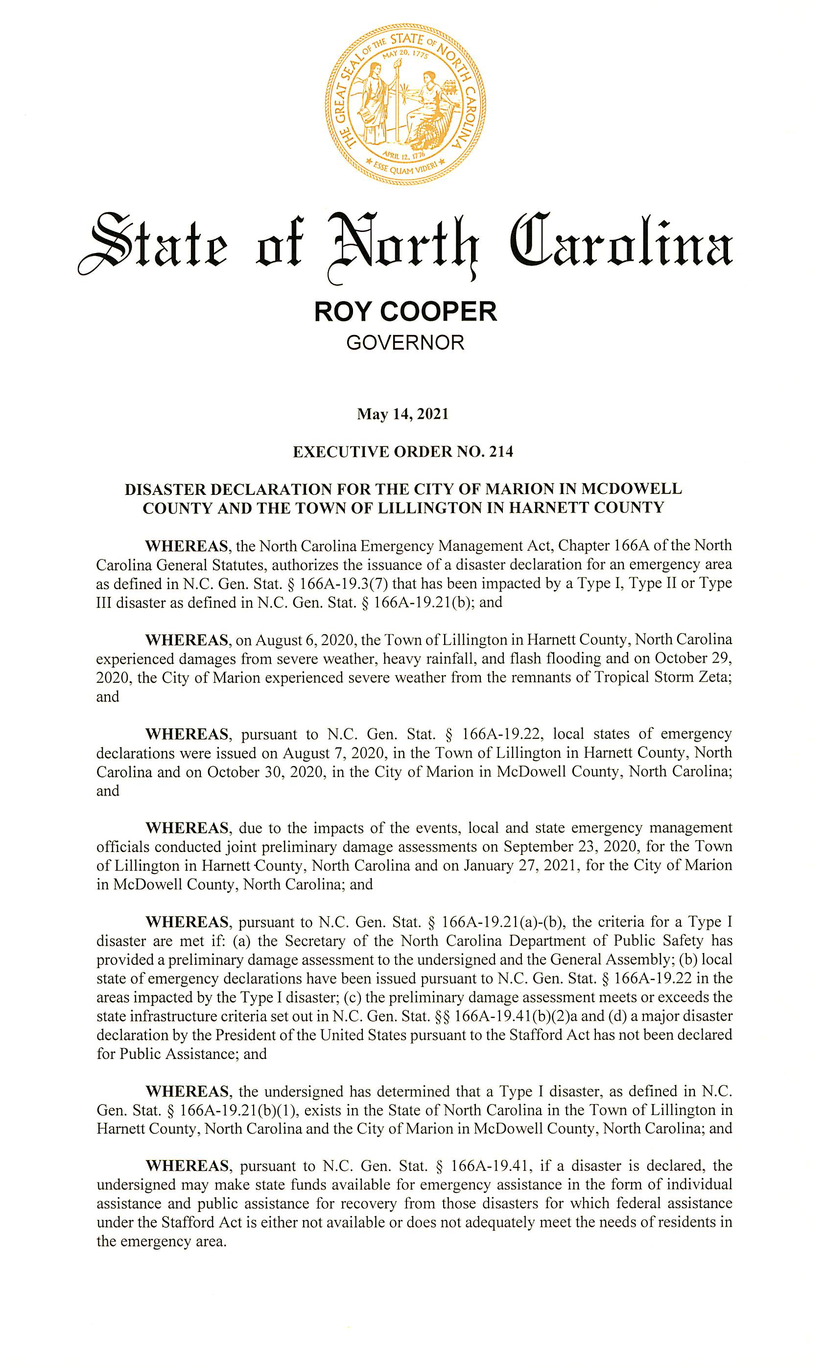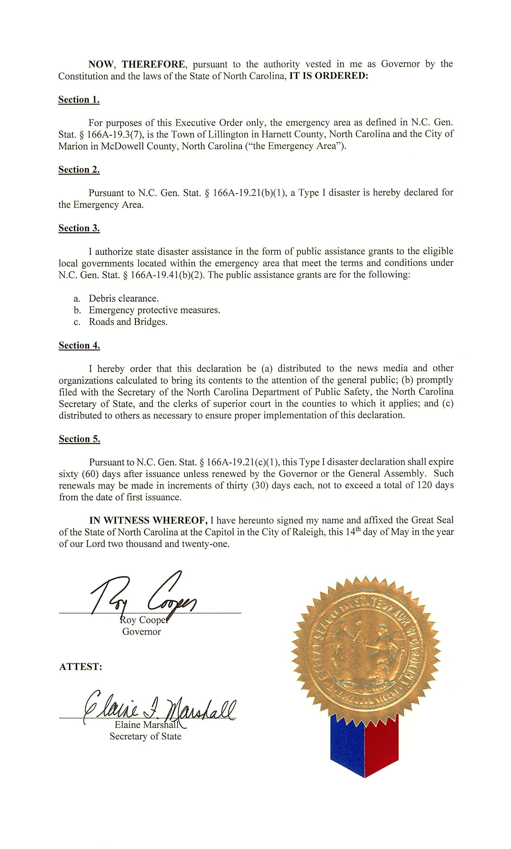
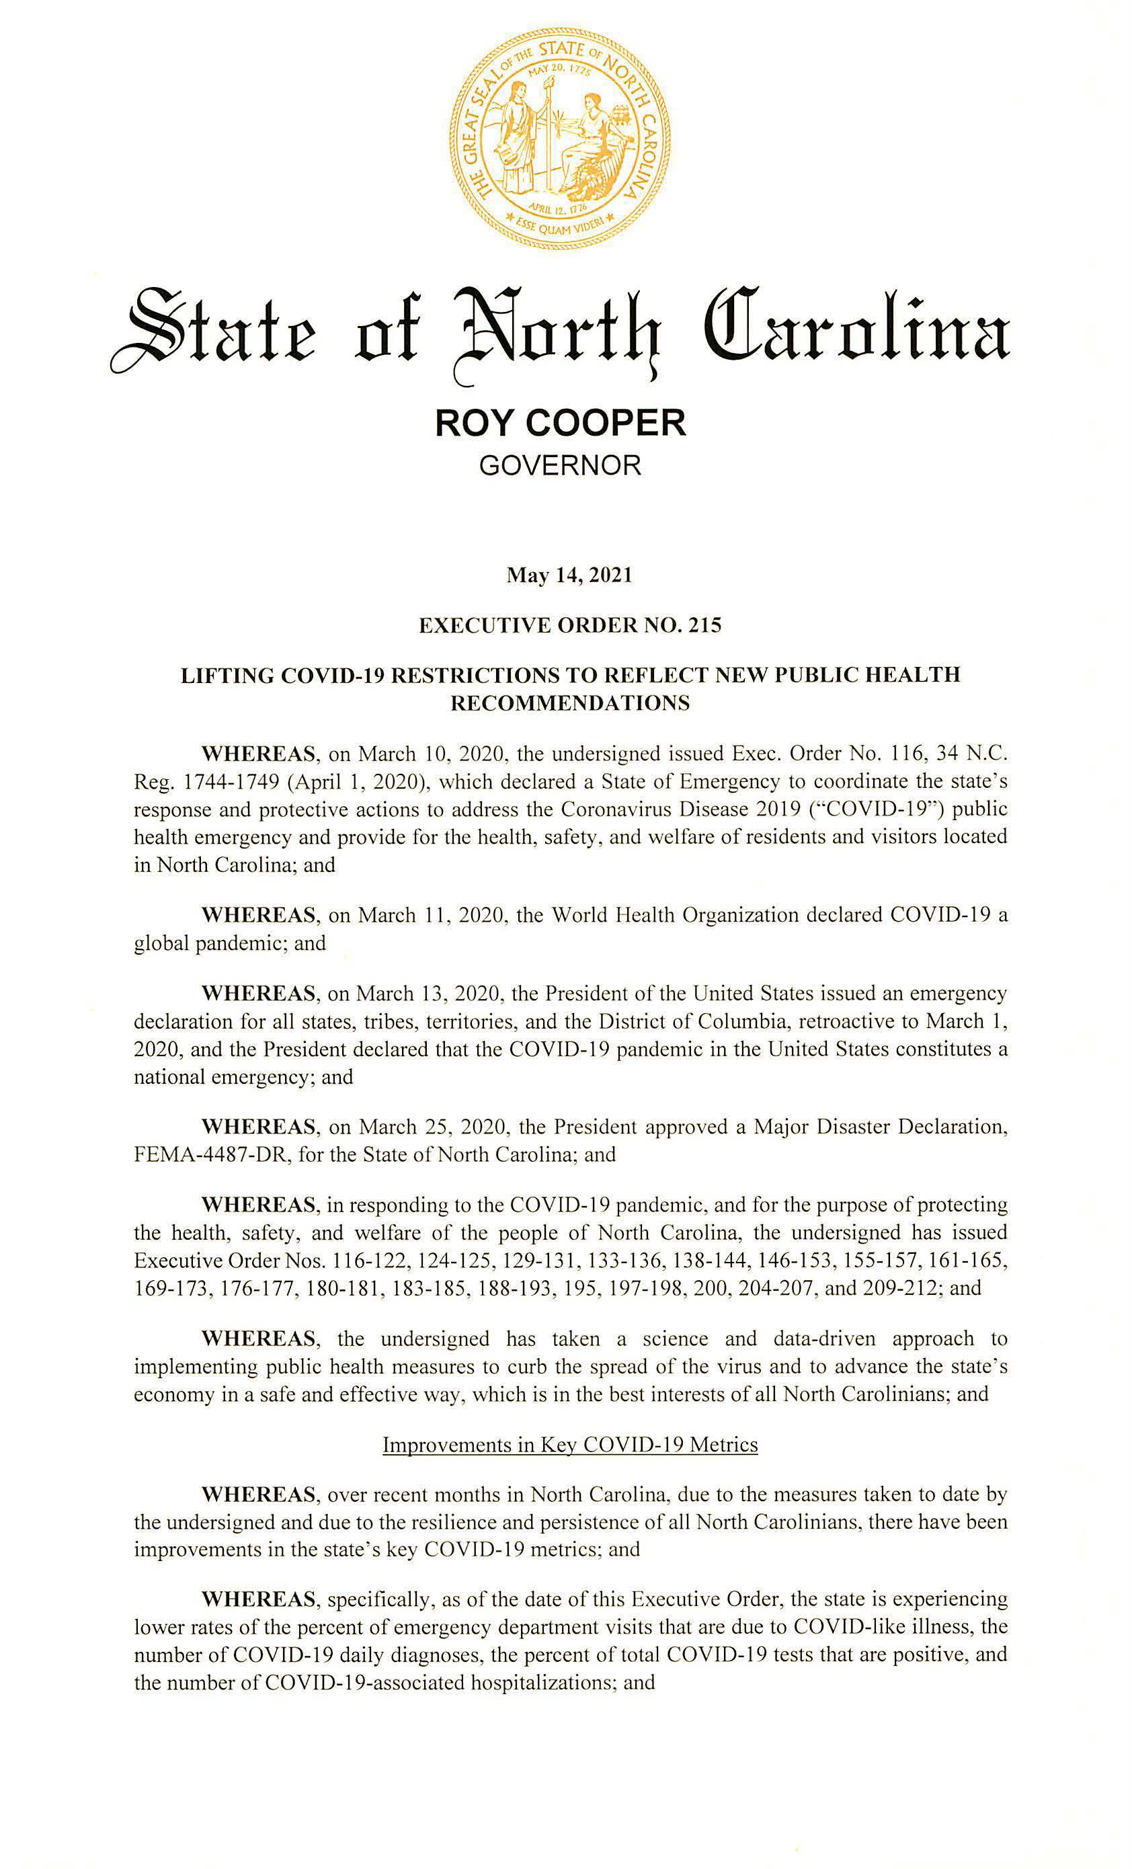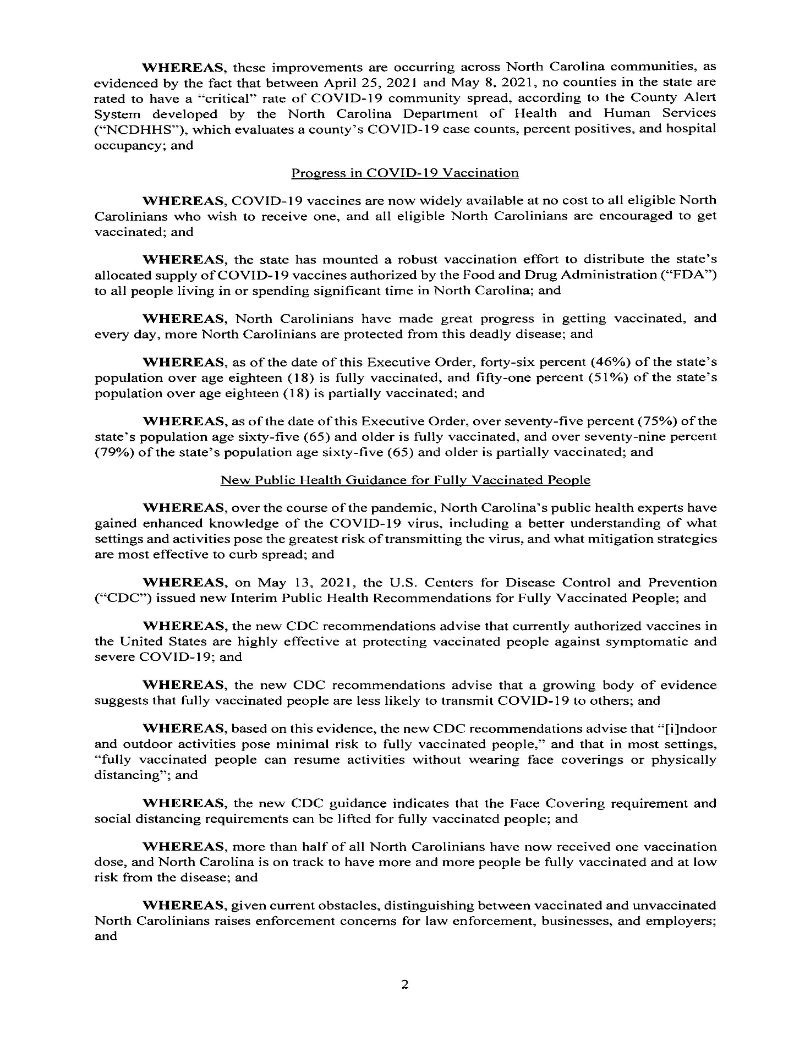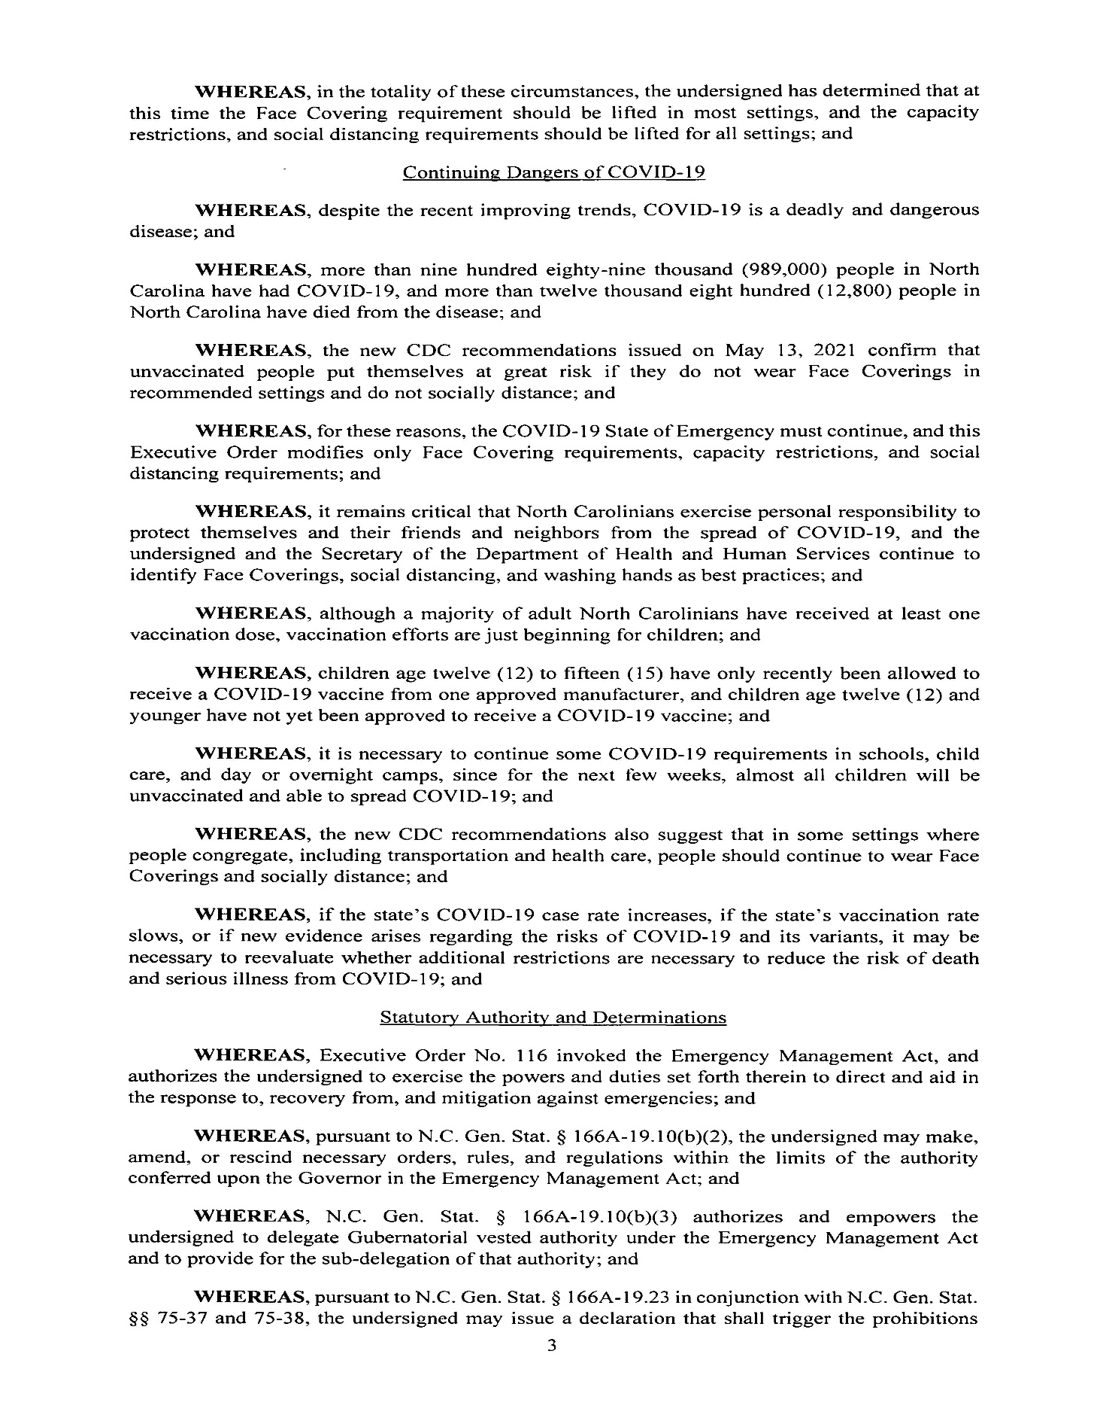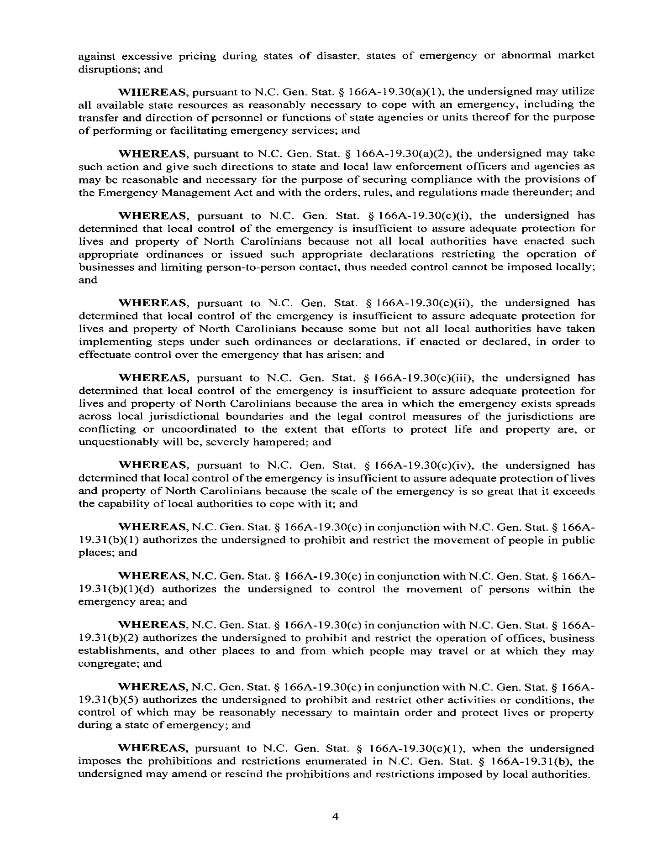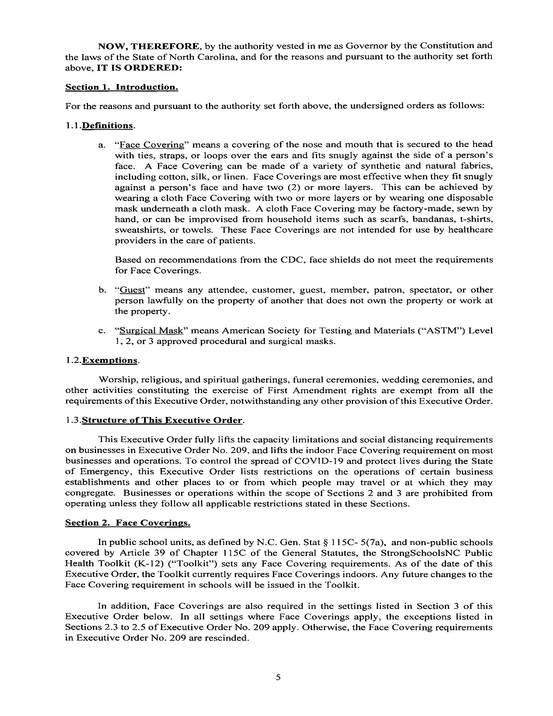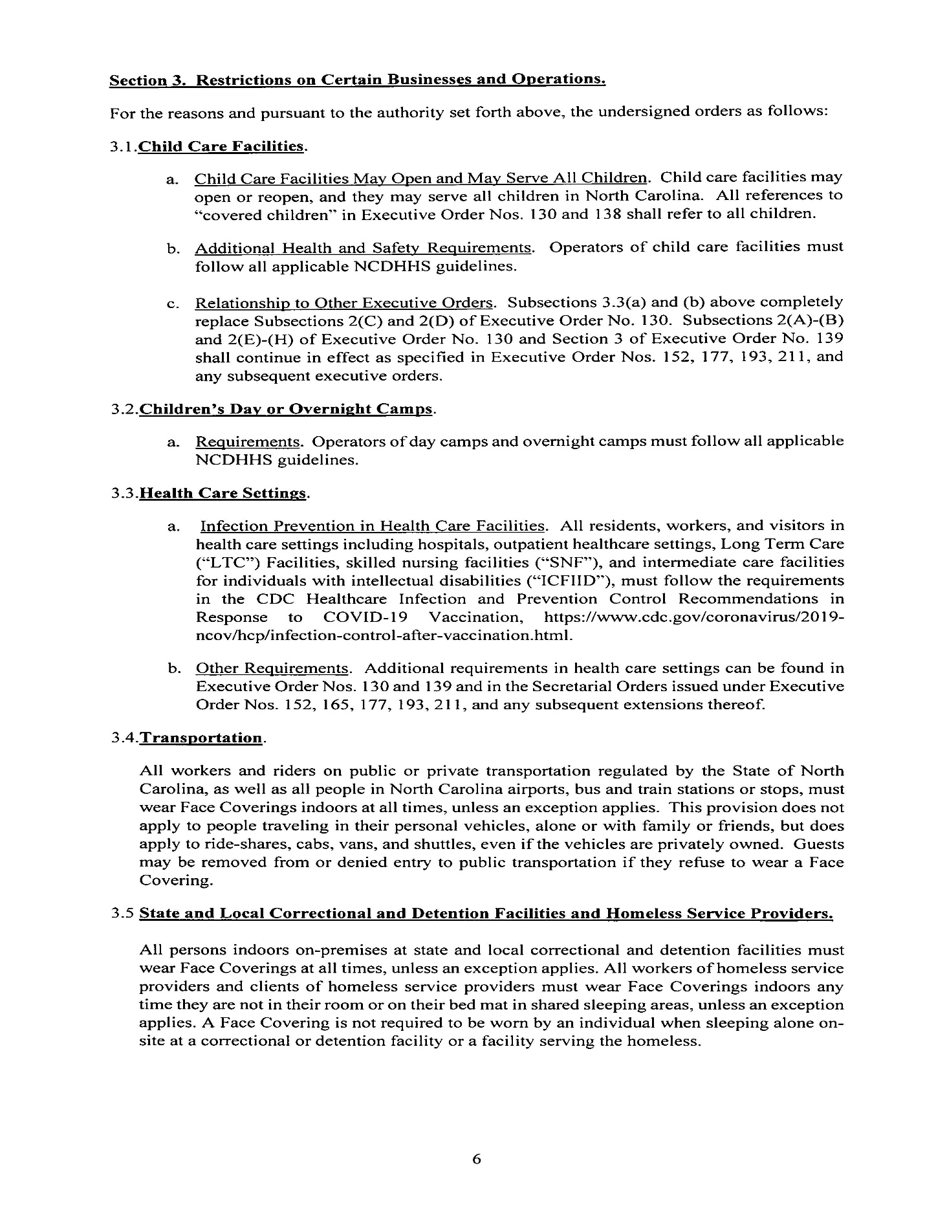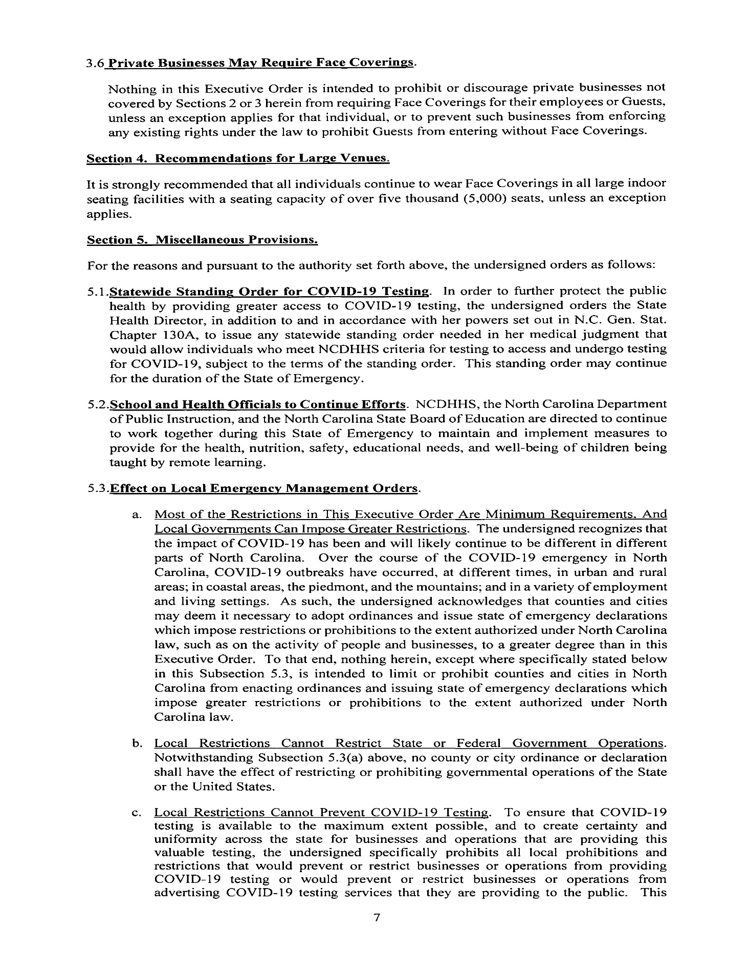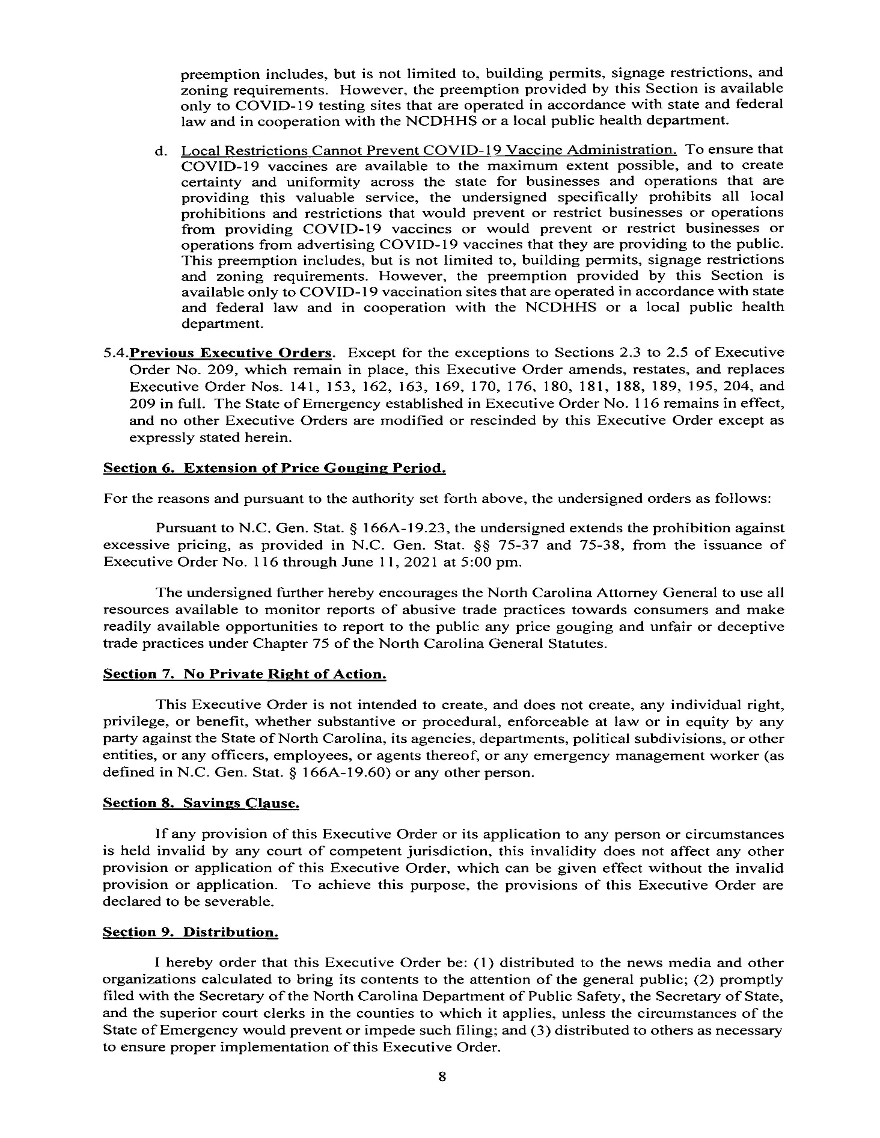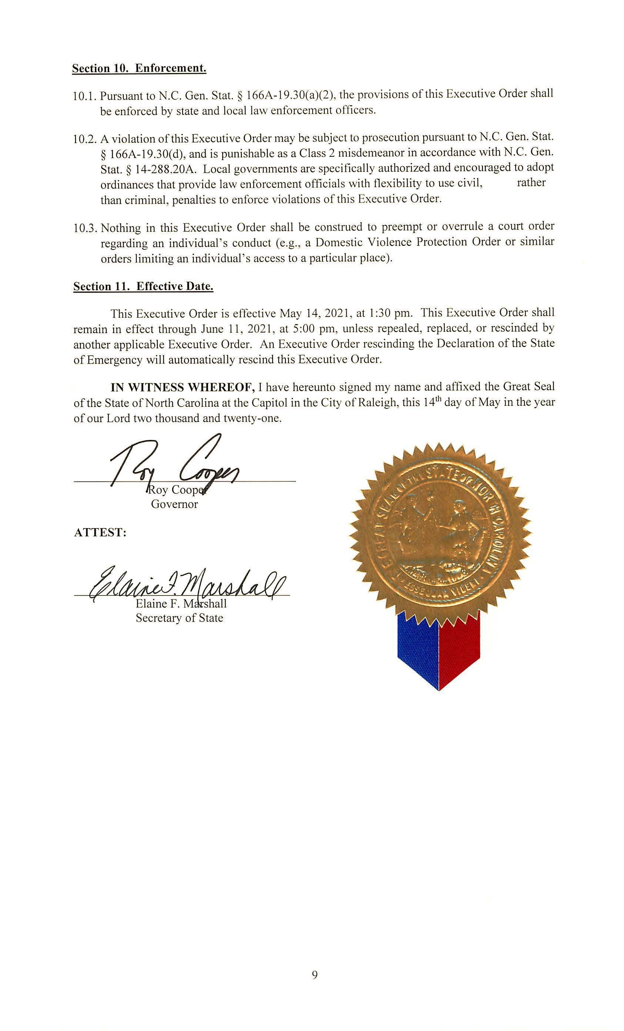
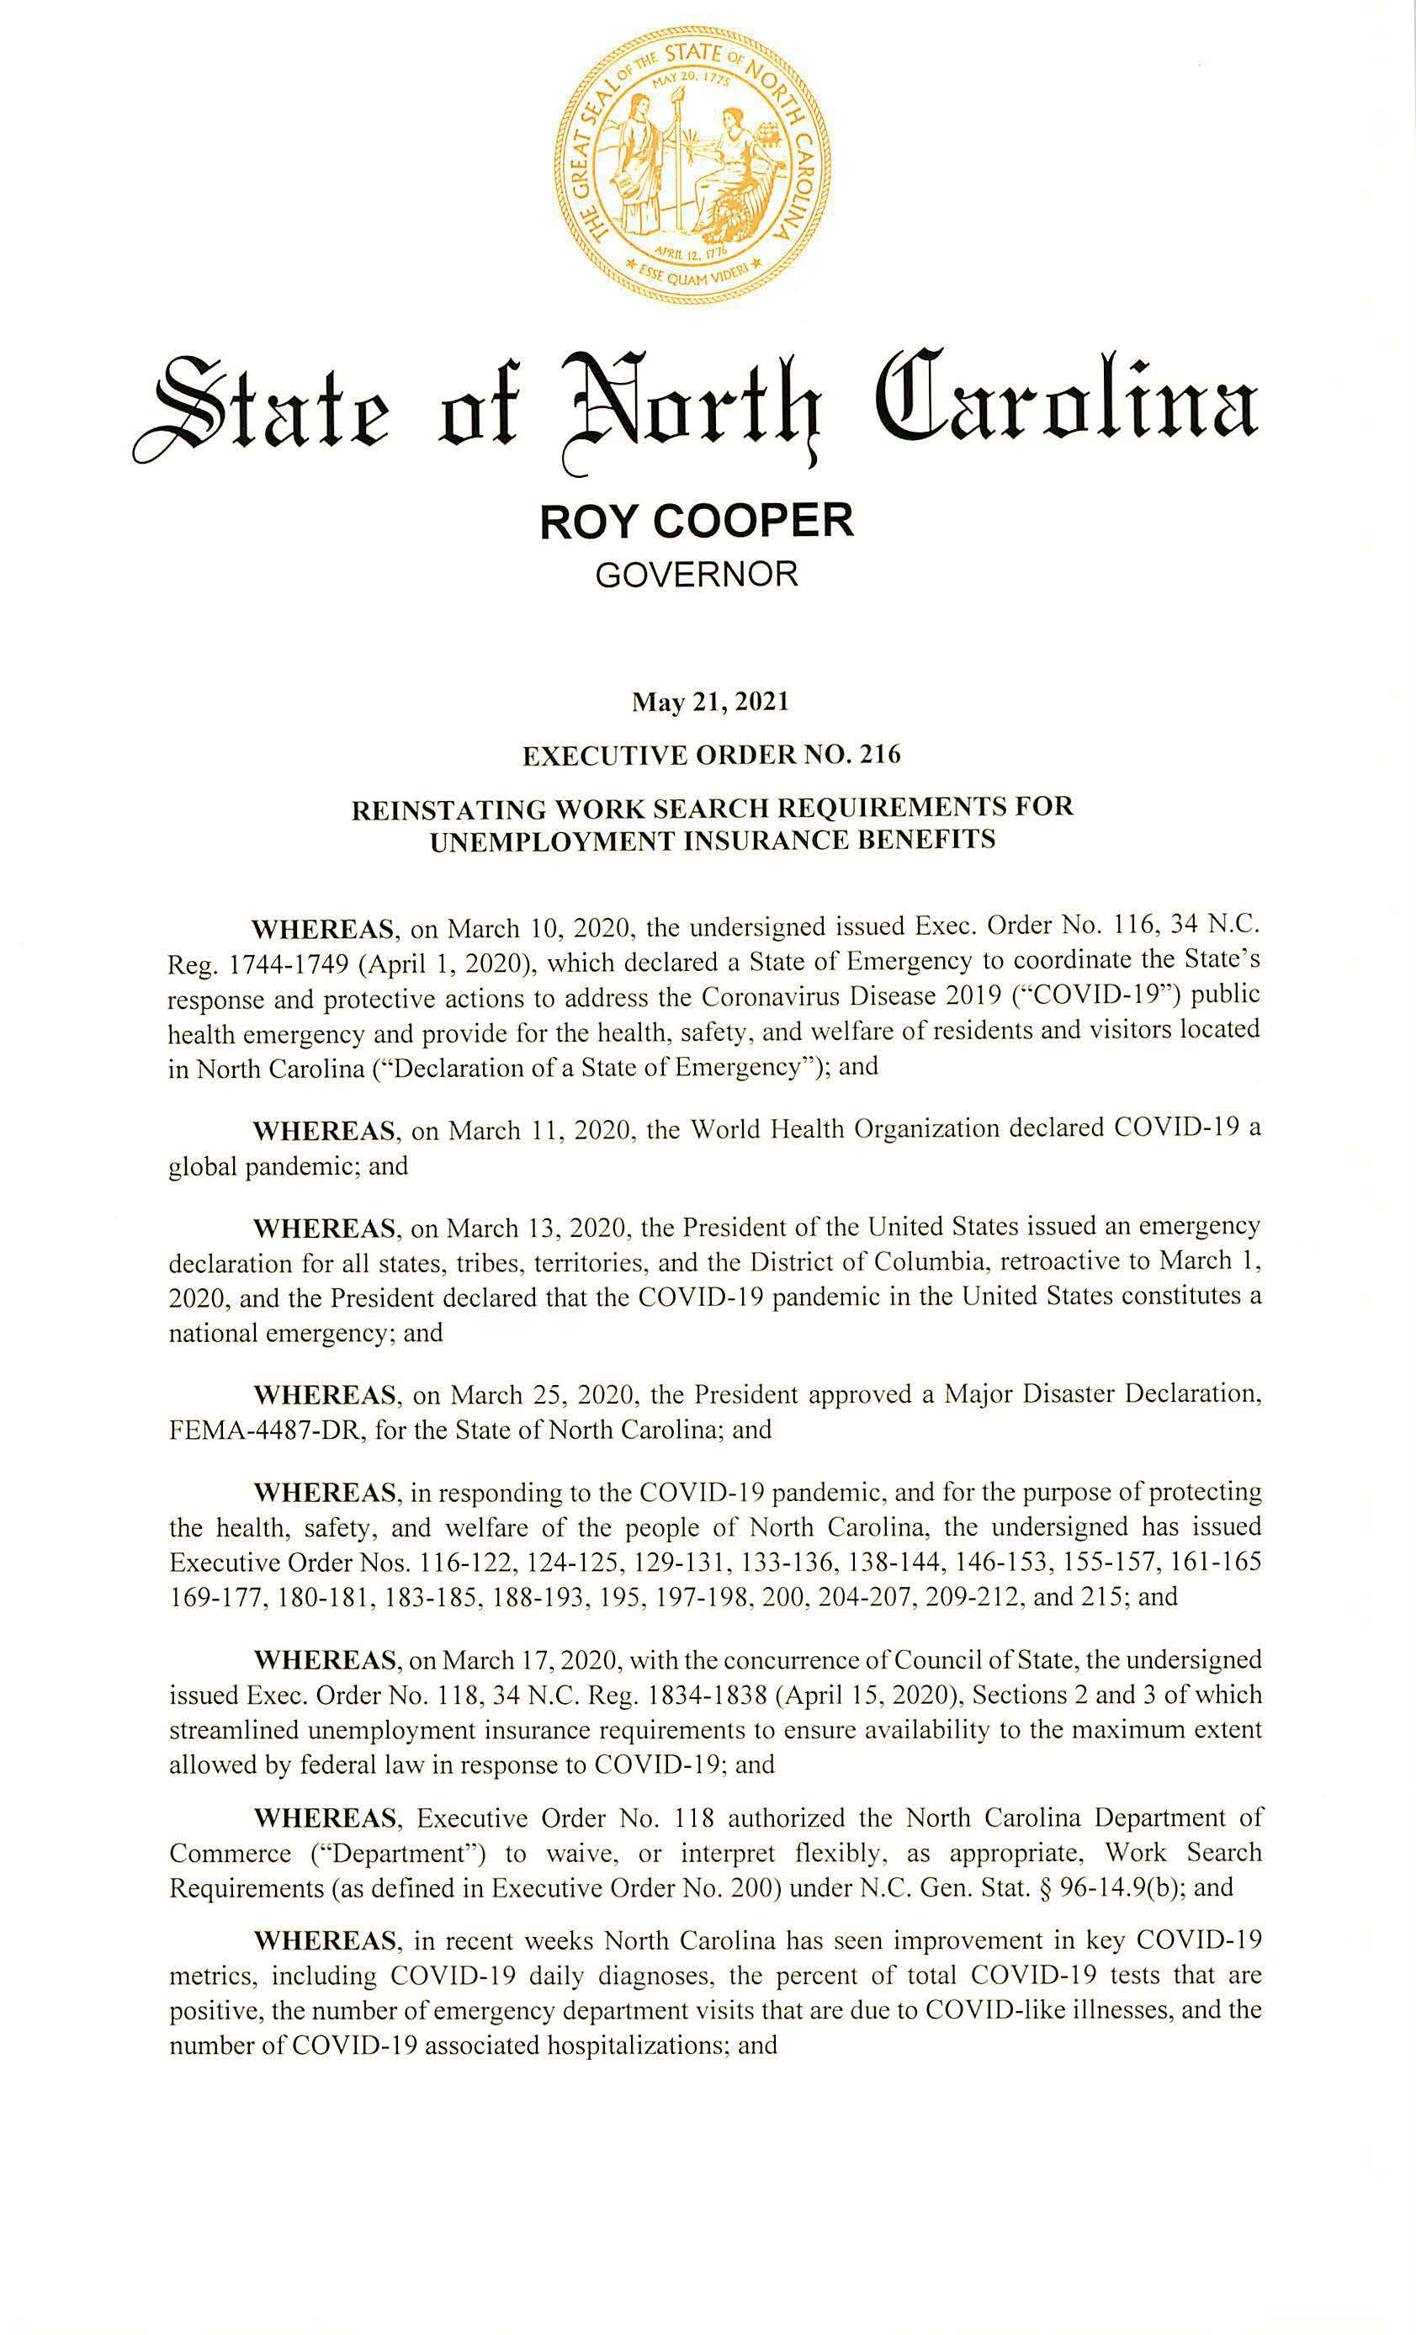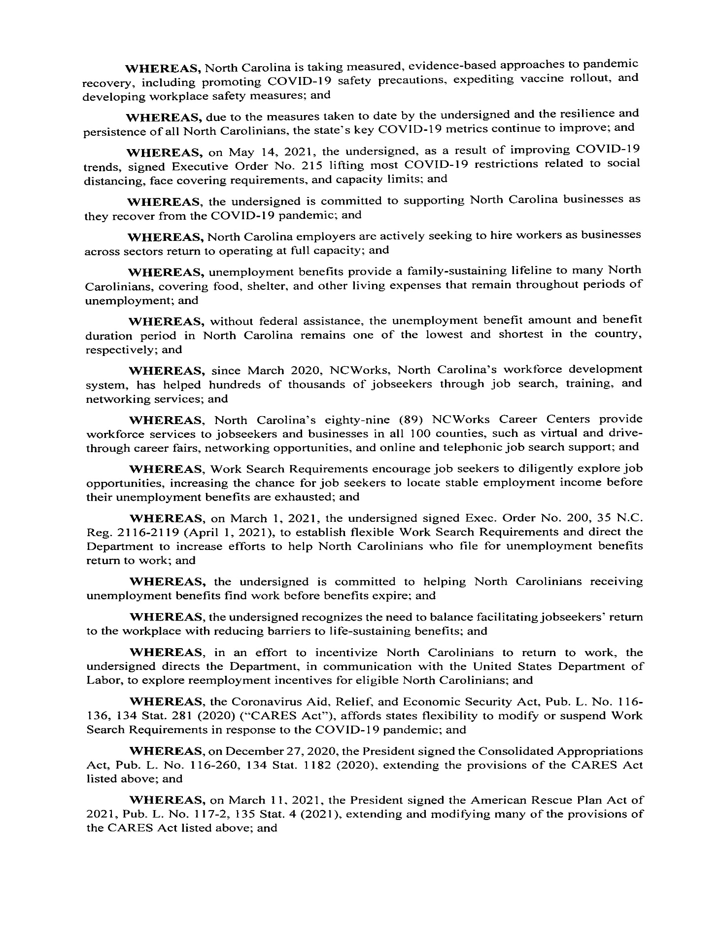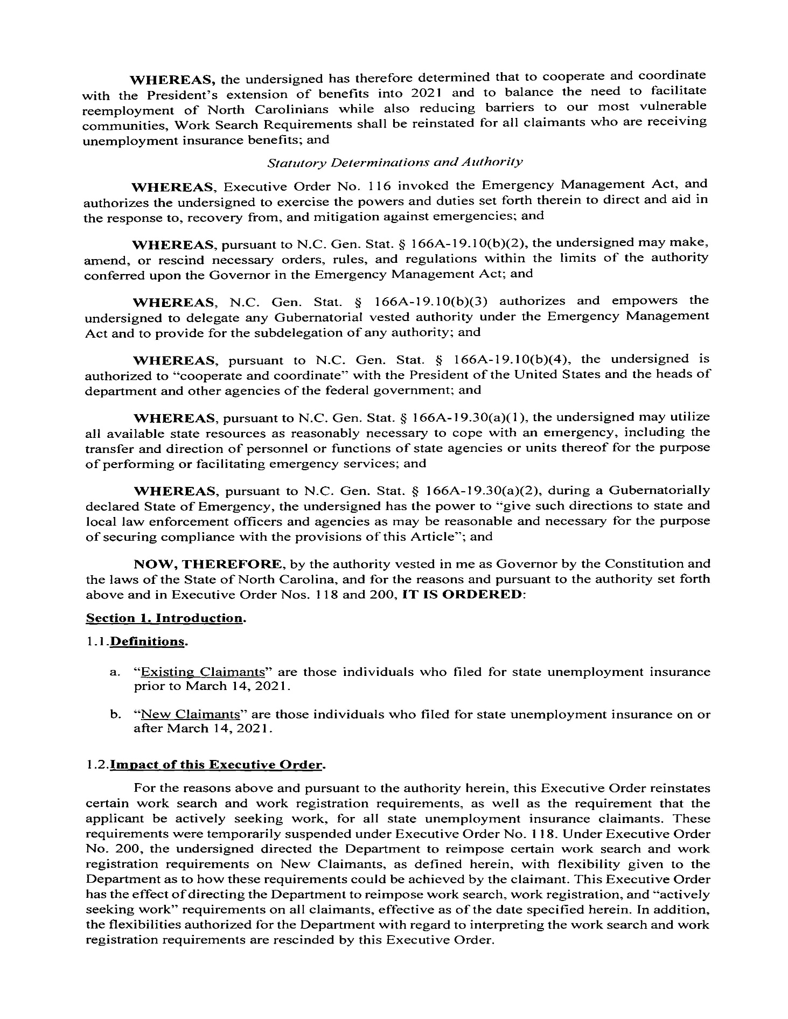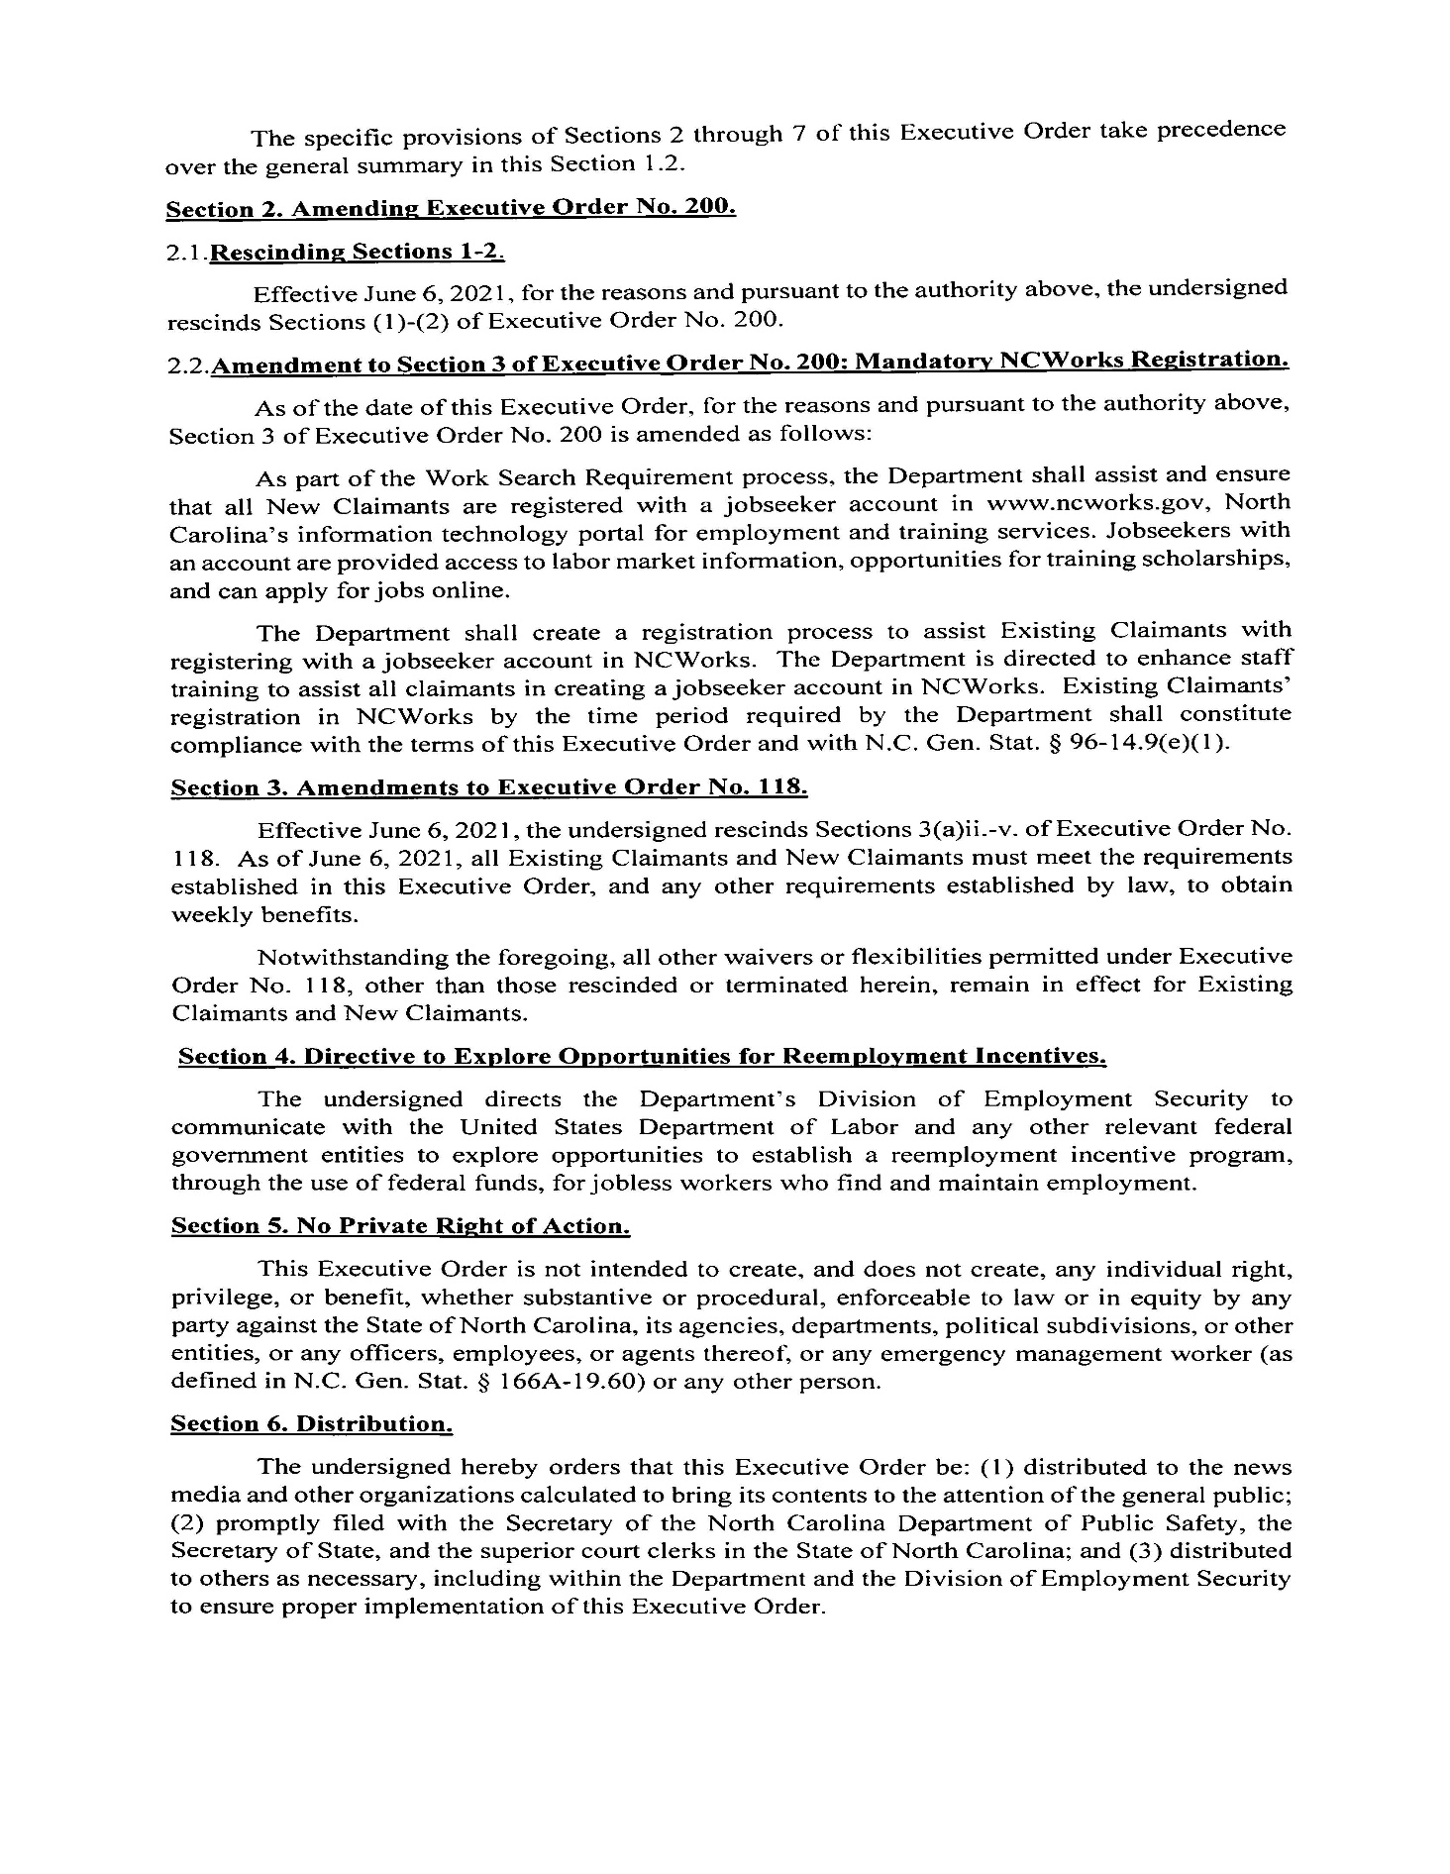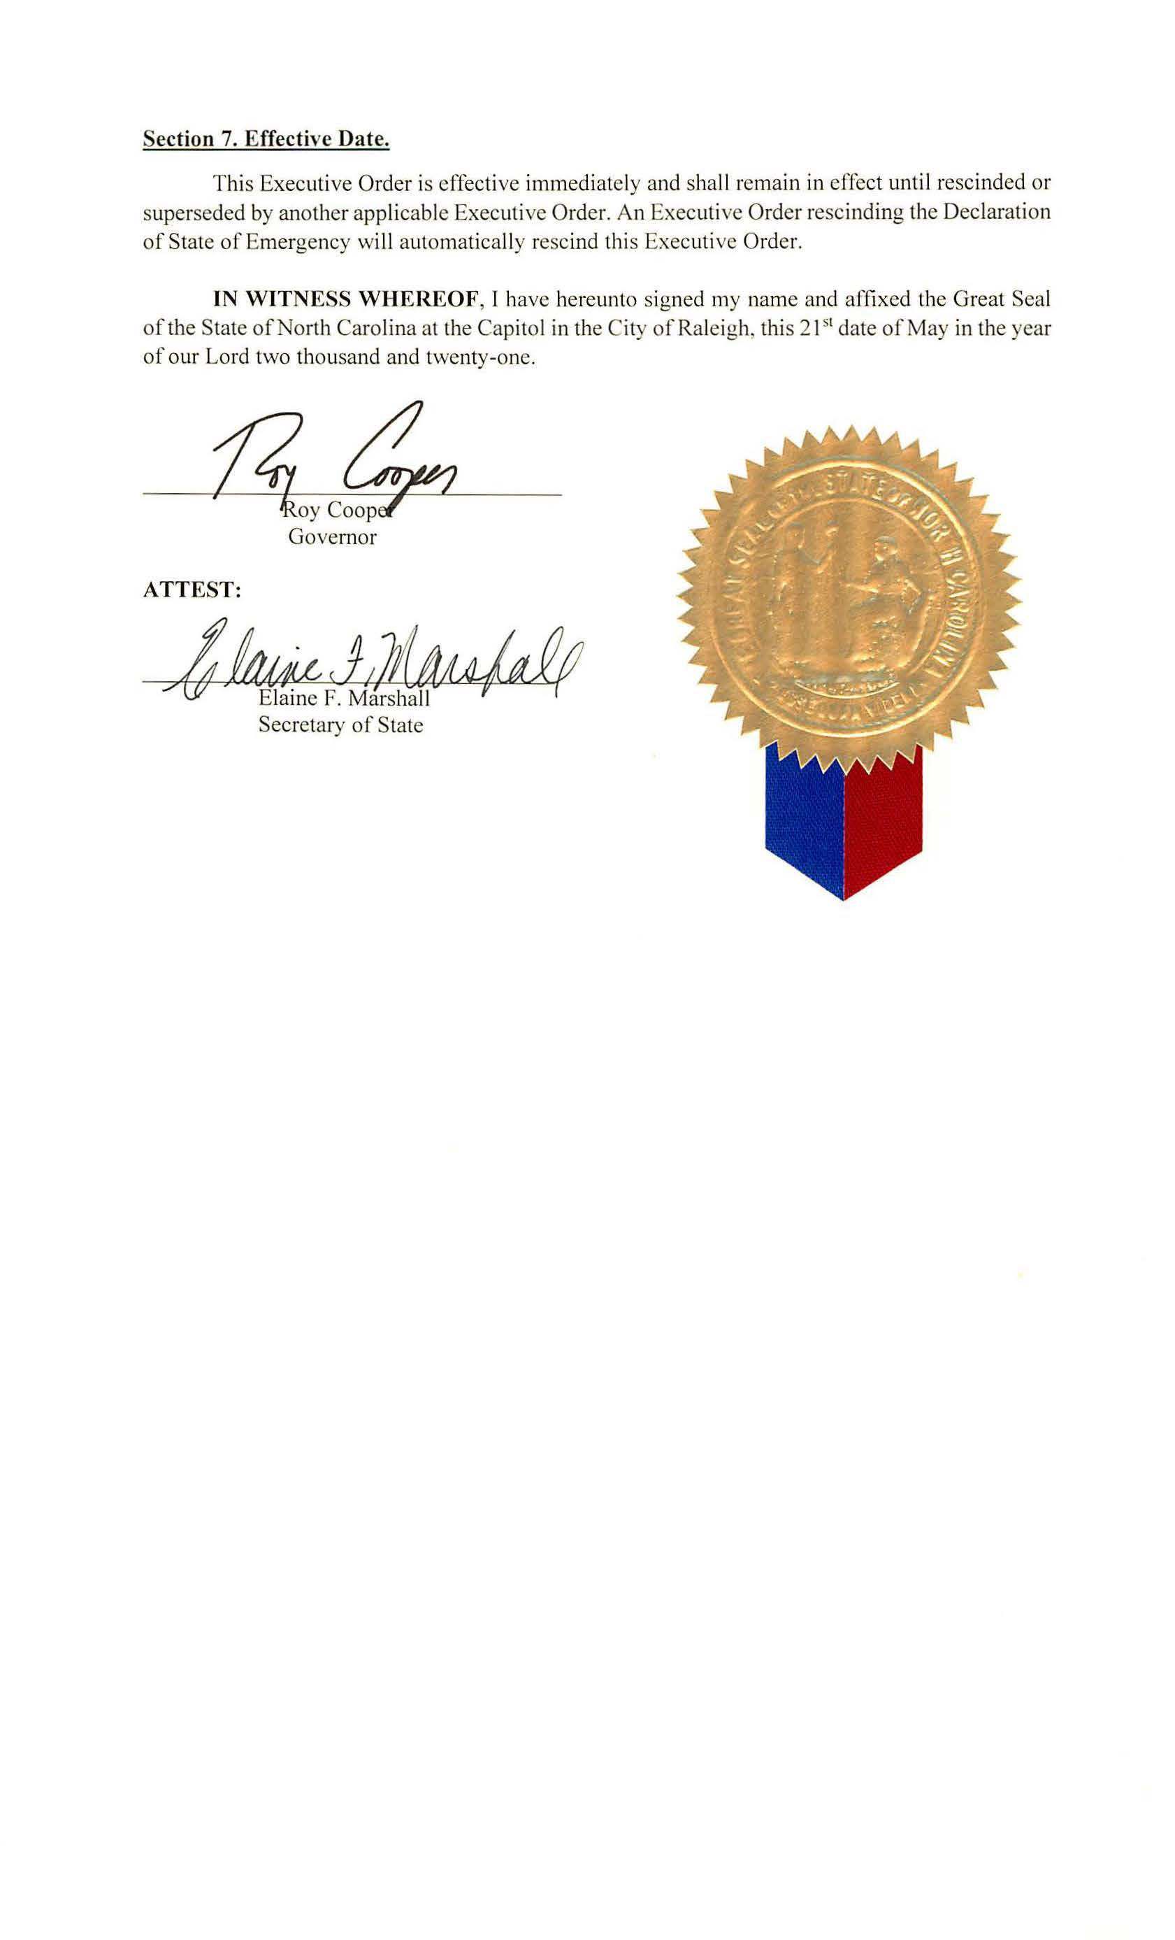

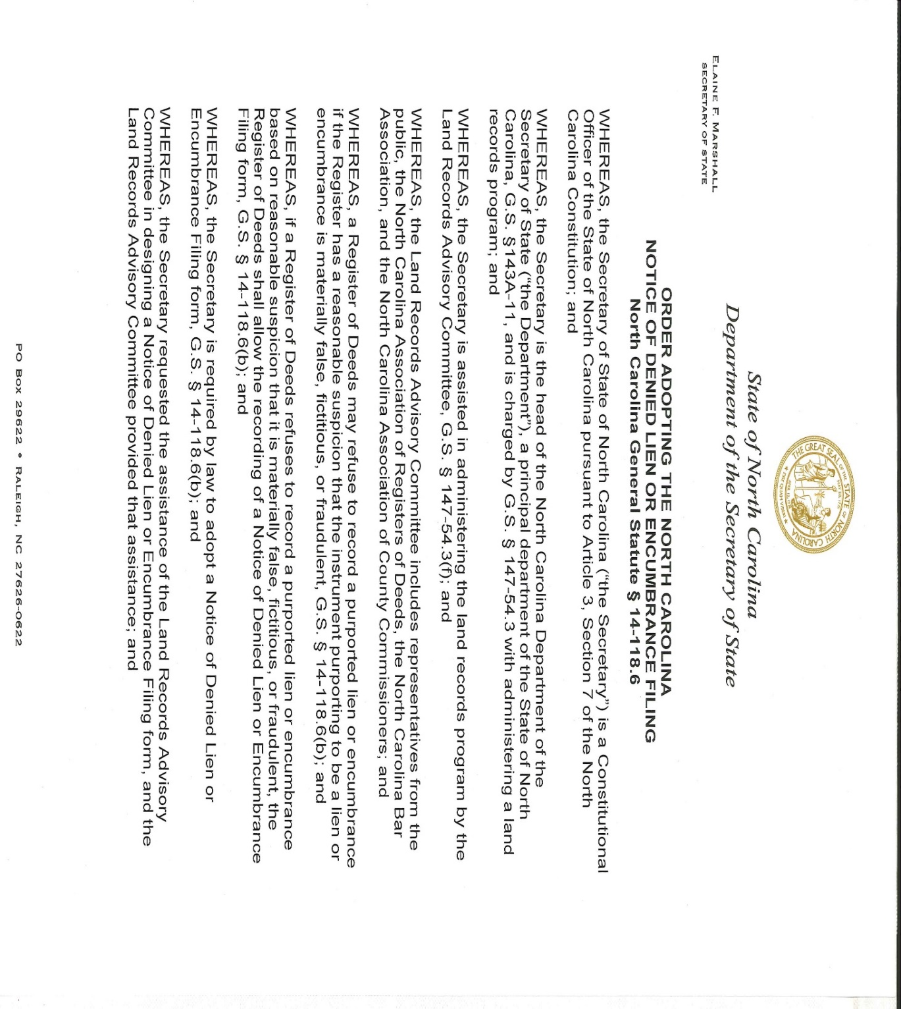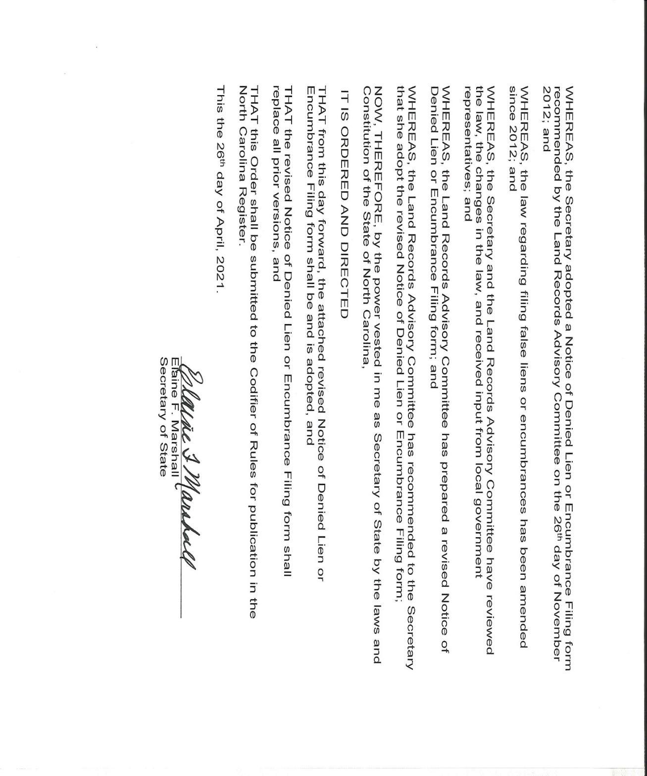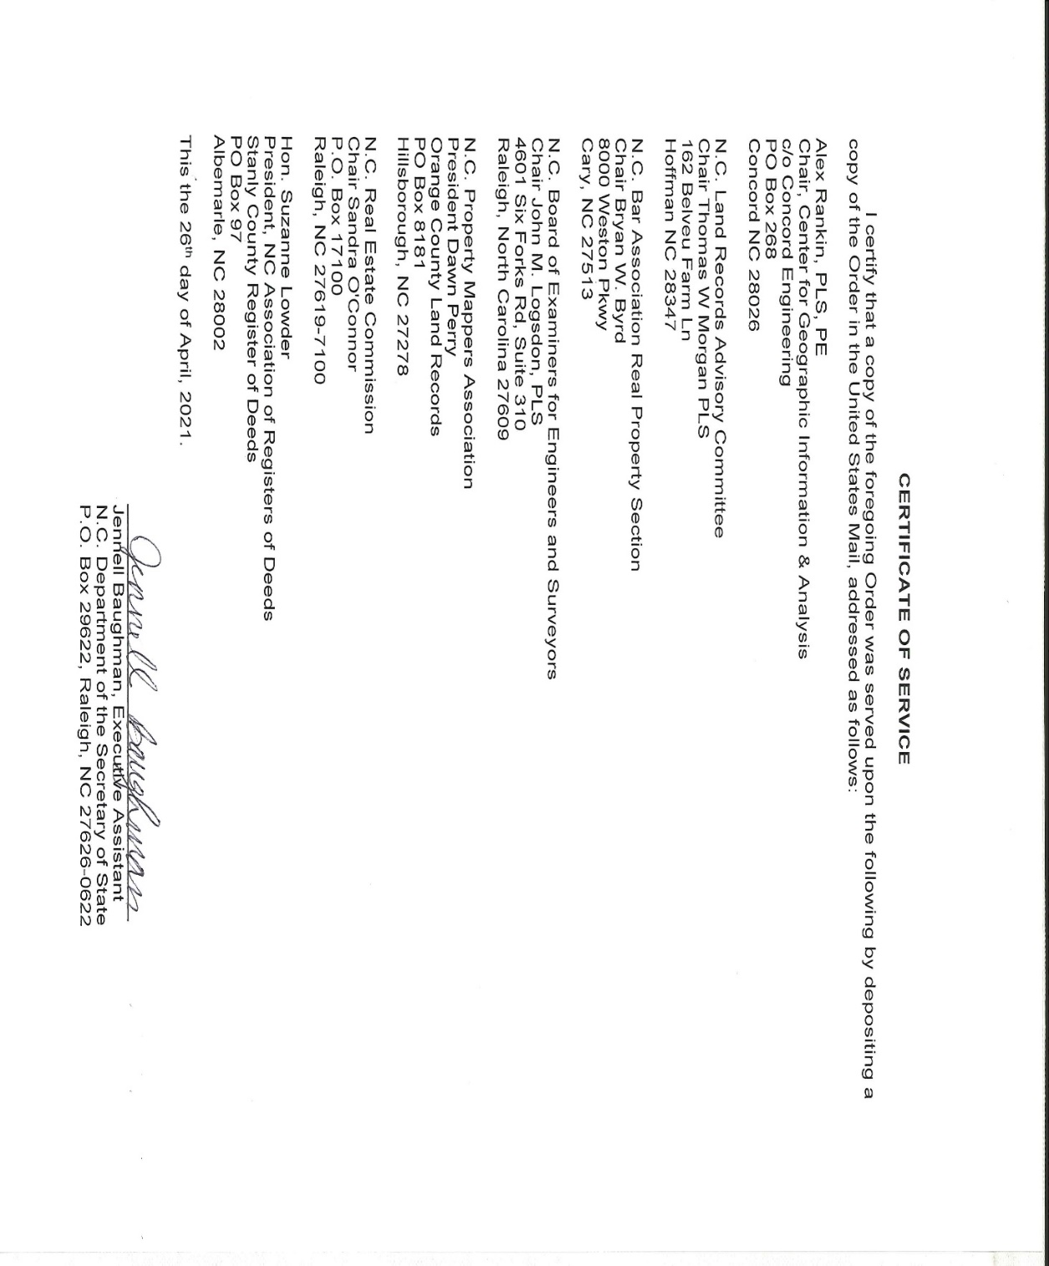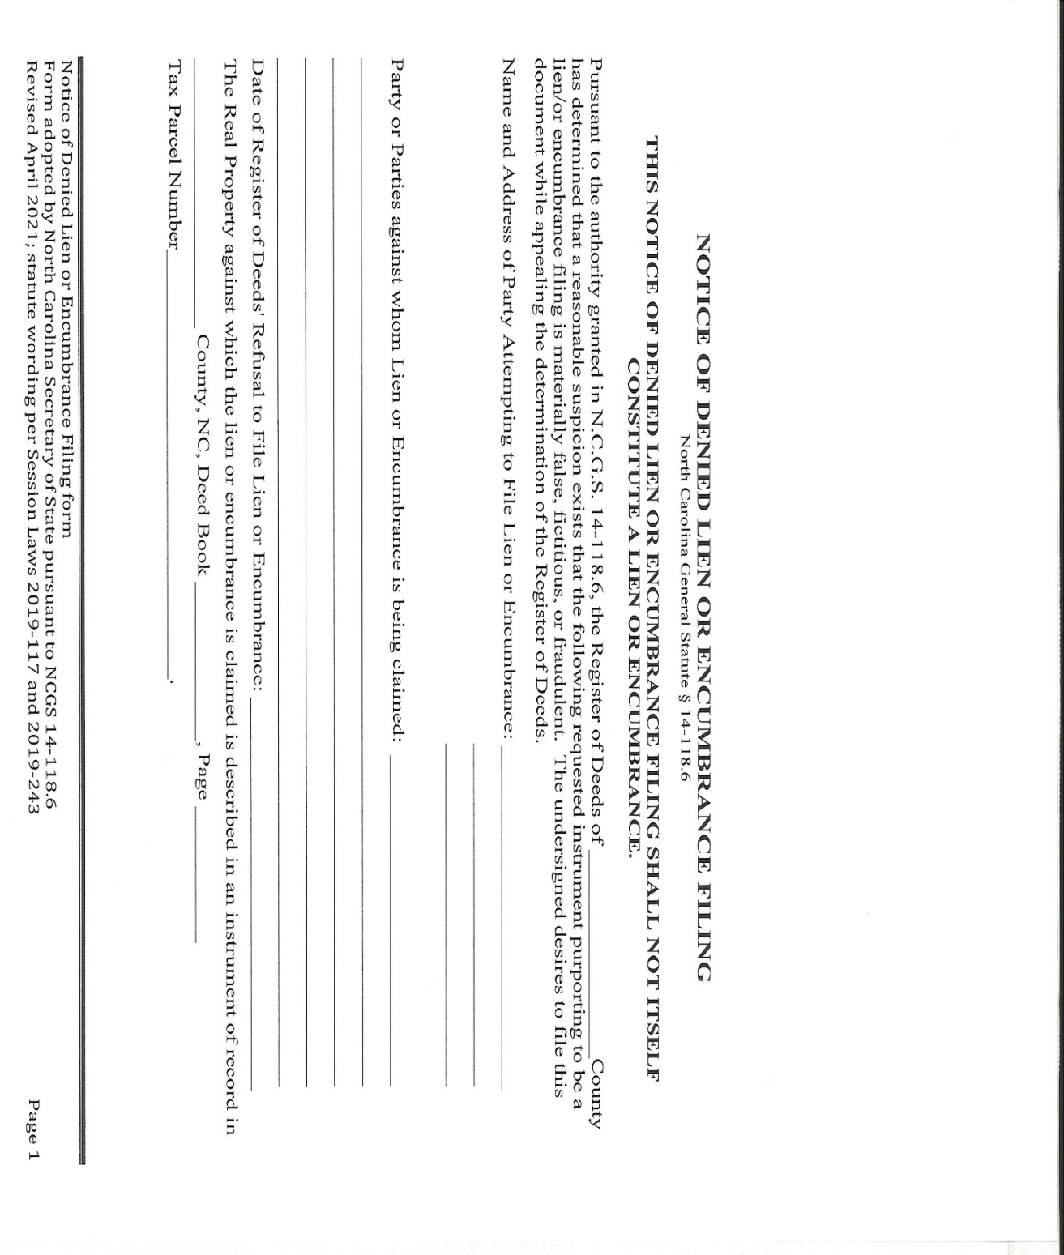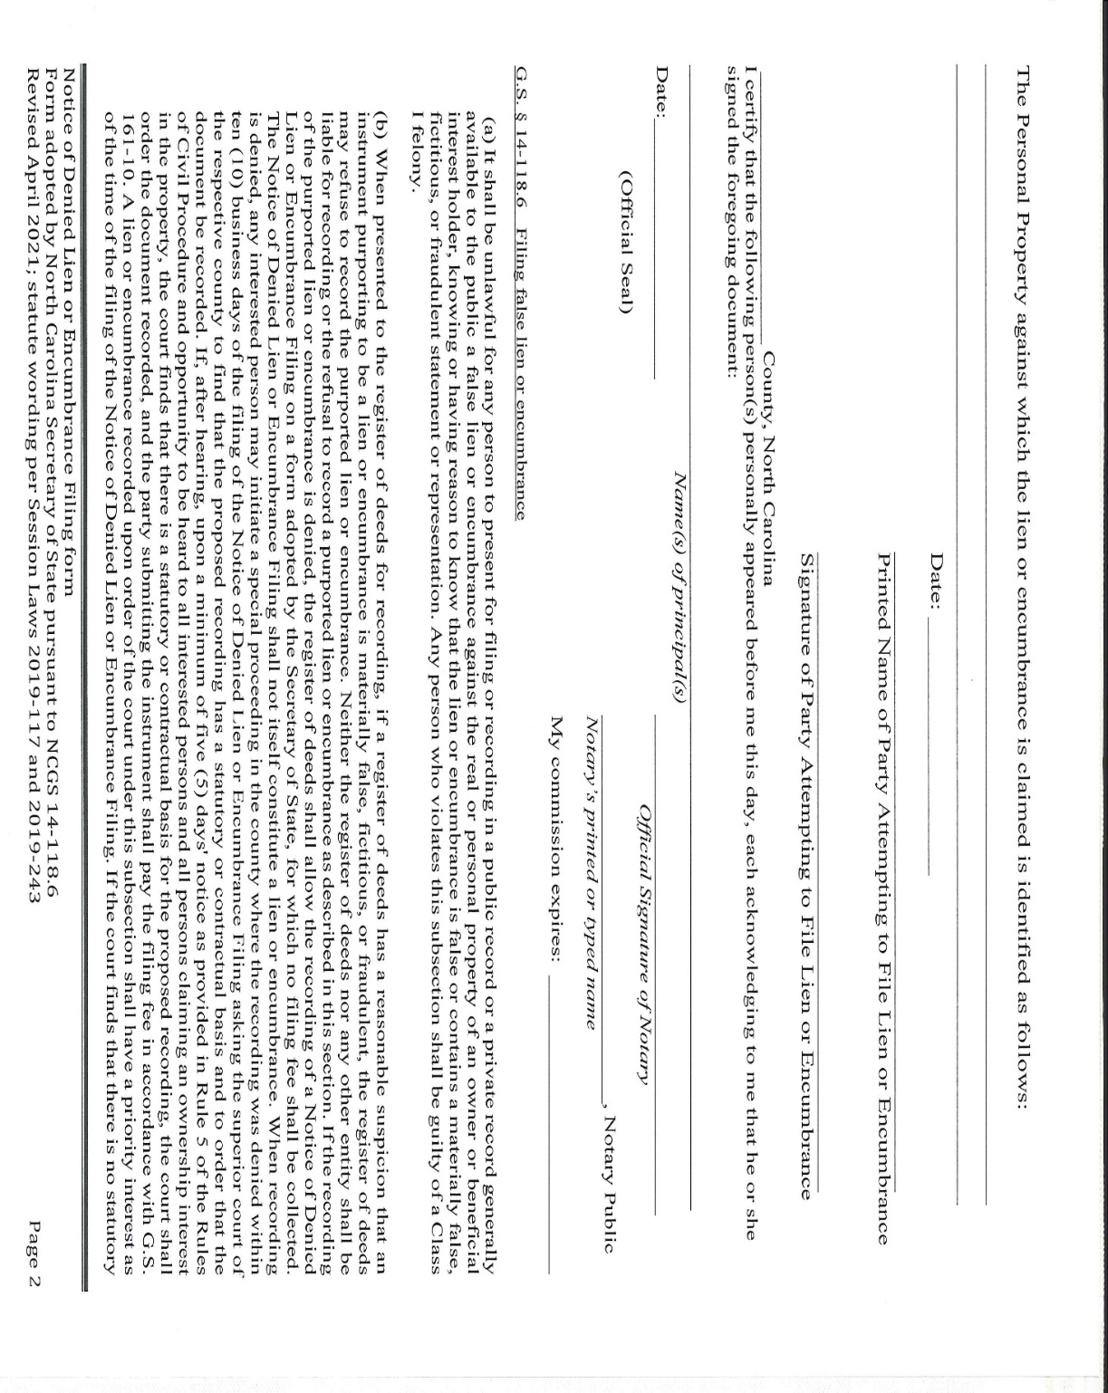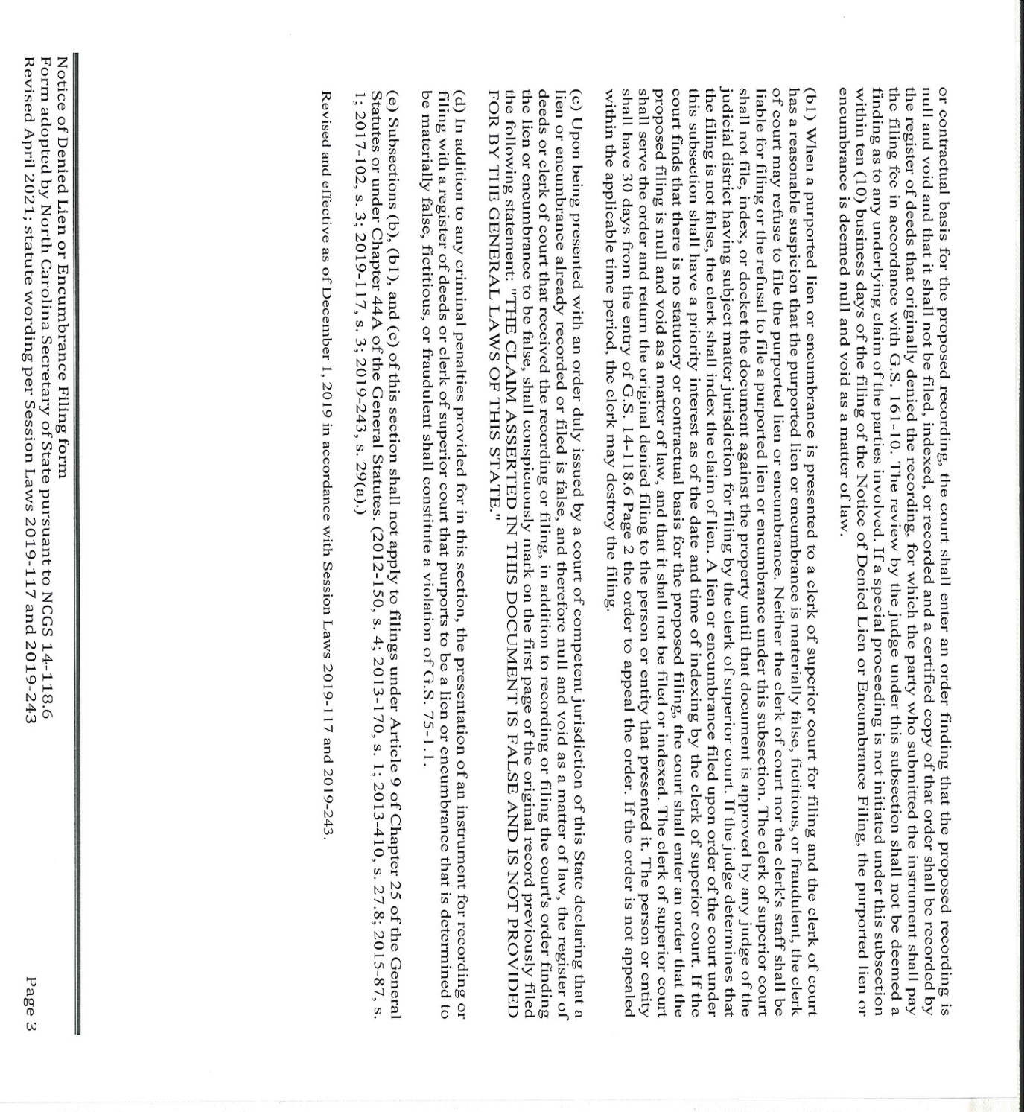

Note from the Codifier: The notices published in this Section of the NC Register include the text of proposed rules. The agency must accept comments on the proposed rule(s) for at least 60 days from the publication date, or until the public hearing, or a later date if specified in the notice by the agency. If the agency adopts a rule that differs substantially from a prior published notice, the agency must publish the text of the proposed different rule and accept comment on the proposed different rule for 60 days.
Statutory reference: G.S. 150B-21.2.

Title 02 – Department of Agriculture and Consumer Services

Notice is hereby given in accordance with G.S. 150B-21.2 that the Pesticide Board intends to amend the rule cited as 02 NCAC 09L .0502.

Link to agency website pursuant to G.S. 150B-19.1(c): http://www.ncagr.gov/AdministrativeRules/ProposedRules/index.htm

Proposed Effective Date: October 1, 2021

Instructions on How to Demand a Public Hearing: (must be requested in writing within 15 days of notice): Any person may request a public hearing on the proposed rules by submitting a request in writing no later than June 30, 2021 to James W. Burnette, Jr., Secretary, NC Pesticide Board, 1090 Mail Service Center, Raleigh, NC 27699-1090.

Reason for Proposed Action: The North Carolina Pesticide Board finds it critical to exempt pesticides approved by the United States Environmental Protection Agency (EPA) on an emergency basis in accordance with 02 NCAC 09L .0318 for use in preventing, destroying, or mitigating COVID-19 from being restricted use pesticides as currently required by 02 NCAC 09L .0502(3). This exemption will bring North Carolina standards in line with other states and ensure North Carolina does not fall behind in its efforts to respond to COVID-19 by allowing for normal distribution of these pesticides.

Comments may be submitted to: James W. Burnette, Jr., 1090 Mail Service Center, Raleigh, NC 27699-1001; email james.burnette@ncagr.gov

Comment period ends: August 16, 2021

Procedure for Subjecting a Proposed Rule to Legislative Review: If an objection is not resolved prior to the adoption of the rule, a person may also submit written objections to the Rules Review Commission after the adoption of the Rule. If the Rules Review Commission receives written and signed objections after the adoption of the Rule in accordance with G.S. 150B-21.3(b2) from 10 or more persons clearly requesting review by the legislature and the Rules Review Commission approves the rule, the rule will become effective as provided in G.S. 150B-21.3(b1). The Commission will receive written objections until 5:00 p.m. on the day following the day the Commission approves the rule. The Commission will receive those objections by mail, delivery service, hand delivery, or facsimile transmission. If you have any further questions concerning the submission of objections to the Commission, please call a Commission staff attorney at 919-431-3000.

Fiscal impact. Does any rule or combination of rules in this notice create an economic impact? Check all that apply.

State funds affected

Local funds affected

Substantial economic impact (>= $1,000,000)

Approved by OSBM

No fiscal note required

Chapter 09 - Food and Drug Protection

SUBCHAPTER 09L - PESTICIDE SECTION

SECTION .0500 - PESTICIDE LICENSES

02 NCAC 09L .0502 LIST OF RESTRICTED USE PESTICIDES

(a) For the purpose of this Subchapter a "restricted use pesticide" shall be:

(1) any pesticide required by the Environmental Protection Agency to bear the designation on its labeling "Restricted Use Pesticide;"

(2) arsenic trioxide; and

(3) any pesticide approved under Rule .0318 of this Subchapter.

(b) Any pesticide approved by the United States Environmental Protection Agency for use in the State of North Carolina in accordance with 02 NCAC 09L .0318 that is labeled as approved for use in preventing, destroying, or mitigating COVID-19 shall be exempt from the provisions of Subparagraph (a)(3) of this Rule and shall not be considered a Restricted Use Pesticide.

Authority G.S. 143-440(a),(b); 143-441; 143-458.

* * * * * * * * * * * * * * * * * * * *

Notice is hereby given in accordance with G.S. 150B-21.2 that the Soil and Water Conservation Commission intends to adopt the rules cited as 02 NCAC 59A .0201- .0204, .0301, .0302, amend the rules cited as 02 NCAC 59A .0101-.0103, and repeal the rule cited as 02 NCAC 59A .0104.

Pursuant to G.S. 150B-21.17, the Codifier has determined it impractical to publish the text of rules proposed for repeal unless the agency requests otherwise. The text of the rule(s) are available on the OAH website at http://reports.oah.state.nc.us/ncac.asp.

Link to agency website pursuant to G.S. 150B-19.1(c): http://www.ncagr.gov/AdministrativeRules/ProposedRules/index.htm

Proposed Effective Date: October 1, 2021

Public Hearing:
Date: July 21, 2021
Time: 1:00 p.m.
Location: Farm Bureau – Smithfield Office – Auditorium (Johnston County) at 1809 S. Bright Leaf Boulevard, Smithfield, NC 27577, with virtual component: Join on your computer or mobile app via - https://teams.microsoft.com/l/meetup-join/19%3ameeting_ZjBiZWZiYTQtOTNmZS00MTZlLTljNmMtOWJkZDI5YTQ3YTMx%40thread.v2/0?context=%7b%22Tid%22%3a%227a7681dc-b9d0-449a-85c3-ecc26cd7ed19%22%2c%22Oid%22%3a%221e9e2b32-1360-4d12-856c-5f2697d63158%22%7d. Join with a video conferencing device ncgov@m.webex.com Video Conference ID: 113 332 538 1 Alternate VTC dialing instructions Or call in (audio only) +1 984-204-1487,989733041# United States, Raleigh Phone Conference ID: 989 733 041#

Date: August 3, 2021
Time: 7:00 p.m.
Location: Virtual: Join on your computer or mobile app via - https://teams.microsoft.com/l/meetup-join/19%3ameeting_YTljOThkZDctZmQ3NC00NWNiLTk3MDgtYTQ0ZWFiMTZjMjlk%40thread.v2/0?context=%7b%22Tid%22%3a%227a7681dc-b9d0-449a-85c3-ecc26cd7ed19%22%2c%22Oid%22%3a%221e9e2b32-1360-4d12-856c-5f2697d63158%22%7d. Join with a video conferencing device ncgov@m.webex.com Video Conference ID: 112 997 621 6 Alternate VTC dialing instructions Or call in (audio only) +1 984-204-1487,457567489# United States, Raleigh Phone Conference ID: 457 567 489#

Reason for Proposed Action: The General Assembly recently enacted Session Law 2018-113 which requires training for appointed and elected soil and water conservation district supervisors under General Statute 139-7.2. Under Session Law 2016-113, the General Assembly provided authority for the Soil and Water Conservation Commission to establish a training program for all district supervisors under General Statute 139-4(d). These rules set forth the guide for this supervisor training program and provide a process for supervisor removal. Supervisor removal authority is provided to the Soil and Water Conservation Commission under General Statue 139-7.

Comments may be submitted to: Vernon Cox, 1614 Mail Service Center, Raleigh, NC 27699-1614

Comment period ends: August 16, 2021

Procedure for Subjecting a Proposed Rule to Legislative Review: If an objection is not resolved prior to the adoption of the rule, a person may also submit written objections to the Rules Review Commission after the adoption of the Rule. If the Rules Review Commission receives written and signed objections after the adoption of the Rule in accordance with G.S. 150B-21.3(b2) from 10 or more persons clearly requesting review by the legislature and the Rules Review Commission approves the rule, the rule will become effective as provided in G.S. 150B-21.3(b1). The Commission will receive written objections until 5:00 p.m. on the day following the day the Commission approves the rule. The Commission will receive those objections by mail, delivery service, hand delivery, or facsimile transmission. If you have any further questions concerning the submission of objections to the Commission, please call a Commission staff attorney at 919-431-3000.

Fiscal impact. Does any rule or combination of rules in this notice create an economic impact? Check all that apply.

State funds affected

Local funds affected

Substantial economic impact (>= $1,000,000)

Approved by OSBM

No fiscal note required

Chapter 59 - Soil and Water Conservation Commission

SUBCHAPTER 59A - ORGANIZATION AND OPERATION

Section .0100 - General Provisions

02 NCAC 59A .0101 OBJECTIVES

The commission Commission administers a comprehensive statewide soil and water conservation program, giving technical, administrative, and financial assistance to local districts; Districts; giving planning assistance to local sponsors of small watershed projects under Public Law 83-566; giving technical and administrative assistance to complete the soils resource inventory for the state; and developing and implementing an agricultural non-point source pollution program. State cost share programs for water quality and water quantity.

Authority G.S. 106-840.

02 NCAC 59A .0102 ADDRESS

Division of Soil and Water Conservation

Department of Environment, Health, and Natural Resources Agriculture and Consumer Services

Archdale Building

512 North Salisbury Street 216 West Jones Street

Raleigh, North Carolina 27603

P.O. Box 27687 1614 Mail Service Center

Raleigh, North Carolina 27611 27699-1614

Authority G.S. 106-840; 106-841.

02 NCAC 59A .0103 DEFINITIONS

As used in this Chapter:
(1) "Association" means the North Carolina Association of Soil and Water Conservation Districts;
(1)(2) "Commission" means the Soil and Water Conservation Commission;
(2)(3) "Department" means the Department of Environment, Health, and Natural Resources; Agriculture and Consumer Services;
(3)(4) "District" means a Soil and Water Conservation District and does not mean a watershed improvement district or a drainage district or a county or municipal service district;
(4)(5) "Division" means the Division of Soil and Water Conservation;
(5)(6) "Public Law 83-566" means the Watershed Protection and Flood Prevention Act of 1954, P.L. 83-566, 68 Stat. 666 [codified at 16 U.S.C. 1001-07 (1976)];
(6)(7) "Supervisor" means a member of the district body.

Authority G.S. 106-840.

02 NCAC 59A .0104 SUPERVISOR VACANCIES

Authority G.S. 106-840.

section .0200 - Supervisor training program

02 NCAC 59A .0201 general

Training is required to ensure Supervisors remain knowledgeable and skilled in soil, water, and natural resources conservation, and the duties and responsibilities of Supervisors. This training shall serve to enhance the overall capacity of local Districts to deliver their programs and services.

The Commission shall provide oversight for a Supervisor Training Program, including both required and continuing training requirements. The Commission may delegate its authority to approve specific training courses and related credits to the Division. The Commission shall retain authority to consider appeals for decisions to deny or limit credit for courses or events.

Authority G.S. 139-4(d)(13); 139-7.2.

02 NCAC 59A .0202 REQUIRED BASIC TRAINING

(a) All Supervisors shall complete Basic Training for Soil and Water Conservation District Supervisors.

(b) Participation in this required basic training course shall be completed within the first year of service as an elected or appointed Supervisor.

(c) For Supervisors serving prior to December 2022, documentation of previous participation in this required basic training course shall meet the requirement outlined in Paragraph (a) of this Rule.

(d) For Supervisors that are re-elected in December 2022 that have not previously participated in this required basic training course, participation shall be required in 2023, or at the next available offering.

Authority G.S. 139-4(d)(13).

02 NCAC 59A .0203 Continuing Training requirements

(a) All Supervisors shall obtain six Supervisor Training Credits per term; Supervisor Training Credits are outlined in Rule .0204 of this Subchapter.

(b) Supervisor Training Credits earned for required training in Rule .0202 of this Subchapter shall be credited toward the requirements of this Rule.

Authority G.S. 139-4(d)(13); 139-7.2.

02 NCAC 59A .0204 Supervisor training credits

(a) Supervisor Training Credits will be assigned as one credit being equal to one hour of instruction that deals with content relevant to the topics included in Paragraph (b) of this Rule. Credits are approved in 15-minute increments.

(b) Credits shall be awarded for training that covers the following topics:

(1) Soil, water, and natural resources conservation; and/or

(2) Duties and responsibilities of Supervisors.

(c) Credits may be attained:

(1) At local board meetings when presentation is delivered by a knowledgeable professional; or

(2) At local board meetings using resource materials approved by the Commission; or

(3) Through classroom training, field days, or events sponsored by the District, the Association, the Commission, the Division, the Natural Resources Conservation Service, or the School of Government of the University of North Carolina at Chapel Hill; or

(4) At another event or activity approved by the Commission that meets the requirements outlined in Paragraph (b) of this Rule; or

(5) At other events or activities individually approved by the Commission which meet the requirements of this Rule. Requests shall be submitted in writing to the Commission through the Division. Supervisors may submit a request for Supervisor Training Credit hours for training achieved beyond Subparagraphs (1) – (4) of this Paragraph. Supervisor requests shall provide documentation for how the other events or activities meet requirements outlined in Paragraph (b) of this Rule.

(d) Credits shall not be given for the same course or resource materials more than two times in a given term. Supervisors shall strive to receive training diversity.

(e) The record of credits earned shall be maintained by the Division. Awarded credits shall be posted on the Division website. Supervisors shall be responsible to verify recorded credits.

Authority G.S. 139-4(d)(13); 139-7.2.

section .0300 - Supervisor removal

02 NCAC 59A .0301 Supervisor removal procedures and reporting

(a) Grounds for removal of District Supervisors are set forth in G.S. 139-7. Evidence of neglect of duty shall include, but is not limited to, the failure to attend three consecutive regularly scheduled district meetings, except when prevented by illness. Evidence of neglect of duty shall also include the failure of sitting Supervisors to meet training requirements set forth in 02 NCAC 59A .0200.

(b) District boards shall submit a Supervisor attendance report, annually, for all members. This report shall be delivered by January 31 of each year. Reports shall cover the time period beginning December 1, and ending November 30, of the previous year.

(c) Each District board, through its Chair or other appropriate member of the board, shall notify the Commission of any member that has failed to attend three consecutive regularly scheduled meetings, except when prevented by illness. Notification from the District shall include explanation for non-attendance and the actions that the District board has taken to address the Supervisor's attendance.

(d) the Division shall provide training documentation to the Commission each year following Basic Training for Soil and Water Conservation District Supervisors, and a summary of Supervisor Training Credits outlined in Rule .0204 of this Subchapter, at the end of each term.

(e) The Inquiry Committee outlined in Rule .0302 of this Section shall review documentation submitted to the Commission by Districts and the Division, and shall take action as outlined in this Rule.

(f) When the Inquiry Committee determines that sufficient cause exists for a Commission hearing, the Commission shall take hardship; including illness, financial and familial obligations, and circumstances beyond the control of the Supervisor, into consideration prior to removal from office for neglect of duty.

(g) At least 30-days prior to the consideration of removing a Supervisor from office, the Commission, through the Division, shall provide the Supervisor notice of the grounds for which removal is being considered, as well as the opportunity to provide a written response within 15-days of notice.

(1) The copy of the notice shall be transmitted to the Supervisor by certified United States Mail, return receipt requested, or by any other means by which a delivery receipt can be provided.

(2) The notice shall include the date, time, and location of the meeting at which removal will be considered, and inform the Supervisor of the opportunity to address the Commission.

(3) The notice shall also notify the Supervisor that the failure to submit a written response and failure to appear before the Commission may be considered evidence that the Supervisor does not object to being removed.

(4) A copy of the notice shall also be forwarded to the District board of which the Supervisor is a member. The copy of the notice may be transmitted to the District board electronically or by United States Mail, First Class. The District board may, but is not required to, submit information in support of, or opposition to, the Supervisor's removal.

(h) When the matter comes before the Commission, the Supervisor shall be allowed an opportunity to address the Commission and provide information regarding the matter. The time period for addressing the Commission shall be limited to 15 minutes, unless a longer period is allowed by the Commission Chair.

(i) If the matter comes before the Commission at the request of a District board, then a member of the District board shall present the request to the Commission and shall provide the Commission with information in support of the request. Any information provided to the Commission to support a District board's request shall also be provided to the Supervisor at issue.

(j) The Commission may also hear information from Division staff and from the District board, including the District board's staff. Upon request, the Commission Chair may allow other individuals who have relevant information regarding the matter to be heard.

(k) If after considering the material before it the Commission acts to the remove the Supervisor, the Commission shall notify the Supervisor in writing.

(l) In making its decision, the Commission shall consider the information in the record before it, including the information received during the hearing.

Authority G.S. 106-840; 139-7.

02 NCAC 59A .0302 Inquiry committee

(a) When a Supervisor is considered for removal under Rule .0301(a) of this Section, an Inquiry Committee will take preliminary actions, prior to any decision needed by the Commission. The Inquiry Committee shall be appointed by the Commission Chair annually. The Inquiry Committee shall include three members; the Commission Chair shall make member replacements when a conflict of interest or need for recusal exists.

(b) Upon receipt of written notice from a District, or supervisor training documentation provided by the Division, the Inquiry Committee will determine if written explanation is required from the Supervisor. When necessary, the Inquiry Committee, through the Division, shall request any supplemental information to be provided by the Supervisor in writing within 30-days. The request shall be transmitted to the Supervisor by certified United States Mail, return receipt requested, or by any other means by which a delivery receipt can be provided.

(c) After reviewing written documentation from the District and any written information provided by the Supervisor, the Inquiry Committee may:

(1) Determine that sufficient cause exists for a Commission hearing; or

(2) Determine that basic or continuing training requirements may be extended by one year; or

(3) Determine that a hearing is unnecessary and the matter will be closed without further action.

Authority G.S. 106-840; 139-7.

Title 08 – State Board of Elections

Notice is hereby given in accordance with G.S. 150B-21.2 that the State Board of Elections intends to amend the rule cited as 08 NCAC 06B .0103.

Link to agency website pursuant to G.S. 150B-19.1(c): https://www.ncsbe.gov/

Proposed Effective Date: January 1, 2022

Public Hearing:
Date: July 8, 2021
Time: 1:00 p.m.
Location: https://ncgov.webex.com/ncgov/j.php?MTID=meff9a0e7dfbf494cf68f7fccd1f06fea

Reason for Proposed Action: A petition for rulemaking was submitted to the State Board on March 26, 2021. The petition requests to amend the rule pertaining to the arrangement and contents of official ballots, to include the word “Nominee” after the candidate’s name and party designation, and to include “Unaffiliated Candidate” after the candidate’s name when they qualify by petition to run unaffiliated. The petition states that no rule currently specifies how the State Board will display party designations in partisan ballot items, and the current ballot arrangement does not distinguish between a candidate’s personal voter registration and the nominating entity of the candidacy. Currently, for party nominees, the ballot displays the candidate’s name and party designation (for example “Republican” or “Democrat”), but does not specify that the candidate is a nominee of that particular political party. Some voters could think that the current designation refer to the voter registration of the candidate, rather than a party’s nomination of the candidate, so this proposal clarifies that the candidate listed is the party’s nominee for that office. For unaffiliated candidates, currently the word “Unaffiliated” appears after their name. The petition requests that this be changed to “Unaffiliated Candidate.”

In addition to making proposed changes to the rule pertaining to the rulemaking petition itself, the agency is also proposing changes to Paragraph (b), which delineates the order of ballot items on the official ballot. State statute provides for the ballot order more generally, but this is a source of confusion for county boards of elections, so we are simply providing greater detail in this proposal as to the order of specific election contests. So for example, the current rule simply states that Federal offices are to be listed first, and we have actually listed out those specific federal offices in the correct order.

Comments may be submitted to: Rulemaking Coordinator, P.O. Box 27255, Raleigh, NC 27611-7255; email rules@ncsbe.gov

Comment period ends: August 16, 2021

Procedure for Subjecting a Proposed Rule to Legislative Review: If an objection is not resolved prior to the adoption of the rule, a person may also submit written objections to the Rules Review Commission after the adoption of the Rule. If the Rules Review Commission receives written and signed objections after the adoption of the Rule in accordance with G.S. 150B-21.3(b2) from 10 or more persons clearly requesting review by the legislature and the Rules Review Commission approves the rule, the rule will become effective as provided in G.S. 150B-21.3(b1). The Commission will receive written objections until 5:00 p.m. on the day following the day the Commission approves the rule. The Commission will receive those objections by mail, delivery service, hand delivery, or facsimile transmission. If you have any further questions concerning the submission of objections to the Commission, please call a Commission staff attorney at 919-431-3000.

Fiscal impact. Does any rule or combination of rules in this notice create an economic impact? Check all that apply.

State funds affected

Local funds affected

Substantial economic impact (>= $1,000,000)

Approved by OSBM

No fiscal note required

Chapter 06 - Partisan Elections

SUBCHAPTER 06B – BALLOTS

08 ncac 06b .0103 ARRANGEMENT OF OFFICIAL BALLOTS

(a) After the close of the filing period, the State Board of Elections shall certify to the county boards of elections the order of the offices and candidate names to be voted on the official ballot. The State Board of Elections shall provide the text and arrangement of referenda to be voted on the official ballot.

(b) The order of precedence for candidate ballot items shall be as follows:

(1) Federal Offices; Offices:
(A) President and Vice President of the United States
(B) US Senate
(C) US House of Representatives

(2) State Offices in the order certified by the State Board of Elections; Offices:
(A) NC Governor
(B) NC Lieutenant Governor
(C) NC Attorney General
(D) NC Auditor
(E) NC Commissioner of Agriculture
(F) NC Commissioner of Insurance
(G) NC Commissioner of Labor
(H) NC Secretary of State
(I) NC Superintendent of Public Instruction
(J) NC Treasurer
(K) NC Supreme Court Chief Justice
(L) NC Supreme Court Associate Justice, in numerical order by seat number
(M) NC Court of Appeals Judge, in numerical order by seat number

(3) District and local offices; offices:
(A) NC Senate
(B) NC House of Representatives
(C) NC Superior Court Judge
(D) NC District Court Judge
(E) NC District Attorney

(4) Non-partisan offices; and Partisan county offices

(5) Referenda, unless the voting system design requires referenda to be before candidate ballot items. Partisan municipal offices

(6) Nonpartisan county offices

(7) Nonpartisan municipal offices

(8) Referenda in the order of precedence established in G.S. 163-165.6(h), unless the voting system design requires referenda to be before candidate ballot items.

Ballot items for offices in the same class shall be listed in alphabetical order by office name or in numerical or alphabetical order by district name. Ballot items for full terms of an office shall be listed before ballot items for partial terms of the same office. The term of the unexpired office only shall be listed as part of the title of the office.

(c) Names of candidates shall be printed in the exact form either certified by the State Board of Elections for those candidates who are required to file the Notice of Candidacy with the State Board of Elections, by convention or by petition. Candidates for all offices shall provide their name as it is to appear on the ballot. Candidates may request in writing a change in the manner that their name is to appear on the ballot during the time the filing period is open. For partisan ballot items, the official ballot shall display party designation by listing a candidate's name followed by the nominating political party and "Nominee." When a candidate qualifies by petition to appear on a partisan ballot item, the official ballot shall display the candidate's name, followed by "Unaffiliated Candidate." This Paragraph applies to ballot items for the general election.

Authority G.S. 163-22; 163-165.6.

Title 10A – Department of Health and Human Services

Notice is hereby given in accordance with G.S. 150B-21.2 and G.S. 150B-21.3A(c)(2)g. that the Medical Care Commission intends to amend the rule cited as 10A NCAC 13F .0509, readopt with substantive changes the rules cited as 10A NCAC 13F .0405, .1213; 13G .1214, and readopt without substantive changes the rule cited as 10A NCAC 13G .0509.

Pursuant to G.S. 150B-21.2(c)(1), the text of the rule(s) proposed for readoption without substantive changes are not required to be published. The text of the rules are available on the OAH website: http://reports.oah.state.nc.us/ncac.asp.

Link to agency website pursuant to G.S. 150B-19.1(c): https://info.ncdhhs.gov/dhsr/ruleactions.html

Proposed Effective Date: January 1, 2022

Public Hearing:
Date: August 4, 2021
Time: 10:00 a.m.
Location: By teleconference using telephone number 1-877-848-7030; Access code: 5133201

Reason for Proposed Action: Pursuant to GS 150B-21.3A, Periodic Review and Expiration of Existing Rules, all rules are reviewed at least every 10 years, or they shall expire. As a result of the periodic review of Subchapters 10A NCAC 13F, Licensing of Adult Care Homes of Seven or More Beds, and 10A NCAC 13G, Licensing of Family Care Homes, four proposed readoption rules were part of the 97 total rules determined as “Necessary With Substantive Public Interest,” requiring readoption. With input from stakeholders, substantive changes are proposed to three rules for readoption, one rule is proposed without substantive changes for readoption, and one rule is proposed for amendment for the regulation of licensed Adult Care Homes and Family Care Homes in N.C. An additional intent of the proposed rules is to make the rules of these two types of assisted living residences comparable, if not the same, for regulatory efficiency since they both house the same type of residents as permitted by law.

These proposed rules clarify the qualifications for the food service supervisor and to require consultation with a dietitian as needed to meet the dietary needs of the residents in an adult care home. The rules update and clarify the requirements for family care home and adult care home food service orientation training, that include the staff members required to complete the training and the means to access the training. The proposed rules clarify the timeframes adult care home and family care home survey reports and corrective action reports are to remain available at the facility for review by residents, residents’ family members and responsible persons. In addition, the rules remove unnecessary and outdated references.

Comments may be submitted to: Nadine Pfeiffer, 809 Ruggles Drive, 2701 Mail Service Center, Raleigh, NC 27699-2701; email DHSR.RulesCoordinator@dhhs.nc.gov

Comment period ends: August 16, 2021

Procedure for Subjecting a Proposed Rule to Legislative Review: If an objection is not resolved prior to the adoption of the rule, a person may also submit written objections to the Rules Review Commission after the adoption of the Rule. If the Rules Review Commission receives written and signed objections after the adoption of the Rule in accordance with G.S. 150B-21.3(b2) from 10 or more persons clearly requesting review by the legislature and the Rules Review Commission approves the rule, the rule will become effective as provided in G.S. 150B-21.3(b1). The Commission will receive written objections until 5:00 p.m. on the day following the day the Commission approves the rule. The Commission will receive those objections by mail, delivery service, hand delivery, or facsimile transmission. If you have any further questions concerning the submission of objections to the Commission, please call a Commission staff attorney at 919-431-3000.

Fiscal impact. Does any rule or combination of rules in this notice create an economic impact? Check all that apply.

State funds affected

Local funds affected

Substantial economic impact (>= $1,000,000)

Approved by OSBM

No fiscal note required

Chapter 13 - NC Medical Care Commission

SUBCHAPTER 13F – LICENSING OF ADULT CARE HOMES OF SEVEN OR MORE BEDS

SECTION .0400 - STAFF QUALIFICATIONS

10A NCAC 13F .0405 QUALIFICATIONS OF FOOD SERVICE SUPERVISOR

(a) The Each facility shall have a food service supervisor shall be experienced in food service in commercial or institutional settings and willing to accept consultation from who shall consult with a registered dietitian. dietitian as necessary, to meet the dietary needs of the residents in accordance with Rule .0904 of this Subchapter.

(b) Rule 10A NCAC 13G .0405 (c) and (d) shall control for this Subchapter.

Authority G.S. 131D-2.16; 131D-4.5; 143B-165.

SECTION .0500 - STAFF ORIENTATION, TRAINING, COMPETENCY AND CONTINUING EDUCATION

10A NCAC 13F .0509 FOOD SERVICE ORIENTATION

The food service supervisor and adult care home dietary staff person in charge of the preparation and serving of who prepare and serve food shall complete a food service orientation program manual established by the Department or an equivalent within 30 days of hire for those staff hired on or after July 1, 2004. hire. Registered dietitians are exempt from this orientation. The orientation program manual is available on the internet website, http://facility-services.state.nc.us/gcpage.htm, or it is available at the cost of printing and mailing from the Division of Health Service Regulation, Adult Care Licensure Section, 2708 Mail Service Center, Raleigh, NC 27699-2708. https://info.ncdhhs.gov/dhsr/acls/pdf/foodsrvman.pdf, at no cost.

Authority G.S. 131D-2.16; 131D-4.5; 143B-165.

SECTION .1200 – POLICIES, RECORDS AND REPORTS

10A NCAC 13F .1213 AVAILABILITY OF CORRECTIVE ACTION AND SURVEY REPORTS

An adult care home shall make available to residents and their families or responsible persons and to prospective residents and their families or responsible persons, upon request and within the facility, corrective action reports by the county departments of social services and facility survey reports by state licensure consultants that have been approved by the Adult Care Licensure Section of the Division of Health Service Regulation within the past 12 months. in a publicly viewable place in the home the following:
(1) the most recent annual or biennial and subsequent facility survey reports issued by the Adult Care Licensure Section of the Division of Health Service Regulation;
(2) any other reports issued by the Adult Care Licensure Section of the Division of Health Service Regulation within the past 12 months; and
(3) corrective action reports issued by the county department of social services within the past 12 months.

Authority G.S. 131D-2.16; 143-165.

SUBCHAPTER 13G – LICENSING OF FAMILY CARE HOMES

SECTION .0500 – STAFF ORIENTATION, TRAINING, COMPETENCY AND CONTINUING EDUCATION

10A NCAC 13G .0509 FOOD SERVICE ORIENTATION (READOPTION WITHOUT SUBSTANTIVE CHANGES)

SECTION .1200 – POLICIES, RECORDS AND REPORTS

10A NCAC 13G .1214 AVAILABILITY OF CORRECTIVE ACTION AND SURVEY REPORTS

A family care home shall make available within the facility, upon request, corrective action reports by the county departments of social services and facility survey reports by state licensure consultants that have been approved by the Adult Care Licensure Section of the Division of Health Service Regulation within the past 12 months to residents and their families or responsible persons and to prospective residents and their families or responsible persons. to residents and their families or responsible persons and to prospective residents and their families or responsible persons, upon request and in a publicly viewable place in the home the following:
(1) the most recent annual or biennial and subsequent facility survey reports issued by the Adult Care Licensure Section of the Division of Health Service Regulation;
(2) any other survey reports issued by the Adult Care Licensure Section of the Division of Health Service Regulation within the past 12 months; and
(3) corrective action reports issued by the county department of social services within the past 12 months.

Authority 131D-2.16; 143B-165.

Title 12 – Department of Justice

Notice is hereby given in accordance with G.S. 150B-21.2 that the Criminal Justice Education and Training Standards Commission intends to amend the rule cited as 12 NCAC 09B .0305.

Link to agency website pursuant to G.S. 150B-19.1(c): https://ncdoj.gov/law-enforcement-training/criminal-justice/forms-and-publications/

Proposed Effective Date: October 1, 2021

Public Hearing:
Date: August 11, 2021
Time: 10:00 a.m.
Location: Wake Technical Community College Public Safety Center, 321 Chapanoke Rd., Raleigh NC 27603

Reason for Proposed Action: To allow the reissuance of an individual's expired Specialized Instructor Certification when that individual has fully met all requirements for reissuance.

Comments may be submitted to: Charminique D. Williams, 1700 Tryon Park Drive, Raleigh, NC 27206

Comment period ends: August 16, 2021

Procedure for Subjecting a Proposed Rule to Legislative Review: If an objection is not resolved prior to the adoption of the rule, a person may also submit written objections to the Rules Review Commission after the adoption of the Rule. If the Rules Review Commission receives written and signed objections after the adoption of the Rule in accordance with G.S. 150B-21.3(b2) from 10 or more persons clearly requesting review by the legislature and the Rules Review Commission approves the rule, the rule will become effective as provided in G.S. 150B-21.3(b1). The Commission will receive written objections until 5:00 p.m. on the day following the day the Commission approves the rule. The Commission will receive those objections by mail, delivery service, hand delivery, or facsimile transmission. If you have any further questions concerning the submission of objections to the Commission, please call a Commission staff attorney at 919-431-3000.

Fiscal impact. Does any rule or combination of rules in this notice create an economic impact? Check all that apply.

State funds affected

Local funds affected

Substantial economic impact (>= $1,000,000)

Approved by OSBM

No fiscal note required

Chapter 09 - Criminal Justice Education and Training Standards

SUBCHAPTER 09B - STANDARDS FOR CRIMINAL JUSTICE EMPLOYMENT: EDUCATION: AND TRAINING

SECTION .0300 - MINIMUM STANDARDS FOR CRIMINAL JUSTICE INSTRUCTORS

12 NCAC 09B .0305 TERMS AND CONDITIONS OF SPECIALIZED INSTRUCTOR CERTIFICATION

(a) An applicant meeting the requirements for Specialized Instructor Certification as set forth in Rule .0304 of this Section shall be issued a certification to expire three years from the date of issuance. The applicant shall apply for certification as a Specialized Instructor within 60 days after the date the applicant achieved a passing score on the state comprehensive exam for the respective Specialized Instructor training course.

(b) Where certification for both General Probationary Instructor as set forth in Rule .0303 of this Section and Specialized Instructor Certification are issued on the same date, the instructor is required to instruct, within three years after certification, a minimum of 12 hours in each of the topics for which Specialized Instructor Certification was granted, and that instruction was provided in a Commission-accredited basic training, Specialized Instructor Training, Commission-recognized in-service training course, or training course delivered pursuant to 12 NCAC 10B .0601, .1302, or .2005. The instructor may satisfy the teaching requirement for the General Probationary Instructor certification by teaching any specialized topic for which certification has been issued.

(c) When Specialized Instructor Certification is issued during an existing period of General Probationary Instructor Certification, the specialized instructor may satisfy the teaching requirement for the General Probationary Certification by teaching the specialized subject for which certification has been issued.

(d) The term of certification as a specialized instructor shall not exceed three years. An application for renewal shall contain, in addition to the requirements listed in Rule .0304 of this Section, documentary evidence that the applicant has remained active in the instructional process during the previous three-year period. Such documentary evidence shall include the following:

(1) proof that the applicant has, within the three-year period preceding application for renewal, instructed at least 12 hours in each of the topics for which Specialized Instructor Certification was granted, and that instruction was provided in a Commission-accredited basic training, Specialized Instructor Training, Commission-recognized in-service training course, or training course delivered pursuant to 12 NCAC 10B .0601, .1302, or .2005. Acceptable documentary evidence shall include official Commission records submitted by School Directors or In-Service Training Coordinators and written certification from a School Director or In-Service Training Coordinator;

(2) proof that the applicant has, within the three-year period preceding application for renewal, attended and completed all instructor updates that have been issued by the Commission. Acceptable documentary evidence shall include official Commission records submitted by School Directors or In-Service Training Coordinators, or copies of certificates of completion issued by the institution which provided the instructor updates; and
(A) a favorable written recommendation from a School Director or In-Service Training Coordinator completed on a Commission Renewal of Instructor and Professional Lecturer Certification Form (Form F-12A) stating the instructor taught at least 12 hours in each of the topics for which Specialized Instructor Certification was granted. The teaching shall have been provided in a Commission-accredited basic training, Specialized Instructor Training course, pursuant to Rule 12 NCAC 09C .0401, Commission-recognized in-service training course, or training course delivered pursuant to 12 NCAC 09F .0101, 12 NCAC 09H, 12 NCAC 10B .0601, .1302, or .2005;
(B) a favorable written evaluation by a School Director, Qualified Assistant, In-Service Training Coordinator, or another Specialized Instructor certified in the same specialized subject, based on an on-site classroom evaluation of a presentation by the instructor in a Commission-accredited basic training, Specialized Instructor Training, Commission-recognized in-service training course, or in-service training course delivered pursuant to 12 NCAC 10B .0601, .1302, or .2005 during the three-year period of Specialized Instructor Certification. Such evaluation shall be certified on a Criminal Justice Instructor Evaluation Form F-16, located on the agency's website: http://www.ncdoj.gov/getdoc/c2eba6aa-12bc-4303-bf4b-5fa0431ef5a1/F-16-6-11.aspx;
(C) proof that the applicant has met the requirement set forth in Rule .0303(d) of this Section;
(D) proof that the individual applying for renewal as a Specialized Firearms Instructor has achieved a minimum score of 92 on the day and night Basic Law Enforcement Training firearms qualification courses, administered by a certified Specialized Firearms Instructor, within the three-year period preceding the application for renewal; and
(E) proof that the individual applying for renewal as a Specialized Physical Fitness Instructor has passed the Basic Law Enforcement Training Police Officer Physical Abilities Test, administered by a certified Specialized Physical Fitness Instructor, within the three-year period preceding the application for renewal.

(e) Certification as a Specialized Instructor in the First Responder, Physical Fitness, Explosive and Hazardous Materials, and Juvenile Justice Medical Emergencies topic areas as outlined in Rule .0304(d)(1), (g)(2), (i)(1), and (j)(1) of this Section shall remain in effect for 36 months from the date of issuance. During the 36 month term all non-Commission certificates required in Rule .0304(d)(1), (g)(2), (i)(1), and (j)(1) for Specialized Instructor certification in the First Responder, Physical Fitness, Explosive and Hazardous Materials, and Juvenile Justice Medical Emergencies topical areas shall be maintained.

(f) Those individuals who have previously held Specialized Instructor Certification and have not exceeded a three year time period from when his or her Specialized Instructor Certification expired are eligible to reapply for re-issuance of the previously held Specialized Instructor Certification. An application for re-issuance shall contain documented evidence that the applicant:

(1) holds a current General Instructor certification;

(2) has completed all pre-qualification requirements for that specialty;

(3) has passed the state examination for that specialty with a minimum score of 75;

(4) has completed eight hours of evaluated instruction in the specialty where re-issuance of certification is taught, as documented on an F-16 located on the agency's website: https://ncdoj.gov/law-enforcement training/criminal-justice/forms-and-publications/. The eight hours of instruction shall be taught within 60 days of the Specialized Instructor Certification being reissued and evaluated by a Specialized Instructor certified in that specialty. Failure to complete the required eight hours of evaluated instruction will result in the reissued Specialized Instructor Certification being revoked.

(5) documented proof that all non-Commission certificates required in Rule .0304(d)(1), (g)(2), (i)(1), and (j)(1) for Specialized Instructor certification in the First Responder, Physical Fitness, Explosive and Hazardous Materials, and Juvenile Justice Medical Emergencies topical areas shall be maintained; and

(6) Applicants for re-issuance of the Specialized Instructor Certification shall have one opportunity to pass the prequalification skills assessment and the state examination for that specialty. Should an applicant not achieve a passing score on either the prequalification skills assessment or the state examination for that specialty, the applicant will be required to successfully complete the specific Specialized Instructor Course in its entirety,

(7) Applicants whose Specialized Instructor Certification is suspended or revoked does not qualify for re-issuance. The applicant shall complete the specific Specialized Instructor Course in its entirety.

(g)(f) The use of guest participants in a delivery of the "Basic Law Enforcement Training Course" shall be permissible. However, such guest participants are subject to the on-site supervision of a Commission-certified instructor and shall be authorized by the School Director. A guest participant shall be used only to complement the primary certified instructor of the block of instruction and shall not replace the primary instructor.

Authority G.S. 17C-6.

Title 15A – Department of Environmental Quality

Notice is hereby given in accordance with G.S. 150B-21.2 that the Environmental Management Commission intends to amend the rules cited as 15A NCAC 02N .0406, .0901, .0905, and .0906.

Link to agency website pursuant to G.S. 150B-19.1(c): https://deq.nc.gov/permits-regulations/rules-regulations/proposed-main

Proposed Effective Date: Pending Legislative Review

Public Hearing:
Date: August 3, 2021
Time: 6:00 p.m.
Location: In an abundance of caution and to address protective measures to help prevent the spread of COVID-19, this public hearing will be held by webinar. WebEx Events meeting link:
https://ncdenrits.webex.com/ncdenrits/onstage/g.php?MTID=e9c6e4d44cd6121746ecfced5f43dc3d0
Event number: 161 060 8781 Event password: 02NRU

Reason for Proposed Action: The rule changes to 15A NCAC 02N are necessary to incorporate two North Carolina Session Laws (NCSL): NCSL 2018-114 Sections 19.(a)-(e) and 19.1.(a)-(e) and NCSL 2020-74 Section 17.(a)-(e).

Comments may be submitted to: Andria Archer, NCDEQ/DWM/UST Section 1646 Mail Service Center, Raleigh, NC 27699-1646; phone (919) 707-8157; fax (919) 715-1117; email andria.archer@ncdenr.gov

Comment period ends: August 16, 2021

Rule(s) is automatically subject to legislative review. Cite statutory reference: SL 2018-114, Sections 19.(d) and 19.1.(d) and SL 2020-74, Section 17.(d)

Fiscal impact. Does any rule or combination of rules in this notice create an economic impact? Check all that apply.

State funds affected

Local funds affected

Substantial economic impact (>= $1,000,000)

Approved by OSBM

No fiscal note required

Chapter 02 - Environmental Management

SUBCHAPTER 02N – CRITERIA AND STANDARDS APPLICABLE TO UNDERGROUND STORAGE TANKS

SECTION .0400 - GENERAL OPERATING REQUIREMENTS

15A NCAC 02N .0406 PERIODIC TESTING OF SPILL PREVENTION EQUIPMENT AND CONTAINMENT SUMPS USED FOR INTERSTITIAL MONITORING OF PIPING AND PERIODIC INSPECTION OF OVERFILL PREVENTION EQUIPMENT

The regulations governing "Periodic testing of spill prevention equipment and containment sumps used for interstitial monitoring of piping and periodic inspection of overfill prevention equipment" set forth in 40 CFR 280.35 are hereby incorporated by reference, excluding any subsequent amendments and editions, except that:
(1) UST system or UST system component installations or replacements completed on or after November 1, 2007, shall meet the requirements of Section .0900 of this Subchapter.
(2) 40 CFR 280.35(a)(1)(ii)(C) shall be rewritten as follows: (C) Requirements determined by the US Environmental Protection Agency or the Division to be no less protective of human health and the environment than the requirements listed in Paragraphs (a)(1)(ii)(A) and (B) of this section.

Authority G.S. 143-215.3(a)(15); 143B-282(a)(2)(h).

SECTION .0900 - PERFORMANCE STANDARDS FOR UST SYSTEM OR UST SYSTEM COMPONENT INSTALLATION OR REPLACEMENT COMPLETED ON OR AFTER NOVEMBER 1, 2007

15A NCAC 02N .0901 general requirements

(a) This Section applies to a UST system or UST system component installation or replacement completed on or after November 1, 2007.

(b) A UST system or UST system component shall not be installed or replaced within an area defined in Rule .0301(b) of this Subchapter.

(c) A tank shall meet the requirements for secondary containment including interstitial release detection monitoring in accordance with this Rule.

(d) All UST system components other than tanks including connected piping, underground ancillary equipment, dispensers, line leak detectors, submersible pumps, spill buckets, siphon bars, and remote fill pipes shall meet the requirements for secondary containment including interstitial release detection monitoring in accordance with this Rule. Spill buckets replaced on tanks installed prior to November 1, 2007 may comply with the interstitial monitoring requirements described in Paragraph (k) of this Rule. Gravity-fed vertical fill pipes, vapor recovery, vent lines, and containment sumps are excluded from the secondary containment requirements in this Rule.

(e) A UST system design is required for installation or replacement of a UST system, UST, or connected piping. If required by G.S. 89C, UST system designs must be prepared by a Professional Engineer licensed by the North Carolina Board of Examiners for Engineers and Surveyors.

[Note: The North Carolina Board of Examiners for Engineers and Surveyors has determined via letter dated December 20, 1993, that preparation of a UST system design constitutes practicing engineering under G.S. 89C.]

(f) If required by the equipment manufacturer, persons installing, replacing or repairing UST systems or UST system components must be trained and certified by the equipment manufacturer or the equipment manufacturer's authorized representative to install, replace or repair such equipment.

(g) UST systems or UST system components shall be installed, tested, operated, and maintained in accordance with the manufacturer's specifications and the codes of practice, and industry standards described in Rule .0907 of this Section.

(h) UST systems or UST system components shall not be installed or replaced in areas where they will be in contact with contaminated soil or free product.

(i) Secondary containment systems shall be designed, constructed, installed and maintained to:

(1) detect the failure of the inner wall and outer wall for UST system components with double wall construction;

(2) contain regulated substances released from a UST system until they are detected and removed;

(3) prevent a release of regulated substances to the environment outside of the containment system;

(4) direct releases to a monitoring point or points;

(5) provide a release detection monitoring device or monitoring method for the interstitial space;

(6) on an uninterrupted basis, monitor the inner and outer walls of double-walled tanks for breaches of integrity using pressure, vacuum or hydrostatic monitoring methods or monitor the interstitial space of double-walled tanks for releases using an electronic liquid detecting sensor method along with periodic testing as specified in Rule .0903(f) of this Section;

(7) on an uninterrupted basis, monitor the inner and outer walls of double-walled non-tank components for breaches of integrity using pressure, vacuum, or hydrostatic methods, or monitor a non-tank component for releases by using an electronic liquid detecting sensor placed in a containment sump and in the interstitial space of a double-walled spill bucket along with periodic integrity testing as specified in Rules .0904(f), .0905(g) and .0906(e) of this Section; and

(8) provide a printed record of release detection monitoring results and an alarm history for each month.

(j) Electronic liquid detecting sensors used to monitor the interstitial space of double-walled tanks and non-tank components shall meet the following requirements:

(1) Electronic liquid detecting sensors used for tanks and spill buckets shall be located at the lowest point in the interstitial space. Electronic liquid detecting sensors used for containment sumps shall be located as specified in Rule .0905(d) of this Section.

(2) A tank shall have a method to verify that an electronic liquid detecting sensor is located at the lowest point of the interstitial space. Verification of the sensor location shall be available for inspection.

(3) Electronic liquid detecting sensors shall detect the presence of any liquid in the interstitial space and shall activate an alarm when any type of liquid is detected.

(4) Any liquid detected in the interstitial space must be removed within 48 hours of discovery.

(k) Spill buckets replaced on tanks installed prior to November 1, 2007 may use mechanical liquid detecting sensors for interstitial leak detection monitoring instead of electronic liquid detecting sensors. If a mechanical liquid detecting sensor is used, then Subparagraphs (i)(7) and (8) of this Rule do not apply. However, the spill bucket shall comply with all spill bucket requirements of Rule .0906 of this Section. In addition, the following specific requirements shall be met:

(1) mechanical liquid detecting sensors shall be located at the lowest point in the interstitial space;

(2) mechanical liquid detecting sensors shall detect the presence of any liquid in the interstitial space. The presence of liquid shall register on a gauge that can be viewed from within the spill bucket;

(3) spill buckets shall be monitored every 30 days. The interstitial leak detection monitoring results shall be documented for each month;

(4) any liquid detected in the interstitial space shall be removed within 48 hours of discovery; and

(5) spill buckets shall be integrity tested every three years in accordance with Rule .0906(e) of this Section.

(k)(l) New or replacement dispensers shall be provided with under dispenser containment sumps and shall meet the secondary containment requirements and performance standards of this Rule.

(l)(m) All release detection monitoring equipment shall be installed, calibrated, operated and maintained in accordance with manufacturer's instructions. All release detection monitoring equipment shall be checked annually for operability, proper operating condition and proper calibration in accordance with the manufacturer's written guidelines. The results of the last annual check must be recorded, maintained at the UST site or the tank owner or operator's place of business, and made available for inspection.

(m)(n) Releases detected in an interstitial space shall be reported in accordance with Rule .0601 of this Subchapter and investigated in accordance with the manufacturer's written guidelines. Any changes in the original physical characteristics or integrity of a piping system or a containment sump shall also be reported in accordance with Rule .0601 of this Subchapter and investigated in accordance with the manufacturer's written guidelines.

(n)(o) UST systems and UST system components shall also meet all of the requirements specified in 40 CFR 280.20(c), (d), and (e). In addition, overfill prevention equipment shall be checked annually inspected at least once every three years for operability, proper operating condition and proper calibration in accordance with:

(1) written requirements developed by the manufacturer;

(2) a code of practice developed by a nationally recognized association or independent testing laboratory; or

(3) requirements determined by the US Environmental Protection Agency or the Division to be no less protective of human health and the environment than the requirements listed in Subparagraph (1) or (2) of this Paragraph. The inspection shall ensure that overfill prevention equipment is set to activate at the correct level specified in 40 CFR 280.20(c)(1)(ii) and will activate when regulated substance reaches that level.

(4) The results of the last annual triennial check shall be recorded, maintained at the UST site or the tank owner or operator's place of business, and made available for inspection.

Authority G.S. 143-215.3(a)(15); 143B-282(a)(2)(h).

15A NcAC 02N .0905 CONTAINMENT SUMPS

(a) Containment sumps shall be constructed of non-corroding materials.

(b) Containment sumps shall be designed and manufactured expressly for the purpose of containing and detecting a release.

(c) Containment sumps shall be designed, constructed, installed, and maintained to prevent water infiltration.

(d) Electronic sensor probes used for release detection monitoring shall be located no more than two inches above the lowest point of the containment sump.

(e) At installation, containment sumps shall be tested for tightness after construction, but before backfilling. Tightness testing shall be conducted in accordance with the manufacturer's written guidelines and PEI/RP100, "Recommended Practice for Installation of Underground Liquid Storage Systems." Other tightness test methods may be used if they are approved by the Division. In approving a containment sump tightness testing method the Division shall consider the following factors:

(1) the inner surface of the sump is tested to at least four inches above the highest joint or penetration fitting, whichever is higher; and

(2) the method is capable of detecting a fracture, perforation or gap in the sump within the specified test period.

(f) If a containment sump fails an installation tightness test, the sump shall be replaced or repaired by the manufacturer or the manufacturer's authorized representative in accordance with the manufacturer's specifications. Following replacement or repair, the containment sump shall be re-tested for tightness in accordance with Paragraph (e) of this Rule.

(g) Containment sumps that are not monitored on an uninterrupted basis for releases using vacuum, pressure or hydrostatic interstitial monitoring methods shall be tested for tightness every three years following installation in accordance with:

(1) written requirements developed by the manufacturer;

(2) a code of practice developed by a nationally recognized association or independent testing laboratory; or

(3) requirements determined by the US Environmental Protection Agency or the Division to be no less protective of human health and the environment than the requirements listed in Subparagraph (1) and (2) of this Paragraph.

If a containment sump fails a periodic tightness test, the sump shall be replaced in accordance with Paragraphs (a), (b) and (c) of this Rule or repaired by the manufacturer or the manufacturer's authorized representative in accordance with the manufacturer's specifications or a code of practice developed by a nationally recognized association or independent testing laboratory. Following replacement or repair, the containment sump shall be re-tested for tightness in accordance with Paragraph (e) of this Rule. The last periodic tightness test record shall be maintained at the UST site or the tank owner or operator's place of business and shall be available for inspection.

(h) All containment sumps shall be visually inspected at least annually in accordance with Rule .0407 of this Subchapter. Any water or regulated substance present in a sump at the time of inspection shall be removed from the sump within 48 hours of discovery. The visual inspection results shall be documented and shall be maintained for at least one year at the UST site or the tank owner's or operator's place of business and shall be available for inspection.

Authority G.S. 143-215.3(a)(15); 143B-282(2)(h).

15A NCAC 02N .0906 SPILL BUCKETS

(a) Spill buckets shall be pre-fabricated with double-walled construction.

(b) Spill buckets shall be protected from corrosion by being constructed of non-corroding materials.

(c) Spill buckets shall be designed, constructed, installed, and maintained to prevent water infiltration.

(d) After installation but before backfilling, the primary containment and interstitial space of the spill bucket shall be tested in accordance with the manufacturer's written guidelines or a code of practice developed by a nationally recognized association or independent testing laboratory. Any change in vacuum during a vacuum test or any change in liquid level in an interstitial space liquid reservoir beyond the limits specified by the equipment manufacturer shall be considered a failure of the integrity of the spill bucket. If the spill bucket fails a tightness test, it shall be replaced or repaired by the manufacturer or the manufacturer's authorized representative in accordance with the manufacturer's specifications. Following any repair, the spill bucket shall be re-tested for tightness in accordance with the manufacturers' written guidelines or a code of practice developed by a nationally recognized association or independent testing laboratory.

(e) Spill buckets that are not monitored on an uninterrupted basis for releases using vacuum, pressure or hydrostatic methods, shall be tested for tightness at installation and every three years following installation. The primary containment and interstitial space of the spill bucket shall be tested in accordance with:

(1) written requirements developed by the manufacturer;

(2) a code of practice developed by a nationally recognized association or independent testing laboratory; or

(3) requirements determined by the US Environmental Protection Agency or the Division to be no less protective of human health and the environment than the requirements listed in Subparagraph (1) and (2) of this Paragraph.

If the spill bucket fails a tightness test, it shall be replaced and tested in accordance with Paragraphs (a) through (d) of this Rule or repaired by the manufacturer or the manufacturer's authorized representative in accordance with the manufacturer's specifications. Following any repair, the spill bucket shall be re-tested for tightness in accordance with the manufacturers' written guidelines or a code of practice developed by a nationally recognized association or independent testing laboratory. The last periodic tightness test record shall be maintained at the UST site or the tank owner or operator's place of business and shall be available for inspection.

Authority G.S. 143-215.3(a)(15); 143B-282(2)(h).

Note from the Codifier: The rules published in this Section of the NC Register are temporary rules reviewed and approved by the Rules Review Commission (RRC) and have been delivered to the Codifier of Rules for entry into the North Carolina Administrative Code. A temporary rule expires on the 270th day from publication in the Register unless the agency submits the permanent rule to the Rules Review Commission by the 270th day.
This section of the Register may also include, from time to time, a listing of temporary rules that have expired. See G.S. 150B-21.1 and 26 NCAC 02C .0500 for adoption and filing requirements.

Title 02 - Department of Agriculture and Consumer Services

Rule-making Agency: Pesticide Board

Rule Citation: 02 NCAC 09L .0502

Effective Date: May 28, 2021

Date Approved by the Rules Review Commission: May 20, 2021

Reason for Action: The North Carolina Pesticide Board finds it critical to exempt pesticides approved by the United States Environmental Protection Agency (EPA) on an emergency basis in accordance with 02 NCAC 09L .0318 for use in preventing, destroying, or mitigating COVID-19 from being restricted use pesticides as currently required by 02 NCAC 09L .0502(3). This exemption will bring North Carolina standards in line with other states and ensure North Carolina does not fall behind in its efforts to respond to COVID-19 by allowing for normal distribution of these pesticides.

Chapter 09 - Food and Drug Protection

SUBCHAPTER 09L - PESTICIDE SECTION

SECTION .0500 - PESTICIDE LICENSES

02 NCAC 09L .0502 LIST OF RESTRICTED USE PESTICIDES

(a) For the purpose of this Subchapter a "restricted use pesticide" shall be:

(1) any pesticide required by the Environmental Protection Agency to bear the designation on its labeling "Restricted Use Pesticide;"

(2) arsenic trioxide; and

(3) any pesticide approved under Rule .0318 of this Subchapter.

(b) Any pesticide approved by the United States Environmental Protection Agency for use in the State of North Carolina in accordance with 02 NCAC 09L .0318 that is labeled as approved for use in preventing, destroying, or mitigating COVID-19 shall be exempt from the provisions of Subparagraph (a)(3) of this Rule and shall not be considered a Restricted Use Pesticide.

History Note: Authority G.S. 143-440(a),(b); 143-441; 143-458;
Eff. February 1, 1976;
Amended Eff. April 21, 1977;
Emergency Amendment [(e)] Eff. July 8, 1977, for a Period of 176 Days to Expire on December 31, 1977; Emergency Amendment [(e)] Expired Eff. December 31, 1977;
Amended Eff. January 1, 1990; August 1, 1982; January 1, 1979; June 30, 1978;
Readopted Eff. August 1, 2020. 2020;
Emergency Amendment Eff. March 25, 2021;
Temporary Amendment Eff. May 28, 2021.

Title 15A - Department of Environmental Quality

Rule-making Agency: Environmental Management Commission

Rule Citation: 15A NCAC 02H .1301 and .1401-.1405

Effective Date: May 28, 2021

Date Approved by the Rules Review Commission: May 20, 2021

Reason for Action: As a result of the US EPA's Navigable Waters Protection Rule: Definition of "Waters of the United States" Rule (effective June 22, 2020), a subset of wetlands classified under the State law are no longer subject to federal Clean Water Act jurisdiction, and therefore no longer eligible for permitting the mechanism available under the Clean Water Act to authorize impacts to these wetlands. Temporary rules are being adopted to create a replacement permitting mechanism for these wetlands.

Chapter 02 - Environmental Management

SUBCHAPTER 02H - PROCEDURES FOR PERMITS: APPROVALS

SECTION .1300 – DISCHARGES TO ISOLATED WETLANDS AND ISOLATED WATERS

15A NCAC 02H .1301 SCOPE AND PURPOSE

(a) The provisions of this Section shall apply to Division of Water Resources (Division) regulatory and resource management determinations regarding isolated wetlands and isolated classified surface waters. This Section shall only apply to discharges resulting from activities that require State review after October 22, 2001 and that require a Division determination concerning effects on isolated wetlands and isolated classified surface waters. For the purpose of this Section, "discharge" shall be the deposition of dredged or fill material (e.g. fill, earth, construction debris, soil, etc.).

(b) This Section outlines the application and review procedures for permitting of discharges into isolated wetlands and isolated classified surface waters that have been listed in 15A NCAC 02B .0300. If the U.S. Army Corps of Engineers (USACE) or its designee determines that a particular water is not regulated under Section 404 of the Clean Water Act, and the water meets the definition of isolated waters in Paragraph (f) of this Rule, then discharges to that water or wetland shall be covered by this Section. If the U.S. Army Corps of Engineers USACE or its designee determines that a particular wetland is not regulated under Section 404 of the Clean Water Act Act, that wetland meets the definition of isolated waters in Paragraph (f) of this Rule, and that wetland is a Basin Wetland or Bog as described in the North Carolina Wetland Assessment User Manual prepared by the North Carolina Wetland Functional Assessment Team, version 4.1 October 2010 (available online at: https://deq.nc.gov/about/divisions/water-resources/water-quality-permitting/401-buffer-permitting-branch/401-isolated https://deq.nc.gov/about/divisions/water-resources/water-resources-data/water-quality-program-development/ncwam-manual), then discharges to that wetland shall be covered by this Section. The Division shall verify the determination, extent, and location of isolated wetlands and isolated classified surface waters using the U.S. Army Corps of Engineers Wetland Delineation Manual (Technical Report Y-87-1) and subsequent regional supplements and the Division publication, Methodology for Identification of Intermittent and Perennial Streams and Their Origins (v.4.11, 2010).

(c) Activities that result in a discharge may be deemed permitted as described in Rule .1305 (b)(a) of this Section or authorized by the issuance of either an individual permit or a Certificate of Coverage to operate under a general permit:

(1) Individual permits shall be issued on a case-by-case basis using the procedures outlined in this Section. These Individual individual permits do not require approval by the U.S. Environmental Protection Agency.

(2) General permits may be developed by the Division and issued by the Director for types or groups of discharges resulting from activities that are similar in nature and considered to have minimal impact. General permits do not require approval by the U.S. Environmental Protection Agency. All activities that receive a Certificate of Coverage under a general permit from the Division shall be covered under that general permit. When written approval is required in the general permit, the application and review procedures for requesting a Certificate of Coverage under a general permit from the Division for the proposed activity are the same as the procedures outlined in this Section for individual permits.

(d) Discharges resulting from activities that receive an individual permit or Certificate of Coverage under a general permit pursuant to this Section shall not be considered to remove existing uses of the isolated wetland or isolated surface waters.

(e) The following are exempt from this Section:

(1) Activities described in 15A NCAC 02B .0230;

(2) Discharges to the following features if they were constructed for erosion control or stormwater management purposes: isolated man-made ponds ponds, isolated man-made wetlands, or isolated man-made ditches; ditches constructed for stormwater management purposes;

(3) Discharges to any man-made isolated pond;

(4) Discharges to any isolated wetland not regulated under Section 404 of the Clean Water Act that is not a Basin Wetland or Bog as described in the North Carolina Wetland Assessment User Manual prepared by the North Carolina Wetland Functional Assessment Team, version 4.1 October 2010 (available online at: https://deq.nc.gov/about/divisions/water-resources/water-resources-data/water-quality-program-development/ncwam-manual);

(5) Discharges of treated effluent into isolated wetlands and isolated classified surface waters resulting from activities that receive NPDES Permits or State Non-Discharge Permits;

(6) Discharges for water dependent structures as defined in 15A NCAC 02B .0202; and

(7) A discharge resulting from an activity if:
(A) The discharge resulting from the activity requires a 401 Certification and 404 Permit and these were issued prior to October 22, 2001;
(B) The project requires a State permit, such as landfills, NPDES discharges of treated effluent, Non-Discharge Permits, land application of residuals and road construction activities, that has begun construction or are under contract to begin construction and have received all required State permits prior to October 22, 2001;
(C) The project is being conducted by the N.C. Department of Transportation and they have completed 30% of the hydraulic design for the project prior to October 22, 2001; or
(D) The applicant has been authorized for a discharge into isolated wetlands or isolated waters for a project that has established a Vested Right under North Carolina law prior to October 22, 2001.

(f) The terms used in this Section shall be as defined in G.S. 143-212 and G.S. 143-213 and as follows:

(1) "Class SWL wetland" means the term as defined at 15A NCAC 02B .0101. .0231(a).

(2) "Class UWL wetland" means the term as defined at 15A NCAC 02B .0101. .0231(a).

(3) "Cumulative impact" means environmental impacts resulting from incremental effects of an activity when added to other past, present, and reasonably foreseeable future activities, regardless of what entities undertake such other actions.

(4) "Director" means the Director of the Division.

(5) "Division" means the Division of Water Resources of the North Carolina Department of Environmental Quality.

(6) "Isolated Wetland" means:
(A) a wetland confirmed to be isolated by the USACE prior to June 22, 2020; or
(B) a wetland that has been determined to be non-jurisdictional by the USACE after June 22, 2020 and for which an evaluation confirmed by the Division documents that a significant nexus is not present pursuant to the Clean Water Act Jurisdiction Following the U.S. Supreme Court's Decision in Rapanos v. United States & Carabell v. United States memorandum dated December 2, 2008 (available online at: https://deq.nc.gov/about/divisions/water-resources/water-quality-permitting/401-buffer-permitting-branch/401-isolated).

(7) "Isolated Waters" means:
(A) a surface water confirmed to be isolated by the USACE prior to June 22, 2020; or
(B) a surface water that has been determined to be non-jurisdictional by the USACE after June 22, 2020 and for which an evaluation confirmed by the Division documents that a significant nexus is not present pursuant to the Clean Water Act Jurisdiction Following the U.S. Supreme Court's Decision in Rapanos v. United States & Carabell v. United States memorandum dated December 2, 2008.

(8) "Project" means the total project proposed or accomplished by one owner/developer or partnership or other association of owners/developers.

(6)(9) "Secondary impact" means indirect effects, which are caused by the action and are later in time or farther removed in distance, but are still reasonably foreseeable to the applicant or the Division.

(7)(10) "Wetland" means the term as defined in 15A NCAC 02B .0202.

History Note: Authority G.S. 143-215.1(a)(6); 143-215.1(b)(3); 143-215.3(a)(1); 143-215.3(c); S.L. 2014-120, s. 54; S.L. 2015-286, s. 4.18;
Codifier determined that findings did not meet criteria for temporary rule on September 26, 2001 and October 12, 2001;
Temporary Adoption Eff. October 22, 2001;
Eff. April 1, 2003;
Readopted Eff. June 15, 2020;
Temporary Amendment Eff. May 28, 2021.

SECTION .1400 – DISCHARGES TO Federally Non-jurisdictional WETLANDS AND federally Non-jurisdictional CLASSIFIED SURFACE WATERS

15A NCAC 02H .1401 SCOPE AND PURPOSE

(a) The provisions of this Section shall apply to Division of Water Resources (Division) regulatory and resource management determinations regarding federally non-jurisdictional wetlands and federally non-jurisdictional classified surface waters. For the purpose of this Section, "discharge" shall be the deposition of dredged or fill material (e.g. fill, earth, construction debris, soil soil, etc.). Isolated Wetlands wetlands and Isolated Waters isolated waters as defined in Rule .1301 of this Subchapter shall be regulated pursuant to Section .1300 of this Subchapter.

(b) This Section outlines the application and review procedures for permitting of discharges into federally non-jurisdictional wetlands and federally non-jurisdictional classified surface waters that have been listed in 15A NCAC 02B .0300. If the U.S. Army Corps of Engineers or its designee determines that a particular water or wetland is not regulated under Section 404 of the Clean Water Act, and the particular water or wetland is not an isolated wetland or isolated water as defined in Rule .1301 of this Subchapter, then discharges to that water or wetland shall be covered by this Section. The Division shall verify the determination, extent, and location of federally non-jurisdictional wetlands and federally non-jurisdictional classified surface waters using the U.S. Army Corps of Engineers Wetland Delineation Manual (Technical Report Y-87-1) (available free of change on the internet at: https://usace.contentdm.oclc.org/digital/collection/p266001coll1/id/4532/) and subsequent regional supplements (available free of charge on the internet at: https://www.usace.army.mil/Missions/Civil-Works/Regulatory-Program-and-Permits/reg_supp/) and the Division publication, Methodology for Identification of Intermittent and Perennial Streams and Their Origins (v.4.11, 2010). Any disputes by the applicant or landowner over on-site wetland or stream determinations shall be referred to the Director in writing within 60 calendar days of written notification from the Division. The Director's determination shall be subject to review as provided in Article 3 of G.S. 150B.

(c) Activities that result in a discharge may be deemed permitted as described in Rule .1405(a) of this Section or authorized by the issuance of either an individual permit or a Certificate of Coverage to operate under a general permit:

(1) Individual permits shall be issued on a case-by-case basis using the procedures outlined in this Section. These Individual individual permits do not require approval by the U.S. Environmental Protection Agency.

(2) General permits may be developed by the Division and issued by the Director for types or groups of discharges resulting from activities that are similar in nature and considered to have minimal impact. General permits do not require approval by the U.S. Environmental Protection Agency. All activities that receive a Certificate of Coverage under a general permit from the Division shall be covered under that general permit. When written approval is required in the general permit, the application and review procedures for requesting a Certificate of Coverage under a general permit from the Division for the proposed activity are the same as the procedures outlined in this Section for individual permits.

(d) Discharges resulting from activities that are deemed permitted as described in Rule .1405(a) of this Section, or that receive an individual permit or Certificate of Coverage under a general permit pursuant to this Section shall not be considered to remove existing uses of the wetland or classified surface waters.

(e) The following are exempt from this Section:

(1) Activities described in 15A NCAC 02B .0230;

(2) Discharges to the following features if they were constructed for erosion control or stormwater management purposes: federally non-jurisdictional man-made ponds, federally non-jurisdictional man-made wetlands, or federally non-jurisdictional man-made ditches; ditches constructed for erosion control or stormwater management purposes;

(3) Discharges to any federally non-jurisdictional man-made pond;

(4) Discharges of treated effluent into federally non-jurisdictional wetlands or federally non-jurisdictional classified surface waters resulting from activities that receive NPDES Permits or State Non-Discharge Permits; and

(5) Discharges for water dependent structures as defined in 15A NCAC 02B .0202.

(f) The terms used in this Section shall be as defined in G.S. 143-212, G.S. 143-213, and Rule .1301 of this Subchapter.

History Note: Authority G.S. 143-215.1(a)(6); 143-215.1(b)(3); 143-215.3(a)(1); 143-215.3(c);
Temporary Adoption Eff. May 28, 2021.

15A NCAC 02H .1402 FILING APPLICATIONS

(a) Any person needing seeking issuance of an individual permit or Certificate of Coverage under a general permit for discharges resulting from activities that affect federally non-jurisdictional wetlands or federally non-jurisdictional classified surface waters shall file with the Director, at 1617 Mail Service Center, Raleigh, North Carolina, 27699-1617, or 512 N Salisbury Street, Raleigh, NC 27604, an original and one copy of an application for a Permit permit or submit one complete copy of an application electronically via the following website: https://edocs.deq.nc.gov/Forms/DWR_Wetlands_Online_Submittal_Page. The application shall be made on a form provided or approved by the Division, available electronically via the following website: https://deq.nc.gov/about/divisions/water-resources/water-quality-permitting/401-buffer-permitting-branch/application. The application shall include at a minimum the following:

(1) the date of application;

(2) the name, address, and phone number of the property applicant. If the applicant is not the property owner(s), name, address, and phone number of the property owners(s);

(3) if the applicant is a corporation, the name and address of the North Carolina process agency, and the name, address, and phone number of the individual who is the authorized agent of the corporation and responsible for the activity for which certification is sought. The corporation must be registered with the NC Secretary of State's Office to conduct business in NC;

(4) the nature of the discharge, including cumulative impacts to all wetlands and waters (isolated wetlands, isolated classified surface waters, federally non-jurisdictional wetlands, federally non-jurisdictional classified surface waters, jurisdictional wetlands wetlands, and jurisdictional waters) that cause or will cause a violation of downstream water quality standards resulting from an activity to be conducted by the applicant;

(5) whether the discharge has occurred or is proposed;

(6) the location and extent of the discharge, stating the municipality, if applicable, and the county; the drainage basin; the name of the nearest named surface waters; and the location of the point of discharge with regard to the nearest named surface waters;

(7) an application fee as required by G.S. 143-215.3D. If payment of a fee is required for a 401 Water Quality Certification, then that fee shall suffice for this Rule;

(8) a map(s) with scales and north arrows that is legible to the reviewer and of sufficient detail to delineate the boundaries of the lands owned or proposed to be utilized by the applicant in carrying out the discharge; the location, dimensions, and type of any structures that affect federally non-jurisdictional wetlands or federally non-jurisdictional classified surface waters for use in connection with the discharge; and the location and extent of the federally non-jurisdictional wetlands or federally non-jurisdictional classified surface waters within the boundaries of said the lands; and

(9) a signature by the applicant or an agent authorized by the applicant. If an agent is signing for the applicant, an agent authorization letter shall be provided. In signing the application, the applicant certifies that all information contained therein or in support thereof is true and correct to the best of their knowledge.

(b) The Division may request in writing, and the applicant shall furnish, any additional information necessary to clarify the information provided in the application under Paragraph (a) of this Rule, or to complete the evaluation in Rule .1405 of this Section.

(c) If the applicant believes that it is not feasible or is unnecessary to furnish any portion of the information required by Paragraphs (a) and (b) of this Rule, then the applicant shall submit an explanation detailing the reasons for omission of the information. The final decision regarding the completeness of the application shall be made by the Division based upon the information required in Paragraphs (a) and (b) of this Rule, and any explanation provided by the applicant regarding omitted information provided in this Paragraph.

(d) Pursuant to G.S. 143-215.3(a)(2), the staff of the Division shall conduct such investigation as the Division deems necessary to clarify the information provided in the application under Paragraph (a) of this Rule or to complete the evaluation in Rule .1405 of this Section. For the purpose of review of an application, the The applicant shall allow the staff safe access to the lands and facilities of the applicant and lend such assistance as shall be reasonable for those places, upon the presentation of credentials. credentials, and advanced notice of at least three days.

(e) Other applications for permitting or certification by a division of the Department shall suffice for application for this Permit permit as long as the application contains all of the information specified in this Rule and it is specifically requested to the Division by the applicant that authorization is sought under this Rule. This application shall be submitted by the applicant to the Division for review under this Permit permit.

History Note: Authority G.S. 143-214.1; 143-215.1(a)(6); 143-215.3(a)(1);
Temporary Adoption Eff. May 28, 2021.

15A NCAC 02H .1403 PUBLIC NOTICE AND PUBLIC HEARING

(a) The Division shall provide public notice for proposed general permits. This notice shall be sent to all individuals on the mailing list described in Paragraph (g) of this Rule and posted on the Division's website: https://deq.nc.gov/about/divisions/water-resources/water-quality-permitting/401-buffer-permitting-branch/public-notices. Notice shall be made at least 30 calendar days prior to issuance of the general permit by the Division. Public notice shall not be required for those activities covered by Certificates of Coverage under a general permit.

(b) Notice of each pending application for an individual permit shall be sent be to all individuals on the mailing list described in Paragraph (g) of this Rule and shall be posted on the Division's website. Notice shall be made at least 30 calendar days prior to proposed final action by the Division on the application.

(c) The notice for each pending application for an individual permits shall set forth:

(1) the name and address of the applicant;

(2) the action requested in the application;

(3) the nature and location of the discharge; and

(4) the proposed date of final action to be taken by the Division on the application.

The notice shall also state where additional information is available online and on file with the Division. Information on file shall be made available upon request between 8:00 am and 5:00 pm, Monday through Friday, excluding State holidays, and copies shall be made available upon payment of the cost thereof to the Division pursuant to G.S. 132-6.2.

(d) The public notice requirement for an individual permit as described in Paragraph (b) of this Rule may be satisfied by a joint notice with the Division of Coastal Management, pursuant to 15A NCAC 07J .0206, U.S. Army Corps of Engineers according to their established procedures, by a joint notice by the Division for an individual certification in accordance with Rule .0503 of this Subchapter, or by a joint notice by the Division for an individual permit in accordance with Rule .1303 of this Subchapter.

(e) Any person who desires a public hearing on a general permit or an individual permit application shall submit a written request to the to the Division at the address listed in Rule .1402 of this Section. The request must be received by the Division within 30 calendar days following the public notice.

(f) If the Director determines that there is significant public interest in holding a hearing, based upon such factors as the reasons why a hearing was requested, the nature of the project, and the proposed impacts to waters of the State, the Division shall notify the applicant in writing that there will be a hearing. The Division shall also provide notice of the hearing to all individuals on the mailing list as described in Paragraph (g) of this Rule and shall post the notice on the Division's website. The notice shall be published at least 30 calendar days prior to the date of the hearing. The notice shall state the time, place, and format of the hearing. The notice may be combined with the notice required under Paragraph (c) of this Rule. The hearing shall be held within 90 calendar days following date of notification to the applicant. The record for each hearing held under this Paragraph shall remain open for a period of 30 calendar days after the public hearing to receive public comments.

(g) Any person may request that he or she be emailed copies of all public notices required by this Rule. The Division shall add the email address of any such person to an email listerv and follow procedures set forth in Rule .0503(g) of this Subchapter.

(h) Any public hearing held pursuant to this Rule may be coordinated with other public hearings held by the Department or the U.S. Army Corps of Engineers.

History Note: Authority G.S. 143-215.1(a)(6); 143-215.3(a)(1); 143-215.3(a)(1e); 143-215.3(a)(3); 143-215.3(c);
Temporary Adoption Eff. May 28, 2021.

15A NCAC 02H .1404 DECISION ON APPLICATION FOR PERMITS OR CERTIFICATES OF COVERAGE

(a) The Director shall issue the permit or Certificate of Coverage, deny the application, provide notice of hearing pursuant to Rule .1403 of this Section, or request additional information within 60 calendar days after receipt of the application. When the Director requests additional information, the 60-day review period restarts upon receipt of all of the additional information requested by the Director. Failure to issue the permit or Certificate of Coverage, deny the application, provide notice of hearing, or request additional information within 60 calendar days shall result in the waiver of the permit requirement by the Director, unless:

(1) The applicant agrees, in writing, to a longer period;

(2) The final decision is to be made pursuant to a public hearing;

(3) The applicant refuses the staff access to its records or premises for the purpose of gathering information necessary to the Director's decision; or

(4) Information necessary to the Director's decision is unavailable.

(b) The Director shall issue the permit or Certificate of Coverage, deny the application, or request additional information within 60 calendar days following the close of the record for the public hearing. Failure to take action within 60 calendar days shall result in the waiver of the permit requirement by the Director, unless Subparagraphs (a)(1), (3), or (4) of this Rule apply.

(c) Any permit or Certificate of Coverage issued pursuant to this Section may contain such conditions as the Director shall deem necessary to ensure compliance with this Section, including written post-discharge notification to the Division.

(d) Modification or Revocation of permit or Certificate of Coverage:

(1) Any permit or Certificate of Coverage issued pursuant to this Section may be subject to revocation or modification by the Director for violation of conditions of the permit or Certificate of Coverage; and

(2) Any permit or Certificate of Coverage issued pursuant to this Section may be subject to revocation or modification by the Director upon a determination that information contained in the application or presented in support thereof is incorrect or if the Director finds that the discharge has violated or may violate a downstream water quality standard.

(e) The Division shall notify the applicant of the final action to issue or deny the application. In the event that the Director denies the application, the Director shall specify the reasons for the denial.

(f) Individual permits and Certificates of Coverage for general permits shall be issued for a period of five years, after which time the permit shall be void, unless the discharge is complete or an extension is granted pursuant to Paragraph (g) of this Rule. The permit shall become enforceable when issued.

(g) Individual permit Permit or Certificate of Coverage renewals shall require a new complete application. The applicant may request in writing that the Division grant an extension before the permit expires. An extension may be granted by the Division based on the new complete application for a time period of one additional year, provided that the construction has commenced or is under contract to commence before the permit expires.

(h) The issuance or denial is a final agency decision that is subject to administrative review pursuant to G.S. 150B-23.

History Note: Authority G.S. 143-215.1(a)(6); 143-215.1(b); 143-215.3(a)(1); 143-215.3(c);
Temporary Adoption Eff. May 28, 2021.
15A NCAC 02H .1405 REVIEW OF APPLICATIONS

(a) DISCHARGES FROM ACTIVITIES DEEMED TO BE PERMITTED. The following activities shall be deemed to be permitted:

(1) Discharges resulting from activities that impact less than 1/2 acre of federally non-jurisdictional classified open waters (e.g., lakes, ponds) surface waters for the entire project are deemed to be permitted provided they fully comply with the conditions listed in Subparagraph (b)(4) of this Rule, (4) of this Paragraph, and it shall not be necessary for the Division to issue permits for these activities.

(2) Discharges resulting from activities that impact less than a total of 150 linear feet of federally non-jurisdictional classified intermittent and perennial streams for the entire project are deemed to be permitted provided they fully comply with the conditions listed in Subparagraph (b)(4) of this Rule, (4) of this Paragraph, and it shall not be necessary for the Division to issue permits for these activities.

(3) Discharges resulting from activities that impact less than or equal to one acre of federally non-jurisdictional wetlands for the entire project in the coastal region, less than or equal to one-half acre of federally non-jurisdictional wetlands for the entire project in the piedmont region, and less than or equal to one-third acre of federally non-jurisdictional wetlands for the entire project in the mountain region are deemed to be permitted provided they fully comply with the conditions listed in Subparagraph (b)(4) of this Rule, (4) of this Paragraph, and it shall not be necessary for the Division to issue permits for these activities. For purposes of implementing this Subparagraph, the coastal, piedmont and mountain regions shall be as follows:
(A) "Coastal Region" includes Beaufort, Bertie, Bladen, Brunswick, Camden, Carteret, Chowan, Columbus, Craven, Cumberland, Currituck, Dare, Duplin, Edgecombe, Gates, Greene, Halifax, Harnett, Hertford, Hoke, Hyde, Johnston, Jones, Lee, Lenoir, Martin, Moore, Nash, New Hanover, Northampton, Onslow, Pamlico, Pasquotank, Pender, Perquimans, Pitt, Richmond, Robeson, Sampson, Scotland, Tyrrell, Washington, Wayne, and Wilson Counties;
(B) "Piedmont Region" includes Alamance, Alexander, Anson, Burke, Cabarrus, Caldwell, Caswell, Catawba, Chatham, Cleveland, Davidson, Davie, Durham, Forsyth, Franklin, Gaston, Granville, Guilford, Iredell, Lincoln, Mecklenburg, Montgomery, Orange, Person, Polk, Randolph, Rockingham, Rowan, Rutherford, Stanly, Stokes, Surry, Union, Vance, Wake, Warren, Wilkes, and Yadkin Counties;
(C) "Mountain Region" includes Alleghany, Ashe, Avery, Buncombe, Cherokee, Clay, Graham, Haywood, Henderson, Jackson, Macon, Madison, McDowell, Mitchell, Swain, Transylvania, Watauga and Yancey Counties.
(D) When a landowner believes their property is not in the correct region for purposes of this Rule, they may have a soil scientist conduct a site-specific evaluation to determine the soil series. The soil scientist shall be an individual who is currently licensed or authorized to practice soil science under G.S. 89F by the North Carolina Board for Licensing of Soil Scientists. If required by G.S. 89F, a soil scientist shall prepare this evaluation. The landowner shall submit the soil report to the supervisor of the 401 & Buffer Permitting Branch of the Division of Water Resources for review. Soil series that occur in North Carolina have been categorized by the Natural Resources Conservation Service of the US Department of Agriculture as defined in Rule .1306 of this Subchapter.

(4) Conditions which shall be met for projects deemed to be permitted:
(A) Erosion and sediment control practices shall equal at a minimum those required by the N.C. Division of Energy, Mineral, and Land Resources (DEMLR) or its local delegated program for the Sedimentation Pollution Control Act and shall be in full compliance with all DEMLR or appropriate local delegated program specifications governing the proper design, installation, operation operation, and maintenance of such Best Management Practices practices in order to help assure compliance with the appropriate turbidity and other water quality standards;
(B) All erosion and sediment control practices placed in federally non-jurisdictional wetlands or federally non-jurisdictional classified surface waters shall be removed and the original grade restored within two months after the Division of Energy, Mineral, and Land Resources or local delegated program DEMLR or appropriate local delegated program has released the specific drainage area within the project;
(C) Uncured or curing concrete shall not come into direct contact with waters of the State; and
(D) All work in or adjacent to federally non-jurisdictional intermittent or perennial streams shall be conducted so that the flowing stream does not come in contact with the disturbed area; and area. Approved best management practices from the NC Sediment and Erosion Control Manual, or the NC DOT Construction and Maintenance Activities Manual shall be used to minimize excavation in flowing water.
(E) Measures shall be taken to ensure that the hydrology hydrologic functions of any remaining federally non-jurisdictional wetland and federally non-jurisdictional classified surface waters are not adversely affected by the discharge.

(b) EVALUATION. The Division shall issue an Individual Permit individual permit or a Certificate of Coverage under a General Permit general permit upon determining that the proposed activity will comply with State water quality standards, which includes designated uses, numeric criteria, narrative criteria criteria, and the State's antidegradation policy, as defined in the rules of 15A NCAC 02B .0200 and the rules of 15A NCAC 02L .0100 and .0200. In assessing whether the proposed activity will comply with water quality standards, the Division shall evaluate if the proposed activity:

(1) has no practical alternative. A lack of practical alternatives may be shown by demonstrating that, considering the potential for a reduction in size, configuration configuration, or density of the proposed project and all alternative designs, that the basic project purpose cannot be practically accomplished in an economically viable manner, which would avoid or result in less adverse impact to federally non-jurisdictional wetland wetlands and federally non-jurisdictional classified surface waters;

(2) has avoided and minimized impacts to federally non-jurisdictional wetland wetlands and federally non-jurisdictional classified surface waters to ensure any remaining surface waters or wetlands, and any surface waters or wetlands downstream, continue to support existing uses during and after project completion;

(3) would not cause or contribute to a violation of water quality standards;

(4) would not result in secondary or cumulative impacts that cause or contribute to, or will cause or contribute to, a violation of downstream water quality standards; and

(5) provides for replacement of existing uses through compensatory mitigation as described in Paragraph (c) of this Rule.

(c) MITIGATION. Replacement or by mitigation of unavoidable losses of existing uses in federally non-jurisdictional wetland wetlands and federally non-jurisdictional classified surface waters shall be reviewed in accordance with all of the following guidelines:

(1) The Division shall coordinate mitigation requirements with other permitting agencies that are requiring mitigation for a specific project;

(2) Mitigation requirements for impacts to federally non-jurisdictional wetlands shall only apply to the amount of impact that exceeds the threshold set out in Subparagraph (b)(3)(a)(3) of this Rule. The mitigation ratio for impacts exceeding the threshold for the entire project shall be 1:1. Impacts to non-jurisdictional wetlands shall not be combined with the project impacts to 404 jurisdictional wetlands that are regulated under Section 404 of the Clean Water Act or isolated wetlands for the purpose of determining when impact thresholds that trigger a mitigation requirement are met;

(3) Total impacts to less than 300 linear feet of federally non-jurisdictional perennial streams for the entire project shall not require compensatory mitigation. For linear publicly owned and maintained transportation projects that the U.S. Army Corps of Engineers determines are not part of a larger common plan of development, impacts to less than 300 linear feet per stream shall not require compensatory mitigation. The mitigation ratio for federally non-jurisdictional stream impacts shall be 1:1;

(4) The required area or length of mitigation required shall be multiplied by 1 for restoration, 1.5 for establishment, 2 for enhancement and 5 for preservation. These multipliers do not apply to approved mitigation sites where the Interagency Review Team has approved other ratios;

(5) Mitigation shall comply with the requirements set forth in G.S. 143-214.11. Mitigation projects implemented within waters or wetlands that are regulated under Section 404 of the Clean Water Act or Section .1300 of this Subchapter may be used to satisfy the requirements of this Paragraph;

(6) Acceptable methods of mitigation as defined in 33 CFR Part 332 available free of charge on the internet at: http://water.epa.gov/lawsregs/guidance/wetlands/wetlandsmitigation_index.cfm, include restoration, including both re-establishment and rehabilitation, establishment (creation), enhancement and preservation. No more than 25 percent of the mitigation required by Subparagraph (2) or (3) of this Paragraph may be met through preservation, unless the Director determines that the public good would be better served by a higher percentage of preservation;

(7) Mitigation for impacts to federally non-jurisdictional wetland wetlands and federally non-jurisdictional classified surface waters shall be conducted in North Carolina within the same river basin and in accordance with 33 CFR Part 332, available free of charge on the internet at: http://water.epa.gov/lawsregs/guidance/wetlands/wetlandsmitigation_index.cfm, unless otherwise approved by the Director; and

(8) In-kind mitigation is required unless the Director determines that other forms of mitigation would provide greater water quality or aquatic life benefit.

History Note: Authority G.S. 143-211(c); 143-214.7C; 143-215.1(a)(6); 143-215.3(a)(1); 143-215.3(c);
Temporary Adoption Eff. May 28, 2021.

Title 21 - Occupational Licensing Boards and Commissions

Chapter 34 – Board of Funeral Service

Rule-making Agency: Board of Funeral Service

Rule Citation: 21 NCAC 34B .0707 and 34C .0202

Effective Date: May 28, 2021

Date Approved by the Rules Review Commission: May 20, 2021

Reason for Action: A serious and unforeseen threat to the public health, safety, or welfare. On March 10, 2020, the Governor of North Carolina by issuing Executive Order No. 116, declared a state of emergency to coordinate a response and enact protective measures to help prevent the spread of COVID-19. The COVID-19 is a respiratory disease that can result in serious illness or death. Since January 1, 2021 the number of daily deaths in North Carolina related to COVID-19 has remained high, putting significant strain on practitioners in the death care industry to ensure that unembalmed decedents are properly stored and maintained until final disposition. Rules 21 NCAC 34B .0707 and 21 NCAC 34C .0202 regulate a crematory's use of temporary refrigeration units and off-site refrigeration units to ensure proper protocols for a decedent's identification, care, and chain of custody.

SUBCHAPTER 34B - FUNERAL SERVICE

SECTION .0700 - PREPARATION OF DEAD BODIES

21 NCAC 34B .0707 REFRIGERATION

(a) Any refrigeration unit procured and maintained by a funeral establishment must satisfy the following requirements:

(1) be capable of storing at least three adult human bodies, each measuring up to seven feet in length and three hundred pounds in weight, in the holding facility;

(2) be capable of maintaining an interior temperature of 40 degrees Fahrenheit while loaded with the maximum number of bodies for which it is designed;

(3) shall have sealed concrete, stainless steel, galvanized, aluminum, or other flooring in walk-in units;

(4) shall have stainless steel, aluminum, or other non-corrosive materials for the remainder of all units; and

(5) be subject to inspection by Board inspectors at all times.

(b) Upon declaration of a state of emergency, as provided in G.S. 166A-19.20, the Board shall allow, for a period not to exceed the length of the emergency declaration, funeral establishments to procure and maintain one or more temporary refrigeration units. Any such temporary refrigeration unit must satisfy the requirements set forth in Subparagraphs (a)(2)-(5) of this Rule. Any such temporary refrigeration unit not located inside the funeral establishment shall be kept locked at all times when human remains are stored inside.

(c) Human remains stored in a refrigeration unit, as set forth in Paragraphs (a) and (b) of this Rule, must be kept in a container than complies with G.S. 90-210.121(9)(b)-(f).

(d) Prior to using a refrigeration unit that is not located on its premises, a funeral establishment shall provide the Board with a written document that sets forth the following:

(1) the name, contact information, and license number, if applicable, of the entity that owns the property on which the refrigeration unit is located;

(2) the physical address of the property on which the refrigeration unit is located;

(3) the name, contact information, and license number, if applicable, of the entity responsible for maintaining the refrigeration unit that meets the requirements of Paragraphs (a) and (b) of this Rule;

(4) certification from both the licensed manager of the funeral establishment and an officer, owner, member, or partner of the entity responsible for maintaining the refrigeration unit in compliance with Paragraphs (a) and (b) of this Rule, acknowledging that:
(A) the funeral establishment shall use the refrigeration unit for the storage of human remains;
(B) the refrigeration unit complies with Paragraphs (a) and (b) of this Rule;
(C) a log documenting the chain of possession of human remains shall be maintained, which sets forth the name of the decedent, the funeral establishment or other entity for whom the human remains are being stored, and the date and time that human remains are placed inside and removed from the refrigeration unit;
(D) the Board inspectors shall have access to the refrigeration unit at all times;
(E) any licensee or permit holder that uses or maintains a refrigeration unit that is not compliant with this Rule is subject to disciplinary action pursuant to G.S. 210.25(d)(4) and 90-210.25(e)(1)(j).

History Note: Authority G.S. 90-210.23; 90-210.27A(h), (l);
Emergency Adoption Eff. February 19, 2021. 2021;
Temporary Adoption Eff. May 28, 2021.

SUBCHAPTER 34C - CREMATORIES

SECTION .0200 - EQUIPMENT AND PROCESSING

21 NCAC 34C .0202 REFRIGERATION

(a) Crematory and hydrolysis licensees shall have located on its premises a refrigeration unit that: capable of storing at least three adult human bodies, each measuring up to seven feet in length and three hundred pounds in weight, in the holding facility. Each refrigeration unit required by this Rule shall be capable of maintaining an interior temperature of 40 degrees Fahrenheit while loaded with the maximum number of bodies for which it is designed; shall be a sealed concrete, stainless steel, galvanized, aluminum, or other flooring in walk-in units; and shall be stainless steel, aluminum, or other non-corrosive materials for the remainder of all units.

(1) is capable of storing at least three adult human bodies, each measuring up to seven feet in length and three hundred pounds in weight, in the holding facility;

(2) is capable of maintaining an interior temperature of 40 degrees Fahrenheit while loaded with the maximum number of bodies for which it is designed;

(3) has sealed concrete, stainless steel, galvanized, aluminum, or other flooring in walk-in units; and

(4) has stainless steel, aluminum, or other non-corrosive materials for the remainder of all units.

(b) A refrigeration unit in compliance with Subparagraphs (a)(1)-(4) of this Rule shall satisfy a crematory or hydrolysis licensee's compliance with Paragraph (a) of this Rule if the refrigeration unit is housed in a funeral establishment, crematory, or hydrolysis licensee sharing common ownership with, and located on the same contiguous piece of property as, the crematory or hydrolysis licensee.

(b)(c) Unembalmed human remains retained in the custody of a crematory or hydrolysis licensee for more than 24 hours prior to cremation or hydrolysis shall be kept in a refrigeration unit. Human remains stored in a refrigeration unit, as set forth in Paragraphs (a) and (c) of this Rule, must be kept in a container than complies with G.S. 90-210.121(9)(a)-(f). Upon declaration of a state of emergency, as provided in G.S. 166A-19.20, the Board shall allow, for a period not to exceed the length of the emergency declaration, a crematory or hydrolysis licensee to procure and maintain one or more temporary refrigeration units. Any such temporary refrigeration unit must satisfy the requirements set forth in Subparagraphs (a)(1)-(4) of this Rule. Any such temporary refrigeration unit not located inside the crematory shall be kept locked at all times when human remains are stored inside.

(d) Prior to using a refrigeration unit that is not located on its premises, a crematory or hydrolysis licensee shall provide the Board with a written document that sets forth the following:

(1) the name, contact information, and license number, if applicable, of the entity that owns the property on which the refrigeration unit is located;

(2) the physical address of the property on which the refrigeration unit is located;

(3) the name, contact information, and license number, if applicable, of the entity responsible for maintaining the refrigeration unit that meets the requirements of Subparagraphs (a)(1)-(4) of this Rule;

(4) certification from both the manager of the crematory and an officer, owner, member, or partner of the entity responsible for maintaining the refrigeration unit in compliance with Subparagraphs (a)(1)-(4) of this Rule, acknowledging that:
(A) the crematory or hydrolysis licensee shall use the refrigeration unit for the storage of human remains;
(B) the refrigeration unit complies with Subparagraphs (a)(1)-(4) of this Rule;
(C) a log documenting the chain of possession of human remains shall be maintained, which sets forth the name of the decedent, the funeral establishment or other entity for whom the human remains are being stored, and the date and time that human remains are placed inside and removed from the refrigeration unit;
(D) the Board inspectors shall have access to the refrigeration unit at all times;
(E) any licensee or permit holder that uses or maintains a refrigeration unit that is not compliant with this Rule is subject to disciplinary action pursuant to G.S. 210.25(d)(4) and 90-210.25(e)(1)(j).

(c) The provisions of this Rule shall not be construed to require a crematory facility and hydrolysis facility that share common ownership and are located on a single contiguous piece of property to maintain more than one refrigeration unit.

History Note: Authority G.S. 90-210.121(9),(12); 90-210.123(g); 90-210.134(a); 90-210.136(d),(h);
Eff. July 1, 1991;
Recodified from Rule .0201 Eff. July 7, 1992;
Amended Eff. July 1, 2004;
Pursuant to G.S. 150B-21.3A, rule is necessary without substantive public interest Eff. August 19, 2017;
Temporary Amendment Eff. May 24, 2019;
Temporary Amendment Expired Eff. March 13, 2020;
Amended Eff. January 1, 2021;
Emergency Amendment Eff. February 19, 2021. 2021;
Temporary Amendment Eff. May 28, 2021.

This Section contains information for the meeting of the Rules Review Commission May 20, 2021 at 1711 New Hope Church Road, RRC Commission Room, Raleigh, NC. Anyone wishing to submit written comment on any rule before the Commission should submit those comments to the RRC staff, the agency, and the individual Commissioners. Specific instructions and addresses may be obtained from the Rules Review Commission at 984-236-1850. Anyone wishing to address the Commission should notify the RRC staff and the agency no later than 5:00 p.m. of the 2nd business day before the meeting. Please refer to RRC rules codified in 26 NCAC 05.

RULES REVIEW COMMISSION MEMBERS

Appointed by Senate | Appointed by House
Jeanette Doran (Chair) | Anna Baird Choi (1st Vice Chair)
Robert A. Bryan, Jr. | Andrew P. Atkins (2nd Vice Chair)
Margaret Currin  Jeff Hyde | Paul Powell  Randy Overton
Robert A. Rucho | Vacant
COMMISSION COUNSEL
Amber Cronk May 984-236-1936
Amanda Reeder 984-236-1939
Ashley Snyder 984-236-1941

RULES REVIEW COMMISSION MEETING DATES
June 17, 2021 July 15, 2021
August 19, 2021 September 16, 2021

RULES REVIEW COMMISSION MEETING
MINUTES
May 20, 2021

The Rules Review Commission met on Thursday, May 20, 2021 in the Commission Room at 1711 New Hope Church Road, Raleigh, North Carolina, and via WebEx. The Commissioners held a WebEx meeting in accordance with the provisions of G.S. 143-318.13.

Commissioner Bob Rucho was present in the Commission Room. Commissioners present via WebEx were Andrew Atkins, Bobby Bryan, Anna Baird Choi, Margaret Currin, Jeanette Doran, Jeff Hyde, Randy Overton, and Paul Powell.

Staff members present were Alex Burgos and Commission Counsel Ashley Snyder, and Amanda Reeder. Commission Counsel Amber May was present via WebEx.
The meeting was called to order at 9:00 a.m. with Chair Doran presiding.
The Chair read the notice required by G.S. 138A-15(e) and reminded the Commission members that they have a duty to avoid conflicts of interest and the appearance of conflict s of interest.
DRAFT
APPROVAL OF MINUTES
The Chair asked for any discussion, comments, or corrections concerning the minutes of the April 15, 2021 meeting. There were none and the minutes were approved as distributed.

Upon the call of the Chair, the minutes were approved by roll-call vote, ayes 8, noes 0 as follows: Voting in the affirmative: Andrew Atkins, Bobby Bryan, Anna Baird Choi, Margaret Currin, Jeff Hyde, Randy Overton, Paul Powell, and Bob Rucho – 8. Voting in the negative: None.

The Chair notified the Commissioners that the following item on the agenda would be taken up out of order at the end of the agenda: Temporary rules for the Environmental Management Commission.

FOLLOW UP MATTERS
Department of Environmental Quality
01 NCAC 41C .0101, .0201, .0202, .0203, .0204, .0205, .0206, .0207, .0208, .0209, .0210, .0211, .0301, .0302, .0303; 41D .0102, .0201, .0202, .0301, .and .0401 – Upon the call of the Chair, the rules were approved by roll-call vote, ayes 8, noes 0 as follows: Voting in the affirmative: Andrew Atkins, Bobby Bryan, Anna Baird Choi, Margaret Currin, Jeff Hyde, Randy Overton, Paul Powell, and Bob Rucho – 8. Voting in the negative: None.
01 NCAC 41D .0101 and .0302 – Upon the call of the Chair, the Commission objected to the rules in accordance with G.S. 150B-21.10 by roll-call vote, ayes 8, noes 0 as follows: Voting in the affirmative: Andrew Atkins, Bobby Bryan, Anna Baird Choi, Margaret Currin, Jeff Hyde, Randy Overton, Paul Powell, and Bob Rucho – 8. Voting in the negative: None.

The RRC objected to the rules for lack of necessity. Specifically, the RRC found for Rule 41D .0101 that as written, the rule does not appear to set any requirements, but instead, partially recites two statutes. For Rule 41D .0302, the RRC found that as written, the Rule does not appear to set any requirements that are not governed by statute. As such, the RRC found that both rules were unnecessary.

Coastal Resources Commission
15A NCAC 07H .0401, .0404, .0405, .0406; 07J .0406 and .0409 – Upon the call of the Chair, the rules were approved by roll-call vote, ayes 8, noes 0 as follows: Voting in the affirmative: Andrew Atkins, Bobby Bryan, Anna Baird Choi, Margaret Currin, Jeff Hyde, Randy Overton, Paul Powell, and Bob Rucho – 8. Voting in the negative: None.
DRAFT

15A NCAC 07J .0403, .0404, .0405, .0406, .0407, .0410; and 07K .0207 - Upon the call of the Chair, the Commission objected to the rules in accordance with G.S. 150B-21.10 by roll-call vote, ayes 8, noes 0 as follows: Voting in the affirmative: Andrew Atkins, Bobby Bryan, Anna Baird Choi, Margaret Currin, Jeff Hyde, Randy Overton, Paul Powell, and Bob Rucho – 8. Voting in the negative: None.

The Commission objected to 15A NCAC 07J .0403, .0404, and .0405 for failure to comply with the APA. The rules contain changes that were not published in the Register, were not subject to public comment, and were not included in the changes approved by the Coastal Resources Commission at adoption. Further, the changes rise to the level of a “substantial change” as defined in G.S. 150B-21.2(g) because they address a subject matter not addressed in the proposed rule or produce an effect that could not reasonably have been expected. The APA has no procedure to add “amendments” to a rule after publication of notice in the Register and after the agency’s final action to adopt a rule. G.S. 150B-21.2 specifically states: “When an agency adopts a rule, it shall not take subsequent action on the rule without following the procedures in this Part.” In short, the Commission objected for failure to comply with the APA because the rules contain changes that are substantial, did not meet the notice and comment requirements of the permanent rulemaking process, and that were not adopted by the agency.

The Commission objected to 15A NCAC 07J .0405 on the additional ground of lack of statutory authority based upon the $400 fee added post-publication to Paragraph (d). The agency provided a 2001 MOA between the Division of Coastal Management and the Department of Environment and Natural Resources, which references G.S. 143-215.3D, as authority for the fee. G.S. 143-215.3D is not listed in the History Note as statutory authority for the Rule. Additionally, the statute grants the authority to establish a fee to the Secretary, not the Coastal Resources Commission. There was no indication in the filing before RRC that the Secretary adopted this Rule. Therefore, the Commission objected for lack of statutory authority.

The Commission objected to 15A NCAC 07J .0407 for lack of clarity. Subparagraph (e)(2) says the Division may suspend or revoke the right to a project if “there has been a change of conditions in the area, or facts that would justify denial of a permit due to additional impacts to coastal resources…”[.] It is unclear under what circumstances “facts” would justify permit denial or under what circumstances “impacts to coastal resources” would justify a permit denial.

The Commission objected to 15A NCAC 07J .0410 for lack of statutory authority. Commission staff could not locate, and the agency did not provide, authority for the agency, instead of a court, to order restoration of sites to pre-development conditions. 113A-126 allows court-ordered restoration.

The Commission objected to 15A NCAC 07K .0207 for ambiguity. It is unclear how the agency determines when alterations are “necessary” and “possible.” It is also unclear when a dune’s capacity as a protective barrier against flooding and erosion is “significantly” diminished.

Department of Transportation - Division of Motor Vehicles
Prior to the review of the rules from the Department of Transportation, Commissioner Bryan recused himself and did not participate in any discussion or vote concerning the rules because his family is involved in litigation with the agency.

19A NCAC 03C .0202, .0220, .0221, .0222, .0223, .0224, .0226, .0228, .0230, .0234, .0235, .0236, .0403, .0404, .0414, .0419, .0420, .0421, .0424, .0425, .0426, .0428, .0429, .0432, .0433, .0436, .0501, .0520, .0521; and 03E .0401 - Upon the call of the Chair, the rules were approved by roll-call vote, ayes 7, noes 0 as follows: Voting in the affirmative: Andrew Atkins, Anna Baird Choi, Margaret Currin, Jeff Hyde, Randy Overton, Paul Powell, and Bob Rucho – 7. Voting in the negative: None.

19A NCAC 03C .0232 – The agency is addressing the technical change requests from the April meeting. No action was required by the Commission.

Board of Environmental Health Specialist Examiners
21 NCAC 62 .0407 and .0411 - The agency is addressing the technical change requests from the April meeting. No action was required by the Commission.

Building Code Council
DRAFT
Residential Code, N1101.13(R401.2) - Upon the call of the Chair, the Commission objected to the rule in accordance with G.S. 150B-21.10 by roll-call vote, ayes 8, noes 0 as follows: Voting in the affirmative: Andrew Atkins, Bobby Bryan, Anna Baird Choi, Margaret Currin, Jeff Hyde, Randy Overton, Paul Powell, and Bob Rucho – 8. Voting in the negative: None.

The RRC objected to this Rule for failure to comply with the APA. Specifically, the agency stated that no fiscal note was required for the Rule in its Notice of Text, published August 17, 2020. Pursuant to G.S. 150B-21.9(a), following a request from the public, the RRC sent the rule to the Office of State Budget Management (OSBM) to determine if the Rule created a substantial economic impact. In a letter dated May 6, 2021, OSBM stated that fiscal note was required for this Rule.

LOG OF FILINGS (PERMANENT RULES)
Sheriffs' Education and Training Standards Commission
Upon the call of the Chair, 12 NCAC 10B .0305 was approved by roll-call vote, ayes 8, noes 0 as follows: Voting in the affirmative: Andrew Atkins, Bobby Bryan, Anna Baird Choi, Margaret Currin, Jeff Hyde, Randy Overton, Paul Powell, and Bob Rucho – 8. Voting in the negative: None.

Department of Transportation - Division of Motor Vehicles
Prior to the review of the rules from the Department of Transportation, Commissioner Bryan recused himself and did not participate in any discussion or vote concerning the rules because his family is involved in litigation with the agency.

19A NCAC 03F .0602; .0208, .0212, .0301; 03I .0303, .0402, .0501; 03J .0201, .0204, .0303, .0305, .0306, .0307, .0402, and .0601 - Upon the call of the Chair, the rules were approved by roll-call vote, ayes 7, noes 0 as follows: Voting in the affirmative: Andrew Atkins, Anna Baird Choi, Margaret Currin, Jeff Hyde, Randy Overton, Paul Powell, and Bob Rucho – 7. Voting in the negative: None.

19A NCAC 03I .0307 - Upon the call of the Chair, the period of review was extended by roll-call vote, ayes 7, noes 0 as follows: Voting in the affirmative: Andrew Atkins, Anna Baird Choi, Margaret Currin, Jeff Hyde, Randy Overton, Paul Powell, and Bob Rucho – 7. Voting in the negative: None.

19A NCAC 03F .0201, .0202, and .0203 - Upon the call of the Chair, the Commission objected to the rules in accordance with G.S. 150B-21.10 by roll-call vote, ayes 7, noes 0 as follows: Voting in the affirmative: Andrew Atkins, Anna Baird Choi, Margaret Currin, Jeff Hyde, Randy Overton, Paul Powell, and Bob Rucho – 7. Voting in the negative: None.
The Commission objected to 19A NCAC 03F .0201, .0202, and .0203 in accordance with G.S. 150B-21.10 for lack of necessity. G.S. 20-166.1(j) states: “The Division may periodically publish statistical information on motor vehicle accidents based on information in accident reports.” These rules are purely informational, restating the information contained in the Division’s statistical reports. Further, these rules do not affect the procedural or substantive rights of the public. As a result, the Commission objected for lack of necessity because the contents of .0201, .0202, and .0203 do not meet the definition of a “rule” in 150B-2(8a).
Board of Dental Examiners
Upon the call of the Chair, the rules were approved by roll-call vote, ayes 8, noes 0 as follows: Voting in the affirmative: Andrew Atkins, Bobby Bryan, Anna Baird Choi, Margaret Currin, Jeff Hyde, Randy Overton, Paul Powell, and Bob Rucho – 8. Voting in the negative: None.

Interpreter and Transliterator Licensing Board
Upon the call of the Chair, 21 NCAC 25 .0501 was approved by roll-call vote, ayes 8, noes 0 as follows: Voting in the affirmative: Andrew Atkins, Bobby Bryan, Anna Baird Choi, Margaret Currin, Jeff Hyde, Randy Overton, Paul Powell, and Bob Rucho – 8. Voting in the negative: None.

Landscape Contractors' Licensing Board
Prior to the review of the rule from the Landscape Contractors' Licensing Board, Commissioner Choi recused herself and did not participate in any discussion or vote concerning the rule because her law firm provides a varied scope of legal services to the Board, some of which includes advice on rulemaking.
Upon the call of the Chair, 21 NCAC 28B .0601 was approved by roll-call vote, ayes 7, noes 0 as follows: Voting in the affirmative: Andrew Atkins, Bobby Bryan, Margaret Currin, Jeff Hyde, Randy Overton, Paul Powell, and Bob Rucho – 7. Voting in the negative: None.

Medical Board
Prior to the review of the rules from the Medical Board, Commissioner Atkins recused himself and did not participate in any discussion or vote concerning the rules because of a potential conflict.
Upon the call of the Chair, the rules were approved by roll-call vote, ayes 7, noes 0 as follows: Voting in the affirmative: Bobby Bryan, Anna Baird Choi, Margaret Currin, Jeff Hyde, Randy Overton, Paul Powell, and Bob Rucho – 7. Voting in the negative: None.
DRAFT
Board of Nursing
Prior to the review of the rules from the Board of Nursing, Commissioner Choi recused herself and did not participate in any discussion or vote concerning the rule because her law firm provides a varied scope of legal services to the Board, some of which includes advice on rulemaking.

Upon the call of the Chair, the rules were approved by roll-call vote, ayes 7, noes 0 as follows: Voting in the affirmative: Andrew Atkins, Bobby Bryan, Margaret Currin, Jeff Hyde, Randy Overton, Paul Powell, and Bob Rucho – 7. Voting in the negative: None.

Onsite Wastewater Contractors and Inspectors Certification Board
Prior to the review of the rules from the Onsite Wastewater Contractors and Inspectors Certification Board, Commissioner Choi recused herself and did not participate in any discussion or vote concerning the rule because her law firm provides a varied scope of legal services to the Board, some of which includes advice on rulemaking.

Upon the call of the Chair, the rules were approved by roll-call vote, ayes 7, noes 0 as follows: Voting in the affirmative: Andrew Atkins, Bobby Bryan, Margaret Currin, Jeff Hyde, Randy Overton, Paul Powell, and Bob Rucho – 7. Voting in the negative: None.

Real Estate Commission
Upon the call of the Chair, the period of review was extended by roll-call vote, ayes 8, noes 0 as follows: Voting in the affirmative: Andrew Atkins, Bobby Bryan, Anna Baird Choi, Margaret Currin, Jeff Hyde, Randy Overton, Paul Powell, and Bob Rucho – 8. Voting in the negative: None.

Respiratory Care Board
Upon the call of the Chair, 21 NCAC 61 .0901 was approved by roll-call vote, ayes 8, noes 0 as follows: Voting in the affirmative: Andrew Atkins, Bobby Bryan, Anna Baird Choi, Margaret Currin, Jeff Hyde, Randy Overton, Paul Powell, and Bob Rucho – 8. Voting in the negative: None.

Board of Examiners for Speech and Language Pathologists and Audiologists
Prior to the review of the rules from Board of Examiners for Speech and Language Pathologists and Audiologists, Commissioner Choi recused herself and did not participate in any discussion or vote concerning the rule because her law firm provides a varied scope of legal services to the Board, some of which includes advice on rulemaking.

Upon the call of the Chair, the rules were approved by roll-call vote, ayes 7, noes 0 as follows: Voting in the affirmative: Andrew Atkins, Bobby Bryan, Margaret Currin, Jeff Hyde, Randy Overton, Paul Powell, and Bob Rucho – 7. Voting in the negative: None.

Building Code Council
Upon the call of the Chair, the rules were approved by roll-call vote, ayes 8, noes 0 as follows: Voting in the affirmative: Andrew Atkins, Bobby Bryan, Anna Baird Choi, Margaret Currin, Jeff Hyde, Randy Overton, Paul Powell, and Bob Rucho – 8. Voting in the negative: None.

LOG OF FILINGS (TEMPORARY RULES)
Pesticide Board
Upon the call of the Chair, 02 NCAC 09L .0502 was approved by roll-call vote, ayes 8, noes 0 as follows: Voting in the affirmative: Andrew Atkins, Bobby Bryan, Anna Baird Choi, Margaret Currin, Jeff Hyde, Randy Overton, Paul Powell, and Bob Rucho – 8. Voting in the negative: None.

Environmental Management Commission
Prior to the review of the rules from the Environmental Management Commission, Commissioner Bryan left the meeting and did not return.

The agency requested a waiver pursuant to G.S. 150B-21.1(a2) waiving the 210-day limitation found in G.S. 150B-21.1(a1). The waiver request was approved by a roll-call vote, ayes 7, noes 1 as follows: Voting in the affirmative: Andrew Atkins, Anna Baird Choi, Margaret Currin, Jeff Hyde, Randy Overton, Paul Powell, and Bob Rucho – 7. Voting in the negative: Jeanette Doran - 1.
DRAFT
Upon the call of the Chair, the rules were approved by roll-call vote, ayes 8, noes 0 as follows: Voting in the affirmative: Andrew Atkins, Anna Baird Choi, Margaret Currin, Jeanette Doran, Jeff Hyde, Randy Overton, Paul Powell, and Bob Rucho – 8. Voting in the negative: None.

Phillip Reynolds with the Department of Justice, and representing the agency, addressed the Commission.

Geoff Gisler, with the Southern Environmental Law Center, addressed the Commission.

Board of Funeral Service
Prior to the review of the rule from Board of Funeral Services, Commissioner Choi recused herself and did not participate in any discussion or vote concerning the rules because her law firm provides a varied scope of legal services to the Board, some of which includes advice on rulemaking.

Upon the call of the Chair, the rules were approved by roll-call vote, ayes 7, noes 0 as follows: Voting in the affirmative: Andrew Atkins, Bobby Bryan, Margaret Currin, Jeff Hyde, Randy Overton, Paul Powell, and Bob Rucho – 7. Voting in the negative: None.

COMMISSION BUSINESS

The meeting adjourned at 9:55 a.m.

The next regularly scheduled meeting of the Commission is Thursday, June 17, 2021 at 9:00 a.m.

Alexander Burgos, Paralegal

Minutes approved by the Rules Review Commission:
Jeanette Doran, Chair

Rules Review Commission Meeting May 20, 2021
Held Via WebEx
Name | Agency
Ben Edwards | Mathis Consulting
Russ Davis
Mary Maclean Asbill | Southern Environmental Law Center
Karen Higgins | DENR
Carl Martin | DOI
Bill Lane | DENR
Carrie Hollis | OSBM
Helen Landi | DOT
Sue Homewood | DENR
Brooks Pearson | Southern Environmental Law Center
Elizabeth Ouzts
Melissa Vuotto | REC
Paul Wojoski | DENR
Stephanie Robinson | DOT
Laura Rowe | Treasurer
Dauna Bartley | Brocker Law
John Green | DOJ
Robert Privott | Home Builders Association
Geoff Gisler | ggisler@selcnc.org
Makeda Harris | mharris@ncha.org
Melanie Mabrey | Bd of Nurses
Angela Willis | DENR
Jennifer Everett | DEQ
Christopher Mclennan | DOJ
Carl Martin | DOI
Phillip Reynolds | EMC/Department of Justice
Connie Stephens | Onsite Wastewater
Bill Croft | Respiratory Care Bd
Diane Konopka | DOJ
Nahale Kalfas | Council of State Governments
Angela Ellis | Bd of Nursing
Calvin Kirven | Landscape Contractors' Licensing Board
Connie Stephens | Onsite Wastewater
Christopher Mclennan | DOJ
Carl Martin | DOJ
John Green | DOJ
Dan Dittman | DOI
Mike Lopazanski | DENR

List of Approved Permanent Rules
May 20, 2021 Meeting

Environmental Quality, Department of
Definitions | 01 | NCAC | 41C | .0101
Eligibility | 01 | NCAC | 41C | .0201
Criteria for Energy Conservation Loans | 01 | NCAC | 41C | .0202
Loan Percentage and Conditions and Limitations | 01 | NCAC | 41C | .0203
Pre-Application Conference | 01 | NCAC | 41C | .0204
Application Procedures | 01 | NCAC | 41C | .0205
Application Review | 01 | NCAC | 41C | .0206
Loan Approval | 01 | NCAC | 41C | .0207
Loan Agreement and Promissory Note | 01 | NCAC | 41C | .0208
Reports | 01 | NCAC | 41C | .0209
Monitoring | 01 | NCAC | 41C | .0210
Default | 01 | NCAC | 41C | .0211
Technical Analysis Required | 01 | NCAC | 41C | .0301
Technical Analyst Disqualifications | 01 | NCAC | 41C | .0302
Report Required | 01 | NCAC | 41C | .0303
Definitions | 01 | NCAC | 41D | .0102
Banking | 01 | NCAC | 41D | .0201
Selling | 01 | NCAC | 41D | .0202
Proceeds and Distribution | 01 | NCAC | 41D | .0301
Reports | 01 | NCAC | 41D | .0401
Sheriffs' Education and Training Standards Commission
Background Investigation | 12 | NCAC | 10B | .0305
Coastal Resources Commission
Public Water Supply Categories | 15A | NCAC | 07H | .0401
AECs Within Public Water Supplies | 15A | NCAC | 07H | .0404
Small Surface Water Supply Watersheds | 15A | NCAC | 07H | .0405
Public Water Supply Well Fields | 15A | NCAC | 07H | .0406
Permit Issuance and Transfer | 15A | NCAC | 07J | .0406
Civil Penalties | 15A | NCAC | 07J | .0409
Transportation - Motor Vehicles, Division of
Titling and Registration of Branded Vehicles | 19A | NCAC | 03C | .0202
Manufacturer's Certificate Of Origin | 19A | NCAC | 03C | .0220
Registration: Out-of-State Registered Vehicles | 19A | NCAC | 03C | .0221
Registration: Custom Built Motor Vehicles And Trailers | 19A | NCAC | 03C | .0222
Registration: Motor Homes: Etc. | 19A | NCAC | 03C | .0223
Purchase Information | 19A | NCAC | 03C | .0224
Registration: Buses to be Operated for Hire | 19A | NCAC | 03C | .0226
Title Only | 19A | NCAC | 03C | .0228
Powers of Attorney: Guardians | 19A | NCAC | 03C | .0230
Minors May Own Vehicles | 19A | NCAC | 03C | .0234
Application for Duplicate Title | 19A | NCAC | 03C | .0235
Penalty for Failure to Make Transfer Within 28 days | 19A | NCAC | 03C | .0236
Van Pool License Plate | 19A | NCAC | 03C | .0403
Original Registration: Staggered Registration System | 19A | NCAC | 03C | .0404
Application for License | 19A | NCAC | 03C | .0414
Golf Carts | 19A | NCAC | 03C | .0419
Handicapped Placard | 19A | NCAC | 03C | .0420
Vehicles Used for Passenger and Property Carrying | 19A | NCAC | 03C | .0421
Trucks and Truck-Tractors (Private Property Carrying) | 19A | NCAC | 03C | .0424
Special Mobile Equipment | 19A | NCAC | 03C | .0425
Ten Day Temporary Registration Plate | 19A | NCAC | 03C | .0426
Application for Replacement License or Validation Stickers | 19A | NCAC | 03C | .0428
License Plate Transfer | 19A | NCAC | 03C | .0429
Transporter's Registration | 19A | NCAC | 03C | .0432
Driveway Registration | 19A | NCAC | 03C | .0433
Highway Use Tax | 19A | NCAC | 03C | .0436
For Hire Operations | 19A | NCAC | 03C | .0501
For Hire Operations Defined | 19A | NCAC | 03C | .0520
Taxicab | 19A | NCAC | 03C | .0521
General Information | 19A | NCAC | 03E | .0401
Administrative Financial Responsibility Hearings | 19A | NCAC | 03F | .0602
Transfer of Certification | 19A | NCAC | 03G | .0208
Date of Cancellation | 19A | NCAC | 03G | .0212
Driver Education Permit | 19A | NCAC | 03G | .0301
Classroom Facility | 19A | NCAC | 03I | .0303
Registration: Insurance: Inspection | 19A | NCAC | 03I | .0402
Requirements | 19A | NCAC | 03I | .0501
Requirements | 19A | NCAC | 03J | .0201
Duplicate Copy | 19A | NCAC | 03J | .0204
Classroom Facility | 19A | NCAC | 03J | .0303
Inspections | 19A | NCAC | 03J | .0305
Courses of Instruction | 19A | NCAC | 03J | .0306
Student Requirements | 19A | NCAC | 03J | .0307
Registration: Insurance: Inspection | 19A | NCAC | 03J | .0402
Requirements | 19A | NCAC | 03J | .0601
Dental Examiners, Board of
Premises | 21 | NCAC | 16J | .0101
Sterilization and Infection Control | 21 | NCAC | 16J | .0103
Interpreter and Transliterator Licensing Board
Continuing Education Requirements | 21 | NCAC | 25 | .0501
Landscape Contractors' Licensing Board
Fee Schedule | 21 | NCAC | 28B | .0601
Medical Board
Definitions | 21 | NCAC | 32M | .0101
Scope of Practice | 21 | NCAC | 32M | .0102
Nurse Practitioner Registration | 21 | NCAC | 32M | .0103
Education and Certification Requirements for Registration... | 21 | NCAC | 32M | .0105
Annual Renewal of Approval to Practice | 21 | NCAC | 32M | .0106
Continuing Education (CE) | 21 | NCAC | 32M | .0107
Inactive Status | 21 | NCAC | 32M | .0108
Quality Assurance Standards for a Collaborative Practice ... | 21 | NCAC | 32M | .0110
Nursing, Board of
Definitions | 21 | NCAC | 36 | .0801
Scope of Practice | 21 | NCAC | 36 | .0802
Nurse Practitioner Registration | 21 | NCAC | 36 | .0803
Education and Certification Requirements for Registration... | 21 | NCAC | 36 | .0805
Annual Renewal of Approval to Practice | 21 | NCAC | 36 | .0806
Continuing Education (CE) | 21 | NCAC | 36 | .0807
Inactive Status | 21 | NCAC | 36 | .0808
Quality Assurance Standards for a Collaborative Practice ... | 21 | NCAC | 36 | .0810
Reporting Criteria | 21 | NCAC | 36 | .0815
COVID-19 Drug Preservation Rule | 21 | NCAC | 36 | .0817
Onsite Wastewater Contractors and Inspectors Certification Board
Definitions | 21 | NCAC | 39 | .0101
Types of Certification | 21 | NCAC | 39 | .0102
Application Requirements for Certification | 21 | NCAC | 39 | .0201
Schedule of Certification Fees | 21 | NCAC | 39 | .0301
On-site Wastewater Contractor, Inspector, or Evaluator Ex... | 21 | NCAC | 39 | .0401
Time and Place of Examination | 21 | NCAC | 39 | .0402
Issuance of Certificates | 21 | NCAC | 39 | .0404
Licensure for Military-Trained Applicant; Licensure for M... | 21 | NCAC | 39 | .0405
Requirements | 21 | NCAC | 39 | .0601
Approval of Continuing Education Courses | 21 | NCAC | 39 | .0602
Determination of Credit | 21 | NCAC | 39 | .0603
Recordkeeping | 21 | NCAC | 39 | .0604
Extension of Time | 21 | NCAC | 39 | .0605
Revocation, or Suspension of Certification | 21 | NCAC | 39 | .0701
Code of Ethics | 21 | NCAC | 39 | .0801
Waiver | 21 | NCAC | 39 | .0904
Definitions | 21 | NCAC | 39 | .1001
General Requirements for Contractors and Inspectors | 21 | NCAC | 39 | .1002
Definitions | 21 | NCAC | 39 | .1101
General Requirements for Evaluators | 21 | NCAC | 39 | .1102
General Exclusions for Evaluators | 21 | NCAC | 39 | .1103
Required Documents for Evaluators | 21 | NCAC | 39 | .1104
Respiratory Care Board
Rule Waivers | 21 | NCAC | 61 | .0901
Speech and Language Pathologists and Audiologists, Board of Examiners for
Waiver | 21 | NCAC | 64 | .0108
Telepractice | 21 | NCAC | 64 | .0219
Definitions | 21 | NCAC | 64 | .1101
General Requirements | 21 | NCAC | 64 | .1102
Licensee Requirements | 21 | NCAC | 64 | .1103
Authorized Tasks of Audiology Assistants | 21 | NCAC | 64 | .1104
Supervision and Continuing Competence Requirements | 21 | NCAC | 64 | .1105
Building Code Council
2018 NC Fire and Building Codes/Delayed Egress | 1010.1.9.7
2018 NC Residential Code/Referenced Standards | Chapter 44
2018 NC Residential Code/Compliance | N1101.13
2018 NC Residential Code/Definitions | R202

List of Approved Temporary Rules
May 20, 2021 Meeting
Pesticide Board
List of Restricted Use Pesticides | 02 | NCAC | 09L | .0502
Environmental Management Commission
Scope and Purpose | 15A | NCAC | 02H | .1301
Scope and Purpose | 15A | NCAC | 02H | .1401
Filing Applications | 15A | NCAC | 02H | .1402
Public Notice and Public Hearing | 15A | NCAC | 02H | .1403
Decision on Application for Permits or Certificates of Co... | 15A | NCAC | 02H | .1404
Review of Applications | 15A | NCAC | 02H | .1405
Funeral Service, Board of
Refrigeration | 21 | NCAC | 34B | .0707
Refrigeration | 21 | NCAC | 34C | .0202

This Section contains a listing of recently issued Administrative Law Judge decisions for contested cases that are non-confidential. Published decisions are available for viewing on the OAH website at http://www.ncoah.com/hearings/decisions/

If you are having problems accessing the text of the decisions online or for other questions regarding contested cases or case decisions, please contact the Clerk's office by email: oah.clerks@oah.nc.gov or phone 984-236-1850.

OFFICE OF ADMINISTRATIVE HEARINGS

Chief Administrative Law Judge

JULIAN MANN, III

Senior Administrative Law Judge

FRED G. MORRISON JR.

ADMINISTRATIVE LAW JUDGES

Melissa Owens Lassiter J. Randolph Ward

J. Randall May Stacey Bawtinhimer

David Sutton Tenisha Jacobs

Selina Malherbe Michael Byrne

Karlene Turrentine

Year | Code | Number | Date Decision  Filed | Petitioner |  | Respondent | ALJ
 |  |  |  | Published
20 | ABC | 03504 | 4/6/2021 | NC Alcoholic Beverage Control Commission | v. | Prachi Adhikary, Inc T/A C Mart | Ward
20 | ABC | 04787 | 4/14/2021 | NC Alcoholic Beverage Control Commission | v. | MAA Gayatri Properties LLC T/A Ganesh Mart | Lassiter
19 | DHR | 06333 | 4/26/2021 | Lacey Queen | v. | NC Department of Health and Human Services | Sutton
20 | DHR | 05322 | 4/6/2021 | Adonai Victory Health Services | v. | NC Department of Health and Human Services Division of Health Benefits | Malherbe
20 | DOJ | 03449 | 4/22/2021 | Robert Erick Jordan | v. | NC Sheriffs Education and Training Standards Commission | Lassiter
20 | DOJ | 04028 | 4/6/2021 | Ladonte Lashawn Hines-Tobar | v. | NC Sheriffs Education and Training Standards Commission | Jacobs
20 | DOJ | 04991 | 4/16/2021 | Dustin Matthew Williams | v. | NC Sheriffs Education and Training Standards Commission | Lassiter
21 | DOJ | 00672 | 4/8/2021 | Julius Jamaal Mckinney | v. | NC Private Protective Services Board | Jacobs
20 | DST | 03183 | 4/12/2021 | Roger L Stancil | v. | North Carolina Department of State Treasurer, Retirement Systems Division | Lassiter
21 | INS | 00074 | 4/12/2021 | Micheala Rose Griffin Coleman | v. | NC State Health Plan | May
21 | INS | 00076 | 4/5/2021 | Melanie Bearror | v. | North Carolina State Health Plan for Teachers and Employees ( A Division of the Department of State Treasurer) | May
20 | UNC | 04605 | 4/22/2021 | Kammeron Stumpf | v. | University of North Carolina Hospitals | Ward
 |  |  |  | Unpublished
20 | CRA | 03865 | 4/9/2021 | Taquila S Nelson | v. | NC Department of Health and Human Services, Division of Social Services, Child Support Enforcement | Lassiter
21 | CRA | 00937 | 4/14/2021 | Mondarius E Henry | v. | NC Department of Health and Human Services, Division of Social Services, Child Support Enforcement | Malherbe
19 | CSE | 05837 | 4/14/2021 | Samuel Fianko-Ofori | v. | NC Department of Health and Human Services, Division of Social Services, Child Support Enforcement Section | Ward
20 | CSE | 04052 | 4/19/2021 | Carol McCullough | v. | NC Department of Health and Human Services, Division of Social Services, Child Support Enforcement | Ward
20 | CSE | 04074 | 4/16/2021 | Verna Ortiz | v. | NC Department of Health and Human Services, Division of Social Services, Child Support Enforcement | Lassiter
20 | CSE | 04174 | 4/12/2021 | Sierras D Cobb | v. | NC Department of Health and Human Services, Division of Social Services, Child Support Enforcement | Ward
20 | CSE | 04175 | 4/1/2021 | Jessica Rappe | v. | NC Department of Health and Human Services, Division of Social Services, Child Support Enforcement | Lassiter
20 | CSE | 04194 | 4/12/2021 | Sharef McBride | v. | NC Department of Health and Human Services, Division of Social Services, Child Support Enforcement | Ward
20 | CSE | 04209 | 4/12/2021 | Devin M Phillips | v. | NC Department of Health and Human Services, Division of Social Services, Child Support Enforcement | Ward
20 | CSE | 04233 | 4/12/2021 | Dwight F McArn | v. | NC Department of Health and Human Services, Division of Social Services, Child Support Enforcement | Ward
20 | CSE | 04257 | 4/12/2021 | Harold Moore Jr | v. | NC Department of Health and Human Services, Division of Social Services, Child Support Enforcement | Ward
20 | CSE | 04275 | 4/19/2021 | Otis L Johnson Jr. | v. | NC Department of Health and Human Services, Division of Social Services, Child Support Enforcement | Ward
20 | CSE | 04276 | 4/12/2021 | Peter B Savage | v. | NC Department of Health and Human Services, Division of Social Services, Child Support Enforcement Section | Ward
20 | CSE | 04293 | 4/16/2021 | Andre D Thompson | v. | NC Department of Health and Human Services, Division of Social Services, Child Support Enforcement | Byrne
20 | CSE | 04315 | 4/27/2021 | Erik J Wilson | v. | NC Department of Health and Human Services, Division of Social Services, Child Support Enforcement | Bawtinhimer
20 | CSE | 04316 | 4/29/2021 | Takoby C Cofield | v. | NC Department of Health and Human Services, Division of Social Services, Child Support Enforcement | Turrentine
20 | CSE | 04317 | 4/20/2021 | Darrell Morgan | v. | NC Department of Health and Human Services, Division of Social Services, Child Support Enforcement | Bawtinhimer
20 | CSE | 04322 | 4/23/2021 | Matthew Asby | v. | NC Department of Health and Human Services, Division of Social Services, Child Support Enforcement | Byrne
20 | CSE | 04323 | 4/29/2021 | Derrick Anthony Breckenridge | v. | NC Department of Health and Human Services, Division of Social Services, Child Support Enforcement | Byrne
20 | CSE | 04333 | 4/5/2021 | Kevin M Bizjak | v. | NC Department of Health and Human Services, Division of Social Services, Child Support Enforcement | Bawtinhimer
20 | CSE | 04390 | 4/16/2021 | Halisaam R Thompson | v. | NC Department of Health and Human Services, Division of Social Services, Child Support Enforcement | Bawtinhimer
20 | CSE | 04394 | 4/12/2021 | Junior R Laguerre | v. | NC Department of Health and Human Services, Division of Social Services, Child Support Enforcement | Bawtinhimer
20 | CSE | 04397 | 4/12/2021 | William Smith | v. | NC Department of Health and Human Services, Division of Social Services, Child Support Enforcement | Malherbe
20 | CSE | 04436 | 4/1/2021 | Rudy Kyle Thompson | v. | NC Department of Health and Human Services, Division of Social Services, Child Support Enforcement Section | Bawtinhimer
20 | CSE | 04455 | 4/21/2021 | Derick V Collier | v. | NC Department of Health and Human Services, Division of Social Services, Child Support Enforcement | Bawtinhimer
20 | CSE | 04468 | 4/16/2021 | Christopher B Walters | v. | NC Department of Health and Human Services, Division of Social Services, Child Support Enforcement | Bawtinhimer
20 | CSE | 04469 | 4/16/2021 | Christopher B Walters | v. | NC Department of Health and Human Services, Division of Social Services, Child Support Enforcement | Bawtinhimer
20 | CSE | 04494 | 4/27/2021 | David Coyote-Garcia | v. | NC Department of Health and Human Services, Division of Social Services, Child Support Enforcement | Sutton
20 | CSE | 04532 | 4/21/2021 | April Burgess | v. | NC Department of Health and Human Services, Division of Social Services, Child Support Enforcement | Sutton
20 | CSE | 04556 | 4/26/2021 | Peter R Knott | v. | NC Department of Health and Human Services, Division of Social Services, Child Support Enforcement Section | Bawtinhimer
20 | CSE | 04569 | 4/26/2021 | Harold L Lofton | v. | NC Department of Health and Human Services, Division of Social Services, Child Support Enforcement Section | Bawtinhimer
20 | CSE | 04572 | 4/26/2021 | Derrick L Terry | v. | NC Department of Health and Human Services, Division of Social Services, Child Support Enforcement Section | Sutton
20 | CSE | 04608 | 4/5/2021 | Michael West Miller | v. | NC Department of Health and Human Services, Division of Social Services, Child Support Enforcement | Jacobs
20 | CSE | 04609 | 4/23/2021 | Cori E Simms | v. | NC Department of Health and Human Services, Division of Social Services, Child Support Enforcement | Bawtinhimer
20 | CSE | 04614 | 4/13/2021 | Gregory Kearn Clyburn | v. | NC Department of Health and Human Services, Division of Social Services, Child Support Enforcement | Malherbe
20 | CSE | 04667 | 4/14/2021 | Jerron C Faulk | v. | NC Department of Health and Human Services, Division of Social Services, Child Support Enforcement Section | Malherbe
20 | CSE | 04669 | 4/19/2021 | Steven T Tipmore II | v. | NC Department of Health and Human Services, Division of Social Services, Child Support Enforcement | May
20 | CSE | 04690 | 4/15/2021 | Jon R Lofthouse | v. | NC Department of Health and Human Services, Division of Social Services, Child Support Enforcement | Bawtinhimer
20 | CSE | 04692 | 4/30/2021 | David M Kroll | v. | NC Department of Health and Human Services, Division of Social Services, Child Support Enforcement | Lassiter
20 | CSE | 04728 | 4/13/2021 | Angelo Newkirk, JR | v. | NC Department of Health and Human Services, Division of Social Services, Child Support Enforcement | Lassiter
20 | CSE | 05042 | 4/16/2021 | Brandon M Terrell | v. | NC Department of Health and Human Services, Division of Social Services, Child Support Enforcement | Byrne
21 | CSE | 00376 | 4/5/2021 | Melvin Lee Williams | v. | NC Department of Health and Human Services, Division of Social Services, Child Support Enforcement | Jacobs
21 | CSE | 00648 | 4/8/2021 | Daniel James Richards | v. | NC Department of Health and Human Services, Division of Social Services, Child Support Enforcement | Jacobs
21 | CSE | 01215 | 4/22/2021 | Darrin Butch Strunk | v. | NC Department of Health and Human Services, Division of Social Services, Child Support Enforcement | Sutton
21 | DCS | 00773 | 4/21/2021 | Robin W Morgan | v. | NC Department of Health and Human Services, Division of Social Services, Child Support Enforcement Section | Sutton
21 | DCS | 00774 | 4/21/2021 | Sarah Stafford | v. | NC Department of Health and Human Services, Division of Social Services, Child Support Enforcement | Sutton
20 | DHR | 04043 | 4/9/2021 | India Haynes by her attorney F Lane Williamson | v. | Department of Health and Human Services, Division of Health Service Regulation | Malherbe
20 | DHR | 04112 | 4/12/2021 | Kathy Irvin | v. | On Site Water Protection Section Rowan County NC Environmental Health | May
20 | DHR | 04502 | 4/23/2021 | Patricia Dixon | v. | NC Department of Health and Human Services, Division of Health Service Regulation | Bawtinhimer
20 | DHR | 04600 | 4/23/2021 | Karen Katrina Wilkins | v. | Department of Health and Human Services, Division of Health Service Regulation | Bawtinhimer
20 | DHR | 04610 | 4/21/2021 | Leslie Dunbar | v. | Ms. Lisa G - General Counsel Department of Health and Human Services Office of Legal Affairs | Sutton
20 | DHR | 04633 | 4/13/2021 | Daryl Bodricks Bar B Q | v. | NC Department of Health and Human Services, Division of Public Health Environmental Health Section | Sutton
21 | DHR | 00358 | 4/6/2021 | Room to Grow Michelle P Jones | v. | NC Department of Health and Human Services, Division of Child Development and Early Education | Byrne
21 | DHR | 00833 | 4/7/2021 | Jeffrey D Dekeyser | v. | DHHS | Lassiter
21 | DHR | 01159 | 4/16/2021 | Dorothy Edwards | v. | Department of Health and Human Services, Division of Health Service Regulation | Turrentine
21 | DHR | 01617 | 4/12/2021 | All My Children Child Care Center Paulette Muhammad | v. | North Carolina Department of Health and Human Services, Division of Public Health, Child & Adult Care Food Program | Ward
21 | DHR | 01643 | 4/30/2021 | Michelle P Jones Room to Grow | v. | NC Dept of Health and Human Services, Division of Child Development | Lassiter
20 | DOJ | 05456 | 4/9/2021 | Ethan Joseph Cornell | v. | NC Sheriffs Education and Training Standards Commission | Ward
20 | DOJ | 05457 | 4/9/2021 | Nicole Claire Leslie | v. | NC Sheriffs Education and Training Standards Commission | Ward
21 | DOJ | 00443 | 4/19/2021 | Jerry Lee McClarin | v. | NC Criminal Justice Education and Training Standards Commission | Bawtinhimer
21 | DOJ | 00943 | 4/27/2021 | Laura Lee Young Steele | v. | NC Private Protective Services Board | Byrne
21 | EHR | 00279 | 4/20/2021 | Kevin G Pool | v. | NC Division of Air Quality | Turrentine
21 | OSP | 00440 | 4/13/2021 | Quinton M Ashe | v. | NC Department of Transportation | Byrne

