INTEGRATED BUDGET INFORMATION SYSTEM (IBIS)
WORKSHEET I TRAINING GUIDE

TABLE OF CONTENTS

PREFACE 3

Create a New Worksheet I – Actuals 5

Create a New Worksheet I – Increase/Decrease 8

BASIC INFORMATION TAB 9

BUDGET OVERVIEW TAB 18

ATTACHMENTS TAB 19

FORM BUTTONS 20

PREFACE

This training guide describes how to use IBIS to complete a Worksheet I Request form. Worksheet I (WSI) is the basic form used in preparing departments/agencies base budget requests. For policy guidance, please consult instructions for preparation of the Governor’s recommended budget that are published before each budget cycle on OSBM’s website.

Once you have successfully logged into IBIS, you should see the Work Queue page similar to what is shown below. This could be a BRU, Agency or OSBM Work Queue page depending on your log-in credentials.

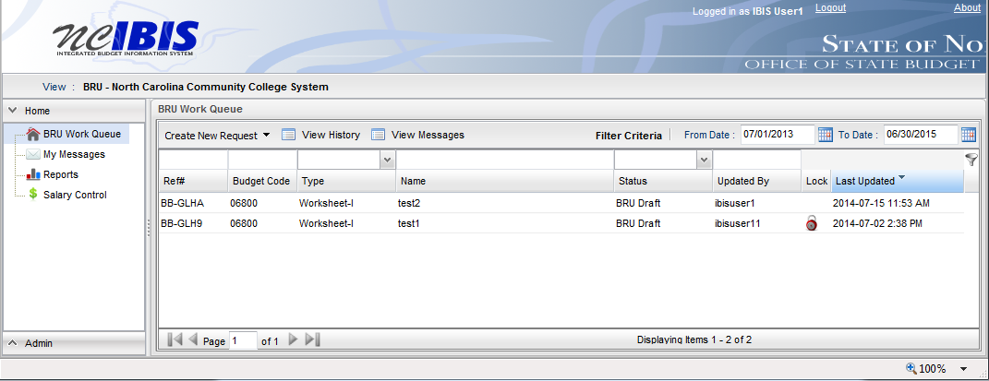

Find the View indicator in the upper left-hand corner of the page. The field should contain only your BRU, Agency or OSBM. If you have access to multiple departments and/or agencies, these will appear in a drop-down list in this field. In the example below, the user is logged in as the North Carolina Community College System.

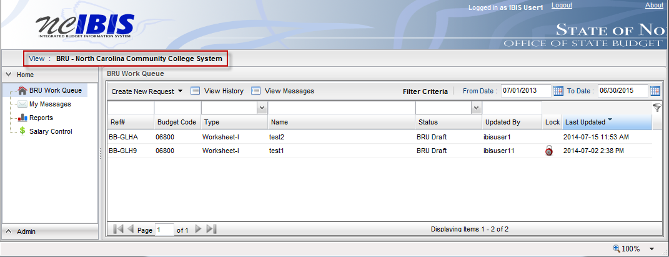

To create a new Worksheet I form, click on the Create New Request dropdown list.

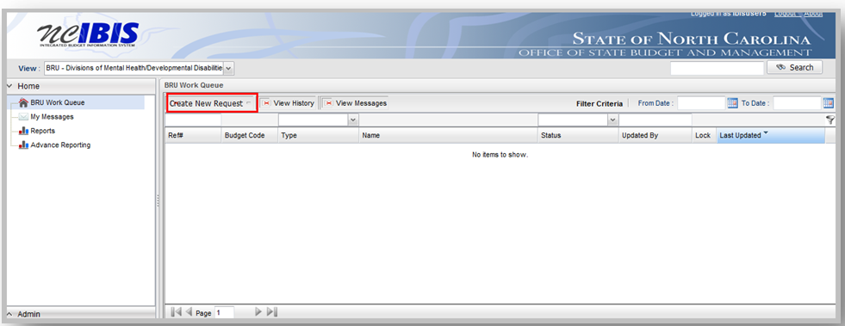

When you click on ‘Create New Request’, the drop-down will display the following options as shown below.
Click on the “Worksheet I” option.

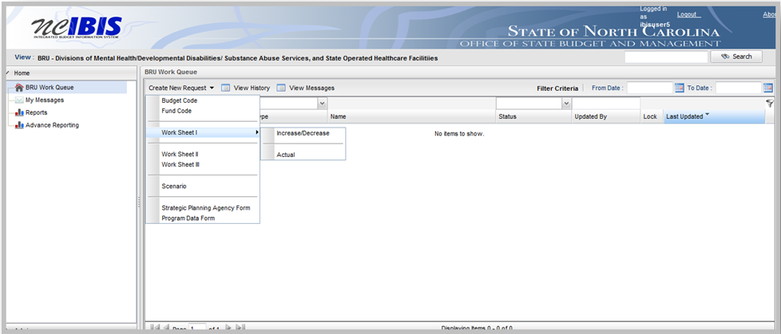

Once you click the Worksheet I option, you will choose an Actual form or an Increase/Decrease form. We will walk through the Actual form creation first.

Create a New Worksheet I – Actuals
Choose Actual, and a New Base Budget Adjustment Form ‘Actual’ – Basic Information window appears as shown in the following screenshot.

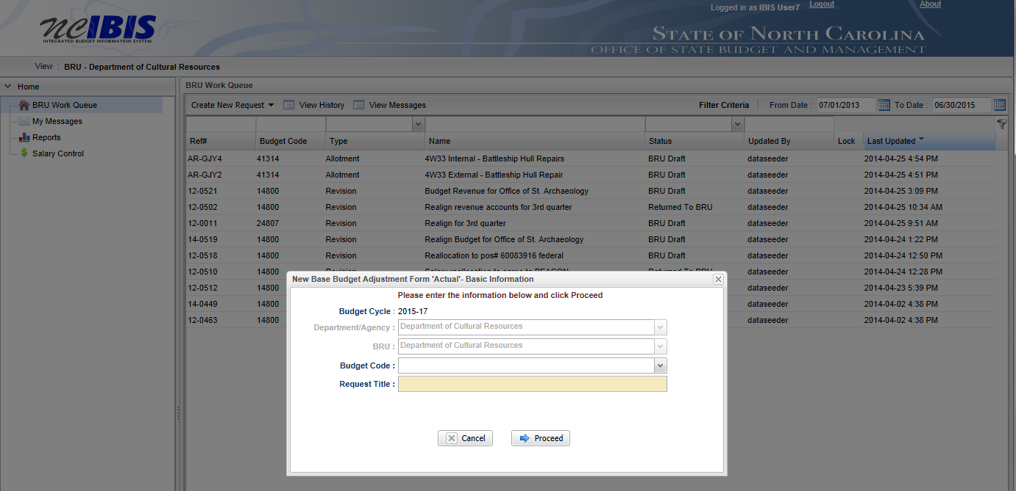

You will need to complete the basic information.

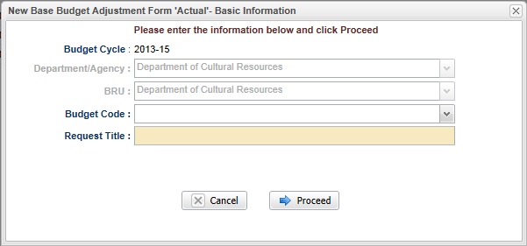

Note the next two fields are labeled Department/Agency and BRU. In most cases, access is restricted to a single department/agency so it will default to your Department/Agency and BRU. If a user has access to multiple departments/agencies and BRUs, a dropdown option will appear for selection.

Choose the appropriate Budget Code from the drop down list. Enter a descriptive title of the requested project. If the request is for multiple facilities across the state, please include this in the title. Please note there is a 255 character limit for this field. Where possible, please do not use acronyms.

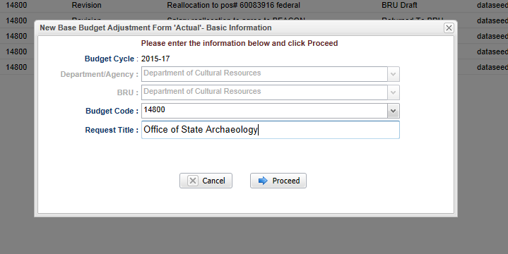

Clicking on the Cancel button will close the window. Nothing will be saved and the Work Queue will reappear. If all entries are satisfactory and there is no need to cancel the form, bypass this step. Click on the Proceed button to continue creating the form.

Once Proceed is clicked, a Worksheet I - Actual form will open as shown on the following page. The form’s four tabs (Basic Information, Budget Detail, Budget Overview and Attachments) will appear in the upper left corner of the screen. To navigate to any of the tabs, simply click on the appropriate tab title and that tab’s data will appear.

Worksheet I - Actual Form:

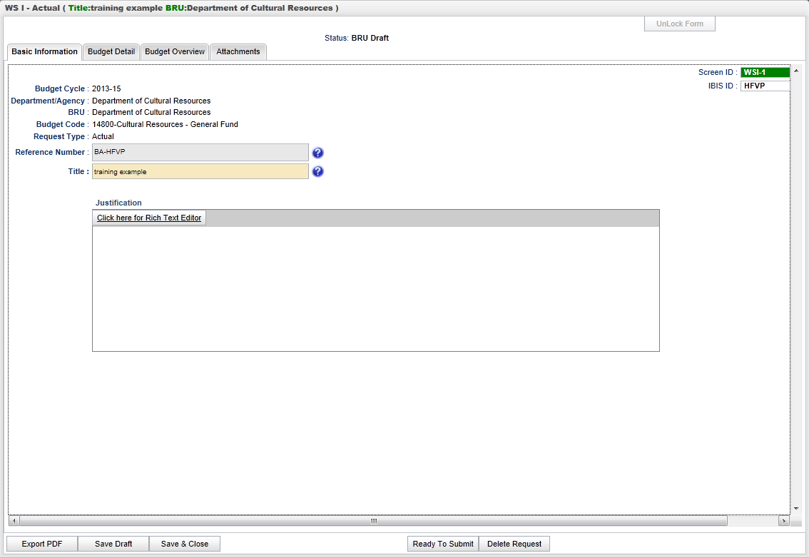

Create a New Worksheet I – Increase/Decrease

Creating a Worksheet I – Increase/Decrease form is essentially the same as creating the Worksheet I – Actuals form. Once you click the Worksheet I option, you need to choose Increase/Decrease form or an Actual form.
Now, we will walk through the Increase/Decrease form creation.

Choose Increase/Decrease, and a ‘New Base Budget Adjustment Form - Increase/Decrease’ – Basic Information window appears as shown in the following screenshot.

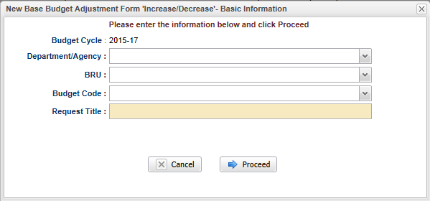

Now that we have walked through the basics of creating each type of Worksheet I form, we will turn to how to complete the forms.

BASIC INFORMATION TAB

The Basic Information screen comes to the forefront since it is the default tab when creating a new or opening an existing form.

The information on the basic information tab is carried forward from the initialization screen and includes the following non-editable fields – Budget Cycle, Department/Agency, BRU, Budget Code, Request Type, and Reference Number.

Verify the information displayed in the following fields – all but Title are non-editable:

Budget Cycle: The form will show Budget Cycle year 2019-21 (system generated)

Department/Agency: The Department/Agency that is associated with your IBIS ID.

BRU: The BRU associated with your IBIS ID.

Budget Code: The Budget Code selected from the New Base Budget Adjustment Form “Actual” – Basic
Information window when the Worksheet I form was created.

Request Type: Actual or Increase/Decrease

Reference Number: A unique, four-digit system-generated number that can be used to track this Worksheet I form. A Worksheet I Actual form begins with “BA.”

Title: Entered when you created the form. It is editable here.

Note the Screen ID and IBIS ID fields in the upper right corner of the form. You will see a Screen ID with a dark background and an IBIS ID with a light background. Neither field is editable.

Click in the Justification field – Either click on the underscored link to the Rich Text Editor, where it says, “Click here for Rich Text Editor” or click directly in the box if you want to bypass the editor. The text editor has the advantage of allowing you to apply a spell checker plus other formatting options.
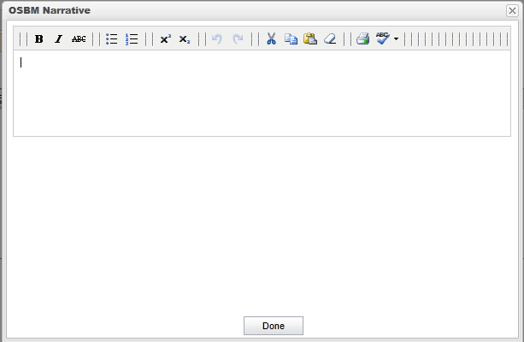

When creating an Increase/Decrease version of the Worksheet I, the Basic Information screen contains two additional fields:

Adjustment Type: this field presents a dropdown list for you to choose an item

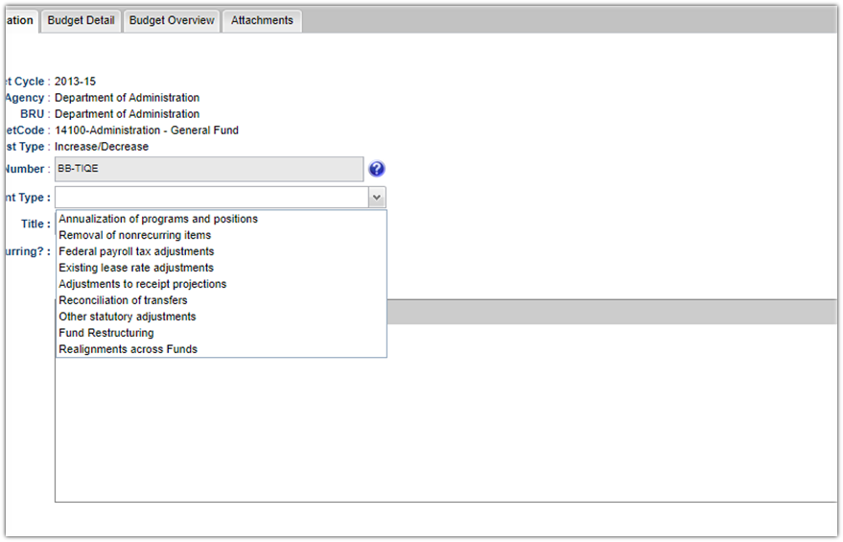

Choose the adjustment type that best fits the adjustment. Please note, two new adjustment types, “Fund Restructuring” and “Realignments Across Funds”. Details on these types of adjustments can be found in the OSBM Budget Instructions.

“Is this recurring?”: this field should be answered either yes or no. Make your selections accordingly.

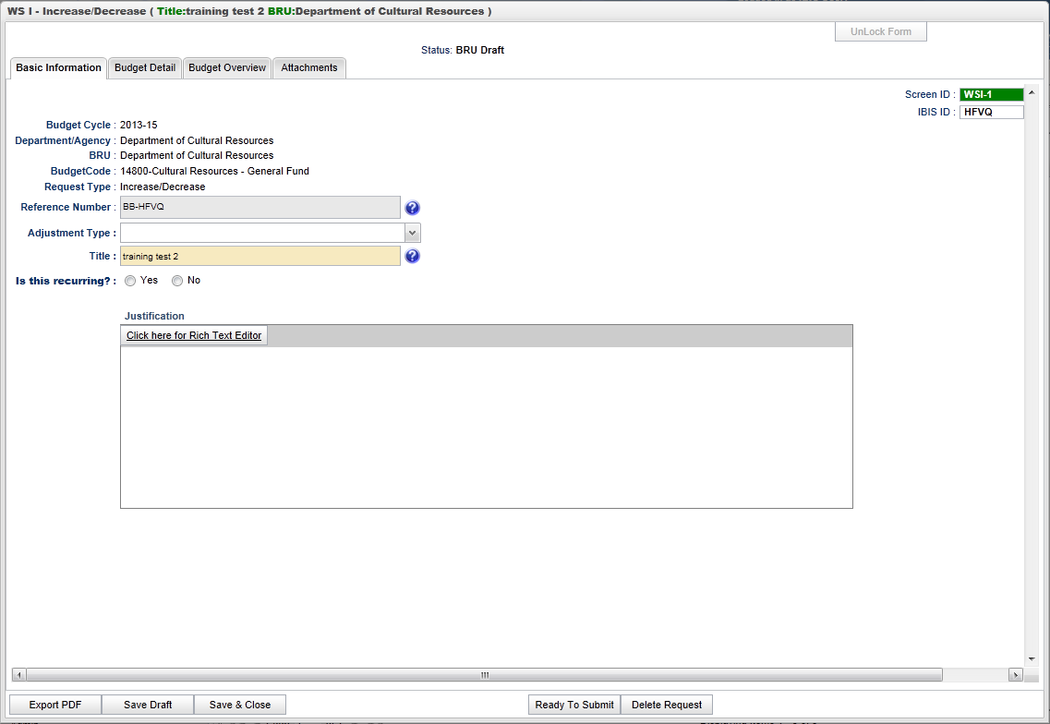

BUDGET DETAIL TAB

The Budget Detail tab is where you enter all the dollar and FTE information about your request. After clicking the Budget Detail tab, the Worksheet I form is displayed as shown below. The form layout for Worksheet I – Actuals is different from the layout of the Worksheet I – Increase/Decrease only in the number of years of information that are gathered in the form.

The Worksheet I – Actuals form collects one year of dollar and FTE information, as shown below:

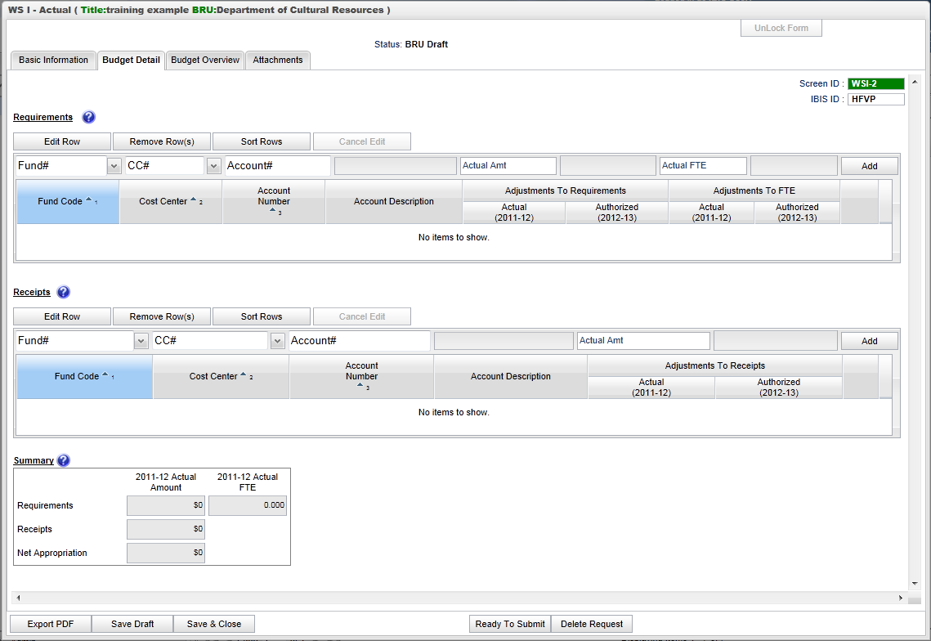

The Worksheet I – Increase/Decrease form collects two years of dollar and FTE information, as shown below:
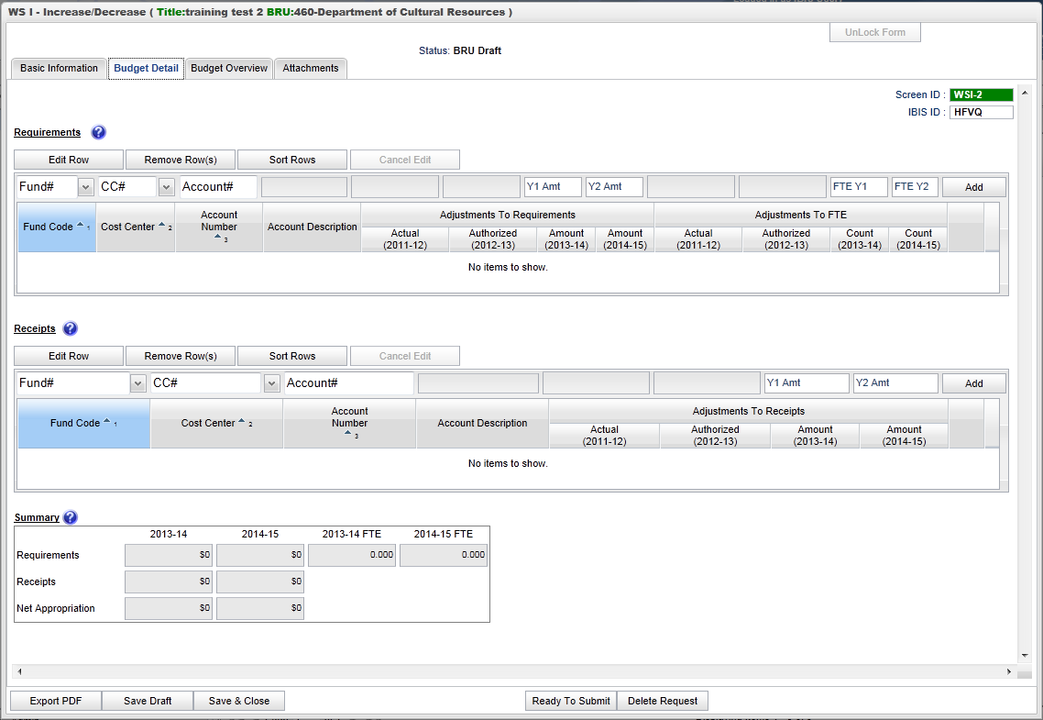
The procedure for completing the budget detail tab are the same for Actual and Increase/Decrease Worksheet I forms.
Data is either system generated, selected from drop-downs, or manually input. The field names are temporarily shown in the boxes (with white backgrounds) where you enter data, as well. When you click on them to enter data, those temporary names are replaced with data entered.
Requirements
Four buttons appear at the top of the Requirements section: Edit Row, Remove Row(s), Sort Rows and Cancel Edit. These functions are only utilized when rows have been entered into the form.

To add a row of data for a requirement on the form, focus on the data entry row directly below the buttons mentioned above. The fields in this row are editable, and when the end of the row is reached, the Add button will save this data so that another row can be entered.
Entering data triggers system-generated data placement in fields shown with greyed out backgrounds.
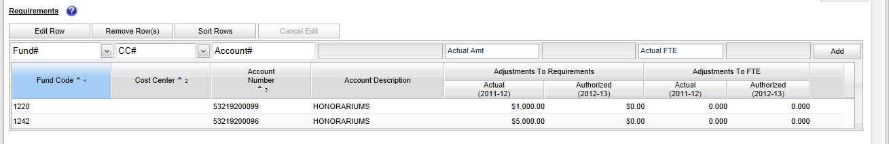

The Fund field contains a dropdown list that displays fund codes available for the budget code associated with the Worksheet I that is being generated. Select the appropriate fund from the list. The selected fund will populate the field and the dropdown list will disappear. The fund code can also be typed in manually.

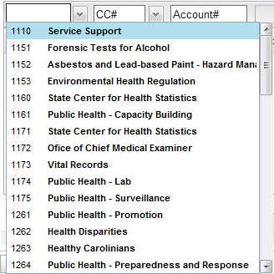

Cost Center is an optional field and the Cost Center dropdown list will only display values if the Department/Agency uses Cost Centers. This field can be bypassed if desired because the form defaults to a blank cost center as highlighted below. If necessary, select the desired Cost Center from the dropdown list. It will populate the field and the dropdown list will disappear. The Cost Center can also be typed in manually.

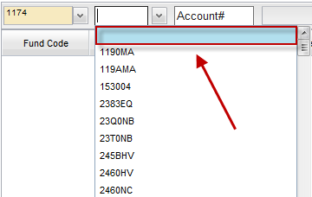

The Account field will present a list of accounts once the user has entered three digits into the field. Accounts are numerous so the system allows you to narrow the list down by entering the first three digits, or the full account code can be entered manually (typed) in the field. Select the desired account from the list or type in the account number manually. It will populate the field and the dropdown list will disappear. By selecting/entering the account number, the associated account description will also populate the adjacent field.

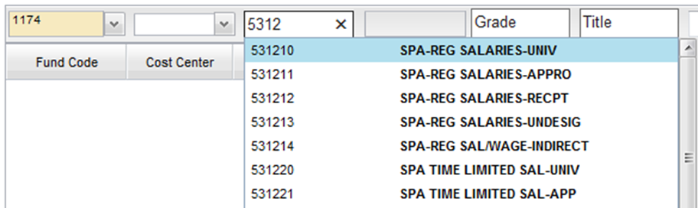

When all data has been entered for a row, click on the Add button.

The row will move down to the grid below, and most of the Add/Edit row will clear (Fund Code and Cost Center information will be retained). Once that occurs, the row may be edited using the Edit button, to revise data.

Add as many rows of requirements as appropriate to complete the form. Once the first row is added, the fund code and cost center codes will pre-populate with the choices made when entering that first row to help quicken the entry of subsequent rows. If these values are not appropriate for subsequent row(s), they can be overwritten.

To edit a row previously added, first select the row you want to edit.
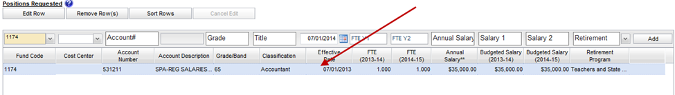
Click on the Edit Row button and the data in the selected row will populate the Edit/Add row line at the top of the grid as show below. When a row has been selected for edit, changes to any of the data previously entered are allowed. Note: You can also double click the row and it will populate the Edit/Add row line.
Once changes are complete, click on the Update button at the far right of the rectangular area to make the change. Once Update has been clicked, the add/update row will clear (except for the Fund Code and Cost Center fields) and the updated data will show in the grid below.

To delete a row that has been entered, click on a row to highlight it.
Click on the Remove Row(s) button and a confirm deletion message box will appear.

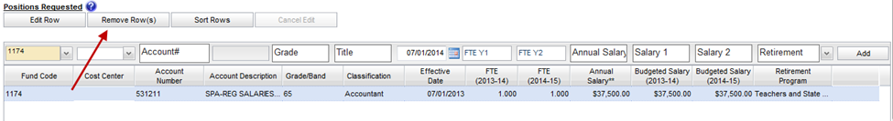
When the Remove Row button is clicked, the following window will appear.

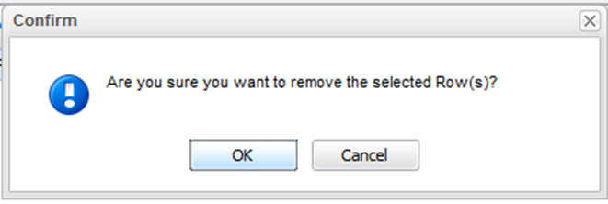
To cancel the deletion, click the Cancel button. To complete the deletion, click the OK button.

To sort the rows - If you have multiple rows and wish to sort them, click on the Sort Rows button.
This will sort the rows in order by Fund Code, Cost Center, and Account Number. Alternatively, you can sort by Fund Code or Cost Center by selecting from drop downs to the right of those field names.
The rows will sort in Fund Code, Cost Center, Account Number order, ascending. Click a second time and they will sort in descending order.

Note: There is also a built-in sort for Fund Code, Cost Center, Account Number, Account Description, etc….
Receipts
The Add/Edit Row(s) functionality for Receipts is identical to the Requirements functionality and therefore each step will not be replicated here.
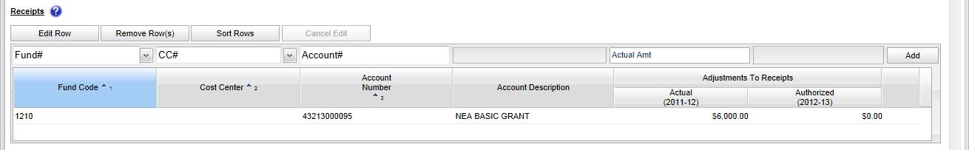

Summary
When Requirements and/or Receipts entries are entered into the Worksheet I form, the data populates the Summary table at the bottom of the Budget Detail tab. The Summary table will add all Requirements and Receipts entered in this form and calculate the Appropriation amount.

An example of the summary table for an Actuals Worksheet I Budget Detail form will look like this:
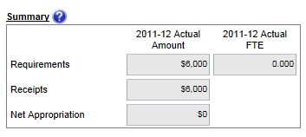

An example of the summary table for an Increase/Decrease Worksheet I Budget Detail form will look like this:

BUDGET OVERVIEW TAB

Move to the top of the Worksheet I form and click on the Budget Overview tab to bring that portion of the form to the forefront. The Budget Overview tab is a read only tab that reflects the data entered on the Budget Detail screen and it shows summaries by fund. None of the data on this tab is editable.

Below is an example of a Worksheet I – Actuals Budget Overview screen:

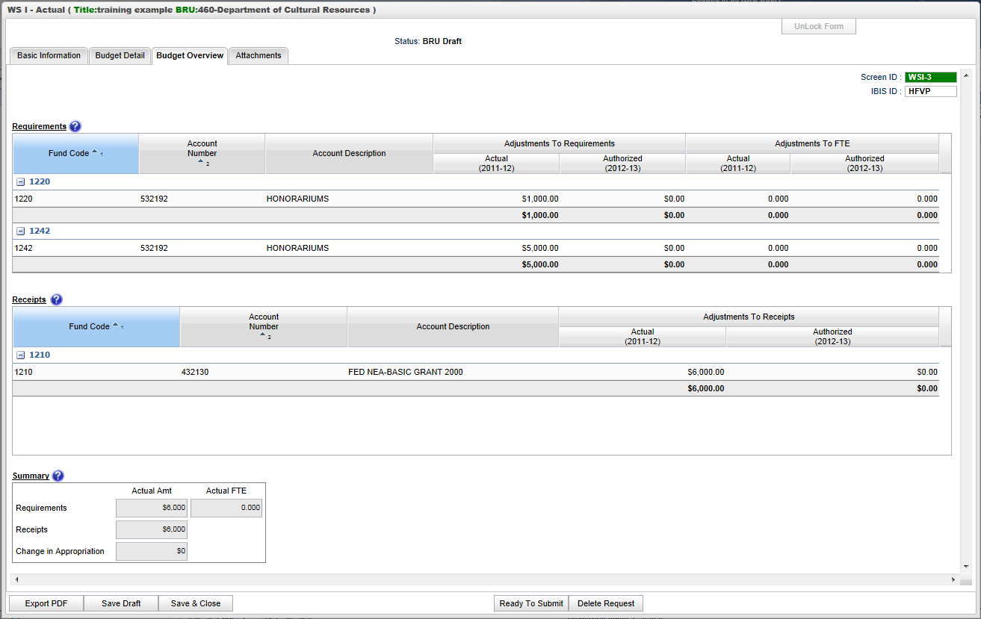

And here is an example of the Worksheet I – Increase/Decrease Budget Overview screen:

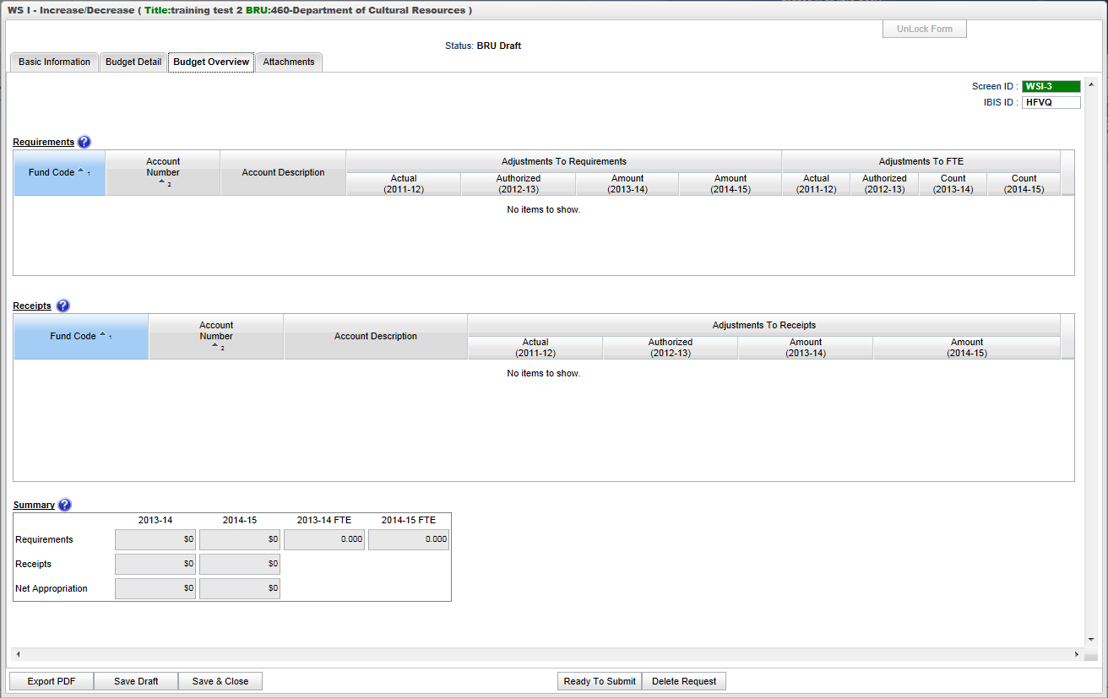

Again, not the only difference between these two screens is the number of years of information displayed.

ATTACHMENTS TAB

The final tab of the Worksheet I form is the Attachments tab. This functionality is addressed in a separte user guide: Attachments and References.

Below is an example of a Worksheet I – Actuals Attachment screen:

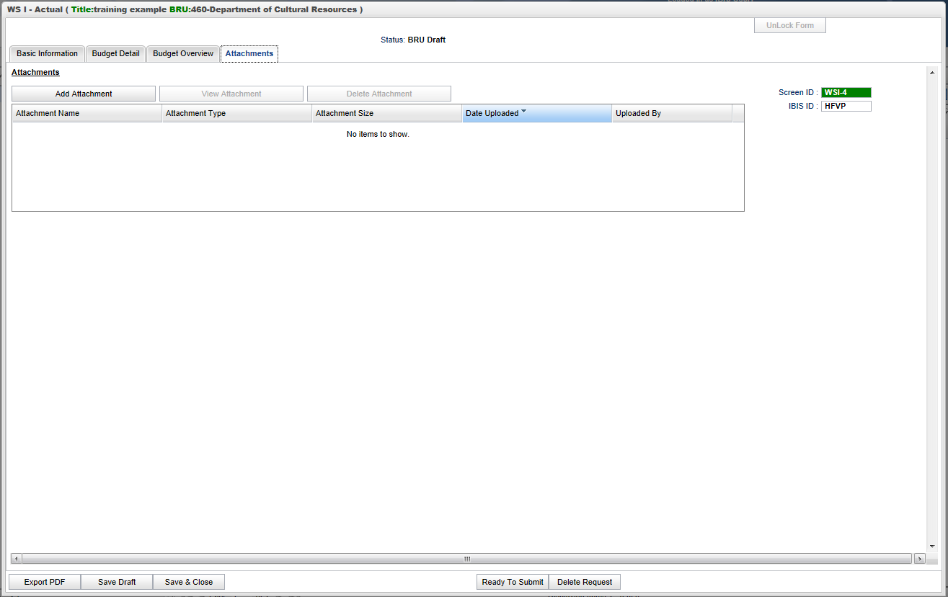

Form Buttons
Additionally, at the bottom of the form there are form action buttons that are available while working on every tab in the form. The buttons are: Export PDF, Save Draft, Save & Close, Ready to Submit and Delete Request. Use of these buttons is standard within the IBIS application and their functionality is covered in the
“Form Workflow and PDF Overview User Guide.”

