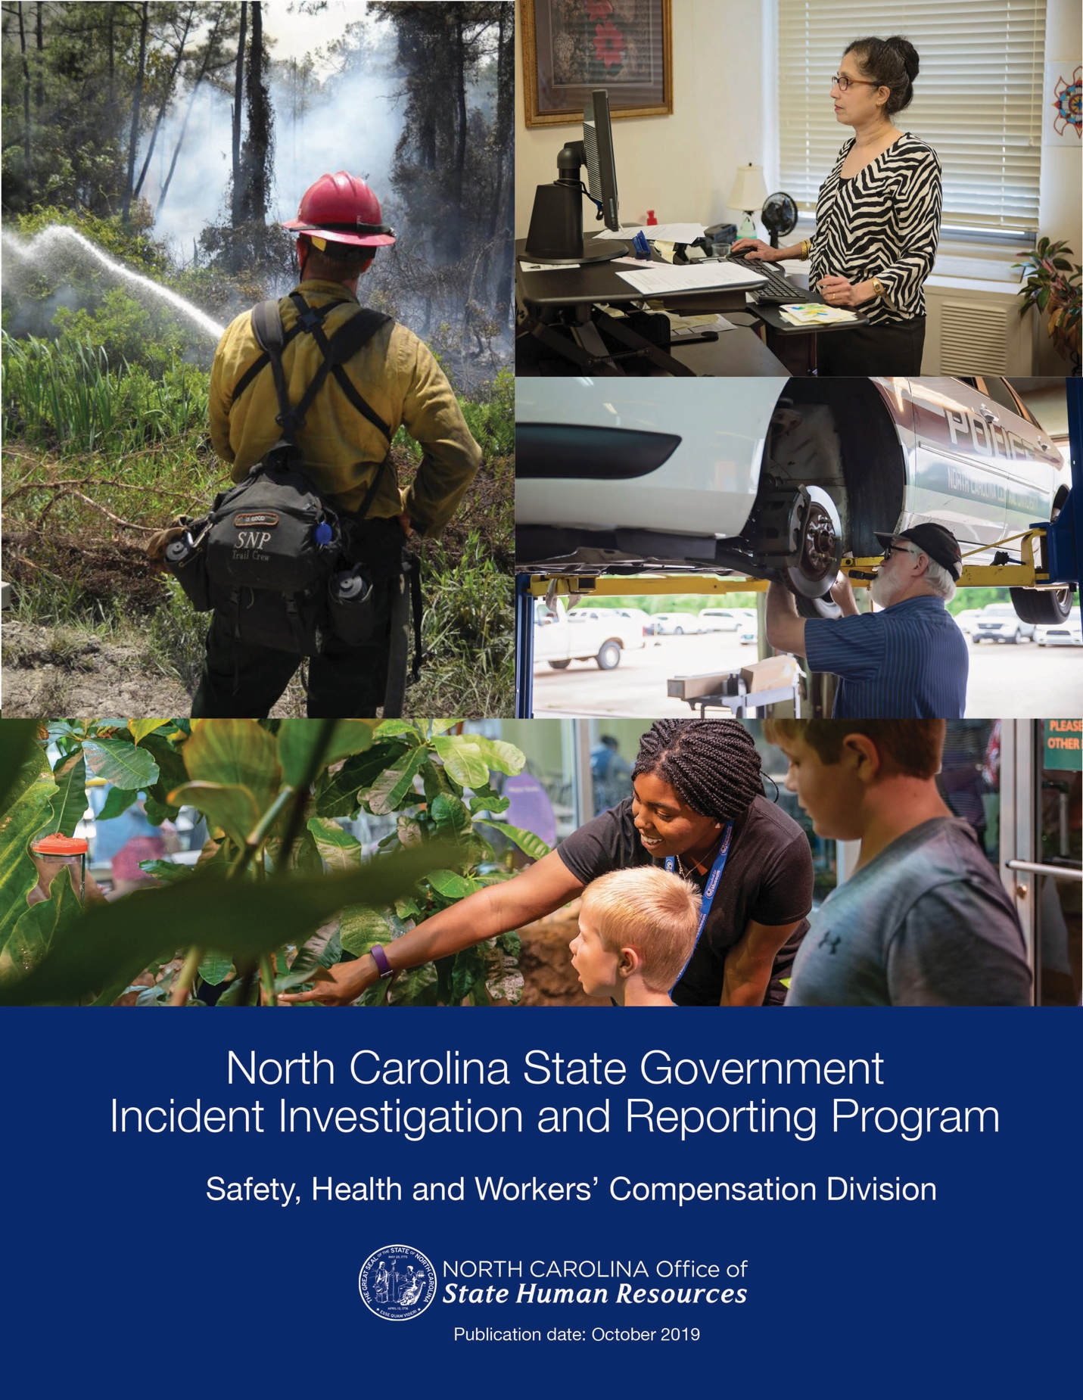

REVISION HISTORY

Revision | Effective Date
Originally published | February 2015
Revision 2 | May 5, 2015
Revision 3 | July 23, 2015
Revision 4 | December 3, 2015
Revision 5 | April 2016
Revision 6 | July 18, 2017
Revision 7 | January 2019
Revision 8 | July 2019

TABLE OF CONTENTS
I. | Program Purpose | 4
II. | Definitions | 4
III. | Program Responsibilities | 5
IV. | Immediate Injury Handling | 7
V. | Incident Investigation Process | 7
VI. | Recommending Corrective Actions | 10
VII. | Training | 10
VIII. | Periodic Program Review | 11
IX. | Record Retention | 11
X. | References | 12
XI. | Appendices
 | Appendix A  NC Employee Incident Report | 13
 | Appendix B  NC Witness Statement Form | 14
 | Appendix C  NC Supervisor Incident Investigation Report | 16
 | Appendix D  OSHR Protocol for Reporting Amputations, Loss of Eye(s), Hospitalization, and Fatalities | 17
 | Appendix E  Workers’ Compensation: What to Do in Case of a Work-Related Injury | 18
 | Appendix F  NC Annual Incident Program Evaluation Report | 19

- Program Purpose

The purpose of the State of North Carolina Incident Investigation and Reporting Program is to provide guidelines and tools for state agencies and universities to implement effective training, documentation, investigation and reporting of work-related incidents and injuries. An effective investigation identifies and effectively communicates root causes of incidents, develops corrective actions to prevent future similar occurrences, and recommends safety training to improve workplace safety.

For instructions on immediate handling of an employee injury, please see Section IV, page 5 of this document.

This program may be used in all state agencies and universities (hereafter “agency”) and applies to all permanent, probationary, temporary, trainee and time-limited employees, and other persons such as students or visitors who may be involved in any incident.

All agencies are strongly encouraged to implement an Incident Investigation and Reporting Program that meets or exceeds these guidelines. All incidents and “near hits” incurred by employees that occur on state property, leased properties, and in the course of business on- or off-site should be properly documented and investigated by the agency to determine the root cause(s). An effective investigation requires cooperation of involved parties including an injured employee, witness(es), and supervisor including written documentation of incident details using:

- NC Employee Incident Report (Appendix A) or agency equivalent form;
- NC Witness Statement Form (Appendix B) or agency equivalent form; and
- NC Supervisor Incident Investigation Report (Appendix C) or agency equivalent form.

The injured employee’s supervisor is responsible for completing an investigation following all reported incidents and near hits to determine root causes and identify and implement appropriate corrective actions.

The North Carolina Department of Labor (NCDOL) has specific legal requirements for employee injuries resulting in hospitalization, amputation, loss of one or both eyes, or fatality. When such injuries occur, the Office of State Human Resources (OSHR) should also be notified. These procedures are detailed in the Protocol for Reporting Amputations, Loss of Eye(s), Hospitalizations, and Fatalities (Appendix D).

- Definitions

Administrative or Work Practice Controls: Procedures that reduce the likelihood of exposure to a hazard by altering the way in which a job is performed. Examples include reducing exposure time and repetitive tasks by job rotation, gradually acclimating employees to new physical job demands or temperature changes, and providing exercise breaks and training.

Contributing Factors: Factors other than the root cause that contribute to an unsafe condition or unsafe act, incident, or near hit. Examples include worker distraction, lighting, temperature, and stress.

Engineering Controls: Specially designed equipment, tools, or work areas that isolate employees from a hazard or lessen the quantity or severity of job risk factors.

Flag the Hazard Report: A report filed by an employee that documents a perceived unsafe act or unsafe condition.

Incident: An event which results in personal injury, property damage, or loss of production.

Lockout/Tagout: A method of de-energizing and isolating a source of energy (electrical, steam, etc.) to prevent another employee from accidental restart during maintenance or servicing of equipment.

Near Hit: A hazardous condition or event that could have resulted in an actual incident involving injury or property loss if the timing or location shifted slightly.

Personal Protective Equipment (PPE): Equipment worn by employees that reduces exposure to a hazard. Examples include gloves, safety glasses, kneepads, etc.

Root Cause: An initiating factor (as opposed to contributing factors) that leads to an unsafe act and/or unsafe condition, incident, or near hit. Examples include ineffective or lack of training, no job safety analysis, no written procedures, poor management, or lack of rule enforcement.

Safety Committee: A team of agency employees and managers responsible for creation and implementation of safety and injury prevention programs. For a full list of responsibilities see the OSHR State Workplace Requirements Program for Safety and Health Committees.
Safety Leader: Employee who has been assigned safety responsibilities for an agency or work unit.

Workers’ Compensation Administrator (WCA): Employee who has been assigned Workers’ Compensation responsibilities for an agency or work unit.

- Program Responsibilities

Agency Human Resources (HR) Director:

- Appoints one or more Safety Leader(s) based on agency needs.
- Establishes a Safety Committee(s) per the State Workplace Requirements Program for Safety and Health.
- Supports Safety Leader(s) and Safety Committee(s) by pledging financial and leadership support for investigation of incidents and near hits.
- Ensures agency incident reporting system is effective and a prompt response is provided to all reported incidents and near hits.
- Supports safety program by emphasizing safety and loss prevention in periodic communications to employees.
- Ensures safety leader has access to equipment necessary to conduct a thorough investigation of incidents, injuries, and near hits.

Agency Safety Leader:

- Reports to an agency manager who is responsible for ensuring the effectiveness of the safety program.
- Ensures an effective system is available for employees to report incidents and near hits.
- Provides training and ongoing assistance to supervisors and other assigned employees responsible for conducting incident investigations.
- Ensures a thorough investigation is conducted for all incidents and near hits.
- Maintains accurate records of all reported incidents and near hits.
- Reviews submitted incident reports and monitors reports for thoroughness, appropriate solutions, and timely implementation of corrective actions.
- Ensures access to basic investigation equipment, i.e. tape measure, flashlight, clipboard, graph paper, barricade tape, PPE, and camera.
- Forwards all completed reports to agency WCA and agency Safety Leader within two business days of incident.
- Contacts OSHR Safety Health and Worker’s Compensation Division if assistance is needed with the investigation process.
- Ensures agency safety committees are actively involved with reviewing incidents and near-hits data.
- Monitors program results to identify trends and determine additional needed focus areas.
- Notifies senior management of hazards that are not minimized or eliminated in a timely manner.
- Conducts an annual review of incident investigation program process to identify opportunities for improvement. The annual review should, at a minimum, evaluate the effectiveness of employee and supervisor training, management support for resolution of identified hazards, and appropriateness of identified incident root causes and corrective actions.

Managers and Supervisors:

- Support and participate in the incident investigation program to ensure the health and safety of all agency employees.
- Contact the agency Safety Leader and agency WCA, as soon as notification of an incident or near hit is received.
- Ensure the affected employee completes the NC Employee Incident Report (Appendix A).
- Coordinate with agency Safety Leader to document all reported incidents and near hits using the NC Supervisor Incident Investigation Report (Appendix C) or the agency’s equivalent form.
- Forward completed NC Employee Incident Report (Appendix A), NC Employee Witness Report(s) (Appendix B), and NC Supervisor Incident Investigation Report (Appendix C) to agency Safety Leader and agency WCA.
- Ensure appropriate incident prevention and investigation training is provided to employees to ensure proper implementation of the Incident Investigation Program.
- Identify and ensure timely implementation of corrective actions.
- Follow procedures outlined in the Workers’ Compensation: What to Do in Case of a Work-Related Injury (Appendix E).

Employees, including Managers and Supervisors:

- Participate in Incident Investigation Program and comply with all other relevant policies.
- Complete appropriate training for incident and near hit prevention and reporting.
- Immediately report any incident or near hit to supervisor.
- Obtain appropriate first aid or medical treatment as quickly as possible following an incident involving personal injury.
- Complete the NC Employee Incident Report (Appendix A) and give it to their supervisor no later than twenty-four (24) hours after the incident.
- Actively participate in the incident investigation process to help identify and correct hazards and recommend further corrective actions to prevent future occurrence.

Workers’ Compensation Administrator (WCA):

- Notifies Worker’s Compensation Third-Party Administrator of all reported injuries.
- Reviews NC Employee Incident Report (Appendix A), NC Witness Statement Form(s) (Appendix B), and NC Supervisor Incident Investigation Report (Appendix C).
- Transmits all incident investigation documents to the Workers’ Compensation Third-Party Administrator within one business day of receiving these reports.

- Immediate Injury Handling

- If a work injury is serious or life-threatening, employers should seek emergency assistance immediately by calling 911. Examples of serious or life threatening symptoms:
- Loss of consciousness
- Seizure
- Bleeding that cannot be immediately controlled
- Chest pain or pressure
- Difficulty breathing
- Confusion
- Inability to talk, walk, or raise both arms

An injured employee may request that emergency medical services (EMS) not be called. Employers have a legal obligation to call EMS if a life-threatening situation is suspected. Employers should not delay seeking medical care or argue with the injured employee; instead, employers should call 911.

- Employees responding to an incident should ensure the scene is safe for other employees and emergency responders. A victim should only be moved from the incident scene in extreme situations when there is an ongoing danger to life and health.

- Emergency vs. non-emergency treatment

  - Emergency treatment: If an injured employee needs emergency transport to a hospital or emergency room, the supervisor or designee accompany the employee to the hospital. The employee’s emergency contacts should also be notified.

- Non-emergency treatment: If an injury requires non-emergency medical care other than first aid, the employer may provide transportation (if needed) for the injured employee’s initial medical visit. Employers should pre-identify the location and business hours of local urgent care facilities in the Workers’ Compensation Third Party Administrator’s medical provider network. If possible, employees should be provided with a medical treatment authorization form to give to the urgent care facility.

- Supervisors should immediately report an employee injury to the agency WCA and Safety Leader.

- Provide the employee with an NC Employee Incident Report (Appendix A). The employee should complete this form and give it to their agency WCA within 24 hours of the injury.

- Supervisors and employees shall not release information to news media. Employees should refer
news media inquiries to the applicable agency’s Public Information Officer or other media
representatives.

- Fatalities, hospitalizations, and amputations should be reported according to the OSHR Procedure for Reporting State Employee Fatality, Amputation, Loss of Eye(s), or Hospitalization (see Appendix D).

- Incident Investigation Process

Incident investigation process instructions for supervisors:

- Supervisors should start the incident investigation process immediately after the occurrence of any incident. The supervisor may obtain assistance from the agency Safety Leader if needed.

- Supervisors should secure the incident scene immediately following the incident with rope, tape, guards, etc. (if needed) as soon as possible after the scene is cleared so that a full incident investigation may be performed.

- Supervisors should identify incident witnesses who were within hearing or visual distance of the incident as quickly as possible. Each witness should complete the NC Witness Statement Form (Appendix B) detailing their perception of the facts of the event, including their own impression of what they heard, saw, or smelled prior to, during, and after the event. Witnesses should independently complete the form without input from others, to ensure the form captures their unique perspective. Employee witnesses should be informed that no retaliation will occur for telling the truth and assigning blame to employees is not the purpose of the investigation.

- Supervisors should collect, record, and/or photograph all materials at the site of the incident that may be relevant to the investigation. Supervisors should also gather records, i.e. inspection reports, maintenance reports, and prior incident reports as needed. Supervisors should consult experts in the process related to the events as needed.

- Supervisor’s incident investigation reports should include a timeline of events that led to the incident or near hit, contributing physical and psychological factors at each step leading up to the incident, and the root cause(s). Psychological conditions include but are not limited to changes in the employee’s emotional state such as depression, anger, loneliness, feelings of grief over a loss, feelings of emotional pressure at work, and/or high stress levels at home. Supervisors should investigate and report any factors that might have caused distraction or a lapse in judgment.

- At a minimum, the affected employee and supervisor should work together, when possible, to identify the root cause(s) of the incident.

  - Supervisors should expand the team to include additional resources and viewpoints, such as safety professionals, management, or others as applicable for more complicated incidents that may result in design or workflow changes.

  - The “Five Whys” technique is one method that may be used to identify the root cause(s) and contributing factors of an incident or near hit. This is a question-asking technique wherein the investigator asks the same question repeatedly: “What caused or allowed this condition/practice to occur?” or by simply asking “Why?” until the root cause(s) are found. The example below illustrates how the “5 Whys” might be applied to an incident:

Problem: The car won’t start.

1. Why? The battery is dead.
2. Why? The alternator is not functioning.
3. Why? The alternator belt is broken.
4. Why? The alternator belt is worn out and had not been replaced.
5. Why? The vehicle was not being maintained per the manufacturer’s service schedule.

  - For complex investigations involving equipment, tasks, and processes, more detailed questions may help to determine root causes for the incident. Below are some examples of questions that may be asked if relevant to the incident:

Tasks and Procedures
- Is there a written procedure?
- Was the procedure used?
- Had conditions changed to make the normal procedure unsafe?
- Were the appropriate tools and materials available? Were they used?
- Were safety devices working properly?

Equipment Related Incidents
- Was there an equipment failure?
- What caused the equipment to fail?
- Were hazardous substances involved?
- Were the substances clearly identified?
- Was a less hazardous alternative substance possible and available?
- Should personal protective equipment (PPE) have been worn?
- Was PPE used?
- Were users of PPE properly fitted, trained, and documented?

Personal Factors
- Were employees experienced in the work performed?
- Have employees been adequately trained?
- How much overtime is being worked?
- Does the employee have a second job that does not allow for recovery between shifts?
- Can the employee physically do the work?
- What was the status of the employee’s health?
- Was the employee tired?
- Was the employee under stress (work or personal)?
- Was there any indication of drug or alcohol use?

Environmental Factors
- Were there changes in the normal work environment (especially sudden changes)?
- What were the weather conditions and humidity?
- Was poor housekeeping a problem?
- Was it too hot or too cold?
- Was noise a problem?
- Was there adequate light?
- Were toxic or hazardous gases, dusts, or fumes present?

Root Causes
- Were safety rules communicated to and understood by all employees?
- Were written procedures and orientation available?
- Were rules and procedures being enforced?
- Was there adequate supervision?
- Were workers trained to do the work?
- Had hazards been previously identified?
- Had procedures been developed to overcome hazards and prevent injuries?
- Were unsafe conditions corrected?
- Was regular preventative maintenance of equipment performed?
- Were regular safety inspections performed?

- Recommending Corrective Actions

- A corrective action should be recommended for each identified root cause of an incident based on risk and opportunity of exposure.

- The following common corrective actions may be considered:
  - Submit work orders for repair or replacement of broken or damaged materials.
  - Purchase recommended equipment or PPE.
  - Create or update policies and/or procedures.
  - Train or re-train employees.
  - Update related training courses.
  - Implement Hazard Awareness meetings across the agency.
  - Request capital budget funding for long-term or costly corrections.

- When selecting and recommending corrective actions, possible solutions are prioritized using the hierarchy of hazard control. Elimination is the most desirable solution followed by substitution, engineering controls, administrative controls, and finally PPE.

- Elimination – eliminating the hazard from the workplace.
- Substitution – replacing a hazardous substance or activity with a less hazardous one.
- Engineering controls – providing guards, ventilation, or other equipment to control the hazard.
- Administrative controls – developing policies and procedures for safe work practices.
- Personal Protective Equipment – using respirators, earplugs, safety glasses, etc.

- Corrective actions need to be as specific as possible. “Be Careful” is not an acceptable corrective action.

- All suggested corrective actions must be considered to determine if the proposed change will introduce additional hazards.

- Management may wish to review corrective actions after implementation to ensure the hazard was minimized or eliminated, that employees are following the new process, and no new hazards were introduced.

- Training

It is recommended that all employees and new hires receive training on the Incident Investigation and Reporting Program. Upon hire or promotion into their position, managers and supervisors should be appropriately trained on the State of North Carolina’s Incident Investigation and Reporting Program. Employees and supervisors should receive appropriate refresher training at regularly scheduled intervals as determined by the agency.

Minimum training for all employees should include the following elements:
- The Incident Investigation and Reporting Program and responsibilities.
- Procedure for reporting incidents and near hits and the importance of prompt reporting.
- Review of the Employee Incident Form, the Witness Statement Form, and the Supervisor Incident Investigation Form.
- How to complete an investigation with emphasis on determining root causes, contributing factors, and corrective actions.

- Periodic Program Review

State agencies have access to workers’ compensation claims data including injury sources, injury types, body parts injured, incident circumstances, and other information to identify incident and injury trends. Conducting regular trend analysis helps agencies focus on needed safety training and injury prevention programs.

It is recommended that each agency conduct, at minimum, an annual review of their Incident Investigation and Reporting Program. The NC Annual Incident Program Evaluation Report (Appendix F) may be used to analyze the following:

- Evaluation of incident/near-hit training programs and records.
- The need for retraining managers, supervisors, and employees.
- The length of time between incident, reporting, investigations, and corrective actions implementation.
- The program’s success based upon comparison to previous years, using the following criteria:
  - Frequency of incidents and near hits.
  - Frequency of Workers’ Compensation claims.
- Employee feedback through tools such as direct interviews, walk-through observations, written surveys, questionnaires, and re-evaluations.

- Record Retention

Pursuant to the Functional Schedule for North Carolina State Agencies (2019) 12. Legal which details records retention requirements, State agencies must:

  - Retain records related to workers’ compensation claims filed with the North Carolina Industrial
- Commission (NCIC) for 60 years from the date received;
- Retain records concerning workers’ compensation claims submitted to the NCIC electronically
until the death of the employee plus 5 years;
- Retain records concerning non-documentary evidence received by NCIC that does not become
part of the case file including exhibits created for hearing until a final judgment is rendered in
the case plus 3 years;
  - Retain records of employee reports of injury to NCIC to which no file number is assigned 1
year from the date received; and
  - Retain agency records for workers’ compensation claims of their employees until the employee
returns to work or separates from the agency plus 5 years.

Pursuant to the Functional Schedule for North Carolina State Agencies (2019) 8. Personnel Management which details records retention requirements, State agencies must:

  - Retain records concerning asbestos, toxic substances, and bloodborne pathogen exposure from
date of exposure for 30 years;
- Retain first aid records of minor job-related injuries for 5 years;
- Retain records concerning physical examinations required by the employer in connection with any
personnel action; includes health or physical examination reports, or certificates created in
accordance with the Americans with Disabilities Act (ADA) for 1 year;
- For employee medical records other than those described in “a” through “c”, retain records until
date of employee separation plus 30 years.

- References

The following references were used in the development of this program:
- NCGS § 95-143 – Recordkeeping and Reporting
- NCGS §95-148 – Safety and Health Programs of State Agencies and Local Governments
- NC OSHR Workplace Requirement Programs for Safety and Health

U.S. Department of Labor, Occupational Safety & Health Administration (OSHA), Incident Investigation
- OSHA’s Injury and Illness Recordkeeping and Reporting Requirements
- North Carolina Industrial Commission
- Canadian Centre for Occupational Health and Safety (CCOHS) Accident Investigation Fact Sheet
- Oregon OSHA Accident Investigation
- Centers for Disease Control and Prevention – Workplace Safety & Health Hierarchy of Controls
- Introduction to Safety & Health at Work: The Handbook for the NEBOSH General Certificate. Hughes & Ferrett (2011). Routledge.
- NC DNCR Functional Schedule for North Carolina State Agencies

NORTH CAROLINA EMPLOYEE INCIDENT REPORT
Instructions: Employee must complete report. If more room is needed, continue in a Word document and attach it to this submission.
Employees are required to complete this form for all incidents and near hits. This form should be completed in its entirety and should be an accurate and truthful account of the accident/incident. Providing false and/or misleading information may result in disciplinary action up to or including dismissal and/or additional criminal and/or civil liability. This form should be completed by the employee only.
Supervisor Review: If an employee is unable to complete this form, the Supervisor must list reason(s) for assisting or completing this report.

My signature below certifies that the information I have provided is true and accurate. I further understand that this information may be used to determine whether the claim will be paid or denied and that I should not complete this form unless there are exceptional circumstances present preventing the employee from completing this form. Check Not applicable (employee completed form) or sign below if you assisted with the completion of this form.

Supervisor Name: Signature:
Employee Information |  |  |  |  |  |  | Date/Location Information
Name (Full): |  |  |  |  |  |  | Date of Incident: |  | / / | Time of Day:
Employee ID #: |  |  |  |  |  |  | Date Reported to Supervisor: |  | / / | Time of Day:
Job Title: |  |  |  |  |  | ⇨ Male  ⇨ Female | Work Address:
Telephone #:
Department: |  |  |  |  |  |  | Incident Location (address, Building name, office, cross streets, fire name, woods, facility, room #, etc.):
Agency/University:
Date Hired: |  |  |  | Time in Current Job:
Supervisor: |  |  |  | Phone #: |  |  | County:
Witness Information
Were there any witnesses to the incident? ⇨ Yes ⇨ No Number of Witnesses (if applicable):

If yes, list all known witnesses/phone #’s below, please include additional names on attachment if needed.
Name: |  |  |  |  |  |  |  | Phone #:
Name: |  |  |  |  |  |  |  | Phone #:
Medical Information
Part(s) of the body injured:
Prior to this accident/incident, have you ever been hurt, suffered injury, or received treatment for the body part(s) listed above? ⇨ Yes ⇨ No
If yes, please provide the date of prior injury, type of injury, names of treating physician or practice group.
Description of Accident/Incident
What was the root cause of the incident? Ask why, and then ask why again. (e.g. Why? I slipped on scrap metal. Why? The work area was not cleaned up. Why? I was rushing to get project done and did not take time to clean up the work area.)
Suggested Corrective Actions
I hereby certify that the information I have provided is true and accurate. Any inaccurate or false statements may result in a delay in process of this claim. I further understand that this information may be used to determine whether the claim will be paid or denied.
Employee Name |  |  |  |  | Signature |  |  |  |  |  | Date | / /

NORTH CAROLINA WITNESS STATEMENT FORM
Instructions: Before providing the required information below, please note that you will have to certify the truthfulness of this information. You will also be required to acknowledge that you understand that in addition to being disciplined for providing false and/or misleading information, up to and including dismissal, you may also be subjected to additional criminal and/or civil liability. To help you write this statement, please include, if possible, the following information:
Type of Investigation:

Safety Incident Accident Review Near Hit Property Damage
Witness Information
Name: |  |  | Title:
Work Address: |  |  | Work Phone #:
Incident Information
Date of Incident: |  |  | Time of Incident:
Location of Incident:
Do you have any pictures of the incident?  If yes, please attach them to this submission. | Yes No
List the names of anyone present who observed or may have knowledge of the incident.
State what you know about the incident. Indicate who, what, where, and when. Be as specific as possible. If you need more space than what is provided here, create a Word document and attach it to this submission.
I hereby certify that the information I have provided is true and accurate. I acknowledge that any inaccurate or false statements may result in a delay in process of this claim. I further understand that this information may be used to determine whether the claim will be paid or denied.
Witness Name: |  | Witness Title:
Signature: |  | Date of Statement: / /

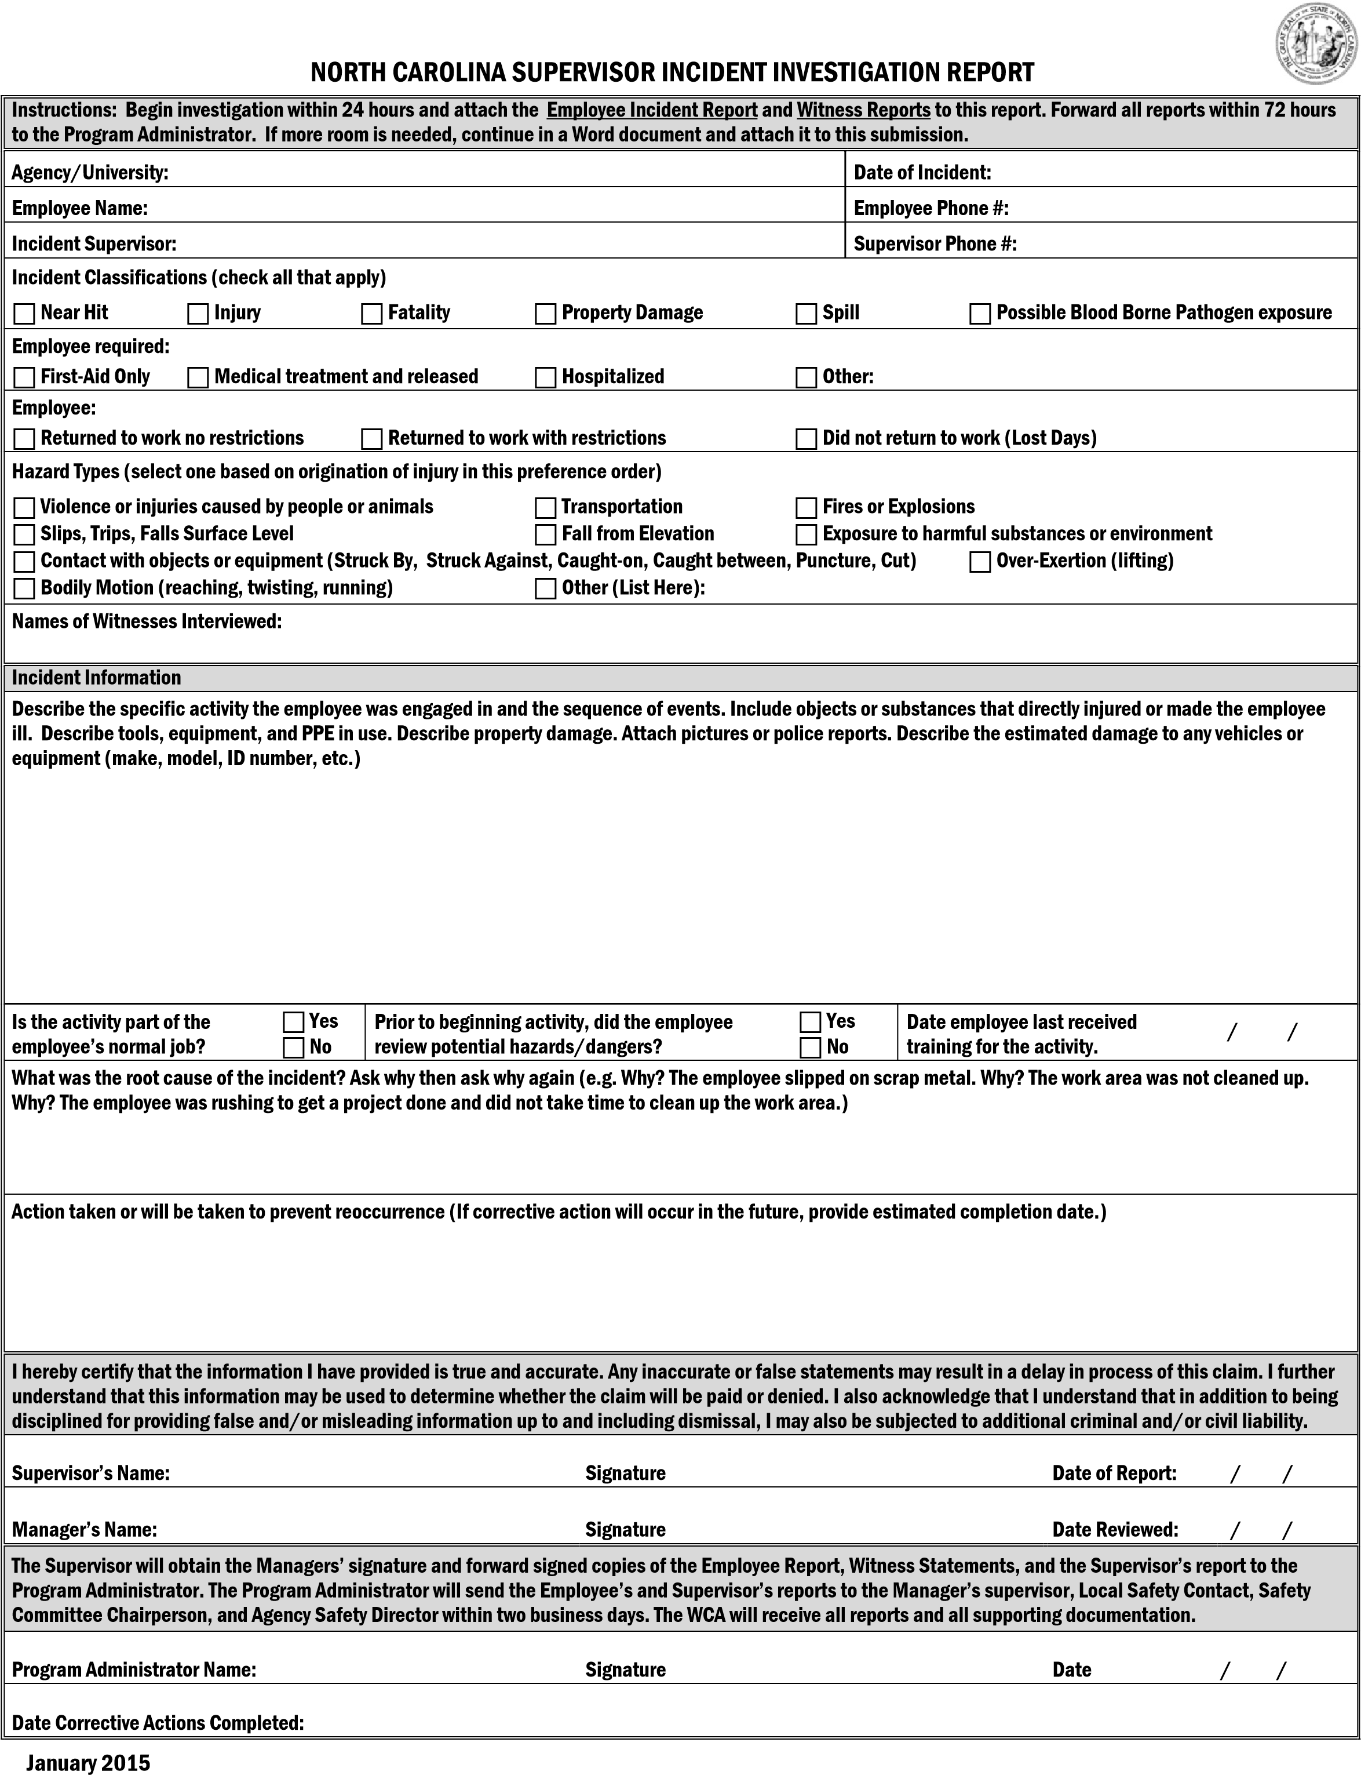

NORTH CAROLINA SUPERVISOR’S INCIDENT INVESTIGATION REPORT – PAGE 2
ACCIDENT BREAKDOWN BY CHARACTERISTIC
(check all that apply)
Nature of Injury |  | Part of Body Affected
- Amputation or Enucleation  - Assault  - Burn or Scald  - Contusion, Bruise  - Electric Shock  - Eye, Foreign body in  - Fracture, Broken Bone  - Freezing, Frostbite  - Hearing Loss or Impairment  - Heat Exhaustion, Sunstroke  - Hernia or Rupture  - Infection  - Inhalation Injury-Toxic Substance  - Insect Bites  - Laceration (Cut )  - Multiple Injuries  - Needle Puncture  - Rash, From Plants  - Rash, Not From Plants (Dermatitis)  - Scratches, Abrasions  - Sprain, Strains  - Other |  | - No Physical Injury  - Head  - Neck  - Eyes (Including Vision)  - Arm(s) (Above Wrist)  - Hand(s) (Including Wrist)  - Finger(s) and Thumb(s)  - Upper Extremity, Multiple Parts (shoulder, arm, forearm, wrist, or hand)  - Abdomen (Including Internal Organs)  - Back (Including Muscles, Spine)  - Chest (Including Internal Organs)  - Hips (Including Pelvic Organs)  - Shoulder(s)  - Trunk, Multiple Parts  - Leg(s) (Above Ankle)  - Foot (Including Ankle)  - Toes  - Lower Extremity, Multiple Parts (from the hip to the toes)  - Multiple Parts of Body, Severe  - Digestive System  - Respiratory System  - Circulatory System  - Skin  - Other
Type of Accidents |  | Safety Equipment in Use
- Bodily Reactions (Sprains, Strains, Rupture, Etc.)  - Caught In, Under, Or Between  - Contact With Temperature Extremes (Fire, Cold)  - Disease Exposure  - Electrical Shock  - Falls (All Types)  - Noise Exposure  - Repetitive Motion  - Rubbed Or Abraded By Object  - Struck Against Object  - Struck by Flying Object  - Struck by Other Object/Person  - Toxic Materials Exposure  - Vehicle or Equipment Accident  - Other |  | - Hard Hat  - Safety Glasses  - Goggles  - Face shield or welder helmet  - Gloves  - Fire Shirt  - Fire Pants  - Safety Shoes  - Fireline Boots  - Ear Protection  - Respirator  - Lanyards & Lifelines  - Fluorescent Vests  - Buoyant Work Vest  - Warning & Control  - Seat Belts  - Shoulder Harness  - Safety Equipment, National Electrical Code (NEC)  - Lab Coat  - Other
When submitting this report, include pictures of incident location, equipment in use, the vehicle used (if applicable), and any third-party reports (i.e. Police Report, OSHA Report, etc.).

OSHR Procedure for Reporting State Employee
Fatality, Amputation, Loss of Eye(s), or Hospitalization

State agencies must report the following injuries involving permanent, contract, or temporary employees to OSHA:

a. Fatalities - within 8 hours
b. Amputation(s), loss of eye(s), hospitalization - within 24 hours.

State agencies must also report these injuries as follows:
- Contact your Agency/University Human Resources Director and your Agency/University Safety Leader. In the event of a fatality, also contact your Agency/University Legal Counsel.

- Contact the NC Department of Labor during working hours (8 a.m. to 5 p.m.) at 919-779-8560 or 1-800-625-2267. After working hours, (5 p.m. to 8 a.m.), weekends or holidays, call State Capitol Police at (919) 733-3333. (See below)*

- Contact a member of the OSHR Safety, Health and Workers’ Compensation Division

Scarlette Gardner, Division Director (984) 236-0848 Scarlette.Gardner@nc.gov
Heather Banta, Safety Director (984) 236-0845 Heather.Banta@nc.gov
Kathy Conner, Safety Consultant (984) 236-0846 Kathy.Conner@nc.gov
OSHR Main Number (984) 236-0800

Be prepared to provide contact information, addresses, and telephone numbers for person(s) involved.

- Follow-up with an email message or fax (984) 236-0949 to OSHR staff listed above. Emails and faxes are public information. Please utilize sensitivity and discretion when describing incident details.

OSHR will notify the Governor’s office and assist in incident investigation.
****************************************************************************************************
*Effective January 1, 2015, Employers are required to contact OSHA for any work-related fatality within (8) hours. Inpatient hospitalizations, all amputations and all losses of an eye must be reported within (24) hours. An amputation is the traumatic loss of a limb or other external body part. Amputations include a part, such as a limb or appendage that has been severed, cut off, amputated (either completely or partially); fingertip amputations with or without bone loss; medical amputations resulting from irreparable damage; amputations of body parts that have since been reattached. Amputations do not include avulsions (tissue torn away from the body), enucleations (removal of the eyeball), deglovings (skin torn away from the underlying tissue), scalping’s (removal of the scalp), severed ears, or broken or chipped teeth.

Workers’ Compensation: What to Do in Case of a Work-Related Injury

Employee’s Responsibilities:
- Report all injuries to your supervisor immediately and no later than 24 hours from the time of injury. If the immediate supervisor is not available, report your injury to the next person in command that is present, another supervisor or manager, or a Human Resources representative.
- Provide the completed NC Employee’s Incident Report to your supervisor within 24 hours of the injury or, in cases of serious injury, as soon as feasible.
- Provide Leave Option Form to your supervisor within 24 hours of the injury.
- Obtain a Medical Authorization Form from your supervisor to take to the physician or medical facility.
- Seek appropriate medical attention from the physician or medical facility as directed by your supervisor or the agency’s Workers’ Compensation Administrator (WCA).
- All medical notes given to you by the authorized treating physician must be given to your supervisor within 24 hours for submittal to the WCA.
- Follow all medical restrictions, as your recovery is a major concern to your agency/university.
- Provide all Work Status Notes received from your authorized physician to your supervisor upon receipt.
- Return to work after your medical treatment unless your authorized physician provides you with a written authorization prohibiting your return to work.
- Provide all out-of-work, return-to-work, and/or any other restriction orders from the authorized treating physician to your supervisor within 24 hours.
- Follow any transitional duty assigned to you as a part of your agency/university Return-to-Work Program.
- If you have questions about your claim, call your agency/university WCA.

Supervisor’s Responsibilities:
- Ensure that the employee receives immediate and appropriate medical attention.

NOTE: In the case of a life-threatening emergency, dial 911! Notify the Worker’s Compensation Administrator (WCA) and your Safety Leader immediately in catastrophic cases, amputations, loss of one or both eyes, or hospitalization of any worker.

- Direct your employee to the closest authorized Urgent Care facility in your area as listed in the Preferred Provider List or as directed by your agency’s Workers’ Compensation Administrator (WCA) unless it is a life-threatening injury. If employee is unable to drive to the facility, transportation may be provided.

NOTE: Be Proactive! Prior to injuries, identify the authorized Urgent Care facilities in your area.
- Provide the employee with a Medical Authorization Form and blank Work Status Note obtained from the Agency WCA for the employee to present upon arrival at the medical facility.
- Report the injury immediately to your agency WCA and Safety Leader.
- Ensure the employee completes the NC Employee Incident Report.
- If employee death occurs due to work-related incident, notify Agency management immediately.
- Conduct an incident investigation to determine the root cause. If possible, correct unsafe conditions immediately.
- Complete the NC Supervisor Incident Investigation Report.
- Send the NC Employee Incident Report, NC Supervisor Incident Investigation Report, and NC Witness Reports (if applicable) to the Safety Leader and WCA within 72 hours.
10. Workers’ Compensation Administrator Periodically communicate with the affected employee to ensure that their needs are met. If the employee is out of work, make contact weekly. Communicate regarding return to work status, work restrictions, or time needed to attend appointments, but refrain from asking for details regarding employee’s medical condition or treatment or commenting on the effect of the employee’s absence.
- Assign transitional duty work when employee is medically able to return to work, if restrictions have been assigned by the authorized physician.
- Notify agency WCA when employee returns to work after being out or if employee fails to return to work as anticipated.
- Refer employee to agency WCA for specific questions regarding his/her claim.

NC ANNUAL INCIDENT PROGRAM EVALUATION REPORT

Date of Evaluation: | / / |  |  | Evaluated By (list all present):
Written Program Reviewed: | Yes | No
Do completed incident investigation records indicate a need for additional manager, supervisor or employee training on the incident investigation program?
Yes No
Is there any pattern of excessive time between:  - Incident occurrence, reporting to the supervisor (lag time) and the completion, submission and receipt of the incident investigation form?  - Determining corrective actions and implementation of those controls?  - The beginning and completion of implementation of controls?  If yes, what corrective action is needed? |  |  |  |  | Yes  Yes Yes | No  No No
The following content was added/modified/removed from the written program:

Comments:
Program Administrator |  |  | Signature |  |  |  | Date | / /

Barbara Gibson, Director
Scarlette Gardner, Safety, Health and Workers’ Compensation Division Director
Office of State Human Resources
116 W. Jones Street, Raleigh, NC 27603
1331 Mail Service Center
Raleigh, NC
27699-1331
October 2019

This example was adapted from the Hughes & Ferrett 2011 Introduction to Safety & Health at Work: The Handbook for the NEBOSH General Certificate (see references).
Used with permission from the Canadian Centre of Occupational Safety and Health (see references).

