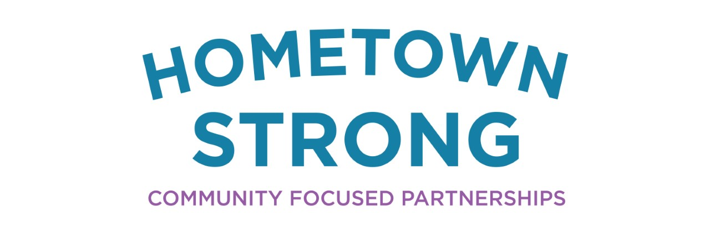

Caswell County, North Carolina

The Community and its History
Caswell County was the first county in North Carolina to be created by the state in 1777. The county was formed from northern Orange County to give those residents greater representation

Searching for a way to bring Caswell County together while promoting overall wellness, Paula Seamster, the Clerk to the Board of Caswell County, worked with Blue Cross Blue Shield to initiate the rural county’s community wellness plan in January 2017. Working with various community partners and health professionals, the program’s goal is overall wellness for its participants. The program is not centered around physical health, but includes resources for mental and emotional wellbeing. By making these free event accessible to all citizens and creating incentives, the wellness program gives each community member an opportunity to invest in their unique wellness.

With the help of Blue Cross Blue Shield and various community partners, Caswell County has successfully implented a county wide wellness program, encouraging participants to take control of their wellbeing.
Points of Interest | County Data
Population | 22,604
Per Capita Income | $22,982
Median Household Income | $43,961
Poverty Rate | 17.1%
Minority Population | 35.5%

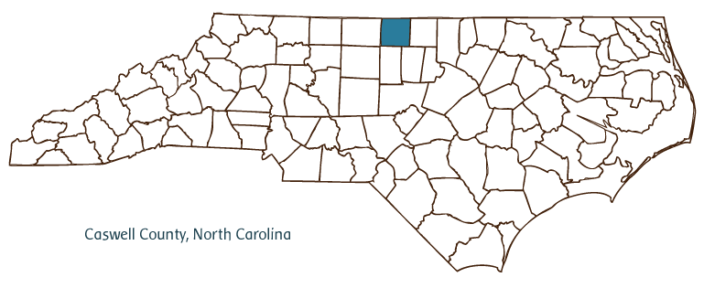
and easier access to the county seat. Named after Richard Caswell, North Carolina’s first governor, the county split once again in 1792, forming Person County to the east of Caswell County. This act granted more representation to members of the eastern half of the county and re-centered the county seat from Leasburg to Yanceyville.
Following the Revolutionary War, Caswell County was the second most populous state in North Carolina with 9,838 residents. The 1830s saw the beginning of the Boom Era, a period of political and economic prosperity in Caswell County that was based around an abundant tobacco industry. This thriving era ended with the American Civil War. While Caswell County was against secession, it was forced to comply with the eventual secession of the state of North Carolina. The subsequent defeat of the Confederacy resulted in a sense of loss that shook the county in a way that it has yet to recover from. Caswell County’s reliance on its agricultural industry, specifically tobacco, and its mistreatment of the land resulted in steady economic decline. This lack of economic diversification remains an issue today, over one hundred years after the identification of the initial issue.3
Today, Caswell County remains a historically rich community. The county celebrates its notable artists such as Thomas Day, a free black craftsman and furniture maker from the 19th century whose home is preserved in the Union Tavern, and Maud

Gatewood, an individualistic visual artist from the 20th century who is commemorated with the Maud Gatewood Memorial Park.2 The community honors its cultural and historical legacy through the Caswell County Historical Association and the Caswell Council for Arts and History. Annual events such as the Brightleaf Hoedown, the Thomas Day House Annual Heritage Tour of Homes, and the Milton Old-Fashioned Fourth of July Celebration display the cultural assets that this historic community has to offer.5

The Strategy
In 2010 Paula Seamster began inquiring about instituting a community focused health program in Caswell County. At the time, the county government was not interested in pursuing such a program, primarily due to cost concerns. In 2016, the health insurance company Blue Cross Blue Shield approached the county about a wellness program, and so with Seamster’s passion and community insight, the county’s government’s willingness to participate, and Blue Cross Blue Shield’s structural support, the Health Promotion Plan kicked off in

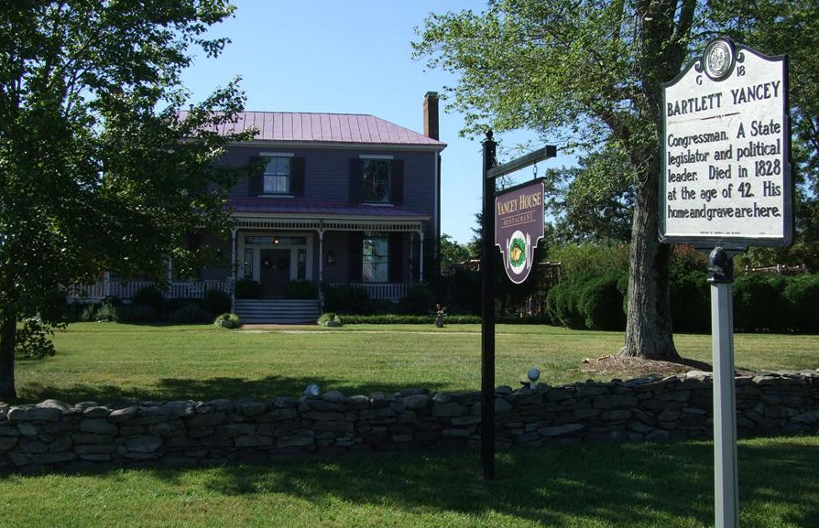
groups, sessions on the latest Alzheimer’s and dementia research, yoga classes, and a host of other opportunities for wellness. The resistance has diminished as the community has come to value various forms of wellness. During the COVID-19 pandemic, these sessions can be held online via Zoom. The Health Promotion Plan also offers incentives for government employees who participate. Each employee is given a Wellness Passport, and after participating in six activities, their name is entered into a raffle for five $50 gift cards to community organizations. If a participant completes twelve activities, their name is entered twice. The raffle is held at the monthly Employee Appreciation Luncheon. Another incentive for participation is the ability to meet certification requirements. The programming is free, and select courses allow groups, such as staff in nursing care facilities, to gain specific certifications.4
The Health Promotion Plan is granted $3,500 from the Caswell County Commissioner, but much of the programming is possible thanks to instructors offering classes at free or reduced rates. The program relies on several community partners such as the Cardinal Health Provider for mental health services and the Caswell County Parks Department to establish accessible walking trails and obstacle courses. Various parts of Caswell County have come together to demonstrate that wellness is a means to feel good about oneself and is for everyone.4

January of 2017. A committee was formed to implement the program across the county. Blue Cross Blue Shield charged an initial fee for an initial twelve-week implementation program that involved Friday meetings where the group would discuss program goals and specific actions that had been taken. The initial phase was a health and wellness program for government employees. After about 18 months, the Health Promotion Plan was opened to allow for all Caswell County citizens to participate for free.4
Initial resistance to the Health Promotion Plan came because of unwillingness to participate in physical activity. In response, the program promoted its mission of wellness as opposed to physical health. This wholistic plan offers freedom for participants to personalize their approach to health and introduces them to unique strategies for wellness.4
There is no shortage of Health Promotion Plan programming. Caswell County has successfully scheduled blood drives, workshops on stress management, eye care clinics, walking

wholistic approach to wellness meets less resistance. The program in Caswell County is effective because of its emphasis on wellness as specific to every individual. Wellness is not as simple as a one size fits all plan to lose weight, but a combination of efforts to make one feel good and good about themselves. By offering diverse wellness opportunities, a community can attract more participants and allow for citizens to explore new aspects of their health.
The unintended benefits of community programs. While Caswell County has unsurprisingly experienced various benefits due to an overall healthier population, such as lower healthcare costs and a stronger sense of community, the wellness program has also granted opportunities for employment. Several wellness courses grant participants certifications that are necessary for fields of healthcare or simply look attractive on resumes. This additional function draws even more members of the community and creates a space where all participants are working towards a higher standard of living for their community.

Endnotes
- “An Overview of the History of Caswell County, North Carolina.” FamilySearch Wiki. Accessed July 8, 2020. https://www.familysearch.org/wiki/en/An_Overview_of_the_History_of_Caswell_County,_North_Carolina.

How and Why the Strategy is Working

Strong and Unique Partnerships. Caswell County has many community partners in this program including the health insurance company, Blue Cross Blue Shield. While the community was able to identify a need for this kind of wellness program before the partnership, strategy and implementation were major challenges. With Blue Cross Blue Shield’s expertise, Caswell County could focus their efforts on designing this program to meet the unique wellness needs of the community. Blue Cross Blue Shield provided needed structure and support.

Willingness of instructors to offer free or reduced rates. While the Caswell County Commissioner does grant the Health Promotion Plan $3,500 a year, the breadth and depth of programming would not be possible without the generosity of instructors. Due to the community building nature of this program, many wellness experts offer their services for a free or reduced price to increase accessibility and participation. This demonstrates the extent to which this initiative is a community effort, and how vital it is to the wellbeing of Caswell County’s citizens.

Lessons Learned

A multi-level approach to health. While community health initiatives can turn citizens away because of the reputation they have for being strenuous and physically demanding, a wholistic

- “Leisure.” Yanceyville, North Carolina. Accessed July 8, 2020. https://yanceyvillenc.gov/index.asp?SEC=D3D5D5B1-FF85-40DF-A0D3-5202E9CA4C11
- Richmond Stanfield Frederick, Jr. Caswell County. Accessed July 8, 2020. http://sites.rootsweb.com/~ncccha/.
- Seamster, Paula. Interview with Claire Shu. July 1, 2020.
- See also: North Carolina Counties (to access links to NCpedia articles for all 100 counties)by William S. Powell. “Caswell County.” NCpedia. Accessed July 8, 2020. https://www.ncpedia.org/geography/caswell.
- “U.S. Census Bureau QuickFacts: Caswell County, North Carolina.” Census Bureau QuickFacts. Accessed July 8, 2020. https://www.census.gov/quickfacts/fact/table/caswellcountynorthcarolina/SEX255219.

