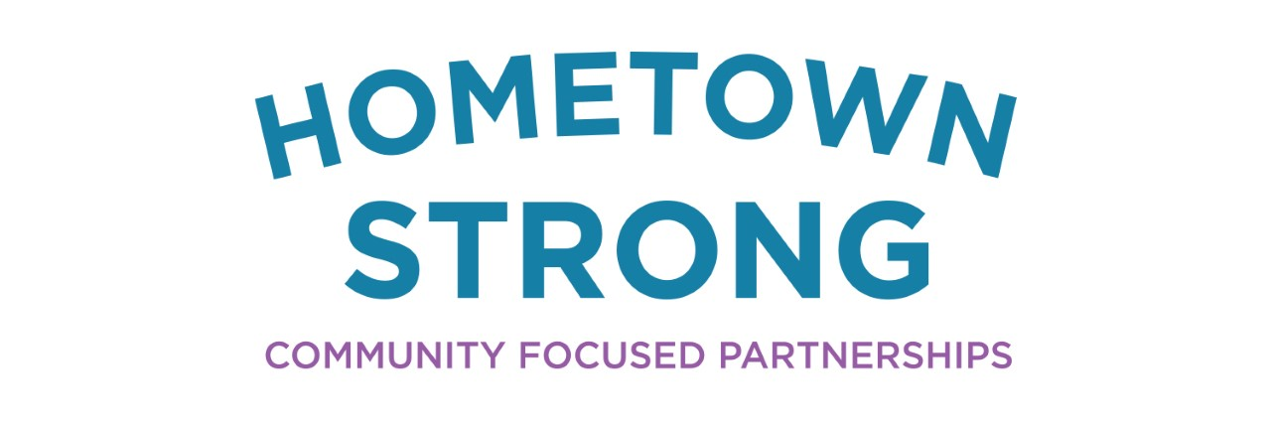

Scotland County, North Carolina
region’s settlers, Scotland County was established in 1899 from Richmond County.6 The county seat, Laurinburg, a three-time recipient of the All American City Award for civically engaged communities, was founded in named after the McLaurin family, an influential Scottish settler family.3 Scotland county is in the southern coastal plains of North Carolina making it especially susceptible to hurricane damage. The
Scotland County Schools outfits students in devices and hotspots in order to address learning gaps in low-income areas.

Gaps in internet access are exacerbated in low-income regions across the United States. This results in fewer opportunities for students who increasingly have online homework. To empower students and advocate for their success, Scotland County schools utilized both public funds and private grants to fund the 1:1 Technology Plan. This initiative supplied several K-12 households with devices and reliable high-speed internet in order to give students more resources to learn and thrive.

The Community and its History
Named after the home country of the

Points of Interest | Scotland County Data
Population | 34,823
Per Capita Income | $18,242
Median Household Income | $35,617
Poverty Rate | 26.9%
Minority Population | 54.9%
Proximity to Urban Center | 43 miles to Fayetville
Proximity to Interstate Highway | US Highway 74 runs through Laurinburg
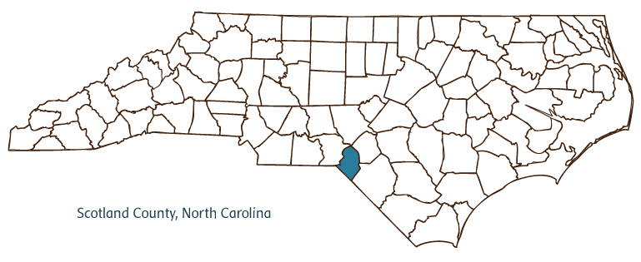
assign homework that requires Internet access,” yet 10% of K-12 households do not have internet access.10 This lack of internet access that hinders at home learning is known as the “homework gap” and disproportionately affects lower income households, such as those in rural communities.10 Scotland County’s median household income is around $17,000 less than the state median household income, thus exacerbating the county’s homework gap.7
Through increasing technology use in school, Scotland County was able to recognize that many of the students in the rural community did not have access to high-speed internet. Additionally, with so much of learning now geared toward technological fluency, the school board understood the increasing importance of internet access for their students’ success and new opportunities for learning.
Responding to this information, Scotland County schools initiated the 1:1 Technology Plan. During the 2017-2018 school year, Scotland County began issuing Chromebooks to all students. This measure was a step towards ensuring that online homework could be completed for grades 3-12.

area is currently recovering from Hurricane Florence in September 2018. With easy access to both the beach and the mountains of North Carolina, Scotland County prides itself on its steady stream of recreational activities from golfing, a truly Scottish pastime, to wine tasting to fishing.5
The county’s economy is largely built on agriculture and textiles but aims to attract new small business through cultural and community-oriented events. This small-town strategy supports small businesses and encourages a tight bond between citizens and their economy.5
The region holds onto its rich cultural heritage through events such as the annual Highland Games and ScotchFest. The county is also home to the Scottish Heritage Center.3 The county’s deep Scottish roots are only one aspect of its cultural history. Scotland County also offers other cultural assets such as the Indian Museum of the Carolinas with 40 exhibits celebrating the Native Americans of the Carolinas as well as the John Blue House, an ornate late nineteenth century home that showcases the county’s past.6

The Strategy
According to a study by the North Carolina Department of Information Technology, in North Carolina “70% of high school teachers, 60% of middle school teachers, and 43% of elementary school teachers regularly

of technology. While many school districts may be resistant to change and too set in their ways, Scotland County understands that in order to give their students the best opportunities for success after graduation, the county’s educational tools must adapt. This means that as universities and professions continue to increase their efficiency through technology, students should have technological fluency. This program was successful because the school district had an open mind when it came to issues of accessible education and exposing their students to new tools.

Lessons Learned
Internet accessibility is a vital investment for education. Access to the internet increases a student’s ability to complete homework and create new learning opportunities for themselves. The homework gap, being the inability to complete assignments, is marginally worse for lower-income households.10 Internet accessibility is a way to minimize this homework gap and create opportunities for these marginalized groups.
Investment can yield unintended

Chromebooks were intentionally chosen and distributed because they are lightweight, easy to transport, and less susceptible to computer viruses.4 In 2018, Scotland County received a $100,000 grant from T-Mobile to buy 500 hotspots for students to take home.4 Since then, T-Mobile launched Project 10Million, a $10 billion project giving internet to 10 million households within the following five years.11 Providing information on setup and usage of the hotspots and Chromebooks has also been a key component of this initiative. Another aspect of this technology plan is adding Wi-Fi to school buses. Wi-Fi on school buses works to shrink the homework gap even more as even students with more familial responsibilities and obligations now have more learning opportunities. They can take full advantage of their time on the way to and from school, empowering students to be time efficient and resourceful.

How and Why
A diverse community. 54.9% of Scotland County’s population have minority status, making this a diverse community.12 Diversity is one of the school district’s core values, demonstrating the district’s dedication to lifting the minority populations.8 Scotland County’s 1:1 Technology Plan works to ensure students from all backgrounds have access to educational tools thus promoting diversity as an asset.
An understanding of the capabilities

wi-fi-hotspots-to-rural- underserved-students/
- Editor, Client. “City of Laurinburg NC - Welcome to Our Charming and Historic City!” City of Laurinburg. Client Editor http://laurinburg.org/wp-content/uploads/2017/08/340x156_MainSiteLogo-SolidBorder-150dpi-01.png, December 31, 2019. https://www.laurinburg.org/.
- Gandee, Katelin. “Schools Receive Grant for Hotspots.” Laurinburg Exchange, August 9, 2018. https://www.laurinburgexchange.com/news/17074/schools-receive-grant-for-hotspots.
- “Home - Laurinburg-Scotland County Area Chamber of Commerce, NC.” www.laurinburgchamber.com. Accessed June 8, 2020. https://www.laurinburgchamber.com/.
- North Carolina Counties. “Scotland County.” NCpedia. Accessed June 8, 2020. https://www.ncpedia.org/geography/scotland.
- “North Carolina Household Income.” Department of Numbers. Accessed June 8, 2020. https://www.deptofnumbers.com/income/north-carolina/.
- Points of Pride. Accessed June 8, 2020. https://www.scotland.k12.nc.us/Page/61.
- Publisher. “John Blue House: John Blue Story.” Rural Heritage Center, September 21, 2016. http://nc-rural-heritage.com/story/.

Investment can yield unintended benefits. While there was no way for Scotland County to know about the upcoming COVID-19 pandemic, the region was better suited in terms of infrastructure for remote work and learning due to their investment in technology updates. The hotspots and Chromebooks were initially intended for students, but the investment yielded positive externalities as entire households then had access to them.
During the COVID-19 pandemic, the North Carolina State Government distributed hotspots that were donated by companies such as Google and AT&T to make remote work and news updates more available for rural communities. Designated rural communities, including Scotland County, received the first 156 hotspots.2 This initiative by the government demonstrates the necessity of investing in accessible internet.

Endnotes
- Brown, Tonya. “Scotland County Schools Providing Internet Access to Students without It.” WPDE. WPDE, August 8, 2018. https://wpde.com/news/local/scotland-county-schools-providing-internet-access-to-students-without-it.
- Childress, Greg. “School Buses to Carry Wi-Fi Hotspots to Rural, Underserved Students.” The Progressive Pulse, May 6, 2020. http://pulse.ncpolicywatch.org/2020/05/06/school-buses-to-carry-wi-fi-hotspots-to-rural-underserved-students/E “City of Laurinburg NC - Welcome to Our Charming
- .
- “Home - Laurinburg-Scotland County Area Chamber of Commerce, NC.” www.laurinburgchamber.com. Accessed June 8, 2020. https://www.laurinburgchamber.com/.
- North Carolina Counties. “Scotland County.” NCpedia. Accessed June 8, 2020. https://www.ncpedia.org/geography/scotland.
- “North Carolina Household Income.” Department of Numbers. Accessed June 8, 2020. https://www.deptofnumbers.com/income/north-carolina/.
- Points of Pride. Accessed June 8, 2020. https://www.scotland.k12.nc.us/Page/61.
- Publisher. “John Blue House: John Blue Story.” Rural Heritage Center, September 21, 2016. http://nc-rural-heritage.com/story/.
- “THE HOMEWORK GAP IN NORTH CAROLINA.” Broadband Infrastructure Office. Accessed June 9, 2020. https://www.ncbroadband.gov/homework-gap/.
- T-Mobile. “Educators: It's Time to Close the ‘Homework Gap.’” T. T-Mobile, December 17, 2019. https://www.t-mobile.com/news/closing-the-homework-gap-project-10million.
- “U.S. Census Bureau QuickFacts: Scotland County, North Carolina.” 2020. Census Bureau QuickFacts. Accessed June 9. https://www.census.gov/quickfacts/scotlandcountynorthcarolina.

John Blue Story.” Rural Heritage Center, September 21, 2016. http://nc-rural-heritage.com/story/.
- “THE HOMEWORK GAP IN NORTH CAROLINA.” Broadband Infrastructure Office. Accessed June 9, 2020. https://www.ncbroadband.gov/homework-gap/.
- T-Mobile. “Educators: It's Time to Close the ‘Homework Gap.’” T. T-Mobile, December 17, 2019. https://www.t-mobile.com/news/closing-the-homework-gap-project-10million.
- “U.S. Census Bureau QuickFacts: Scotland County, North Carolina.” 2020. Census Bureau QuickFacts. Accessed June 9. https://www.census.gov/quickfacts/scotlandcountynorthcarolina.

