- To request an International Wire, use the following link to access the International Wire Out Form on the State Treasurer’s website:
https://www.nctreasurer.com/fod/Pages/Banking-Forms.aspx
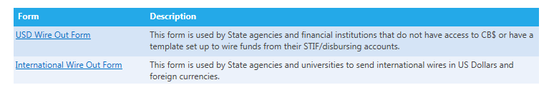
- Once the International Wire Out Form has been selected, it will generate a PDF form. For help completing the wire out form, please see pages 3 - 4.
*Note: All wire transfers must be signed by an officer listed on the signature card of the disbursing account used to fund the wire.
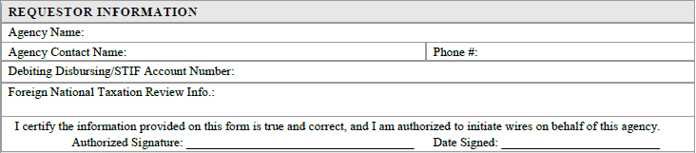

- Email the completed form to INTLwires@nctreasurer.com. With this form, please include supporting information, such as invoices, communications, and any relevant documentation for OSC to review to determine tax liability.

- After emailing the International Wire Out Form to DST, transfer the wire amount plus the $25.00 wire fee to the international wire account ending in 2688 using a core banking template.
For questions about setting up a template, email dst.disbursing@nctreasurer.com.

- After SBU receives the completed form and supporting information and all documentation will be forwarded to the Office of State Controller (OSC) for review of foreign national tax status.
Once the tax requirements have been reviewed, OSC will “reply all” with a message similar to the following:
*Note: Your agency may also receive a response asking for further information. If so, please respond as soon as possible for OSC to review. This will help us process your wire in a timely manner.

- After OSC has reviewed national tax requirements, and the DST international wire account has been funded for the wire, DST will initiate the wire transfer through Wells Fargo.

- Once the wire has been completed, your agency will receive a confirmation email with a reference number and a wire confirmation attached.
For any questions or concerns regarding International Wires, please email
INTLwires@nctreasurer.com.

Below is information regarding completion of the International Wire Form.
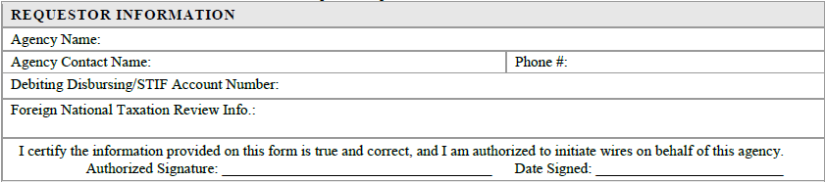
The information in this section pertains to the requesting agency.
Agency Contact Name: The person submitting the wire request form
Debiting Disbursing/STIF Account Number: The account used to fund the international wire account
Foreign National Taxation Review Info: Within this box, please provide your institutions review of Chapter 3 of the Internal Revenue Code for foreign national tax withholding. If your payment is foreign source, tax treaty exempt or reduced withholding, or withholdable, please provide those details within this box. This information will assist OSC in their review and release of wires
Authorized Signature: An officer or authorized agent listed on your agency’s Disbursing/STIF account signature card.

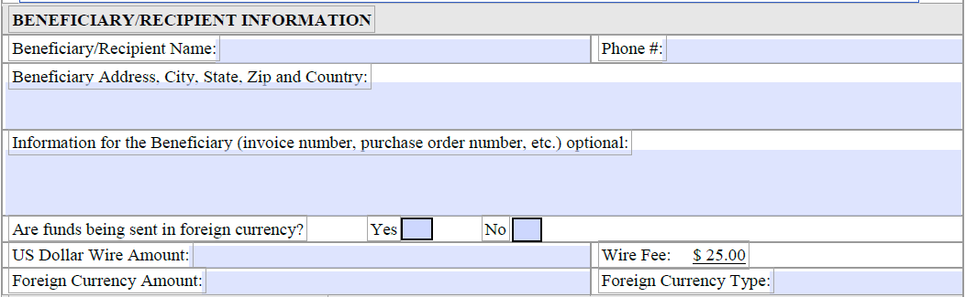
Beneficiary/Recipient Name: The person who is receiving the wire
Beneficiary Address, City, State, Zip, and Country: The recipients full address
Are the funds being sent in foreign currency? No, for wires sent in USD
US Dollar Wire Amount: USD amount (do not include wire fee here)
Foreign Currency Amount: Not applicable for USD wires
Wire Fee: The processing fee for international wires
Foreign Currency Type: Not applicable for USD wires
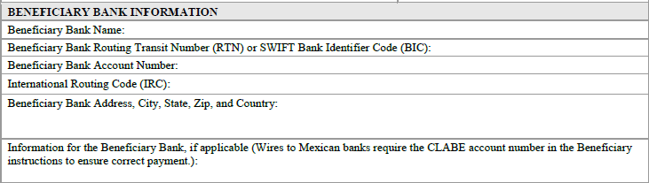
Beneficiary Bank Name: Receiving bank name
Beneficiary Bank Routing Transit Number or SWIFT Bank Identifier Code (IBC): Specifies the bank receiving the wire
Beneficiary Bank Account Number: Wire recipient’s bank account number
International Routing Code (IRC): Does not apply to every international wire, this number should be included in the wire instructions provided to your agency/university
Beneficiary Bank Address, City, State, Zip, and Country: Address of receiving bank, this may vary
Information for the Beneficiary Bank: Is not applicable for all wires, some countries require additional information such as a CLABE or IRC number
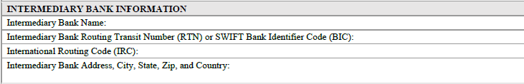
Intermediary Bank Information: Recipient will provide this information if applicable

