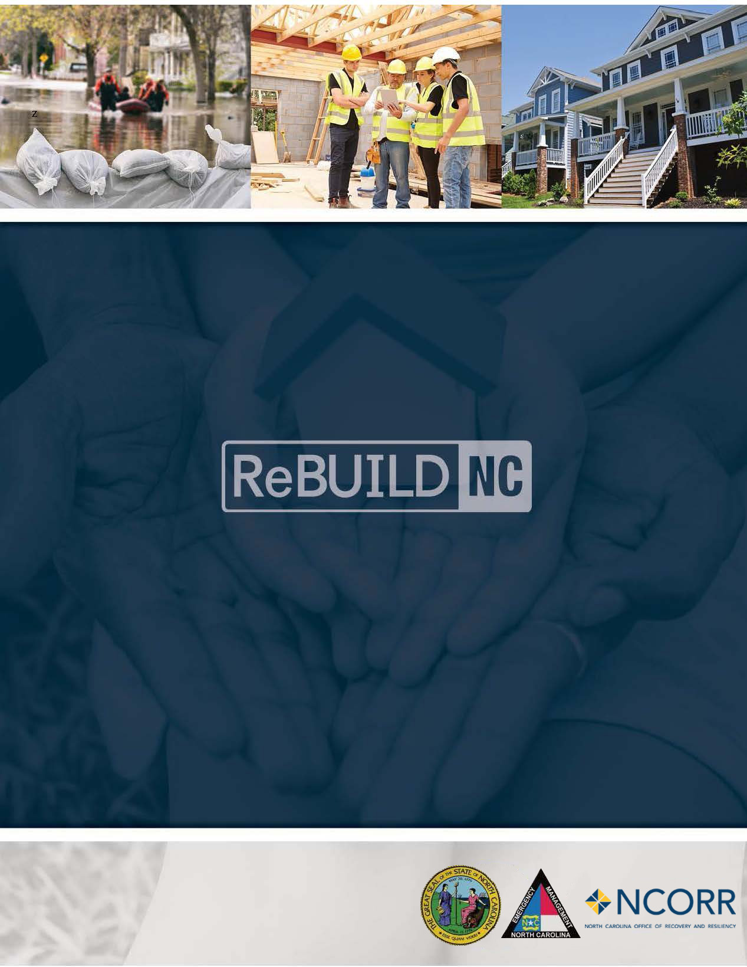

Substantial Amendment 5 November 22, 2019

CDBG-DR Action Plan
State of North Carolina

For CDBG-DR Funds
(Public Law 114-254, January 18, 2017 and Public Law 115-31, August 7, 2017)

This page intentionally left blank.

Revision History

Amendment # | Date | Description
 | 04.21.2017 | Initial Action Plan Submitted
#1 | 11.07.2017 | Substantial Amendment 1
#2 | 04.09.2018 | Non-substantial Amendment 2 Clarification of Method of Distribution
#3 | 12.16.2018 | Substantial Amendment 3 – Method of Distribution and Program Caps
#4 | 03.12.2019 | Non-substantial Amendment 4 – Amended method of determining construction intent (rehabilitation vs. reconstruction) and amended method of determining elevation assistance.
#5 | 11.22.2019 | Substantial Amendment 5—NCORR designated as recipient, federal and local policy and programmatic changes.

This page intentionally left blank.
Table of Contents

1.0 Summary of Action Plan Changes 1
1.1 Action Plan Amendment 5 1
2.0 Introduction 7
3.0 Unmet Needs Assessment 9
3.1 Housing 10
3.2 Vulnerability of the Most Impacted Communities 24
3.3 Economic Recovery 33
3.4 Public Infrastructure and Facilities 34
4.0 Planning, Coordination, and Community Outreach Needs 39
5.0 Nexus Between Unmet Need and Allocation of Resources 41
5.1 National Flood Insurance Restrictions 41
6.0 Allocation of CDBG-DR Funding 43
6.1 MID Allocation of Funding 44
6.2 Non-MID Allocation of Funding 44
7.0 Method of Distribution & Delivery 45
8.0 Recovery Programs 47
8.1 Homeowner Recovery Program 47
8.2 Small Rental Repair Program 52
8.3 Multi-Family Rental Housing 53
8.4 Buyout and Acquisition Program 54
8.5 Public Housing Restoration Fund 56
8.6 Small Business Recovery Assistance 58
8.7 Community Recovery Program 61
9.0 General Eligibility Requirements 65
10.0 Leveraging 67
11.0 Program Income 69
12.0 Schedule of Expenditures and Outcomes 71
13.0 Minimum Threshold for Substantial Amendment 73
14.0 State of North Carolina Green Building Standards for Construction and Contractor Oversight 75
15.0 Duplication of Benefits 78
16.0 Broadband 81
17.0 Monitoring Standards and Procedures 83
18.0 Contractor Performance Standards and Appeals Process 87
19.0 Citizen Participation Plan 89
19.1 Encouragement of Citizen Participation and Outreach 89
19.2 Individuals with Limited English Proficiency (LEP) 90
19.3 Persons with Disabilities 90
19.4 Response to Citizen Complaints and Appeals 90
19.5 Public Notice, Comment Period and Website 91

Summary of Action Plan Changes
The purpose of Substantial Action Plan Amendment 5 is to formally identify the North Carolina Office of Recovery and Resiliency (NCORR), a division of the NC Department of Public Safety (NCDPS) as the direct recipient of U.S. Department of Housing and Urban Development (HUD) Community Development Block Grant – Disaster Recovery (CDBG-DR) funds. Previously, NCORR administered programs on behalf of the North Carolina Department of Commerce (NCDOC). NCORR’s role as grantee, as well as its relationship to NCDOC, is updated throughout the Action Plan.

Additionally, the Action Plan is revised to include a definition for “emergency repairs” undertaken by homeowners impacted by Hurricane Matthew. Homeowners affected by this change to the Action Plan began repair work on their damaged homes prior to guidance from NCORR or other coordinating State agency and continued repairs after the application period to protect, repair, or restore the property after the effects of the storm. The applicability of Emergency Repairs, applicant eligibility for reimbursement for such repairs, and participating homeowner requirements will be set forth in the ReBuild NC Single-Family Housing Manual. Further changes incorporated in this Action Plan Amendment include clarification on program delivery for the Multi-Family Rental Housing Program, timeline changes for the Small Rental Repair Program, clarifications on program policy for the Buyout and Acquisition Programs, changes to funding caps for the Homeowner Recovery Program, and Citizen Participation Plan Updates.

A significant change to the program includes the addition of Columbus and Bladen Counties to the Most Impacted and Distressed (MID) areas. The HUD requirement to expend 80% of CDBG-DR funds within MID areas remains, therefore a portion of the allocation for all MID counties now includes expenditures in Columbus and Bladen Counties. Finally, the Action Plan Amendment adjusts allocations to programming after reviewing program participation and current recovery needs. The updated allocations are included in a summary table at Table 1.

Action Plan Amendment 5

Transition of Grantee Responsibilities to the North Carolina Office of Recovery and Resiliency
Previously, NCDOC participated in a Grantee relationship with the U.S. Department of Housing and Urban Development (HUD) for the receipt of Community Development Block Grant – Disaster Recovery (CDBG-DR) funds. However, NCORR was subgranted CDBG-DR funds and has been administering programs in the role of subgrantee on behalf of NCDOC. Effective July 1, 2019, NCORR, an office within the North Carolina Department of Public Safety (NCDPS), has assumed Grantee responsibilities and has formed a Grantee relationship with HUD. Throughout the Action Plan, references to the Grantee are now construed to refer to NCORR. NCORR has agreed to the necessary “Certifications, Waivers, and Alternative Requirements” set forth for this CDBG-DR allocation. These certifications are found in Appendix A of the Action Plan.

Duplication of Benefits Policy Change
On June 20, 2019, HUD published two Federal Register (FR) notices on the calculation of Duplication of Benefits (DOB): 84 FR 28836 (here after referred to as the “DOB Notice”) and 84 FR 28848 (here after referred to as the “DOB Implementation Notice”). After reviewing the notices, NCORR is updating its DOB policy to comply with the new guidance. A detailed explanation of the DOB Notice and its applicability to NCORR programming, specifically for single-family homeowner recovery programs, is found at Page 77 of the Action Plan.

As a part of HUD’s implementation requirements, NCORR has reviewed the unmet need based on the current program applicants which have a declined, cancelled, or active loan with a balance which may be cancelled.

The Program will recalculate awards which have been completed prior to the implementation of this new policy and will issue new award letters as appropriate and subject to all program caps. Reimbursement Only Awards that have already reached the maximum allowable cap or for which the applicants have an open and undisbursed subsidized loans will not be recalculated.

Method of Program Delivery
NCORR, in coordination with the impacted counties, have revised the program delivery matrix to accurately reflect NCORR’s role in program delivery. This section is also updated to remove the Tier 1 and Tier 2 designations for counties in favor of MID and Non-MID designations. MID refers to the designation assigned by HUD for “most impacted and distressed” area. HUD defines MID areas as counties that are eligible to receive FEMA Individual Assistance (IA) funds, have a housing recovery need greater than $13 million after other funds to repair have been received. HUD requires that 80% of CDBG-DR funds for this allocation are spent in MID areas. These updates are located on Page 45. The updated responsibility matrix is included on Page 46.

Rehabilitation Assistance Minimum Award
The minimum award provided in the Single Family Homeowner Repair Program is $1,000. Homeowners with less than $1,000 in rehabilitation assistance are not eligible for the Single Family Homeowner Repair Program. The rehabilitation minimum was included in a previous Action Plan amendment, but is clarified in this Action Plan amendment on Page 50.

Emergency Repairs
This Action Plan Amendment modifies language specific to the Reimbursement track of the Homeowner Recovery Program to define Emergency Repairs undertaken by eligible homeowners. The previous language in the Action Plan allowed for reimbursement of certain expenses that “were incurred prior to application for assistance to the program or September 14, 2018, whichever occurred first.” Language modifying this condition for participation in the Reimbursement track is added to Page 48 of the Action Plan as follows:

“Homeowners that performed Emergency Repairs after the “stop work” period (from the time of the application until completion of the Tier II environmental review) may still be eligible for assistance following a review of the scope of the repairs. Emergency Repairs are defined at 24 CFR Part 58.34(a)(10) as repairs that ‘do not alter environmental conditions and that are necessary only to arrest the effects from a state or federally declared public disaster or imminent threats to the public safety including those resulting from physical deterioration’.

Homeowners that performed Emergency Repairs during the “stop work” period will be asked to submit documentation demonstrating that the repairs performed comply with 24 CFR Part 58.34(a)(10). Homeowner-provided documentation will be reviewed to determine eligibility to participate in the program. Participating homeowners must certify that their repairs meet the definition of Emergency Repairs before receiving reimbursement funding. Emergency Repair scope items eligible for reimbursement, the ReBuild NC review process for eligibility, and homeowner certification forms will be incorporated in the ReBuild NC Single-Family Housing Manual.”

Multi-Family Rental Housing Program
To administer and execute the Multi-Family Rental Housing Program, NCORR will enter into a subrecipient agreement with the North Carolina Housing Finance Authority (NCHFA). NCORR will subgrant $18,204,256 to NCHFA through a subrecipient agreement and will monitor NCHFA’s execution and administration of the Multi-Family Rental Housing Program. An additional $5 million is allocated to the program to allow funding for additional projects, as they are identified and approved by NCORR. Additionally, NCORR has clarified that one for one replacement of Multi-Family Rental Housing is allowable to rebuild affordable housing out of the 100-year floodplain. Additions to the Action Plan specifying NCHFA’s role in administering the Multi-Family Rental Housing Program are found at Page 53 of the Action Plan.

Temporary Relocation Assistance
Temporary Relocation Assistance (TRA) eligibility is expanded from low- to moderate-income (LMI) applicants only to owner-occupants and households earning less than 120% area median income (AMI). Owner-occupants and households earning more than 120% AMI may qualify for TRA assistance if a hardship is demonstrated by the program applicant. Clarification on TRA is found on Page 50 of the Action Plan.

Small Rental Repair Program
A number of changes have been made to the Small Rental Repair Program. After program refinement, the eligible property unit count has been reduced to 4 or fewer units and the maximum award has been increased to $70,000 per unit. The minimum award is set at $5,000 total. To continue development of an effective small rental repair solution for impacted landlords and renters, NCORR has adjusted the start date of the Program to December 2019 from July 2019. Changes to the Program are found on Page 52 of the Action Plan.

Buyout Program
Multiple updates to the Buyout Program have been made, including revising the Buyout Program to provide Pre-Storm Fair Market Value for buyouts, to be capped at the current FHA mortgage limits. A definition for Disaster Risk Reduction Area (DRRA) and buyout priority zones is included in the buyout program section of the manual. The Buyout Program will also include incentives to be determined by a formula set forth in the Buyout Program manual. NCORR has adjusted the start date of the Program to January 2020 from July 2019. Changes to programming are included on Page 54 of the Action Plan.

Homeowner Recovery Program
The program cap of $70,000 for projects funded by the Single-Family Homeowner Rehabilitation Program is clarified to exclude costs necessary for lead and asbestos abatement, and certain change orders approved by the Program which are necessary and reasonable to complete the project. These costs are considered based on need in excess of the program funding cap. Details on the program cap are found on Page 47 of the Action Plan.

The elevation assistance cap has been changed in favor of an elevation assistance cost formula to be included in the NCORR Construction Standard Operating Procedure (SOP). The elevation assistance maximum for rehabilitation awards is a dollar-per-square foot ($/SF) cap and constrained to the actual cost of elevation. Elevation assistance costs are in addition to the program cap for rehabilitation, reconstruction, and Mobile/Modular Home Unit (MHU) replacement activities.

Citizen Participation Plan Updates
Content and contact information for the Citizen Participation Plan has been updated to properly reflect NCORR points of contact as well as accurately reflect federal guidance on citizen participation.

Addition of Columbus County and Bladen County to the Most Impacted and Distressed Areas
After consultation with HUD, Columbus and Bladen Counties have been added to the Most Impacted and Distressed (MID) counties. In accordance with HUD guidance, 80% of CDBG-DR funds received must be expended to recover MID areas. The 80% allocation of funds to MID counties will now be expended between all six MID counties – Edgecombe, Wayne, Robeson, Cumberland, Bladen, and Columbus.

Allocation of CDBG-DR Funding
The State previously identified the thresholds which will trigger the requirement for a substantial amendment. Those thresholds are a) a change in program benefit or eligibility criteria, b) the addition or deletion of an activity, or c) the allocation or reallocation of $5 million or more within the approved Action Plan activity allocations. In accordance with the $5 million or more of activity allocations threshold, the Action Plan is revised and the following reallocations have been made to better serve the recovery effort:
- Action Plan Amendment 5 removes funding for the supportive services program based on a lack of qualifying projects. Projects previously considered for supportive services funding have been reallocated to the Community Recovery Program and Public Housing Recovery allocations, consistent with the proposals received from impacted counties. This is consistent with the existing unmet recovery needs analysis, as these projects were incorrectly categorized previously and are now correctly associated with the proper programs.
- An additional $5 million is added to the Multi-Family Rental Housing Program budget to allow for additional projects to be executed by NCHFA as they are approved by NCORR.
- The Public Housing budget has been increased by $4.959 million to account for recategorization of proposed projects from the counties to the correct programs. This is consistent with the existing unmet recovery needs analysis, as these projects were incorrectly categorized previously and are now correctly associated with the proper programs.
- The Small Business Recovery Assistance Program allocation has been reduced to $3.76 million to fund currently active projects under the subgrantee management of NCDOC. Additional information about changes to the Small Business Recovery Assistance program are incorporated in the programming section of the Action Plan for that part.
- After reallocations, the remaining balance of CDBG-DR grant funds are allocated to the continued unmet housing recovery need, increasing the Housing Program allocation by $8.78 million.

The updated allocations consistent with the changes incorporated in this Action Plan Amendment are summarized in the table below:

Table 1: Distribution of CDBG-DR Funds by Program
 | APA4 Allocation | Change from APA4 to APA5 | APA 5 Allocation | APA5 LMI Allocation | APA5 MID Allocation
Administration | $11,826,450 | $0 | $11,826,450 | $0 | $9,408,568
Planning | $11,826,450 | $0 | $11,826,450 | $0 | $9,408,568
Housing | $104,083,349 | $8,780,483 | $112,863,832 | $80,133,321 | $90,291,066
Buyout and Acquisition | $25,000,000 | $0 | $25,000,000 | $18,000,000 | $20,000,000
Small Rental | $18,204,756 | $0 | $18,204,756 | $18,204,756 | $14,563,805
Multi-Family | $18,204,756 | $5,000,000 | $23,204,756 | $23,204,756 | $18,563,805
Supportive Services | $10,000,000 | ($10,000,000) | $0 | $0 | $0
Public Housing Authority | $5,000,000 | $4,959,517 | $9,959,517 | $9,959,517 | $8,959,517
Small Business Recovery | $12,500,000 | ($8,740,000) | $3,760,000 | $2,632,000 | $3,008,000
Community Recovery | $19,883,239 | $0 | $19,883,239 | $13,918,267 | $15,906,591
TOTAL | $236,529,000 | $0 | $236,529,000 | $166,052,617 | $190,109,920
PERCENT OF TOTAL ALLOCATION | 100% | - | 100% | 70% | 80%
*MID Calculation of 80% does not include the portion of State level administration and planning expenditures that will be captured in the final MID calculation.

Introduction
Hurricane Matthew began as a Category 5 storm in the Caribbean, before hitting the coast of North Carolina (the State) on October 8, 2016. Fifty counties in North Carolina were declared federal disaster areas with historic communities in eastern North Carolina like Princeville, Kinston, Lumberton, Goldsboro, Fayetteville, and Fair Bluff experiencing catastrophic damages. Matthew lingered along the North Carolina coast for several days, causing rivers and their tributaries to swell and ultimately overflow into adjacent communities. Over a three-day period, central and eastern parts of North Carolina were inundated with rain, and 17 counties set new records for rain and flooding. Five river systems, the Tar, Cape Fear, Cashie, Lumber, and Neuse Rivers, flooded, remaining at flood levels for two weeks.

After Matthew passed, the State assessed the damage and documented that Matthew’s impact was devastating, significantly impacting residents in eastern and central North Carolina and causing catastrophic losses in the housing, business, public infrastructure, and agricultural sectors. More than 800,000 families lost power from Matthew, resulting in millions of dollars in food cost losses for families whose food needed to be frozen or refrigerated. 3,744 individuals needed to be moved to shelters, and 77,607 households applied for Federal Emergency Management Agency (FEMA) emergency assistance.

When FEMA completed its analysis of impacts to housing stock, 34,284 households had evidence of flood damage and nearly 5,000 homes had major to severe damage, many of which were located in rural communities, where not only the home but the farm and livestock were impacted and/or lost. The State estimated that more than 300,000 businesses experienced physical and/or economic impacts from the storm, including many small “mom and pop” businesses located in small rural communities. Matthew’s impact on the agricultural industry was particularly hard hit, as the industry has a significant presence in driving the local economy in eastern North Carolina, where the State is among leaders in the nation in livestock and crop production. North Carolina’s farms, including many small multi-generational family farms, along with the firms that provide materials needed to grow livestock and produce crops and food producers that take these products to market, lost tremendous amounts of inventory, livestock, and crops, with millions of dollars of the losses not covered by United States Department of Agriculture (USDA) programs. The impact to communities was also catastrophic, with public buildings, parks, schools, roads, water and wastewater systems, and other public infrastructure heavily impacted. Portions of the interstate system closed in some cases for up to ten days. In total, the State estimated that Matthew’s total economic impact was roughly $2 billion.

This page intentionally left blank.

Unmet Needs Assessment
The Unmet Needs Assessment within this Action Plan Amendment represents the second analysis of unmet needs in the State of North Carolina following Hurricane Matthew. It presents damage estimates and recovery needs as of October 15, 2017, roughly one year after the flooding occurred, using revised Small Business Administration (SBA) and FEMA data. Since the publication of the State’s initial Unmet Needs Assessment in the Spring of 2017, the State has focused recovery actions in four areas:
- Beginning to design housing programs focused on the findings of the State’s initial Unmet Needs Assessment and centered around the needs of low to moderate income persons and housing recovery in the most impacted communities and counties;
- Completing the State’s 50 county planning process to determine how to best align and structure the community recovery program with information and projects developed through this bottom-up community planning process;
- Working with FEMA to ensure that damages to public infrastructure were captured; and
- Working to confirm that the Matthew impacts to small businesses and the agricultural sector in particular remains unaddressed nearly a year after the storm.
As a result, the State’s prior Unmet Needs Assessment remains valid as housing still has significant unmet needs, in the public infrastructure and facilities area of the Unmet Needs Assessment the State are seeing increases in FEMA public assistance obligations that are in line with initial estimates. In the Economic Recovery section, with new SBA data, it is apparent that the State’s small businesses and agricultural enterprises in eastern and central North Carolina continue to need assistance. The analysis presented in the initial Unmet Needs Assessment, particularly for housing and vulnerable populations in most impacted communities remains particularly relevant and is included in this revised analysis as it is unchanged and is a key component for the overall program design.

As part of this Action Plan Amendment, the State of North Carolina has made it a priority to focus on continuing to assist low to moderate income families who experienced severe flooding and saw their homes and communities impacted by Matthew. Therefore, the funding priorities in this action plan emphasize housing and supportive service needs with the majority of this allocation going to housing recovery and housing assistance programs. The State understands that community health is not just about rebuilding homes but restoring the basic fabric of neighborhoods and ensuring future economic health and community infrastructure is restored. Therefore, the State is also providing funding to assist small businesses and farmers struggling to get back on their feet and ensuring that, as the planning process is complete, projects to rebuild and make more resilient communities can occur.

Based on this analysis, effective October 15, 2017, North Carolina’s current unmet recovery needs total $1,292,447,463.

Housing

Summary
As part of the Substantial Action Plan Amendment process, the State reviewed and analyzed unmet needs related to disaster recovery. This Unmet Needs Assessment updates the previous analysis provided by the State in the initial Action Plan. While HUD’s methodology only addresses part of the full unmet needs of State generated by Hurricane Matthew, the State’s updated unmet needs assessment is based on HUD’s CDBG-DR Allocation Methodology as published in the January 18, 2017, Federal Register Notice FR–6012–N–01. This unmet need assessment incorporates the housing unmet need addressed through the previous action plan. Based on a variety of data sources consistent with HUD methodology, the State observed the housing unmet need remains largely unchanged. The analysis below validates the State’s plan to allocate a majority of the funding, 85% in total funding, and 93% of this allocation to address a continuing housing unmet needs.

Analysis
This housing Unmet Needs Assessment relied heavily on the work that was conducted in the original action plan Unmet Needs Assessment. After comparison of data from FEMA, SBA, and the county planning process, the major changes to the housing Unmet Needs Assessment include a large unmet need for homeowners who wish to sell their homes and relocate to higher and safer ground and additional damages and unmet needs for Public Housing Authorities in storm impacted counties.

Hurricane Matthew inflicted devastating damage to families throughout North Carolina’s eastern and central parts. The swelling of the Tar, Neuse, and Lumber Rivers caused rainwater to overflow into neighboring towns, inundating business districts and homes with floodwaters. In total, almost 35,000 homes were damaged in the storm, and the homes of roughly 5,000 families were damaged so extensively as to make them unlivable.

North Carolina’s number one priority is to allow families to return to their homes and to ensure those homes are in safe and sanitary conditions. For this reason, the Unmet Needs Assessment focuses on housing recovery programs and supportive services to families and persons in need. This includes an understanding of where homes experienced the greatest damage and the capacity of those families to recover from the disaster.

The analysis and resulting recovery programs also account for long-term sustainability, with a priority placed on the homeowner and renter finding safe and suitable housing rather than simply rebuilding a damaged unit. Therefore, North Carolina will conduct a cost-benefit analysis on rebuilding a severely damaged home versus constructing a new home in an area safe from repetitive flood loss, which will take into account the cost of repairing versus replacement and estimated long-term losses due to repeat flood events.

We began the process of assessing unmet housing need by analyzing the prior Unmet Needs Assessment, which included who applied for FEMA assistance, the first step most flood victims take immediately after a disaster. This information is combined with the State’s own damage assessments and the SBA’s loan application information. From this data, we generated a detailed understanding of housing damages and recovery needs and compared the original analysis with updated data from FEMA and SBA. Specifically, we were able to estimate the following:
- What counties, towns, and neighborhoods experienced the greatest damage;
- The types of units that were damaged (rental versus homeowner and the structure);
- The incomes of the homeowner or renter impacted, and, combined with household size, the income classification of these impacted families;
- How many homeowners and renters were impacted, categorized by severity of damage;
- An estimate of housing recovery needs (in dollars); and
- In combination with other data, what impacted neighborhoods have a high concentration of vulnerable populations and/or additional needs.

The following is a summary of this analysis, which North Carolina will continue to build upon as the State captures more information from our community engagement meetings and outreach efforts at the county and local level.

Where did most of the damage occur?
Hurricane Matthew impacted 50 counties in North Carolina, largely along the eastern and central regions and along major rivers and tributaries. As previously noted, almost 35,000 families experienced some degree of damage to their homes, but the majority of damage was minor. For the purpose of the Unmet Needs Assessment, we assume that the majority of homes which experienced minor damage have likely been repaired six months after the storm event.

Unfortunately, families whose homes received major to severe damage have a far greater challenge in recovering, particularly when their homes are rendered uninhabitable due to mold, insulation issues, unstable foundations, leaky roofs, and lack of heat or plumbing due to flood damage of pipes and HVAC systems. These families either remain in their damaged homes, living in unsafe conditions because they are unable to find alternative housing they can afford, or they are displaced from their homes. The families with limited resources – low and moderate-income families who have limited savings or disposable income – are the families with the greatest needs. These homes are the focus of this Unmet Needs Assessment.

To determine which counties, towns and neighborhoods experienced major damage, the State mapped the FEMA applications by the address of the damaged unit and then associated that “point” with the neighborhood, town, and county the home falls within.

What we found, based on this analysis, is that major housing damage happened in very specific areas, as follows:
- 64% of major to severe damage is concentrated in the “most impacted” four counties.
- 52% of major to severe damage is concentrated in 13 towns.
- 41% of major to severe damage is concentrated in 14 neighborhoods.

So, while damage was widespread due to power outages, minor flooding, and wind damage, the serious impacts of Hurricane Matthew were felt in a specific handful of places. These counties, towns, and neighborhoods are defined in Table 2 through Table 4.

Table 2: Most Impacted Counties (updated October 17, 2019)
County | Owners | Renters | Total
CUMBERLAND | 408 | 447 | 855
EDGECOMBE | 270 | 305 | 575
ROBESON | 687 | 705 | 1,392
WAYNE | 299 | 275 | 574
COLUMBUS | 168 | 125 | 293
BLADEN | 71 | 13 | 84
TOTAL | 1,903 | 1,870 | 3,773

Note that since the initial Action Plan, Columbus and Bladen Counties have been added to the MID areas.

Table 3: Towns that Experienced Major to Severe Damages from Hurricane Matthew (where at least 100 homes experienced major to severe damage)
County | Community | Damage Level | Owners | Renters | Total
COLUMBUS | Fair Bluff | Severe | 50 | 59 | 109
CUMBERLAND | Fayetteville | Severe | 169 | 283 | 452
EDGECOMBE | Princeville | Severe | 156 | 211 | 367
LENOIR | Kinston | Severe | 49 | 132 | 181
ROBESON | Lumberton | Severe | 350 | 526 | 876
WAYNE | Goldsboro | Severe | 87 | 164 | 251
Total |  |  | 984 | 1,570 | 2,554
As % of All Major to Severe Damage in NC |  |  | 38% | 66% | 52%

Table 4: Neighborhoods that Experienced Major to Severe Damages from Hurricane Matthew (where at least 50 homes experienced major to severe damage)
Town | County | Neighborhood | Owner | Renter | Total
LUMBERTON | ROBESON | 37155960801 | 150 | 320 | 470
PRINCEVILLE | EDGECOMBE | 37065020900 | 156 | 211 | 367
LUMBERTON | ROBESON | 37155960802 | 125 | 144 | 269
FAYETTEVILLE | CUMBERLAND | 37051003203 | 26 | 107 | 133
FAIR BLUFF | COLUMBUS | 37047930600 | 50 | 59 | 109
FAYETTEVILLE | CUMBERLAND | 37051000200 | 53 | 40 | 93
Rural | WAYNE | 37191000901 | 44 | 48 | 92
GOLDSBORO | WAYNE | 37191001500 | 24 | 61 | 85
Rural | ROBESON | 37155961802 | 16 | 61 | 77
Rural | DARE | 37055970502 | 47 | 28 | 75
Rural | CUMBERLAND | 37051003001 | 52 | 16 | 68
Rural | PENDER | 37141920502 | 41 | 24 | 65
KINSTON | LENOIR | 37107010800 | 2 | 62 | 64
Rural | ROBESON | 37155961500 | 47 | 14 | 61

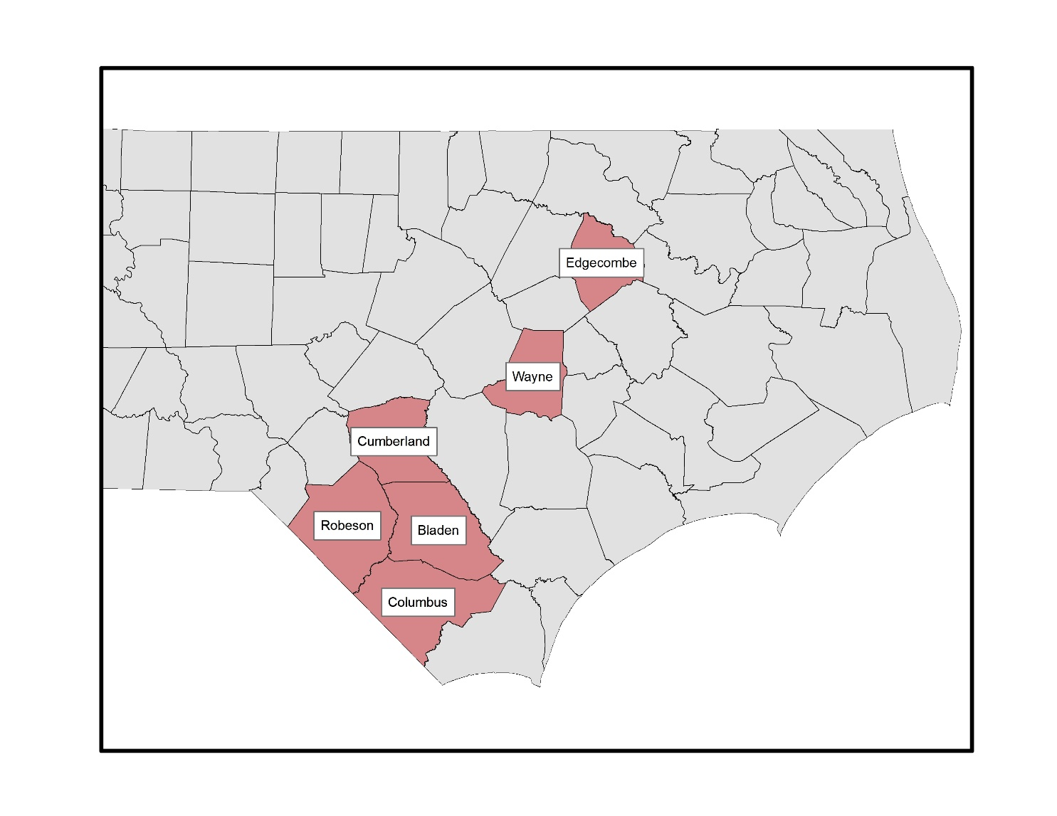
Figure 1: Most Impacted Counties
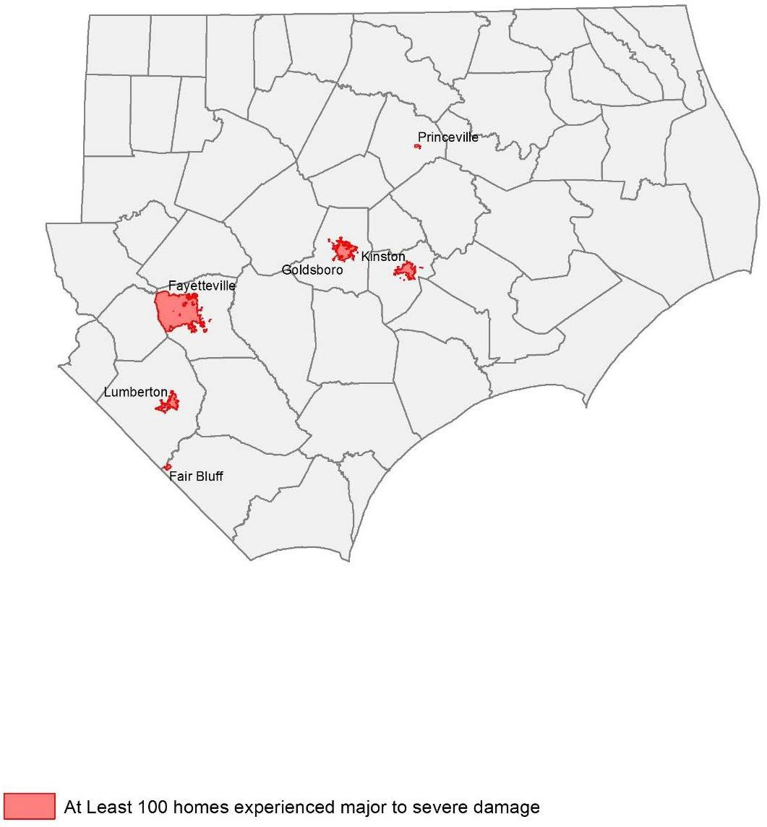
Figure 2: Most Impacted Communities

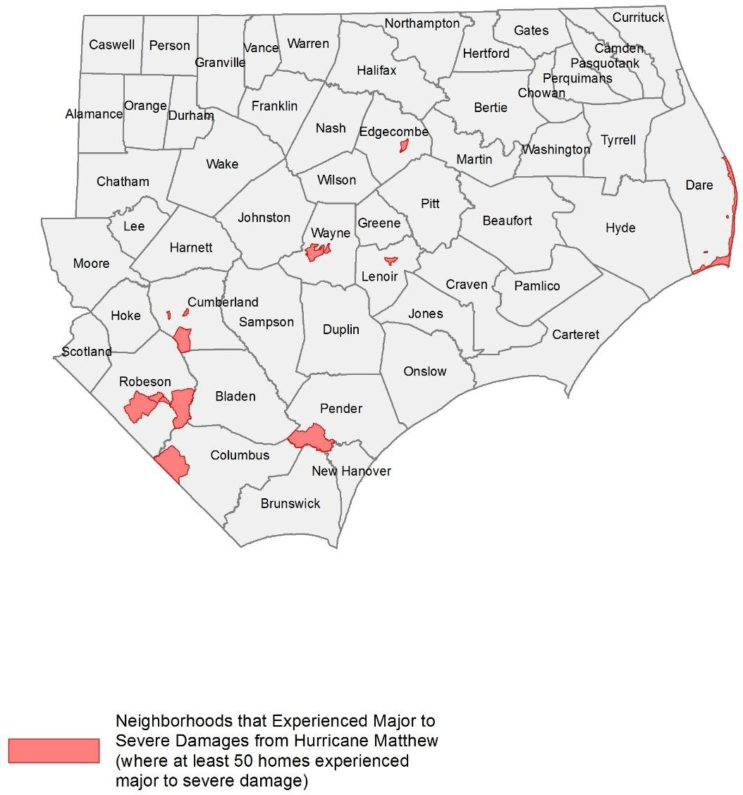
Severely Impacted Communities
Figure 3: Most Impacted Neighborhoods
Hurricane Matthew concentrated its damage within specific areas, in particular riverine communities already grappling with a heavy rain season. There are six towns we consider “severely impacted,” where more than 100 homes experienced major to severe damage. These communities are predominantly low- and moderate-income (LMI) and have a higher concentration of African American, Native American, and Hispanic residents.

Princeville – 367 homes had major to severe damage: The town of Princeville, with a population of 2,373, is located in Edgecombe County along the Tar River just south of Tarboro. It is a largely African American community (96% of its residents are African American) and is reportedly the oldest community settled by freed slaves in the US. It is also located in a floodplain that has experienced frequent and substantial flooding over the years. The community is a low-income community, with the median household income of $33,011. In addition to flooded homes, the school and fire station were reported as flooded.

Kinston – 181 homes had major to severe damage: The town of Kinston, with a population of 21,589, is located in Lenoir County along the Neuse River. The community is predominantly African American (67%), and most of its residents are low-income, with the median household income of $28,608. The town experienced substantial damage to its main business district, flooding many small businesses serving the community.

Lumberton – 876 homes had major to severe damage: The city of Lumberton, with a population of 21,707, is located in Robeson County along the Lumber River. A racially and culturally diverse county, where 33.8% of the population is African American, 12.4% Native American (the Lumbee Tribe), and 11% Hispanic/Latino. Most of its families are LMI, with a median household income of $31,899. The community experienced substantial flooding after Hurricane Matthew, particularly along Fifth Street, its main commercial corridor, and among its public housing residents, where almost 500 very low-income renters lost their homes.

Goldsboro – 251 homes had major to severe damage: The town of Goldsboro, with a population of 35,086, is located in Wayne County along the Neuse River. It is a diverse, LMI community, where roughly 53% of the population is African American, and the median income is $29,456. It is also an agricultural community, where substantial livestock was lost.

Fayetteville – 452 homes had major to severe damage: Fayetteville, located on the Cape Fear River in Cumberland County, is a densely populated city of 200,000. It is a middle-income community, with a median household income of $44,514, and is racially diverse, where 41% of the population is African American and 10% are Hispanic. The flooding in Fayetteville was concentrated in the downtown area and in subdivisions near the Little River tributary, where flooding was so severe many residents had to be rescued to evacuate.

Fair Bluff – 109 homes had major to severe damage: Fair Bluff is a small town located along the Lumber River in Columbus County. Given its small population of 1,181 households, it was devastated by Hurricane Matthew, where approximately 25% of all families were severely impacted. The community is racially diverse, with 38% of the population white and 60% African American, and the majority of families are very low-income, with the median household income at $17,008. Fair Bluff’s main commercial district was particularly impacted by the floodwaters.

Repairing Owner-Occupied Homes
The Unmet Needs Assessment examines the impact and unmet needs of homeowners using HUD’s own standard approach to analyzing housing damages, with slight modifications to the original plan based on available data.

The analysis uses the FEMA Individual Assistance (IA) data, SBA loan data to homeowners, and structural inspections performed by the State as of October 15, 2017. We determine the level of damage each property incurred using FEMA’s initial estimate of Real Property Loss and HUD’s guidance in FR-60120N-01. The damage categories range from 1 to 5; 1 being Minor-Low Damage and 5 being Severe Damage.

In total, 28,164 homeowners experienced some degree of damage to their homes; 2,569 homeowner families experienced major to severe damage. 78% of the total damages were to and 69% of the homeowners with major or severe damage were LMI.

Table 5: Damage Counts of Owner-Occupied Homes by Damage Category and Income of Homeowner Family
Damage Category | All Owners | Low and Moderate Income (LMI) Owners
Minor-Low | 22,795 | 18,128
Minor-High | 2,800 | 2,102
Major-Low | 1,581 | 1,121
Major-High | 830 | 550
Severe | 158 | 107
Total - All Damage | 28,164 | 22,011
Total - Major to Severe Damage | 2,569 | 1,780
Source(s): FEMA IA analysis effective 9/13/17

Because FEMA’s initial inspections have historically underestimated damage costs significantly, FEMA’s damage estimates are adjusted upwards based on the average SBA loan amount by damage category. For homes that received an SBA inspection, the damage costs are equivalent to that SBA inspection amount. For homes that did not receive an SBA inspection, damage costs are presumed to be the average SBA inspection amount for that damage category.

To estimate unmet needs, the Assessment subtracts the funds received from FEMA, SBA, and insurance from the damage costs. For homeowners that have flood insurance, the analysis assumes insurance covers 80% of the damage costs not covered by FEMA and SBA. The analysis also includes mitigation costs for homes that received major to severe damage, equivalent to 30% of damage costs. This reflects additional measures needed to ensure long-term sustainability of flooded homes.

The initial Unmet Needs Assessment examined what types of owner-occupied homes experienced major to severe damage. Approximately two thirds were single family structures, while the remaining one third were mobile homes.

Table 6: Owner-Occupied Housing Units that Experienced Major to Severe Damage by Structure Type
 | Count | Percent
Apartment | 1 | 0%
Boat | 1 | 0%
Condo | 4 | 0%
House/Duplex | 1,709 | 67%
Mobile Home | 831 | 32%
Other | 2 | 0%
Townhouse | 4 | 0%
Travel Trailer | 6 | 0%
(blank) | 11 | 0%
Total | 2,569 | 100%
Source(s): FEMA Individual Assistance data. Analysis effective 3/15/17

Rental Housing
Almost half of all the housing that withstood major to severe damage from Hurricane Matthew was rental housing. The storm caused severe damage or destroyed at least 2,388 occupied rental homes, with 83% of this damage occurring in the six most impacted counties. In particular, Lumberton experienced the greatest loss of rental housing, with 526 units impacted. This is followed by Fayetteville (283 units) and Princeville (211 units). Far more than owner-occupied homes, the vast majority (86%) of renters severely impacted by the storm were LMI.

Table 7: Damage Counts of Renter-Occupied Homes by Damage Category and Income of Renter Family
 | All Renters | Low and Moderate Income Renters
Minor-Low | 2,632 | 1484
Minor-High | 1,097 | 618
Major-Low | 963 | 543
Major-High | 1,244 | 701
Severe | 181 | 102
Total - All Damage | 6,117 | 3,448
Total - Major to Severe Damage | 2,388 | 1,346
Source(s): FEMA Individual Assistance data. Analysis effective 9/15/17

Of the rental units, seriously damaged by Hurricane Matthew, we see approximately half were apartment buildings, while 40% were single family homes or duplexes. A significant number of rented mobile homes were also flooded (13% of all major to severe damage).

Table 8: Rental Housing Units that Experienced Major to Severe Damage by Structure Type
 | Count | Percent
Apartment | 1,084 | 45%
Assisted Living Facility | 4 | 0%
Condo | 13 | 1%
House/Duplex | 955 | 40%
Mobile Home | 308 | 13%
Other | 5 | 0%
Townhouse | 8 | 0%
Travel Trailer | 1 | 0%
Unknown | 10 | 0%
Total | 2,388 | 100%
Source(s): FEMA Individual Assistance data. Analysis effective 9/15/17

Other Rental Housing
The State of North Carolina conducted outreach to housing providers in impacted areas to determine the damages, displacement, and unmet needs of subsidized and supportive rental housing. This included emails, a survey, and follow-up phone calls that took place between March 2 and March 20, 2017. NCEM contacted multiple Public Housing Authorities (PHAs), the State Housing Finance Agency, State Community Development Block Grant Disaster Recovery (CDBG-DR) Communities, and North Carolina’s Department of Health and Human Services (DHHS) to quantify the disaster’s results, understand how it has impacted the families served by the agencies, and determine what needs are still unmet. The following is a summary of these communications. This information will be updated as more details become available to include any data from the most impacted counties and communities.

Public Housing
The State contacted PHAs in the most impacted areas, including Greenville Housing Authority, Pembroke Housing Authority, Lumberton Housing Authority, the Housing Authority of the City of Rocky Mount, and Wilmington Housing Authority. The survey asked which properties/units (if any) were damaged and where they are located; how many people were displaced and if they have returned; what the overall damage cost is; whether the units have been repaired; and if any costs or repairs are remaining. Information was received by four of the five housing authorities, which resulted with Wilmington having no damage, Greenville and Rocky Mount having minor damage, and Lumberton experiencing severe damage. Pembroke is calculating the overall costs and will provide the information when available. Each of these facilities will be eligible for FEMA Public Assistance (PA) and will have, in addition to unmet needs, a 25% local match requirement that will need to be met and is part of the State’s unmet need.

Table 9: Survey Results from Public Housing Authorities as of March 15, 2017
City/County | What are the overall damage costs? | What amount of those costs was/is/will be covered by insurance and/or other sources? | Remaining Costs | Are there repairs that still need to be made?
Lumberton | $8,000,000 +/- | $3,000,000 +/- | Yes | Yes, $5,200,000
Greenville | ~$8,000-  $10,000 | None | No | No
Rocky Mount, Edgecombe, Nash Counties | $6,000 | $2,020 | $3,980 | Interior water damage not covered by insurance - repairs are being completed by force labor.
Wilmington | 0
Pembroke | Unknown
Source: Survey results from PHA outreach, effective 3/10/17.

The Lumberton Housing Authority had, by far, the most extensive damage totaling an estimated $8 million, with approximately $5 million in remaining unmet need. There are currently 264 families displaced, currently living with family members or using housing vouchers, who have yet to move back into their homes as all units are still in the process of being repaired.

In addition to Lumberton, Greenville and Rocky Mount had damages with a combined total of $16,000, and Rocky Mount still has $3,980 costs remaining. In Greenville, 105 Public Housing families were displaced; however, all of the units have since been repaired, and all families have moved back.

The housing programs within this Action Plan will address remaining unmet needs, after taking into account funds available from insurance and other sources, to restore public housing and return families to their homes.

Other Subsidized Housing
Similar to the PHAs, the State sent a survey to the North Carolina Housing Finance Agency (NCHFA), USDA, and other housing providers in impacted communities, to assess damages and unmet needs due to Hurricane Matthew. According to the NCHFA, 397 units were damaged. The agency believes they have sufficient funds to make the needed repairs using insurance proceeds. However, if there are instances where subsidized affordable rental housing has remaining unmet needs, their recovery will be given priority in the rental housing programs outlined in this Action Plan.

Table 10: NC Housing Finance Agency Properties Damaged by Hurricane Matthew
Name | City | County | Units
Prince Court Apartments | Princeville | Edgecombe | 30
Asbury Park Apartments | Princeville | Edgecombe | 48
Holly Ridge Apartments | Lumberton | Robeson | 110
Mount Sinai Homes | Fayetteville | Cumberland | 99
ARC/HDS Northampton Co GH | Woodland | Northampton | 6
First Baptist Homes | Lumberton | Robeson | 40
Cypress Village | Fair Bluff | Columbus | 40
Glen Bridge | Princeville | Edgecombe | 24
Source: North Carolina Housing Finance Agency, effective 3/10/17

The State also sent surveys to CDBG-DR Entitlement Communities in the impacted areas, and received responses back from Fayetteville and Rocky Mount. In Fayetteville, a reported 952 rental properties were severely damaged, and 671 remain unrepaired. The City cited a need for substantial mitigation and resiliency measures, as many damaged properties were severely damaged, exceeding 50% value. The city is currently determining the costs of repair and unmet needs, after factoring in other federal assistance and insurance proceeds. Rocky Mount reported 340 rental homes damaged and are currently determining repair costs and unmet needs.

Permanent Supportive Housing
The State contacted North Carolina’s to understand the impact Hurricane Matthew had on homeless shelters, transitional housing facilities, or any housing facilities that serve those with disabilities or supportive housing damages. They were asked what the total damaged properties were, how many people were displaced, and if they are still displaced.

The DHHS manages the delivery of health- and human-related services for all North Carolinians, especially our most vulnerable citizens – children, elderly, disabled, and low-income families. DHHS has not yet reported damage to any permanent supportive housing or service facilities, while the State is currently assessing unmet needs.

In addition to restoring existing permanent supportive housing and services, this disaster event likely calls for new services to families and residents who have not historically been served by DHHS. For many very low-income owners and renters, older adults, and persons with disabilities, the impact of severe flooding can lead to a variety of needs. For many families, the loss of their homes; lost wages due to job interruption; limited access to transportation; and the stress associated with living in overcrowded or unsafe conditions due to “doubling up” or remaining in their damaged homes out of necessity warrants additional services in the form of emergency housing assistance, mental health support services, homeless prevention services, and health and transportation assistance. The State will address these needs, working closely with local communities, with emphasis on assisting families currently displaced or at risk of displacement.

Housing Unmet Need Summary
The State of North Carolina has taken multiple steps in estimating the unmet housing needs resulting from Hurricane Matthew. This includes conducting field inspections of damaged homes; analyzing and updating FEMA IA data, SBA loan information, and insurance information; conducting county-led planning efforts; and surveying PHAs and other housing providers to determine what financial needs will be required to restore our homes and neighborhoods.

This estimate accounts for the costs to repair damaged homes that are owned or rented by LMI persons. The State estimates that, to assist 7,831 LMI homeowners, it would need an additional
$104,081,224 and, to assist 3,448 LMI renters, it would need an additional $68,912,793, which includes providing required mitigation for these homes to avoid future losses, resulting in an additional $172,994,017 in unmet need.

There are additional needs beyond repairing damaged homes. The State has been proactive in initiating outreach with the most impacted communities to determine the cost benefit of repairing homes that experience repetitive flood loss and/or are located in flood-prone areas versus the cost of acquiring these properties and relocating these families to safer ground. This is an ongoing effort, and as of October 15, 2017, the State estimates an additional need of $260,971,916 to elevate homes, or acquire and demolish homes, and then relocate families to new housing.

Additionally, the State will require that all new construction and repair of substantially damaged homes meet, at a minimum, Advisory Base Flood Elevations. All homes located in the 100-year floodplain that receive assistance for reconstruction or repair of substantial damage shall be elevated to at least two-feet above Base Flood Elevation. The method of determining elevation assistance and cost-reasonableness will be outlined in detail in the ReBuild NC Single-Family Housing Manual.

The estimate also accounts for the repair of the public housing units that were severely damaged ($15,200,000) as well as an increased estimate of need for support services for persons needing assistance relating to the homeless, families living in poverty, persons needing medical or mobility assistance due to disabilities, permanent supportive housing needs, persons who are currently displaced and need additional housing assistance, and services to older residents especially challenged by displacement ($17,371,361).

Finally, the unmet needs factors in a preliminary estimate of subsidies needed for LMI homeowners who will expect to see their insurance premiums increase and who will not be able to afford flood insurance once their homes are rebuilt ($8,800,000). In addition, the estimate includes the providing funds to address shortfalls for homeowners who sell their homes to the State through a buyout program and, because of the cost of new housing, will have a gap in what the home sale price was and the cost to move into the new residence ($10,077,200).

These estimates are based on existing data; as the State and local planning efforts continue to work with the most impacted communities, these figures may be adjusted based on better data and feedback.

Table 11: Housing Unmet Needs
Owner - Repair Damages | $104,081,224
Renter - Repair Damages | $68,912,793
Elevation/Buyout | $260,971,916
Public Housing | $15,200,000
Supportive Services | $17,371,361
Homeowner Assistance Program | $10,077,200
Insurance Subsidies for LMI Owners | $8,800,000
TOTAL | $485,414,494
Source(s): FEMA Individual Assistance, Small Business home loan data; survey responses from State and local housing providers and agencies; analysis effective 9/13/17

Vulnerability of the Most Impacted Communities
As was articulated in the initial Action Plan, North Carolina’s approach to recovering its homes and neighborhoods after Hurricane Matthew is to strategically examine where the damage occurred and then focus its recovery efforts in those areas, paying special attention to the housing types, household types, and special needs of these unique communities. The allocation of funds in the Action Plan Amendment, shows North Carolina’s commitment to the most vulnerable communities. The original analysis remains unchanged, and the use of the metrics in this analysis is shaping program design.

Families and individuals with social vulnerabilities oftentimes face greater challenges in evacuating during a disaster event, including finding suitable and affordable housing if displaced, and being able to afford making the repairs needed so that they can return to their homes. To address this issue, North Carolina analyzed IA applications to determine which neighborhoods withstood the brunt of Hurricane Matthew’s impact and then examined the socio-economic and demographic profiles of these neighborhoods.

For the purpose of this study, we consider a neighborhood to be “most impacted,” if at least 25 homes experienced major to severe damage (i.e. homes with a category 3, 4, and 5 damage level, or Major-Low, Major-High, and Severe damage), or where at least 5% of all homes had major to severe damage. The analysis defines vulnerable populations as older residents (65 years old or older), persons with disabilities, homeless or individuals at risk of homelessness, neighborhoods where at least 50% of households earn less than 80% Area Median Income (AMI) (LMI neighborhoods), households with English language barriers, and households who do not own personal vehicles. This data is publicly available using the 2010-2014 American Community Survey (ACS) and is collected at the Census Tract-level (aligned with our definition of a neighborhood). To determine if a Census Tract has a disproportionate number of residents or families with social vulnerability, we compare the figures to state averages, or use HUD-standard benchmarks (i.e. majority of households are low-income, for example).

Based on this analysis, there are five neighborhoods located in Lumberton, Princeville, Fayetteville, and Fair Bluff that were severely impacted (where at least 100 homes experienced major to severe damage). Of these five neighborhoods, an impacted family is more likely to be low-income, minority, and without a family car than what is typical in the State. Among the other impacted neighborhoods, there are pockets of damage where residents have English language barriers, disabilities, and are also low-income and minority neighborhoods. There are no substantially impacted neighborhoods with a disproportionate number of older residents. Even so, North Carolina understands that many older households have substantial rebuilding challenges, and their needs will be addressed through local outreach efforts and prioritization among programs.

Additionally, North Carolina is committed to rebuilding damaged communities in a manner that furthers fair housing opportunities to all residents. For this reason, the Assessment identifies which impacted neighborhoods have a disproportionate concentration of minority populations. As these communities rebuild, the State will focus its planning and outreach efforts to ensure that rebuilding is equitable across all neighborhoods, which may include providing affordable housing in low-poverty, non-minority areas where appropriate and in response to natural hazard-related impacts.

Table 12: Most Impacted Neighborhoods and Social Vulnerability [Y = Disproportionate Social Vulnerability]
Town | County | Neighborhood | Owner | Renter | Total | Disability | Language Barriers | No Access to Vehicle | Minority | LMI
Lumberton | ROBESON | 37155960801 | 150 | 320 | 470 | N | N | Y | Y | Y
Princeville | EDGECOMBE | 37065020900 | 156 | 211 | 367 | N | N | Y | Y | Y
Lumberton | ROBESON | 37155960802 | 125 | 144 | 269 | Y | N | Y | Y | Y
Fayetteville | CUMBERLAND | 37051003203 | 26 | 107 | 133 | N | N | N | Y | N
Fair Bluff | COLUMBUS | 37047930600 | 50 | 59 | 109 | Y | N | Y | N | N
Fayetteville | CUMBERLAND | 37051000200 | 53 | 40 | 93 | Y | N | Y | Y | Y
Rural | WAYNE | 37191000901 | 44 | 48 | 92 | N | Y | N | N | N
Goldsboro | WAYNE | 37191001500 | 24 | 61 | 85 | Y | N | Y | Y | Y
Rural | ROBESON | 37155961802 | 16 | 61 | 77 | Y | N | N | Y | Y
Rural | DARE | 37055970502 | 47 | 28 | 75 | N | N | N | N | Y
Rural | CUMBERLAND | 37051003001 | 52 | 16 | 68 | N | N | N | N | N
Rural | PENDER | 37141920502 | 41 | 24 | 65 | N | N | N | N | N
Kinston | LENOIR | 37107010800 | 2 | 62 | 64 | Y | N | N | Y | N
Rural | ROBESON | 37155961500 | 47 | 14 | 61 | N | N | N | N | N
Hope Mills | CUMBERLAND | 37051001601 | 32 | 17 | 49 | N | N | N | N | N
Fayetteville | CUMBERLAND | 37051003800 | 4 | 42 | 46 | Y | N | Y | Y | Y
Lumberton | ROBESON | 37155961302 | 23 | 23 | 46 | N | Y | N | Y | N
Rural | ROBESON | 37155961601 | 35 | 10 | 45 | N | N | N | Y | N
Goldsboro | WAYNE | 37191001400 | 12 | 31 | 43 | N | N | Y | Y | Y
Rural | EDGECOMBE | 37065021500 | 34 | 8 | 42 | N | N | N | N | N
Fayetteville | CUMBERLAND | 37051001400 | 22 | 20 | 42 | Y | N | N | Y | Y
Goldsboro | WAYNE | 37191002000 | 13 | 27 | 40 | N | N | Y | Y | Y
Rural | WAYNE | 37191001101 | 27 | 13 | 40 | N | N | N | N | N
Rural | PENDER | 37141920501 | 31 | 8 | 39 | N | Y | N | Y | N
Rural | BLADEN | 37017950100 | 34 | 4 | 38 | Y | N | N | N | N
Seven Springs | WAYNE | 37191000602 | 22 | 12 | 34 | N | Y | N | Y | N
Kinston | LENOIR | 37107010200 | 7 | 26 | 33 | Y | N | Y | Y | Y
Rural | SAMPSON | 37163971000 | 30 | 3 | 33 | N | Y | Y | Y | N
Whiteville | COLUMBUS | 37047930900 | 6 | 26 | 32 | Y | N | Y | Y | Y
Lumberton | ROBESON | 37155960701 | 29 | 2 | 31 | N | Y | N | Y | Y
Kinston | LENOIR | 37107011300 | 23 | 7 | 30 | Y | N | N | N | N
Windsor | BERTIE | 37015960400 | 18 | 12 | 30 | Y | N | Y | Y | N
Rural | CUMBERLAND | 37051001903 | 0 | 29 | 29 | N | N | N | N | N
Tarboro | EDGECOMBE | 37065021000 | 10 | 19 | 29 | N | N | Y | Y | Y
Rural | CRAVEN | 37049960200 | 24 | 3 | 27 | Y | N | N | N | N
Rural | LENOIR | 37107011300 | 15 | 12 | 27 | Y | N | N | N | N
Rocky Mount | EDGECOMBE | 37065020400 | 0 | 27 | 27 | N | N | Y | Y | Y
Rural | WAYNE | 37191001000 | 24 | 3 | 27 | N | Y | N | N | N
Fayetteville | CUMBERLAND | 37051000800 | 0 | 26 | 26 | N | N | N | N | N
Rural | CUMBERLAND | 37051001400 | 6 | 19 | 25 | Y | N | N | Y | Y
Rural | GREENE | 37079950102 | 20 | 5 | 25 | Y | N | N | Y | Y
Rural | MOORE | 37125950501 | 14 | 11 | 25 | N | N | N | N | N
Source: Source(s): FEMA Individual Assistance data dated 1/16/17; American Community Survey 2010-2014; analysis effective 3/15/17.

The challenges associated with vulnerable populations can be categorized as follows:

Evacuation Needs – Many low-income families lack the financial capacity to evacuate during a storm event, with limited resources to pay for alternative lodging. Many do not own a vehicle and simply cannot evacuate without assistance. Similarly, older residents and persons with disabilities may not be able to evacuate due to mobility challenges and the need to be near their existing medical care. There are also residents who are unaware of impending disasters due to language barriers and social isolation from to lack of technology. These individuals and families often risk their safety, and even their lives, due to their inability to get out of harm’s way as storm approaches. Although the storm has since passed, North Carolina acknowledges that many impacted neighborhoods are at continued risk of flooding in the event of a future storm and are using this flood event to understand what the evacuation needs may be for the neighborhoods hit hardest by flooding.

Displacement and Temporary Housing Needs – The greatest challenge most low-income families face immediately after evacuation is finding suitable temporary housing that is affordable and located near their jobs and basic services. Many are not able to pay for two homes (a mortgage on their damaged home and renting a new home) leading to severe debt or households “doubling up” with other family members. Even more challenging, many older adults and persons with disabilities have mobility challenges and medical needs, and moving far from their existing support network can lead to a sedentary, unhealthy living environment, or worse, a medical crisis. Very low-income residents, persons with disabilities, and many older adults impacted by Hurricane Matthew have supportive service needs like medical care, access to medicine, transportation assistance, and financial support during the rebuilding process.

Rebuilding Needs – The long-term goal of North Carolina is to safely return families and individuals to their communities and homes. The cost of repair is a major issue for low-income homeowners, particularly for those whose homes were devastated by flooding and whose insurance did not cover the damages. Many low-income residents cannot afford to move and cannot afford to rebuild. What often happens is that they remain in their damaged home, living in an environment that poses health risks like mold and structural damage. Renters may face even greater challenges, since it is up to the landlord to rebuild or not, and if the rental income was insufficient to encourage rebuilding, the landlord may choose to keep the insurance payout and not rebuild. This leads to long-term displacement of renters, which can be particularly challenging in smaller communities where there is a limited supply of rental units.

North Carolina will address these challenges by tailoring its housing recovery programs to the communities most impacted while providing a suite of supportive services and financial assistance to low-income families and other vulnerable populations struggling to rebuild their lives.

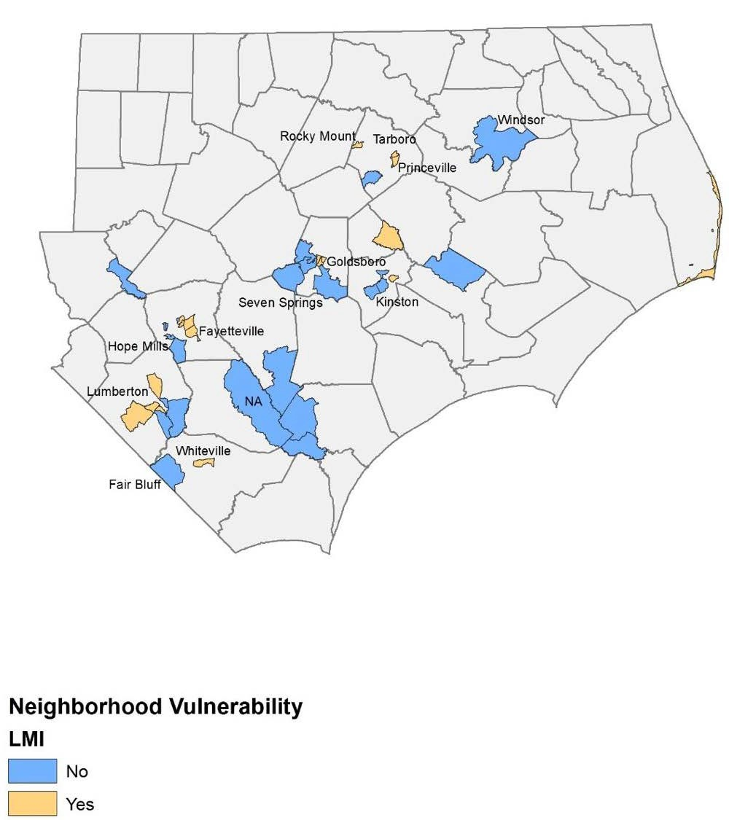
Figure 4: Most Impacted Neighborhoods that are Low- and Moderate-Income
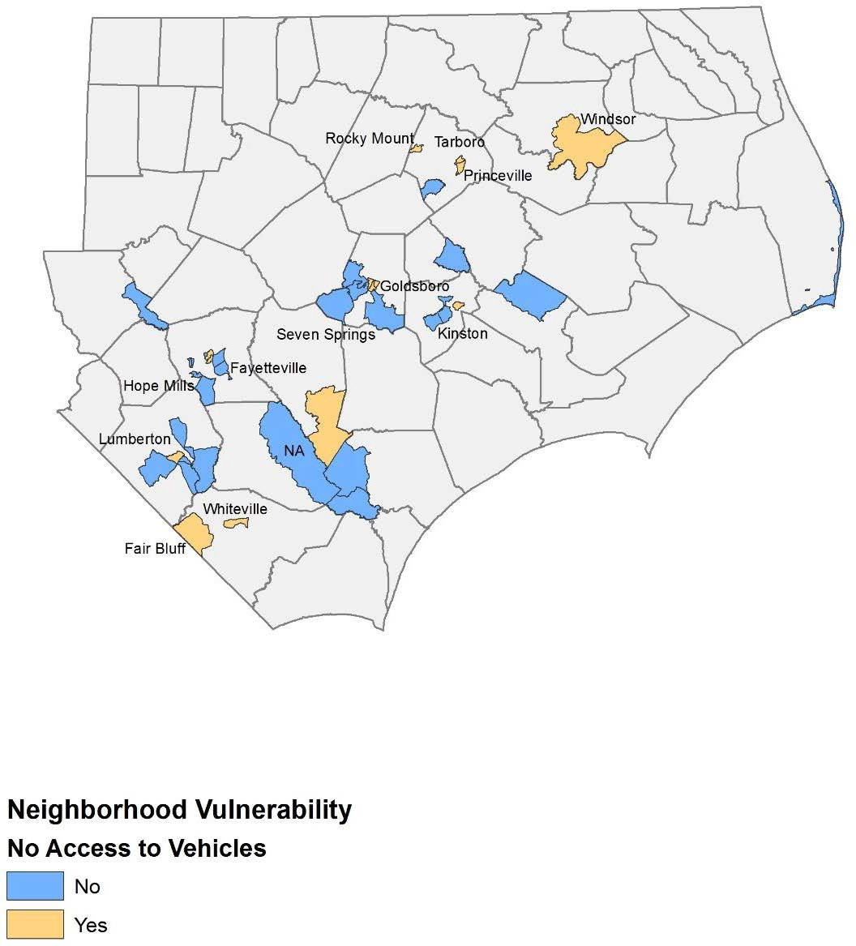
Figure 5: Most Impacted Neighborhoods with a Disproportionate Concentration of Households without a Car
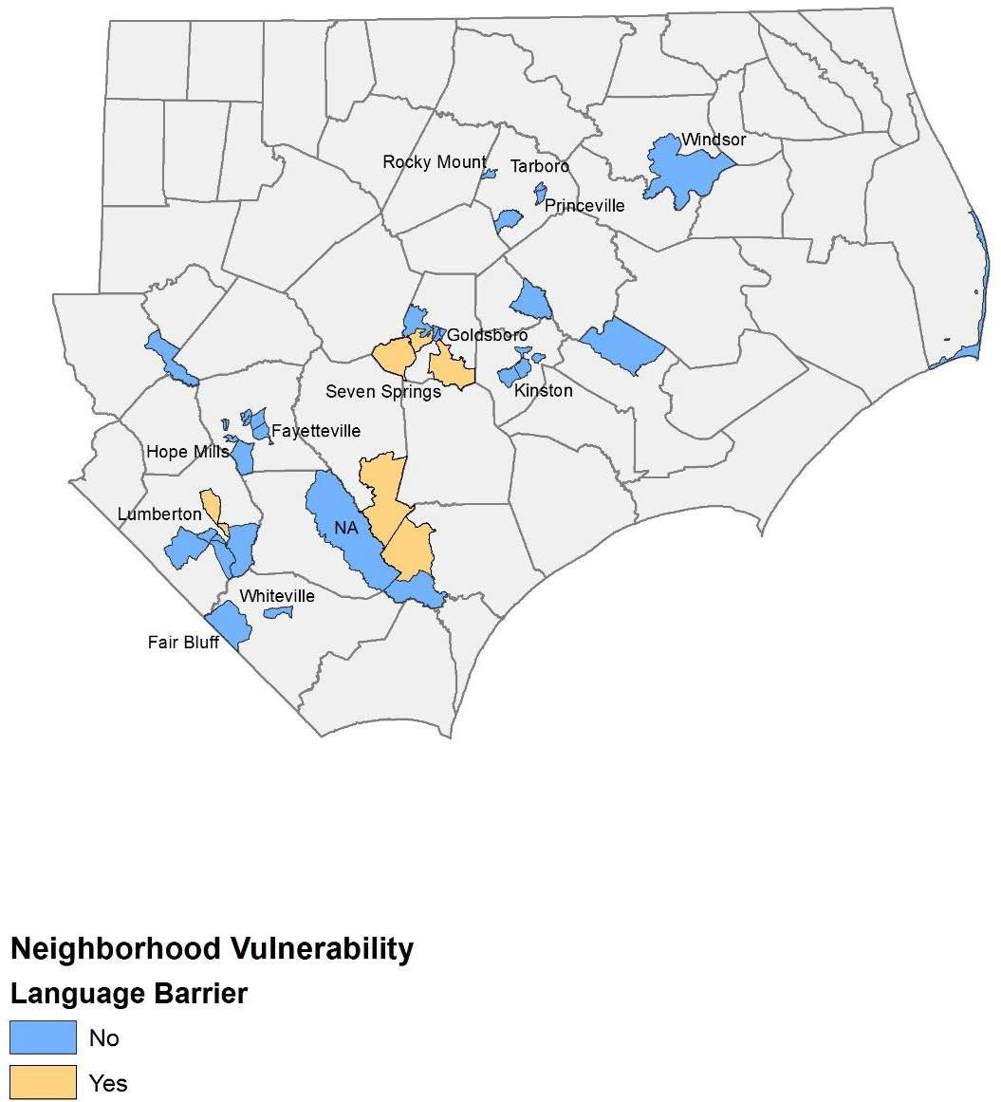
Figure 6: Most Impacted Neighborhoods with a Disproportionate Concentration of Residents who Maintain Language Barriers
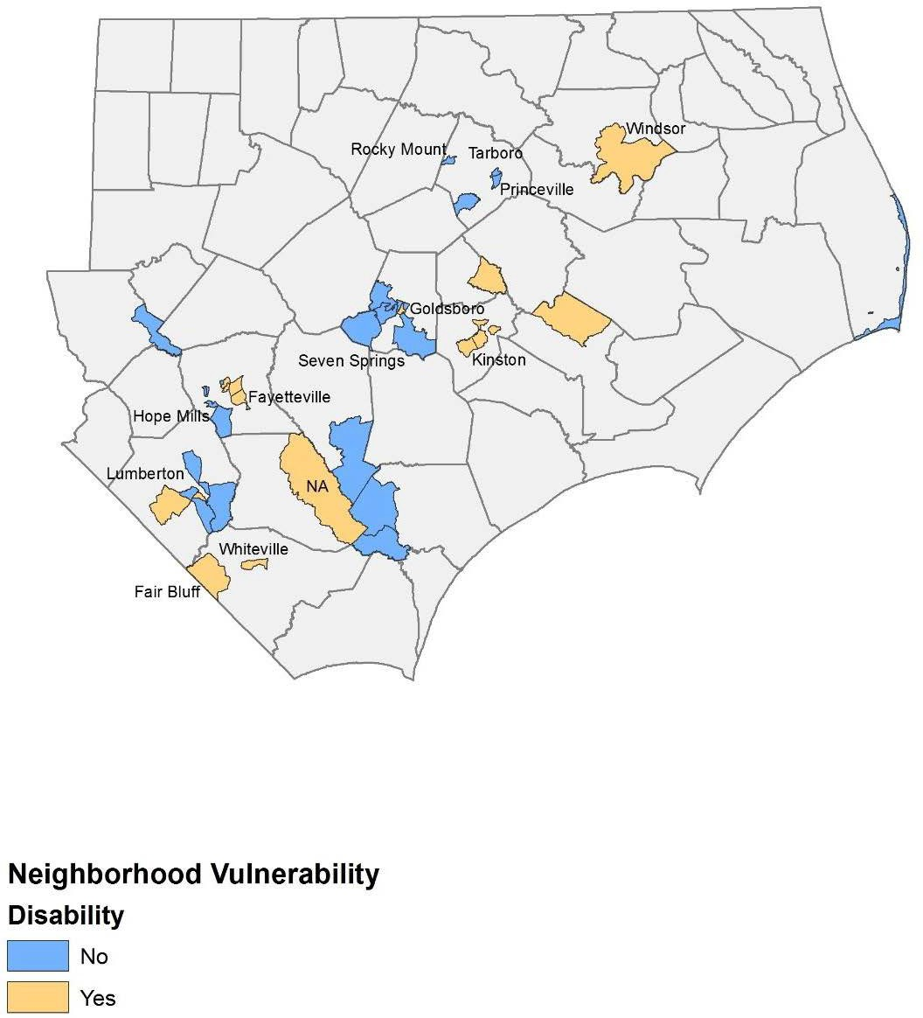
Figure 7: Most Impacted Neighborhoods with a Disproportionate Number of Residents with Disabilities
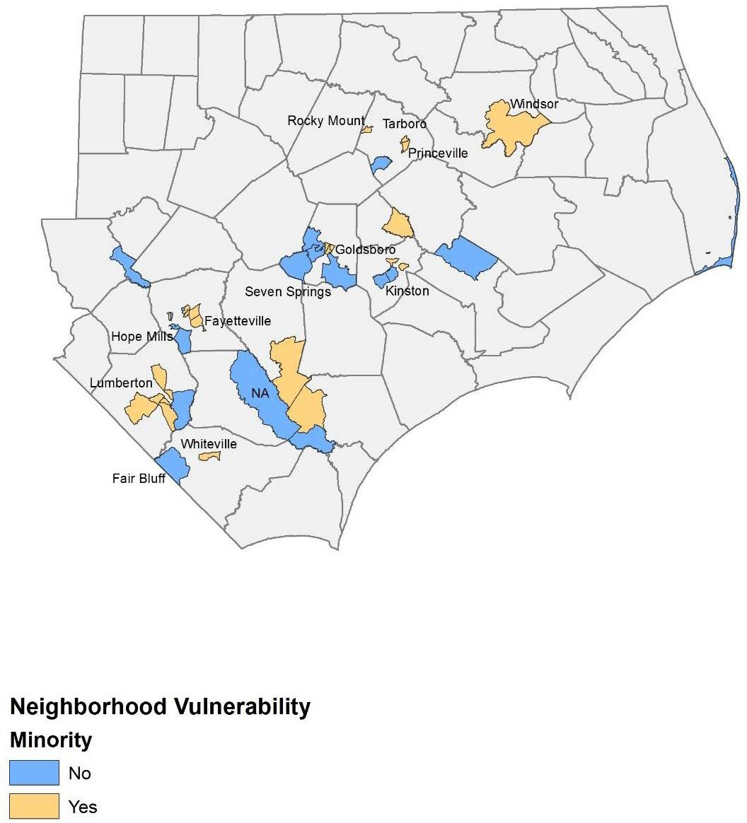
Figure 8: Most Impacted Neighborhoods with a Disproportionate Concentration of Minority Populations

Economic Recovery
As was shown in the initial Unmet Needs Assessment, Hurricane Matthew caused extensive damage to small businesses in eastern and central North Carolina with most businesses located in rural counties leaving a large unmet need. That analysis continues to be accurate as, to date, neither the SBA nor USDA has addressed the recovery needs following Matthew. Small businesses are the economic backbone of most towns in North Carolina, and these businesses are where residents shop for groceries, buy gas, dine, lodge, and acquire retail and other services that define the community. Many businesses also support and rely on the state’s agricultural economy, including family farms and agribusinesses, for survival. As was shown in the initial Action Plan, a key industry sector that was impacted by Matthew was the State’s agricultural economy. The State still estimates that in part due to SBA loan denials and lack of dedicated recovery funding from the USDA for the farming community, the agricultural and small business community continues to have a $263 million unmet need.

The most recent data from the SBA, continues to show that the counties most impacted by Matthew have the highest number of per county applications for assistance, and 95% of these businesses have less than 100 employees. Based on the September 2017 data on business related loans programs, small businesses in North Carolina are seeing more loans denied than approved, with 645 applications approved and 752 denied.

In addition to the businesses who were denied an SBA loan, there were 7,740 businesses who were referred to the program but never applied. The State, in consultation with community leaders and through the planning process, believes that many of these businesses, while having unmet recovery need, did not submit the loan package to SBA because they knew they would not qualify.

A primary component of North Carolina’s economic strength is its agricultural sector. The USDA declared 79 of the State’s 100 counties as having significant agricultural damage from Matthew and the North Carolina Department of Agriculture & Consumer Services reported that 48 counties were seriously impacted, with these counties accounting for 71% of the total farm cash receipts and representing $9.6 billion of the $13.5 billion total. The Department assessed that Matthew had a $422 million impact to major commodities and, because agriculture production is seasonal, many farms lost an entire year’s crop from Matthew and, along with it, a potential loss of markets. As a result, the State is continuing to assess agricultural recovery throughout the 2017-2018 growing season, but based on current information, there is substantial evidence that small agricultural businesses were substantially impacted, losing their anticipated 2017 earnings in the floodwaters. Without being fully compensated from USDA or SBA, they represent a large, unmet need.

Based on information from State Agencies and SBA, the current estimated unmet need for small businesses, including the agricultural sector, is $263,435,519. This assessment is based on a conservative approach of taking (1) 10% of the business losses for firms that were referred to FEMA who did not submit an application for an SBA, (2) all businesses that applied for an SBA loan but were denied, (3) an assumption that SBA business loans cover 80% of unmet needs, and (4) State estimates of ongoing agricultural losses that were not addressed by USDA through its programs. The data highlights that the most vulnerable businesses in North Carolina continue to be small businesses in rural counties, within the service, agriculture, and retail industries. The fact that these firms are located within or connected to the residential areas in the hardest hit counties amplifies the importance of obtaining funding to address the unmet needs of the business and agricultural sector as the services, local employment, and stability provided by small businesses are critical factors in ensuring that overall community and regional recovery will occur.

Table 13: Unmet Business Needs
 | Business Loans Denied | Business Loans Approved | Referrals only | Average Loan Amount | Estimated Damages | Amount Received | Estimated Unmet Need
Total | 752 | 645 | 25,064 | $92,981 | $288,186,019 | $24,750,500 | $263,435,519
Source: US SBA, 09/18/17

Public Infrastructure and Facilities
As was shown in the State’s initial Action Plan, Matthew devastated public infrastructure in eastern and central North Carolina. The State recognizes that the primary funding source used to repair and restore damaged public infrastructure is FEMA’s PA program. Since the initial Action Plan was published, the State has completed its 50-county comprehensive, ground up, community planning process. As a result, infrastructure-related projects will be implemented that were developed from these plans.

FEMA, through its PA program, assists communities rebuild following a disaster. Table 14 shows the current FEMA PA obligations for Matthew. In total, over 424 applicants now have eligible PA projects. While the amount of funding and number of applicants in the FEMA PA program is expected to grow as of October 10, 2017, these applicants had $292,780,270 obligated to PA projects, an increase of $279,253,605 since the initial Action Plan was published. As was shown in the State’s initial Action Plan, and remains true for this Amendment, the State estimates that once all FEMA PA projects are accounted for, the PA program will exceed $400 million, with over $101 million in match required.

Table 14: FEMA PA Obligations by Category
FEMA Category | Category | Project Obligations (Project Worksheets (PWs)) |  | Match Requirements
 |  | 100% PW | Estimated | Current | Estimated
Debris Removal | A | $43,520,496 | $46,648,598 | $10,880,124 | $11,662,150
Emergency Protective Measures | B | $54,284,215 | $55,465,188 | $13,571,054 | $13,886,297
Roads & Bridges | C | $43,792,986 | $116,750,334 | $10,948,246 | $29,187,584
Water Control Facilities | D | $17,304,456 | $10,634,800 | $4,326,114 | $2,658,700
Public Buildings and Contents | E | $35,885,478 | $74,620,505 | $8,971,370 | $18,655,126
Public Utilities | F | $47,524,289 | $48,290,124 | $11,881,072 | $12,072,531
Parks, Recreational, Other Facilities | G | $50,468,351 | $53,932,676 | $12,617,088 | $13,483,169
FEMA PA Total |  | $292,780,270 | $406,342,226 | $73,195,067 | $101,585,557
FEMA PA Data: October 10, 2017

In addition, to the PA program the State anticipates receiving $100 million in Hazard Mitigation Grant Program (HMGP) funding with FEMA providing $75 million and the State required to provide $25 million. The State will use its HMGP allocation to buyout and acquire homes turning them into greenspace. As a result, the match required for both the FEMA PA and HMGP programs the current estimate for all FEMA programs exceeds $107 million.

As was disclosed in the original Action Plan, all infrastructure related projects will refer to the Federal Resource Guide for Infrastructure Planning and Design: http://portal.hud.gov/ hudportal/documents/huddoc?id=BAInfra ResGuideMay2015.pdf.

The following sections provides more information on unmet public infrastructure and facilities service to address community recovery needs.

Community and Supportive Facilities
As was documented in the State’s original Action Plan, some public facilities that were damaged will be repaired using FEMA PA funds. However, State facilities that provide social, community, and health (including mental health) services to support Matthew also incurred unmet needs that are not eligible for FEMA PA program funds. Through local outreach and needs assessments, the State continues to estimate an additional unmet need of $45.4 million to address and pay for these services and facility upgrades.

Dams and Levees
As was documented in the State’s original Action Plan, North Carolina has the largest number of dams in the nation with 1,200 high hazard dams that could potentially endanger lives and property if they fail. North Carolina’s Division of Energy, Mineral, and Land Resources reported that 20 dams were breached and 46 additional dams damaged as a result of Matthew, including the levee protecting the Town of Princeville, which resulted in millions of dollars in damages while other dams threatened more than 500 structures and residences.

North Carolina’s dam/levee work, which represents an unmet need of $38 million, will ensure the structures admitted under the United States Army Corps of Engineers (USACE) P.L. 84-99 are accredited under the FEMA National Flood Insurance Program (NFIP). The State will maintain file documentation of a risk assessment prior to flooding the flood control structure. That the investment includes risk reduction measures.

Department of Transportation (DOT)/HUD/Federal Highway Association (FHWA) Transportation Facilities and Infrastructure
As was shown in the State’s original Action Plan, North Carolina’s road system was heavily impacted by Matthew. An important component of the national disaster response plan is the integration and delineation of how FEMA and US DOT provide funding to states to address storm- related repairs to road systems. As a result of Matthew, approximately 42,000 miles of roads needed to have either debris removal, emergency protective measures, and or specific site repairs. These activities will require the State to provide matching and, as disclosed in the initial Action Plan, represent an unmet need of $52.6 million dollars.

USDA / FSA Disaster Grant Programs
As was shown in the State’s original Action Plan and highlighted in the Economic Recovery section, Hurricane Matthew caused substantial damage to North Carolina’s rural areas. This included the loss of field crops and livestock who perished in the floodwaters, causing environmental hazards in the streams, ponds, and other bodies of water. The State, working with the USDA, continues to estimate an unmet need of $177.7 million for USDA related activities including clean-up efforts and restoration of watersheds that are tied to Matthew.

Environmental Protection Agency (EPA) – Drinking Water and Wastewater Repair and Mitigation
As was highlighted in the State’s original Action Plan, since the publication of the plan, the State has continued to work with the EPA and FEMA, to address the substantial unmet needs for the repair and mitigation of the water and wastewater treatment systems that were impacted by Matthew. Even after taking into account opportunities to restore and mitigate these systems with FEMA PA funds the State continues to have an unmet need of $274 million dollars.

National Guard Facilities and Equipment
The National Guard plays a vital and critical role in disaster recovery during the initial response period, providing emergency response functions (ESFs), helping citizens to safe ground, and securing assets. Its staging facilities and equipment must be maintained. Matthew impacted five facilities that will require a match that represents an unmet need of $730 thousand.

Table 15: Infrastructure Unmet Need
 | Unmet Need
FEMA PA and HMGP Match (estimate) | $101,585,557
Repair health care, daycare, and other supportive facilities with remaining unmet needs (after subtracting FEMA and insurance) | $45,370,264
Other Federal Agencies
USACE - Levee and Dam Repair Safety | $38,132,675
DOT/HUD/FHWA - pavement, storm pipes, highway embankment | $52,586,192
USDA /FSA Disaster Grant Programs | $177,663,583
EPA - Drinking Water and Waste Water Repair and Mitigation | $274,481,000
National Guard | $734,000
TOTAL | $543,597,450

The State recognizes that the data collection and documentation of community infrastructure and public facilities needs is ongoing at this stage in the State’s recovery process. In addition to the documented costs in from Federal sources with the completion of the State’s community planning effort, additional recovery related projects will be implemented that represent an unmet need for infrastructure projects. The infrastructure projects are contained in each of the 50 county plans that were submitted to the State in the summer of 2017 and are shown on the rebuild.nc.gov website at https://www.rebuild.nc.gov/resiliency/hurricane-matthew-resilient-redevelopment-plans. As a result of the large unmet need in this program area, the State will need to maximize all funding sources and obtain additional resources to address this program area’s unmet need. As a result, the State may need to modify funding levels for sub-programs within this CDBG-DR allocation.

This page intentionally left blank.

Planning, Coordination, and Community Outreach Needs
The State’s initial Action Plan highlighted the robust planning effort in response to the unmet needs resulting from Hurricane Matthew. In addition to the Action Plan process, the North Carolina General Assembly established the North Carolina Resilient Redevelopment Planning (NCRRP) program as part of the 2016 Disaster Recovery Act (Session Law 2016-124). This effort was funded by the State and did not use CDBG-DR funds. North Carolina Emergency Management served as the coordinating body to develop regional planning strategies to ensure consistency across the State and establish the basis for the state’s disaster recovery action plan. The planning effort was initiated in February of 2017 and was completed in August of 2017 with the final submission of 50 county recovery plans. The plans can be found at https://www.rebuild.nc.gov/resiliency/hurricane-matthew-resilient-redevelopment-plans#a-b-c.

The purpose of the program was to 1) provide a roadmap of strategic plans and actions for a more resilient community rebuilding and revitalization for areas that were impacted by the Matthew, and; 2) define any unmet funding needs required to implement those actions after other funds are used. The program empowered communities to prepare locally-driven recovery plans, to identify redevelopment strategies, suggest innovative reconstruction projects, and identify other needed actions to allow each community not only to recover from Matthew but also to become more resilient to future storm events. At the state level, this planning effort assisted in promoting sound, sustainable, long- term recovery planning. By using post-disaster evaluation of hazard risk, especially land-use decisions that reflect responsible floodplain management, the potential for possible sea level rise, increasing frequency and severity of rain and other storm events, the plans helped shape the recovery process that is incorporated in this Action Plan, which along with citizen input, provides a roadmap for how recovery, rebuilding, and resiliency can occur in impacted counties.

With the planning process complete, implementation of the proposed projects and actions described in the Plans can begin, subject to applicable federal, state, and local laws and regulations. Proposed projects or actions may be eligible for state or federal funding or could be accomplished with municipal, nonprofit, or private investments. While the State will utilize the Plans as a roadmap for recovery as it engages with community and county governments through this recovery process, inclusion of a project or action in a specific Plan does not guarantee that it will be eligible for recovery funding as currently the State is significantly oversubscribed and underfunded across all program areas.

This page intentionally left blank.

Nexus Between Unmet Need and Allocation of Resources
The State’s initial Action Plan prioritized providing funds to communities that experienced the most significant damage from Hurricane Matthew as described in the Unmet Needs Assessment. The State continues to be focused on providing assistance to these communities and the counties that were most impacted. Based on the recently completed 50 county planning process, the State will support recovery objectives in each of the impacted counties, with a focus on the four most impacted counties. Based on the county planning process, community outreach, and research and analysis of revised and updated available Federal data, the following unmet needs are the main priorities for this Action Plan Amendment #1 as reflected in the proposed recovery activities:
- Providing a significant portion of the allocation as additional assistance to the housing sector to ensure that homeowners that were impacted by Matthew have resources and options available as they begin to rebuild, repair, or replace homes with major to severe damage. Continuing to ensure that an adequate supply of rental housing is available that is safe, sustainable, and affordable in the most impacted areas.
- Providing additional assistance to LMI families and other persons with supportive service needs.
- Providing additional assistance to address community recovery needs, including funds to assist with the local match for FEMA funded programs (PA and HMGP) so that homeowners can relocate to higher and safer ground, to assist units of government address recovery and rebuilding needs of public infrastructure, and to ensure that some projects and priorities identified in the county planning process can be implemented.

All proposed activities and uses described in the following programs are authorized under Title I of the Housing and Community Development Act of 1974 or allowed by waiver or alternative requirement and will be located in a Presidentially declared county eligible for assistance.

National Flood Insurance Restrictions
The State's initial Action Plan described in detail the general eligibility requirements for the program. These requirements remain in force with this Action Plan and can be found on the agency website.

For homeowners who receive Hurricane Matthew CDBG-DR funds via the suite of housing programs detailed in the Action Plan, homeowners should be aware that as part of the duplication of benefit check, the State must conduct a check to see if the homeowner has maintained flood insurance if they are located in specific areas that were previously assisted with FEMA IA or other federal disaster funds. In the event that a homeowner is found to have not maintained adequate flood insurance after receiving prior federal disaster assistance, this property will be ineligible for repair, replacement, or restoration assistance with CDBG-DR funds. After receiving Hurricane Matthew CDBG-DR funds, the homeowner must maintain adequate flood insurance to be eligible for future disaster assistance.

Allocation of CDBG-DR Funding
The State of North Carolina continues to prioritize housing activities for CDBG-DR assistance with a total of $184,232,861 (77.89%) in funding dedicated to this activity. Previous Action Plan amendments have defined MID and non-MID areas as Tier 1 and Tier 2 counties, respectively. This Action Plan amendment simplifies the Tier 1 and Tier 2 designation as MID or non-MID. MID refers to the designation assigned by HUD for “most impacted and distressed” area. HUD defines MID areas as counties that are eligible to receive FEMA Individual Assistance (IA) funds, have a housing recovery need greater than $13 million after other funds to repair have been received. Table 16, as shown below, summarizes the current allocation of CDBG-DR funding followed by a description of the methods of distribution to MID and non-MID Counties.

Table 16: Distribution of CDBG-DR Funds by Program
 | APA 5 Allocation | APA5 LMI Allocation | APA5 MID Allocation
Administration | $11,826,450 | $0 | $9,408,568
Planning | $11,826,450 | $0 | $9,408,568
Housing | $112,863,832 | $80,133,321 | $90,291,066
Buyout and Acquisition | $25,000,000 | $18,000,000 | $20,000,000
Small Rental | $18,204,756 | $18,204,756 | $14,563,805
Multi-Family | $23,204,756 | $23,204,756 | $18,563,805
Supportive Services | $0 | $0 | $0
Public Housing Authority | $9,959,517 | $9,959,517 | $8,959,517
Small Business Recovery | $3,760,000 | $2,632,000 | $3,008,000
Community Recovery | $19,883,239 | $13,918,267 | $15,906,591
TOTAL | $236,529,000 | $166,052,617 | $190,109,920
PERCENT OF TOTAL ALLOCATION | 100% | 70% | 80%
*MID Calculation of 80% does not include the portion of State level administration and planning expenditures that will be captured in the final MID calculation.

Of the allocated amounts, at least 80% of the total funds provided to the state of North Carolina will address unmet needs in HUD’s Most Impacted and Distressed (MID) counties of Cumberland, Edgecombe, Robeson, Wayne, and as of June 21, 2019, Bladen and Columbus. Non-MID counties, including Anson, Beaufort, Bertie, Brunswick, Camden, Carteret, Chatham, Chowan, Craven, Currituck, Dare, Duplin, Franklin, Gates, Greene, Halifax, Harnett, Hertford, Hoke, Hyde, Johnston, Jones, Lenoir, Martin, Moore, Nash, New Hanover, Northampton, Onslow, Pamlico, Pasquotank, Perquimans, Pitt, Richmond, Sampson, Tyrrell, Wake, Warren, and Wilson remain eligible for the remaining 20% of CDBG-DR assistance. In addition, 70% of the aggregate of CDBG-DR program funds will be used to support activities benefitting low- and moderate-income persons.

MID Allocation of Funding
In accordance with the State’s Citizen Participation Plan, the CDBG-DR program held several public meetings throughout the impacted regions to review the State’s Action Plan and proposed activities eligible for the first allocation of CDBG-DR funding resulting from Public Law 114-254 These meetings were held during the months of June, July and August 2017 and were targeted to County Managers, Emergency Management Personnel, Planners and Community Development Specialists. The meetings highlighted the total amount of funding ($198,553,000) that the State received for the DR program and potential amount of funding by activity that would be made available to both MID and Non-MID counties as well as the process for applying for funding. Public comments were also submitted and included as part of the State’s initial Action Plan.

Subsequent to the first Action Plan, the State of North Carolina was provided an additional $37,976,000, bringing the total CDBG-DR allocation to $236,529,000 under Public Laws 114-254 and 115-31. This additional funding was amended into the first Substantial Action Plan Amendment in which public commentary was considered and included as part of the plan.

The Federal Register Notices for both State allocations require the expenditure of 80% of CDBG-DR funding in the “most impacted and distressed areas” which include the counties of Cumberland, Edgecombe, Robeson, Wayne, and as of June 21, 2019, Bladen, and Columbus. The breakdown of available funding for MID counties is as follows:

Federal Register Notice CDBG-DR Allocation MID Counties Allocation
Public Law 114-254 $198,553,000 $158,842,400
Public Law 115-31 $ 37,976,000 $30,380,800___________
TOTAL $236,529,000 $189,223,200

As required, a minimum of $189,223,200 will be disbursed in MID Counties in order to address unmet needs in all program areas. Existing subrecipient agreements with MID Counties will be adjusted as funds are re-allocated and/or as specific projects are approved.

Non-MID Allocation of Funding
Funding is currently available to Non-MID Counties for CDBG-DR projects. Non-MID County funding will be obligated, de-obligated, or re-allocated to specific projects as detailed applications are reviewed and approved by NCORR as part of an application process. Existing subrecipient agreements with certain Non-MID Counties will be adjusted as funds are reallocated and/or specific projects are approved.

Method of Distribution & Delivery
Action Plan Amendment 5 clarifies the method of distribution for program activities to better define state administered programs and activities versus those administered by the counties in the state. The HUD designated Grantee is the North Carolina Office of Recovery and Resiliency (NCORR).

In addition to Program Administrative and Planning funding, NCORR, as the Grantee, will be responsible for managing the majority of CDBG-DR programs to include the Single-Family Housing Recovery Program, Small Rental Repair, and Buyout and Acquisition Programs. NCDOC, acting as a subrecipient to NCORR, will manage the Small Business Recovery Assistance Program in conjunction with Community Development Financial Institutions (CDFIs). The North Carolina Housing Finance Authority will be subgranted funds to execute the Multi-Family Rental Housing Program. Counties executing program delivery will be responsible for administering Community Recovery/Infrastructure Programs and portions of the Single-Family Housing Recovery Programs as shown in Table 17. If requested by a county, NCORR may enter into a subrecipient agreement with municipalities within the county, or with other non-federal entities such as public housing authorities, to carry out CDBG-DR programs within the county.

Supplemental to the Method of Distribution for CDBG-DR funding, Table 17 depicts the method of delivery for the Single-Family Housing Recovery Programs for counties that have elected not to participate in the State-Centric model managed by NCORR. As can be seen by reviewing this table, the method of program delivery varies depending upon the county in which the applicant resides. While most affected counties have elected to participate in the state-centric model managed by NCORR, some have chosen to become Subrecipients and administer all or a portion of housing assistance provided by the Single-Family Housing Recovery Program. Table 17 depicts the 8-steps of the Single-Family Housing Recovery Program and the method of program delivery in each county not participating in the state-centric model. Note that only counties which are participating in program delivery are depicted. If a county is not included in the table, the State-Centric model applies.

Table 17: Method of Program Delivery for CDBG-DR Single-Family Housing Recovery Programs
 | Step 1 Application | Step 2 Eligibility Review | Step 3 Duplication Check | Step 4 Inspection  & Environmental Review | Step 5 Grant Determination | Step 6 Contractor Selection | Step 7 Construction | Step 8 Completion
Bertie | S | S | S | S | S | C | C | S
Cumberland | C | S | S | S | S | S | S | S
Edgecombe | C | S | S | S | S | S | S | S
Robeson | C | C | C | C | C | C | C | C
Wayne | C | S | S | S | S | S | S | S
S=State-Centric Activity administered by NCDEM,
C=County-Centric Activity administered by the County and/or Municipality

Recovery Programs
The State’s initial Action Plan created a suite of disaster recovery programs to address the impacts from Hurricane Matthew. While the current CDBG-DR program types remain unchanged as a result of this substantial amendment to the Action Plan, some program requirements and caps have been adjusted to address any potential unmet needs that may arise as a result of subsequent damages resulting from Hurricane Florence. The following sections of the Action Plan describe each program in detail.

Homeowner Recovery Program
The Homeowner Recovery Program will provide assistance to homeowners who experienced major to severe damage to their homes and have remaining unmet needs, after subtracting other benefits received from FEMA, NFIP, private insurance, and charitable organizations. SBA benefits received are applied to the benefits calculation based on HUD guidance set in 84 FR 28836 Updates to Duplication of Benefit Requirements Under the Stafford Act for Community Development Block Grant (CDBG) Disaster Recovery Grantees. The program will include rehabilitation, repair, and reconstruction activities as well as elevation, buyout/acquisition and flood insurance subsidies to eligible homeowners. Homeowner Recovery Programs will be administered by NCORR unless otherwise listed in Table 17.

Available homeowner assistance is listed below:

Single-Family Rehabilitation and Reconstruction
For homeowners who wish to remain in their homes or rebuild on their existing property, the program will provide grants for rehabilitation or reconstruction. Applicants eligible for rehabilitation assistance may reach a level of repair scope, cost, or other situation in which reconstruction, instead of rehabilitation, is more feasible. The method of determining the construction intent (rehabilitation, substantial rehabilitation, or reconstruction) will be outlined in detail in the ReBuild NC Single-Family Homeowner Recovery Manual.

Manufactured Home Repair or Replacement
Manufactured homes with damages between $1,000 and $5,000 may be eligible for assistance with repairs. Applicants with repairs exceeding $5,000 may be eligible for replacement.

Reimbursement
LMI homeowners and owners with an income equal to or less than 120% AMI who expended funds that are not a duplicating benefit to make necessary repairs or purchased a replacement manufactured home may be eligible for a reimbursement grant if these expenses were incurred prior to application for assistance to the program or September 14, 2018, whichever occurred first.

Homeowners that performed Emergency Repairs after the “stop work” period (from the time of the application until completion of the Tier II environmental review) may still be eligible for assistance following a review of the scope of the repairs. Emergency Repairs are defined at 24 CFR Part 58.34(a)(10) as repairs that ‘do not alter environmental conditions and that are necessary only to arrest the effects from a state or federally declared public disaster or imminent threats to the public safety including those resulting from physical deterioration’.

Homeowners that performed Emergency Repairs during the “stop work” period will be asked to submit documentation demonstrating that the repairs performed comply with 24 CFR Part 58.34(a)(10). Homeowner-provided documentation will be reviewed to determine eligibility to participate in the program. Participating homeowners must certify that their repairs meet the definition of Emergency Repairs before receiving reimbursement funding. Emergency Repair scope items eligible for reimbursement, the ReBuild NC review process for eligibility, and homeowner certification forms will be incorporated in the ReBuild NC Single-Family Homeowner Recovery Manual.

Elevation Assistance
In addition to assistance for rehabilitation and reconstruction, homeowners may receive elevation assistance to ensure that their homes are elevated. Elevation assistance is provided in addition to the rehabilitation and reconstruction award limits. The elevation assistance maximum for rehabilitation awards is a $/SF cap and limited to the actual cost of elevation. Elevation assistance costs are in addition to the program cap for rehabilitation, reconstruction, and MHU replacement activities. Mandatory elevations include:
- Properties located within the 100-year floodplain that are considered by ReBuild NC to meet the FEMA definition of “substantially damaged” or will be “substantially improved”
- Any property located in the floodplain which is required to be elevated by local ordinance and the local code enforcement officials;
- Properties outside of the 100-year floodplain which are required to be elevated by local ordinance as part of a reconstruction.

ReBuild NC will not elevate slab-on-grade structures. If a slab-on-grade structure is required to be elevated in compliance with the mandatory elevation criteria above, ReBuild NC will offer the Single-Family Homeowner Resilient Reconstruction option to the homeowner.

At a minimum, homes will be elevated to 2’ above the Base Flood Elevation (BFE) as required by HUD or at least 2’ above the highest level of water that can be documented in the home using FEMA data or height of documented water marks in the home as measured by the Damage Assessor, whichever documented water level is highest.

Optional Elevations may be offered to homeowners outside of the 100-year floodplain that:
- Sustained at least 6” of water damage during Hurricane Matthew and/or sustained water damages from both Hurricanes Matthew and Florence due to flooding and not roof or other “horizontal” water penetration; AND

- Are considered to be “substantially damaged” or will be “substantially improved” by the program.

Applicants outside of an area with a designated Base Flood Elevation (BFE) will be required to elevate their home at least 2’ above the highest level of water that can be documented in the home using FEMA data or height of documented water marks in the home as measured by the Damage Assessor, whichever documented water level is highest. The method of determining elevation assistance and cost reasonableness is outlined in the Elevation Standard Operating Procedure (SOP). Elevation costs are based on the actual cost of elevation and capped by a $/SF amount.

Flood Insurance Subsidies
LMI homeowners whose damaged home is located in the 100-year floodplain may be eligible for payment of their flood insurance premiums for up to two years.

Application Process
North Carolina citizens who were directly impacted by the disaster who are located in an eligible county can apply to the Housing Recovery Programs through one application into the program at any of the intake centers as listed on the ReBuild NC website. The application allows applicants to list their housing recovery needs in more than one eligible category of assistance listed above.

Allocation for Housing Activities
$112,863,832

Maximum Award
Single-Family Homeowner Rehabilitation: up to $70,000 per home.
- Additional assistance is available for structural elevation, consistent with the elevation assistance cost calculation found in the Elevation SOP, based on actual elevation costs.
- Costs necessary to perform lead abatement and/or asbestos remediation are in addition to the program cap. Reasonable and necessary costs for lead abatement and asbestos remediation will be paid as needed separate from the program cap of $70,000.
- Unforeseen circumstances identified by a construction contractor, engineer, or architect may result in change orders which exceed the $70,000 cap. Change orders will be reviewed to ensure that costs are necessary and reasonable. Change orders that increase the costs of the rehabilitation above the $70,000 cap may be allowable based on a review of the facts and circumstances of each change order proposed.

The minimum amount of rehabilitation assistance needed to participate is $1,000.

LMI applicants located in the 100-year floodplain may also receive up to $2,000 in Flood Insurance Assistance.

Single-Family Homeowner Resilient Reconstruction: Reconstruction Assistance may be available to applicants that qualify for assistance to resiliently rebuild their property. Reconstruction costs are based upon the needs and actual bids for reconstruction not to exceed the program cap of $127 per square foot. An additional amount may be available for structural elevation, as set in the Single-Family Homeowner Program Manual.

Housing Repair Reimbursement: up to $70,000 to reimburse homeowners for non-duplicative expenses to repair their homes following the disaster prior to applying to the Homeowner Recovery Program. The reimbursement of expenses will be paid to homeowners who have completed disaster related repairs verified by inspections and program staff subject to environmental review. The conditions for exceeding the program cap specified in the ‘Maximum Award’ section of the Single-Family Homeowner Rehabilitation Program are also in effect for the Housing Repair Reimbursement Program. Costs are only reimbursable if expended after Hurricane Matthew and prior to application for CDBG-DR assistance or September 14, 2018, whichever occurred first. Homeowners that performed Emergency Repairs during the “stop work” period may still be eligible for assistance following a review of the scope of the repairs. Emergency Repairs are defined at 24 CFR Part 58.34(a)(10) as repairs that ‘do not alter environmental conditions and that are necessary only to arrest the effects from a state or federally declared public disaster or imminent threats to the public safety including those resulting from physical deterioration’.

Homeowners that performed Emergency Repairs during the “stop work” period will be asked to submit documentation demonstrating that the repairs performed comply with 24 CFR Part 58.34(a)(10). Homeowner-provided documentation will be reviewed to determine eligibility to participate in the program. Participating homeowners must certify that their repairs meet the definition of Emergency Repairs before receiving reimbursement funding. Emergency Repair scope items eligible for reimbursement, the ReBuild NC review process for eligibility, and homeowner certification forms will be incorporated in the ReBuild NC Single-Family Housing Manual.

Mobile Home Repair: Up to $5,000 per applicant for homes with damages totaling between $1,000 and $5,000.

Manufactured Home Replacement: up to $60,000 for single-wide manufactured homes and $90,000 for double-wide manufactured homes, if it is determined that the manufactured home has over $5,000 in damages.

Temporary Relocation Assistance (TRA): NCORR has adopted an Optional Relocation Policy to provide owner-occupants or households with incomes less than 120% of Area Median Income (AMI) with TRA for those households who are unable to occupy their home during construction activities. Owner-occupants or households making greater than 120% AMI may qualify for TRA through a hardship exception. Up to $12,000 in TRA is available. This benefit is in addition to program caps for construction assistance.

Uniform Relocation Act (URA) policies and notification requirements will be followed to assist any tenants who are temporarily or permanently displaced due to program activities.

Any units occupied and paid for with CDBG-DR funds are subject to inspection.

National Objective
LMI, Urgent Need.

Eligible Activities
105 (a) (1) (3) (4) (5) (6) (7) (8) (9) (10) (11) (13) (14) (15) (16) (18) (20) (23) (24) (25) Rehabilitation; Reconstruction, Acquisition; New Residential Construction; Relocation, Demolition and Clearance, Non-Federal Match, and Homeowner Assistance.

Geographic Eligibility
Homes must be located in one of the damaged-declared counties eligible to receive HUD funds.

Priorities
Homeowner Rehabilitation, Repair, and Reconstruction: LMI households will be prioritized for assistance.

Homeowner Reimbursement: Funds will be distributed on a first- come-first-serve basis.

Eligible Applicants
All owner-occupants whose primary residence was directly impacted by Hurricane Matthew are eligible for Homeowner Rehabilitation, Homeowner Reconstruction, Manufactured Home Repair, and Manufactured Home Replacement.

Homeowner Reimbursement will be limited to homeowners with incomes up to 120% AMI.

Flood Insurance Assistance is limited to LMI applicants (80% AMI) located in the 100-year floodplain.

Program Start Date
July 2017

Projected End Date
July 2023

Small Rental Repair Program
The Small Rental Repair Program (SRRP) will provide assistance to landlords whose rental units experienced damage and have not been repaired or reconstructed. The program is reserved for small rental structures, including single family rental units, duplexes, triplexes, and buildings with 4 or fewer units. The program will be administered by NCORR.

Allocation for Activity
$18,204,756

Maximum Award
A minimum of $5,000 total and a maximum of $70,000 per unit. Permissible construction costs greater than the $70,000 cap include lead and asbestos abatement costs and NCORR-approved construction change orders if necessary and reasonable to complete construction. These additional costs are addressed in a manner consistent with the Single Family Homeowner Rehabilitation Program.

National Objective
LMI, Urgent Need.

Eligible Activity
Sec. 105 (a) (1) (3) (4) (5) (6) (7) (8) (9) (10) (11) (13) (14) (15) (16) (18) (20) (23) (25) Rehabilitation; Reconstruction, Acquisition; New Residential Construction; Relocation, Demolition and Clearance, Non-Federal Match.

Geographic Eligibility
Homes must be located in one of the damaged-declared counties eligible to receive HUD funds.

Priorities
The program will prioritize damaged rental units located in MID counties, followed by similarly damaged rental units in non-MID counties.

Eligible Applicants
Owners of rental units with 4 or fewer units that experienced storm-related damage and have remaining unmet needs. A separate application is required for each property, and an owner may submit a maximum of 4 applications under this program. Units must be affordable to renters earning less than 80% AMI for at least five years.

Projected Start Date:
December 2019

Projected End Date
July 2023

Multi-Family Rental Housing
The Multi-Family Rental Housing Program has been designed to provide gap financing to repair majorly to severely damaged rental housing in the most impacted communities, and to create new affordable multi-family housing for LMI renters in the most impacted communities. The Multi-Family Rental Housing Program may also fund the one for one replacement of units within the 100-year floodplain to a new location outside of the 100 year floodplain. The program will be administered by the North Carolina Housing Finance Authority (NCHFA) on behalf of NCORR. NCHFA will loan CDBG-DR funds to qualified developers to execute construction of new multi-family facilities. NCORR will monitor NCHFA to ensure compliance with the Action Plan and adherence to the Multi-Family Rental Housing Program policies and procedures, as well as crosscutting federal statutory requirements.

Allocation for Activity:
$23,204,756

Maximum Award
Up to $53,000 per unit for rehabilitation. Up to $150,000 per unit for reconstruction or new construction. The State, upon review of applications for this Housing Program, reserves the right to alter the maximum award based on applications and may on a case by case basis utilize this exception policy to address specific rental housing needs. The conditions through which the program maximum award can be exceeded will be detailed in program policies and procedures and NCORR will document when the exception is applied.

National Objective
LMI, Urgent Need

Eligible Activity
Sec. 105 (a) (1) (3) (4) (5) (6) (7) (8) (9) (10) (11) (13) (14) (15) (16) (20) (23) (25) Rehabilitation; Reconstruction, Acquisition; New Residential Construction; Relocation, Demolition and Clearance, Non-Federal Match, Construction of Housing.

Geographic Eligibility
Rental housing must be located in a damaged-declared county eligible to receive HUD funds.

Priorities
Priority will be given to projects located in the most impacted and distressed counties. Priority will also be given to projects that leverage other resources and produce new housing that is sustainable, integrated with neighborhood services and jobs, and provides deeper affordability. Projects will be selected through a competitive application process overseen by NCHFA.

Eligible Applicants
Developers building rental housing reserved for households earning less than 80% of AMI. Projects must be multi-family new construction or substantial rehabilitation, consisting of more than 8 units.

Projected Start Date
July 2019

Projected End Date
July 2023

Buyout and Acquisition Program
Homeowners who do not wish to remain at their damaged address may be eligible for participation in either the Buyout or Acquisition programs depending upon the location of their damaged property. Applicants approved for participation in the Buyout Program may be eligible to receive funding based upon the pre-storm value for their damaged property minus any duplicative assistance. Applicants approved for participation in the Acquisition Program may be eligible to receive funding based upon the post-storm value of their property minus any duplicative assistance. The program will be administered by NCORR.

Applicants of properties located in defined Disaster Risk Reduction Areas (DRRAs) may be eligible to receive the pre-storm Fair Market Value of their property plus incentive(s) as outlined below.

Disaster Risk Reduction Areas (DRRAs) or Enhanced Buyout Areas
The Buyout Program will be prioritize eligible property owners located in Buyout Zones. These zones are comprised of priority areas, properties located in floodways, and/or DRRA(s). A DRRA is an area of increased hazard risk that is located outside of the 100-year floodplain. A priority area is a discrete area based on existing buyout or acquisition interest and/or repetitive loss property located within the 100-year floodplain.

Applicants of properties located in defined Buyout Zones may be eligible to receive the pre-storm Fair Market Value of their property plus incentive(s). The method of determining the amount of the incentive will be outlined in the Buyout Program Manual. DRRAs and priority areas comprising the Buyout Zones are posted on the ReBuild NC website as they are finalized.

Program Description
In accordance with the notice governing the use of these funds, properties purchased as a “buyout” will be maintained in perpetuity as buffer zones, while properties purchased as “acquisitions” will be eligible for redevelopment in the future in a resilient manner to protect future occupants of this property. The post-purchase fate of acquired properties will be determined by the State, in consultation with local officials, to ensure these properties best serve the future goals of the community. In some cases, the properties will remain undeveloped and be transformed into parks or other non-residential uses, while in other cases they may be redeveloped in a resilient manner. The final disposition plan will be further detailed by the State in the acquisition program guidelines, but disposition may include: the sale of property through an FMV and competitive process for resilient redevelopment; the conversion of the property into public green space; and/or the donation of property to an eligible recipient to carry out eligible activities.

The State will use the current Federal Housing Association (FHA) loan limits as the ceiling for the purchase price for properties that participate in this program.

Activity Type
Buyout or Acquisition of single-family property.

Allocation for Activity
$25,000,000

Maximum Award
Pre-Storm Fair Market Value will be provided to eligible applicants with properties identified for Buyout. Post-Storm Fair Market Value will be provided to eligible applicants with properties identified for Acquisition. The State upon review of applications for the Program reserves the right to offer incentives to alter the maximum award amount.

National Objective
LMI, Urgent Need.

Eligible Activity
Sec. 105 (a) (1) (2) (4) (11) (24) 42 U.S.C. 5305(a) (1) (2) (4) (11) FR–5696–N–01 (VI) (B) (31)

Geographic Eligibility
Homes must be located in one of the damaged-declared counties eligible to receive HUD funds for Acquisition and Buyout. In addition, properties identified for Buyout must be located in a floodway, floodplain, or designated Disaster Risk Reduction Areas (DRRAs), described in Section 8.4.1 above.

Priorities
Homes located in the floodway, floodplain, or DRRA, with a history of repetitive flooding and loss in a HUD defined most impacted county followed by a non-MID county.

Eligible Applicants
Applicants must own damaged properties as primary residences meeting the geographic eligibility requirements listed above.

Projected Start Date
January 2020

Projected End Date
July 2023

Public Housing Restoration Fund
The State’s initial Action Plan created the Public Housing Restoration Fund and allocated $5 million to the program. Action Plan Amendment 5 has increased the Public Housing Restoration Fund by $4.959 million to correctly identify projects in Robeson, Wilson, and Wayne counties as eligible for the Public Housing Restoration Fund. Addressing these needs was previously identified as multi-family housing or infrastructure-related projects. The types of activities that PHAs can engage in, including using funds to cover the non-federal share or local match from FEMA PA program and engaging in activities that make facilities and units more resilient to future storm events, have also been added.

The original Action Plan highlighted the significant damages that PHAs suffered as a result of Hurricane Matthew based on surveys administered to PHAs in March 2017. The action plan singled out the Lumberton Public Housing Authority as having $5 million of unmet recovery need. Since the initial Plan, additional PHAs have identified potential unmet recovery needs. In total, seven PHA’s have been identified as having eligible FEMA PA claims that will require a local match. As a result of the additional facilities having identified unmet recovery needs, funds from the program can be used to assist any of the PHAs that were impacted by Matthew.

Program Description:
The Public Housing Restoration Fund will be administered by NCORR. Funds from the Program can be used to rehabilitate and/or repair PHA properties that were damaged from Hurricane Matthew. Funds can also be used to address unmet recovery needs after accounting for insurance and other Federal disaster funding, to cover the non-Federal share or local match that PHAs have to provide to access FEMA PA grant program, or to make facilities more resilient from future storm events. Based on direct communication between NCORR and the PHAs, deeply affordable rental units managed by PHAs in impacted areas experienced severe damage due to Hurricane Matthew. NCORR is working directly with the PHAs to assess and determine the total unmet need for each facility. In the event that the unmet need of the PHAs exceeds the total allocation of funds, the program, through its policy and procedures, will document how funding allocations to PHAs were made and what eligible activities will be prioritized. The State also reserves the right for this program to either State-manage the Public Housing Restoration fund or provide grants directly to the PHAs to implement the projects using program funds.

Activity Type
Public Facilities Repair and Rehabilitation.

Allocation for Activity
$9,959,517

Maximum Award
Award amounts based upon PHA unmet needs.

National Objective
LMI, Urgent Need.

Eligible Activity
Sec. 105 (a) (1) (2) (4) (5) (8) (9) (11) (14) (18) (24)

Geographic Eligibility
PHA must be located in a federally declared county for Matthew.

Priorities
PHAs located in a HUD defined most impacted county.

Eligible Applicants
PHAs

Projected Start Date
September 2018

Projected End Date
July 2023

Small Business Recovery Assistance
The State’s initial Action Plan created the Small Business Recovery Assistance Program providing forgivable loans to impacted businesses after highlighting the significant damages that small businesses suffered as a result of Hurricane Matthew. For the purposes of the programs detailed herein, economic revitalization is not limited to activities that are ‘‘special economic development’’ activities under the Housing and Community Development (HCD) Act, or to activities that create or retain jobs. For CDBG-DR purposes, Economic Revitalization can include any activity that demonstrably restores and improves some aspect of the local economy; the activity may address job losses, or negative impacts to tax revenues or businesses. All Economic Revitalization activities must address any economic impact(s) caused by the disaster (e.g., loss of jobs, loss of public revenue). At the time of unmet needs analysis, 10,419 North Carolina small businesses had applied for assistance with SBA with business types ranging from, retail operations, entertainment, and tourism-based businesses to industries that support the agricultural and fishing sectors. While many businesses were impacted by Matthew, unfortunately, two-thirds of businesses that applied for an SBA business loan were denied funding, due to SBA’s tightened credit requirements, reporting requirements, and repayment stipulations, leaving a large amount of unmet need.

The Small Business Recovery Assistance Program is administered by NCDOC on behalf of NCORR. NCDOC will continue the administration, service, and closeout of $3.76 million in granted funds. The remaining allocation of $8.74 million is redistributed to other programs in consideration of the remaining unmet recovery needs.

Program Description
The Small Business Recovery Assistance Program will be administered by the NCDOC who has expertise and experience working with small businesses providing resources and technical assistance. The NCDOC also has relationships with key partners including Small Business Development Centers (SBDCs) and Community Development Financial Institutions (CDFIs) located in the impacted areas. This lending program is being carried out through multiple Community Development Financial Institutions (CDFIs), established as program subrecipients. The NCDOC has begun to implement this recovery program.

Funding of up to $300,000 per business can be used to address unmet recovery needs and to rehabilitate small businesses that were damaged from Hurricane Matthew. This includes using funds to address storm-related business losses, repair or replace and install furniture fixtures and equipment, provide working capital, pay for marketing costs, operating expenses, and inventory or to undertake storm-related repairs in the future. The Small Business Loan Program will provide small businesses the financial support needed to stabilize their business operations. Standard, uniform, underwriting procedures will be followed by the program CDFI’s in determining both capacity and amount of loan per business and will be documented in the programs policy and procedures manuals and provided online at the ReBuild NC website.

The program will enable a broad spectrum of activities to support the varied needs of businesses and communities recovering from the Matthew. By expanding assistance to include a comprehensive range of economic development activities, the State and local governments will also have the opportunity to address economic impacts of the disaster in such a way that aligns with the long-term economic development goals of impacted communities. Additional activities supporting the business sector may include: small business technical assistance, commercial redevelopment or enhancement by public or private entities, development of public facilities related to economic development, industry cultivation and/or preservation, workforce training or development, planning for economic growth, and other activities to catalyze the state’s economic recovery. Eligible activities may also include infrastructure development for economic revitalization purposes as well as mitigation, resiliency, and green building efforts to protect, strengthen, and increase efficiency of such investments. Through this comprehensive approach to revitalize, the State will be able to support communities as they rebuild and grow.

Allocation for Activity
$3,760,000

Maximum Award
Up to $300,000 per business.

Activity Type
Reimbursement, repair, replacement, or rehabilitation of damaged facilities and equipment, business operating losses, inventory, and customer base.

National Objective
LMI, Urgent Need.

Eligible Activity
Sec. 105 (a) (1) (2) (4) (8) (11) (14) (15) (17) (21) (22) (24) 42 U.S.C. 5305(a) (14) (15) (17) (22); Economic Revitalization FR– 5696–N–01 (VI) (D);

Applicants can use funds to address business operation losses that were already incurred (reimbursement for the repair and/or replacement of damaged structures and equipment) or to undertake remaining repair and business rebuilding and expansion costs.
- In addition to providing direct assistance to impacted small business through the loan program mentioned above and assisting microenterprise and special economic development activities needed to restore commercial activity, the program can use economic revitalization efforts to enable a multi-pronged approach to ensure the businesses in North Carolina’s most impacted areas are provided the support they require. This includes: financial and technical assistance to microenterprise, small and medium-sized businesses coordination of priority projects and to key economic revitalization needs identified within the County Resiliency Reconstruction Plans.
- Aligning to state and local long-term economic development priorities, financial support can be provided to impacted communities for economic revitalization efforts including, but not limited to:
- Prioritized economic revitalization assistance to impacted LMI communities.
- Workforce training in key economic sectors.
- Development of high-growth industry clusters.
- Revitalization and preservation of key industry sectors including agriculture and fisheries.
- Rebuilding and expansion of infrastructure to attract and retain businesses and improve job access.
- Rebuilding and development to mitigate and increase resiliency for future impacts.
- Conducting planning activities to develop comprehensive revitalization and development plans.
- Enhancement of public facilities promoting economic development, including but not limited to: streetscapes, lighting, sidewalks, other physical improvements to commercial areas, and other activities for transformative projects such as property acquisition, demolition, site preparation and infrastructure repair and installation.

Geographic Eligibility
Small Businesses located in one of the damaged-declared counties.

Priorities
80% of program funds are set aside for services within the most impacted counties.

Eligible Applicants
Any SBA/NC defined Small Business or agriculture enterprise who has documented unmet recovery needs related to Hurricane Matthew, or will contribute to the economic recovery of one of the damage-declared counties through the addition of jobs and added economic activity to the community. Eligible applicants may also include local and county governments and nonprofits, who are engaged in activities that support small business economic recovery in the most impacted areas.

Projected Start Date
January 2019

Projected End Date
July 2023

Community Recovery Program
Funding in this program can be used to address a wide range of community recovery and infrastructure needs including engaging in projects that restore, repair, rebuild, or make more resilient public assets that were impacted by Matthew. Examples include but are not limited to: roads, schools, water and wastewater treatment facilities, parks, and other public facilities that communities have determined are important publicly owned assets. The funds provided in this round will primarily be for recovery projects that are community-based projects or for cost share for FEMA disaster recovery programs including the HMGP and the PA Program, which allows the State to have FEMA provide 75% of the cost for each project with the State or applicant providing the remaining 25%. Via HMGP, the State is offering homeowners who live in the floodplain or have homes that suffer repetitive losses, the opportunity to take part in a state-run buyout program that allows homeowners to sell their homes and relocate to higher and safer ground.

In addition to using funds to implement community recovery plans from the planning process that was completed in the summer of 2017, the State will be using funds to address the non-federal share requirements for other Federal disaster recovery programs. To ensure that the nonfederal share program remains compliant with HUD, The State has added two activities, debris removal and buyout and acquisition as eligible activities, as to utilize CDBG-DR funds for non-federal share program activities, the State must identify one eligible HUD activity in addition to match as an eligible activity.

In addition to the planning process, FEMA’s disaster recovery programs have a 25% local cost share. Currently 423 units of local government and not-for-profits have obligated FEMA PA claims. While costs within the PA program are expected to increase, currently there is $292,780,272 obligated to address recovery from Matthew with an estimated total match across the disaster of $101,585,557.

The State’s HMGP is focused on offering a voluntary homeowner buyout program for residents who wish to sell their homes and relocate to higher and safer ground out of the floodplain. This program is dramatically oversubscribed, with over 2,987 residents requesting a buyout. FEMA provided funding for the buyout program will only cover 800 homes whose total cost is $100,649,434. FEMA will only provide 75% of the total cost of the program providing $75,487,098 in funds, leaving a $26,162,366 match that is an unmet need that the State will be providing through this program. In addition to funding provided in this allocation, the State will implement a HUD funded housing buyout program providing an additional $10 million of funds to acquire more homes.

Program Description
The community recovery program will be managed and run by NCORR. NCORR will implement the program by providing grants to assist to local and county jurisdictions and not-for-profits to repair and make more resilient storm damaged facilities after factoring in FEMA funding, other federal funds, and private insurance proceeds. While the program is expected to be primarily state managed, the State may enter in subrecipient agreements with units of governments or not-for-profit entities in storm impacted areas to implement specific programs. Funding for the community recovery program is expected to be used to cover the nonfederal share or local match for FEMA disaster recovery programs, centered on the PA and HMGP, however a significant portion of the funds may also be used to address recovery and resiliency needs of public facilities that are not covered by FEMA PA and or have been identified through the county recovery and resiliency plans.

Each UGLG's total allocation for the program will be determined based on criteria outlined and published in the program's policy and procedure manual that is shown on the ReBuild NC website. Additional program specific information will be contained in the policy and procedures manual, including how projects were selected. All applicants to the program will need to clearly document that the facility was damaged by Matthew. They will also need to document that the facility is used and needed by residents living in the community and that the applicant has accessed and exhausted all other resources to address the recovery need. The CDBG-DR share of the project is capped at $2 million, but eligible, necessary, and reasonable costs above $2 million may be allowable by NCORR after review. In the event that a UGLG desires to use more than $2 million of its CDBG-DR allocation for a project, a written request must be submitted to the State, prior to entering into project design, to exceed the $2 million cap. The request should justify how the proposed use of funds addresses a recovery objective for the UGLG and is subject to approval by the State. The conditions through which the program maximum award can be exceeded will be detailed in program policies and procedures and NCORR will document when the exception is applied.

Due to the large unmet need, the State plans to prioritize funding to assist community facilities that serve older adults, children, persons with disabilities, and/or families living in poverty. It will also prioritize funding projects that are located within a substantially damaged, town, cities, or neighborhoods.

Activity Types
To repair, replace, rebuild, make more resilient or improve public facilities that were damaged by Hurricane Matthew. To engage in public service activities that support community recovery and or to provide funds to cover the local match from other Federal disaster recovery programs primarily FEMA.

Allocation for Activity
Total Program Allocation is $19,883,239. The State as documented in its policy and procedures manual will provide specific allocation of funds to UGLGs.

Maximum Award
Up to $2,000,000 per project. Applicants may request an exception to the maximum award amount.

National Objective
LMI, Urgent Need.

Eligible Activity
Sec. 105 (a) (1) (2) (3) (4) (5) (7) (8) (9) (11) (12) (14) (15) (16) (17) (19) (21) (22) (23) – public facilities, public services, debris removal, relocation, buyout and acquisition, and payment of the non-federal share.

Geographic Eligibility
Projects must be in a Federally declared county for Hurricane Matthew.

Priorities
80% of program funds are set aside for services within the most impacted counties.

Eligible Applicants
Local, county and State governments, non-profit organizations in a storm eligible county. All applicants in FEMA PA program with a DR-4285 designated project who have been determined to be eligible for funding.

Projected Start Date
March 2019

Projected End Date
July 2023

This page intentionally left blank.

General Eligibility Requirements
According to federal regulations mandated under the National Flood Insurance Reform Act
(NFIRA) of 1994, buildings and property which utilized financial assistance from the Federal
Government following a Presidentially declared disaster may have been required to have and maintain flood insurance coverage. In the event that flood insurance lapsed or was no longer in effect at the time of Hurricane Matthew’s impact, the owner of the building and/or property may not be eligible for additional federal assistance.

This page intentionally left blank.

Leveraging
The State’s initial Action Plan and through this Amendment has described how, given the limited resources and large amount of unmet need, the State would need to leverage and maximize every available resource to address the recovery needs from Matthew. Since the posting of the original Action Plan, the State has continued to advance strategies that will maximize Federal funds, and is looking at innovative strategies and techniques that other States who are recovering from disasters are employing to repair, rebuild, and make more resilient public and private assets. The State continues to look for additional funding to address large unmet needs in three primary areas;
- Funds in the housing and Homeowner Assistance Programs;
- Funds for the community recovery program that will not only address public assets that were damaged by Matthew but also funding for innovative projects identified through the planning process that will make communities more resilient to future storm events; and
- Targeted recovery funds for the business community focusing on the needs of rural businesses and key industry sectors including the agriculture industry.

The State is committed to maximizing the impact and use of all CDBG-DR funds. This includes ensuring that all other available funds available for recovery are utilized before CDBG-DR funds are used; continuing to work in close coordination with other local, State, and federal agencies, to address North Carolina’s recovery needs; and, when feasible, combining CDBG-DR funds with other public and private investment as a means to increase the overall benefit to impacted residents, families, businesses, and communities.

The State of North Carolina most recently introduced and identified Opportunity Zones as part of its effort to leverage additional funding and maximize other community investment opportunities as part of the overall recovery strategy across the state in the areas impacted by the storm. This new federal program was created by the recently passed federal tax legislation, known as the Tax Cuts and Jobs Act (H.R.1). North Carolina’s Governor designated 252 Opportunity Zones throughout the state on May 18, 2018. Of these 252 zones, 50 of them correlate with counties that have been impacted by [both] Hurricanes Matthew and Florence. The complete list of North Carolina Opportunity Zones can be downloaded here: https://public.nccommerce.com/oz/NorthCarolinaDesignatedQOZ.xlsx

This page intentionally left blank.

Program Income
In the previously submitted Action Plan, the State described how any program income that is derived will be utilized to address remaining unmet recovery needs within the program area where the program income was derived. This Action Plan Amendment modifies how the State will address program income. In the event that the State receives program income from a project, the State will assess and determine how to allocate the program income to other recovery programs that maintain unmet recovery needs. The determination of what program to allocate the funding will be based on existing program priorities, determining what remaining unmet needs have not been addressed with prior CDBG-DR funding, and prioritizing what programs are in the most urgent need. While throughout the life of this recovery program priorities are expected to change, the State currently estimates the program area with the most pressing unmet recovery need is housing. In the event that program income results from economic revitalization and development projects or from assisting small business through the planned revolving loan program, to address other recovery needs in the housing or community recovery program areas, the State may use the program income generated from those programs and create a revolving loan fund for future generations of loans to address remaining unmet recovery needs and community recovery and revitalization objectives that are consistent with the policies and procedures of the program.

The State will retain up to 5% of any funds to address unanticipated administrative costs resulting from the program income. The maximum 5% administrative cap will be maintained for the overall total of CDBG-DR funds including program income. In the case that program income is generated through an activity that a subrecipient undertakes, the State, in consultation with the sub-recipient, may determine that program income will remain with the subrecipient, providing the activity or activities in the subrecipient agreement continue to have unmet need. The State reserves the right to have the program income be returned to the State to address other unmet recovery needs. In the case of a subrecipient which maintains no remaining unmet needs, any program income shall be returned to the State. The State will then allocate the funds to programs and projects in a manner consistent with this policy. The State’s administrative policy and procedure manual will document how reallocation of any program income will occur.

This page intentionally left blank.

Schedule of Expenditures and Outcomes
With the additional $37,976,000 in funding provided in the second substantial Action Plan combined with $8,000,000 of funds reallocated from planning and capacity building to programs areas, the State of North Carolina has updated the schedule of expenditures and outcomes section shown in the original Action Plan to reflect the new allocation. The schedule of expenditures and outcomes is located at https://www.rebuild.nc.gov/reporting-and-compliance/reporting. All funds will be expended within six years of HUD’s grant execution date.

This page intentionally left blank.

Minimum Threshold for Substantial Amendment
In the State’s initial Action Plan, the State identified the thresholds which will trigger the requirement for a substantial amendment. Those thresholds being a) a change in program benefit or eligibility criteria, b) the addition or deletion of an activity or c) allocation or reallocation of $5 million within the approved Action Plan activity allocations. This Action Plan Amendment maintains these same threshold levels.

This page intentionally left blank.

State of North Carolina Green Building Standards for Construction and Contractor Oversight
The State will follow best practices such as those provided by the U.S. Department of Energy’s Guidelines for Home Energy Professionals–Professional Certifications and Standard Work Specifications for homes that are rehabilitated. Reconstruction and replacement activities that include changes to the structural elements such as flooring systems, columns, or load bearing interior or exterior walls must fully incorporate Green Building Standards.

For homes that are rehabilitated or substantially rehabilitated, the project scope will incorporate Green Building materials to the extent feasible according to specific project scope. Materials must meet established industry-recognized standard that have achieved certification under at least one of the following programs:
- ENERGY STAR (Certified Homes or Multifamily High-Rise),
- Enterprise Green Communities;
- LEED (New Construction, Homes, Midrise, Existing Buildings Operations and
- Maintenance, or Neighborhood Development),
- ICC-700 National Green Building Standard, (v) EPA Indoor AirPlus (ENERGY STAR a prerequisite), or
- any other equivalent comprehensive green building program.

North Carolina will implement and monitor construction results to ensure the safety of residents and the quality of homes assisted through the program. All Single-Family, Rental and Manufactured Home repairs will comply with current HUD Housing Quality Standards (HQS). In addition, NCORR will ensure that applicants are aware of the risks associated with mold and take steps to limit the impact of any mold issues that may arise.

Contractor compliance will be maintained through the review and approval of monthly project performance reports, financial status reports, and documented requests for reimbursement throughout the contract period. The State will utilize the HUD-provided contract reporting template (for PL 113-2) for upload to the Disaster Recovery Grant Reporting (DRGR) on a quarterly basis: https://www.hudexchange.info/resource/3898/public-law-113-2-contract-reporting-template/.

All program activities will meet HUD requirements for national objectives, which will be supported by documentation in the program file system of record. North Carolina is dedicated to prioritizing assistance toward residents that face the most financial barriers to recovery and fully intends to comply with the HUD Low-to-Moderate Income (LMI) national objective requirement of 70% of the total grant.

Residents will be required to provide household income information and supporting documentation at the time of application for processing and verification. North Carolina will apply a methodical approach to applicant assistance that assigns priority to program applicants based on household income and other social vulnerability factors.

The State will review files and test for compliance with financial standards and procedures including procurement practices and adherence to cost reasonableness for all operating costs and grant-funded activities. All program expenditures will be evaluated to ensure they are:
- • Necessary and reasonable;
- • Allocable according to the CDBG contract;
- • Authorized or not prohibited under state/local laws and regulations;
- • Conform to limitations or exclusions (laws, terms, conditions of award, etc.);
- • Consistent with policies, regulations and procedures;
- • Adequately documented; and
- • Compliant with all Cross Cutting Federal Requirement including Uniform Administrative Requirements at 2 CFR 200.

The FR allows individuals, businesses, and non-profits to be reimbursed for out of pocket repair cost that would have been covered under a CDBG-DR program repair program if the program had existed at the time. This type of reimbursement is eligible for repairs made up to one year after the disaster, although an extension can be granted by HUD if requested by the Grantee on a case-by-case basis, or until application to the CDBG-DR repair program (whichever comes first). Before making these reimbursements, a retroactive environmental review must be done by the program. This is when SHPO, FWS, and NMFS will be contacted. These steps will be followed before any reimbursement for repairs is made by the State.

This page intentionally left blank.

Duplication of Benefits
Applicants will be required to provide information regarding all assistance received for the recovery purposes as required by the HUD’s Certification of Duplication of Benefits Requirements Under the Stafford Act for Community Development Block Grant (CDBG) Disaster Recovery Grantees (76 FR 71060, November 16, 2011). Any funds found to be duplicative will be deducted from the CDBG-DR award.

On June 20, 2019, HUD published two Federal Register (FR) notices on the calculation of Duplication of Benefits (DOB): 84 FR 28836 (here after referred to as the DOB Notice) and 84 FR 28848 (here after referred to as the DOB Implementation Notice). After reviewing the notices, NCORR is updating its DOB policy to comply with the new guidance.

The following policies will apply to the Single-Family Housing Recovery Program which includes Reconstruction, Rehabilitation, and MHU Replacement. The DOB Notice provided guidance on the treatment of subsidized loans in Duplication of Benefits analysis as follows: “The full amount of a subsidized loan available to the applicant for the same purpose as CDBG-DR assistance is assistance that must be included in the DOB calculation unless one of the exceptions [in the DOB Notice] applies including the exception in V.B.2 (iii) authorized in the DRRA amendments to section 312 of the Stafford Act (which applies to disasters occurring between January 1, 2016 and December 31, 2021, until the amendment sunsets October 5, 2023). A subsidized loan is available when it is accepted, meaning that the borrower has signed a note or other loan document that allows the lender to advance loan proceeds.”

Declined SBA loans are loan amounts that were offered by a lender in response to a loan application, but were turned down by the applicant, meaning the applicant never signed loan documents to receive the loan proceeds. NCORR will not treat declined loans as DOB. The Program will request documentation for the declined loan only if the information received from the third party (SBA, FEMA, etc.) indicates that the applicant received an offer for the subsidized loan and the program is unable to determine from that available information that the applicant declined the loan. In this case, the applicant must provide written certification that they did not receive the loan. The applicant will complete the Affidavit of Declined or Canceled Subsidized Loan form. The Program will submit the Affidavit of Declined or Canceled Subsidized Loan to SBA (or other lender) and will re-verify DOB at project completion.

Cancelled loans are loans (or portions of loans) that were initially accepted, but for a variety of reasons, the loan commitment terms have expired, the loan has been withdrawn, all or a portion of the loan amount was not disbursed and is no longer available to the applicant or cancelation was requested by the borrower. The following documentation will be required to demonstrate that any undisbursed portion of an accepted subsidized loan is cancelled and no longer available to the applicant:
- A written communication from the lender confirming that the loan has been cancelled and undisbursed amounts are no longer available to the applicant OR
- A legally binding agreement between the Program and the applicant indicating that the period of availability of the loan has passed and the applicant agrees not to take actions to reinstate the loan or draw any amounts in the future.

Without either of the two documents listed above, any approved but undisbursed portion of a subsidized loan must be included in the DOB calculation of the total assistance unless another exception applies.

For canceled SBA loans, the Program will send the Affidavit of Declined or Canceled Subsidized Loan to SBA as notification that the applicant has agreed to not take any actions to reinstate the cancelled loan or draw down any additional undisbursed loan amounts by submitting.

In cases of cancelled loans where partial disbursements were made prior to cancellation of the loan, the disbursed funds will be treated as funds disbursed for active loans below.

As with declined loans, awards with canceled subsidized loans will have DOB re-verified at project close-out.

A subsidized loan is not a prohibited duplication of benefits under section 312(b)(4)(C) of the Stafford Act, as amended by section 1210 of the DRRA, provided that all Federal assistance is used towards a loss suffered as a result of a major disaster or emergency. As part of the DOB analysis, the Program will exclude disbursed loan amounts as non-duplicative provided the funds were provided for a different purpose or were provided for the same purpose as the Program’s activities, but for a different, allowable use.

The Program will revise awards to applicants with undisbursed subsidized loan assistance from SBA or other sources to provide additional CDBG-DR assistance. The amount of any additional Program assistance will be based on a revised DOB analysis that excludes accepted but undisbursed loan amounts from the total assistance when calculating the maximum CDBG-DR awards. The Program will evaluate loans remaining open for non-duplicative activities. In cases where the undisbursed loan amount is for potentially duplicative activities, the Program will notify the lender (SBA or other) and will obtain a written agreement from the applicant that the applicant will not make additional draws from the subsidized loan without the Program’s approval. Applicable program funding caps remain in effect for any award amount changes performed under this guidance.

The Program will re-verify all DOB at project close-out.

This page intentionally left blank.

Broadband
The State’s initial Action Plan, highlighted that all recipients receiving CDBG-DR funds for the substantial rehabilitation or new construction of residential units, with four or more units per structure, must include broadband infrastructure in accordance with program requirements. This requirement remains in force with this Action Plan Amendment.

This page intentionally left blank.

Monitoring Standards and Procedures
The State will begin monitoring shortly after commencement of contracted activities, and risk-based on-site monitoring will occur as appropriate to contracted activities and award amounts. The State will also conduct at least one on-site monitoring visit with each subrecipient prior to project completion, to verify funds were expended appropriately.

The State will implement its monitoring and compliance program for both state managed and subrecipient managed programs using policies and guidance that are designed to be consistent with the US HUD monitoring policies as defined in the HUD Monitoring Desk Guide: Policies and Procedures for Program Oversight. The Desk Guide is located at: http://portal.hud.gov/hudportal/documents/huddoc?id=DOC_35339.pdf.

Summary of Monitoring Objectives
- To determine if an entity is carrying out its grant-funded program, and its individual activities, as described in the Grant Agreement between the State of North Carolina and sub-recipients.
- To determine if an entity is carrying out its activities in a timely manner, in accordance with the schedule included in the Agreement.
- To determine if an entity is charging costs to the project which are eligible under applicable laws and federal regulations and reasonable in light of the services or products delivered.
- To determine if an entity is conducting its activities with adequate control over program and financial performance, and in a way that minimizes opportunities for waste, mismanagement, fraud and abuse.
- To assess if the entity has continuing capacity to carry out the approved project, as well as other grants for which it may apply.
- To identify potential problem areas and to assist the entity in complying with applicable laws and regulations.
- To assist entities in resolving compliance problems through discussion, negotiation, and the provision of technical assistance and training.
- To provide adequate follow-up measures to ensure that performance and compliance deficiencies are corrected by entities, and not repeated.
- To determine if any conflicts of interest exist in the operation of the federally funded program.
- To ensure that required records are maintained to demonstrate compliance with applicable regulations, such as rent, occupancy, household income, meeting property standards, Fair Housing, Affirmative Action and Davis-Bacon wage rates.
- To conduct site visits/inspections of CDBG-R assisted units to ensure that units are in full compliance with all applicable regulations, codes and ordinances.

Risk Analysis
The State will, at the beginning of each calendar year, conduct a monitoring Risk Analysis for all recipients of CDBG-DR funding. The Risk Analysis identifies risk criteria and establishes a baseline level of risk for each recipient on annual basis. The Risk Analysis is used to determine which recipients will need to receive an on-site monitoring visit during the funding year, the frequency of visits, and if additional reporting and monitoring requirements are necessary. Each criterion is weighted based on the level of risk indicated by each item and applicants that are selected for monitoring following the published procedures will be informed of the monitoring activity.

All recipients are assigned levels of monitoring based on the outcome of the above Risk Analysis criteria. A preliminary schedule of on-site monitoring visits is established at the beginning of the calendar year. The level of monitoring can be adjusted during the contract period for reasons such as non-compliance with contract provisions, failure to meet performance objectives, failure to submit accurate and timely reports, findings identified from on-site monitoring, staff turnover in key positions of the organization, and other identified changes that increase the risk of administering grant funds. Non-compliance by the recipients can result in suspension of funds, termination of the contract, and request for repayment of all funds provided under the contract.

On-Site Agency Monitoring
Prior to notifying organizations of an on-site monitoring, the monitoring staff will read the grant agreements, notes any late and/or incorrect submissions of invoices and performance reports, and reviews any previous monitoring letters, regardless of the funding source. The purpose of this review is to determine the scope of the monitoring visit prior to sending a letter notifying the organization of the visit.

Two weeks prior to conducting an on-site monitoring visit, a letter is sent to the organization. The letter confirms the dates and scope of the monitoring and indicates the information and/or documentation that will be reviewed.

Within 45 days of the monitoring visit, staff issues a monitoring letter noting any findings, concerns, and any resolutions discovered during the review. The letter is addressed to the appropriate staff member(s). Organizations will be given 30 days to respond to monitoring letters.

This page intentionally left blank.

Contractor Performance Standards and Appeals Process
In the State’s initial approved Action Plan, the State outlined the contractor performance standards and appeals process, stating that construction contractors performing work funded with CDBG-DR funds shall be required to be a licensed contractor with the State of North Carolina and to possess all applicable licenses and permits from applicable jurisdictions where work will be performed, prior to incurring any costs to be CDBG-DR reimbursed. Licenses will confirm the required standards set forth by the applicable county, city and/or town code to conduct work within the jurisdiction and the reflected scope of work (SOW) in the construction contract. Permits will be the required registration and documentation of county, city, and/or town code to be secured prior to any construction work commences. It will be the obligation of the contractor to secure all such permits, provide copies to the State agency or subrecipient administering the contract prior to commencing work.

This requirement will be included as a standard provision in any applicable subrecipient agreement and will need to be enforced by the subrecipient involving housing, small business, or community recovery programs and or projects. All CDBG-DR-funded contracts involving construction contractors performing work for homeowners and small business activities shall be required to have in the contract work pertaining to an individual homeowner and small business owner a one-year warranty on all work performed. The contractor is required to provide notice six months and one month prior to the end of the one-year warranty to the homeowner and small business owner with a copy of each notice to the state agency and/or sub recipient administering the applicable activity.

Each homeowner and small business shall be provided prior to the commencement of any work involved through such contracts, a written notice of their right to appeal the work being performed when it is not to the standards set forth or the scope established. The homeowner and small business owner shall be provided an appeal contact person within the state agency or sub recipient responsible for managing the activity. Policies and procedures will be established as part of the activity setting forth timelines and step-by-step process for resolving appeals and said policies and procedures shall be provided to each homeowner and small business prior to the start of any work and shall be included in the contract with each participating contractor as an enforceable part of the contract.

This page intentionally left blank.

Citizen Participation Plan
The State of North Carolina is in receipt of a U.S. Department of Housing and Community Development Block Grant-Disaster Recovery (CDBG-DR) appropriation in accordance with the Disaster Relief Appropriations Act, 2016 (Public Laws 114-254 and 115-31). The Act describes the applicable waivers and alternative requirements, relevant statutory and regulatory requirements, the grant award process, criteria for the action plan approval, and eligible disaster recovery activities. These funds are being made available to assist disaster recovery efforts in response to Hurricane Matthew as described in Federal Register Notice published Wednesday January 18, 2017, at 82 FR 5591.

The primary goal of this Citizen Participation Plan is to provide all North Carolina citizens with an opportunity to participate in the planning, implementation, and assessment of all the State’s recovery programs. The plan sets forth policies and procedures for citizen participation, which are designed to maximize the opportunity for involvement in the community recovery process from citizens, property owners, renters, business owners, developers as well as federal, state, local stakeholders. A copy of the Citizen Participation Plan is available on the ReBuild NC website.

Encouragement of Citizen Participation and Outreach
NCORR will invite and encourage citizen participation in the Action Plan and associated amendments process with a focus on outreach to low- and moderate-income persons, racial/ethnic minorities, persons with disabilities, and persons with Limited English Proficiency.

Strategy: The State will advertise opportunities for public participation in the Action Plan process through various state, federal, local governments, tribal communities, public housing authorities, other housing related service providers, churches and faith-based organizations, for-profit developers, professional organizations, other known constituency groups, and citizens who have requested notification. Additionally, the State will advertise through:
- Neighborhood associations and groups, community-based organizations, agencies, and churches providing services to or advocating for low- and moderate-income persons, racial/ethnic minorities, persons with disabilities, and persons with Limited English Proficiency; and
- Media sources that have direct contact with low- and moderate-income persons, culturally diverse persons, racial/ethnic minorities, persons with disabilities, and persons with Limited English Proficiency.

The North Carolina Office of Recovery and Resiliency (NCORR) is committed to ensuring that all populations impacted by the storm are aware of and have equal access to information about the programs to assist in the recovery from Hurricane Matthew. Through in person meetings, outreach events, online and traditional media, the State has publicized existing programs and will publicize changes to such programs, and conducted outreach efforts throughout the storm impacted areas. In addition, the Governor’s Office has engaged a grass-roots community driven process that engages the public as a key stakeholder in the planning and rebuilding process.

Individuals with Limited English Proficiency (LEP)
Based on LEP data within the impacted areas collected by the State, both the instructions for commenting on, and access to, the Action Plan will be translated into Spanish. Comments will be accepted through the online commenting form in English and Spanish. The State will make every possible effort to translate and consider comments submitted in any other language within the timeframe.

NCORR provides both oral Interpretation and written Translation services to persons at no cost and are available upon request. Meaningful and equal access to federally funded programs and activities is required by Title VI of the Civil Rights Act of 1964 and its implementing regulations.

Persons with Disabilities
As noted above, hard copies of Action Plans will be available in large print format (18pt font size) at the location listed above. The online materials will also be accessible for the visually impaired. For more information on how people with disabilities can access and comment on the Action Plan, dial (800) 735-2962.

Response to Citizen Complaints and Appeals
The State of North Carolina shall provide a written response to every complaint relative to the CDBG-DR Plan within fifteen (15) working days of receipt if practicable. The state will execute its Appeals Process in response to appeals received and will require subgrantees to adopt a similar process. The process will be tiered whereby applicants will be able to appeal a decision and received further review from another level.

All sub-contractors and local government grantees will be required to develop an appeals and complaint procedure to handle all complaints or appeals from individuals who have applied for CDBG-DR housing, infrastructure and business programs or other programs that may be included through subsequent amendments. A written appeal may be filed when dissatisfied with program policies, eligibility, level of service or other complaints by including the individual facts and circumstances as well as supporting documentation to justify the appeal.

Generally, the appeal should be filed with the administrating entity or sub-contractor. The appeal will be reviewed by the administrating entity with notification to NCORR, the CDBG-DR state implementation agency, for the purpose of securing technical assistance. If the appeal is denied or the applicant is dissatisfied with the decision, an appeal can be made to NCORR directly. If NCORR denies the appeal, the final step in the internal appeals process is to appeal to the Secretary of the Department of Public Safety

Applicants to the State’s Recovery Programs may appeal their award determinations or denials that are determined based on Program policies. However, it should be noted that an applicant is unable to appeal a federal statutory requirement.

Public Notice, Comment Period and Website
A comment period of at least fourteen (14) days, as required by HUD, shall be provided for citizens, affected local governments, and other interested parties an opportunity to comment on substantial amendments to the Action Plan.

In accordance with CDBG-DR requirements, NCORR has developed and will maintain a comprehensive website regarding all disaster recovery activities assisted with these funds. NCORR will post all Action Plans and amendments on the NCORR’s CDBG-DR website at http://www.rebuild.nc.gov. The website gives citizens an opportunity to read the plan and to submit comment(s). This website is featured prominently on, and is easily navigable from, NCORR’s homepage. NCORR will maintain the following information on its website: actions plan, any substantial amendments, all performance reports, citizen participation requirements, and activities/program information that are described in the action plan, including details on contracts and ongoing procurement opportunities and policies, including opportunities for minorities, women and other disadvantaged persons, veteran, and other historically underutilized businesses (HUB). Paper copies of the Action Plan Amendment will be available in both English (including large, 18pt type) and Spanish as needed at applicant service centers. Applicant service center locations are found at the ReBuild NC website at https://www.rebuild.nc.gov/information-assistance.

After the conclusion of the required comment period, all comments shall be reviewed and the State will provide responses to the comments as best as information currently available allows. The State’s consideration on all public comments can be reviewed in Attachment B.

Upon approval of the State’s Action Plan, HUD provided the state an action plan approval letter, grant terms and conditions, and grant agreement. Upon receipt of the grant agreement, the State will reviewed and began the process of executing the grant agreement with HUD.

Contact Information: Interested parties may make comments or request information regarding the Citizen Participation Planning process by mail, telephone, facsimile transmission, or email to NCORR.

Comments and complaints may be submitted as follows:
- Electronically to the NCORR CDBG-DR website:
http://rebuild.nc.gov
- Written comments may be mailed to:
North Carolina Office of Recovery and Resiliency (NCORR)
PO Box 110465
Durham, NC 27709
- Email comments: info@rebuild.nc.gov.
- By telephone for those hearing impaired:
(984) 833-5350, TDD 1-800-735-2962
- By Fax transmission:
(919) 405-7392

NCORR will post this and all Action Plans and amendments on the State’s CDBG-DR website at https://www.rebuild.nc.gov/reporting-and-compliance/action-plans to give citizens an opportunity to read the plan and to submit comment(s). Please provide comments to NCORR directly at 984.833.5350 or info@rebuild.nc.gov. At the conclusion of the public comment period, all comments will be reviewed with the State providing responses to the comments. The State’s consideration of all public comments can be reviewed in Attachment #1. Following submittal by the State of the action plan amendment to HUD, HUD has an expedited 60-day period to review and approve the amendment. The State estimates that this Action Plan Amendment will be submitted to HUD on or before October XX, 2019. Copies of the Final Action Plan will also be available upon request. The State estimates that HUD’s 60-day period shall conclude on or before December XX, 2019. Upon approval by HUD, a final version of this amendment will be posted on NCORR’s website.

Major and Severe Damage is defined using United States (US) Department of Housing and Urban Development’s (HUD’s) definition within FR-6012-N-01, where an owner-occupied home is considered majorly or severely damaged if it incurs at least $8,000 in real property loss according to FEMA Individual Assistance inspections. Similarly, a renter-occupied home is considered majorly or severely damaged if it incurs at least $2,000 in personal property loss.
For this analysis, a neighborhood is defined as a Census Tract, which is a geographic area defined by the US Census that on average contains 2,000 to 4,000 residents.
Basic rule: If the cost of improvements or the cost to repair the damage exceeds 50 percent of the market value of the building, it must be brought up to current floodplain management standards. www.fema.gov/pdf/floodplain/nfip_sg_unit_8.pdf

